

ENTREPRENEURSHIP

Written Report/ Business Plan
Module Lecturer: Vasilios Tavlaridis
Name: Dorin Barban
Student ID: 2114965
Module code: LCBB5001
Program and level: Business Management, Year 2 L5

Table of Contents
Overview of the business idea and its product/service 3
Ownership and Legal format of the start-up 5
Management of the company 5
Explanation of the target market and the marketing strategies the company will adopt to reach their customers. 6
Marketing Strategy 6
Promotional Plan 6
Evaluation of the business idea by using the SWOT analysis model 7
Assessment of the current external environment by using the PESTEL analysis model 8
Identification of the key marketing factors by using the 4Ps of marketing mix model 10
Product (Services) 10
Place 10
Promotion 10
Pricing 11
A cash flow forecast for the first 12 months. 11
References 13

Overview of the business idea and its product/service
The upcoming transportation firm Cataleya Logistics LTD will have its main office in Birmingham, United Kingdom. I, Dorin Barban, the owner and chairperson, have more than five years of HGV driving services experience in transportation and distribution, and I intend to establish this firm as the UK's top supplier of transporting operations for both enterprises and individuals. To oversee the day-to-day activities of the business, I intend to assemble a group of extremely trained drivers, marketing agents, customer relations executives, and operators. Despite client demands, Cataleya Logistics LTD will offer customers a comprehensive choice of goods transportation operations. The company will assist individuals deliver their items promptly and effectively to their destination (Hay et al., 1974 p.137). The newest technologies will be employed by Cataleya Logistics LTD to guarantee that each consignment is effectively dispersed and managed with the utmost attention. For specialised transportation solutions in the Birmingham, UK area, Cataleya Logistics LTD is going to be the best option.
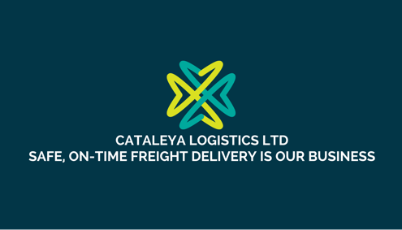
Figure 1: Company Logo
(Developed by author)
The facilities that Cataleya Logistics LTD shall offer are as follows:
- Assistance for a specific group (Gibb, 1996 p.317)
- Delivery operations using flatbeds, curtains, and box trailers.
- Tools for local delivery
- Transportation assistance
- Storage services

According to GOV.UK, Department for transport, moving freight, also referred to as long-distance freight hauling, is a type of transportation that involves moving various items such as commodities and refrigerated goods. The industry has experienced moderate growth over the past couple of years due to the improving economy and the need for transportation services.
The high prices of diesel fuel have also contributed to the industry's moderate growth. In the future, however, competition will drive down the transportation costs.
The industry's revenue is expected to grow at a rate of 2.2% over the next five years. It is expected to reach a total of £33.3 billion by 2022-23. Domestic road freight has also shown a steady increase over the past couple of years (Department for Office Rail and Road,2021).

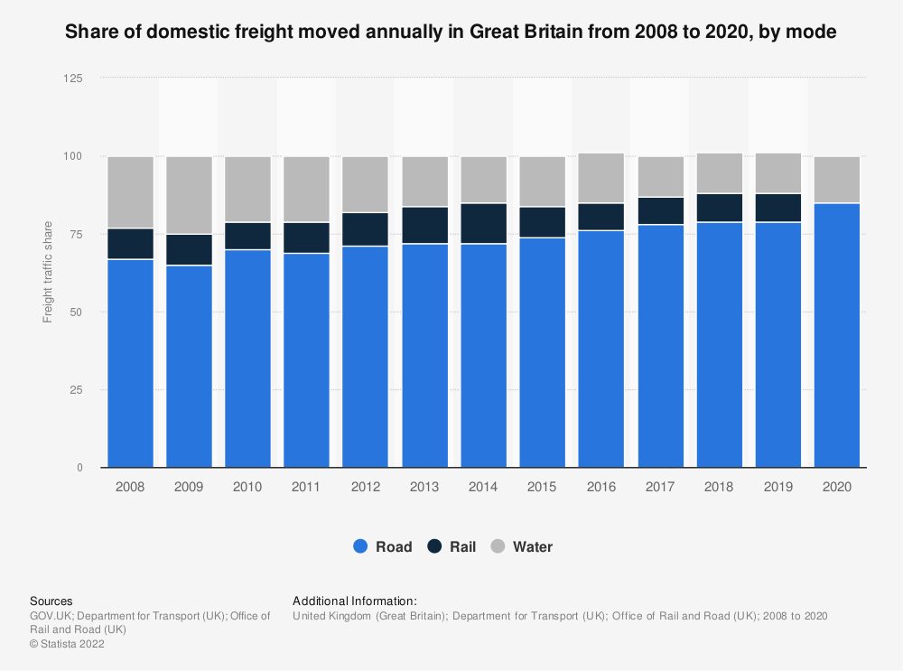
Figure 2: Freight moved annually in UK from 2008-2020
(Source: GOV.UK, Department for Transport (UK), Office of Rail and Road)
Ownership and Legal format of the start-up
I must apply for Operator's license, which is required for businesses carrying goods for hire or reward (UK Government, 2021). I must probably have to take and clear a CPC (Certificate of Professional Competence) exam on my own to get the CPC Transport Manager or I will have to employ a transportation management who currently possesses it. I will have to complete several documents and present banking information proving I have the money to run a trucking company to receive a manufacturer's permit (May,1975 p.164). To make certain my funds are in control prior registering, I must do the following. The Department of Transportation will receive my paperwork and determine whether to award me the licence or not.
I will require making sure I pick the appropriate commercial trucks after I receive my operator's licence. There are several stiff trucks on the market, with weights ranging between 7.5 tonnes to 44 tonnes. It is also important to give careful thought to the sort of trailers I want to use, as this choice will affect the trucks I need. For example, if I decide to just utilise trailer, I will need to rent or buy a 44-ton modular truck since my current truck will not be capable of hauling it! On the reverse side, a curtain-sided truck could prove more appropriate if I choose to deal with trucks.
Management of the company
Only certain candidates who really are pertinent to the company objectives will be hired, according to the business's strict hiring policy. The organisation has implemented a variety of steps, such as strict screening requirements, to guarantee that it only hires the finest drivers (Longenecker et al., 2013). Professional drivers can manage the rigours of the work since they are well experienced. To promote safety as well as other driving mistakes, the corporation is searching for cautious drivers to join its workforce (Chowet al., 1982). The firm feels that safe driving is the finest method to keep cars on the highway for a longer period, thus this is crucial to its long-term profitability.
I will organize and administer Cataleya Logistics LTD. To serve as the future firm's CEO and oversee the accountancy council's finances, we hired a previous Accountant, Harrison McDermott. I am completing my degree In Business Management at University of Wales Trinity Saint David. Furthermore, I am an experimented HGV driver, and I was a logistics supervisor for one year, that helped me to create my image as a logistical administrator with rigorous expectations for customer relations is a result of my organisational abilities and customer-first mind-set. For more over one decade, Harrison McDermott has overseen the accountancy firm of a nearby transportation firm. He had held a CPA position in a nearby taxation business before beginning his career in transportation. I depend heavily on Harrison's research, meticulous planning, and emphasis on cost-effective alternatives. Another member of the crew is the web designer, and we hired a trucking experimented driver. The idea is that when upper company gets together to discuss how the business will be handled, successful outcomes will follow.
Explanation of the target market and the marketing strategies the company will adopt to reach their customers.
Cataleya Logistics LTD will target anybody who requires transportation operations in Birmingham, UK, and the neighbouring districts. The firm will specifically serve people and minor enterprises, which may require regional delivery or have minor deliveries.
Clients Dissection
Cataleya Logistics LTD will focus on the essential clientele:
- Proprietors of micro businesses
- A few minor manufacturers
- Those that require goods delivery facilities.
Competitiveness Benefit
Above its rivals, Cataleya Logistics LTD would be capable to provide the succeeding benefits:
- Group of truckers and transportation professionals that are competent, kind, and have vast expertise in the industry.
- Utilisation of cutting-edge freight and transportation equipment to guarantee each shipment is managed with the utmost caution and transported quickly.
- Regional transmission is provided by Cataleya Logistics LTD, which also accepts smaller loads that bigger transportation firms would turn down.

Marketing Strategy
Values Principle and Branding
The essential special service proposition that Cataleya Logistics LTD would provide to its clients are:
- Knowledgeable staffs can offer a wide variety of transportation operations, covering exporting, collecting, surveillance, and local and short-distance hauling.
- To give shipping clients the highest level of service, technology and adaptability are utilised. This strategy is tailored to every firm's specific requirement.

Promotional Plan
The following is Cataleya Logistics LTD 's marketing tactic:
- Recommendations from other people
By offering top quality assistance and knowledge throughout the seasons, I have developed a community of customers. Several of my customers agreed to join me when I announced I was quitting my employment to launch my personal trucking business and assist in promoting Cataleya Logistics LTD.
- Print Marketing
To appear in trade journals, Cataleya Logistics LTD will spend money on properly created print advertisements.
SEO/Website Promotion
Our internal promotional coordinator will create the webpage for Cataleya Logistics LTD. All our activities will be included on the webpage, which will be comprehensive and well organised. Furthermore, the webpage will include their personal knowledge and other details for those who are considering towards becoming transporters. The firm's webpage is going to be managed by the head of advertising using SEO business strategies so that Cataleya Logistics LTD appears at the head of searching results every time somebody searches for "Birmingham trucking company" or "trucking near me" in either Bing or Google.
Evaluation of the business idea by using the SWOT analysis model
An established method for doing comprehensive research is the SWOT framework, which stands for strength, weakness, opportunity, and threats (GURL, 2017). It may assist in determining the goals of a business or program as well as the inside and outside components required to meet certain goals. SWOT may be useful for separating possibilities from risks and turning shortcomings into advantages (Leigh, 2009 p.129).
Strengths | Weaknesses
- I have worked with retailers and merchants before, and I understand how to foster an environment that motivates people to market my goods and spend in educating their marketing staff so that clients can get the most out of utilising our goods.  - Learning and growth initiatives that were effective led to our qualified labour force. To ensure all our staff members are both extremely trained and strongly driven to accomplish much more, we must devote significant expenditures to learning and growth.  - The overwhelming bulk of Cataleya Logistics LTD’s prospective clients will be catered to by the system of transmission that will be built. This will assist the firm in expanding and preserving a devoted clientele. | - The transportation sector is outperforming the business. To ascertain whether it will expand in the years ahead, Cataleya Logistics LTD should closely examine the numerous developments in the trucking industry.  - To maintain the commercial operations, operating a firm in the transport business sector occasionally demands high operating expenditures.  - Keeping up with today's emerging advancements is challenging due to the rapid developments in innovation. Improvements to regularly utilized equipment may also be costly, particularly if they call for employee development.  - Merchandise occasionally becoming damaged during shipping and distribution operations is a typical issue that can harm the business's image.
Opportunities | Threats
- The delivery of produced products will expand as there is an expand in global trading, that will result in more revenue for Cataleya Logistics LTD.  - Companies can use decent technological advances to strengthen their project management and augmentation processes by engaging in it. This has been made possible by the development of information mining and artificial intelligence.  - By utilising the assets of some other firm, purchases might aid in the expansion of an established firm. By utilising the assets of some other firm, purchases might aid in the expansion of an established firm. | - Political turmoil has the potential to hurt distribution personnel and harm those items which must be transported. This might cause issues for firms while having a detrimental effect on how they operate.  - There are a few disadvantages to the fact that several businesses have been around for a while and have been flourishing, and this will restrict Cataleya Logistics LTD to keep its place in the industry.

Assessment of the current external environment by using the PESTEL analysis model
PESTLE evaluation is a tactical technique for comprehending the present and potential upcoming situation of Cataleya Logistics LTD. This examination considers several elements, such as issues in politics, economic, society, technology, the ecology, and law (Perera, 2017). Cataleya Logistics LTD may make wise judgements about how to do commerce in an evolving landscape by being aware of these variables.
Political | - Political consistency and the significance of the transportation industry to the economic growth.  - Army incursion possibility  - Degree of impropriety, particularly the degree to which the business industry is regulated.  - Federal red tape and intervention in the transportation business.  - Governing body of law for enforcing compliance  - Safeguarding of trade secrets
Economic | - Interference by the state with the capitalist model and associated components  - Monetary prices and financial sustainability in the local population.  - Building standards in the transportation sector  - Competitive benefits between the local population and its solutions provider.
Social | - Census figures and skillet  - Educational quality and degree within the General Haulage Transport sector  - Society (sex roles, societal customs etc.)  - Although some civilizations support innovation, others do not.  - Values (wellness, sustainability, etc.)  - Recreational pursuits
Technological | - Latest technical advancements by rivals of General Haulage Transport  - Influence of technologies on service offerings  - effect on the transportation firm's cost base  - effect on the business firm's product network framework  - Technology dispersion ratio
Legal | - Competitive legislation in the nation's transport sector  - Legal prejudice  - Trademarks, economic domain legislation, and licensing  - Customer safety and online shopping  - Occupational regulation  - Medical and security legislation  - Data security
Environmental | - Changing weather  - regulations to control contamination of the ecosystem.  - Laws on air and water pollutants in the transportation sector  - Reprocessing  - Managing pollution in the services industry  - stances on environmentally friendly or "environmental" items  - the opinions about and advocacy for sustainable power

Identification of the key marketing factors by using the 4Ps of marketing mix model
Through offering top-notch customer care, making deliveries on schedule, and effectively operating logistics, several transportation companies have grown their enterprises (Goi, 2009, p.4). Yet, efficient advertising and interaction with prospective and even current consumers are necessary to advance General Haulage Transport. The four Ps of marketing—product, place, promotion, and price—are the foundation of successful advertising.
Product (Services)
Identifying our consumer base and providing consumers with the goods or services as soon and easily as you can are the two main goals of Cataleya Logistics LTD. Regardless your demands are distinct from others', Cataleya Logistics LTD attend to them. They will work to meet your deadline for purchase fulfilment, deliver correct invoices, and prevent any harm along the process.
Place
The use of location in commercial transportation enables the business to streamline interactions among customers and logistical providers (Håkansson et al., 2005, p112). The Cataleya Logistics LTD should carry out procedures in a manner that keeps the consumer from being mindful of the difficulties, which are present. The outcome remains more significant to the client than method.
Promotion
A company’s commercial distribution network, that also involves organising the transportation of different commercial products, involves advertising as a crucial step. For instance, the design studio may create the painting for the company is packaging, while a third-party provider could produce the containers with the picture (Håkanssonet al., 2005, p116). By coordinating their efforts, these organisations can create the advertising required components to advertise the commodity.
Pricing
Pricing in commercial transportation should consider both the goods and the client. Commercial operations should be ready to adjust when often-changing variables, such as the goods and the consumer's characteristics, occur (Goi, 2009, p.9). Quantity reductions from Cataleya Logistics LTD could be available, and transportation logistics fees may have an impact on how much a client must pay. The length of the production cycle, labour expenses, and the kinds, amounts can also affect pricing, and grade of supplies utilised throughout the production cycle.
A cash flow forecast for the first 12 months.
To finance the start-up costs of the Cataleya Logistics LTD, a start-up loan for £25000 will be obtained from a bank.
A start-up loan is a type of financing provided to entrepreneurs to help them start and grow their new businesses. It is a type of business loan that can be used for various purposes, including purchasing equipment, hiring staff, marketing, and office space rental. According to the British Business Bank (2021), start-up loans are specifically designed to support new businesses in their early stages, providing them with the financial resources they need to get their operations off the ground.
In the case of Cataleya Logistics LTD, UK, a start-up loan of £25,000 from a bank can help to cover the initial costs associated with setting up the business. This could include purchasing a truck, acquiring necessary permits and licenses, and paying for insurance coverage. As noted by the UK Government (2021), start-up loans can be obtained from a range of sources, including traditional banks, alternative lenders, and online platforms, depending on the specific needs of the business.

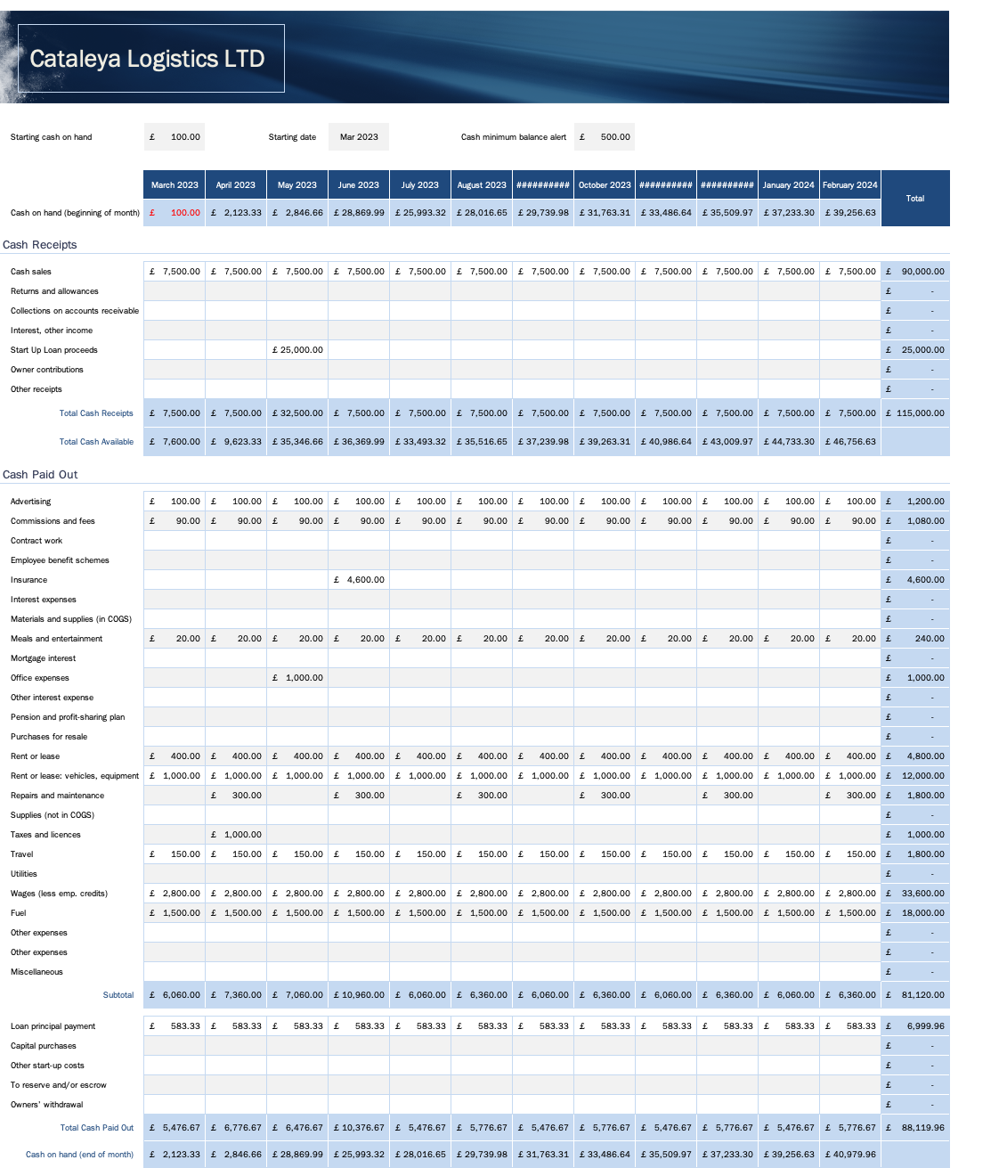
Figure 3: Forecast for the first 12 Months
(Developed by author)
References
British Business Bank. (2021). Start Up Loans. https://www.british-business-bank.co.uk/ourpartners/start-up-loans/ UK Government. (2021).
Chow, G. and Button, K., 1982. The Economic Regulation of road haulage (trucking) in Canada and the United Kingdom.
Gibb, A.A., 1996. Entrepreneurship and small business management: can we afford to neglect them in the twenty‐first century business school? British Journal of management, 7(4), pp.309-321.
Goi, C.L., 2009. A review of marketing mix: 4Ps or more. International journal of marketing studies, 1(1), pp.2-15.
GURL, E., 2017. SWOT analysis: a theoretical review.
Håkansson, H. and Waluszewski, A., 2005. Developing a new understanding of markets: reinterpreting the 4Ps. Journal of Business & Industrial Marketing, 20(3), pp.110-117.
Hay, R. and Gray, E., 1974. Social responsibilities of business managers. Academy of management journal, 17(1), pp.135-143.
Leigh, D., 2009. SWOT analysis. Handbook of Improving Performance in the Workplace: Volumes 1‐3, pp.115-140.
Longenecker, J.G., Petty, J.W., Palich, L.E. and Hoy, F., 2013. Small business management. Cengage Learning.
May, A.D., 1975. Supplementary licensing: an evaluation. Traffic engineering and control, 16(4), pp.162-167.
Perera, R., 2017. The PESTLE analysis. Nerdynaut.
Statista. (2021). UK economy. https://www.statista.com/topics/2266/uk-economy/
UK Government. (2021). UK haulage industry. https://www.gov.uk/guidance/uk-haulage-industry
UK Government. (2021). Haulage Permits and Operators Licensing: Guidance for International Transporters. https://www.gov.uk/guidance/haulage-permits-for-eu-and-efta-countries
UK Government. (2021). Start up loans. https://www.gov.uk/business-finance-support/start-up-loans

