University of Wales Trinity St David.
Materials Engineering-ACBA5022.
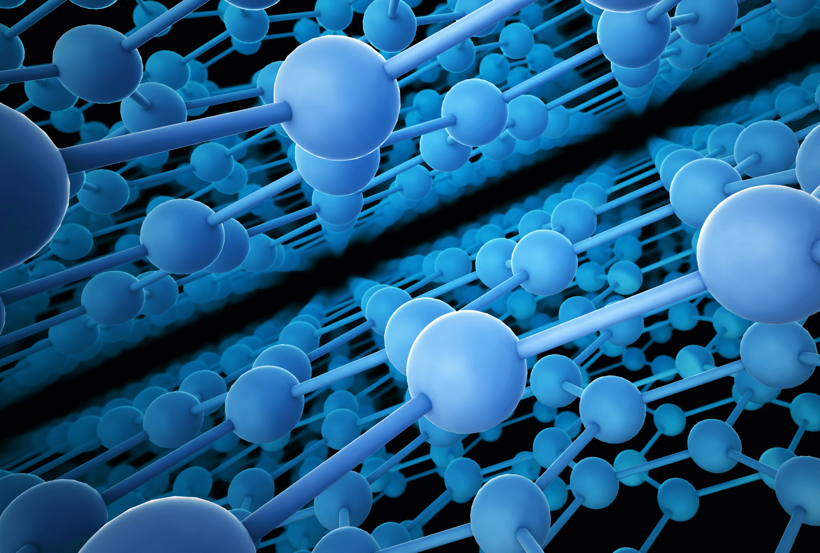
The Potential Use of Plastics as a Replacement Material in Concrete and Mortar Mixes.

By- Thomas Caddell (2217174)

- Recent Research Methods-
  - As a replacement for aggregates in concrete-
With the increase in population across the globe having a negative impact of waste material such as plastic, beginning to store, recycle and re-use plastics is becoming a major issue due to the chemical makeup of the material. (DeWeerdt, 2022) (University of Bath, 2018)

A case study I will be gathering information from-
‘KULE SURGEON- ASSESSING THE EFFECT OF PARTIAL REPLACEMENT OF COARSE AGGREGATE IN CONCRETE WITH RECYCLED PLASTIC-WASTE PALATES.’
The sole purpose of Mr Surgeon’s research method was to assess the effects of partially replacing coarse aggregates in concrete used for suspended slabs with recycled plastic waste pallets. The study examined both the fresh and hardened properties of the concrete. The only variable in this experiment was the degree of partial substitution of plastic pallets for coarse aggregates. Meanwhile, the dependent variables include the concrete's workability, compressive strength, and cube weight at different replacement percentages. (Surgeon, 2018)

Mr Surgeon then began his methodology by creating plastic aggregates mainly consisting of plastic water bottles, tv sets and jerry cans. These were cleaned using natural detergents then melted and moulded into ‘10mm x 10mm x 10mm’ cubes/aggregate. (Surgeon, 2018)
When casting the concrete mix one part cement, two parts fine aggregates, and four parts fine aggregates were combined to create the volume-batched concrete. A control concrete mix was also batched with a replacement of 0% plastic aggregates to compare workability.

The increments of plastic aggregate increase per sample were as follows-
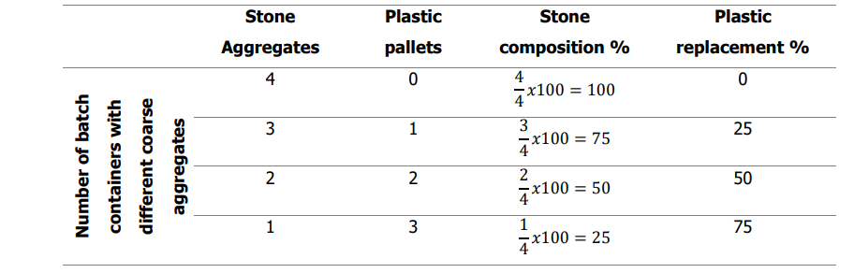
(Surgeon, 2018)
3 tests were then carried out on each sample; Compressive strength, Weight/Density and Slump. The results were as follows-
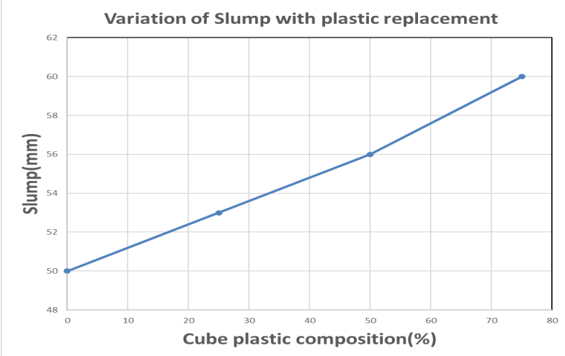
- Slump test:

(Surgeon, 2018)
We can see from the results of the slump test the increase in plastic aggregate (%) to the sample there is an increase in workability (slump mm) this is explained due to the plastic having low or no absorption of water resulting in the material lacking adherence.

- Weight/Density:
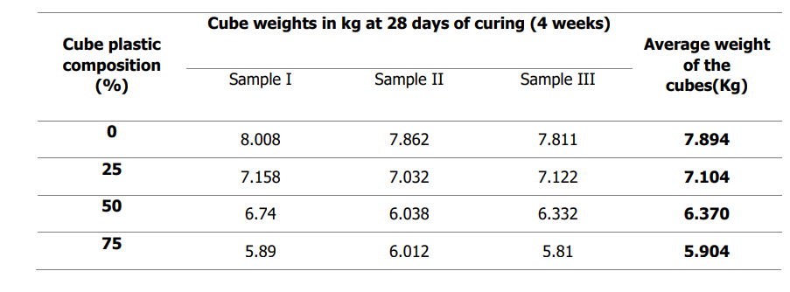
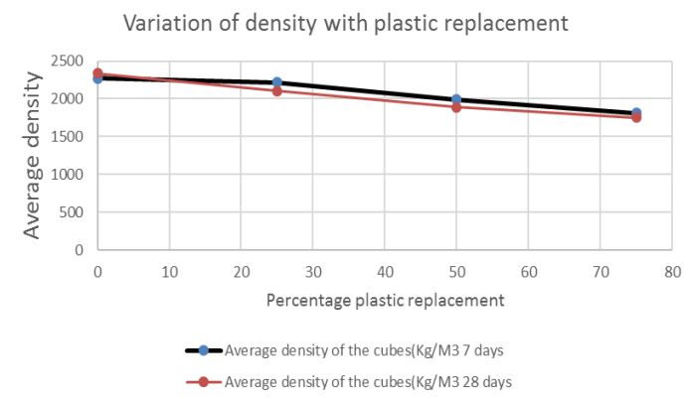
(Surgeon, 2018)
Plotting the densities of concrete cubes against the various percentage changes typically reveals a tendency towards density decrease as the percentage replacement of plastic increases. This is because the density of the plastic employed is lower than that of the aggregates of natural stone. Therefore, a cube's density decreases as its percentage of plastic increases.

- Compressive strength test:
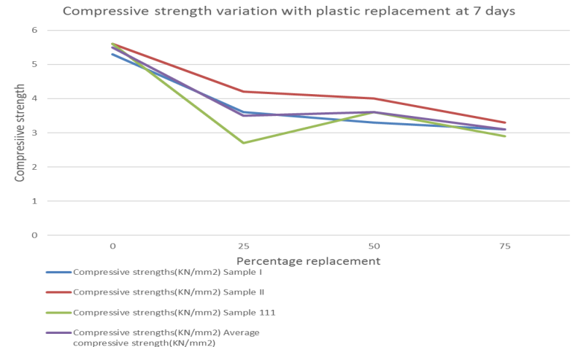
(Surgeon, 2018)
Plotting trends of compressive strength variation with plastic replacement revealed that, generally speaking, compressive strength decreased as the fraction of plastic in each cube increased. Plotting trends of compressive strength variation with plastic replacement revealed that, generally speaking, compressive strength decreased as the fraction of plastic in each cube increased.
Nevertheless, it was also shown that the trend first declines between 0 and 25% before dipping somewhat rises and then progressively falls for each of the three samples. This is explained by the fact that concrete cubes tested after seven days typically exhibit an odd and unpredictable behaviour in strength, hence it is impossible to use them to infer how plastic affects compressive strength.

  - As reinforcement material in mortars-
A case study I will be using to derive information from-
‘Abdulaziz Alsaif and Mohammad Alshannag- Flexural Behavior of Portland Cement Mortars Reinforced with Hybrid Blends of Recycled Waste Fibers.’ (Alsaif & Alshannag, 2022)
The flexural performance of Portland cement mortars reinforced with recycled fibres was assessed in laboratory experiments. The goal was to improve the flexural behaviour and ductility of cement-based composites by determining the optimal combination of unsorted recycled post-consumer tire steel fibres (RTSF) and recycled plastic fibres (RPF).
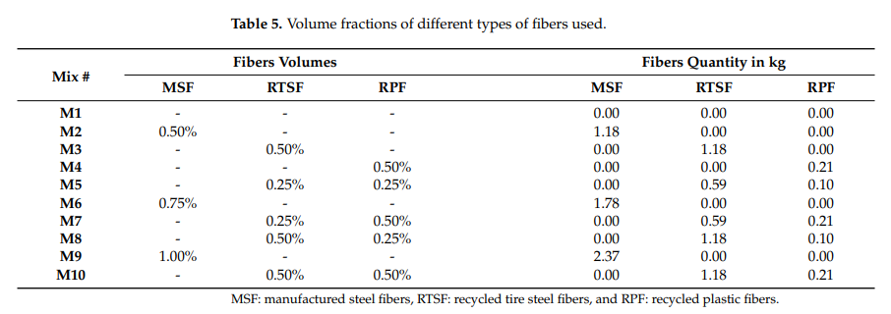
(Alsaif & Alshannag, 2022)
A vibrating table was used to compact the prism and cube specimens after they had been cast in two layers. Every specimen was kept in the lab setting for twenty-four hours after being coated with damp hessian. After being released from the mould, they underwent a 28-day water cure before being ready for testing.
The tests carried out on the samples were; flow of fresh mortar, compressive strength, flexural strength, and flexural toughness.

- Flow test:
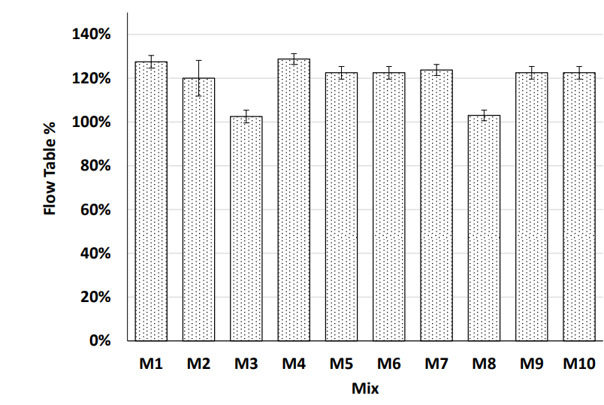

(Alsaif & Alshannag, 2022)
After trialling several mixes to reach a control to a standard, The average of four diameter measurements is represented by each flow value. As can be shown, the flow of the majority of the fibre-reinforced mortar mixes was nearly identical to that of the control mix and satisfied the flow range specified by the ASTM C1437-20 standard. This is due to the cement mortar mixture's consistent qualities as well as the reduced fibre doses per volume. Additionally, the mixtures reinforced with MSF and hybrid blends of RTSF and RPF showed comparable flow. (Alsaif & Alshannag, 2022) (Merlo, 2021)

- Compressive strength:
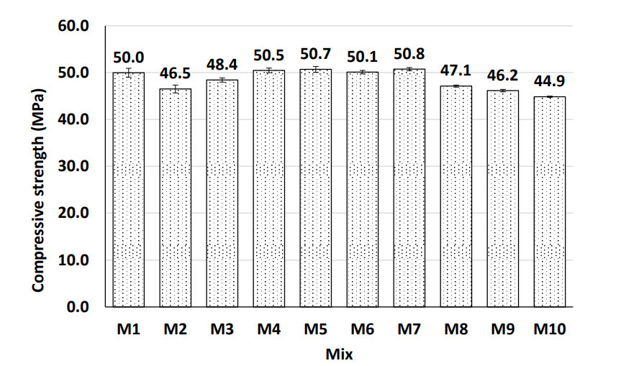
(Alsaif & Alshannag, 2022)
As can be seen, the mortar mixes reinforced with M5, M7, M8, and M10 hybrid blends of recycled fibres demonstrated compressive strengths that were somewhat comparable to those of the mixes reinforced with M2, M6, and M9 produced steel fibres. However, as compared to control mix M1, the compressive strength of certain of the fibre-reinforced mixes, M2, M3, M8, M9, and M10, decreased by between 3% to 10%. This might be the result of fibre lumping brought on by the recycled fibres' uneven distribution in these mixtures. Even though certain mixes' compressive strengths somewhat decreased, their final compressive strengths were still within the range of high-strength mortar. Additionally, out of all the mixes examined, M7, which had a hybrid blend of 0.25 percent RTSF and 0.50 percent RPF on a volume basis, had the highest compressive strength.

- Flexural Strength:
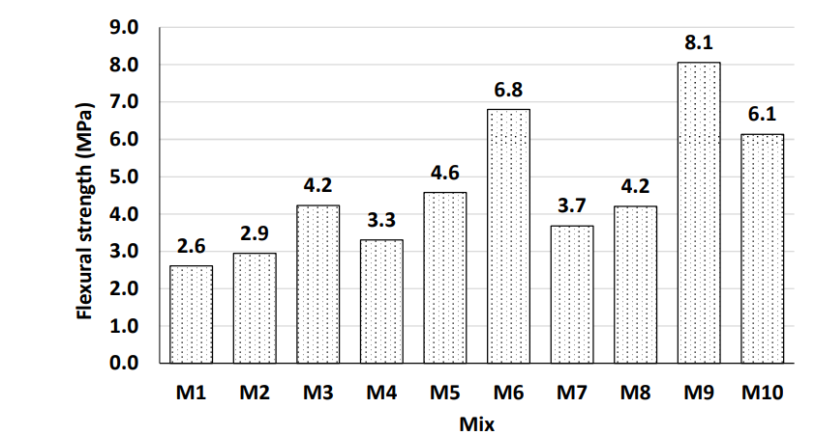
(Alsaif & Alshannag, 2022)
The uniform distribution and alignment of the fibres within the mortar matrix, as well as the combined action of the hybrid blends of recycled plastic and tire steel fibres at pre-cracking and post-cracking levels, respectively, may be the causes of the mixes M3, M5, M6, M9, and M10's superior post-peak response. The fibres within the samples allow micro cracks to be filled whereas with the controlled sample the micro cracks are not filled and therefore fail under less pressure.

In the conclusion of the investigation it is found that-
“(1) Echo-friendly, unsorted, recycled fibres extracted from post-consumer tire steel and plastic wastes could be recommended for enhancing the flexural performance of cement-based composites at a lesser cost.
(2) All the mortar mixes reinforced with hybrid blends of recycled fibres exhibited flexural behaviour characterized by the occurrence of numerous fine cracks within the middle third of the specimens tested, followed by the formation of a major single crack at failure.

(3) Both types of recycled fibres, RTSF and RPF, were effective in sustaining relatively high stress levels after the peak load. This is due to the crack arresting capability and gradual pullout of these fibres from the mortar matrix after cracking.
(4) At the same total dosage of fibres, the flexural toughness of the mortar mix reinforced with a hybrid blend of fibres M10 (0.5% of RTSF and 0.5% of RPF), outperformed the flexural toughness of M2 by 146%, and achieved a flexural toughness of 88%, and 76% of the toughness of M6 and M9, respectively.
(5) At the same total dosage of fibres, the mortar mixes reinforced with MSF showed up to a 6% drop in post-cracking strength at 2 mm deflection, compared to the post cracking strength at 0.5 mm deflection, whereas the mixes reinforced with hybrid blends of RTSF and RPF showed up to a 29% drop in post-cracking strength at the same deflection limits.
(6) Among the recycled fibre blends investigated, the mix containing 0.5% RTSF and 0.5% RPF (on volume basis) exhibited relatively superior flexural characteristics compared to the mixes reinforced with the same dosage of manufactured steel fibres (MSF) only.” (Alsaif & Alshannag, 2022)

- Evaluation of Case studies and Problems Within.
The inclusion of recycled plastics as aggregates in concrete offers an innovative solution to address the growing issue of plastic waste while reducing the dependence on traditional natural aggregates. However, the practice comes with significant challenges that must be carefully evaluated. These challenges can affect the mechanical, physical, and chemical properties of the concrete, potentially limiting its application in structural projects.
This evaluation outlines the key problems associated with using plastics as aggregates in concrete, highlighting areas where improvements or mitigation strategies may be necessary.
2.1) Reduced Strength and Load-Bearing Capacity
One of the primary concerns with incorporating plastics into concrete and mortar is the reduction in strength, particularly compressive strength. Natural aggregates, such as crushed stone or gravel, provide the bulk of concrete's compressive strength due to their rigidity and compatibility with the cement matrix. In contrast, plastics, being significantly less rigid and possessing a lower modulus of elasticity, cannot achieve the same load-bearing capacity. (Shapariya & Panchal, 2021) (Manning, 2019)
The studies above show as the proportion of plastic aggregates increase the compressive strength of the sample decreases. This occurs because plastics are generally more deformable and less adherent to the cement paste (do not absorb or absorb very little water), leading to weak interfacial zones. These weak zones can create points of failure under stress, limiting the use of plastic aggregate concrete in load-bearing applications. (Tota-Maharaj, 2022) (Manning, 2019)

2.2) Challenges with Bonding

The bond between aggregates and the cement paste is critical to the overall strength and stability of concrete. Natural aggregates are typically rough and angular, providing a mechanical interlock with the surrounding cement paste. In contrast, plastic aggregates often have smoother surfaces and lower surface energy, resulting in weaker adhesion. (Khajuria & Sharma, 2019)
This weak bond can reduce the transfer of stress within the concrete matrix, further diminishing its mechanical properties. Surface treatments, such as roughening the plastic particles or applying chemical coatings, can improve bonding but add complexity and cost to the production process. (Khajuria & Sharma, 2019)

2.3) Durability

Durability is another critical challenge when using plastics in concrete. The presence of plastic aggregates can compromise the long-term performance of the material in several ways:
- Increased Porosity: Plastics may introduce voids or gaps within the cement matrix, leading to increased porosity. This higher porosity reduces the concrete's resistance to water ingress, potentially accelerating processes like freeze-thaw damage, carbonation, or chloride ion penetration.
- Thermal Expansion Mismatch: Plastics and cementitious materials have differing coefficients of thermal expansion. Under temperature fluctuations, this mismatch can create stresses within the concrete, leading to cracking and reduced durability over time. (Oddo, et al., 2024)

2.4) Workability Issues
Plastic aggregates also affect the workability of fresh concrete. Depending on the type and shape of the plastic used, the material can exhibit poor bonding with the cement paste, leading to segregation or uneven distribution within the mix. For instance, smooth plastic particles have lower surface friction, reducing cohesion and increasing the tendency for the mix to bleed or segregate.
Furthermore, the lower density of plastics compared to traditional aggregates can cause floating during mixing or compaction, resulting in an uneven texture. This behaviour complicates the casting process and requires modifications in mix design or additional additives to achieve a homogeneous mix. (Duraiswamy, et al., 2024)
- Critical Assessment of using Plastics in Concrete/Mortar
3.1) Practicality & Functionality
Using plastics as aggregates in concrete offers a sustainable solution to mitigate plastic waste and reduce reliance on natural resources. This innovative approach is particularly practical for non-structural applications, such as lightweight panels, pavement blocks, and decorative elements, where reduced strength is acceptable. The lower density of plastics results in lighter concrete, which can simplify handling and transportation while providing thermal insulation benefits. (Babafemi, et al., 2018) (Cousins, 2019)
However, the practicality of plastic aggregate concrete in structural applications remains limited due to several challenges. Plastics tend to weaken the mechanical properties of concrete, such as compressive strength and stiffness, making it unsuitable for high-load or high-stress environments. (Hamada, et al., 2023) Workability issues, caused by the non-adhesive nature and low density of plastics, can complicate mixing and placement processes. Furthermore, durability concerns arise from increased porosity and the potential for thermal expansion mismatch between plastics and the cement matrix. (Minde, et al., 2024) (Sau, et al., 2024)
3.2) Future efficiency
The future efficiency of using plastics as aggregates in concrete hinges on advancements in material science, engineering practices, and sustainability-focused innovations. While challenges currently limit their widespread adoption, ongoing research and development efforts offer promising pathways to improve their performance and utility in construction. (Awoyera & Adesina, 2020)
One area of focus is enhancing the bond between plastic aggregates and the cement matrix. Surface treatments, such as chemical coatings or physical roughening, can improve adhesion and address issues related to weak interfacial zones. This would enhance mechanical properties, including compressive and tensile strength, making plastic aggregate concrete more viable for structural applications. (Minde, et al., 2024)
Some of the most recent and innovative uses of plastics as a replacement of aggregate in concrete is ‘Plasticrete’, this is a product formed without water and is 90% plastic with 10% fine aggregate (sand) as a binder. The compressive strength of ‘Plasticrete’ meets and exceeds that of regular mortar mix. (Invent Penn State, N/A)
3.3) Conclusion
The use of plastics as aggregates in concrete offers a promising avenue for sustainable construction, but it is not without significant challenges. Reduced strength, durability issues, and practical constraints must be addressed through innovative research and engineering solutions. Surface treatments, optimized mix designs, and the development of standards could help mitigate these problems, making plastic aggregate concrete a viable material for a wider range of applications.
While its use may currently be limited to non-structural elements or areas where environmental benefits outweigh performance trade-offs, further advancements in technology and material science could enhance its feasibility. Addressing these challenges will be crucial to unlocking the full potential of plastics in sustainable construction.

References
Alsaif, A. & Alshannag, M., 2022. Flexural Behavior of Portland Cement Mortars Reinforced with Hybrid Blends of Recycled Waste Fibers. [Online]
Available at: file:///C:/Users/tomcaddell/Downloads/Flexural%20behaviour%20of%20mortars%20with%20plastic%20fibres.pdf
[Accessed 04 January 2025].
Awoyera, P. & Adesina, A., 2020. Plastic wastes to construction products: Status, limitations and future perspective. [Online]
Available at: https://www.sciencedirect.com/science/article/pii/S2214509520300024
[Accessed 05 January 2025].
Babafemi, A., Savija, B., Paul, S. & Anggraini, V., 2018. Engineering Properties of Concrete with Waste Recycled Plastic: A Review. [Online]
Available at: https://www.mdpi.com/2071-1050/10/11/3875?utm_source=chatgpt.com
[Accessed 05 January 2025].
Cousins, S., 2019. Sustainability double puts plastic in concrete. [Online]
Available at: https://www.ribaj.com/products/extreme-spec-waste-plastic-in-concrete-university-of-bath-goa-engineering-college
[Accessed 05 January 2025].
DeWeerdt, S., 2022. Why It’s So Hard to Recycle Plastic. [Online]
Available at: https://www.scientificamerican.com/article/why-its-so-hard-to-recycle-plastic/
[Accessed 29 December 2024].
Duraiswamy, S., Neelamegam, P., Priyan, V. & Alaneme, G., 2024. Impact of plastic waste fiber and treated construction demolition waste on the durability and sustainability of concrete. [Online]
Available at: https://www.nature.com/articles/s41598-024-78107-w?utm_source=chatgpt.com
[Accessed 05 January 2025].
Dynamic Concrete Pumping, 2024. Will Concrete Stick to Plastic. [Online]
Available at: https://www.dcpu1.com/blog/guide-to-concrete-adhesion/
[Accessed 05 January 2025].
Hamada, H. et al., 2023. Enhancing sustainability in concrete construction: A comprehensive review of plastic waste as an aggregate material. [Online]
Available at: https://www.sciencedirect.com/science/article/abs/pii/S2214993724000575#:~:text=Furthermore%2C%20the%20durability%20properties%20can,pollution%20for%20a%20cleaner%20environment.
[Accessed 05 January 2025].
Invent Penn State, N/A. Cement and Water-Free Concrete Using Recycled Plastic Binder. [Online]
Available at: https://invent.psu.edu/ip_item/cement-and-water-free-concrete-using-recycled-plastic-binder/#:~:text=Novel%20waste%20plastic%2Dbased%20concrete,addition%20of%20water%20during%20production.
[Accessed 05 January 2025].
Khajuria, A. & Sharma, P., 2019. Use of Plastic Aggregates in Concrete. [Online]
Available at: https://www.ijitee.org/wp-content/uploads/papers/v9i1/A5088119119.pdf
[Accessed 05 January 2025].
Manning, T., 2019. The Performance of Concrete Containing Recycled Plastic Aggregates. [Online]
Available at: https://thekeep.eiu.edu/cgi/viewcontent.cgi?article=1148&context=honors_theses
[Accessed 05 January 2025].
Merlo, A. L. L. S.-R. D. P. M., 2021. Recycling of WEEE Plastics Waste in Mortar: The Effects on Mechanical Properties. [Online]
Available at: https://www.mdpi.com/2313-4321/6/4/70
[Accessed 03 January 2025].
Minde, P., Mrudula, K., Patil, J. & Shelake, A., 2024. Comprehensive review on the use of plastic waste in sustainable concrete construction. [Online]
Available at: https://link.springer.com/article/10.1007/s43939-024-00126-1
[Accessed 05 January 2025].
Oddo, C. M., Cavaleri, L., Mendola, L. L. & Bilal, H., 2024. Integrating Plastic Waste into Concrete: Sustainable Solutions for the Environment. [Online]
Available at: https://pmc.ncbi.nlm.nih.gov/articles/PMC11277989/?utm_source=chatgpt.com
[Accessed 05 January 2025].
Sau, D., Shiuly, A. & Hazra, T., 2024. Utilization of plastic waste as replacement of natural aggregates in sustainable concrete: effects on mechanical and durability properties. [Online]
Available at: https://link.springer.com/article/10.1007/s13762-023-04946-1
[Accessed 05 January 2025].
Shapariya, H. J. & Panchal, R., 2021. MECHANICAL PROPERTIES OF CONCRETE BY USING PLASTIC WASTE. [Online]
Available at: https://www.irjmets.com/uploadedfiles/paper/volume3/issue_5_may_2021/10144/1628083406.pdf
[Accessed 05 January 2025].
Surgeon, K., 2018. ASSESSING THE EFFECT OF PARTIAL REPLACEMENT OF COARSE AGGREGATE IN CONCRETE WITH RECYCLED PLASTIC-WASTE PALATES.. [Online]
Available at: https://irbackend.kiu.ac.ug/server/api/core/bitstreams/2b474684-3cb0-48d0-91ac-a71673c2d23b/content
[Accessed 29 December 2024].
Tota-Maharaj, K., 2022. Effects of waste plastics as partial fine-aggregate replacement for reinforced low-carbon concrete pavements. [Online]
Available at: https://www.tandfonline.com/doi/full/10.1080/19397038.2022.2108156#abstract
[Accessed 05 January 2025].
University of Bath, 2018. Waste plastic in concrete could help support sustainable construction in India. [Online]
Available at: https://www.bath.ac.uk/announcements/waste-plastic-in-concrete-could-help-support-sustainable-construction-in-india/
[Accessed 29 December 2024].

