
CAREER DEVELOPMENT REPORT.


Natalie Reynolds
2003716
February 21, 2020
University of Wales Trinity Saint David

Table of Contents

Introduction …………………………………………………………………………………………………………………………….2

Findings…………………………………………………………………………………………………………………………………….3-11

Conclusion…………………………………………………………………………………………………………………………………12

References…………………………………………………………………………………………………………………………………13-14

Introduction –

This report will demonstrate the Importance of how Self-awareness and Self-assessment together play a key role in enhancing my employability skills.
What is Self-awareness?
This is a critical tool for self-control and self-evaluation. It helps you recognise what your strengths and weaknesses are and how to improve your weaknesses. You can evaluate your values, passions, goals and work on them to fit into your current lifestyle and commitments. This tool also gives you the opportunity to see how others view you to ensure better, stronger relationships with colleagues, this makes you a better leader and gives you job satisfaction (Forsey,2018).
What is Self-assessment?
This is a process of analysing, evaluating and judging your own achievements and skills, and how to improve through various learning techniques. Analysing my strengths and weaknesses and converting my weaknesses into strengths (Ukessays,2018).

In this report I will provide the evidence of the learning tools used to improve on my career development. It will include the methods and theories of, Stephen Covey’s ‘7 Habits Theory’, such as developing the habit of sharpen the saw, referring to renewing oneself by focusing on physical, Social/emotional, mental, and spiritual (Covey,2019). SMART method setting goals and achieving them within a given timeframe. SWOT method to analyse your strengths and weaknesses and turn them into opportunities and learning styles such as VARK and Honey & Mumford personality profiling questionnaires these identifying the style of learning that suits me best. With these techniques it has enabled me to identify the areas I need to improve on and given me the ability to write my own personal development plan setting targets to achieve and then on completion setting new ones. This enabling me to continue enhancing and developing my knowledge and skills.

Findings

According to Stephen Covey if I’m to be a highly effective person I need to implement the ‘7 Habits’ theory.
- Be proactive
- Begin with the end in mind
- Put first things first
- Think win-win
- Seek first to understand, then to be understood
- Synergise
- Sharpen the saw
Habits 1,2 and 3 to accomplish
Habits 4,5 and 6 to Connect
Habit 7 To Grow (Covey,2019).
Whilst applying Covey’s habits, I would like to focus with the, beginning with the end in mind and looking at my SMART Goal, where I want to end up. This will require me to plan and take action by being proactive and to achieve it I’ll need to sharpen the saw, seek continuous improvement and renewal professionally and personally and to do this I need to look after my Well-being, my body, heart, mind and spirit (Covey,2019).
SMART Goals
To Start with one needs to focus on a SMART Goal.
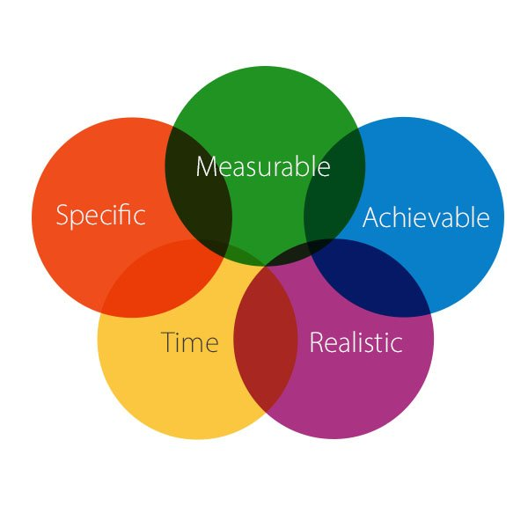
A SMART, the acronym that you can use to guide your goal setting (Mindtools,2018) combining these two is a good way of setting a realistic and good Smart goal.

My personal smart goal is that in four years I will get a job as Human Resources manager, and according to Stephen Covey’s theory to be a highly effective person in this role I will need to use his theory of ‘7 habits’. I will need to get qualifications and develop my employability skills to do so. I will complete my Level 4 course and then level 5 and will have a degree in Business Management within 3 years. Using the experience and contacts I have in previous employment I look to get work experience and up to date knowledge in order to improve my skills further within the human resources field. I will research the up to date skills required for Human resources. I will set timeframes to complete different skills and write a personal development plan to keep track of targets I set and complete, setting new targets upon completion.

SWOT ANALYSIS
The swot method was written by Albert Humphreys 1960, (Mindtools, 2017). The benefits of applying this method to yourself is to recognise your strengths and weaknesses. Then converting those weaknesses into strengths and the strengths into opportunities.

Personal swot analysis
Strengths | Weaknesses
I have experience in Human Resources  I’m good at organising  I’m Always on time  I Speak Welsh  I Communicate well with people  I’m Good at time management  I’m a hard worker and committed  I’m empathetic of people  I have connections in the Human Resources industry | Lack of qualifications  Lack of Confidence in writing skills  IT/Digital Skills  Lack of confidence in Presenting skills
Opportunities | Threats
Training courses in Human Resources  Work experience  Knowledge from people’s experience  Shadow a Human resources manager  Learn digital Skills  Volunteering  Approach organisations | Competitors better qualified and more experience  Funding for courses  Not up to date on current IT Skills  Not completing course
Tows Conversion
(SO) | (ST)
With Having connections in the human resources industry, I could arrange work experience. | With being able to speak welsh it could reduce the number of competitors for the job role.
(WO) | WT
My lack of confidence in presenting skills the current course at University will help me and other training courses to better my skills. | My lack of qualifications, by doing courses and getting better qualified.

Abraham Maslow’s Hierarchy of needs theory 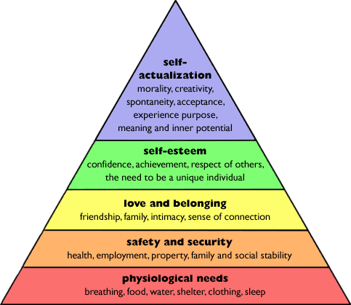
Maslow said ‘’We are only motivated to fulfil all of our safety need when we have fulfilled our psychological ones ‘’ (Hopper, 2020)
According to Maslow’s theory I sit between level three and four on the pyramid, and my ultimate- goal is to achieve self-actualisation which is my SMART Goal. The idea of the theory being, as you went up a level the previous level would no longer prove as motivating. Enhancing the motivation to continue to climb to the top level. I like the theory of Maslow as it is does not just relate to business but to life in general.

Skills Audit

Audit of current skills and skills required for a Job as HR Manager

My Current Skills | My Desired Skills
Communication | IT Skills
Time management | Presentation Skills
Working Independently | Report Writing
Critical thinking | Analytical Skills
Resourcefulness | Essay Writing
Teamwork | Budgeting skills
Planning and organising | Performance Management
Empathetic to people | Training and Development Skills
Decision making | Numeracy
Motivation | Business Acumen

To enable me to reach my desired goals and skills, combining and implementing self-reflective techniques such as Johari Window and Kolb’s Learning cycle will help me see how I view myself and how other people view me and will help me develop these skills.
The Johari Window technique was created by Joseph Luft and Harry Ingham in 1955, I find it is one of the better methods to emphasise my soft skills such as behaviour, empathy, co-operation and a simple way to learn about myself. It’s a great technique that can be used to suit a variety of situations and environments, this helping to contribute to develop my skills and input feedback into my development plan, (Self-awareness, 2013).

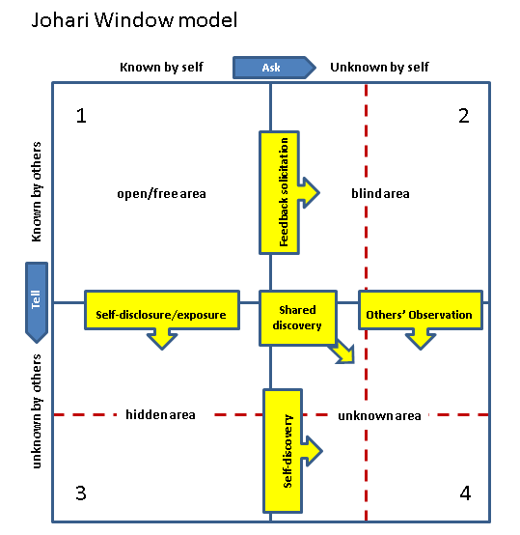

Currently some of the skills I have recognised in myself in the open/free area are, Teamwork, empathetic to people, motivation and planning and organising, and in my blind area some of the skills which are the ones I will need to further develop and bring into the open area are Analytical skills, essay writing, budgeting skills and presentation skills.

Kolb’s Learning method (Mcleod,2017)
Kolb’s theory works on two levels, four stage cycle of learning and four learning styles, Diverging, Assimilating, Converging and Accommodating.
Learning Cycle
Learning Styles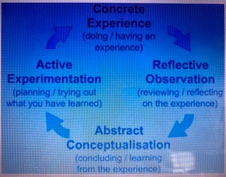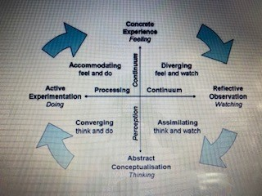
To learn effectively using this method I would need to progress through the cycle at each stage feeding into the next.
Experience > Reflection > Conceptualise > Test
Using this method will help me think about my experiences learning new skills, and then reflect and improve on them where improvement is needed. This giving myself feedback to implement in my Personal development plan.
I currently learn a new skill in the order of the cycle illustrated above. For example, for Presentation skills I would experience doing a presentation, then reflect on how I did after it from feedback from fellow students and lecturers noting where I did well, and where improvement was needed. I would then develop the areas in need for improvement and implement the changes ready for my next presentation.

Questionnaires on learning styles and Personality profiling.
To discover more about my personality, personal effectiveness and what learning styles would suit me I conducted four questionnaires.
- VARK Learning Style

VARK model written by Neil Fleming 1987 identifies what your best learning preferences are, be that Visual, auditory, reading and writing or kinaesthetic learning. It gives me the tools to give me the best experience and understanding in my learning to develop and improve the skills I require in a level of understanding more suited to myself. (Janssen,2019)
Questionnaire result = Aural study Strategies, from this result I will take note of the suggestions listed e.g. attend lectures, attend tutorials, ask others to hear your understanding of a topic, read summarised notes aloud and convert lecture notes into a learnable package by reducing them.

- Peter Honey and Alan Mumford Learning Style
Honey & Mumford’s method is very similar to Kolb’s Cycle with just a few differences. Honey & Mumford four learner types are, Activist, Reflector, Theorist and Pragmatist. Honey & Mumford suggest that, activists learn from experience, reflectors upon reflection, theorists from developing their own ideas and preferring theoretical input and Pragmatists from taking information, looking to the future and looking for the ‘what if’s’. From my results I will look to develop myself by taking the best characteristics of all four learner types to make me a far more efficient Manager, (Farooq, 2016).
The result of my questionnaire = Reflector, suggesting that I will be cautious and careful in what I do. I am somebody that will collect a great deal of information before making a judgement or decision. I would in a group discussion prefer to listen to other’s before making my views known.
3 Myers-Briggs personality profiling Test
Developed in the 1940’s this test is to determine the differing types of personalities in a workplace setting or other setting. The test can provide insight into a person’s perception, decision making, leadership skills and other attributes. It suggests that these functions can show how we approach solving problems and interacting with others, (Wolff,2018).
My results = Extrovert, Sensing, Feeling, Judging.
- The Keirsey Questionnaire

Keirsey’s assessment differs from the Myer-Briggs in a few different ways. Keirsey’s assessment stresses the sensing/intuition spectrum while Myers and Briggs centre their work on the extroversion/introversion spectrum. Keirsey’s assessment categorizes personality by temperament, while Myer-Briggs groups types according to cognitive functions such as the thinking and feeling. Keirsey’s sorter stresses actual observable behaviours, while the Myers-Briggs is more focused on internal thoughts and feelings, (Cherry, 2017)
My results
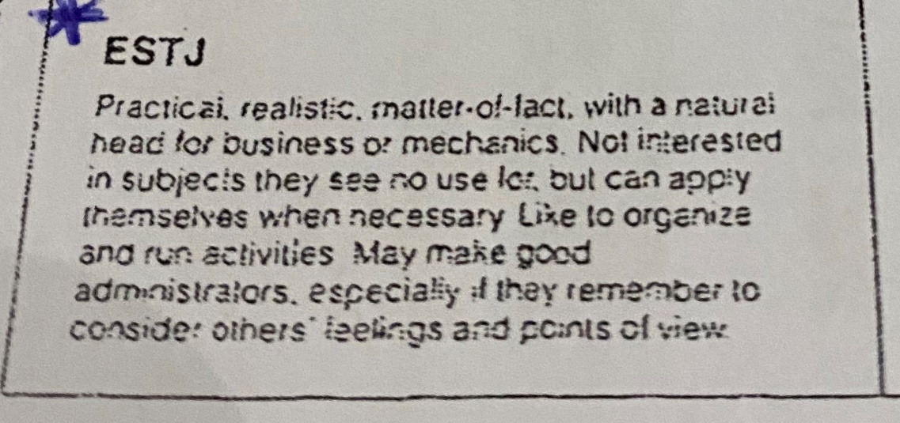

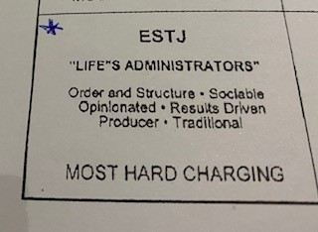

My Personal Development Plan

Development  objective | Specific actions | Blockers and how they will be removed | Support required | How I will know when I have achieved the objective
- To develop  Presentation Skills | As suggested by VARK I learn best observing others and then practicing. I will use this  Skill and watch how other’s present and Practice in front of family.  I will Develop a presentation checklist.  Allow plenty of preparation time and practice time. | Lack of confidence- I will practice speaking using family members and friends.  Allow myself plenty of time to prepare for presentation’s at University so I can practice over and over ‘Practice makes perfect’. | Family members  Fellow Students  Lectures | From My presentation assignment.  How I feel doing the presentation and how I feel after.
2. To improve Time management Skills | According to my Keirsey results suggesting I plan and organise well I will use this skill together with Tools such as Stephen Covey’s Time management Matrix, I will prioritise urgent and non- urgent tasks to set myself daily goals and weekly goals and plan-ahead doing a to do checklist and ticking off when completed. | Family Life – I will try and find the balance of what needs doing and what can wait. Allowing time for unforeseen circumstances. | Family members support in allowing me time to achieve the goals I set myself daily and weekly. | I will see the evidence of tasks completed on my daily and weekly goals checklist.
3. To Acquire academic writing skills | I am reflector based on Honey & Mumford’s Learning styles so I will develop this skill by gathering ideas from group discussions and then draft reports based on those ideas to present to lecturers for feedback. | Lack of confidence  Self-doubt  Lack of experience  I will believe in myself more  By practicing more and analysing feedback grow in experience bringing the confidence back. | University studies  Lecture’s feedback | The evidence of the marks I receive on my reports, presentations, essays etc.

This Personal development plan is concentrating on three specific skills, I will also need to develop a plan with daily, weekly goals to monitor and complete. Once I have completed a skill, I will update my development plan with a new skill from my skills audit and look to then improve and develop that skill. By developing a few skills at a time, it can ensure that I don’t become overwhelmed keeping me more motivated and focused.

Conclusion
To be successful in reaching my Ultimate goal of becoming a Human Resources Manager, I will need to set myself short term and long-term goals. I will need to concentrate on specific skills that are required for the job and concentrate on further developing them. Through developing these skills, achieving my goals and completing my studies, I will have far better employability skills and a better chance of becoming a highly efficient person enabling me to get that job as Human resource manager.

For me to achieve this I will need to update my personal development plan regularly, setting myself daily, weekly, monthly and end of year goals. I will need to monitor my progress and reflect on areas of success and areas I have struggled with, looking for ways of improving and making sure the experience motivates me. I will continue to use methods such as SWOT to analyse areas where there has been improvement, and areas that need more work. Conduct an audit of my skills every so often to keep track of whether I’m achieving my desired skills. Use the learning styles suggested by my results of Vark and Honey & Mumford questionnaires to improve my learning ability. Update methods like Johari window to get feedback from others of how they view me and my skills and see my progress. When setting goals use the SMART method to ensure I set realistic goals. To use Stephen covey’s matrix for time management to prioritise my time ensuring I complete my goals set.

If I ensure I commit to the learning tools/methods, stay motivated and focused I will achieve my Ultimate goal at the end of my studies. In four years ‘time the hard work will have paid off and the reward being myself with a Degree and a job as Human Resources Manager.

References

Cherry, K (2017) What is The Keirsey Temperament Sorter? Available at https://www.explorepsychology.com/keirsey-temperament-sorter/ Accessed (12th February)

Covey, F (2019) The 7 Habits Available at https://resources.franklincovey.com/the-7-habits-of-highly-effective-people/habit-1-be-proactive Accessed ( 9th February 2020)

Farooq, S (2016) Honey & Mumford Learner Types Available at https://www.eln.io/blog/honey-mumford-learner-types-1986-questionnaire-online Accessed (12th February 2020)

Forsey, C (2018) The true meaning of self-awareness Available https://blog.hubspot.com/marketing/self-awareness Accessed (8th February 2020)

Hopper, E (2020) Maslow’s Hierarchy of Needs Explained Available at https://www.thoughtco.com/maslows-hierarchy-of-needs-4582571 Accessed (14th February 2020)

Janssen, M (2019) overview of VARL Learning Styles Available at https://www.verywellmind.com/vark-learning-styles-2795156 Accessed (12th February 2020)

McLeod, S A (2017) Kolb-Learning styles Simply Psychology Available at https://www.simplypsychology.org/learning-kolb Accessed (11th February 2020)

Mindtools (2017) Swot Analysis Available at https://www.mindtools.com/swot Accessed (11th February 2020)

Mindtools (2018) Smart Goals Available at https://www.mindtools.com/pages/article/smart-goals.htm Accessed (11th February)

Self-awareness 2013) understanding the Johari window model Available at https://www.selfawareness.org.uk Accessed (12th February 2020)

UKEssays (2018) Introduction to Self-Awareness and Self-Analysis Philosophy Essay. Available at https://www.ukessays.com/essays/philosophy/introduction-to-self-awareness-and-self-analysis-philosophy-essay.php?vref=1 Accessed (9th February 2020)
Wolff, J (2018) What Is the Myers-Briggs Personality Test (and How to take it) Available at https://www.talkspace.com/blog/myers-briggs-personality-test-how-to-take-it/ Accessed (12th February 2020)

