Introduction
Within this essay I will critically analyse the relevance and limitations of Henry Morgan’s cultural evolution theory in relation to contemporary contexts. The first section will address Henry Morgan’s contribution to anthropology, explaining how his work inaugurated the modern anthropological study of kinship systems whilst exploring the importance of his discoveries.
The second section will critically analyse the relevance and limitations of his theory in contemporary contexts, with reference to British anthropologists Tim Ingold and Michael Carrithers. My main argument is that one-size fits all theories have no relevance in a contemporary context, concluding that whilst Morgan’s findings were initially ground-breaking, they no longer fit our amalgamation of cultures as a way of ‘organising’ society into neat categories.

Henry Morgan.
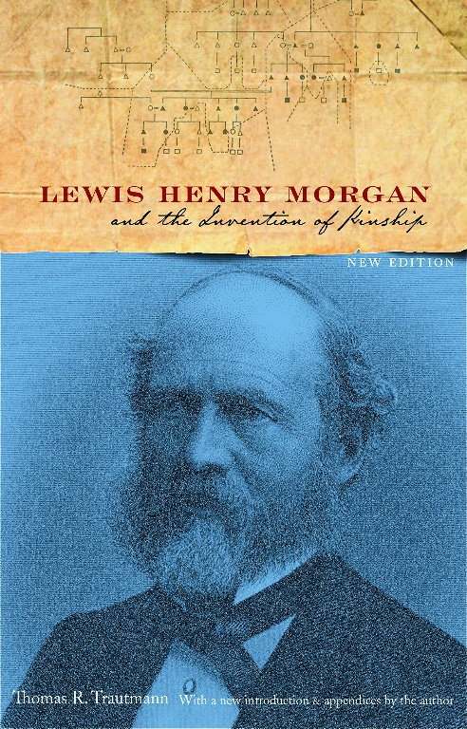
Henry Morgan (1818 – 1881) was an American Anthropologist who developed the study of kinship systems as basic a way of organising preindustrial societies. He conducted in depth studies of the kinship terms used by other cultures. The information he gathered resulted in pioneer research that led to his cultural evolution theory. He hoped to define the birth of civilisation using three categories:
Savages = hunter gatherer
Barbarism = settled agricultural
Urban society = advanced agricultural
Morgan claimed that human social life began with promiscuity, then after undergoing various forms of family life monogamy was born, along with the birth of civilisation.

Contemporary Contexts.
In historical contexts his ethnographic studies of the Iroquois nation forced the rationalists out of their armchairs and encouraged field work. However, the theory and terminology he used are considered obsolete by most contemporary anthropologists.
Tim Ingold is a leading anthropologist who forced us to rethink our approach to ethnographic study. In his Radcliff Brown lecture in 2007 he stated that anthropology is not ethnography, believing accuracy and sensitivity can only come from first-hand experience via prolonged study. Whilst recognising the significance of ethnography he made it clear that ethnography is a part of the anthropological process and not vice versa. Approaching ‘exotic’ cultures and examining non-white societies like subhuman species is now thankfully outdated. Chagnon’s approach to ethnography is generally disregarded as arrogant and egocentric.
Contemporary British anthropologist Michael Carrithers has been conducting ethnographic studies in east Germany. He proposed that “we think of human beings as having a particularly intense form of intersubjectivity, and a particularly rich and creative capacity for social forms.” (2019) This supports my argument that a more humanist approach is being applied to contemporary ethnography. The white privileged male academics are no longer hunting the hunter gatherers as trophies.
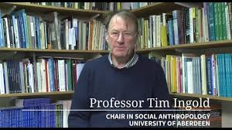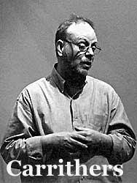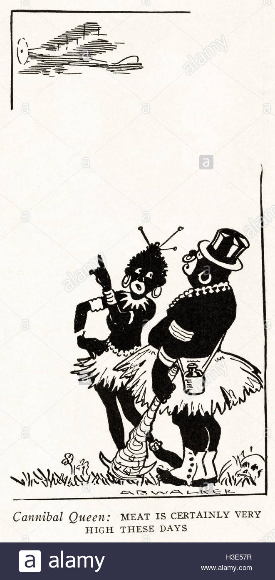
Pictured above from left to right: British Anthropologists Tim Ingold and Michael Carrithers.
The third picture is a cartoon that reflects the xenophobia and racism during the late nineteenth century in North America. Morgan’s cultural evolution theory was established in 1871.

Conclusion.
The initial studies conducted by Morgan were valuable at the time, making armchair anthropology obsolete. This was the foundation for today’s more in- depth and less xenophobic ethnographies. In context, there wasn’t the mass migration in the late nineteenth century that we see today, cultures had not yet begun to amalgamate. In conclusion Henry Morgan’s cultural evolution theory is no longer relevant in contemporary contexts and it is limited due to its xenophobic approach when studying what makes us human.
(word count 544)

BIBLIOGRAPHY:
- Ingold, T. (2008). Anthropology is NOT Ethnography!. Radcliffe-Brown lecture in social anthropology.
- Dur.ac.uk. (2020). Prof MB Carrithers - Durham University. [online] Available at: https://www.dur.ac.uk/anthropology/staff/profile/?id=126 [Accessed 16 Feb. 2020].
- Morgan, L. (2012). Systems of consanguinity and affinity of the human family. [Place of publication not identified]: Hard press Publishing.
- Encyclopaedia Britannica. (2020). Lewis Henry Morgan | American anthropologist. [online] Available at: https://www.britannica.com/biography/Lewis-Henry-Morgan [Accessed 16 Feb. 2020].

