AN INVESTIGATION INTO
THE RECOGNITION OF FACES FOLLOWING A DISTRACTOR TASK

Danielle Evans
UWTSD
Abstract

This study was conducted to determine if participants could recall their own-race faces more effectively and accurately than that of another-race. The participants took part in a paired sample t-test which was aimed to support the original hypothesis. The results in this study found a significant difference between the recognition of black faces vs white faces with black faces being recalled more often than that of white therefor rejecting the hypothesis.

Introduction

Own-race bias or sometimes referred to as cross-race effect is the tendency to recognize faces that are of the same race more easily than those of a different race. Previous laboratory and field studies have consistently supported this hypothesis and results have shown that individuals recognize faces of own race more accurately, quickly and more confidently than that of another race, these studies include Brigham & Malpass. (1985). and Valentine. (1991), although Valentine. (1991). points out that the theoretical basis of this effect is not clearly understood.
This T-test study was conducted to determine if own-race bias affects the memory recall of face-recognition among students at the UWTSD following a distractor task. It was hypothesised that participants would recall faces of the same race more than that of another race, as supported by previous studies.
An investigation into the Contact Hypothesis as proposed by Chiroro, Patrick. & Valentine, Tim. (1995). Sees participants split into two groups, one group that have a high degree of contact with faces of both races, and the other with a low degree of contact with faces of both races, results in this study confirm hypothesis and see that even though on the whole participants recognized own-races more accurately and more confidently than they recognised other-race faces, the own-race bias in face recognition was significantly smaller among the high-contact participants than it was among the low-contact participants.
An investigation into the murder of Khomos Revels during a robbery that took place in Tallahassee, Florida in 1971, saw five Black men wrongfully indicted. These five men who later became known as the “Quincy Five” were positively identified by five White eyewitnesses as the perpetrators, despite the lack of physical evidence against these men, two of the five defendants were found guilty based on eye witness testimony. It was only at the third trial, where by hired investigators on the defense team located the three actual perpetrators known as the “Jacksonville Three.” These men were later brought to trial and convicted of the robbery and murder based on latent fingerprint evidence and identification of the vehicle used in the murder. The “Quincy Five” were finally exonerated. At the time of this trial the only evidence against the “Quincy Five” was in the form of cross-racial identification, Haythorn & Brigham, (1971). Set out to locate empirical evidence on the claim that other-race persons all look alike. Due to the lack of scientific evidence on cross-racial identification at the time the court prohibited the expert testimony of Haythorn. Though today many studies have revealed the own-race bias theory is reliable across cultural and racial groups, Kassin, Ellsworth & Smith. (1989).
This study will help us to determine if the hypothesis is supported or rejected and if own-race bias exists among a group of University student participants at the UWTSD. As supported by previous studies with the same hypothesis.

Method

Participants
A total of 29 participants were recruited through a Research Methods Lecture at the UWTSD, all participants were first-year students studying a Psychology degree at the University, of these participants 7 were males and 22 were female, with the mean age being 27.31 years and (SD = 10.81). All participants were Caucasian.

Design
This study is a within subject design, a paired sample t-test will be used to establish the results with the Independent variable being Race, the categories of the Independent variable will be White or Black, whilst the dependent variable is that of the number of faces recalled.
Materials
A PowerPoint presentation was used to create this study, part 1 of this study saw 12 faces shown individually for 2 seconds each, part 2 saw 6 pages of 6 faces totalling 36 faces with each page being shown for 12 seconds each. A recall or response sheet was used to collect demographic data with space for participants to report their responses.
Procedure
Participants were firstly given a consent form to read over and sign, participants were then told to watch the screen, following this, additional instructions were shown on the PowerPoint, participants were instructed to remain quiet throughout to maintain concentration on the task ahead. A 3 second count down started Part 1 of the task, here the presentation of the 12 initial individual faces were shown for 2 seconds each with no interval slides, at the end of Part 1 participants were given a distraction which showed the lecturer introducing information for 1 minute, upon instructions to look at the screen again Part 2 of the PowerPoint was shown with additional instructions given on screen, participants were told to write down the numbers associated with the faces already seen in Part 1 if any and again reminded to keep quiet throughout. Part 2 showed 6 slides with 6 faces on each totalling 36 faces with each page being shown for 12 seconds each. Participants recalled faces anonymously on response sheet. At the end of the task participants were shown an on-screen debrief sheet and the data was collected.

Results

A paired-samples t-test was conducted to determine whether a group of white participants were able to recall more of their own-race faces (white) than that of another race (black faces) following a distraction task of one minute. The results show that participants recalled significantly more black faces (M=3.34, SD= 2.42) than white faces (M=2.67 SD=1.97); t(28)=3.12, p<.05. The original hypothesis for this study that participants would recall significantly more white faces must be rejected and is not supported by these results.

Discussion

Further research into the original hypothesis and theory of own-race bias should consider increasing the sample of participants, with a limited number of participants it gives the potential of non-generalisation, whilst larger samples are likely to increase the significant difference.
This study took place in a group setting, this brings the potential for more distractions and therefore less concentration on the task in hand, if this study had participants individually perform the task with no distractions it is possible this could be reflected within the results.
During this study only one ethnic group participated therefore results are only based on white raced participants recalling black and white faces, though the results reject the own race bias hypothesis for white ethnicity it does not tell us if own-race bias affects the recall for black ethnicity participants.
In part 2 of this study participants saw the picture size of the faces shown on a much smaller scale than that of Part 1, linked in some degree to the group setting participants whilst taking part in the study were not at the same distance from the presentation as if they would be in an individual study setting, with both the picture sizes being reduced and some participants sitting further away from the presentation this could result in not having a clear view of faces in Part 2, potentially affecting the results of participants towards the back compared with those at the front.
Further evidence following, Chiroro, Patrick. & Valentine, Tim. (1995). And the Contact hypothesis has been mixed Cross, Cross, & Daley. (1971). found that white children from segregated neighbourhoods showed a greater own-race bias in face recognition than did white children from integrated neighbourhoods. However Cross et al. (1971). did not find a similar difference among black children. Inadequate cross-racial controls might account for these inconsistencies. Brigham, (1986). notes that “measures of contact and experience which more accurately assess the quality and depth of contact, as well as its frequency, may help us identify the relationship between experience and a cross-race effect if indeed one exists.”
With us becoming more of a cross-race society to that of earlier years perhaps more recent studies would indicate a change in results of own-race bias in facial recognition studies.
To conclude this study shows that participants recalled significantly more black faces than white faces and all participants were of white ethnicity, because of this the original hypothesis must be rejected.

Reference List

Brigham, J. C., & Malpass, R. S. (1985). The role of experience and contact in the recognition of
own- and other race-faces. Journal of Social Issues, 14, 139-155.

Brigham, J. C. & Ready, D. J. (1985). Own-race bias in lineup construction. Law & Human Behaviour,
9, 415-424.

Brigham, J. C., Wasserman, A. W. & Meissner, C. A. (1999): Disputed eyewitness identification
evidence: Important legal and scientific issues. Court Review, 36, 12-25.

Chiroro, P. & Valentine, T. (1995). An investigation of the contact hypothesis of the own-race bias in
face recognition. Quarterly Journal of Experimental Psychology, 48A, 879-894.

Cross, J. R, Cross, J. & Daly, J. (1971). Sex, race, age, and beauty as factors in recognition of faces.
Perception and Psychophysics, 10, 393-396.

Valentine, T (1991). A unified account of the effects of distinctiveness, inversion and race in face
recognition. The Quarterly Journal of Experimental Psychology, 43A, 161-204.

Valentine, T., Chiroro, P., & Dixon, R. (in press). An account of the own-race bias and the contact
hypothesis based on a “face space” model of face recognition. In T. Valentine (Ed.), Cognitive
and computational aspects of face recognition: Explorations in face space. London:
Routledge.

https://en.oxforddictionaries.com/definition/bias

Appendices
Appendix A

School of Psychology
Townhill Campus
Swansea

Study Consent Form

I understand that taking part in this research study will involve me viewing a number of faces and attempting to recall the faces I have already seen.
I understand that this study consists of two parts. Part one will take approximately two minutes and will consists of me viewing a number of faces. For part two, I understand that I need to pay attention to the faces being presented and record which faces were shown in part one.
I understand that participation in this study is entirely voluntary and I am free to withdraw at any time without giving a reason. I am aware that if I have concerns about the study I can discuss these concerns with the researcher at any time during or after the study.
I understand that the information provided by me will be used for the purpose of providing data for analysis, but that this data will be held confidentially and anonymously, with a code assigned in place of my name. These data will be stored in accordance with the Data Protection Act.
I also understand that at the end of the study I will be provided with a debrief form and the opportunity to discuss any issues with the researcher.

I, ___________________________________( NAME) consent to participate in the study conducted by Stacey Coleman, School of Psychology, University of Wales Trinity Saint David, Swansea.
Participant Signature:________________________________________________
Date:___________________
Name and signature of researcher taking consent:
Stacey Coleman
Appendix B

Data Collection Study

Thank you for agreeing to take part in
this study.

Part One

You will now be shown 12 images of
black and white faces for 2 seconds each.
Please remain silent during this phase of the study.
3 2 1
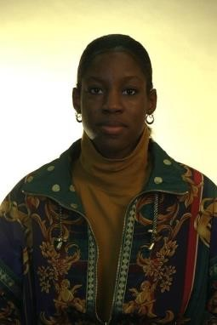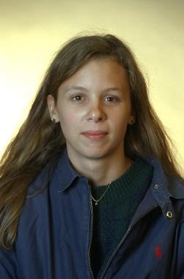

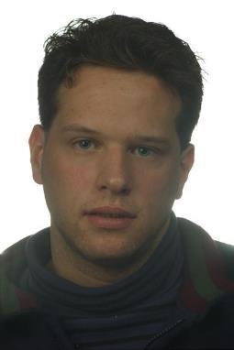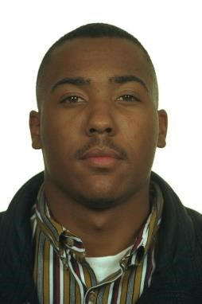
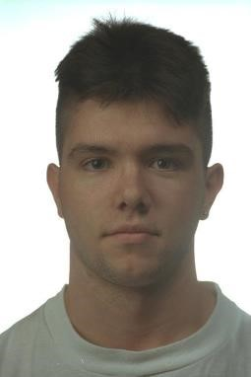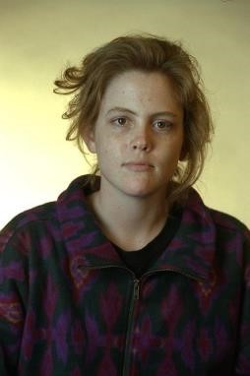
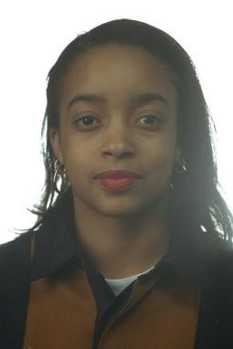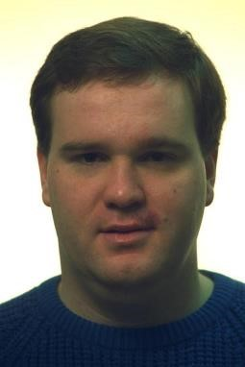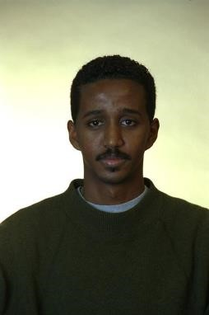
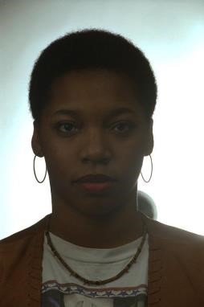

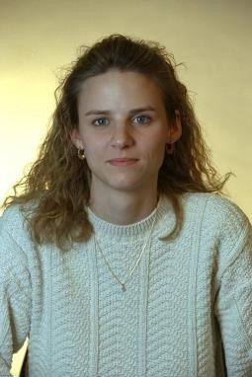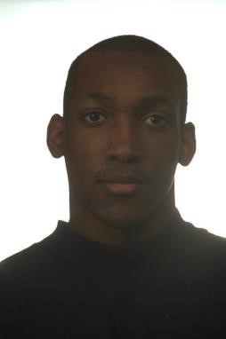

Thank you. Part One is now complete.

Part Two
You will now be shown 6 pages of images containing 6 faces per page.

Please write down the numbers associated with the faces you have already seen in Part One.
Some pages will contain no faces you have previously seen, some may contain one, some may contain two, and so on

Please remain silent throughout this phase of the study

3 2 1 1

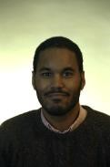

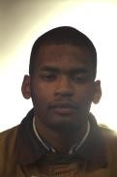


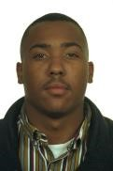
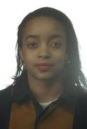
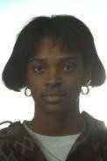


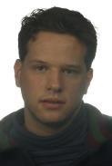
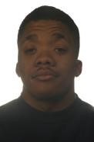
2
3
5
6
8
9
11
12



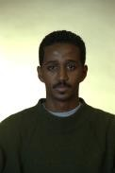

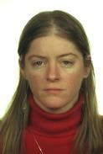
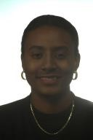



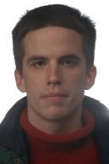
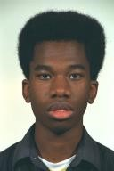
18
17
15
14
24
23
21
20

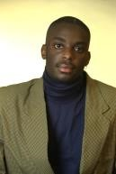
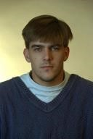

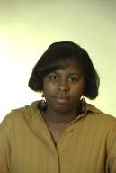
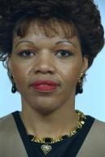


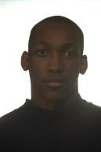

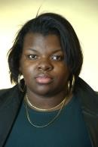
30
29
27
26
36
35
33
32

Thank you. The study has now finished.
Please place your completed response sheets facing down on your table to be collected.

Appendix C

Debrief information
Thank you for taking part in this study.
The main aim of this study was to explore whether people are better able to recall and identify faces that belong to the same ethnicity as them – their ‘in-group’. We specifically hypothesised that participants would be able to recall significantly more faces that belonged to their in-group than their out-group.
If you wish to withdraw your data from the study you must tell the researcher now. After this point, all of your data will remain confidential and we will not trace it back to you.

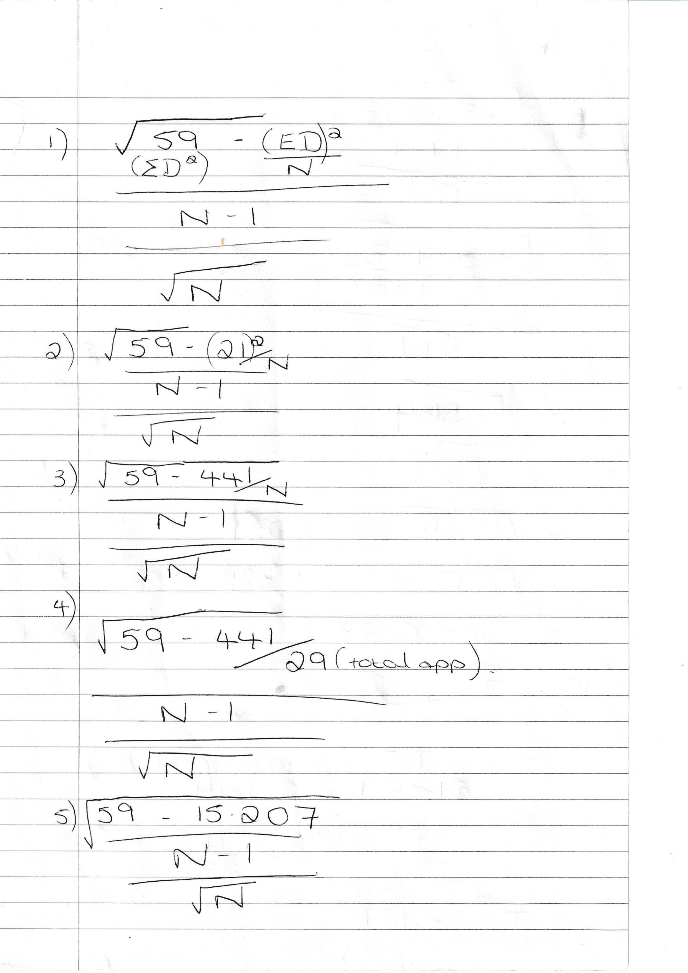
Appendix D


