An Early Years Practitioners Handbook:
A Guide to Transitions


(Source: Gender GP, 2018)

Contents

Introduction: Transitions in Early Years 3-4
The role of the adult 5-7
The needs of the child 8-9
Environment 10
Partnership Working & Interventions 11
Proposed Outcomes 12
Reference list 13-14

Introduction
Aims
The main aim of this handbook is to support practitioners in early years settings through children’s transitions. The main transition that this will be aimed at throughout will be the transition from a baby room (age 0-2) to the toddler room (age 2-3). This handbook will explain the term transition, the role of the adult which will include parents and key workers, the needs of the child, the learning environment of the child, the importance of working in partnerships, interventions that adults can implement to create smoother transitions as well as some of the preferred outcomes these will have for the child. Throughout the handbook, some of the theories linked to transitions in early years settings will be discussed.

What is a transition?
Education Scotland Foghlam Alba (2023) describes transitions as the movements that children make in their lifetime from various settings such as home to early years settings, from there to primary school and further along. They also state that transitions affect everyone throughout life and that some children may find these transitions smooth and look forward to them, whereas others may find it difficult and more challenging to transition. It is important to understand that all children are different and unique and will require different approaches to a transition, which we will discuss further below. Teach Early Years (2023) explains how powerful and trusting relationships between parents and early years practitioners provide the starting point for a positive transition. Furthermore, having strong relationships with those closest to the children can boost the child's confidence and knowledge in the future (Teach Early Years, 2023). Birth to 5 matters (No Datea) emphasise how transitions are a process and how key workers can develop connections with the children to provide a more positive transition with continuity throughout. The main aim of this handbook is to provide support and guidance for early years practitioners to be able to support the transitions of young children that are transitioning from rooms for the first time. There are a variety of theories linked to transitions and they will be covered in this handbook to help guide Early Years practitioners to provide a positive transition linked on theories. Bronfenbrenner’s ecological systems theory explains child development as a network of relationships that can be affected by a variety of different things such as the environment, extended family, immediate family, schools and nurseries, as well as culture and laws (Simply Psychology, 2023a). This handbook will discuss Bronfenbrenner’s theory in more detail and how each aspect that can affect transitions can be adapted to help aid a smoother transition. Below is an image of Bronfenbrenner’s Ecological Systems theory and it shows the different levels of systems that can affect transitions.

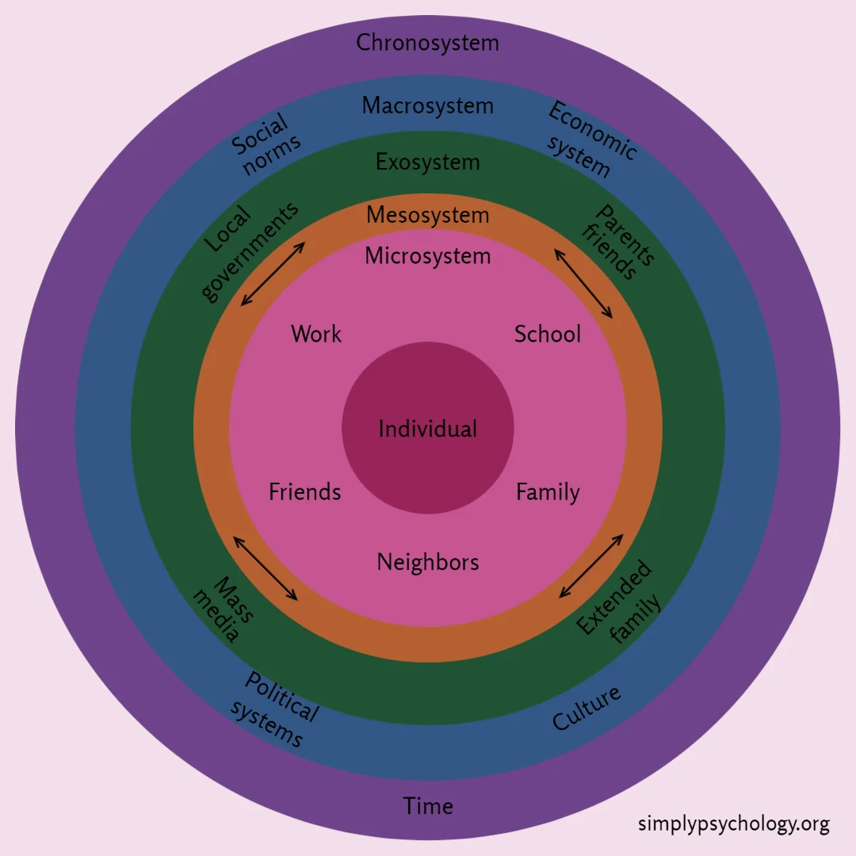
(Source: Simply Psychology, 2023a)

The role of the adult
According to NSPCC Learning (2021), a child may begin to show a preference towards their primary caregiver, which is usually their mum and/or dad, between the ages of 6 weeks and 8 months. Following this, they then say that between the ages of 8 months and 2 years, a child may then have a strong attachment to their primary caregiver. Welsh Government (2023) provide the developmental pathways for children 0 to 3 and they say that between the ages of 1 and 2, which is the age of transition between the baby room and the toddler room, a child should be learning to seek reassurance from familiar adults. This could then include the keyworkers or any practitioners in the setting.

Parents
Education Scotland Foghlam Alba (2023) talk about how parents can help aid a smooth transition by talking to the child about what is going to happen during a transition and encourage them to ask questions if they are able to. Welsh Government (2023) identifies in the developmental pathways of children ages 0 to 3 that all children should feel safe and secure between the ages of 0 to 3. Maslow’s hierarchy of needs shows that feeling safe and secure is one of the human basic needs and that transitions can cause this to be unsettling (City of Bradford Metropolitan District Council, No Date). They also share some ideas that parents could do to help aid a smooth transition such as sending the child in with their favourite toy, as well as bringing in a photo of them to bring to their new room. The first level of Bronfenbrenner’s theory is the Microsystem, which includes things that immediately affect the child, such as parents, keyworkers, and their immediate environment (Simply Psychology, 2023a). They also explain the second level as being the Mesosystem, which is where the communication between different people in the child’s microsystems comes from. They also explain how any barriers between these microsystems, such as parents and keyworkers disagreeing about the child or not communicating correctly, can cause harm for the child and impact them negatively. This shows us that positive communication between parents and the setting will have a positive impact on the child’s smooth transition. Simply Psychology (2023a) also discuss the Exosystem, which is the third component of Bronfenbrenner’s theory and although the Exosystem does not impact the child directly, it can still influence the child and the microsystems. For example, if a parent has stress at work and lack of time for the child then this can impact them and their response to transition. The fourth layer is the Macrosystem, which according to Simply Psychology (2023a), is aimed more at family beliefs and cultures and how this can affect the child. This links with how it is important for parents to communicate about their beliefs and cultures with the setting from the beginning so that key workers and practitioners can take this into account when starting a transition. Gray and Macblain (2015) discuss how Bronfenbrenner emphasized that all adults should see children as individuals who are just starting out in their lives and as they grow and develop, we should be considering the environmental changes around them.

Key worker
Linking on from the role of a parent, a key worker should value and respect a child’s parents and should create powerful relationships with them whilst working together to put the individual needs of the child first (Welsh Government, 2023). Unicef (No Date) provides information from The United Nations Convention on the Rights of the Child (UNCRC) and Article 3 explains how the child as an individual should always be at the centre of everything. Article 12 from the UNCRC explains how the child should always be listened to, which is an important aspect of the role of a key worker during transitions (Unicef, No Date). Norfolk county council (No Date) explain how a good understanding of the child through observations can help to aid a smooth transition as this is something the key worker can then pass onto the child’s new key worker. They also say about how key workers should be having regular contact with parents at handovers to ensure that they are discussing important events that may have recently happened that have involved the child, either at home or during the nursery day. Having this level of communication when dealing with a transition can then help to ensure a smoother transition as everyone involved will be aware of the child’s level of ability and personal needs and can ensure that these are getting met throughout. Responding to a child’s cry or smiles during a transition is a positive level of interaction according to John Bowlby (Simply Psychology, 2023b). Birth to 5 matters (No Dateb) explains how a key person should be able to not only communicate with the parents and families of the child but also be able to communicate with other agencies if needed, as well as other practitioners in the settings during the child’s transition. They also describe how working with other practitioners during transitions would enable them to understand how it is an ongoing process.

Setting manager
The role of the setting manager would be to ensure policies are in place for a settling and transitions procedure and to ensure that all key workers are aware of these (Early years alliance, 2019). The early years alliance (2019) also explains that these policies should always be accessible to key workers and parents to enable smooth and consistent future transitions between parents, key workers and children. Norfolk county council (No Date) describe how setting managers could use their regular supervisory meetings to check if the key worker relationships with parents and children are still effective.
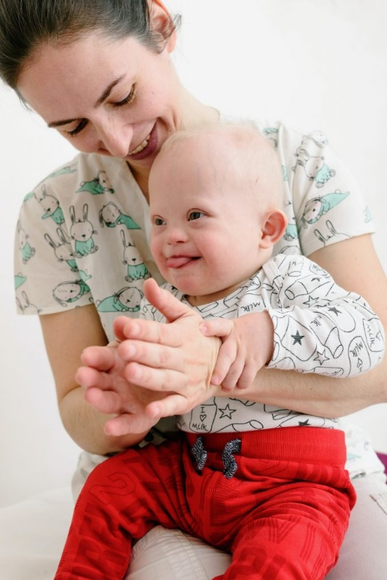
(Source: Birth to 5 matters, No Dateb)
The needs of the child
During the transition from the baby room to the toddler room between the ages of 1 and 2, according to Welsh Government (2023) a child needs to form attachments, feel loved, safe and secure as well as needing to be understood and getting responded to. Unicef (No Date) shows us in article 12 from the UNCRC how the child has the right to be listened to and should always be taken seriously. Lindon (2005) explains Bowlby’s theory and how the child needs a strong bond for safety and security as well as creating a long term and strong psychological connectiveness. Teach Early Years (2023) explains how allowing a child to have time with a new key worker which is special to that child can allow the child to feel safer and secure about changing to a new environment. They also say about how the child would need their current key worker involved in the transition to allow the key worker to be able to recognise any of the child’s cues if they were feeling unhappy or unsettled in any way. Furthermore, Teach Early Years (2023) continue to focus on the child’s needs and how familiarity and reassurance can lead to positive outcomes. They say about how responding to the child’s needs and allowing them to play and have a choice will also enable positive outcomes. Child Mind Institute (2023) talks about how gaining the child’s attention through various ways will help them with a transition and how they need praise when they have done well during a transition. They also say about how having a unique soundtrack for a transition could help benefit the child, especially if there seems to be a barrier or difficulty with the transition. This could include a specific song when you are taking the child to the other environment where the transition is taking place, for example, when taking the child from the baby room to the toddler room you could sing or play the child’s favourite song and continue to do so each time you make that transition. This will provide continuity and consistency for the child. Welsh Government (2023) state how a child needs to have reassurance from an adult that’s familiar, so enabling them to take their key worker along with them during a transition would be positive and considering the needs of the child and putting them at the core of the transition, in line with article 3 from the UNCRC. Harvard University (2023) explains how the way a child’s brain develops provides the basis for the learning of their future. Simply Psychology (2023c) talk about Maslow’s Hierarchy of Needs and the 5 layers that show what a child needs. These layers are prioritised starting from the bottom with the child’s more basic needs such as breathing and food and states that you cannot move up a level without meeting the needs of the level below. They also describe how the levels are not completely fixed and how you may be able to reach a higher level before a lower level, such as reaching self-esteem before love and belonging. This shows that once the child can see they have basic needs in their new environment, they can then focus on feeling safe and secure before forming friendships and confidence with their new environment. This takes time and the child would need to do this at a pace they are comfortable with.

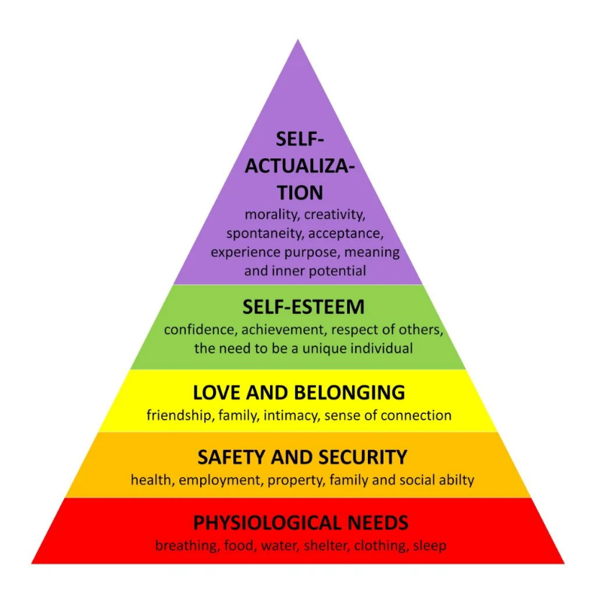
(Source: Simply Psychology, 2023c)

Gray and Macblain (2015) discuss Rudolf Steiner and how he believed that the role of education should be to follow what the children need and their changes, physically and emotionally. They also discuss how he emphasized learning through play up to the age of 7, which is linked to the UNCRC, Article 31, which states that children have the right to play (Welsh Government, 2023).
Environment
Lindon (2005) explains how a child’s environment, as well as them being a unique individual, has an impact on their development. Welsh Government (2023) explain how a child should be able to notice different things in their environment and this can become a crucial in supporting the child and their needs during transition. Lindon and Brodie (2016) explain Piaget’s theory and how children can create their own understanding through play and active learning which therefore means that their environment should be created in a way that children can learn from them themselves. This approach is now linked to learning through play. In contrast to this, Lindon and Brodie (2016) tell us about how Vygotsky did not agree with Piaget’s theory and believed that learning was more through social interaction over Piaget’s theory of the child being their own interaction. They also explain how Vygotsky did agree that play was important but that a child being social with other children was also important. Cambridge Assessment International Education (No Date) talk about how children can develop new skills and further knowledge through play, that is meaningful and enjoyable to them. They also explain how having an environment which a child can play happily and confidently in, will lead to the child being happier and more settled during a transition. This would link with communicating with the staff in the new environment and ensuring that if the child loves playing with the dollies and the prams in the current room, then ensuring that they have access to something similar in their new environment to ensure a happier and smoother transition. Early Years Matters (2023) explain about enabling environments and how they allow children to feel relaxed, safe and secure which will allow them to play and develop further. In the Parent information pack (Do Re Mi, 2023a), it is explained that the environment provided for the children will be a home from home environment which will allow the children to blossom and develop through the play that works for them through regular observations and assessments. Gray and Macblain (2015) talk about the Montessori Method and how the Montessori leader emphasizes and guides the environment which the child is in and how the leader can adapt the environment for the child to grow and develop at a rate that is right for them.
Partnership Working & Interventions
Working in partnership would be linked to the child, parents, key workers, setting managers as well as any multiagency teams if needed. Pacey (No Date) explains how joint planning and working in partnership between transition rooms can provide all sides with better knowledge of their individual role in the transition of the child. In return, this could increase the confidence and the smooth transition for the child. Early years alliance (2019) discusses partnership working and how key workers, parents and setting managers need to work closely for the best interests of the child and that there should be policies in place if multiagency teams are needed to intervene. Children need to be treated as an individual and some may take longer than others to transition from room to room. It is important to put the child first and to allow them the relevant time needed to adapt to their new environment with new key workers whilst all working together and communicating about the child’s responses to the change. In the Do Re Mi (2023a) Parent information pack, there are forms that the parents will initially fill out before the child starts the setting. This, along with the child’s developmental folder, will be handed down to the key workers taking over the child in the new room. This will allow the new key workers to get to know the child, alongside communication from the previous key worker. The Do Re Mi (2023b) transitions policy states how the child will be allocated time to explore and adapt to their new environment with the current key worker. This will be based on the individual child. Some children may need a couple of half days whilst others may need to start with an hour here and there, over a longer period. This will all be discussed with the child’s parents at handover and communication between everyone involved will be crucial to a smooth transition.

Proposed Outcomes
The proposed outcome will be for the child to be settled well in their new environment. Greenfield Nursery School (No Date) believe that there are two ways to tell if a child is settled. These are if they are confident to play in their new surrounding and if they are playing and talking with the new key worker within their new room. They also say that although transitioning from different rooms can be difficult, if the child is able to be comforted and helped by their new key person then it is a positive sign. Welsh Government (2023) state that if a child can feel loved, safe, able to show their preferences as well as being able to show emotion within their new environment whilst being comforted then this is a positive transition. They need to have strong attachments with their new key worker whilst relying less on their previous key worker. Welsh Government (2023) also talk about how the child should be more independent and able to have support and comfort from the new familiar adults in the room.

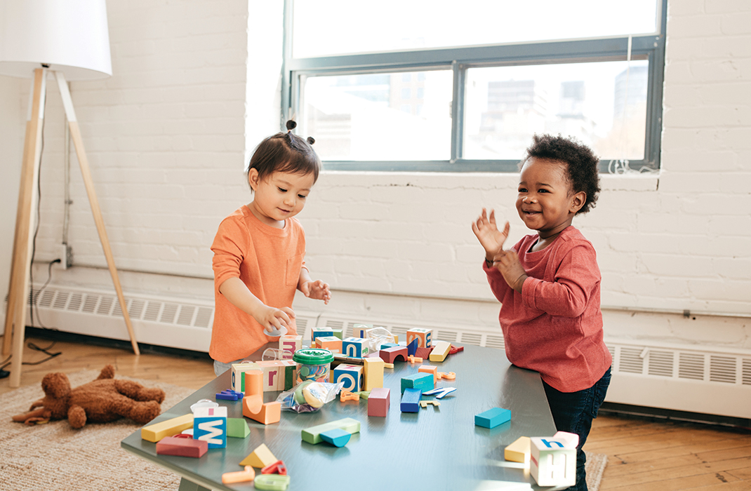
(Source: Baby, 2023)

Reference list
Baby (2023) How to help your toddler settle in at nursery. Available at: https://www.baby-magazine.co.uk/settling-in-at-nursery-tips/ (Accessed: 3rd December 2023).
Birth to 5 matters (No Datea) Transitions. Available at: https://birthto5matters.org.uk/transitions/ (Accessed: 21st November 2023).
Birth to 5 matters (No Dateb) Attachment and the role of the key person. Available at: https://birthto5matters.org.uk/attachment-and-the-role-of-the-key-person/ (Accessed: 2nd December 2023).
Cambridge Assessment International Education (No Date) Getting started with play-based learning in early years. Available at: https://www.cambridge-community.org.uk/professional-development/gswpbl/index.html (Accessed: 3rd December 2023).
Child Mind Institute (2023) How can we help kids with transitions?. Available at: https://childmind.org/article/how-can-we-help-kids-with-transitions/#:~:text=When%20helping%20kids%20with%20transitions,repeat%20back%20what%20you%20said. (Accessed: 2nd December 2023).
City of Bradford Metropolitan District Council (No Date) Supporting successful transitions. Available at: https://bso.bradford.gov.uk/userfiles/file/EPT/Supporting%20Successful%20Transitions.pdf (Accessed: 2nd December 2023).

Do Re Mi (2023a) Parent information pack. Wales: Do Re Mi.
Do Re Mi (2023b) Transitions policy. Wales: Do Re Mi.
Early years alliance (2019) Hello, ‘big school’ - managing transitions. Available at: https://www.eyalliance.org.uk/hello-big-school-managing-transitions#:~:text=The%20setting%20manager%20should%20approach,with%20teachers%2C%20parents%20and%20children. (Accessed: 2nd December 2023).
Early Years Matters (2023) Enabling Environments. Available at: https://www.earlyyearsmatters.co.uk/our-services/school-and-nursery-improvement-partner/enabling-environments/ (Accessed: 3rd December 2023).
Education Scotland Foghlam Alba (2023) What are transitions?. Available at: https://education.gov.scot/parentzone/my-child/transitions/what-are-transitions/ (Accessed: 20th November 2023).

Gender GP (2018) Stages of transition for gender variant children and youth. Available at: https://www.gendergp.com/stages-of-transition-for-gender-variant-children-trans-youth/ (Accessed: 20th November 2023).
Gray, C. and Macblain, S. (2015) Learning Theories in Childhood. London: Sage Publications.
Greenfield Nursery School (No Date) Transition and settling in. Available at: https://greenfieldnursery.co.uk/transition-and-settling-in/#:~:text=There%20are%202%20things%20we,playing%20with%20their%20key%20person. (Accessed: 3rd December 2023).
Harvard University (2023) Brain Architecture. Available at: https://developingchild.harvard.edu/science/key-concepts/brain-architecture/ (Accessed: 2nd December 2023).
Lindon, J. (2005) Understanding child development: Linking theory and practice. London: Hodder Arnold.
Lindon, J. and Brodie, K. (2016) Understanding child development 0-8 years. 4th edn. London: Hodder Education.
Norfolk county council (No Date) Transitions between settings, rooms and key people. Available at: https://www.wensumtrust.org.uk/_site/data/files/documents/wells/transition/nursery/F5594AE50E79DD96535D0E96BD4E5E69.pdf (Accessed: 2nd December 2023).
NSPCC Learning (2021) Attachment and child development. Available at: https://learning.nspcc.org.uk/child-health-development/attachment-early-years#:~:text=6%2D8%20months%20until%2018,(Bowlby%2C%201997)8. (Accessed: 2nd December 2023).
Pacey (No Date) Early years: working in partnership. Available at: https://www.pacey.org.uk/Pacey/media/Website-files/PACEY%20general/pacey_sst_FINALforprint.pdf (Accessed: 3rd December 2023).
Simply Psychology (2023a) Bronfenbrenner’s Ecological Systems Theory. Available at: https://www.simplypsychology.org/bronfenbrenner.html (Accessed: 2nd December 2023).
Simply Psychology (2023b) John Bowlby’s Attachment Theory. Available at: https://www.simplypsychology.org/bowlby.html (Accessed: 2nd December 2023).
Simply Psychology (2023c) Maslow’s Hierarchy of Needs. Available at: https://www.simplypsychology.org/maslow.html (Accessed: 3rd December 2023).
Teach Early Years (2023) Transitions in early years – Ideas for supporting children and families. Available at: https://www.teachearlyyears.com/a-unique-child/view/supporting-transitions-in-the-early-years (Accessed: 21st November 2023).
Unicef (No Date) How we protect children’s rights. Available at: https://www.unicef.org.uk/what-we-do/un-convention-child-rights/?sisearchengine=284&siproduct=Campaign_G_02_Our_Work&gad=1&gclid=CjwKCAjw-eKpBhAbEiwAqFL0mvqHTye2McxL0RHiynE4mGhVQn2FpTB_9g4GOOUTBhgNDbcOXf340hoCdrUQAvD_BwE (Accessed: 2nd December 2023).
Welsh Government (2023) Early childhood play, learning and care: Developmental pathways 0 to 3. Available at: https://hwb.gov.wales/api/storage/56774946-48aa-4fab-adda-f27508d8dc8f/early-childhood-play-learning-and-care-developmental-pathways-0-to-3.pdf (Accessed: 30th November 2023).

