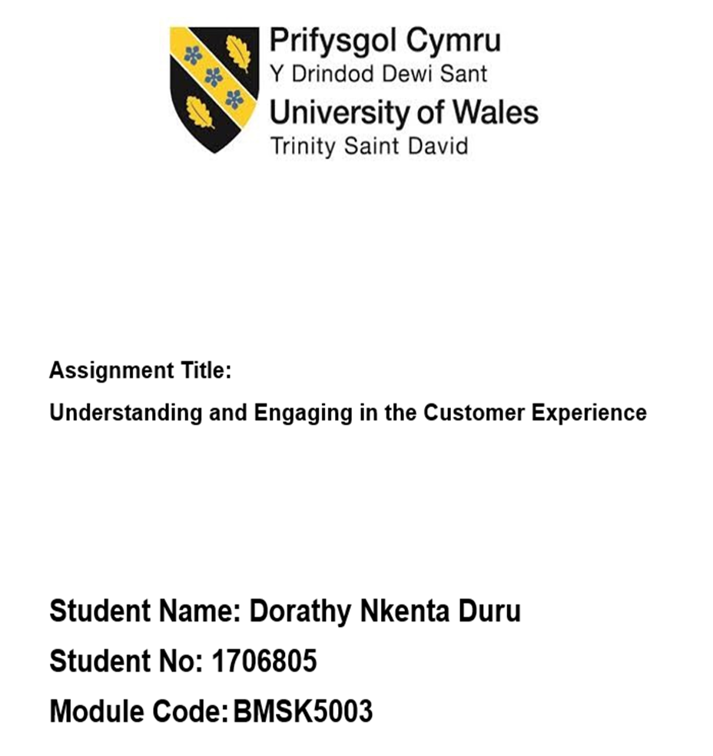

Abstract

This paper examined the relationship between customer satisfaction and customer loyalty. The paper has further evaluated how product and service quality lead to a long term business success. The author attempted to evaluate the organisational culture of Sugarman Health Services that earned the organisation the reputation of possessing a strong customer service, high customer satisfaction and loyalty in bringing improvement in the business of the organisations and the factors that influences customer satisfaction and customer loyalty.
Organisations have recognised the importance of customer satisfaction as the main key in generating product or service repurchase. Customer service is the cornerstone for expanding market values and the main ingredient for business success of the business. Customers happily buy from the market those products and services that have the capability of satisfying their needs and wants. A brand can the best name in the market but if their products and services do not satisfy their target customers, the result is failure. Therefore, it is very essential for organisation to know their customers and their needs. They should maintain long-term affiliation determining their pricing using product quality to attract the customer.

Contents

Introduction 4
1.1 Company background of Sugarman Health & Wellbeing 5
1.2 Overview of the social care sector 5
2.0 The Factors That Affect Customer Value 6
2.1 Customer satisfaction 6
2.1.1 The importance of customer satisfaction 7
2.2 Customer Loyalty 7
2.2.1 The importance of customer loyalty 8
2.3 Customer Value 8
2.4 Customer Focused ecosystem and Product Focused Ecosystem 9
2.5 Understanding your customer 10
2.6 The customers’ experience of an organisation 11
2.6.1 How to improve customer experience, moving from touchpoints to journey 11
3.0 Service Quality 12
3.1 The five gaps organisations should measure, minimise and manage according to Parasuraman et al; (1991). 13
3.2 The five SERVQUAL dimensions are: R-A-T-E-R 14
3.3 Quality Management Process in the Workplace 15
3.4 Factors That Influence Organisations to Ability to Maximise Customer Values 16
4.0 Conclusion 17
5.0 Recommendations 18
6.0 References 19

Introduction

The success of every organisation is directly related to the satisfaction of its customers. A business considers first customer before profit because customers bring cash to business and there is no profit without them. An organisation acquires a large market share if its customer base is large too, therefore, customer satisfaction is an important factor in build a successful organisation that remains in the top position in a market.
Today, mode of doing business has drastically change from product oriented to customer oriented “customer centric”. Organisations have recognised the importance of customer satisfaction as the main key in generating product or service repurchase. Customer service is the cornerstone for expanding market values and the main ingredient for business success of the business. Customers happily buy from the market those products and services that have the capability of satisfying their needs and wants. A brand can the best name in the market but if their products and services do not satisfying their target customers, the result is failure. Therefore, it is very essential for organisation to know their customers and their needs. They should maintain long-term affiliation determining their pricing using product quality to attract the customer.
This paper has the objective of examining the relationship between customer satisfaction and customer loyalty. The paper will further look into how product and service quality leads to a long term business success. The author will attempt to evaluate the organisational culture of Sugarman Health Services that earned the organisation the reputation of possessing a strong customer service, high customer satisfaction and loyalty in bringing improvement in the business of the organisations and the factors that influences customer satisfaction and customer loyalty.

1.1 Company background of Sugarman Health & Wellbeing

Sugarman is a healthcare services provider with head office in London. The company is one the leading providers of private and public healthcare services in UK operating for over 30 years. Their parent company is Cordant Group, one the largest social enterprise in the UK.W
Sugarman is an equal opportunity employer and has the ploicy that support diversity workforce which has become their main strenght, a workforce that understands, first hand, the organisation’s needs and the customers needs too. Sugarman consider their employees as their greatest assets and management has committed to providing an environment in which they can prosper and professionally and humanly develop. The employees add value to organisation through their commitment and passion for their work and that of their clients.
Sugarman is highly committed to exceed their customers expectations starting from the front desk. are also an Equal Opportunities employer and r
Sugarman’s Mission: “To transform the way recruitment services are delivered around the globe, offering customers a unique and superior service”. (www.sugarman.co.uk, 2019).
Sugarman’s Values:
“Candour – We will be open and honest with ourselves and others.
Collaboration – We will work as a team and succeed together.
Opportunity – We will inspire, support and invest in our people who will share in our success.
Relentlessness – We are driven to be the best.
Disruptive Innovation – We will continually challenge convention” (www.sugarman.co.uk, 2019).

1.2 Overview of the social care sector

Social care is a very large sector in England, in 2017 it has an estimated workforce of 1.6 million people, 21,200 organisations and 41,000 care providing locations.
The social care sector employs more people than NHS which has a workforce of 1.4 million people and social care with a workforce 1.6 million people. The reason is that many people in the UK aged 85 years or older require a round-the-clock care service for their daily activities such as: feeding, dressing, washing and going to toilet. According to the research done by the sector, in the next 20 years there will be an explosion in social care needs.
The research further stated that in 2035 more 446,000 over-85s will have high dependency care needs, an increase of 233,000 from 2015. According to the study, over 1 million people aged 65 or over in 2035 will need intensive care assistance, an increase of 783,000 from 2015 (shreenathyog.blogspot.com, 2019).
In England, the social care sector contributes to the economy an estimate amount of £38.5 billion annually while in Yorkshire and the Humber region the annual estimated contribution was between £3.6 and £3.9 billion (www.skillforcare.com, 2019).

2.0 The Factors That Affect Customer Value

The present century of globalisation and tight business competition, product competitive advantage has its important value to customers. The competitive advantage of an organisation influence the its product position of value and supports customers in making purchase choices. (Johnson and Weinstein, 2004). It is very essential for organisation to know the taste of their customers especially, consumer culture and social psychological aspects in order to maintain them.

2.1 Customer satisfaction

One of the most important factors for organisations that provide products or services is customer satisfaction. Every organisation’s goal is to make their customers happy through the satisfaction of their needs and through this the organisation will gain competitive advantage. According to Anderson (2005) the key element in the business activities is satisfying customers in competitive market.
The definition customer satisfaction according to Oliver (1999) is the fulfilment of customers’ needs, the perception of customer that the product or service satisfied its needs in a pleasurable manner. Contrarily, Kotler (1994) retained that customer satisfaction emerges from customer’s feelings of pleasure or disappointment comparing his/her expectations to a product’s perceived performance. Kotler further stated, when the performance of a product or device is better than the expectation of the customer, customer feels satisfied. When performance is below their expectation they feel disappointed and they feel neutral when product or service performance is equal to their expectation.

2.1.1 The importance of customer satisfaction

The performance of any organisation can be fatally affected by customer satisfaction. Satisfaction stimulates repurchased intention based on the opinion of LaBarbera and Mazursky (1983), while dissatisfaction is considered to the primary reason why some customers choose to patronise other competitors’ products or services. A satisfied customer is likely to repeat purchase. Customers satisfaction generates customer loyalty which leads to long term relationship and increase on long term profitability of the organisation. Customer dissatisfaction makes customers to engage in negative word of mouth that might cause other potential customer to discontinue purchasing the organisation’s products or services.
Good customer service generates customer satisfaction that indirectly attracts more customers through word of mouth increasing the repeat intention of customers that leads to customer loyalty.

2.2 Customer Loyalty

Customer want to spend their money and also cherish respect while spending their money. Product is as important as the service of delivering the product to the customer. Services quality elevates the attractiveness of the consumer goods or services offered to customer by the producer. An organisation will enjoy a long term benefit of customer loyalty through the maximisation of service and satisfaction. Customer satisfaction is relevant to customer loyalty because it makes customer to be loyal and will not switch to other similar products in the market. It is a tendency for a customer to come back to repurchase a certain type product or service repeatedly from a particular company or a brand. For an organisation, it very essential for the its success the quality of customer value and customer loyalty. "Loyalty is the behavioural reaction based on prejudice as the function of psychological processes by the decision maker in the existence of one or more alternative in time" (Jacoby and Kyner, 1973). For Sugarman managers attach more importance to increase the relationship with their customers to enable the achievement of competitive advantage in their organizational performance through the improvement their service quality. The organisation understood that customer loyalty will cease if they find a better alternative that will attract them to switch to other suppliers.

2.2.1 The importance of customer loyalty

Providers of products and services are obligated to build customer loyalty for the simple reason that enable old customers to come back (patronage loyalty) and can attract more new customers (recommended loyalty). According to Woodruff (1997), customer loyalty can be considered as a significant source of competitive advantage for most service providers to survive in the turbulent global market. The reason is that loyal customers are less price sensitive since they are satisfied with the value received from the products purchased and they also have the tendency of buying more and frequently (Reichheld, 2001).

2.3 Customer Value

For the continuity of any business, organisation must manage their loyal customers as long term investment by giving quality services. Vargo and Lusch (2004) suggested that in the process of buying and providing good services companies must be able create customer value. Organisation must learn to be able produce better and satisfactorily utilising customers’ preferences and market surveys in other to support customer value for their products and services.
In other to satisfy customer, organisations must incorporate several elements such as their capabilities, human resources and customer information. The organisation strategy is expected to create customer satisfaction to increase customer value, but if the customer is not satisfied due to poor service quality, it will have a negative impact on the products and services offered by the organisation (Gronroos, 2008).

2.4 Customer Focused ecosystem and Product Focused Ecosystem

For an organisation to embrace a customer-centric approach marketing, they must place the customer in the centre of their brand and business. While in the product centric marketing method, the manufacturers force their products and services on the consumers using the promotion mix. A customer centric organisation put customer in the centre of all its operations using marketing instruments like feedback and surveys to satisfy customer needs. Their strategy is to give customers exactly what they want by first determining their customer preferences producing products and services according to their specifications.
For example, in the care industry, each customer has his/her individual care plan. The care industry is customer focused by giving every service user his own care plan. A customer focus approach of marketing offers the customer the opportunity of choice. A customer focused approach offers the consumers the possibility of making choice by ensuring that the customer gets the right product and services that they need. Recently, with the help of technology customers have change from being the object a sale to partners, collaborating with the manufactures in decision making about what to produce and how to produce and market it according to their specifications.
In the 1960s, TV was in black and white and their customers has no individual choice because when the customers’ expectation is low, they are forced to take only what the manufacturers offer to them.
A good example of a product focused organisation is Nokia and Blackberry. These companies are not doing well today because they were product focused, they failed to learn how to meet their customers needs. While good examples of customer focused organisations are Apple and Samsung, they manufacture according to their customers’ need and the expectations important to them. One of the foundations of marketing is putting the customer first because you have the products and service, but they have the cash, the most important element in business.
Finally, being customer-centric means that the organisation focuses mostly on their customer’s value in making business decisions that have the outcome of satisfying their customers’ needs and wants.

2.5 Understanding your customer

In order to be costumer centric, communicating efficiently and effectively is very essential in understanding customer, important in building business their needs and preferences.
The key to an efficient and effective communication with customer is a good understanding of what they need. The information that drives business strategy is knowing why customers purchase your products or services and why the value your company.
A customer-centric businesses must posses the following attributes according to www.experian.co.uk, (2019):
- Good Knowledge of your customers – listen attentively to your customer needs, their lifestyle and values.
- Adopting a Customer-focused business strategy – the foundation of the business of the organisation should be constructed on a deep knowledge of your customers
- Organisational culture – the culture of the organisation should encourage the employees to breathe and live customer centricity
- “Customer metrics – make sure your KPIs take into account customer interactions – you don’t want to be prioritising chasing numbers at the risk of not servicing your customers as well as you could be” (www.experian.co.uk, 2019).

2.6 The customers’ experience of an organisation

Customer experience in business is the interaction between the customer and the organisation during their business relationship. This interaction can be divided in the following three parts: customer journey, touchpoints and the environment. “A good customer experience means that the individual's experience during all points of contact matches the individual's expectations” (Thompson and Kolsky, 2004).
Customer experience implies the involvement of the customer in different levels such as emotional, rational and physical. Customer involvement at different levels, direct and indirect contact with a company. When a customer initiates a purchase or uses a service, a direct contact occurs. Examples of indirect contact are: word-of-mouth recommendations, unplanned engagements with sales representatives, advertising or news reports including criticisms (Meyer and Schwager, 2007).

2.6.1 How to improve customer experience, moving from touchpoints to journey

Customer can be defined as total sum of all the experience of the customer when interacting with a company or brand. A progression of touchpoints that sum the complete experience a customer gets over the period of interaction with a brand or company. For an organisation to understand how to better organize and mobilize their employees around customer needs, they should have a good understanding of their customer journey, knowledge of a full experience of being a customer instead of just looking at a part of transaction or experience.
To improve customer experience, organisations should identify and understand their customer’s journey by paying attention from the perspective of the customers their end-to-end experience. A percentage of customers will defect once they have a bad experience, therefore, it is helpful to use digital technologies to reinvent customer journey (www.mckinsey.com, 2019).

3.0 Service Quality

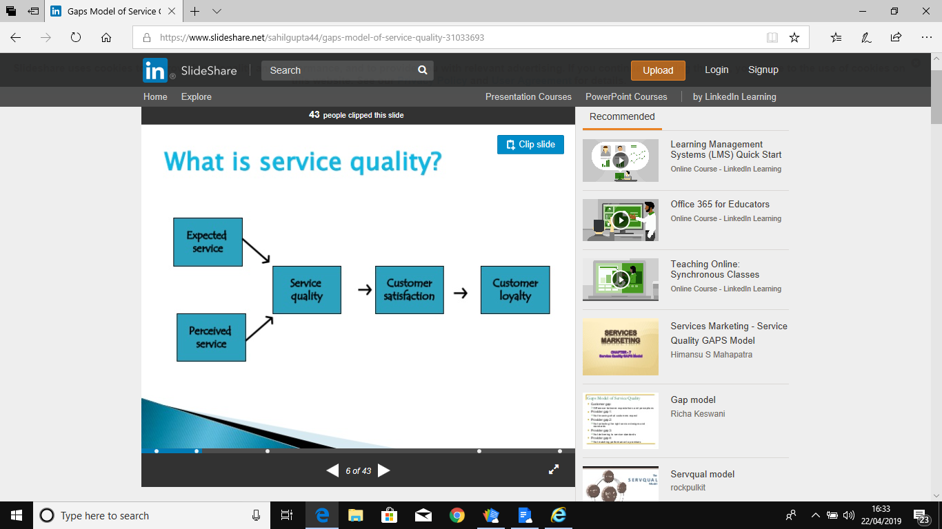
Service quality is used to measure how well the customer expectation matches how well the service is delivered. Meeting the customers expectation is a sign of quality service delivering (Lewis and Booms, 1983). According to Gronroos (1982), in evaluating service quality, customers compare the service they expect with perception of service they receive. While Smith and Houston (1982) claim that confirmation or disconfirmation is directly related to satisfaction with service.
Parasuraman et al, (1991) sustain that there are five major gaps that organisations that seeking to meet customer’s expectation of the customer experience are facing.

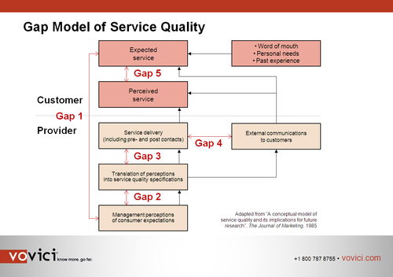

According to Parasuraman et al (1991), the most efficient organisation meets and exceeds customers expectation by studying the behaviours of their current and potential customers through constant customer feedback and surveys. The authors highlight the main requirements for an organisation to deliver high quality customer service by identifying gaps as causes for unsuccessful service delivery. Therefore, customer service gap occurs when there is a difference between customer’s expectation/preferrence and organisation’s performance in delivering customer service.

3.1 The five gaps organisations should measure, minimise and manage according to Parasuraman et al; (1991).

- Gap 1 is distance between about the understanding of the management of what the customer expects rom the organisation and the actual services the customer expects to receive from the organisation. This type of gap occurs when organisations do not know what customers actually expect from them as a good service. Survey is the most suitable strategy organisations can use in closing this gap.
- Gap 2 -This type of gap occurs when organisations do not know how to chosse the right service and standards in delivering customer service. It is very vital for organisation to define the service level they believe is needed.
- Gap 3 -This type of gap occurs when organisations do not know how to deliver the right service standards to their customers. Managers must audit the customer experience that currently delivered by their organisation to ascertain that it is up to the specification.
- Gap 4 -This type of gap occurs when organisations do not know how to match performance to their promises. Most of the time organisations exaggerate in what they will provide to their customers thereby raising customer expectation. The consequence of unmet expectation is negative customer perception which leads to customer dissatisfaction.
- Gap 5, finally, this gap exists between the customer’s expectation of the service and the customer’s perception of the experience. Personal experience, word of mouth and past experience have shaped customers’ experience.
- Finally, Gap 5 occurs when what the quality of service customer is expecting to experience is below the level quality of services the customer think they have received. – Customer’s expectations have been formed by their personal needs, word of mouth and past experiences. It is important for organisation to measure customer perception after delivering the customer experience using routine transactional surveys
Lastly, organisations through diligent attention from management can close each gap in the customer experience (Parasuraman et al; 1991).

3.2 The five SERVQUAL dimensions are: R-A-T-E-R

Zeithaml et al. (1988) retains that is a high leve of correlation between several of these variables and classified them into the following dimensions below:
The five SERVQUAL dimensions are:
- TANGIBLES-The organisation’s appearance of physical facilities such as equipments, communication materials and personne. Sugarman employees are trained to recognise the importance of the service users’ privacy in the course of exercising their duties (Zeithaml et al.1988).
- RELIABILITY-The organisation’s ability to do what they have promised service dependably and accurately. For example, Sugarman employees keep to the appointment schedule of the service users and adequately follow their care plan in delivering cares services to them (Zeithaml et al.1988).
- RESPONSIVENESS- This means how the customer service members are willing to interact with customers and provide prompt service. All Sugarman employees are very accessible to listen to the service users to understand their needs in other to deliver a person-centred care (Zeithaml et al.1988).
- ASSURANCE- the ability of the organisation customer services members in conveying trust and confidence to the customer, the knowledge and courtesy of the customer service team. Sugarman’s workforce are highly skilled and their level and constantly sent to adjournment courses and this has contributed to reputation of organisation as one the UK’s leading care providers (Zeithaml et al.1988).
- EMPATHY-How caring the employees are towards the customers, the level of attention an organisation provides to its customer iindividually. The policy of Sugarman is that all service users must be supported to maintain their personal respect and dignity (Zeithaml et al.1988).

3.3 Quality Management Process in the Workplace

The establishment an effective quality management system (QMS) increases the quality of an organisation’s products and services. A quality organisation makes the concept of the relationship between the customer and its suppliers working together its cornerstone.
An organisation’s quality management system is a set of co-ordinated activities to direct and control its possesses to achieve a continuous improvement of effectiveness and efficiency of its performance. This system cannot be understood wholly by studying the system singularly, these activities interact and are affected by being together in the system (Zeithaml et al.1988).
Some of essential benefits of a QMS:
First, quality management system ensures that organisations have the ability of responding to customers’ requirements with confidence by delivering desired products and services that meet customers’ expectations. Secondly, quality management system allows organisations to meet both their external and internal requirements by using efficiently the available resources such as technology, information, materials and human at an optimum cost.
Quality management enables consistency in an organisation’s products and services. The four components of “quality management are quality planning, quality assurance, quality control and quality improvement” (Zeithaml et al.1988). Quality management does not focus only on products and services quality, but also on the production processes. Quality management achieves more consistency of quality products and services through quality assurance and control of processes. The simple of determining quality is what the customer is willing to pay for a product or service and how well the product performs or fit for its intended use.

3.4 Factors That Influence Organisations to Ability to Maximise Customer Values

Notwithstanding the impact of technological developments has on the modern business environment, customer service remains basically a matter of human interactions. Employees still bring to the organisation personal skills and traits that make a big difference. The management of Sugarman incorporated in the policy of the organisation what qualities their employees need to make the organisation succeed in achieving its aims and objectives. Since, employees interact daily with customer, there are certain customer skills they must master. Sugarman train and retrain its customer service representatives to acquire the most desirable customer service qualities such as:
Communication skills- In other to answer clearly to customer needs, the representatives of the Sugarman customer service team need strong communication skills. It will enable them to effectively communicate information to the customer in person, writing, or by phone.
Customer-service skills- Sugarman relies on the capability of its customer service team to retain its customers by providing to their needs in a polite and professional manner. The team is trained to answer customer questions and listening to their complaints so as to provide a pleasant solution to the customer.
Interpersonal skills- It is very essential for the customer service team of Sugarman to understands that creating positive interactions with customers leads to good customer experience, Sugarman’s employees are meant to make it a very important part of their job requirement.
Listening skills- For the customer service team to be able to attend to customers’ needs efficiently, listening skill is key a good understanding of the customers’ situations leading to a satisfactory fulfillment of the customers needs.
Patience- patience and politeness are the words for being efficient for all the members of customer’s service team, more especially, when they are dealing with problematic or irate customers.
Problem-solving skills- The Sugarman customer service team members are trained to adequately determine solutions to customers’ problems. The efficiency of the customer team in resolving or assuring solution to issues contributes immensely to customer loyalty and retention.

4.0 Conclusion

In conclusion, this paper has examined the relationship between customer satisfaction and customer loyalty. The paper has further looked into how product and service quality leads to a long term business success. The author attempted to evaluate the organisational culture of Sugarman Health Services that earned the organisation the reputation of possessing a strong customer service, high customer satisfaction and loyalty in bringing improvement in the business of the organisations and the factors that influences customer satisfaction and customer loyalty.

5.0 Recommendations

The following Steps are recommended to Sugarman for creating a quality management system for the organisation to still maintain its position as the leading providers of private and public healthcare services in UK.
The first for an organisation to create an effective quality management system is to clarify their vision, mission and values is by making sure that their employees have good understanding on how their actions is tied to organisational strategy and objectives. It is very essential to educate new employees during induction where the organisation is going (vision), what it aims to accomplish (mission) and the principles guiding its operations (values) that steers its priorities and decision making (ASQ, 2019)
Second, the organisation must identify the critical success factors (CSF) that enable them meeting their objectives and achieve their mission. Examples of these factors are: customer service, financial performance, employee satisfaction and product or service quality (ASQ, 2019).
Third, customer feedback gives organisations the possibility of knowing how well if their customers are enjoying good experience by meeting their requirements. Creating a structured process to solicit feedback from customers has the advantage of knowing how to improve customer satisfaction.
Finally, organisation’s technology should be user-friendly, easy to navigate websites and easy to understand content.

6.0 References

- Asq.org. (2019). Quality Certification - Get Professionally Certified | ASQ. [online] Available at: https://asq.org/cert [Accessed 30 Apr. 2019].
- Kotler, P. (1994), Marketing Management –Analysis, Planning, Implementation and Control (8th ed.), Prentice-Hall, Englewood Cliffs, NJ.
- LaBarbera, P. A., & Mazursky, D. (1983). A Longitudinal Assessment of Consumer Satisfaction/Dissatisfaction: The Dynamic Aspect of the Cognitive Process, Journal of Marketing Research, Vol. 20, No. 4, pp. 393-404.
- Meyer C; Schwager A, (2007). Understanding Customer Experience. Harvard Business Review. pp. 1–12.
- Thompson, Ed and Kolsky, Estaban (2004). "How to Approach Customer Experience Management". Gartner.com. (Accessed on 29/03/2019).
- William C. Johnson and Art Weinstein, (2004) Delivering superior customer value in the new economy: Concepts and cases, 2nd ed. Boca Raton, Florida: CRC Press.
- www.experian.co.uk (2019). Customers should be the centre of your brand and your business. [online] Available at: https://www.experian.co.uk/blogs/latest-thinking/marketing/customer-centric-marketing/ [Accessed 10 Apr. 2019].
- Skillsforcare.org.uk. (2019). [online] Available at: https://www.skillsforcare.org.uk/NMDS-SC-intelligence/Workforce-intelligence/documents/Local-authority-area-summary-reports/North-west/Liverpool-Summary.pdf [Accessed 20 Apr. 2019].
- Oliver, R.L. (1999). Whence consumer loyalty. Journal of Marketing. Volume 63, pp 33-44.
- Oliver, R.L. (1997). Satisfaction: A Behavioural Perspective on the Consumer. Irwin/ McGraw.
- Parasuraman. (1988). SERQUAL: A Multiple-Item Scale for Measuring Consumer Perceptions of Service Quality. Journal of Retailing, pp.12-40.
- Parasuraman, A, Berry, LL & Zeithaml, VA, (1991), “Understanding Customer Expectations of Service”, Sloan Management Review, Issue: 32(3)
- Zeithaml Valerie A., (2000) "Service Quality, Profitability, and the Economic worth of Customers: What we know and what we need to learn," Journal of Academy of marketing Science, vol. 28, no. 1, pp. 67-85.

