

Name: Krisztina Szegvari

Student Number: 1908223

University: University of Wales Trinity Saint David London

Course: Certificate of Higher Education in Skills for the Workplace Health and Social Care

Module: Digital Skills and Research Method (BMSK4003_LON)

Title: Digital Skills and Research Methods

Date:08 May 2020

Table of contents:

Introduction 1.0.......................................................................................3
Background 2.0........................................................................................3
Aims and Objective 3.0...........................................................................4
Method 4.0...............................................................................................5
Results 5.0................................................................................................6
Discussion 6.0.........................................................................................11
Conclusion 7.0........................................................................................12
Reference List 8.0..................................................................................20
Appendix 9.0..........................................................................................14

Assignment

- INTRODUCTION:

In this report, you will see how I will use what I have learned in the lesson by collecting and analyzing primary data and secondary data, how the use of the Moodle page and how to present its analysis has had an impact. There are two halves of the type of primary and secondary data. Its main feature is that the data were collected to fulfill the purpose of the researcher. The secondary data was collected as primary data but used by others for other purposes. The difference between them is that the primary data is unique because the researcher obtains the information directly from the source while the secondary data has been released or printed by someone else in the past so the information is secondary. The primary data is confidential information that has not been disclosed to the public. The other main difference is the method of data collection. Secondary data is much more delicate and more difficult to access(Pearlson and Saunders, 2009).

I describe how to examine and how Moodle helps learners learn. Here, teachers share with the students the curriculum from which they can learn. Download the day's curriculum or share the lessons on the website. With various questions and then a slide, I will present what feedback I received after the questionnaires.
You will see the impact of Moodle users on how useful they are or how much it does not help them in learning. Based on the data collected, it will be possible to see the difference between the questions during the analysis. How and how it was important to the respondent(UWTSD, 2020).

- BACKGROUND:

Based on a brief overview of the lessons learned, there are data, there are primary and secondary data. The data already know. Various information is information that stores or transmits something. They determine facts or figures, these can be the primary data that the researcher has gathered in the course of research using something and collects it from a direct source. For example, be it a questionnaire or tests, for example. Research is very important and collects data from these primary sources. It can be, for example, interviews, data, questionnaires, question lines. And the secondary data that I already received during the answer and I can find and analyze correlations between it. This can be through letters, newspapers, books, Google or various websites to draw conclusions. In this dissertation, primary and secondary data will also be collected and analyzed. During the preparation of the questions, I also took into account that I also have experience with using Moodle and what are the advantages and disadvantages as I have experienced them in the same way as my group colleagues. The questionnaire was circulated to the students as the answers had already been returned the same day. Using the SurveyMonkey page, it was easy to measure respondents ’responses were transparent and easy.

Analyzing the secondary data using SurveyMonkey, the majority of respondents in the group were between 35 and 44 years old. Respondents are some who almost daily and some who only frequently use the website to learn or gather information. Most of the respondents have no problem logging in to the site. Most have positive feedback about the website. Most of the group needs to use better Moodle. The site and the information there is a great help to them. 80% of people can easily find out about it. In today’s world of technology, half of the group uses the tablet and the other half uses their mobile phone to log in and use the site. And the reason they use it is that there are students and learners in the group. And the group revealed more men than women in the survey. You can see that in most of the questions, Moodle has a high impact on many people in the group as they find everything there for learning and lessons. The data based on the questions that were made were useful for the answers and the primary data based on the questionnaire was useful and made the secondary data for the members of Moodle useful(SurveyMonkey: The World’s Most Popular Free Online Survey Tool, 2020).

- AIMS AND OBJECTIVES:

In this search because we want to know the impact of using moodle on how it helps people and how. You can read step by step what effect it has. How important it is to people or how often they log on to the site or, for example, how easily they find information on the website. The answers and feedback will be displayed in Microsoft Excel and after that analyze. Used my own experience as a student to develop the questions and since I use Moodle on a daily basis and for secondary questions I looked around at what questions can be used to create suitable surveys to submit on the Google. Analyzes conducted with excel show that the majority of students gave similar answers, with the majority agreeing on the website as to why and what it is used for.

- METHOD:

Using a website, created a research line for the research work so that they could see exactly the classmates ’feedback on the questions. Used the questionnaire to obtain the primary data and therefore prepared the questions. Assessing who is affected by the Moodle site used in learning how much it helps them what the pros and cons are. Respondents in the group of women and men mixed with no specific stratum. These issues are all about moodle and its effects. With the help of the questionnaire, I can sufficiently analyze the proportion of the respondents who felt the questions were important or whether I asked questions about them. This page will show you exactly how many people have completed the questionnaire and will also show you the feedback as a percentage. Also represented by the diagram in the resulting point is what feedback the respondents gave. The data analyzed during the survey are mixed as I received male and female responses so I received different feedback. The questions is created using the Survey page and I will analyze them(SurveyMonkey: The World’s Most Popular Free Online Survey Tool, 2020).

- RESULTS:

Question one: What is your age?

Question two: How you often use the Moodle?

Question three: Do you have any problem when you are trying to login to the Moodle?

Question four: What experience do you have with the Moodle?

Question five: What improvements would you make on the Moodle website?

Question six: How do you feel the Moodle is helpful in the learning?

Question seven: How do you feel you can easily navigate on the Moodle?

Question eight: What you have the opportunity to login to the Moodle?

Question nine: Why are you using the Moodle?

Question ten: What is you are gender?

- DISCUSSION:

The secondary data collection: In the first question, the age question is answered by 18-24 year olds 50%, 35-44 year olds 50%, 55-64 year olds 10%, here you can see how mixed the age of the students is. The majority of respondents in the middle age group can be classified. The second question is how often is Moodle used according to feedback from 20% on a daily basis, someone logs in often only 50% and someone only occasionally. It has a big impact on the site and helps half of the respondents. The third question was some problem when logging on to the website, 40% of the group indicated that they already had it and 60% of respondents said they did not. For most students, logging in is not a problem as they always have to log in with their own data with codes. This is never change is you are not changging by yourself. The fourth question reads what experience they have with using Moodle and the group has a 100% positive experience. This is the one of the question the respondents were 100% the same answer they chose 100% positive answer there is about Moodle is high impact.

The fifth question in line is what you would develop on the site, you can see here that people like 50% better mobile applications and would need more information to learn. And the sixth question is how helpful Moodle is to you 10% of members thought it was not helpful and 40% felt very helpful 50% thought it was helpful to them. The seventh question shows how easily students can navigate the website 10% are very easy and 10% think it is very difficult and 80% are easy. It is very important to be able to adapt to Moodle without any problems due to learning and fast information transfer. In the eighth question, how do you log in to the website and half of the respondents are mobile and the other half use a laptop to help them log in and nobody using any tablet or computer to sign in to the website. The ninth question is why are you use Moodle and the answer was 100% was a student and the other opportuntity is the IT, lecture, library assistant. Students find it really important to use the site regularly as teachers upload the curriculum every day to share with students the new information time to time. In this question, the answers belong to the same stratum this is really important as the users of the Moodle site are largely used and visited by the learners frequently. Collect and learn data to write what to submit. In our group, members can only be students when completing the questionnaire. In the tenth question, 40% of the respondents are women and 60% are men. Summarizing the primary and secondary data identified during the study, the questions asked were helpful(UWTSD, 2020).

- CONCLUSION:

In this report, we analyzed the low or high impact of the school website used to learn students in Moodle. How useful and helpful they are to what they would change or what difficulties they have with the site or what exactly they use it for and how often they log in to the site. From the conclusions drawn from the analysis and collection of primary and secondary data, I can see how much help the people interviewed have, how much impact the site has on them, and that they have a positive experience with it. In the modern world, people consider using the phone and laptop more important by logging in to the website and learning from there. Respondents want a better Moodle app for faster information. They easily align the website with the people and the feedback is very helpful for them on the website. By doing the analysis and gathering the data, it can be said that Moodle has a big impact in helping people learn. The secondary data collected show this. The conclusions drawn from the analysis and analysis in Moodle are useful for students(UWTSD, 2020).

8.0 Appendix:

The impact of Moodle on students learning experience, University of Tales Trinity Saint David.

- What is your age?
18-24
35-44
55-64

2. How you often use the Moodle?
Everyday
Often
Sometimes
Never

3. Do you have any problem when you're trying to login to the Moodle?
Yes
No

4. What experience do you have with the Moodle?
Very positive
Positive
Negative
Very negative

5. What improvements would you make on the Moodle website?
Easier to login
Orderly
Better app
New information time to time

6. How do you feel the Moodle is helpful in the learning?
Very helpful
Not so helpful
Somewhat helpful
Not at all helpful

7. How do you feel you can easily navigate on the Moodle?
Very easy
Easy
Difficult
Very difficult

8. What you have the opportunity to log in to the Moodle?
Phone
Tablet
Laptop
Computer

9. Why are you using the Moodle?
Lecutre
Student
Libary assisstant
IT

10. What is you are gender?

Female

Male
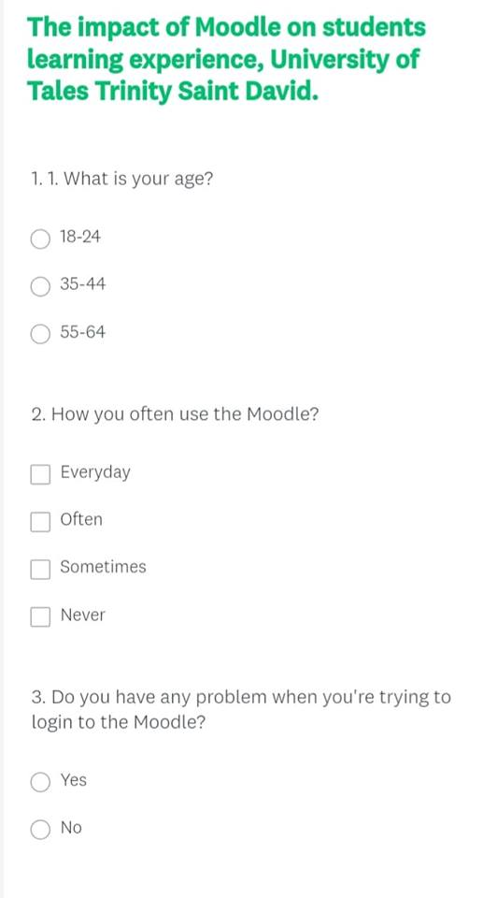

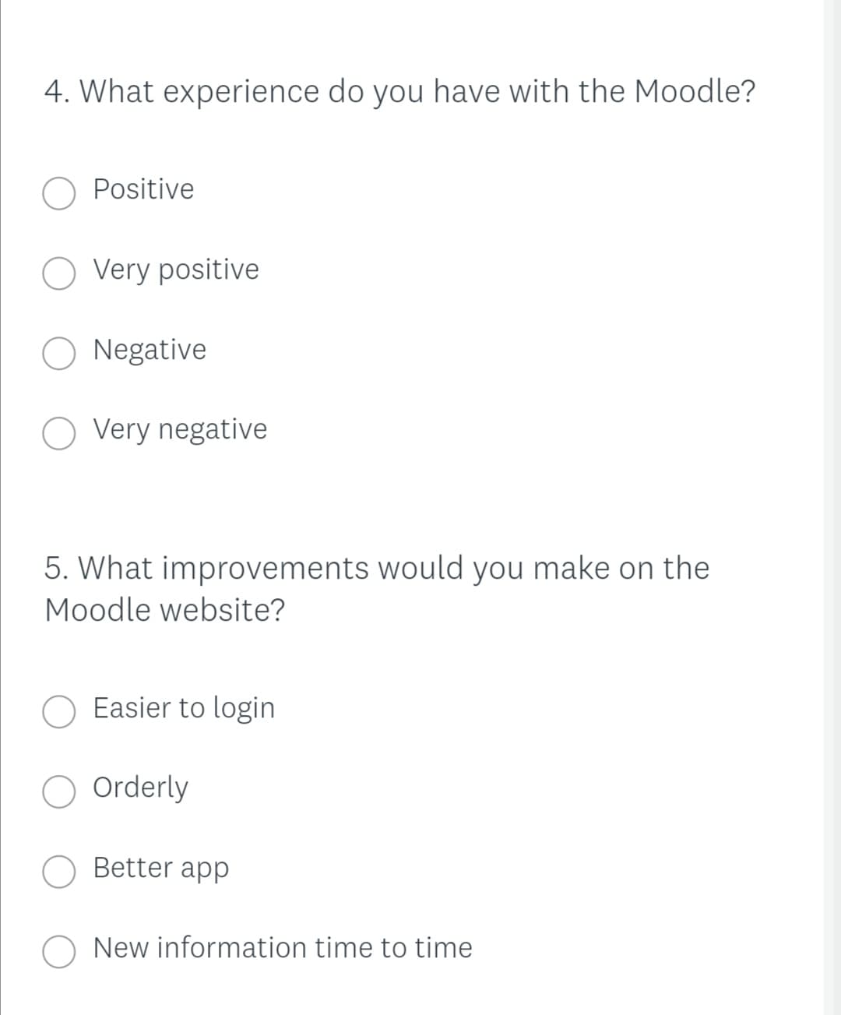

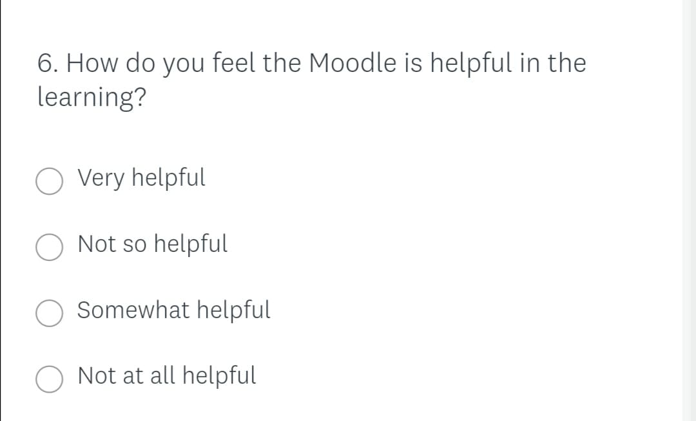

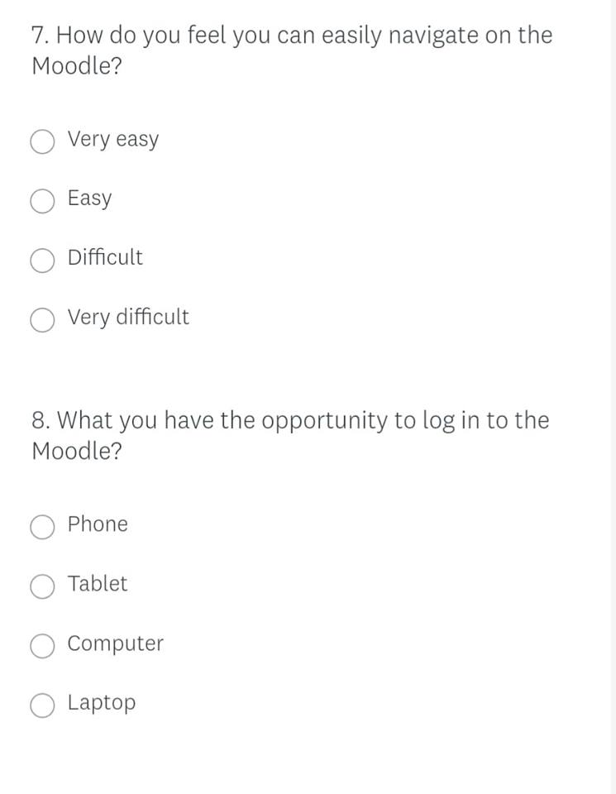

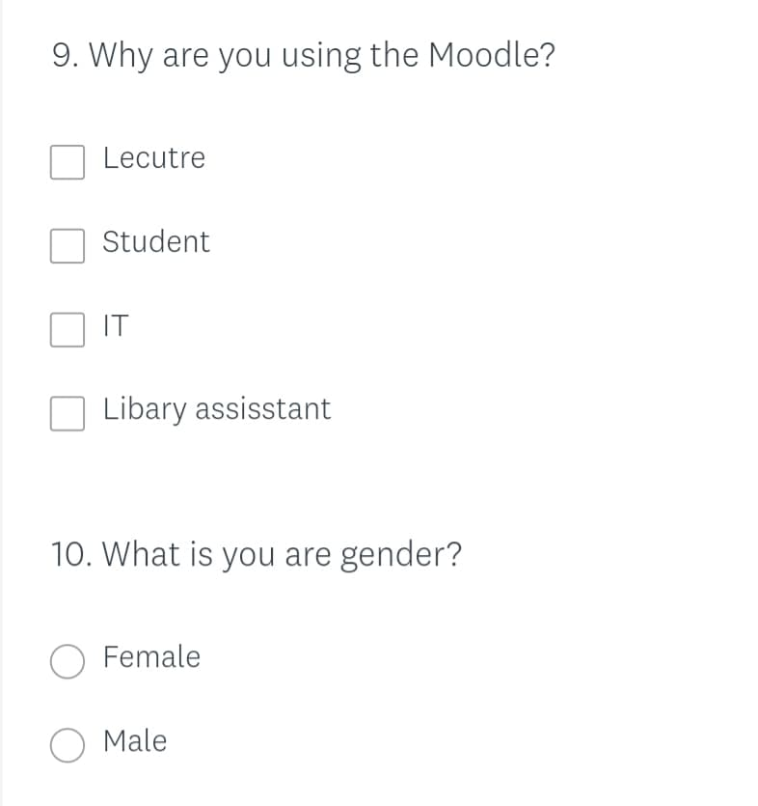

9.0 Reference List:

Surveymonkey.com. 2020. Surveymonkey: The World’S Most Popular Free Online Survey Tool. [online] Available at: <https://www.surveymonkey.com/> [Accessed 8 April 2020].

UWTSD, W., 2020. Moodle Links - University Of Wales Trinity Saint David. [online] Uwtsd.ac.uk. Available at: <https://www.uwtsd.ac.uk/tel/technology-enhanced-learning/moodle-links/> [Accessed 8 April 2020].

Pearlson, K. and Saunders, C., 2020. Managing And Using Information. pp.https://books.google.co.uk/books?hl=hu&lr=&id=nwO2DwAAQBAJ&oi=fnd&pg=PA1&dq=(Pearlson+and+Saunders,+2009+primary+and+secondary+data+explain&ots=kH8I2cAgeb&sig=uAJ9DbI8cwe9VTg_Jx28v7A7PIE&redir_esc=y#v=onepage&q&f=false.

