Module: Big Data

Report Title: Retail Store Sales

Submitted By

Student Name: Moij gugarman

Student ID: 1704972

Course ID: ACUA6002

Submitted on:14th September 2020.

Contents
Module: Big Data 1
Report Title: Retail Store Sales 1
Submitted By 1
Student Name: Moij gugarman 1
Student ID: 1704972 1
Course ID: ACUA6002 1
Submitted on:14th September 2020. 1
Task 1: 3
Introduction 3
Data Set 3
Datamining Tool 3
Data warehouse structure 3
ETL process 5
Evaluate reports on data set 7
References 9

K

Task 1:

Introduction
Information Technology plays vital role in E-Commerce since small and large business has to improve the count of customer, product sale, profit and out reach in all possible ways. The collection of data grew up from Mega bytes to Giga Byte for small business to store the data efficiently to utilize it to improve the business in various aspect. One of the major domains is retail store where customer and products are key element. The data warehouse plays significant role in retail store which help to analyse the key to improve the sales of retail stores. To analysis the data first we need historical data in standard format which can perform by preparing data warehouse. We have various software available which help to create data warehouse such as Hadoop, oracle, Netezza etc. The data warehouse prepared then we can use dataset to analysis the data. This report simulated retail store data warehouse to improve the business process.

Data Set
This report used retail dataset which collected from Kaggle.com. Use of this retail data set, we can take the better decision based on the historical data. This data set has sales details of 45 stores which are located in various regions and each store has various department. The data set has three excel sheet for store, features and sales details. The store sheet has 45 stores information which indicate the type and store size. The feature data set has store number, department details and activities on reginal. The sales data set has completely covered from 2005 to 2012 sales details which includes the store number, department, date, weekly sales etc.

Datamining Tool
The data analytic tool is Power BI which has set of software services, connectors and apps. All work together to unrelated data into visually predict, coherent etc. This software can support excel sheet of the data or cloud-based data. The power BI can easily connect the various data sources to visualize and discover the important of the business requirements. The retail store dataset can analysis in power BI to visualize the sales details for each store, most valuable customer and demand product details.

Data warehouse structure
The primary objective of the data warehouse is to extract data from flat files or online transaction process that consolidate into a single data warehouse which help to easily access and bast way to use the data. The data ware house of process are data load and access. The data ware house system must be robust in order to achieve the business aim. The loading process of the data warehouse can perform by the use of ETL process.
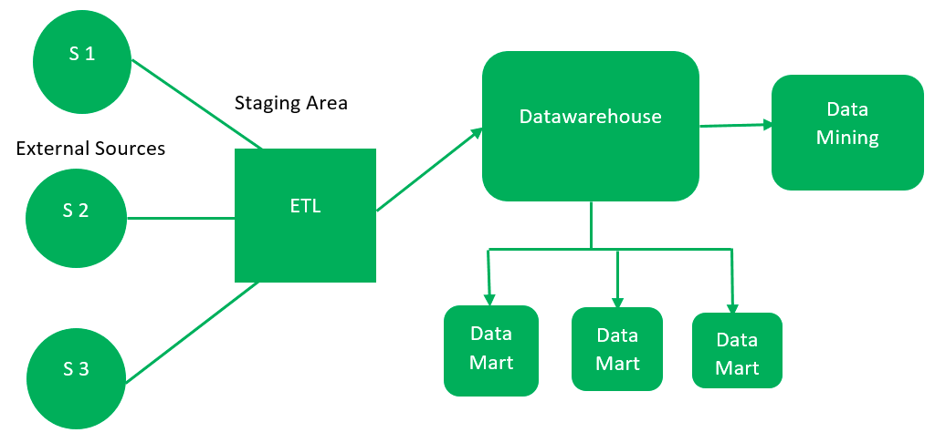
Figure 1: Data warehouse Structure
The retail data warehouse has five dimensions with a fact table created. The dimension tables are described below
Dim_Customer
Dim_Customer dimension table consists of details of customer such as name, id, key. Here customer key is primary key in the Dim_Customer dimension. The primary key should be unique that no duplicate records maintain in the table.
Dim_Product
Dim_product dimemnsion table consists of product _key that is primary key to maintain the product id unique. This table also maintain the details of the product such as name of the product, sold product details which help to analysis the products such as highest selling product and demand products etc.
Dim_Location
Dim_location dimension table has location key as primary key to maintain unique id for each location. This table also consists of state name, state id , region name and store location. This table will help to analysis the sales details in region or state wise. It is also used to analysis the earned revenue details in state or region wise.
Dim_Source
Dim_Source dimension table data is unstructured. It has season_key as primary key. The month_id is represented the particular month and this table is help to analysis the sales in monthwise.
Dim_Month
Dim_month dimension has month_key as primary key which is used to maintain id for each month. This table data is used to analysis the data for highest sales in state or region wise in particular month.
Fact_Table
The retail store has a fact table which is used to connect each dimension table that are relationship using foreign key. This fact table has three column which is used to measure the product quantity, total sale and revenue of each store in month and state wise.
The Star Schema of retail store with dimension tables and Fact Table given below which are connected using Star schema in figure 2.
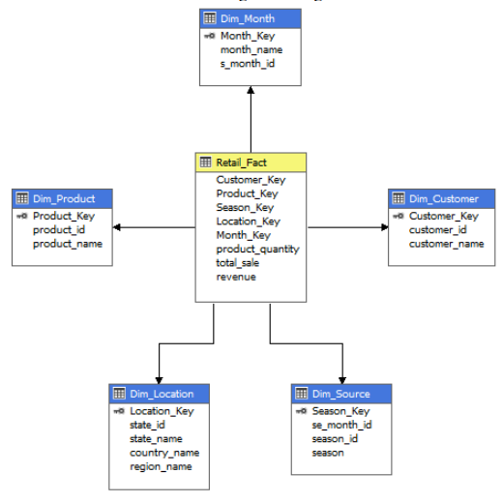
Figure 2: Star Schema
ETL process
The expansion of ETL is Extract Transform Load process which is help to build the data warehouse. To process ETL we have to use SSIS toolbox and this process data collect from various external sources which are extracted tin database. The second step of ETL process is transformation of staging database. Finally, load the staging data into ETL process in fact table. The ETL process data populated in retail fact table and dimension table. The figure 3 show the process of ETL.
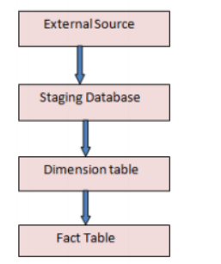
Figure 3: ETL Process

Extraction
The retail store data extract from the Kaggle external source which is in the form of excel sheets. This extracted data has to load into database and all data load into database from excel files.
Transformation
Once data extracted from excel sheet to database staging then need to perform transformation of ETL process. For transformation we have to use the join tool to load the data from the dimensional tables. The retail store has five-dimension tables in database and one fact table. The dimension tables are customer, location, product, month and source. The fact table name has retail. These dimensions are very important factors to analysis the retail data set. In case of matching not matched then ETL process will terminate the flow.
Loading
Once data populated into dimension table then next step of ETL process is to populate the fact table. The fact table consist of all dimension table of the primary key which is used for purpose of analysis with rule of aggregation.

Evaluate reports on data set
Sales details of each store
The sales details of each store involved three data set to predict the total sales, season and state. The below graph shows that sales details of various states and season. This graph shows clearly that Texas has highest sales in summer season and next one is New York.
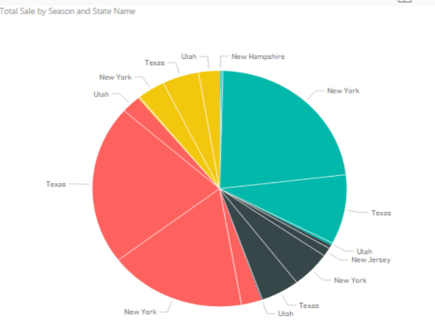
Most potential customers
The most potential customers details can retrieve using details of maximum number of products buying details which has quantity of the product, customer name and season to target the specific customer. The below graph shows the most potential customer details in four seasons which help to increase the sales.
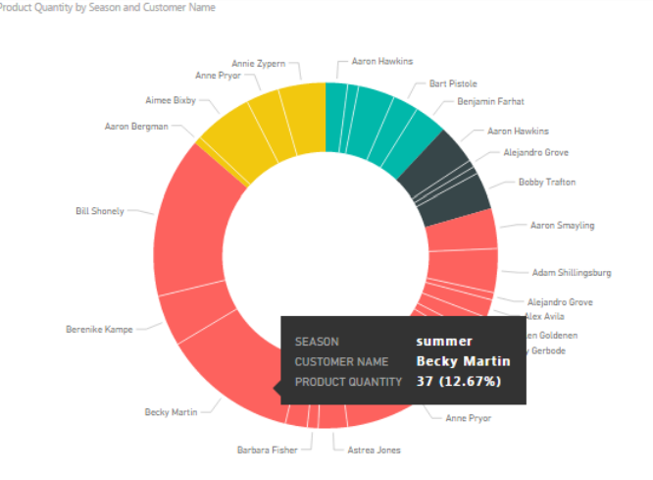

Revenue Details in region and season
We have various seasons in three region of USA and it effect the business of retail store in revenue. The below graph shows that how much revenue generated in region and in season. This graph shows clearly that eastern US has highest revenue in summer crossed 1.0 Million generated revenue. The lowest revenue in western US on winter which has 0.02M
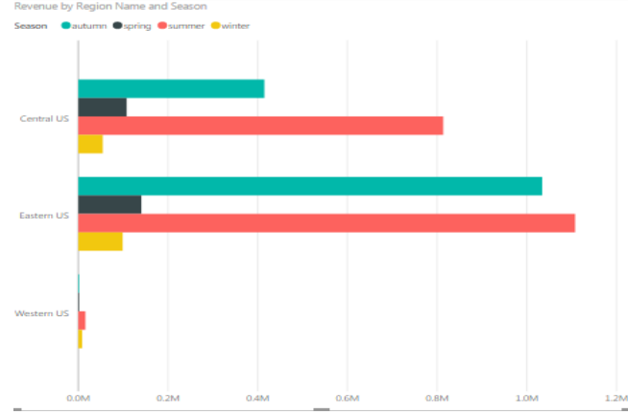
Revenue Details in state and season
To predict the revenue details in state and season wise we need to analysis the three data set. The below graph shows that amount of the revenue in each state in different season.
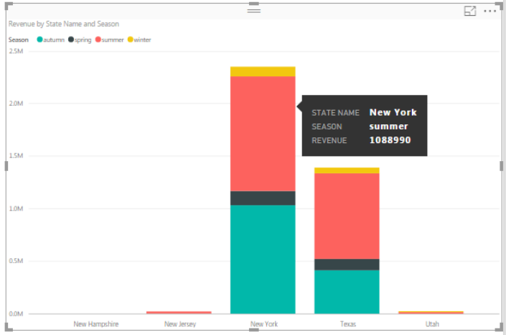
The above graph shows that New York state generated highest revenue amount of revenue is all season. The lowest one is New Hampshire.

References
- Ralph Kimball and Margy Ross. The Data Warehouse Toolkit: The Complete Guide to Dimensional Modeling (2nd ed.). John Wiley & Sons, Inc., New York, NY, USA. 2002.
- Acuma Training Institute: Data Warehouse Design.
- John Paredes. The Multidimensional Data Modeling Toolkit: Making Your Business Intelligence Application Smart with Oracle OLAP. 2009.
- Connolly, T. & Begg, C. Database Systems - A Practical Approach to Design, Implementation and Management (6th ed.), Pearson Education. 2014.

