ANALYSIS OF CONCRETE FRAMED BUILDING
Material Science and Building Services
ACBA4006
Keaton Lewis Davies
2320042
(Word count excl. References:2,269)


Trump International Hotel and Tower

Design
The Trump Tower in Chicago has a genuinely distinctive design. Skidmore, Owings & Merrill and architect Adrian Smith had visions of it as an ultra-tall tower. The tower's unique appearance is a result of its design, which included four setbacks and was influenced by the modernist architecture of Mies van der Rohe. Standing proudly at 1,389 feet (423.2 metres), the reinforced concrete tower is among the highest structures in the world. It's truly a multipurpose masterpiece with a blend of hotel, business, and residential areas. A broadcast antenna was part of the initial plan for Trump Tower in Chicago, which would have made it the highest structure in the world. But with the horrific events of 9/11, questions concerning the design's viability and safety surfaced. Consequently, the design was altered to eliminate the antenna and lower the building's height. Although it was a significant adjustment, safety was the top priority.
(Source: Wikimedia, 2023)

The effect of building on the environment of the Chicago River was one of the main worries. The tower's scale also adds to the urban heat island effect, which causes metropolitan regions to typically be warmer than the nearby rural areas The height of Trump Tower Chicago and its effect on the skyline of the city were issues prior to the building's construction. Concerns were also raised regarding possible gridlock in the streets and the Chicago River's environmental effects. Not to mention the standard concerns about larger construction projects, such as noise and disturbance. On the other hand, The Trump Tower has offered hundreds of jobs to local residents in the area.


The Trump Tower was built up from the concrete structural system often referred to as a core and ‘outrigger’ construction. This method of construction was chosen due to the heavy wind loads in Chicago. The structure had to be as stable as possible so at the peak of the structre, it wouldn’t swing back and forth. Trump Tower in Chicago is oriented in a very strategic way. Its purpose is to offer the greatest views of the Chicago River and the city. It is also oriented to minimise wind pressure and maximise natural light which will cut down the energy costs.

The Trump Tower is built up from 140,000m3 of concrete and 3,800 tons of steelwork (main resources). The Tower was built facing East-West in the same direction in which the wind blows. The curvature and shape of the Tower helps the wind pass through without causing any harm to the individuals inside the Tower.

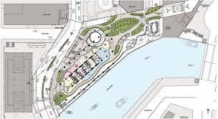
Site Location – Site Layout
Trump Tower will be found in Chicago, near the junction of North Wabash Avenue and East Upper Wacker Drive, on the northern bank of the Chicago River. In the centre of the city, on outstanding real estate with breathtaking views of the river and the city skyline, is this position.
Google.com. (2023). Redirect Notice

1. The frame's likely durability and climatic resistance, given the environmental
conditions the site is exposed to.
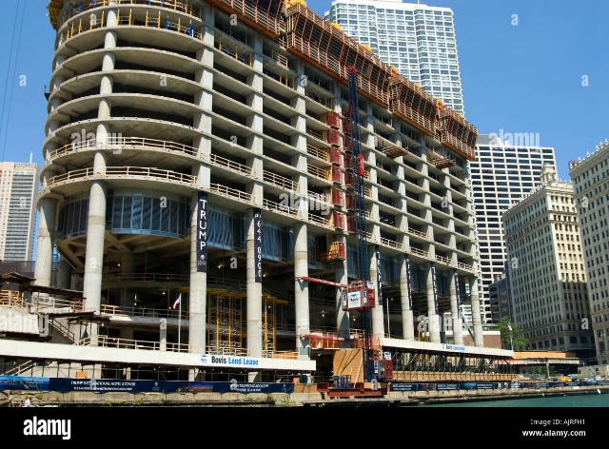
Concrete is the main construction material used to create high-rise structures. Concrete will be used for the foundations and in the centre of even steel buildings. Water, however, is the enemy of concrete. There is water everywhere, even in desert regions, and there are several ways that water intrusion can harm concrete structures. In addition to causing leaks and cracks, water also introduces corrosive substances into the reinforcing steel. Concrete can fracture due to several expansion processes, some of which involve water. Water intrusion must be prevented from reaching the building's concrete base and core for it to continue being strong and genuinely sustainable. Due to their extraordinary strength and adaptability, concrete frames are being used more and more often in the construction of tall structures. They are a crucial component of structural design because they offer stability and support in demanding situations.
Tall structures may be made stronger and more durable by using concrete frameworks, which also improves safety. Potential fires are prevented by the fire resistance and high-temperature tolerance of concrete. The building's and its occupants' overall safety is greatly increased by this capability. Moreover, tall structures last longer because of the resilience of concrete frameworks. Over the years, concrete has required little upkeep and repair because of its extended service life. This lowers the building's total lifespan cost, giving developers and owners a cost-effective option.

Foundation used in the construction of Trump Tower in Chicago.
The deep foundation used to support Trump Tower Chicago is called a caisson (pier) foundation. Large cylindrical shafts are drilled into the earth and filled with concrete to create this extremely robust structure. Trump Tower in Chicago was built on caisson foundations because of the peculiar ground conditions in the city. Chicago's soil is notorious for being quite marshy and silty, especially in the riverfront areas.
Caisson foundations can reach the more robust bedrock beneath the weaker soil, caisson foundations are ideal in this situation as they provide a strong footing for the skyscraper.
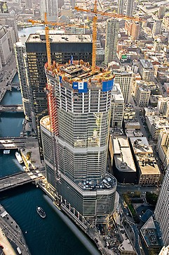
Concrete frames are incomparably strong when it comes to enduring the pressures and large weights that towering buildings are subjected to. Cement, particles, and water combine to form concrete, which has exceptional compression strength. Concrete frames that are reinforced with steel bars equally distribute weight, which makes them perfect for supporting vertical weights.
This extraordinary strength allows engineers and architects to create stronger, higher buildings, pushing the envelope of what is deemed feasible in terms of height. As a result, our metropolitan skylines are now influenced by famous buildings.

2. The Material’s original production process, and any impacts that this process would have on the social and ecological environment, referencing all resources used in the material’s manufacture, and any harmful bi-products produced.
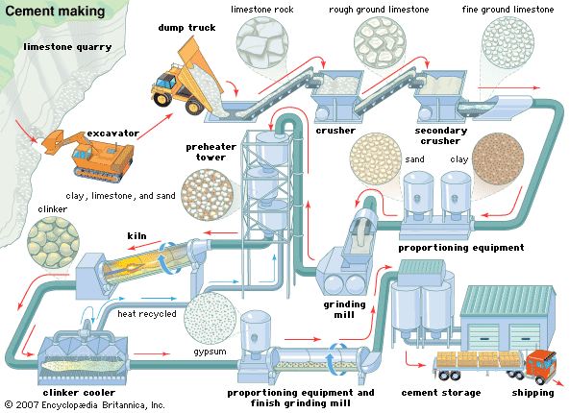
The main ingredients of concrete are cement, water, and aggregate (sand, gravel). The first step in the manufacturing of cement is the excavation of clay and limestone from quarries. Soil erosion and habitat damage may result from this process. In a kiln, the basic ingredients are crushed and fired to create a "clinker." This procedure uses a lot of energy and produces a lot of CO2. To make cement, the cooled clinker is crushed into a fine powder and combined with a small amount of gypsum. Concrete is then created by combining cement, water, and aggregates. Energy use in this process is another possibility.
Due to CO2 and other emissions, the manufacture of concrete pollutes the air and water through runoff that contains heavy metals and other pollutants. The noise and dust from quarries and cement facilities also affect the communities that surround them. On the other hand, the sector does produce jobs, but the working conditions in quarries can be hazardous, and the surrounding inhabitants' quality of life may be adversely affected by the noise and dust from the production facilities. In an attempt to lessen these effects, the industry is attempting to create "greener" cement through the use of less energy-intensive procedures, as well as to enhance safety regulations and working conditions. Although it is a perplexing task, it's essential for both our earth and civilization.
Limestone extraction
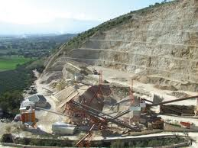
Finding appropriate locations, usually close to the surface, is the first step in the extraction of limestone. To make sure there is a good limestone deposit there, experts survey the area. Clearing the area above the site frequently entails removing dirt and plants. They will then begin to drill holes into the site and plant explosives to break up the soil. This will break up the limestone into manageable sizes ready to be loaded on trucks or conveyors and transported for further processing.

Why are aggregates essential in concrete structures?
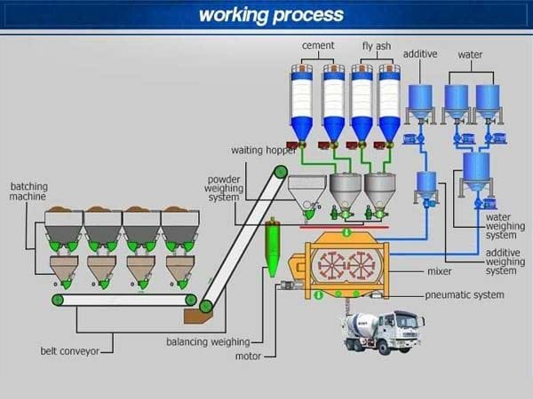
Concrete with increased strength is utilised to build skyscrapers such as the Trump Tower in Chicago. Crushed stone or well-graded gravel is frequently used as the aggregate in this. These substances are able to withstand extreme pressure. Because they provide concrete mixtures bulk, stability, and durability, aggregates are essential. Because they are less expensive than cement, they lessen shrinkage and cracking and increase the mixture's economy. It resembles the skeleton holding up the remainder of the building. Concrete would be extremely brittle and prone to breaking without aggregates. It also wouldn't be as cost-effective or long-lasting.
How are aggregates graded?
Collection
Aggregates are gathered from designated locations such as quarries and riverbeds.
Crushing
After that, they are broken up into smaller bits that may be combined.
Sieving
A sequence of sieves with varying-sized holes are used to filter aggregates. The weight of the aggregates in each filter is recorded after they are shaken.
Gradation
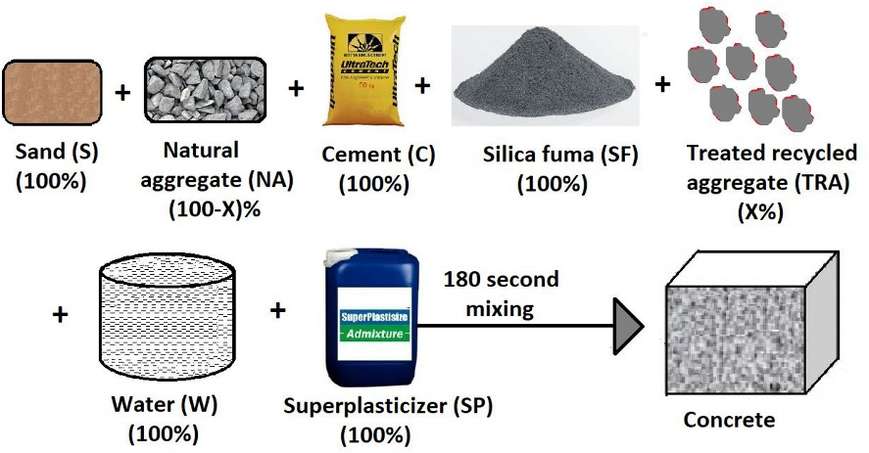
Aggregates are categorised as fine or coarse based on the weight distribution throughout the sieves. Coarse aggregates are bigger than 4.75mm, whereas fine aggregates are smaller.
Quality check
They are examined for contaminants, organic debris, and other unwanted substances.
Mixing
Lastly, they are combined with the concrete in the amounts needed for that particular job.

3. The frame's ease of assembly and any aspects with regards to building services provision and the potential ease of its adaptation to different building shape and use, when compared to the use of a steel frame.
Concrete frames are renowned for their strength, but they also provide for design freedom. It is possible for architects to produce amazing aesthetics without sacrificing structural soundness. Because of its adaptability, this material may be creatively used to shape structures and create distinctive architectural styles. The options for design have been further enhanced by advances in concrete mixing and pouring processes and modern technologies. Tall structures can have more visual appeal by moulding concrete frameworks into a variety of forms and curves. The ability to be creative with design is essential to producing iconic buildings that draw attention from all around the world.
Which material is better for high-rise construction, Concrete or Steel?
Which is safer and which is stronger are the two most crucial issues that require an answer. The industry opinion up until recently was that concrete is safer. This is due to a few factors. In concrete construction, two foot of concrete is used to contain the building's central components. The purpose of this is to safeguard the structure against potential attacks and fires. The lift, stairs, electrical systems and emergency exit are in the building's core.
Steel frame buildings have an exceptionally long lifespan. They are perfect for earthquake-prone locations since they can endure strong forces or severe weather conditions. Additionally, they are less expensive for foundations since they are lighter than reinforced concrete. If steel is not managed correctly, it can corrode easily, causing an increase in maintenance and the expenses of additional labour. Unless it is covered with a specific fire-resistant compound, it is also less fire-resistant than concrete. Conversely, reinforced concrete combines the benefits of both concrete and steel in one. It resists fires quite well and corrodes less easily. It's a popular option for corporate and residential buildings since it is excellent at insulating against heat and sound. However, because reinforced concrete is heavier, larger, more costly foundations are usually needed. In addition, preparation and pouring take longer than with steel frames, which might cause delays in the construction process.
Concrete frameworks may be rather flexible. Their ability to be moulded into almost any shape is quite advantageous when working with unique architectural concepts. When it comes to building services, concrete can be more problematic than steel. Plumbing paths and conduits need to be designed in advance since they will be embedded directly into the concrete. Steel is less customizable than concrete in terms of personalization. Changing the building's form or function would definitely require a significant amount of work. Contrarily, steel frames are more modular, which facilitates easier changes. They might not, however, offer the same degree of upfront design flexibility.

Preliminary Design & Planning
The building is designed by the construction crew, structural engineer, and architect in concert. They choose the locations of the reinforced concrete floors, beams, and columns.
Preparation
Deep piles driven into the earth are frequently used to prepare the building site and lay the foundation.
Formwork Construction
Formwork is constructed using temporary moulds that are filled with concrete. Usually constructed of steel or wood, it aids in shaping the concrete while it is still liquid.
Rebar Placement
The steel reinforcing bars, also known as rebar, are then inserted within the formwork. Tensile strength and resistance to breaking and cracking are provided by the rebar.
Concrete Pour
The formwork surrounding the reinforcing bar is filled with the concrete mix, which is normally composed of cement, sand, aggregate, and water.
Curing Process
It takes time for the concrete to strengthen and cure. Depending on the size of the building and the surrounding circumstances, this process may take many days or weeks.
Formwork Removal
The formwork is carefully removed when the concrete has dried and strengthened enough.
Repeat the Process
Floor after floor, this procedure is carried out until the tower reaches its highest point.
Finishing
Once the structure is complete, the final changes like exterior and interior claddings, electrical wiring, plumbing, and insulation are added.

Conclusion
In conclusion, reinforced concrete is superior for skyscrapers even if steel has advantages as well. The substance created by combining concrete with steel reinforcement is extraordinarily robust and long-lasting, making it perfect for supporting the massive weights of skyscrapers. When compared to steel, it also provides higher fire resistance. In addition, concrete's adaptability allows it to be used with a variety of architectural styles. For skyscrapers, reinforced concrete is the material of choice for all these reasons.

References:
Real, C. (2023). CoStar | # 1 Commercial Real Estate Information Company. [online] CoStar. Available at: http://www.emporis.com/buildings/102119/trump-international-hotel-tower-chicago-il-usa (Accessed 30 Nov. 2023)
Wikimedia.org. (2023). Available at: https://upload.wikimedia.org/wikipedia/commons/thumb/c/c4/Trump_International_Hotel_and_Tower_in_Chicago_llinosis.jpg/1200px-Trump_International_Hotel_and_Tower_in_Chicago_llinosis.jpg (Accessed 30 Nov. 2023).

Google.com. (2023). Redirect Notice. [online] Available at: https://www.google.com/url?sa=i&url=https%3A%2F%2Fglobal.ctbuh.org%2Fresources%2Fpapers%2Fdownload%2F29-case-study-trump-international-hotel-tower.pdf&psig=AOvVaw2Jvw455SWBY-YMnM_HeUKk&ust=1701439308130000&source=images&cd=vfe&ved=0CBIQjRxqFwoTCOiEkr7x64IDFQAAAAAdAAAAABAE (Accessed 30 Nov. 2023).
Utilities One. (n.d.). Concrete Frames in Tall Buildings Balancing Strength and Design. [online] Available at: https://utilitiesone.com/concrete-frames-in-tall-buildings-balancing-strength-and-design#anchor-1 (Accessed 3 Dec. 2023).
Wood, H. (2023). The Role of Aggregate in Concrete. [online] Materials Market. Available at: https://materialsmarket.com/articles/the-role-of-aggregate-in-concrete/.
‌ www.linkedin.com. (n.d.). How limestone ore is processed? [online] Available at: https://www.linkedin.com/pulse/how-limestone-ore-processed-zhang-xiaoyan/ (Accessed 7 Dec. 2023).
‌
www.converge.io. (n.d.). Environmental impacts of concrete construction and manufacturing. [online] Available at: https://www.converge.io/blog/environmental-impacts-of-concrete.
‌

‌
‌

‌

‌

