Master of Business Administration

Human Capital Management

(LCMB7023)

Lecturer: Eno Maycock

Student name: Priyanka DigeshKumar Bhavsar

Student ID number: 2535480

Word count: 2568

Contents
- Introduction………….…………………………………………………………….....3

Task A:
- Van Maanen & Schein's theories…………………………………………………..3
- Psychological contract theory………………………………………………………4
- Identity construction………………………………………....................................4
- Structured socialisation framework for Helios…………………………………….5
- Mechanisms to Cultivate…………………………………………………………….6

Task B:
- Innovative Job Design Strategy…………………………………………………….7
- Job Crafting…………………………………………………………………………..8
- Skills-based architecture with an internal talent marketplace……………………9
- Explanation of job design…………………………………………………………..9

Task C:
- Reflective Report………………………………………………………………….10
- References…………………………………………………………………………11

Introduction:
Helios Urban Mobility (HUM) is a rapidly growing European company developing AI-based electric mobility systems for city governments. After rapidly expanding in London, Berlin and Singapore, the organisation is facing challenges like weak organisational socialisation, reduced employee engagement and difficulties in retaining highly skilled graduates. These issues have arisen due to limited onboarding, cultural differences, inadequate guidance and psychological contract gaps. To tackle these challenges, Helios needs to adopt a structured and strategic socialisation approach.

Task A. Socialisation, Identity & Business Activism
A.1.1: Van Maanen & Schein's traditional onboarding versus strategic organisational socialisation:
Traditional Onboarding | Van Maanen & Schein's Strategic Organisational Socialisation
Individual | Collective Socialisation
Informal | Formal Socialisation
Random | Sequential Socialisation
Variable | Fixed Socialisation
Disjunctive | Serial Socialisation
Divestiture | Investiture Socialisation

Part of the most outstanding models of socialisation is Van Maanen and Schein’s categorisation of socialisation strategy (Ashforth & Saks, 1996). Van Maanen and Schein (1979) defined a socialisation plan as how the experiences of individuals in transition from one role to another are structured for them by others in the organisation. In their strategy of organisational socialisation, they identified six methods and described how they provide a path to a newcomer’s keeper, content-novelty, or job-novelty responses (Van Maanen and Schein, 1979). The tactical proportions rely on an emotional scale that features significant space between the poles (Van Maanen and Schein, 1979).
Collaborative socialisation is a group of new employees, putting them into common experiences instead of separating them from each other and placing them into different experiences. In the traditional socialisation, the new employee is separated from the organisational employee during the desired socialisation period, instead of differentiating a new employee from experienced staff. The straight socialisation includes an order of separate and recognisable steps that indicate role assumption, as compared to an equivocal, unknown or frequently changing order. It provides a schedule for orders that aligns with role assumption and the time taken in the process; on the other hand, a changeable process does not provide that information. The serial tactic provides new employees with an experienced member as a role model; in contrast, the separating tactic has no role model. Lastly, the new employee could retain their identity and personal characteristics rather than reconsidering, denying, or removing them (Van Maanen and Schein, 1979).

A.1.2: Psychological Contract Theory:
The theory has a history in organisational research. To the broader concepts of the organisations-individuals interchange of March and Simon’s inducement-contribution model (1958), and even earlier to Barnard’s (1938) equilibrium model (Roehling 1996).
CONTRIBUTION FROM THE EMPLOYEE |  | CONTRIBUTION FROM THE EMPLOYER
 | →
Efforts | → | Pay
Ability |  | Job Security
Loyalty | ← | Benefits
Skill | ← | Career Opportunities
Time |  | Status
 |  | Promotion Opportunity
(Idea taken from Google, made by self)
Barnard (1938) asserts that the employment relationship is one of give-and-take between employees and employers. While employees offer efforts, abilities, loyalty, skills, and time, the employer gives salaries, job security, promotions, and status. If the employee feels that the bargain is balanced, their commitment and motivation increase (Rousseau, 1995; Conway and Briner, 2005).

A.1.3: Identity construction:
Identity construction means the process by which an employee identifies their own identity, that is, "who they are," in the context of an organisation and aligns their value system, behaviours, and objectives with those of the organisation (Alvesson and Willmott, 2002; Brown, 2015).
In traditional onboarding, the employee mainly focuses on administration and job-related information. With limited guidance, they build an independent identity where they think that their job is just performing the task (Bauer et al., 2007). With the limitation of introduction, policy and training, they train for short-term and detached with organisational attachment (Ashforth and Saks, 1996).
In contrast, strategic organisational socialisation focuses on long-term integration of staff into organisational culture and identity. The company oversees the progress of organisational identity among workers via principles, standards, and companionship (Alvesson and Willmott, 2002). Employees are encouraged to become organisational citizen who identify with the organisation’s mission and purpose. Intensive socialising by mentoring, teamwork, networking and cultural events. Resulting in higher levels of organisational commitment and loyalty (Bauer et al., 2007; Brown, 2015).
In the context of identity construction, the conventional process of onboarding emphasises equipping employees with knowledge about their duties but pays little attention to the formation of organisational identity among employees (Ashforth and Saks, 1996). In this regard, strategic organisational socialisation ensures that employees internalise organisational values and feel part of the organisation in the sense of being committed members of the organisation. Consequently, strategic socialisation engenders greater engagement, commitment, and organisational citizenship behaviour (Bauer et al., 2007; Brown, 2015).

A.2: Structured socialisation framework for Helios
1. Pre-boarding:
Employees learn about the mission of the organisation and its values and expectations from them. Mentors and culture ambassadors are assigned at this point to minimise uncertainty and ensure the creation of a positive psychological contract (Rousseau, 1995; Bauer et al., 2007).

2. First 90 Days:
Employees become involved in an induction programme, training, team building exercises, and regular feedback. Such activities help create a perception of the directorial philosophy, relationships with other people and a sense of belonging (Bauer et al., 2007; Saks and Gruman, 2018).

3. Year One Development:
Employees undergo development in leadership, working on interdepartmental projects, getting coaching, and participating in innovation initiatives (Bauer et al., 2007).

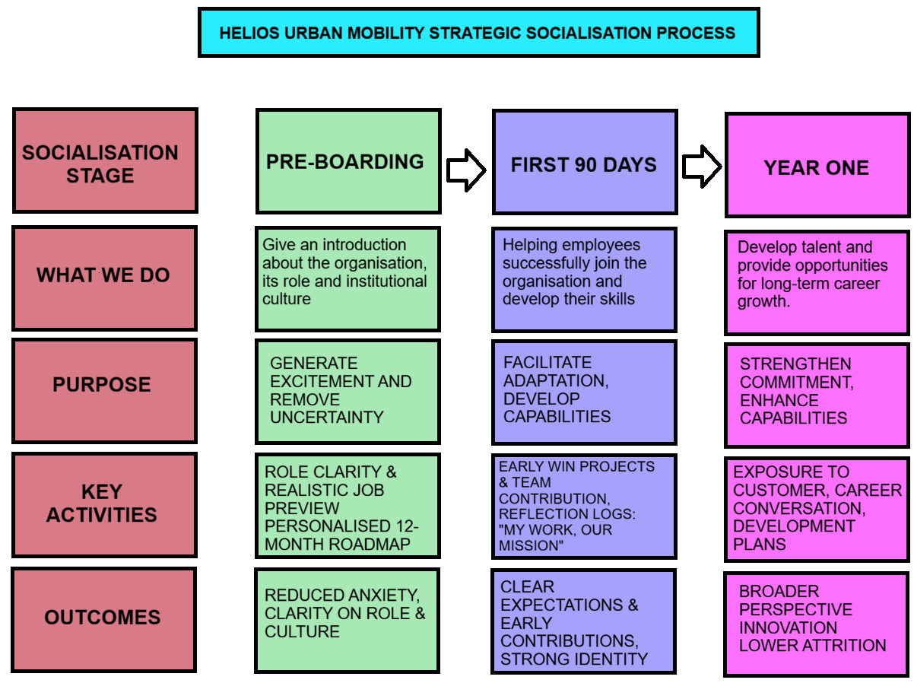
Culture and Mindset Enablers:
During all three stages, organisational values, ethics, continuous learning, collaboration, and the ability to speak up are encouraged in employees (Rousseau, 1995; Alvesson and Willmott, 2002).
Outcome:
This process results in engaged employees who feel aligned with organisational goals, behave as good citizens within organisations, innovate and stay committed to their organisations (Bauer et al., 2007; Saks and Gruman, 2018).

A.3: Mechanisms to Cultivate
1. Organisational identification:
The Helios model can help enhance organisational identification by using methods such as mission-based induction programs, mentoring schemes, organisational culture champions, and leadership storytelling to reinforce organisational values (Ashforth and Mael, 1989; Alvesson and Willmott, 2002). Other ways include teamwork, reward systems, and employee networking (Brown, 2015; Bauer et al., 2007).
This makes employees feel strongly attached to the organisation and connect their personal identity with organisational identity and objectives (Ashforth and Mael, 1989).

2. Ethical professionalism:
Ethics training and workshops on AI and sustainability, along with the development of codes of conduct may assist Helios to create a culture of ethical professionalism. The use of ethics-related case studies, ethics champions, and inclusion of ethical behaviour in the performance reviews will encourage individuals to behave ethically (Treviño and Nelson, 2021; Brown and Treviño, 2006).

3. The “business activist” mindset:
Using Ulrich’s HR Business Partner model and stakeholder capitalism, Helios can foster the development of employees thinking outside of the box in order to help achieve goals that reach further than those related to the immediate job duties (Ulrich, 1997; Freeman, 1984). In doing so, through innovation competitions, stakeholder engagement projects, sustainability programs, and voice mechanisms for employees, Helios enables employees to act as change agents that produce positive results that benefit stakeholders from different angles, whether shareholders, customers, society, or the natural environment (Freeman, 1984; Ulrich and Brockbank, 2005).

TASK B: Job Design
It is recommended to adopt an Internal Talent Marketplace at Helios Urban Mobility to boost innovation, agility, and employee engagement using the Job Characteristics Model, Job Crafting Theory, and Skills-Based Architecture (Hackman and Oldham, 1976; Wrzesniewski and Dutton, 2001).
B.1: 1. Innovative Job Design Strategy using JCM:
The Job Characteristics Model (JCM) was informed by J. Richard Hackman and Greg Oldham in 1976 & aims to explain how job design affects employee engagement and well-being.
Overview of the JCM
The Job Characteristics Model submit that certain job characteristics can guide to favourable emotional conditions, which in turn enhance employee motivation and satisfaction (Hackman and Oldham, 1976). The model presents five essential job characteristics:
- Skill Variety: The certificate required for a job needed a variation of different activities and skills. Example: In Helios, a project engineer uses technical, communication, and problem-solving skills while working with different departments.

- Task Identity: The expanse of the task includes finishing a whole and recognisable work. Example: The employee handles the entire management of the smart mobility project from planning to implementation.

- Task Significance: The job's effect on people's lives and work. Example: A data analyst develops traffic solutions that make public transport in cities more efficient and reduce traffic congestion.
- Autonomy: The amount of flexibility employees have in managing their work activities. Example: Employees can schedule their work and choose the right method to complete tasks.

- Feedback: The job gives clear information regarding performance success. Example: Employees regularly get performance reviews and project feedback from their managers and team members.
These measurements promote three significant psychological states:
Experienced Meaningfulness: The certificate to which the employee feels that their work is meaningful.
Experienced Responsibility: The sense of ownership and accountability for the outcomes of the job.
Knowledge of Results: The extent to which the employee knows how well they are doing a task.
The model suggests that when psychological forms are present, staff experience higher job motivation, fulfilment and performance.

B.1. 2: Job Crafting Theory:
This theory by Wrzesniewski and Dutton (2001) proposes that workers are not simply passive accepters of their job design but are active in making changes to their work to enhance meaning and engagement. Employees use job crafting to change some of the dimensions of their jobs in a manner that would suit their strengths, interests and values.
There are three main types of job crafting. The first one is mentioned as task creating, during which the worker changes the amount, variety, or content of tasks that they carry out. For instance, an engineer will willingly get involved in various projects associated with sustainability irrespective of his/her official duties. This allows him/her to enrich his/her competencies and become a more productive employee for the company. The second type is relational crafting. It includes changing the character and/or frequency of interactions at work. The employees cooperate with people from other departments or even other cities to enhance their contacts and share information.
For employees at Helios, all types of job crafting can be enabled through innovation projects, cross-functional teams, mentorship programs, and involvement in strategy development initiatives. This allows employees to make changes to personalise their experiences while still working towards organisational goals (Tims, Bakker and Derks, 2013).
Job crafting has a supportive impact on psychological outcomes in the workplace. Task crafting allows people to feel a higher level of meaningfulness and purpose in their jobs. Working together increases feelings of connectedness and organisational identification (Berg, Dutton and Wrzesniewski, 2013). Cognitive crafting allows people to understand the importance of their job and how it affects others. As a result, job crafting leads to the top degree of engagement, intrinsic motivation, job fulfilment, and company faithfulness, promoting creativity and innovation Tims, Bakker and Derks, 2013; Berg, Dutton and Wrzesniewski, 2013).

B.1. 3: Skills-based architecture with an internal talent marketplace:
In Helios Urban Mobility, an interesting approach for job design would be that of adopting Skills-Based Architecture (SBA) along with an Internal Talent Marketplace (ITM). Whereas conventional approaches to job design tend to define roles and responsibilities within a job structure, the skills-based approach would allow the company to adapt more easily to changing technologies and environments (Deloitte, 2023)..
In this approach, employees would have electronic profiles of their technical, managerial, and behavioural capabilities. Instead of limiting themselves to only one set of responsibilities from a certain job profile, employees would be able to take part in projects within various departments by leveraging their competencies. For instance, an engineer with expertise in data analysis can also work on a smart mobility initiative regardless of his or her job responsibilities (World Economic Forum, 2025).
The Internal Talent Marketplace is expected to be an online forum through which managers post details about project assignments, challenges, and growth opportunities within the organisation (Mercer, 2024). Employees will then volunteer themselves for these assignments based on their qualifications and career goals.
The above strategy will be effective due to Job Crafting Theory, which posits that employees will be more committed to their jobs if they craft their roles in line with their skills and interests. In addition, this strategy will make the psychological contract stronger since it will show that the organisation is committed to developing its employees (Rousseau, 1995).
Strategically speaking, such a model enables Helios to solve skill shortages issues, enhance employee retention efforts, and ensure their readiness for the future. Employees will get more autonomy and flexibility to pursue their careers, whereas the company gets the benefit of higher innovation, flexibility, and productivity. Hence, a Skills-Based Architecture and an Internal Talent Marketplace constitute a contemporary and sustainable job design strategy (Deloitte, 2023; Mercer, 2024).

B.2: Explanation of job design will stimulate intrinsic motivation and support innovation:
The new job design for Helios Urban Mobility will motivate employees intrinsically because it will give employees more freedom and autonomy, skill variety, significance, and growth opportunities (Hackman and Oldham, 1976). Employees will be able to use the Internal Talent Marketplace to participate in projects that match their skills and interests, thereby generating a sense of ownership. In accordance with Job Crafting Theory, employees create the conditions for their own jobs, which increases their engagement and makes them satisfied. Innovation occurs because of interaction and knowledge sharing among cross-functional teams (Berg, Dutton and Wrzesniewski, 2013).

TASK C: Reflective Report:
AI is playing a bigger role in business and HR decisions. As an emerging HR specialist, I consider AI a decision-supporting mechanism but not a substitute for human intuition (Davenport and Kirby, 2016). AI can process huge amounts of data and detect patterns, offering better and more efficient ways to approach issues (Tambe, Cappelli and Yakubovich, 2019). Nevertheless, AI does not have enough capability to understand the organisational culture, ethics, or human emotions. Thus, I would apply AI to enhance my work on recruitment, strategic staffing, employee analysis, etc., making sure that I take the ultimate decision based on critical thinking.
To increase my employability opportunities for the future, I have created a personal plan that highlights key areas such as data literacy, AI assistance in HR, strategic influencing, and global mobility awareness. For example, I am going to boost my data literacy through understanding how to analyse data and use visualisation tools in the evidence-based practice of HRM (Marler and Boudreau, 2017). The second area will be AI assistance within the field of HR
The first aim for me as an HR is to improve my skills in data inspection as well as assembling, decoding and examining data of HR. In the modern world, working with HR data is one of the important tasks, as data proficiency leads to decisions with recent information and statistics, rather than hunches. We can use Microsoft Excel and Power BI tools to figure out HR affairs, including workers' presentation and measuring how the hiring process, attendance, workers' movement and socialisation among the other members. For example, if a company has a turnover issue, then with the help of Power BI, the company can figure out which department has a higher rate of turnover data, as per worker age, turnover and roles (Marler and Boudreau, 2017).
The second thing to learn is artificial intelligence. This technology is recently most used in everyday work and helps in taking decisions with surveys. To gain the knowledge of these technologies, I can complete the task effectively and fairly. I have also learned about the complications that come with these technologies, as well as peace, secrecy and rule-based flip side. For example, AI can help in the hiring process as it can shortlist the skilled applicants from the thousands of candidates. It makes the hiring process speedy (Tambe, Cappelli and Yakubovich, 2019). Still, if the formulas are set to old data, AI might focus on a particular group of candidates. To solve these problems, as an HR, I prefer AI-generated information only as support for individual decisions (Davenport and Kirby, 2016).
Third, my influencing capabilities will be improved through presentations, teamwork, and leadership training sessions. Fourth, my awareness of mobility issues will be enhanced through the acquisition of knowledge on international HR issues, cultural diversity, and global workforce trends (World Economic Forum, 2025). This will be particularly useful in multinational organisations that operate in many countries.
In conclusion, I believe that merging my knowledge of technology with critical thinking and ethical judgment will help me succeed in my career as an HR professional (Davenport and Kirby, 2016; Tambe, Cappelli and Yakubovich, 2019).

References:
Alvesson, M. and Willmott, H. (2002) ‘Identity regulation as organisational control: Producing the appropriate individual’, Journal of Management Studies, 39(5), pp. 619–644.
Ashforth, B.E. and Mael, F. (1989) ‘Social identity theory and the organisation’, Academy of Management Review, 14(1), pp. 20–39.
Ashforth, B.E. and Saks, A.M. (1996) ‘Socialisation tactics: Longitudinal effects on newcomer adjustment’, Academy of Management Journal, 39(1), pp. 149–178.
Barnard, C.I. (1938). The Functions of the Executive. Cambridge, MA: Harvard University Press.
Bauer, T.N., Bodner, T., Erdogan, B., Truxillo, D.M. and Tucker, J.S. (2007) ‘Newcomer adjustment during organisational socialisation: A meta-analytic review of antecedents, outcomes, and methods’, Journal of Applied Psychology, 92(3), pp. 707–721.
Berg, J.M., Dutton, J.E. and Wrzesniewski, A. (2013). Job Crafting and Meaningful Work. Washington, DC: American Psychological Association.
Brown, A.D. (2015) ‘Identities and identity work in organisations’, International Journal of Management Reviews, 17(1), pp. 20–40.
Brown, M.E. and Treviño, L.K. (2006) ‘Ethical leadership: A review and future directions’, The Leadership Quarterly, 17(6), pp. 595–616.
Conway, N. and Briner, R.B. (2005) Understanding Psychological Contracts at Work: A Critical Evaluation of Theory and Research. Oxford: Oxford University Press.
Coyle-Shapiro, J.A.M. and Kessler, I. (2000) ‘Consequences of the psychological contract for the employment relationship’, Journal of Management Studies, 37(7), pp. 903–930.
Davenport, T.H. and Kirby, J. (2016). Only Humans Need Apply: Winners and Losers in the Age of Smart Machines. New York: Harper Business.
Deloitte (2023). The Skills-Based Organisation: A New Operating Model for Work and the Workforce. Deloitte Insights. Available at: https://www2.deloitte.com (Accessed: 24 June 2026).
Freeman, R.E. (1984). Strategic Management: A Stakeholder Approach. Boston, MA: Pitman.
Hackman, J.R. and Oldham, G.R. (1976) ‘Motivation through the design of work: Test of a theory’, Organisational Behaviour and Human Performance, 16(2), pp. 250–279.
Humphrey, S.E., Nahrgang, J.D. and Morgeson, F.P. (2007) ‘Integrating motivational, social, and contextual work design features: A meta-analytic summary and theoretical extension of the work design literature’, Journal of Applied Psychology, 92(5), pp. 1332–1356.
March, J.G. and Simon, H.A. (1958) Organizations. New York: Wiley.
Marler, J.H. and Boudreau, J.W. (2017) ‘An evidence-based review of HR Analytics’, The International Journal of Human Resource Management, 28(1), pp. 3–26.
Mercer (2024) Global Talent Trends 2024. New York: Mercer. Available at: https://www.mercer.com (Accessed: 24 June 2026).
Parker, S.K., Morgeson, F.P. and Johns, G. (2017) ‘One hundred years of work design research: Looking back and looking forward’, Journal of Applied Psychology, 102(3), pp. 403–420.
Roehling, M.V. (1996) ‘The origins and early development of the psychological contract construct’, Journal of Management History, 2(2), pp. 204–217.
Rousseau, D.M. (1995) Psychological Contracts in Organisations: Understanding Written and Unwritten Agreements. Thousand Oaks, CA: Sage Publications.
Saks, A.M. and Gruman, J.A. (2018) ‘Socialisation resources theory and newcomers’ work engagement’, Career Development International, 23(1), pp. 12–32.
Tambe, P., Cappelli, P. and Yakubovich, V. (2019) ‘Artificial intelligence in human resources management: Challenges and a path forward’, California Management Review, 61(4), pp. 15–42.
Tims, M., Bakker, A.B. and Derks, D. (2013) ‘The impact of job crafting on job demands, job resources, and well-being’, Journal of Occupational Health Psychology, 18(2), pp. 230–240.
Treviño, L.K. and Nelson, K.A. (2021) Managing Business Ethics: Straight Talk About How to Do It Right. 8th edn. Hoboken, NJ: Wiley.
Ulrich, D. (1997) Human Resource Champions: The Next Agenda for Adding Value and Delivering Results. Boston, MA: Harvard Business School Press.
Ulrich, D. and Brockbank, W. (2005) The HR Value Proposition. Boston, MA: Harvard Business School Press.
Van Maanen, J. and Schein, E.H. (1979) ‘Toward a theory of organisational socialisation’, in Staw, B.M. (ed.) Research in Organisational Behaviour. Greenwich, CT: JAI Press, pp. 209–264.
World Economic Forum (2025) Future of Jobs Report 2025. Geneva: World Economic Forum. Available at: https://www.weforum.org (Accessed: 24 June 2026).
Wrzesniewski, A. and Dutton, J.E. (2001) ‘Crafting a job: Revisioning employees as active crafters of their work’, Academy of Management Review, 26(2), pp. 179–201

