  Component One:  What are the key skills required to work on the hotels front desk? 750 words (+/- 10%)  Contribution to Overall Module Assessment: 25% | Student No: | 2208667
 | Module Title: | Hotel Administration
 | Module Code: | BMIH4004
 | Lecturer:
Introduction
The hotel front desk gains a significant place in the administrative segment of the hospitality industry. 'Front desk management' plays the role of attracting the attention of the guests with their delivery of services and attendance at the time of inquiry and during their stay at the hotel. The skills which are required for conducting the operation of hotel front desk administration are going to be illustrated in this component.
The key skills required for the hotel’s front desk
The ' hotel front desk’ is one of the main areas for developing hotel administrative services including data entry of guests, attending the customers with proper provision of information, and cordial communication to convince the customers regarding the responsibility of service management of the hotel in the hospitality industry. As per Shin et al. (2019), the front desk officer or manager holds the responsibility to communicate with the hotel staff and provide them guidance to maintain cooperation and 24/7 attendance to the guests. Among the hard and soft skills the front desk operation managers the most important are technological management skills, leadership, and personal integrity development with other staff. The front desk has the responsibility to interact with the guests while they are checking in at the hotel and guiding them with proper room facilities according to their suitability and preference.
The SERVQUAL Model can be taken into consideration in this discussion of the responsibilities of the front desk operation (Priyo et al. 2019). Assurance, reliability, empathy, and responsiveness are the important skills that are needed to develop front desk operation management in the hospitality and hotel industry.
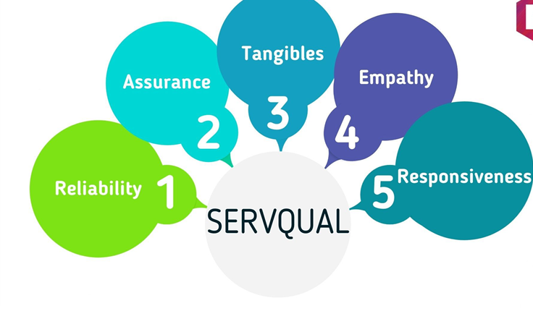
Figure 1: SERVQUAL model
(Source- Priyo et al. 2019)
The most important role of the ‘front desk manager’ in managing hotel administration can be the following-
● Technological savvy- Technology orientation has to be developed among the skills and experiences of the front desk manager to deal with the operational practices of front office management. The front desk manager has to be courteous, and responsible to handle all the phone calls, inbound mail, checking and confirming reservations, and payment transactions with customers. The front desk operation of data entry has been conducted by the artificial technological tool of Machine Learning and software integration to keep storage of data without repetition and proper restoration (Smart et al. 2021). The customer service management and communication development with the department of restaurants, accommodating transportation to the guests has been handled by the front desk manager via virtual communication.
● Financial literacy- The management of reception at the front desk has been coordinated by the front desk receptionist and executives. The front desk manager coordinates among them with financial knowledge of accounts maintenance in the hotel, the transaction record keeping with the customers, and other service development for hotel expenditure. Payroll, night audit, inventory control, and profitability assessment of the hotel have been maintained by the front desk manager.
● Problem-solving and decision-making- Enforcing the hotel policies in the management for staff discipline maintenance, ensuring guest service and customer satisfaction are the significant tasks of a front desk manager. In order to maintain guest service, customer satisfaction, and management among the staff, problem-solving, and firm decision-making ability has to be possessed among front desk managers (Rutherford, 2021). The situational decision about the innovation implementation in room service, and maintenance of customer collaboration training for staff has been handled by the problem-solving and decision-making skills of managers.
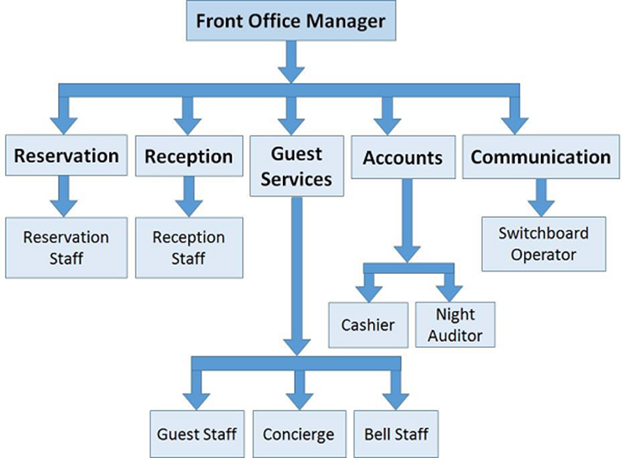
Figure 2: The front desk operation of hotels
(Source- Rutherford, 2021)
● Leadership- Excellent customer service and strong leadership skills are the primary qualities of a front desk manager. The handling of front desk operation, and coordination of receptionists, front desk clerk, and executives has been conducted by the manager with great leadership skills. The motivation giving, and training of the staff to maintain customer relations has been executed by the front desk manager with dynamic leadership skills and multi-tasking ability.
● Interpersonal skill- The interpersonal skill of personal integrity, sympathy, and communication ability with the diversified staff has to be possessed among the frog desk managers in the hotel industry (Alrawadieh et al. 2021) effective communication with diversified staff helps in taking decisions about the facility of training provision for them to equip the clerk or receptionists with phone handling training, customer communication. The front desk receptionists have to be quick in response, and skilled in phone call attending and customer data entry at the hotel front desk to enhance the service quality and performance.
Conclusion
In this assignment, the important roles of the front desk manager, the receptionists, and the staff have been discussed. The skills and experience of a manager and associate staff help to develop business efficiency and customer service in the hotel industry.

Word Count

Component Two:
Contribution to Overall Module Assessment: 25%
In this scenario – It is your first day as a front desk associate and your manager has phoned in sick. Create an action plan and answer the following questions.

Issues | What are you going to do to ensure that the hotel is represented well to guests? | How will operations run smoothly throughout your shift? | Why would you consider your plan being the most effective? | What contingency plan will you put in place to ensure quick resolution of this scenario in the future?
The lack of attendance to the guests | A front desk associate is a person who greets the guest first while entering the hotel (Bardi, 2021). I as a manager develop with the simplest trick of the perfect smile by recognizing the presence of the guest | I would communicate with the front office receptionist, clerk, and attendants to develop proper recognition and attendance to the guests at my shift | Attending the guests with cordial welcome to make them feel comfortable, and homely is according to me the best way of attracting the attention of a front desk associate manager | In future, the training of front desk clerks will have to be properly executed
Customer complaints about service issues | I would discuss with the service providers regarding the service quality delay and not responding to the room service call and ask them to apologies to the guests | During my shift, I would ensure the complete participation and performance of the staff in customer attendance and satisfaction by motivating them to serve their duty well 24/7 | I think the plan of cheering the front desk and service staff up by giving them security | In future, the monitoring and supervising front desk clerk will have to be developed
Lack of communication with the staff regarding the reservation | In case of any communication problem regarding reservation confirmation of the guests from the front desk, I would ensure the spot reserved for the client according to their room preference | During my shift, I would ensure that the operation of front desk management may go smoothly without any interruption and ignorance | The plan I think will be most effective in the service management of front desk operation | In order to avoid this kind of incident in future I would request the HRM of the hotel to arrange skill efficiency training for the staff.
Ignored request for transportation facility | Being an associate front desk manager, I would try to get information about the process for providing guests with transportation assistance | During my shift, I would ensure all the guests about their comfort and hospitality in the hotel from staff and management. | My plan would be most effective to discuss with the management regarding the transportation facility for the guests and provide them with attendance. | In the future, the budget of the operation cost of the hotel will have to be increased to provide transportation facilities to all the guests for brand equity.
Long waiting time while checking in | In order to develop mitigation measures for the guests not to make them wait long at the time of checking in luggage. | In my shift long waiting with luggage at the entry point will not occur again by alarming the staff about their duty well | My plan would be most effective as the tired guests have to be attended to early while their check-in. The collection of ID proof and signs can be in their room in a comfortable manner without waiting. | In the future, more staff will have to be available at the front desk to attain the guests while checking in.

Component Three:
Contribution to Overall Module Assessment: 50% (1000 words +/- 10%)
Writing in essay format - Describe the key elements that are required when considering these four elements of hotel operations:

Element 1 – Property Management Systems (PMS)

The key functions of the property management system (PMS) consist of allowing the property owner to communicate with clients and send professional emails to guests at the time of their stay and post-stay. The PMS has been developed daily in the hotel hospitality and operation management to manage guest reservation, check-in/check-out, housekeeping, guest service quality development at pre and post-stay, pricing, availability, channel connection, and reporting analysis. Keeping the assessment of revenue generation, room inventory is a very important element of PMS in achieving business growth in the hotel and hospitality sector. The hotel property management system conducts and maintains the Control Dashboard, Channel Management, Reservation calendar, and housekeeping management. (Mak and Chang, 2019)
Payment processing of hotel operations, revenue earning, online booking engine (OBE) maintenance, and open API are other key functions of developing PMS in hotels. The hotel managers or owners want to know the most important information about the current competitive strategy of the market and the trend of front management which can be helpful by introducing a friendly and helpful dashboard (Li et al. 2020). The cloud bed PMS dashboards and reservation system have been found most effective to get to know about the room inventory, occupancy, arrivals, and departures of the guests. Developing online visibility to improve two-way interaction in the profit generation process of the Property Management System of hotels is very important. The unlock optimisationThe maintenance of channel reservation, possibilities, availability of the room and optimise occupancy can be seen by the PMS in hotel operations. The cloud bed calendars allow the managers of the front desk to enhance the housekeeping process and direct room reservations from the panel.

Element 2 – Hotel reputation

Hotel Reputation is interrelated with the service quality of hotel staff, front desk performance, and customer satisfaction approach (Bardi, 2021). Hotel reputation in the hospitality industry has to be developed to gain the competitive advantage of brand equity in the market. In the globalised world of business innovation implementation in hotel guest services, operations, and staff management has to be developed to satisfy guests by facilitating proper attendance, 24/7 service, digital cashless transactions, and maintenance of safety and security of digital data of individuals. Hotel Reputation depends on several elements such as location, gastronomy, personnel, and marketing the hotel to the airport or station. On the first day joined of a manager it would assure the guests to give some time for better service.
Location of a hotel at a crowded,business market area or at a distinct place of tourist attractions can enrich the reputation of the brand. For example the location of Hotel Emporium in London attracts the attention of the guests most (Lai, 2019). Hotel online reputation management can be developed by importing the cloud bed reservation optimisation for clients to give them visibility of room availability and easy access is to maintain the service quality, reservation confirmation, and booking for guests in case without any delay to the hotel website. The monitoring, replying and enhancing the property service of the hotels has to be conducted to improve reliability of customer and reputation of the brand. Online reviews play a significant role in building the reputation of hotels. The sending of online automated feedback to customers increases the chance of repeat stay.

Element 3 - Communication

Communication
‘Communication’ is one of the most significant skills of hotel operation management that has to be possessed among managers, staff to gain the attraction of customers. The elements include being respectful, showing empathy and emotion, clarity in the speech, and listening power development are important elements of building effective communication with guests and staff of hotel operation. Arrange staff training, listening to staff regarding any problem faced by them, training employees to attend guests to improve customer satisfaction while stay can be successfully maintained by mindful communication and relationship maintenance with staff. A well-trained and communicative staff can solve any situation in the hotel operation in case of service delivery to guests and problem-solving (Rabiul and Yean, 2021). The development and building relationships with customers at the first impression through effective communication can enhance the reputation of the hotel, and proper guidance to attend to the guests at each and every requirement without delay will be effective for boosting their morale, communicating with them to manage the situation with a welcome smile, and recognition at the front desk. Communication skills of the front desk manager and executive have to be developed to attract the attention of the guests at their first impression and visit. Communication with the staff and the customers has to be developed to maintain the association and relation in collaboration with the strategic management for facilitating service.

Element 4 - Staffing

‘Staffing’ in the hotel industry depends on several elements such as planning the manpower requirement, requirement of new employees, orientation and placement, selection of preferable employees and training development program for the staff. The employee policy development in the hotel industry, performance monitoring and promotion of staff has been maintained by the leaders’ front desk associates on the very first day in the absence of my manager who will try to welcome the guest cordially. The HR management of the hotels develop effective interview strategies to recruit skilled and efficient staff for the organisation. Structured interview with a proper interview sheet can help the interviewer to assess the performance of the interviewees rather than any unstructured or random interview (Miah et al. 2020). Training development for the service staff and front desk executives has to be organised by the hotel brands to make them efficient and more skilled in their job.
On the other hand, on-the-job training makes the problem-solving ability and situation handling process sharper for the staff. Skilled and compassionate staff of hotel brands can enhance the scope of developing reputation and improve brand awareness and loyalty. Staffing in the hotel industry aims to signify the future of the brand in terms of improving customer relations, marketing promotion and service quality improvement for the brand.

Word Count

References
Shin, H., Perdue, R.R. and Kang, J., 2019. Front desk technology innovation in hotels: A managerial perspective. Tourism Management, 74, pp.310-318.
Smart, K., Ma, E., Qu, H. and Ding, L., 2021. COVID-19 impacts, coping strategies, and management reflection: A lodging industry case. International Journal of Hospitality Management, 94, p.102859.
Rutherford, D.G., 2021. Hotel management and operations.
Alrawadieh, Z., Alrawadieh, Z. and Cetin, G., 2021. Digital transformation and revenue management: Evidence from the hotel industry. Tourism Economics, 27(2), pp.328-345.
Priyo, J.S., Mohamad, B. and Adetunji, R.R., 2019. An examination of the effects of service quality and customer satisfaction on customer loyalty in the hotel industry. International Journal of Supply Chain Management, 8(1), pp.653-663.
Bardi, J.A., 2021. Hotel-Front-Office-Management.
Mak, A.H. and Chang, R.C., 2019. The driving and restraining forces for environmental strategy adoption in the hotel industry: A force field analysis approach. Tourism Management, 73, pp.48-60.
Rabiul, M.K. and Yean, T.F., 2021. Leadership styles, motivating language, and work engagement: An empirical investigation of the hotel industry. International Journal of Hospitality Management, 92, p.102712.
Miah, M.M. and Intan Adha Hafit, N., 2020. The Relationship between Selective Staffing, Work Environment and Employee Turnover in the Malaysian Hotel Industry. International Journal of Business and Social Science, 11(12), pp.77-80.
Lai, I.K.W., 2019. Hotel image and reputation on building customer loyalty: An empirical study in Macau. Journal of Hospitality and Tourism Management, 38, pp.111-121.
Li, H., Liu, Y., Tan, C.W. and Hu, F., 2020. Comprehending customer satisfaction with hotels: Data analysis of consumer-generated reviews. International Journal of Contemporary Hospitality Management, 32(5), pp.1713-1735.

