Designing a Race Car Rear Wing: Fluid Flow Assessment
ACMA 6010: Structural & Fluid Analysis
Andrew Burgess (2115107)
2023
Contents
Introduction 2
Reynolds Number and Wing Performance 2
The Boundary Layer and Fluid Flow 5
Construction of the Rear Wing 6
Modelling 8
Experimentation 10
Conclusion 11
References 12

Introduction
The objective of this report is to investigate the aerodynamic properties of a given rear wing used on a race car. As part of this investigation, a number of factors contributing to the wing’s aerodynamic properties are explored.
One of the features examined is Reynold’s number. Reynold’s number impacts the aerodynamics of the rear wing, especially over the length of the wing. This number has been estimated, based on the geometry provided which lead onto the principles of the boundary layer common to any solid within a fluid.
Another factor considered was the construction of the rear wing. At higher speeds, the materials and structure affect the aerodynamic performance of any rear wing. Testing was required to explore these principles. Methods are discussed along with their benefits and drawbacks. This testing would encompass the simulation of the expected conditions as well as physical testing.

Reynolds Number and Wing Performance
Reynolds number is a measure of numerous factors that each have their own impact on the aerodynamic properties of an object’s interaction with a fluid (Al-Shemmeri, 2013). The name of this measure is tributed to Osbourne Reynolds who determined, by experimentation, that the flow of a fluid at a low flow rate produces what is now known as Laminar flow (NASA, 2021a). As shown in Figure 1 the fluid travels in layers of varying velocities whilst in laminar flow.
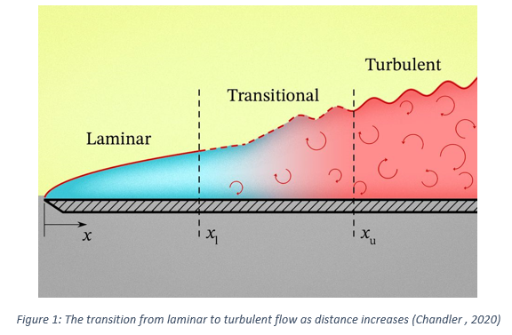
Fluid closest to a surface have zero velocity whilst the farthest fluid has a higher velocity: not being under the influence of adhesion to the surface. Normally, as the flow rate increases, the flow of fluid becomes disorderly to the point where unidirectional flow stops completely (Alexander, 2017). This is known as turbulent flow and the intermediate state between laminar and turbulent flow is known as transitional flow. Transitional flow exhibits traits of both laminar and turbulent flow (Al-Shemmeri, 2013).
The Reynolds number takes into accounts the factors in the equation below.
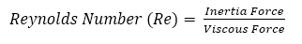
Which can be further expanded to,
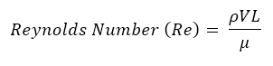
Where,
ρ = Density of the Fluid (kg/m³)
V = Fluid velocity (m/s)
L = The distance travelled over the surface (m)
μ = Dynamic viscosity of the fluid (kg/ms)
Reynolds number is dimensionless as it is a ratio of the Inertia and viscous forces and has no units. According to (Al-Shemmeri, 2013) turbulent, transitional and laminar flow is seen within Figure 2.
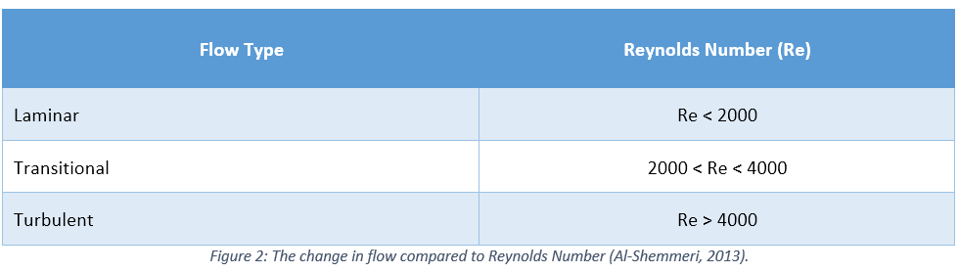
Increasing the dynamic viscosity yields a lower Reynolds number due to the resistance by the fluid when pressure is applied. Similarly, increasing the velocity or the distance travelled produces a higher Reynolds number. Higher fluid velocities increase disruption and increasing the distance travelled over the surface increases disruption due to the adhesion and resulting no-slip condition (Alexander, 2017).
To estimate the Reynolds number of the provided rear wing, the formula above is used. Assuming the worst-case for each attribute to obtain the highest value of Reynolds number and the most turbulent. The cord length of the wing is used (Jones, 1990). Shown in Figure 3, this measured approximately 355mm, or 0.355m, long. Jung & Schindler (2019) found that the average air density at sea level is approximately 1.235kg/m³. The fastest speed set in a Formula One car is 246.9 mph or 110.374 m/s (Duxbury, 2022). The dynamic viscosity of air at 15°C (the same temperature taken for the air density) is approximately 1.802 x 10⁻⁵ kg/ms. This ultimately yields a Reynolds number of 2.6854x10⁶, making it turbulent according to Al-Shemmeri (2023). Given the nature of this data it is unlikely that this value would be reached. Atmospheric conditions like the pressure, temperature and moisture content of the air offset the actual value. Meanwhile, the velocity of the air varies depending on the velocity of the car, wind velocity and its direction.
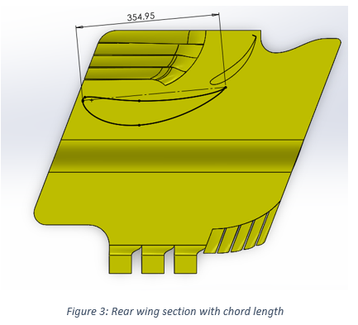
Given the changing environmental conditions that race cars are subjected to, velocity, air density at altitude or differing climate, it is to be expected that the performance changes along with the Reynolds number. A study by Jain, et al. (2015) found that increasing the Reynolds number of the fluid surrounding an aerofoil, the Coefficient of Lift increases due to the high velocities and the subsequent lift that is generated. Additionally, the Drag Coefficient decreases with an increasing Reynolds number, especially beyond the critical point between laminar and turbulent flow (NASA, 2021c). At lower Reynolds numbers, the viscous forces of the air provide the most drag whilst above the critical point the most drag is produced by a difference in air pressure (Jain, et al., 2015). Viscous and inertial forces increase at separate rates with respect to velocity, hence the variation in the drag coefficient (Alexander, 2017).

The Boundary Layer and Fluid Flow
The boundary layer describes the volume of air that surrounds the object (Alexander, 2017). The air within this layer moves at differing velocities depending on its position. Shown in Figure 4, air particles in contact with the wing experience zero velocity relative to the wing’s surface whilst air at the end of the layer moves at 99% of the outer free flow (Ting, 2022). This variation is attributed to the viscous forces at the given speed of the fluid. Having a lower velocity near the surface provides the air in the boundary with layer less momentum. Hence the air separates as the pressure increases again towards the end of the wing (Palanivendhan, et al., 2020). For higher Reynolds numbers, the boundary layer experiences a higher velocity. The higher momentum opposes the increasing pressure over the aerofoil camber. This means separation take place further downstream and results in a smaller wake. A smaller wake means less overall drag and as found by Jain, et al. (2015), produces a higher downforce. For this reason, the aerodynamic performance is important in Formula-one racing.
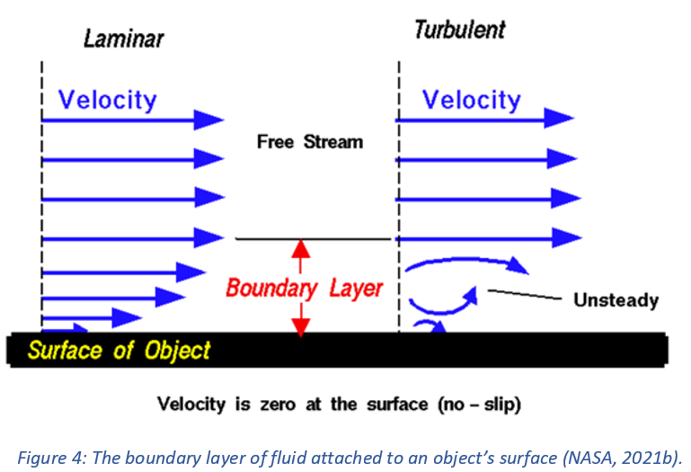
From observing the layout of the given rear wing, a multi element setup can be seen. The intention behind a multi-element wing is to maximise the downforce on the rear axle. The number of elements may vary and those subsequent from the first are often smaller. This allows for a larger angle of attack without generating excessive drag (Katz, 2006). The slot diameter between the aerofoils allows for attached flow to transfer from the trailing edge of the existing wing and over the leading edge of the next and extract even more downforce. The subsequent element has a relatively large camber combined with a higher angle of attack to prevent flow separation (Palanivendhan, et al., 2020). The slot from the previous wing means the flow separation is delayed and produces a greater downforce. The cost of this is additional drag (Massachusetts Institute of Technology, 2014). Recent designs offset this by having an actuated rear element to increase the slot size and reduce the front facing area of the rear wing. Yet this system compromises on control given the lower downforce when deployed (Autosport, 2020).

Construction of the Rear Wing
The first inverted rear wing to be used was on the Chaparral 2C race car (Figure 5) in the 1965 World Manufacture’s Championship. This is much simpler to the wing in question, using a single symmetrical aerofoil with an adjustable angle (Durrer, 2016). As the reliance on downforce and the need for lightweight materials increased, the design of the rear has changed considerably (Autosport, 2020).
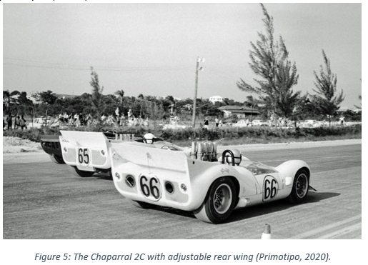
With the specification of carbon fibre reinforced plastic (CFRP) to be used, the impact this has on the performance of the wing must be considered. To understand this, the properties of CFRP must first be understood. CFRP parts are manufactured using strands of graphite. As the raw material, these strands tend to be unidirectional (Katz, 2006). This provides high strength against tensile forces in the direction of the strands but much less perpendicular to the strand direction. The design of the part utilises ply direction or the ply direction is staggered during lay-up to increase strength in multiple axis (Das & Roy, 2018). The provided rear wing is expected to handle about 600kg (Anderson, 2022) of the downforce it generates the exact ply orientation varies by team and the properties of the materials is controlled by the Fédération Internationale de l'Automobile (FIA) (Fédération Internationale de l’Automobile, 2022).
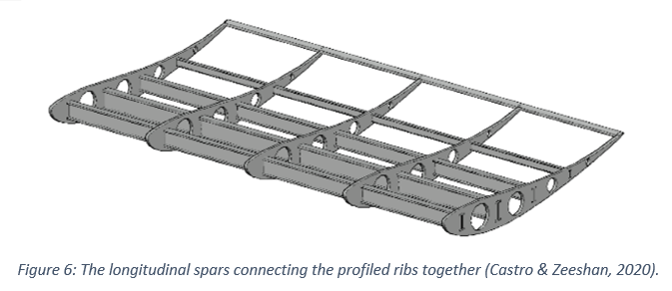
Related to the strength of the rear wing is the stiffness of each element. Shown in Figure 6, the spars connect the skin, ribs and endplates. These are longitudinal pieces connecting the ribs at different positions along the wing. Larger wings have spars positioned around its perimeter whilst others secure the spars at the centre of each rib (Katz, 2006). The shape of the spar is dependent on the desired deflection of the wing. The 2022 Formula one wings use extruded I-sections that minimises deflection due to its shape (Castro & Zeeshan, 2020). The materials used include steel, magnesium, titanium and aluminium alloys. Racing regulations are increasingly stringent to counter deflection in wing elements. At high speeds, purposely designed wing elements can deflect to reduce drag and increase the car’s top speed, giving an unfair advantage (Autosport, 2020). To counter this, it was decided by the FIA to set a minimum wing stiffness. Thus, an extremely stiff material like carbon fibre is suitable for this application. Carbon fibre minimises the weight of the ear wing elements and provides the skin stiffness required to comply within the FIA regulated 2mm at 60N of force and an overall element deflection of 6mm at a maximum of 1000N (Fédération Internationale de l’Automobile, 2022).
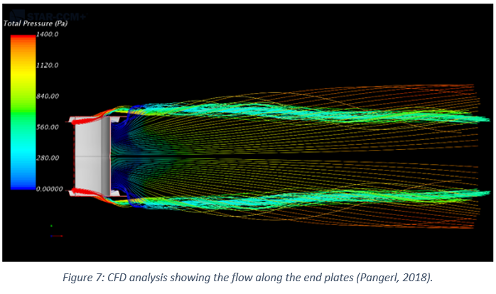
Other feature of the ring wing that contribute to its performance includes endplates, which are designed to prevent air spilling over the sides of the wing and maximise downforce (see Figure 7) (Katz, 2006). As found by (Douglas and Sakurai, 2006) the slots present on the endplates acts as a compromise, allowing some spillage to reduce the pressure at the tip of the wing and reducing the vortex left in its wake. This has the benefit of reducing drag with a slight decrease in downforce (Om Raj, et al., 2020).

Modelling
To ensure that the wing functions as intended, testing is required. It is understood that verifying the outcomes at each stage of a project yields a better result. This allows work to be assessed and refined before further time and investment is made into a solution that falls short of the brief (de Weck, 2016). A general brief of a formula one rear wing would stipulate it must use aerodynamic principles to gain a competitive advantage over competitors. Hence, testing should be focussed on increasing the downforce but minimising the drag (Palanivendhan, et al., 2020). It is in the early stages of development where CFD is most commonly used.
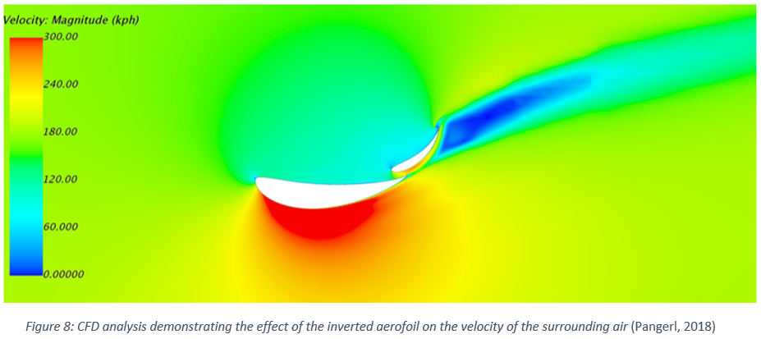
The purpose of CFD is to analyse the effect of a body’s surface on its surrounding fluid medium (Anderson, Jr., 1995). Given the equipment is available to use, it is an inexpensive option when compared to other methods like wind tunnel testing (Chaudhry, et al., 2015). As seen in Figure 8, the downforce can be calculated using the CFD software at any region, without potentially interfering with the results or obtaining results in only a few areas as with physical methods (Anderson, Jr., 1995). However, this is limited by the computing power of the device and any assumptions (for instance wind speed and surface finish) will contribute towards the inherent error in the results, especially when modelling turbulent flow (Om Raj, et al., 2020).
This analysis begins with a CAD model. This should be at the same scale as it would be on the car to avoid error in the Reynolds number and the subsequent simulation results. (Durrer, 2016). If the scale was to change, the chord length would change and result in a different value of the viscous forces on the wing (Al-Shemmeri, 2013). This would yield a different Reynolds number. The CAD model requires simplification to allow the geometry to be analysed in a satisfactory time. Some of the features that may require modification includes ridges between parts and dimples in the surface. These features would normally have a small impact on the overall result in the analysis but would add more time when solving the complex geometry (Andersson, et al., 2011). Normally the model can be edited to determine the correct aerodynamic effect before creating physical prototypes (Tucker, 2016). As seen in Figure 9, the volume of fluid (or domain) to be analysed needs to be determined, being large enough encompass the full effect of the wing on the surrounding fluid including the wake extending relatively far from the rear of most bodies (Parra & Kontis, 2006).
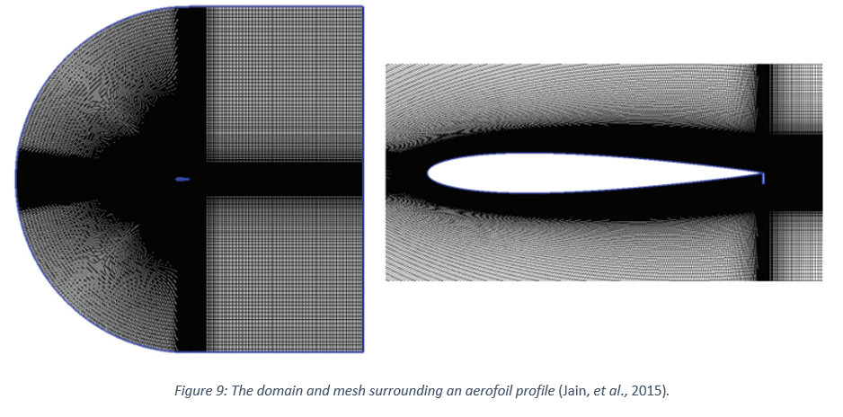
The mesh is intended to subdivide the fluid to solve each section using the solver to be determined later. To reduce the amount of time taken to solve this model, the size mesh should vary according to its locality to the wing (Tucker, 2016). Areas immediately surrounding the wing should have a much smaller mesh size in order to refine the results and reduce the preventable error. The finer mesh should be extended further back to capture the effects of the wake that is left by the wing. Radiating from the wing, the mesh should grow gradually and is normally done automatically by the analysis software. The effect of the wing decreases as the radial distance from the wing increases (Jain, et al., 2015).
Once this is complete, the most suitable physical models need to be applied to the model prior to solving (Andersson, et al., 2011). This includes the physical parameters of the fluid, variation over time and any motion that can affect the performance like cornering or wing deflection. There are limitations to each model and are selected based on prior knowledge and experience. This may be subject to change given the results after analysis (Parra & Kontis, 2006). Some of the most pertinent results are the velocity, pressure, coefficient of lift and coefficient of drag. By analysing the varying pressure over the wing, areas of high and low pressure can be established. This indicates positions of varying lift and drag, showing the separation of flow over the element. This would indicate features to be altered such as the angle of attack and length of the wing camber. The coefficient of lift and drag can be used for comparison to an existing rear wing or a competitor’s design (Jain, et al., 2015).

Experimentation
According to Katz (2006), there are a number of methods that are to test the aerodynamic effectiveness of a particular feature. CFD analysis is used for testing the rear wing design before the physical prototype can be developed. This saves the expense of producing and altering the prototype for consecutive physical tests (Wittwer, et al., 2013). These tests can vary in the results that are obtained and the costs they incur. Yet, both are necessary in effectively testing the rear wing design (Tucker, 2016) and to ensure the results of both methods correlate to each other (Anderson, 2020). CFD is used as verifcation of the design decisions whilst wind tunnel testing is used to verify the CFD results and examine the effects of physical attributes (see Figure 10) such surface irregularities, manufacturing features like lay-up seams, exposed fasteners and deviation within the set tolerances (Andersson, et al., 2011).
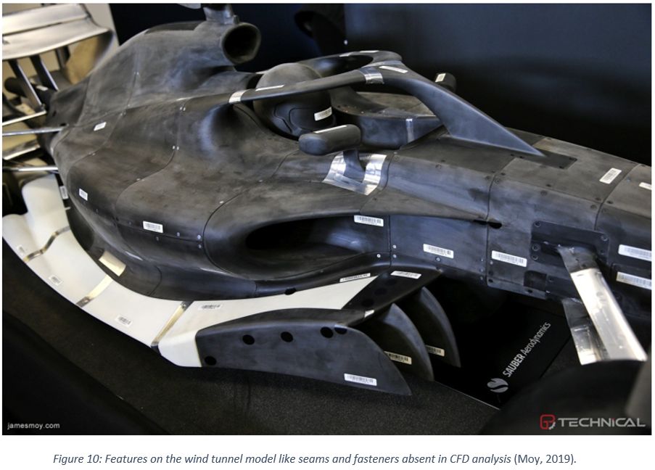
Once a confident result has be obtained using CFD, further development can be completed using the prototype. To simplify the process of selecting a wind tunnel, the model should be manufactured as close to the original scale as possible. This reduces the required velocity to be generated by the wind tunnel (Katz, 2006), providing a wider selection of wind tunnels based on the available velocity. However, the larger the body the larger the disruption in causes in the air around it. This is expressed numerically as the blockage ratio, which considers the cross-sectional area of the front of the body to the cross-sectional area of the wind tunnel aperture (Wittwer, et al., 2013). This should be limited to approximately 5% to prevent the air flow around the body being hampered and offsetting the results (Takedo & Kato, 1992).
For race car applications, a closed jet system is commonly used and, as shown in Figure 11, recirculates the air in a closed loop. Closed jet systems provide a higher degree of precision as airflow remains almost constant. Open jet systems are more susceptible to variations in pressure as air is exchanged constantly and react to the changing external environment (McBeath, 2006). The long ducting associated with closed jet systems means there is a higher degree of wall friction and restriction of flow around corners which leads to a higher air temperature. A higher air temperature reduces its density and offset the values of the collected data (Wittwer, et al., 2013). To simulate the ground effect, a rolling road is used by Formula One teams (McBeath, 2006). As with the case of the Renzo Piano Wind tunnel, the road is simulated with a driven belt synchronized to the wind speed (Ferrari, 2013).
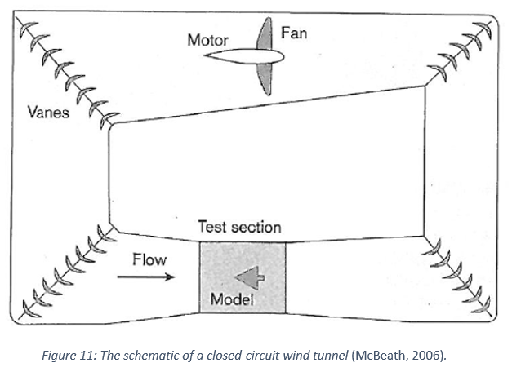
The factors to be collected and calculated depends on the application. In the case of the rear wing, the most prominent features are the downforce and drag the wing generates (Autosport, 2020). To measure the downforce, a force balance is used to measure any changing forces as testing is carried out. Considering surface factors like Reynolds number, a computer linked to the system calculates the downforce and the coefficient of lift (Wittwer, et al., 2013). The drag can be calculated using a number of pressure sensors, or taps, mounted on or just under the surface of the model. Taps placed on the front and rear of the model can measure the pressure difference as well as the low pressure within the wake of the wing. Again, a linked computer calculates the drag and the coefficient of drag (Wordley & Saunders, 2006).
Comparing the CFD results to the wind tunnel results can verify the results gained from the cheaper CFD method. In the case of (Chaudhry, et al., 2015) an error of 6% can be considered satisfactory but acceptance will vary depending on the application (Chaudhry, et al., 2015). If these results do not fall within the expected error, there may be issues with the quality of the mesh or parameters set within the solver (Andersson, et al., 2011).
This is safer than testing on the track immediately as any failure or excessive deflection can only damage the equipment or the prototype (Katz, 2006). Yet this process is expensive due to the energy, labour and maintenance required can cost up to £300,000 for some full-scale tests (Tucker, 2016). Wind tunnels have a larger footprint than that of CFD Analysis. The power unit comprises of a set of fans that generate enough flow to generate the correct velocity required for testing. The contraction chamber reduces the flow area and increases the velocity of the air for testing. The testing chamber itself must be large enough to house the prototype or scale replica without the internal surfaces of the chamber interfering with the outputs of the test. Scaling the model requires proportionally higher wind speeds to account for the difference in area and requires a wind tunnel with more power and subsequently demand a higher price (Wittwer, et al., 2013).

Conclusion
From researching Reynolds number, it was found that the size and velocity of the fluid influenced the performance of the wing. This proved useful when establishing the importance of scale during testing. The effect this had on the flow characteristics around the wing was also explored, which is influenced by the geometry, surface finish and the above conditions. Additionally, CFD and wind tunnel testing was explored, along with their benefits and drawbacks. This found testing should conducted using both CFD and Wind tunnel testing to test a design and verify the results.

References
Alexander, D. E. (2017) ‘Fluid Biomechanics’, Nature's Machines,2017, pp. 51-97.

Al-Shemmeri, T. (2013) Engineering Fluid Mechanics. Telluride: Bookboon.com.

Anderson, Jr., J. D. (1995) Computational Fluid Dynamics-The Basics with Applications. New York: McGraw-Hill.

Anderson, G. (2022) Gary Anderson: How F1 Uses Windtunnels, and How it’ll Change
Available at: https://the-race.com/formula-1/gary-anderson-how-f1-uses-windtunnels-and-how-itll-change/
(Accessed: 29 June 2023).

Anderson, G. (2022) Gary Anderson: What 2022-Style F1 Ground Effect Looks Like
Available at: https://the-race.com/formula-1/gary-anderson-what-2022-style-f1-ground-effect-looks-like/
(Accessed: 01 June 2023).

Andersson, B. et al. (2011) Computational Fluid Dynamics for Engineers. Cambridge: Cambridge University Press.

Autosport (2020) How does a Formula 1 car work? Wings, diffusers and more explained.
Available at: https://www.autosport.com/f1/news/how-does-a-formula-1-car-work-wings-diffusers-and-more-explained-4982275/4982275
(Accessed: 18 June 2023).

Castro, X. and Zeeshan, R. A. (2020) ‘Aerodynamic and Structural Design of a 2022 Formula One Front Wing Assembly’ Fluids, 5(4), pp. 237-260.

Chandler , D. L. (2020) Understanding how fluids heat or cool surfaces.
Available at: https://news.mit.edu/2020/how-fluids-heat-cool-surfaces-0428
(Accessed 17 June 2023).

Chaudhry, H. N., Calautit, J. K., Hughes, B. R. and Sim, L. F. (2015) ‘CFD and Experimental Study on the Effect of Progressive Heating on Fluid Flow inside a Thermal Wind Tunnel’ Computation, 2015(3), pp. 509-527.

Das, S. K. and Roy, S. (2018) ‘Finite Element Analysis of Aircraft Wing Using Carbon Fiber Reinforced Polymer and Glass Fiber Reinforced Polymer’ (from the Proceedings of the 2nd International conference on Advances in Mechanical Engineering, SRM Institute of Science and Technology, Kattankulathur). IOP Conference Series, 402(1), pp. 1-12.

Durrer, S. (2016) Aerodynamics of Race Car Wings: A CFD Study. Masters thesis. Grand Valley State University

Duxbury, A. (2022) How Fast is an F1 Car? Top Speeds of F1, IndyCar, MotoGP and More.
Available at: https://www.autosport.com/f1/news/how-fast-is-an-f1-car-top-speeds-of-f1-indycar-motogp-and-more-4980734/4980734/
(Accessed: 5 June 2023).

Fédération Internationale de l’Automobile (2022) 2023 Formula 1 Technical Regulations. Paris : Fédération Internationale de l’Automobile.

Ferrari (2013) Inside the Ferrari F1 Wind Tunnel [video]
Available at: www.Ferrari.com (Accessed: 19 June 2023).

Jain, S., Sitaram, N. and Krishnaswamy, S. (2015) ‘Effect of Reynolds Number on Aerodynamics of Airfoil with Gurney Flap’ International Journal of Rotating Machinery, Volume 2015, pp. 1-10.

Jones, R. T. (1990) Fundemental Considerations. Princeton: Princeton University Press.

Jung, C. & Schindler, D. (2019) ‘The Role of Air Density in Wind Energy Assessment - A Case Study From Germany’. Energy, 171(1), pp. 385-392.

Katz, J. (2006) Race Car Aerodynamics. 2nd edn. Cambridge: Bentley Publishers.

Massachusetts Institute of Technology (2016) Fundamentals of Systems Engineering
Available at: https://ocw.mit.edu/courses/16-842-fundamentals-of-systems-engineering-fall-2015/5a7dcfe333cbeab4df8d8a34c38b57cc_MIT16_842F15_Ses9_Ver.pdf
(Accessed: 10 June 2023).

McBeath, S. (2006) ‘Tunnel Vision’ Racecar Engineering, 13 August, pp. 42-48.

Massachusetts Institute of Technology (2014) Multi-Element Foils
Available at: http://web.mit.edu/towtank/www/multielementfoils.html
(Accessed: 18 June 2023).

Moy, J. (2019) A model car at a 2021 Regulations Press Conference. [Online]
Available at: http://jamesmoy.com/preview.aspx?gallery=main&search=model&index=13&count=105
(Accessed: 25 June 2023).

NASA (2021b) Boundary Layer
Available at: https://www.grc.nasa.gov/www/k-12/BGP/boundlay.html
(Accessed: 18 June 2023).
NASA (2021a) Reynolds Number
Available at: https://www.grc.nasa.gov/www/k-12/airplane/reynolds.html
(Accessed: 17 June 2023).

NASA (2021c) The Drag Coefficient
Available at: https://www.grc.nasa.gov/www/k-12/rocket/dragco.html
(Accessed: 5 June 2023).

Om Raj, R. R., Prakash, N. and Naggari, T. (2020) ‘Design and CFD Analysis of a Rear Wing of a Motorsport Car’ International Journal of Vehicle Structures and Systems, 12(1), pp. 234-240.

Palanivendhan, M., Vengatesan, S., Dutta, S. and Jain, S. (2020) ‘Design and Development of Multi Element Wing for Automobile Application’, Institute of Science and Technology, Kattankulathur, Bristol: IOP Publishing.

Pangerl, J. (2018) F1 Rear Wing CFD Study
Available at: https://grabcad.com/library/f1-rear-wing-cfd-study-1
(Accessed: 2 June 2023).

Parra, F. L. and Kontis, K. (2006) ‘Aerodynamic effectiveness of the flow of exhaust gases in a generic formula one car configuration’, The Aeronautical Journal, 110(1111), pp. 573-587.

Primotipo (2020) Chaparral 2C
Available at: https://primotipo.com/tag/chaparral-2c-chev/
(Accessed: 25 June 2023).

Takedo, K. and Kato, M. (1992) ‘Wind tunnel blockage effects on drag coefficient and wind-induced’, Journal of Wind Engineering and Industrial Aerodynamics, 42(1-3), pp. 897-908.

Ting, D. (2022) ‘Moving Fluids’, Thermofluids From Nature to Engineering. Cambridge: Academic Press, pp. 33-50.

Tucker, P. G. (2016) Advanced Computational Fluid and Aerodynamics. Cambridge: Cambridge University Press.

Wittwer, A. R., Welter, G. S. and Loredo-Souza, A. M. (2013) Wind Tunnel Designs and Their Diverse Engineering Applications. London: IntechOpen.

Wordley, S. and Saunders, J. (2006) ‘Aerodynamics for Formula SAE: A Numerical, Wind Tunnel and On-Track Study’, Journal of Passenger Car: Mechanical Systems Journal, 115(2006), pp. 744-756.

