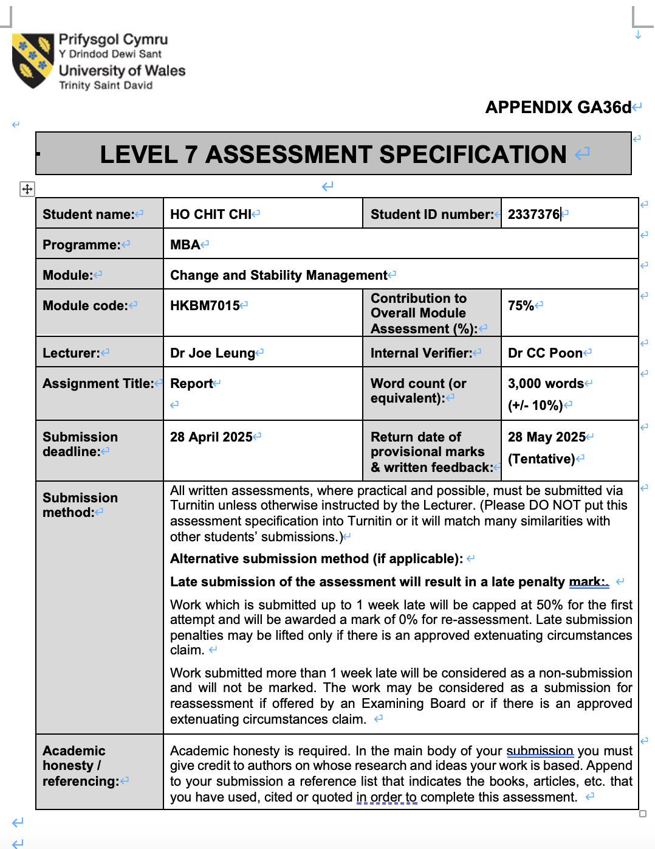

Table of Contents
- Introduction P.3
- Company Background P.4
- Overview of Tsui Wah’s economic performance P.4
- Factors that affect Tsui Wah’s performance
4.1 Economic and market challenges P.5
4.2 Consumer Behaviour and Brand Relevance P.5
- Force Field Analysis for the organizational change P.6-8
- Applying a change model/ approach P.8-10
- The Style of Leadership in organizational change P.10-11
- Managing resistance to change P.11-13
- Conclusion and Recommendations P.13-14
- Reference List P.15-17

1. Introduction
Tsui Wah Group, a prominent Hong Kong-based food and beverage (F&B) conglomerate, faces significant challenges amid evolving market dynamics, including declining local consumption, rising operational costs, and shifting consumer preferences toward cross-border spending. This report critically assesses the organization’s challenges, applies Kurt Lewin’s Force Field Analysis to evaluate change dynamics, critiques the suitability of the chosen change model, examines leadership’s role in balancing stability and innovation, and provides recommendations grounded in change management literature.

2. Company Background
Tsui Wah Group is a prominent Hong Kong-based food and beverage (F&B). It was founded in 1967 as a small ice parlor in MongKok. Tsui Wah has grown into Hong Kong’s leading chain restaurant group. They made Hong Kong style diner to be listed on the Hong Kong Stock Exchange main board (stock code: 1314). The group has 6 sub-brands with over 70 stores across Hong Kong, Macau, Mainland China and Singapore. Their brands separately specializing in Hong Kong comfort food, western style food, shanghai-style food and Japanese dishes. Tsui Wah Group vision and mission is to share Hong Kong’s exceptional dining culture to the world and to pass on Hong Kong’s quality dining heritage to new generations (Tsui Wah Group, 2024) .

3. Overview of Tsui Wah’s economic performance
(in HK$’000) | 2024 | 2023 | 2022 | 2021 | 2020
Revenue | 954,128 | 845,797 | 993,324 | 956,382 | 1,381,479
Profit  (After Tax) | 32,970 | 55,880 | (124,049) | (126,094) | (319,724)
Total Assets | 890,324 | 1,039,619 | 1,267,918 | 1,552,238 | 1,637,712
Total Liabilities | (405,010) | (505,459) | (760,797) | (935,630) | (934,660)

According to the annual report of Tsui Wah Group, group’s revenue dropped from 2020’s 1381 million HK dollars to 2024’s 954 million HK dollars, but its profit increases from -319 million HK dollars to +32 million HK dollars. However, the profit is too low being a listed company, chain store, and food industry lead. As mentioned in the company background, Chui Wah Group has 74 stores worldwide. Taking Year 2024 as example, the group has +32 million profit in the financial year, which only HKD36,036 profit per store each month.

4. Factors that affect Tsui Wah’s performance
4.1 Economic and market challenges
COVID-19 heavily affected the food industry including Tsui Wah Group. Citizens are not allowed to eat their meal in the restaurants and only takeaways allowed, which decreases the groups revenue while the operating cost still existed. Other than local citizens, foreigners could not eat in Tsui Wah Group during the pandemic due to closed borders, which affected some store’s revenue relying on foreigners. Furthermore, operation cost start continuing increase after post-pandemic period, this cuts the profit that the group could earn.

4.2 Consumer Behaviour and Brand Relevance
To extend that COVID-19 shifts customer’s behaviour habits from sit-in dining to take-away or food delivery. Also, some citizens decided to eat in Mainland China since the cost is cheaper than Hong Kong. This cause the decrease number of diners and revenue. Furthermore, due to the lack of brand visibility as a Hong Kong Brand, there are not that much tourists visit Tsui Wah Group. Additionally, Tsui Wah must face pressures from competitors.

5. Force Field Analysis for the organizational change

Score | Driving Forces | Increase number of Hong Kong food sub brands stores and brand building | Restraining Forces | Score
4 | Low profitability |  | High Cost to arrange new stores | 4
3 | Economic change and competition |  | Local Low consumption power | 3
3 | Customer behaviour change |  | Cost increase affected by global economy and tariffs | 3
2 | Tourist want Hong Kong food
Total: 12 |  |  |  | Total: 10

Tsui Wah Group’s current operational and financial landscape necessitates strategic organizational change to address decreasing profitability and shifting market dynamics. A force field analysis reveals critical driving and restraining forces affecting the feasibility of this move. The driving forces-low profitability, economic volatility, evolving customer behavior, and tourist demand for Hong Kong cuisine underscore the need for change. Conversely, restraining forces such as high expansion costs, weak local consumption, and global economic pressures complicate implementation. Balancing these forces is essential to determine the viability of proposed reforms and make actionable strategies.

Driving Forces
Low profitability (Score 4) remains the most important for change. With monthly per-store profits averaging HKD 36,036, as reported in the 2024 Annual Report, Tsui Wah’s earnings lag behind as a listed F&B company. This reflects systemic inefficiencies, including underperforming non-core sub-brands like Japanese-themed Nijuuichi Don and Homurice, which dilute brand identity and divert resources from the core Hong Kong-style dining concept.
Economic changes and competition (Score 3) further show the need for restructuring. Hong Kong’s F&B sector faces a 2.1% year-on-year decline in restaurant receipts (Q2 2024), driven by locals favoring cheaper mainland Chinese dining options and cross-border spending. At the same time, rising operational costs-rent, labor, and imported ingredients-squeeze margins, as noted in JLL’s analysis of Hong Kong’s “high-cost, high-competition” environment. Tsui Wah’s reliance on traditional dine-in models clashes with consumer preferences for affordable, convenient alternatives, such as delivery or grab-and-go services (JLL, 2024).
Customer behavior shifts (Score 3) compound these challenges. Post-pandemic frugality and a surge in “northbound consumption” (locals dining in Shenzhen) have reduced footfall, while younger demographics prioritize experiential dining over legacy brands. However, tourist demand for authentic Hong Kong cuisine (Score 2) presents a latent opportunity. Despite weaker local spending, Hong Kong’s cultural appeal to international visitors-evident in the 2023 World Brand Award-positions Tsui Wah to leverage its heritage as a unique selling point in tourist-heavy areas.

Restraining Forces
High costs for new store arrangements (Score 4) pose a significant barrier. Hong Kong’s extreme rental prices and limited retail space inflate capital expenditure, while global expansion into markets like Singapore requires navigating complex regulations and cultural preferences. The Group’s 74 global stores already face operational fragmentation, with sub-brands confusing consumers and eroding its revenue.
Low local consumption power (Score 3) increases revenue challenges. Stagnant wage growth and inflationary pressures have destroyed discretionary spending, with restaurant receipt volumes dropping 4.6% year-on-year in Q2 2024. This trend is unlikely to reverse amid Hong Kong’s sluggish economic recovery, forcing Tsui Wah to explore alternative revenue streams, such as campus dining partnerships or premium takeaway services.
Global cost increases (Score 3), including tariffs on imported ingredients and supply chain disruptions, further strain profitability. For instance, rising global food prices-compounded by geopolitical tensions-have elevated input costs by 15–20% since 2023, per industry reports.

Strategic Implications
The cumulative driving forces (total score: 12) marginally outweigh restraining forces (total score: 10), indicating that change is feasible but requires targeted interventions. To tip the balance, Tsui Wah must prioritize its core Hong Kong identity by phasing out non-core sub-brands and reinvesting in menu innovation (e.g., modernizing classic dishes or introducing plant-based options). Cost optimization through digitalization-enhancing delivery platforms and AI-driven inventory management-could mitigate operational expenses. At the same time, doubling down on tourist-centric marketing would capitalize on unmet demand for authentic experiences. While restraining forces like global economic uncertainty are largely external, proactive risk management-such as diversifying suppliers-could buffer volatility. By aligning its strategy with these insights, Tsui Wah can transform challenges into catalysts for sustainable growth.

6. Applying a change model/ approach

Lewin’s Change Model offers a clear and practical framework for Tsui Wah Group to manage its organizational transformation amid the pressing challenges of low profitability, shifting consumer behaviors, and rising operational costs. The model’s three stages-Unfreeze, Change, and Refreeze-provide a structured approach to remove the status quo, implementing new practices, and embedding these changes into the company culture, ensuring sustainable success (Whatfix, 2025; Prosci, 2025). The initial Unfreeze stage is critical for Tsui Wah, as it involves creating awareness and readiness for change across all levels of the organization. Given the Group’s modest profit per store (HKD 36,036 monthly) and the external pressures from economic shifts and competition, leadership must communicate these realities transparently to build a compelling case for change (Tsui Wah Group, 2024). This stage requires addressing employee concerns honestly, removing complacency, and fostering a sense of urgency akin to Kotter’s model, which is essential to overcome inertia and resistance (Whatfix, 2025). For Tsui Wah, this could involve sharing detailed financial data, market trends, and customer insights that highlight the risks of maintaining the current course, such as the decline in local restaurant receipts by 2.1% year-on-year and the rise of mainland competitors offering lower-priced alternatives (Census and Statistics Department, 2025; South China Morning Post, 2024). Engaging stakeholders through workshops and open forums can facilitate buy-in and collective ownership of the change vision.

The Change phase is where Tsui Wah implements its strategic realignment, focusing on core Hong Kong cuisine and streamlining its brand portfolio by phasing out non-core sub-brands like Japanese and Western concepts that dilute brand identity (Tsui Wah Group, 2024). This stage demands agility and continuous communication to manage uncertainty and resistance. Providing comprehensive training on new menu offerings, operational efficiencies, and customer engagement techniques will empower employees to adapt effectively (Deliveroo, 2025). Moreover, leadership should encourage feedback loops and celebrate quick wins, such as improved customer satisfaction scores or cost reductions, to maintain momentum and morale (Whatfix, 2025). Given the high operational costs in Hong Kong, including steep rents and inflationary pressures, Tsui Wah must also innovate in delivery services and digital ordering platforms to meet evolving consumer preferences and increase revenue streams (JLL, 2024; Census and Statistics Department, 2025). The Change stage is not merely about process adjustments but also about transforming mindsets and behaviors, which requires consistent reinforcement and support.

Finally, the Refreeze stage ensures that the new ways of working become embedded in Tsui Wah’s organizational culture, preventing regression to old habits. This involves institutionalizing new policies, updating performance metrics, and recognizing employees who champion the change (Prosci, 2025; Whatfix, 2025). For Tsui Wah, reinforcing the renewed focus on authentic Hong Kong cuisine through branding, marketing, and customer experience standards will solidify its market position. Regular feedback collection and ongoing training will help sustain improvements and adapt to future market dynamics (Annals of Human and Social Sciences, 2022). The Refreeze phase is crucial to maintaining long-term benefits and building resilience in a volatile hospitality sector where consumer tastes and economic conditions frequently fluctuate (South China Morning Post, 2024). By following Lewin’s model, Tsui Wah can systematically dismantle barriers, implement strategic changes, and embed a culture of continuous improvement, positioning itself for sustainable growth in a competitive market.

7. The Style of Leadership in organizational change
Kurt Lewin’s leadership styles-autocratic, democratic, and laissez-faire-offer a useful framework to analyze Tsui Wah Group’s current leadership approach and recommend a more effective style for its organizational change.

Currently, Tsui Wah Group appears to adopt a predominantly autocratic leadership style, driven by the urgent need to address low profitability-only HKD 36,036 per store per month as reported in the 2024 Annual Report-and operational challenges such as rising costs and intense competition (Tsui Wah Group, 2024). The Group’s recent decisions to close underperforming stores and phase out non-core sub-brands like Japanese and Western concepts reflect top-down directives aimed at refocusing on core Hong Kong cuisine. This autocratic approach allows swift strategic realignment but risks alienating employees and killing innovation, which are crucial in the fast-evolving foodservice sector where consumer preferences increasingly favor convenience and experiential dining (Deliveroo, 2025; South China Morning Post, 2024).

To successfully implement its organizational change, Tsui Wah should transition toward a democratic leadership style. This approach would actively engage employees across all levels, encouraging their input on menu innovation, customer service, and operational improvements. Such participation fosters ownership, reduces resistance, and promotes creative problem-solving-essential for revitalizing the brand and adapting to market shifts (Annals of Human and Social Sciences, 2022). For example, involving staff in workshops during Lewin’s “Unfreeze” and “Change” stages can surface practical insights and build commitment (Whatfix, 2025). Democratic leadership also balances the need for cost control with enhancing customer experience, as employee feedback can improve service quality and operational agility.

While laissez-faire leadership offers autonomy, it is less suitable for Tsui Wah’s current context, which requires coordinated focus and consistent brand messaging to overcome market pressures and operational fragmentation (Tsui Wah Group, 2024). Therefore, shifting from autocratic to democratic leadership will better support Tsui Wah’s change efforts by fostering collaboration, boosting morale, and driving sustainable innovation, ultimately strengthening its competitive position in Hong Kong’s challenging restaurant industry (JLL, 2024; Census and Statistics Department, 2025).

8. Managing resistance to change
Managing resistance to change is a critical challenge that Tsui Wah Group must address effectively to ensure successful organizational transformation amid its current market pressures and operational shifts. Resistance usually came from employees’ uncertainty, fear of personal impact, and lack of awareness about the reasons behind change, which can manifest as passive disengagement or active opposition (Prosci, 2021). To manage this resistance proactively, Tsui Wah’s leadership should adopt a comprehensive change management approach grounded in empathy, communication, and participation. According to Prosci’s research, the most effective way to handle resistance is to prevent it through early planning, stakeholder engagement, and transparent communication rather than reacting to resistance after it arises (Prosci, 2021). For Tsui Wah, this means conducting assessments and involving employees from the outset to build awareness of the Group’s low profitability challenges-HKD 36,036 profit per store per month-and the external economic and competitive pressures documented in its 2024 Annual Report (Tsui Wah Group, 2024). Honest communication about why change is necessary, what it entails, and how it benefits both the company and employees can reduce uncertainty and build trust. Senior leaders should deliver the strategic rationale, while frontline managers communicate the personal and operational impacts, ensuring messages resonate at all levels (Prosci, 2021).

Engaging employees in the change process is equally important. Participation fosters ownership and reduces feelings of exclusion, which are common sources of resistance (Primeast, 2024). Tsui Wah can implement feedback sessions and pilot programs that invite input on menu innovation, service improvements, and operational adjustments aligned with the Group’s renewed focus on authentic Hong Kong cuisine. This inclusive approach not only surfaces practical insights but also strengthens commitment by making employees active contributors rather than passive recipients of change (Annals of Human and Social Sciences, 2022). Moreover, leadership must form team of support, with sponsors at the executive level visibly promoting the change and middle managers reinforcing it daily, as employees prefer hearing about change from their direct supervisors (Prosci, 2021).

Addressing the root causes of resistance requires empathy and support. Resistance often appears from fear of job loss, skill gaps, or altered roles, so providing training, resources, and reassurance is essential to help employees navigate the transition (Prosci, 2021). Two-way dialogue enables leaders to understand concerns and adjust strategies accordingly, fostering a culture of openness and adaptability (Whatfix, 2025). Resistance is dynamic and can evolve, so Tsui Wah’s leadership must remain flexible, continuously monitoring feedback and modifying tactics to meet diverse employee needs. Demonstrating quick wins-such as improved customer satisfaction or cost savings-can also motivate staff and validate the benefits of change (Jointhecollective, 2024).

To conclude, managing resistance at Tsui Wah requires a holistic, proactive approach that requires early planning, transparent communication, inclusive participation, empathetic support, and ongoing reinforcement. By transforming resistance into engagement, Tsui Wah can smooth its change journey, strengthen employee morale, and enhance its ability to adapt and thrive in Hong Kong’s competitive and evolving restaurant industry.

9. Conclusion and Recommendation
Tsui Wah Group faces significant challenges that require urgent and strategic responses to secure its future growth and competitiveness. The key problems identified include persistently low profitability, with an average monthly profit of just HKD 36,036 per store, intense competition from lower-priced mainland restaurants, rising operational costs such as rent and labor, and shifting consumer behaviors that favor convenience and diversified dining experiences (Tsui Wah Group, 2024; Census and Statistics Department, 2025). Additionally, the Group’s current brand dilution through multiple sub-brands offering Japanese and Western cuisines has weakened its core identity as a player of authentic Hong Kong-style food, which remains a unique selling point and a source of tourist demand (Tsui Wah Group, 2024; Deliveroo, 2025). These issues are compounded by the broader economic environment in Hong Kong, where local consumption power remains subdued and rental costs, although showing some signs of easing, continue to exert pressure on margins (JLL, 2024; South China Morning Post, 2024).

To address these challenges, Tsui Wah should concentrate on consolidating its brand by focusing exclusively on authentic Hong Kong cuisine, thereby strengthening its market positioning and simplifying marketing efforts. Phasing out non-core sub-brands will reduce operational complexity and enhance brand clarity, which is critical in a competitive market increasingly driven by consumer preference for real and differentiated dining experiences (Tsui Wah Group, 2024; Annals of Human and Social Sciences, 2022). The Group should also accelerate its expansion in the Southeast Asia, leveraging its heritage and international awards to capture growing demand for Hong Kong-style food abroad (Tsui Wah Group, 2024). Domestically, enhancing digital platforms and takeaway services will align with evolving consumer behaviors favoring convenience and contactless dining, supported by the rising importance of food delivery channels highlighted in recent industry surveys (Deliveroo, 2025; QSR Media, 2025).

Moreover, Tsui Wah must continue strict cost management, focusing on controlling rent, labor, and supply chain expenses while investing in staff training and engagement to improve service quality and operational efficiency (Tsui Wah Group, 2024; ESG Report, 2024). The Group’s commitment to sustainability and governance, as detailed in its ESG reports, should be integrated into its strategic initiatives to enhance brand reputation and meet stakeholder expectations in an increasingly socially conscious market (Tsui Wah Holdings Limited, 2024). By adopting a focused, customer-centric, and innovation-driven strategy, Tsui Wah can overcome current headwinds, restore profitability, and secure sustainable growth in both local and international markets.

10. Reference List:

Annals of Human and Social Sciences. (2022). Transforming resistance into resilience: Exploring the influence of change management on employee engagement in Hyderabad’s restaurant industry through the Kurt Lewin model. Annals of Human and Social Sciences, 3(2), 704–717. https://doi.org/10.35484/ahss.2022(3-II)67

Chew, M. M., Cheng, J. S. L., & Petrovic-Lazarevic, S. (2006). Managers’ role in implementing organizational change: Case of the restaurant industry in Melbourne. Journal of Global Business and Technology, 2(1), 58-64.

Census and Statistics Department. (2025). Report on Quarterly Survey of Restaurant Receipts and Purchases [Data set]. Hong Kong SAR Government.

Colife Hong Kong. (2024). Rental Price Increases in 2025 to Exceed 2024 Levels. Available at: https://colife.hk/news/rental-price-increases-2025

Deliveroo. (2025). Hong Kong Restaurant Confidence Index Rises to 6 in Q4 2024. Available at: https://deliveroo.hk/en-HK/restaurant-confidence-index

JLL. (2024). Hong Kong Real Estate Market Faces Continued Challenges in 2025. Available at: https://www.jll.com.hk/en/trends-and-insights/research/hong-kong-real-estate-market-2025

Jointhecollective. (2024). 10 Effective Strategies for Managing Resistance to Change. Available at: https://www.jointhecollective.com/article/navigating-resistance--10-techniques-for-addressing-pushback-to-change/

Kurt, H. (2024). Change management in the restaurant industry. LinkedIn. Available at: https://www.linkedin.com/pulse/change-management-restaurant-industry-h-kurt/

Marvin, C. (2023). Adapt and thrive: A guide for restaurant owners in change management. LinkedIn. Available at: https://www.linkedin.com/pulse/adapt-thrive-guide-restaurant-owners-change-management-christopher-marvin/

Nory.ai. (2024). Managing change management in the hospitality industry. Available at: https://nory.ai/blog/managing-change-in-hospitality

Primeast. (2024). 7 Strategies for Overcoming Resistance to Change in the Workplace. Available at: https://primeast.com/insights/7-strategies-for-overcoming-resistance-to-change-in-the-workplace-2/

Prosci. (2021). The Complete Guide Managing Resistance to Change. Available at: https://www.prosci.com/managing-change-resistance

QSR Media. (2025). Hong Kong restaurant show growing optimism for 2025-survey. Available at: https://www.qsrmedia.com/asia/hong-kong-restaurant-show-growing-optimism-2025-survey

Rating and Valuation Department. (2025). Rates and Government Rent Calculator. Hong Kong SAR Government. Available at: https://www.rvd.gov.hk/en/business/rgc.htm

ResearchAndMarkets. (2025). Hong Kong Foodservice Market Report 2025. Available at: https://www.researchandmarkets.com/reports/foodservice-hong-kong-2025

South China Morning Post. (2024). Hong Kong restaurants hit rocky road in 2024, but analysts optimistic. Available at: https://www.scmp.com/lifestyle/food-drink/article/3151234/hong-kong-restaurants-hit-rocky-road-2024-analysts-optimistic

S&P Global. (2025). Hong Kong Landlords Should Brace for Slashed Retail Rents in 2025. Available at: https://www.spglobal.com/marketintelligence/en/news-insights/latest-news-headlines/hong-kong-landlords-should-brace-for-slashed-retail-rents-in-2025-68348218

Tsui Wah Group. (2024). Annual Report 2024. Available at: https://www.tsuiwah.com/images/report/eng_report/annual/2024_annual.pdf

Tsui Wah Holdings Limited. (2024). Environmental, Social and Governance Report 2024. Available at: https://www.tsuiwah.com/images/report/eng_report/esg/2024_esg.pdf

Whatfix. (2025). Lewin's 3-Stage Model of Change Theory: Overview. Available at: https://whatfix.com/blog/lewins-change-model/

Zendesk. (2024). Top 10 Change Management Models: A Comparison Guide. Available at: https://www.zendesk.hk/blog/change-management-models/

