
Strategic Management and Sustainability
Europe’s leading manufacturer of Sportswear

November 26, 2018

Raheleh Haji-Ghazitehrani P138823

Table of Contents
List of figures 2
Executive summary 3
Competitive Strategy of Adidas 4
Porters Generic Strategies 4
Strategy 1: Cost Leadership 5
Strategy 2: Differentiation 5
Impacts of Focus Strategy 5
Current Market Position 6
Advantages and Limitations of Strategy in the Current Environment 7
Limitations 12
Conclusion 13
Recommendations 14
References 15

List of figures

FIGURE 1 – Advantages and Limitations of Strategy in the Current Environment………………………………..9
FIGURE 2 – Global Operations……………………………………………………………………………………………………………10
FIGURE 3 - Adidas Sport Performance miCOACH Fit Smart watch/Reebok Cardio Ultra studio shoe…..11
FIGURE 4 – Adidas Group strategic pillars……………………………………………………………………………………………12

Executive summary

The aim of this report is to present the competitive advantage of Adidas’ in different regions of the world. Adidas is the 2nd leading sports retailers known for clothing and sports hardware. In this report, Adidas’ has used the discriminatory strategy by using various indicators in the competitive position of Adidas on target customers and market on the market and customers. This report also examines the strengths and weaknesses of Adidas. Based on these properties that conclusions and shortcomings, the Adidas proposal is presented.

Introduction
Adidas is one of the world's leading companies specialising in the production of high-quality sports and sporting goods. The company has its headquarters in Germany and has excellent brands to introduce its products. The company operates in Europe, North America and Asia. Adidas employs around 39,000 people worldwide. The company has over 150 branches in Europe, the United States and Asia, and it emphasises production. Adidas focuses on sports and footwear brands, clothing and accessories (Wilk and Arnold, 2016, p.6). Adidas, brand image running, football, basketball, tennis and so on. It is very popular among sports departments that are introduced in sports. Reebok mainly focuses on sports, fitness and casual shoes, clothing related styles and products and equipment. The company produces a wide range of high-quality sneakers and eventually became the premier sports shoe supplier for all the world's most famous events in the 1960s. In the late 1960s, Adidas was firmly in the top spot in the sports shoe industry. However, in the 1970s, Adidas did not realise that the civilian movement had become a trend or focused on professional sports shoes.

Competitive Strategy of Adidas

Porters Generic Strategies
Porter pointed out that companies have three basic strategic choices: “cost leadership strategy”, “differentiation strategy” and “target concentration strategy”. He believes that enterprises must make strategic choices in order to obtain a relative competitive advantage; if a company fails to select a strategy explicitly, it will be in a dilemma (Turner et al., 2015, p.127).

Strategy 1: Cost Leadership
The cost leadership strategy refers to: "Based on the maximum experience value accumulated in the industry, the cost control is lower than the opponent's strategy. To achieve cost leadership, the specific approach is usually achieved by large-scale operations. As for the scale of expression, it is people have me strong. In the "strong" here, the primary pursuit is not high quality, but low price. Therefore, in the fierce market competition, companies with low-cost status will receive higher returns than the average level of the industry (Tomczak et al., 2018, p. 49).

Strategy 2: Differentiation
The purpose of the discrimination strategy is to use factors other than cost so that customers feel different. Companies that raise prices use different design changes in route design and additional cost, but most customers are willing to pay more "differences" than competitors. The company's high price and the sign of discrimination are "people do not feel me". It is different from all companies using discriminatory strategies make another price and price. The first consideration is whether they are not normal. This "non-traditional" one could be his design and branding design or patented technology, which is very confident about the appearance of customers or the production of a unique product (Taylor et al., 2015).

Impacts of Focus Strategy
When implementing a focus strategy, Adidas can focus on different parts of the sport as companies can use the infrastructure. This strategy has a particularly negative impact because it is time for companies to focus on different segments and customers in the market. Ultimately, due to low efficiency, companies can ignore new focus areas, companies will lose a lot of money, time and more importantly, profits may be lower, and costs will increase. Adidas uses various marketing strategies to become market leaders, but the main threat of this strategy is that Nike and other competitors can easily copy it. The Adidas traditions will be supported by various sporting events such as the Olympic Games, the FIFA World Cup and various European games. Adidas is the sponsor of the Beijing Olympics. Adidas is also used to sponsor various football teams in Germany because of the company's origin in Germany (Stevens and Johnson, 2016, p.19).
Adidas acquired Reebok, aiming to be the market leader, managed to increase its market share in 2005. The main strategy behind Reebok is about sports and clothes that use ordinary life. Reebok held 9.6% of its shares as well as the US market with a market share of 9.6% at the time of purchase. By buying Reebok, Adidas had more celebrities such as brand ambassadors such as Yao Ming, Shakira (singer) and Christina Ricci (actor). After buying Reebok, Adidas was used to develop a common strategy to defeat the market leader Nike for Reebok and Adidas. In response to Nike's strategy of developing a strategic partnership with Apple, Adidas has signed a contract with Samsung to create an ad campaign via phone (Santos et al., 2017). In this strategic partnership, both companies developed mobile phones for use with shoes during training. The main function of this phone is to use it to alert and guide players during training. Adidas initially started with the American and German markets, but now focused on other parts of the world, such as Beijing's Olympic sponsors. During this event, Adidas used the largest Adidas store in Beijing during the Olympic Games. Now they are focusing more on United Kingdom; they have increased the number of stores in UK to 6300 in 2010 (Saeidi et al., 2015, p.341).

Current Market Position
There is no doubt that Adidas is currently the biggest headache for Nike. According to Naidoo and Gasparatos, (2018), an analyst at Garnier Bryan Investment Bank, Adidas is gradually replacing Nike's market share. In 2016, Adidas collaborated with fashion designer Stella McCartney, what's better than Stan Smith's marketing is that it is a more colour-matching colour added to NMD. Adidas abandoned the mainstream colour scheme of black and white grey, infused with more vivid colours, and launched a global limited edition, even if the stars cannot buy, the hunger marketing will be in full swing. In order to attract more young consumers, Adidas also adjusted the sponsorship of the team, ending the 11-year NBA sponsorship agreement last year, and began sponsoring young athletes such as NBA star James Harden and European football star Paul Pogba. Herbert Hainer distributes most of Adidas' marketing spending to six of the world's trendies including New York, Los Angeles, London, Paris, Tokyo and Shanghai, and is a star-studded NMD campaign and social media communication.

Advantages and Limitations of Strategy in the Current Environment
Adidas strategies of completive advantage are evaluated critically based on the data, reports and research, adopted by Adidas to gain completive advantage or which can be applied to gain a competitive advantage to increase their sales and differentiation. Adidas group is on the second number in producing accessories, apparel and sports footwear. For over 80 years, the company has been operating in the market, and it has a tradition to provide its customers innovative, customer’s high quality and technically goof products. All over the world, Adidas products are available, and athletes love Adidas products. Adidas, they follow a simple competitive strategy to sustain in the market, for example, they would increase the features and strengthens of a product in order to improve their differentiation in order to earn profits and revenues (Merlo et al., 2018, p.73).
Adidas main competitor present in the market is Nike as it has almost 33% of the market share. Additionally, for Adidas, there are many other competitors too present in the market but are smaller than Nike such as Puma, New Balance and Nike Asics operating in European countries and the United States. While in Asia, the main rival is Li Ning that deals with the athletic shoes. All these competitors are trying to rub out the Adidas out of the market but are not able to do so because of strong market positioning and segmentation (Merlo et al., 2018, p.73).
For the competitive advantage, Adidas has established a solid plan strategy named as “Creating the New”. This is a name of Adidas strategic plan until 2002 in order to accomplish their company’s mission. Having core to create new ambitions and new stands to drive further top-to-bottom line by increasing the desirability of the brand increasingly. Therefore, focusing on their brand innovation as the engage and connect with the customers. Herbert Hainer, the CEO of Adidas, claimed that in order to be a success, Adidas is trying to get close to their customers than ever before. In order to achieve that plan is based on three of the strategic choices Speed, Cities and Open. However ultimately in the corporate culture, the Creating New has a unique and powerful foundation (Mahdi et al., 2015, p.167).
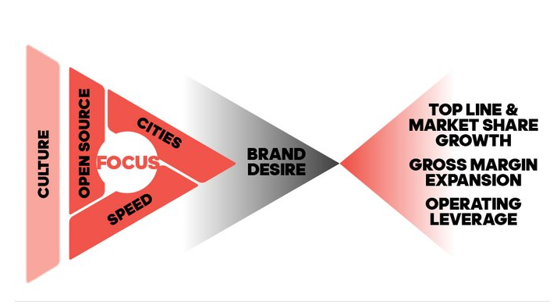
Figure 1 (Santos, 2017)
As per the Adidas strategy overview, the global function is split up into two various department retail and wholesale that caters the needs of their business model. However there the alliance is becoming popular increasingly in the corporate world, they do not always benefit the parties involved in it. For example, it was observed by the critics that 13 years of Alliance with Reebok, the alliance still lags in its sales, while the other three brands profits are growing up to 16% annually, and in the same period, the growth of Reebok is just about five per cent. In these cases, Madsen and Walker, (2015) suggested that the partnership use of systems of performance measures such as the “Balanced Scorecard” to determine the non-financial and financial position of Adidas potential alliances. This is done to sustain the strategy of corporate level for a long run so that all the divisions could work hard and emphasise in their departments respectively in order to make most out of their efforts. Adidas also implements the multi-brand strategy by having a diverse portfolio that would allow them to cater the market segments from sports to everyone. This helped Adidas to keep the identity unique and focus on their core competencies.
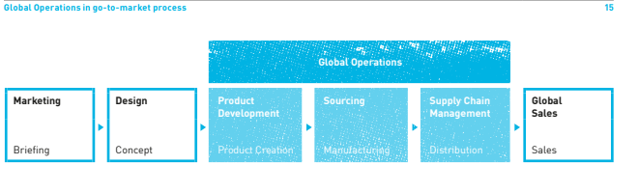
Figure 2(Santos, 2017)
The focus is given in the distribution and best marketing channels in various countries by evaluating the buying behaviours of consumers and constant struggle to secure space and prime shelf. As per the Adidas competitive advantage as per the Financial report of Adidas annual report (2014) Adidas have one competitive advantage based on their distribution channel, its brand equity and product quality. Globally there are almost 2400 stores that are accounting almost $4.3 billion business. So, in order to associate themselves with the community, they have sponsored some events such as UEFA, Cricket, NBA, FIFA & Olympic. Ang, C. and Rusli, H., 2018. The Impact of Marketing Mix 4Ps and Consumer Behavior toward Purchase Decision of Adidas Products. Bucs Management stated that over the years Adidas has known to the best market products there comfortable, long lasting and normal (Keiser et al., 2017).
Their Strong relationship with organisations such as international France Corporation, International Labour organisation has also given them an edge in this competitive environment. E-commerce also embraces by Adidas in order to become more appealing and efficient to their customers that are making their purchases easier for them. Their supply chain method is communicated closely, and hence it helps in product customisation, which appeals to a large number of customers. The cultures of organisation obligate the employees towards innovation. This culture helps them to produce well that are innovative, and by using those products, their goods are of good quality. To make the company more sustainable the right balance between the interests of shareholders concerns and needs of their employees the suppliers and factory workers as well as the environment is found. Based on the Adidas-Salomon information the latest technologies use help them in producing the products that enhance their player's performances and help them to innovate more sports, such as tennis, football, basketball even different training shoes that used for the running (Frow et al., 2015, p.463).
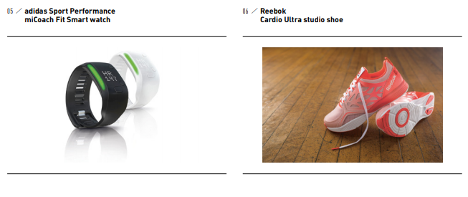
Figure 3(Santos, 2017)
Their running shoes were updated with Clima Cool; it is a system that ventilates design and a3, an energy management technology for footwear that guides and drives an athlete’s foot through each stride (Belton et al., 2017).
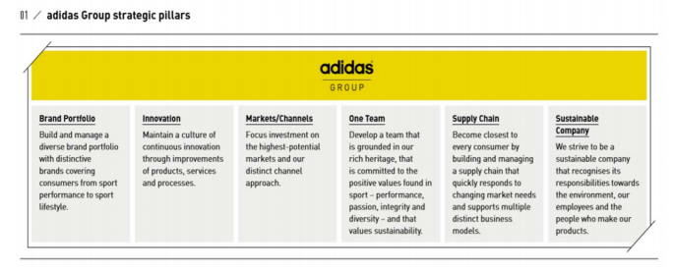
Figure 4(Santos, 2017)

Limitations
These strategies do face limitations by its competitor Nike as both Nike and Adidas are the two most popular companies that are dealing with sports equipment around the world. The major limitation in it competitive strategies is lack of celebrity sponsorships as Nike has more celebrity sponsorship compared to Adidas in which they are targeting basketball players mainly. Thus, having a market in States and globally too (Ang and Rusli, 2018).
Whereas the strategy of Adidas is only involved in tennis and football, as comparing it Nike, the pricing strategy of Adidas is quite different. Nike focuses on the premium segments as their customers based on are of high –class. Whereas Adidas, in which the price depends on it, adopt market-skimming strategy’s look, colour, for example, the Adidas of white colour is more expensive than the other colour shoes. As stated by (Wilk and Arnold, 2016, p.6) Adidas is now successful to integrate various cultures. As it is mentioned above Adidas can successfully integrate into small companies, but its strategy has a share of failures to merge firms that have various work culture.
Adidas is required to build the mechanism of feedback internally directly from the team of sales as its competitive strategy lack the feedback system that could provide the firm with a competitive edge on the ground to counter the challenges. Regarding sustainability, Adidas competitive strategy does not cater the solution for high attrition rate present within its workforce comparing it to sports industry or other organisation Adidas processes high attrition rate, and they need to spend a lot as compared to its competitors on development and training of its employees. Their competitive strategy is also not very good at the demand of products that are leading to the missed opportunities at a higher rate as compared to its competitors. The reason for adding inventory to remain high compared to its competitors is that Adidas is not goofed at forecasting demands. Thus, they end up keeping the inventory both in the channel and higher inventory (Turner et al., 2015, p.127).

Conclusion
Future Adidas stores will operate production facilities directly and may use robots. The group said that in the future, customers would get a pair of personalised sports shoes in 15 minutes, which is almost the time to enjoy a cup of coffee. “This will shock the entire industry.” Roland Auschel speculates that sporting goods manufacturers will be the first to adopt this new business model in the industry, expecting a 20% increase in regular-price sales and a reduction in inventory risk.

Recommendations
A large portion in Asia and Africa is still untapped by Adidas; no such company is operating there such as Adidas and Nike. Adidas has won his race against its competitor Nike in Japan, India and China. So now they could easily develop a strategic partnership among their local companies in order to increase their market share and to highly be successful in the market. Emerging markets such as the Middle East, China, India and South Africa, must be on top of the priority list of market concentrations due to the high population it is a good opportunity that the customers that are existing can easily be retained and new customers can also be targeted. For example, Adidas in China can develop a strategic partnership with the brand LiNing they can easily beat Nike if this partnership is established. Moreover, by sponsoring the untapped markets local sports event, the brand association can be developed with its target customers, and this can also bring customers to the market. Adidas can also attract the consumers of the untapped market to a perception of having a low price, by this they could develop a new market in order to compete against Nike (Santos et al., 2017).
The application on the internet must be made more effective so that the products can be present in the retailing stores. This sponsorship must not be confined towards a certain sport, but instead, it must be identified popular sports and those sports that are present in the markets where it is sponsoring and operations such activities, so that brand is easily taken into the customer's mind (Merlo et al., 2018, p.73).

References

Ang, C. and Rusli, H., 2018. The Impact of Marketing Mix 4Ps and Consumer Behavior toward Purchase Decision of Adidas Products. iBuss Management, 6(2)
Belton, P., 2017. Competitive Strategy: Creating and Sustaining Superior Performance. Macat Library.
Frow, P., Nenonen, S., Payne, A. and Storbacka, K., 2015. Managing co‐creation design: A strategic approach to innovation. British Journal of Management, 26(3), pp.463-483.
Keiser, S., Garner, M.B. and Vandermar, D., 2017. Beyond design: The synergy of apparel product development. Bloomsbury Publishing USA.
Madsen, T.L. and Walker, G., 2015. Modern competitive strategy. McGraw Hill.
Mahdi, H.A.A., Abbas, M., Mazar, T.I. and George, S., 2015. A Comparative Analysis of Strategies and Business Models of Nike, Inc. and Adidas Group with special reference to Competitive Advantage in the context of a Dynamic and Competitive Environment. International Journal of Business Management and Economic Research, 6(3), pp.167-177.
Merlo, O., Eisingerich, A., Auh, S. and Levstek, J., 2018. The benefits and implementation of performance transparency: The why and how of letting your customers ‘see through’your business. Business Horizons, 61(1), pp.73-84.
Naidoo, M. and Gasparatos, A., 2018. Corporate Environmental Sustainability in the retail sector: Drivers, strategies and performance measurement. Journal of Cleaner Production.
Saeidi, S.P., Sofian, S., Saeidi, P., Saeidi, S.P. and Saaeidi, S.A., 2015. How does corporate social responsibility contribute to firm financial performance? The mediating role of competitive advantage, reputation, and customer satisfaction. Journal of business research, 68(2), pp.341-350.
Santos, D.F., 2017. Adidas Group: equity valuation thesis (Doctoral dissertation).
Stevens, G.C. and Johnson, M., 2016. Integrating the supply chain… 25 years on. International Journal of Physical Distribution & Logistics Management, 46(1), pp.19-42.
Taylor, T., Doherty, A. and McGraw, P., 2015. Managing people in sport organizations: A strategic human resource management perspective. Routledge.
Tomczak, T., Reinecke, S. and Kuss, A., 2018. Market-Oriented Corporate PlanningMarket-oriented corporate planning. In Strategic Marketing (pp. 49-95). Springer Gabler, Wiesbaden.
Turner, T., 2015. German Sports Shoes, Basketball, and Hip Hop: The Consumption and Cultural Significance of the adidas ‘Superstar’, 1966–1988. Sport in History, 35(1), pp.127-155.
Wilk, R.R. and Arnold, E.J., 2016. Why do the Indians Wear Adidas? Or, Culture Contact and the Relations of Consumption. Journal of Business Anthropology, 5(1), pp.6-36.

