Hotel Placement- Managing Hotel Administration
Module Code: BMIH6004
Student Name: Ayesha Siddiqua
Student Id: 2233548
Lecturer’s Name: Jessica Newport
Word Count: 1251

AI Declaration
I confirm that I have not used any AI tools in the research and creation of this assignment. I confirm that I have not presented any AI generated materials as my own work. I confirm I have copies of my drafts, notes, and other resources I used, which I may be asked to provide in evidence.

Table of Contents
Introduction: 4
Section 1: Role Reflection 4
Section 2: Analysis of Key Hotel Administration Issues 7
Section 3: Future Trends in Hotel Administration 8
Conclusion: 9
Reference: 10

Introduction:
The job of the Front Desk team at Hampton by Hilton London Luton Airport is to look after check-ins, arrange reservations, take care of billing and provide concierge service. Hotel systems used today help the department enhance satisfaction among guests. I wanted to strengthen my customer service talk, manage property systems skilfully and handle guest grievances with respect and care. Hotels offer guests a range of options to stay these days (Bardi, 2010).

Section 1: Role Reflection
Role and Responsibilities:
While I was at Hampton by Hilton London Luton Airport, my role was Front Desk Assistant on the Front Desk. Following Gibbs’ reflective cycle, I managed check-ins and check-outs with guests, processed bookings using the system and collected payments. Hospitality companies can’t operate efficiently without the lodging department (Casado, 2012).
Management in the department was mainly done with supervisors giving clear instructions and steering the team’s work. I noticed supervisors sharing leadership responsibilities, letting everyone contribute and solve difficulties as a group which went with the reflective evaluation part of Gibbs’ model. In 1988, Graham Gibbs developed Gibbs' Reflective Cycle to organize how people learn from what they go through (The University of Edinburgh, 2024).

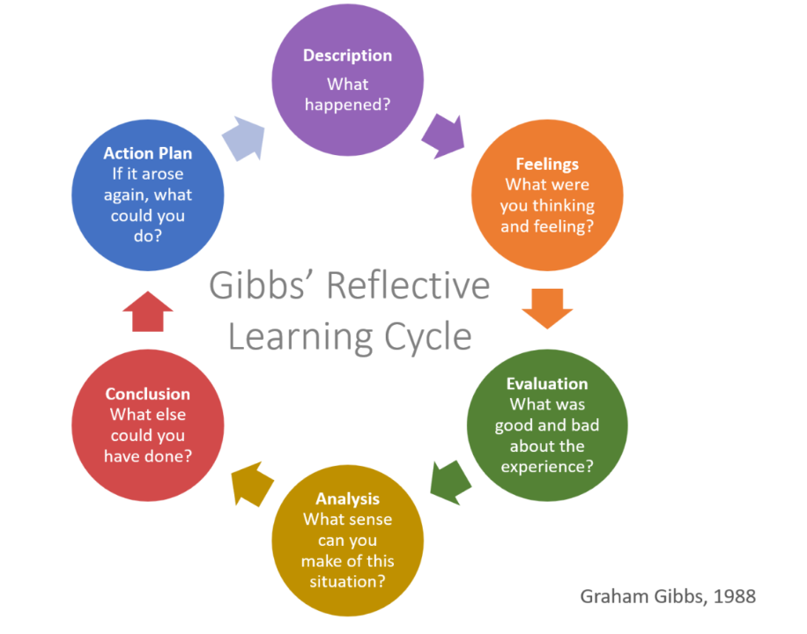
Gibbs’ Reflective Cycle
Source: [Assignment Studio, 2025]
Impact of Supervisory Role:
As mentioned in Gibbs’ evaluation and analysis stages, the team needed strong leadership, effective communication and good time management to maintain how well the work was done. Leaders now focus on a range of things that was not the case in the past (Stone, and Patterson, 2023).
I used both PMS and CRM systems for bookings and guest records which helped us work smarter and more accurately.
When things are busy, people might come to you with problems and need to be dealt with right away. Dealing with them in a calm and coordinated way was enough, but additional training and more careful forward planning for all surgeons would improve things further.
Real Examples and Skills:

Hotelkeeping goes through ups and downs that match the economy’s cycles (Vallen, and Valen, Jerome, 2014). One time, someone showed up at the hotel extremely late and had not officially booked a room. Using the PMS according to Gibbs’ reflective cycle, I verified the guest’s residence and worked with them to have a target check-in. using the knowledge, I have and setting aside time for guests allows them to feel secure and resolved.
I was also occasionally asked to manage group check-ins for the crew members on-board a plane. I kept in close contact with housekeeping and made sure rooms were available by using the property’s messaging software. I needed to clearly communicate, handle different tasks at once and make good use of our CRM. Using Gibbs’ method, I realized I do well in teamwork and changes, but I struggle when managing my time under pressure.
Action Plan:
Goal | Action | Timeline | Measure of Success
Improve Time Management | Look for an online class on time management. | 4 weeks | Timely performance of everyday duties
Improve PMS Proficiency | Request from the supervisor some advanced training. | 2 weeks | Confident use of all PMS features
Strengthen Complaint Handling | Rehearse with our friends. | Ongoing | Decreased escalation of guest complaints
Source: [Self-Made]
In the final part of Gibbs’ reflective cycle, I make an action plan for making specific, measurable changes in how I work. The actions came from considering real experiences and suggestions, so I could focus on improving specific areas seen during my placement. The hospitality industry is not independent from other activities (Wood, 2013).

Section 2: Analysis of Key Hotel Administration Issues
Identified Administrative Issue:
I found that new employees received little training during their induction. Incorrect and flawed training methods meant staff were unsure what to do, messages to guests were inconsistent and new employees depended too heavily on seasoned colleagues. We start to lead our learning in order to achieve our specific career goals (Hagg, 2013).
Contemporary Academic Literature Support:
Training people the same way every time helps them do their duties well, feel more confident and stay on the job. Not having good training leads to less engagement by staff and bad ratings from guests, mainly in front desk departments. Students will be able to develop answers and strategies that will help them at work because of human resource cases (Baum, 2006).
Literature Analysis and Practical Link:
To guarantee that staff are confident and their service is always of good quality, Nickson (2013) argues that training should be well-planned and systematic (Nickson, 2013). Induction did not prepare us well enough and this caused both confusion and inefficient usage of the PMS system at check-ins.
Learning organizations motivate and recognize employees for collecting knowledge, producing it and sharing it with co-workers (Zamir, 2023). Learning new skills makes employees better able to cope with technology. In my case, people who had received training could deal with the PMS tools better than those who were not trained.
Module Link:
Staff development gets special emphasis because it is directly linked to the Personnel Resourcing & Development module. Good training gives employees the skills to do their jobs well which improves how they work and connect with guests. The success of any organization depends on how satisfied its employees are (Gregory, 2011).

Relevance of Chosen Module:
The module matters since it supplies ways to recruit employees, train them and help them improve their performance. Using this theory allowed me to understand why a clear onboarding process helps and ways we could improve how we learn new things over time.

Section 3: Future Trends in Hotel Administration
Future Trends Overview:
Artificial intelligence (AI) is allowing hotels to handle guest services more efficiently while learning from their information. These tools are changing the ways organizations engage customers and are overseen. By applying AI, key hotel tasks, including check-in and handling reservations and guest inquiries, are accomplished automatically. It wouldn’t allow the industry to operate and serve its guests as well as it does now.
Departmental Impact and Literature Support:
Hampton by Hilton London Luton Airport’s Front Desk could see AI help by speeding up check-in procedures for guests.
It is predicted that service robots and intelligent applications in AI will greatly improve how operations, labour and service quality work in hospitality (Ivanov, Webster, and Berezina, 2017).
Literature Analysis and Practical Link:
Automation of Routine Tasks: With AI, people don’t need to complete tasks that are routine and repetitive (Ivanov, Webster, and Berezina, 2017). Today, the front desk team must manually input guest information; AI-assisted kiosks would make this task happen more quickly.
Enhanced Guest Interaction: AI allows businesses to offer a personal and continuously smooth experience to their customers (Tussyadiah, 2020). The quality of personal service went up and down a lot, mainly during the busiest hours. AI might guarantee the same level of service for all users.

Skill Shift Requirements: According to both studies, AI requires people to acquire new knowledge and skills. I found that workers need more digital training because their current skills are not up-to-date.

Conclusion:
In conclusion, being part of Hampton by Hilton London Luton Airport helped me grow strong skills in administration and customer service on the Front Desk team. Through using Gibbs' Reflective Cycle, I saw how hotels operate, realized training was a significant issue and looked at what AI might do in the future. I may not have achieved every objective in the end, but I became better in communication and technology. What I’ve learned has advanced my career and prepares me well for the future in hospitality management.

Reference:
Assignment Studio (2025). Gibbs Reflective Cycle - Assignment Help Australia. [online] Assignment Studio. Available at: https://assignmentstudio.net/gibbs-reflective-cycle/. [Accessed on: 27th May, 2025]
Bardi, J. (2010) Hotel Front Office Management. 5th Ed. London: Wiley. Available on: https://books.google.com/books/about/Hotel_Front_Office_Management.html?id=5a8bAAAAQBAJ [Accessed on: 27th May, 2025].
Baum, T., 2006. Human resource management for tourism hospitality and leisure. Thomson. Available on: https://strathprints.strath.ac.uk/8025/ [Accessed on: 27th May, 2025].
Casado, M. (2012) Housekeeping Management. 2nd Ed. London: Wiley. Available on: https://books.google.co.in/books?hl=en&lr=&id=AsU9EQAAQBAJ&oi=fnd&pg=PR13&dq=Casado,+M.+(2012)+Housekeeping+Management.+2nd+Ed.+London:+Wiley.&ots=sclrs-YQTK&sig=K8ZDsp4qM1kqExkzh5OQEIDoIf4 [Accessed on: 27th May, 2025].
Gregory, K., 2011. The importance of employee satisfaction. The Journal of the Division of Business & Information Management, 5, pp.29-37. Available on: https://www.academia.edu/download/33282172/Gregory.pdf [Accessed on: 27th May, 2025].
Hagg, E. (2013) Internship Guide: Work Placements Step by Step. 5th Ed. The Hague: Eleven International Publishing. Available on: https://webdocs.aub.ac.uk/PSBAAEP(2023-24)2024.pdf [Accessed on: 27th May, 2025].
Ivanov, S.H., Webster, C. and Berezina, K., 2017. Adoption of robots and service automation by tourism and hospitality companies. Revista Turismo & Desenvolvimento, 27(28), pp.1501-1517. Available on: https://papers.ssrn.com/sol3/Delivery.cfm?abstractid=2964308 [Accessed on: 27th May, 2025].
Nickson, D., 2013. Human resource management for hospitality, tourism and events. Routledge. Available on: http://dspace.kottakkalfarookcollege.edu.in:8001/jspui/bitstream/123456789/4149/1/human%20resource%20management%20for%20the%20hospitality%20and%20tourism%20industries%20%28%20PDFDrive%20%29.pdf [Accessed on: 27th May, 2025].
Stone, A.G. and Patterson, K., 2023. The history of leadership focus. Springer Books, pp.689-715. Available on: https://ideas.repec.org/h/spr/sprchp/978-3-031-01323-2_38.html [Accessed on: 27th May, 2025].
The University of Edinburgh (2024). Gibbs’ Reflective Cycle. [online] The University of Edinburgh. Available at: https://reflection.ed.ac.uk/reflectors-toolkit/reflecting-on-experience/gibbs-reflective-cycle. [Accessed on: 27th May, 2025].
Tussyadiah, I., 2020. A review of research into automation in tourism: Launching the Annals of Tourism Research Curated Collection on Artificial Intelligence and Robotics in Tourism. Annals of Tourism Research, 81, p.102883. Available on: https://openresearch.surrey.ac.uk/view/delivery/44SUR_INST/12139660090002346/13140311640002346 [Accessed on: 27th May, 2025]
Vallen, G.K. & Valen, Jerome J. (2014) Check-In Check-Out: Managing Hotel Operations. 9th Ed. Harlow: Pearson Education Limited. Available on: https://api.pageplace.de/preview/DT0400.9781292034355_A24589367/preview-9781292034355_A24589367.pdf [Accessed on: 27th May, 2025].
Wood, R.C. (2013) Key Concepts in Hospitality Management. London: SAGE Publications Ltd. Available on: https://sk.sagepub.com/dict/mono/preview/key-concepts-in-hospitality-management.pdf [Accessed on: 27th May, 2025].
Zamir, Z., 2023. Can the system, information, and service qualities impact employee learning, adaptability, and job satisfaction?. Applied Computer Science, 19(1), pp.25-46. Available on: https://ph.pollub.pl/index.php/acs/article/download/3493/3117 [Accessed on: 27th May, 2025].

