Event Plan Report
1. Event Overview
Event Name: Feel Good Health & Wellness.
Event Type: A wellbeing fayre event.
Concept & Theme: The concept for our event was to promote and encourage wellbeing and self-care and love. We were aiming to create an event that serves as a space for people to engage in varying conversations on topics surrounding self-care, such as life motivation, sports, and medicinal practices. The theme is comprised of calming and neutral colours such as beige, cream, green, and yellows.
Target Audience: The primary target audience for the event is people who have an interest in wellbeing and self-care, regardless of ages.
2. Timing, Location & Programme
Date & Time: Tuesday, March 17th, 2026.
Venue: The UWTSD Innovation Matrix.
Event Programme
Registration & Welcome Speech – 10:00.
Key Activities/Sessions – 13:00-16:30 in the immersive room, stall vendors will be available from 10:00-16:00.
Breaks & Networking – Breaks not scheduled, networking can be conducted throughout the day.
Closing & Wrap-up – 16:00-17:00. The event is ending at 16:00, but our final demonstration in the immersive room ends at 16:30.
3. Aim and Objectives
Overall Aim: to primary aim of this event is to help promote holistic wellbeing whilst also aiding community engagement, as well as integrating key industry members to promote their businesses with those who are seeking to get into wellbeing and self-love.
Objectives:
Objective 1 – promote awareness around health and wellbeing.
Objective 2 – provide connections between university students and the necessary support services needed.
Objective 3 – promote and encourage healthier lifestyle choices through the simple things, such as gym memberships or coffee alternatives.

4. Project Planning Techniques.
Work Breakdown Structure (WBS):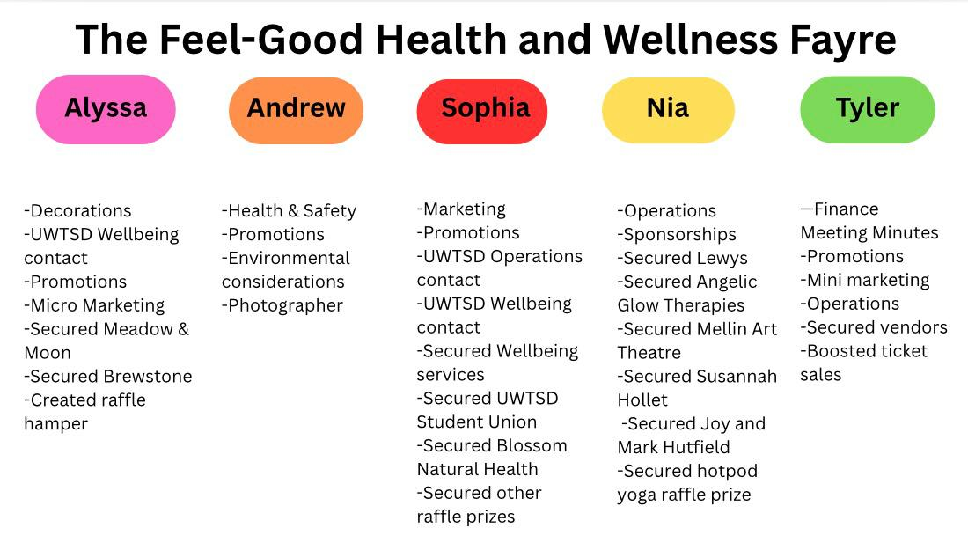
Gantt Chart: Gantt Chart was not sent or received in time for submission.
Running Order:
08:00 – Arrive at the event location and assist vendors with setting up their stalls.
09:00 – Finalise the decoration process.
09:30 – Host morning brief to vendors and staff.
10:00 – Event starts (vendors available from 10:00-16:00).
12:00-12:30 – Draw the raffle.
13:00-14:00 – Qi Gong class in immersive room.
14:00-14:30 – Susannah Hollett Crystals class in immersive room.
14:30-15:00 – MTA Pilates class in immersive room.
15:00-15:30 – Jemma Joel Life Coaching class in immersive room.
15:30-16:30 – Ian Standen Yoga class in immersive room.
16:30 -17:30 – Event close down.
17:00 – Event debrief.
EMBOK Domains: The Event Management Body of Knowledge, or EMBOK, is a framework that is structured model that serves to support the practical, study element of event management through degining key processes, and knowledge domains that are relevant to the field (O’Toole, 2011). It serves to intergrate the management of events with project management principles, to help create a series of charts that outline processes that are involved with managing events- including the scope of the event, stakeholder and sponsorship management, design, marketing, and financial management (O’Toole, 2011). The EMBOK framework aims to provide a logically sound structure to analyse and manage events systematically (O’Toole, 2011).
Administration: The administration domain focuses on the overall planning and coordination of an event. Project timelines with help to outline key milestones, such as venue booking, marketing launches, and the confirmation of suppliers. Responsibilities are allocated between the group members, which helps with ensuring efficient communication between members, whilst budget monitoring procedures will be implemented to help with the control of expenditure.
Design: The design and the theme of the event is comprised of very natural and nature-based themes; when discussing colour schemes
Marketing: Promotion, sponsorship, audience engagement**
Operations: Venue setup, safety, and security**
Risk Management: Any potential risks will be assessed and evaluated, before being implemented in our risk assessment within the appropriate channels and rated on a scale of low-medium-high as to how relevant of a risk it is.
5. Market Research & Target Audience
Market Segments: Self-care is of incredible significance for Generation Z (birth years ranging 1997-2012), as evidenced by several studies that focus on the behvaiours and attitudes of Gen-Z. Younger millennials and Gen-Z- often referred to as GenZennials, often engage with self-care that serves to integrate spirituality, mental health management, and general wellness which then reflects a broader understanding of self-care that exceeds physical health (Park et al., 2023).
Competitor Analysis: There isn’t very much noticeable competition within this sector as of right now- we believe the event we are hosting is rather niche and is not something you would see several of at one time. However, it is worth noting that the Swansea Waterfront Museum is hosting a free wellbeing event from the 16th-19th of March, 2026, which does coincide with our event. The Waterfront Museum event is also free of charge, which makes the likelihood of more people attending the museum event over ours, higher than it otherwise would be if they were charging for tickets (Swansea.Scoop, 2026).
Consumer Preferences: No further research has been conducted regarding market segmentation or consumer preferences for this event.
6. Event Marketing Plan
Marketing Channels: The primary method of marketing this event will be the use of our social media page- @feelgoodwellness.events, however marketing will also be carried out via email as we reach out to possible clients and sponsors for their collaboration. Posts will be shared weekly in the run-up to the event, and the week prior to the event, they will be posted daily in order to create as much excitement around the event as we can.
Promotional Timeline: We plan for the marketing to be conducted from the inception of the event, right up until the day of the event, in order to help with attracting as many visitors as possible, for as long as possible.
Key Messages & Branding: We have marketed the event as an opportunity for people to focus on their wellbeing, and as such, as have marketed it as an affordable event that is appropriate for all ages- as we believe that wellbeing should not be restricted to finances or age.
Sponsorship: We plan on reaching out to as many people as possible, whose visions align with our event plans. For example, we have conducted
7. Budget & Financial Plan
Projected Income: [Ticket sales, sponsorships, donations, etc.]
Expected Expenditure:
Venue & Equipment: [Cost]
Marketing & Promotion: [Cost]
Staffing & Security: [Cost]
Catering & Logistics: [Cost]
Miscellaneous: [Cost]
External Suppliers: [List of vendors and service providers]
Budget Report: [Request a detailed budget report outlining income and expenses for transparency and financial tracking]
8. Risk Management & Health & Safety
Risk Assessment: [Identify potential risks and mitigation plans]
Health & Safety Measures: [First aid, security, crowd control, etc.]
Legal Requirements: [Licences, permits, insurance]
Public Liability Insurance: [Attach document]
Required Licences: [List required permits]
Emergency Plan: [Evacuation and contingency procedures]
9. Contingency Planning
Alternative Venue: [Backup location]
Weather Contingencies: [Plan for outdoor events]
Key Supplier Failures: [Substitutes for critical suppliers]
Crisis Communication Plan: [Handling PR issues]
10. Evaluation Strategy
Post-Event Surveys: [Attendee feedback collection method]
Key Performance Indicators (KPIs): [Metrics for measuring success]
Attendance Measuring: [Strategies to track event attendance and engagement]
Debrief Meeting: [Internal review process]
11. Sustainability & Event Legacy
Sustainability Considerations: [Eco-friendly practices, waste reduction, and energy efficiency]
New Economics & Legacy: [How the event contributes to long-term benefits, economic impact, and community engagement]
Event Impacts: [Environmental, social, and economic impacts of the event]
12. Key Areas of Managing Event Operations
Staff Rota: [Work schedules for event staff and volunteers]
Logistics & On-Site Management: [Transportation, crowd control, technical setup]
Stakeholder Coordination: [Liaising with partners, vendors, and authorities]
13. Division of Work & Responsibilities.
Meeting Minutes: Tyler-Belle Condon.
Email Correspondence: Sophia Rabaiotti, Tyler-Belle Richards, Nia Mugford, Alyssa Stoneman (promoting and contacting vendors through emailing systems).
Task Assignments:
Alyssa – Decorations, promotions, marketing (partial).
Tyler – Finance, spreadsheet, meeting minutes, promotions.
Andrew – Team leader, health and safety.
Sophia – Marketing, promotions.
Nia – Operations Manager, promotions.
Coordinator: Alyssa, Tyler, Sophia; ensuring overall project direction and leadership.
Shaper: Alyssa, Nia, Tyler, Sophia; driving progress and keeping the team focused.
Plant: Alyssa.
Monitor Evaluator: Tyler, Sophia, Nia; assessing ideas critically and ensuring quality.
Implementer: Alyssa, Nia, Tyler, Sophia, Andrew; turning plans into actionable steps.
Completer Finisher: Alyssa; ensuring all details are perfected.
Resource Investigator: Alyssa, Sophia, Nia, Tyler; seeking external opportunities and connections.
Teamworker: Sophia, Nia; Promoting harmony and collaboration within the team.
Specialist: Sophia, Nia; Providing in-depth knowledge in key areas. ________________________________________
This document will serve as a guide throughout the planning and execution of the event, ensuring alignment with best practices in event project management, incorporating the EMBOK framework to enhance structured event planning and risk mitigation while integrating Belbin Team Roles for effective collaboration and task distribution.

