Managing People
Assessment 2

Tutor Name: Charles Oham
Student ID: 1916174
Student Name: Ilie Topliceanu
Level 5, Gr 2

Table of Contents
Introduction 3
Reviews the concept and drivers of employee engagement 4
Evaluates diagnostic tools to measure engagement 5
Constructs an employee value proposition from the ideas and analysis previously covered, including strategies to raise levels of engagement 6
Conclusion 10
Reference List 11

Introduction
Managing People can be defined as the interpersonal strategies used to maintain order within an organisation and facilitate productivity (Martin and Siebert, 2016). It is essential that an understanding of managing people is facilitated as it improves overall employee-employer bonding. Throughout this assessment, for the concerned organisation and the case study, different measures have been taken for the business. These measures focus upon work from home facilities, flexible job timings, reconstructing job roles, and helping in creating a corona virus safe environment for optimised workplace atmosphere has been detailed. The way in which employee engagement can be improved at a further margin shall be evaluated through this research. Throughout this research, value proposition through compensation, benefits, career and cultural development aspects shall be underpinned here in this research as well.

Reviews the concept and drivers of employee engagement
The concept of employee engagement can be defined as the fundamental approach of building effective relationships within an organisation with the employers and employees (Sun and Bunchapattanasakda, 2019). This is a strategy based upon communication, reward systems, and other aspects which are both quantifiable and scalable in nature as better relations and engagement result in better productivity. There are various functions of employee engagement within the concerned organisation that facilitates in the alignment of goals, mission establishment, defining the values of the business, and other aspects to which employees are able to understand how they can work in tandem with the vision of the business. All of this is important as it can helps in making sure that conflict, lack of direction, are not aspects which are present in the venture.
Some of the different types of drivers of employee engagement might include:
Employee Rewards: In accordance with the tangible and intangible rewards being provided to subordinates, the likelihood of an enhanced margin of performance is assured in most cases. 401(k), paid leaves, having better communicative relationships, and other types of strategies are an important fragment of employee rewards (Eldor and Vigoda-Gadot, 2017). In order to establish these in remote working scenarios and flexible work timing, the amount of productivity and sales performed is an adequate gauge through which these aspects can be measured.
Workforce Data: In the concerned organisation, being able to analyse the way in which individuals are performing independently and with other individuals is an adequate margin on the basis of which specific work timings, the type of remote work being provided, and other aspects can be determined. These factors can influence the measure in which engagement can be promoted amongst teams and the prospect of better accountability, reliability, and other aspects can be considered.
Career Growth: Several different hierarchical layers must be made clear to every employee within the enterprise as this can facilitate in making sure that the need for there to work more and achieve a better role in the business must be provided to candidates. This can help in making sure that continuous improvement and focused towards better goals is being facilitated (Mann and Harter, 2016).
Employee Wellness: Creating different types of medical features, sanitary measures, social distancing aspects, and insurance are some of the aspects through which support can be given to the employees. This can help in making sure that it would be easier for any type of sickness, paranoia from working in teams with other employees can be eradicated. As a result of this, efficiency can rise in the business and engagement can enhance as well.
Social Relations: This is a program setting endeavours through which corporate gatherings, food meetings, different association with subordinate companies, and other aspects are focused upon. This helps in making sure that employees at different levels and layers are able to interact effectively and an understanding of the enterprise at a wider scale is being enabled. Social relations is important as it can help in making sure that the overall workplace culture is developing and employees are being empowered to interact and spread out their network throughout the business (Osborne and Hammoud, 2017).

Evaluates diagnostic tools to measure engagement
Multiple different types of diagnostic measures strategies are present through the Human Resource Manager that can help in enabling and understanding what type of performance is being exhibited by the employees within the business.
Employee surveys: Employee surveys are an important strategy within an organisation as it enables the human resource managers to ask employees on various factors and parameters on how they are suited in the business. These different types of parameters might include of work atmosphere satisfaction, understanding what aspects of management can be improved, which equipments are lacking presently in the business, and other aspects. All of these areas are essential as they help in understanding the overall opinion of the business and how an improvement margin can be implemented for the future.
Interaction with Team Leaders/Managers: Many employees work under the umbrella of a team leader or manager who is responsible for the amount, quality, and the timeframe within an employee works. It is important to engage with these individuals. These managerial individuals facilitate in understanding the performance of subordinates and if a higher margin of employee engagement is required through which it can be easier for there to be any type of interpersonal issues being shared and mitigation strategies being implemented that can enable the prospect of future development to be attained effectively (Mone and London, 2018).
Human Resource Software: Many employees might not want to provide their opinions on a wide variety of factors openly. In order for anonymity to be maintained, issues relating to bullying, harassment, and other types of activities can be reported, discussed, and taken up through human resource software that are initiated to take surveys (Roque et al., 2016). Moreover, any type of discussion in relation to performance management, feedback towards the business, goals being said differently, can also be taken into consideration. These help in making sure that contracted measures for improvement is being taken.
Social media: Presently with remote work, flexibility in work timing, and people operating from far distances, social media has emerged as a communicative tool in order to bring people together (Greenwood et al., 2016). Through the help of videoconferencing, chat messaging, group discussions, it is easier for there to be an informal engagement being facilitated and this helps in understanding employees at a much deeper level. Any type of issues, problems attempted to be eradicated at this level as internal politics; bureaucracy can be much more transparent when interacting through social media.
Employer Satisfaction Index (ESI): This is an effective indicator and told through which employer satisfaction within the business and how customer experience can be affected through this can be engaged. This is an index which focuses upon a scale of 1 to 10 whereby which, the higher the score the more the employee satisfaction. It can be illustrated that making a query on to different types of questions on workplace happiness, rate of promotion being obtained, salary satisfaction, benefits being obtained, some of the factors that can contribute towards a higher score on this specific index that can help in better satisfaction to be provided to people working remotely (Sahti, 2019).

Constructs an employee value proposition from the ideas and analysis previously covered, including strategies to raise levels of engagement
Employee Value Proposition defines the way in which the labour market and the subordinates within an organisation receive the amount of value that they can gain from working within an enterprise (Rounak and Misra, 2020). There are multiple ideas that can be taken from the above discussion that can facilitate in creating a better employee value proposition through which improved engagement can be created. Some of these ideas include of paid holidays, 401(k), improved relations through communication, and other aspects.
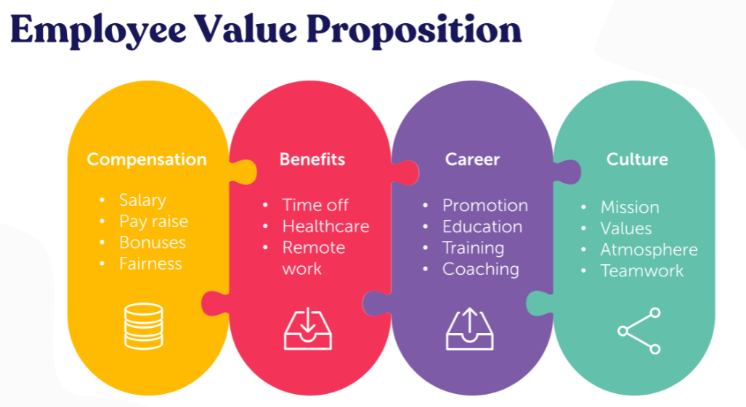
Figure 1: Employee Value Proposition
(Source: Pawar and Charak, 2016)
Through the above some of major aspects are present in value proposition as can be observed in the diagram provided above, these four different types of value proposition puts emphasis upon compensation, benefits, career, and culture development. In the umbrella of compensation, several aspects such as pay raise, increased bonuses, salary increment, more fairness, are some of the aspects that are important. All of these are extrinsic motivational factors through which, employees are provided the chance of working for a higher margin of payment and equal treatment if they feel that they are being discriminated against.
In addition to this, benefits can be highlighted as something extra which is intrinsic or indirectly providing some form of advantage to employees. This might include of providing remote work facilities that has been an increasing trend by the concerned organisation to help empower subordinates in the pandemic situation. Moreover, healthcare insurance facilities are also being provided to employees as these value proposition elements are making sure that it is easier for protection against the contagious virus to be minimised at a maximised capacity.
Along with this, in the aspect of career development, promotions, enhanced education, training and coaching are aspects that facilitate in employee growth. Along with this, portfolio diversification and raising the competency level are also aspects that are important within the concerned organisation. These help employees to become much more efficient and focus upon creating better quality commodities and provide effective services that are less time-consuming. These are intrinsic in nature however, using these skills, being able to obtain extrinsic monetary goals can be much easier as better results can be achieved effectively (Rounak and Misra, 2020).
Cultural development is the final fragment of helping in developing a better employee value proposition as being able to communicate a good and well-defined mission and value driven system can help in making sure that an effective environment is promoted. The culture of an organisation can improve through emphasis upon work aspects. Brainstorming activities, eliminating interpersonal conflict, are all aspects that can help in making sure that an improved collaboration environment is created. These are all important components through which it can be easier for there to be a value driven system being created and much more focus to be established as well.
All of these four factors are important as a combination or single implementation of these different types of value propositions can help in changing the mindset of employees as to how they will behave in the business. In order to determine what type of advantage can be provided to the employee, the utilisation of Maslow's Hierarchy of Needs can be implemented. This is a motivation framework which helps in understanding what type of factors influence employees. Five different layers are present within this pyramid framework which encompasses physiological, safety, belonging, esteem, and self-actualisation needs (Einstein et al., 2016).
- Physiological: These are basic food, water, and warmth related needs
- Security: Being able to stay protected, sheltered from different types of physical dangers is an important aspect in this category
- Belonging: Having intimate relations with other people facilitate in making sure that psychological well-being is established
- Esteem: Having prestige, feeling accomplished, are aspects that can help in self sustainability
- Self-actualisation: Having reached one's own creative potential and obtaining different types of achievements are an effective methodology through which progress can be attained
Through survey of employees, it can be determined what type of needs they fall under. For instance, if they belong towards physical and safety needs, then bonuses, higher pay, housing facility, and other benefits can be provided through compensation as well. However, if individuals fall under the higher layer of self-actualisation, then training, coaching, and other aspects on the basis of the position can be provided. This will help in enabling much more focused towards obtaining goals that are important for their portfolio development (Soni and Soni, 2016).

Conclusion
Throughout this people managing study, a wide variety of aspects in relation to how employee engagement can enhance, the factors that lead towards understanding what influences employee engagement, and other aspects are explored. Along with this, important framework such as Maslow's hierarchy of needs and how they can help in being an important facet of employee value proposition and understanding their how their satisfaction within the organisation can raise at a further margin. Throughout this research, some of the aspects that have been explored encompasses of salary increment, remote work benefits being provided, training and facility, work atmosphere developing, and other aspects. Throughout this assessment, the way in which these elements facilitate in intrinsic and extrinsic needs being fulfilled for engagement to enhance within an organisation has been underpinned here in this research.

Reference List
Einstein, A., Addams, J. and Roosevelt, E., 2016. Maslow's hierarchy of needs.
Eldor, L. and Vigoda-Gadot, E., 2017. The nature of employee engagement: Rethinking the employee–organization relationship. The International Journal of Human Resource Management, 28(3), pp.526-552.
Greenwood, S., Perrin, A. and Duggan, M., 2016. Social media update 2016. Pew Research Center, 11(2), pp.1-18.
Mann, A. and Harter, J., 2016. The worldwide employee engagement crisis. Gallup Business Journal, 7, pp.1-5.
Martin, G. and Siebert, S., 2016. Managing people and organizations in changing contexts. Routledge.
Mone, E.M. and London, M., 2018. Employee engagement through effective performance management: A practical guide for managers. Routledge.
Osborne, S. and Hammoud, M.S., 2017. Effective employee engagement in the workplace. International Journal of Applied Management and Technology, 16(1), p.4.
Pawar, A. and Charak, K.S., 2016. Prominence of Employee Value Proposition on Employer Branding in Business Development. International Research Journal of Business and Management, 9(2), pp.14-19.
Roque, L., Araújo, A.A., Dantas, A., Saraiva, R. and Souza, J., 2016, October. Human resource allocation in software projects based on task similarities. In International Symposium on Search Based Software Engineering (pp. 291-297). Springer, Cham.
Rounak, S. and Misra, R.K., 2020. Employee value proposition: an analysis of organizational factors–the way to enhance value perception. Development and Learning in Organizations: An International Journal.
Sahti, R.B., 2019. Creating an employer brand index (Doctoral dissertation).
Soni, B. and Soni, R., 2016, July. Enhancing Maslow's hierarchy of needs for effective leadership. In Competition Forum (Vol. 14, No. 2, p. 259). American Society for Competitiveness.
Sun, L. and Bunchapattanasakda, C., 2019. Employee engagement: A literature review. International Journal of Human Resource Studies, 9(1), pp.63-80.

