Marketing Fundamentals
An Essay on Marketing Fundaments, Analyses and Evaluation
LCBB4004
Assessment-2

Daniel Andrei Orosz
2010834
Lecturer: Tushara Balendran

An Essay on the Role of Marketing in case of Creating Value of customer and Shareholder Engagement and their Impact on the Marketing Activities of an Organization
Marketing is a process of selling the products or services of a company to the customer. This is the process of creating the values of the products or services to the customers and selling the products or services of a company (Hartley, 2013). Marketing activities play a significant role in the case of creating value for the customers, communicating, delivering, and exchanging the products or services of the company. The marketing process plays a significant role in the case of creating value for the customers by providing their various products according to their need and want (Miller, et al, 2019). It influences the people and motivates them to buy their products and makes them a loyal customer of a company. The marketing process helps a lot to motivate the people to buy company products or services. This report will discuss various issues related to the marketing process. It will explain the role of marketing in the case of creating virile for the customers and the impact of marketing activities on the shareholder's engagement process of accompanying.
The marketing process plays is significant role and impact in creating values for the customers and shareholder engagement process. The various productive functions of marketing increased the loyalty level of the customers and try to fulfill their demand according to their preference which satisfies them properly and increasing their value proportion level as well. The shareholder of the company can engage with the impact of various market activates. The following theories of marketing examined how the marketing process played a significant role in case of creating customers values and engaged the shareholder with the organization through the marketing activities process that is described below-
- Customer Value Creation Theory of Marketing
Customer value creation theory was provided by Kotler in 1998 (Russell, 2018). This theory explained that the value of the customers is generated if the benefits of the products id more than the cost of the product. A customer is satisfied more if they get huge internal benefits from a product or service rather than the cost he or she provided for the products or services. The satisfaction level helps to create positive customer value and increase the loyalty level of the customers described in this theory. Kotler explained that the marketing process created huge customer value by providing the proper information of the company what the customer required and the organization ate able to generate that kind of products or services within a desirable cost limit. Thus, according to this theory of Kotler marketing process helps a lot to created positive customer value by capturing the need to fulfill customer and enable an organization to provide that kind of products or services to the consumer.
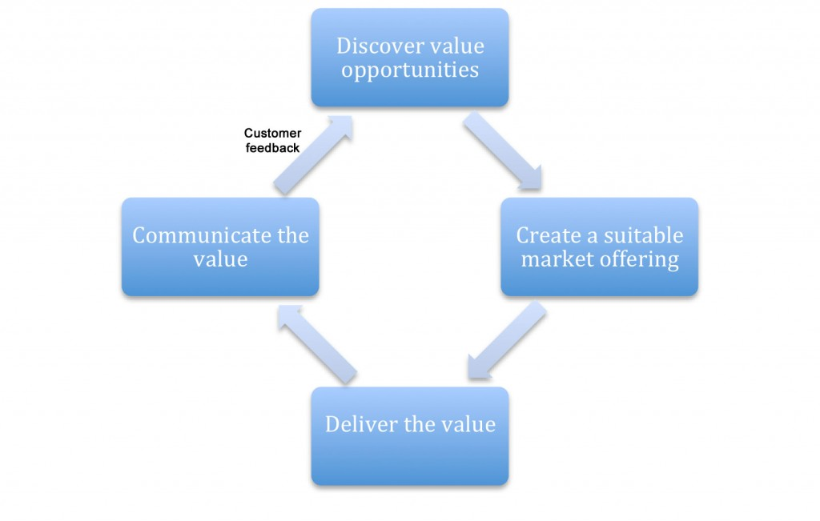
Figure: Customer Value Creation Theory of Marketing
Source: (Sommers and Nowell, 2018)
- Shareholder Mapping Theory of Marketing
This theory of marketing defined how the various marketing activities engaged the internal and external shareholders of an organization. Shareholders are the people of an organization that have an interest in the strategy of the organization (Verhage and Visser, 2018). Shareholders consist of internal and external shareholders. The internal shareholders are the manager of the organization, director, employees, distributors, and the external shareholder of the organization are consists of the company. The various marketing activities critically analyses the shareholders of an organization and engaged them within the organization by providing various information and making effective internal and external strategy as well. Various marketing activities according to this theory explained that shareholders on an organization by creating a clear picture of eh organization and connected with them by monitoring the financial, environmental issues by using the different modern media communication process.
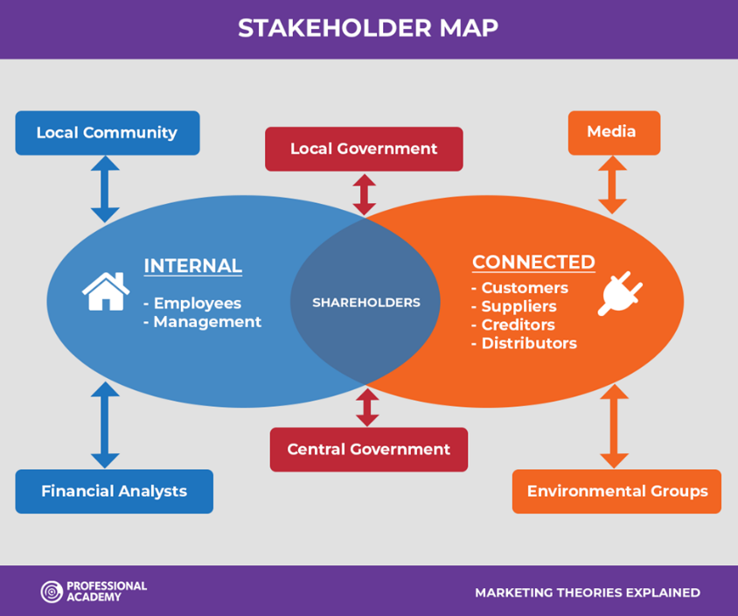
Figure: Shareholder Mapping Theory of Marketing
Source: (Möller, 2016)
- The Role of Marketing in creating Value for Customer
The role of marketing in creating value for customers is huge. Customer value is created by involving the customers between the people and products and customers and company’s through effective marketing activates the process. The way marketing creating value for the customer are explained below-
Providing Proper Information: The marketing activities provide proper information about the customer's need and wants through their information gathering process and enable the organization to fulfill the requirement of the people according to their desire (Grönroos and Ravald, 2011). The organization provides the product that is required by the customer. Thus, through this process marketing activities create value for the customer by satisfying their need properly. For example, Unilever Company creates value for their customer by providing proper information through their marketing activities.
Explaining the Features of the Products or Service: The marketing activities focus on explaining the new and innovative features of products or services among the customer. The new innovative features of the products create value for the customers and motivating them to purchase the products of a company. For example, Apple Company explains the new innovative features of their new iPhone which attract the customer and also create value among them and encouraged them to purchase their products as well.
Identify Customer Expectation Properly: The marketing functions help an organization to find out customers' expectations properly through the market research process. It identifies what customer needs and the market demand properly and delivers the kind of products or services which attract the customer and create positive customer value as well. For example, Amazon periodically does market research to identify their customers’ expectations properly to create customer value.
Identifying the Value Driving Factors of Customers: The marketing process proudly helps to identify the value-driving forces of the customers. It knows the value-driving forces of the customers are known through marketing surveys, polls, and research process which help the organization to create customer value properly.
Identification and Segmentation of the Customer of an Organization: The marketing process help to identify and segmented the customer of an organization. It helps to segment their customer based on different criteria and help an organization focusing on each segment properly and providing them the products which customer need.
Designing Customer Driven Marketing Strategy: Another way the marketing process creates customer value by properly design and focusing on the customer-driven strategy process. Marketing activities help an organization to establish such a strategy which focus on the requirement of the customers (Mahmoud, et al, 2018). As they focus on the customer they can provide various products according to the requirement of the customer which creates the value of their products and services among them.
Constructed Integrated Marketing Program: The marketing process also focuses on constructed integrated program which ensures to provide superior customer value. The marketing process of an organization helps to disseminate all the information of the customers and based on them the organization critically analyses their customer need and provides them the products according to their preference which creates positive customer value (Gifford, et al, 2010). For example, Nestle Company arrange a different integrated program to gain the internal information of their customer on different occasions.
Quantify Organization Value with Real Data: The marketing process providing a significant role in the case of creating customer value. It quantifies organization value with real data through different customers’ survey processes. It enables an organization to gather real feedback from the customer and information related to their satisfaction level that helps an organization to create positive customer value by taking proper action based on their customer's feedback.
Creating Win-Win Pricing Strategy: The marketing process also creates customer value by focusing on the win-win pricing strategy process. Win-win pricing means determining the product's price at such a level that provides benefits from both customer and the organization's point of view (Barko, et al, 2018). Through the marketing, process the organization can set the product's price at a win-win level through a proper analysis process of their customer’s requirement. This helps to create greater customer values as the customer gets more value compared with their cost of products and the organization also gets benefited. Through this process, both of the parties are enjoying benefits and which help them to create a positive customer value towards their organization. For example, Amazon Company able to set their product price for their various products with help of their marketing process.
Focusing Investment on the Valuable Customer: Through the marketing analysis process an organization able to find out the most valuable customer through the information collection process. Then they provide the best service to them and make them more loyal from the organization's point of view. This process helps an organization building strong customer value by giving more importance to their valuable customer. For example, Walmart provides a special offer to their most valuable customer by analyzing the purchasing history.
Thus the role of marketing in the case of creating customer value is huge. The marketing process of an organization played a significant role in creating customer value through their various internal and external functions and encouraged the people to become more loyal to their organization.

- Shareholder Engagement and their Impact on the Marketing Activities of an Organization
Shareholder engagement is a process through which the investors of a company leverage their position as means of a shareholder to impact the corporate decision-making process (Gifford, et al, 2010). This is the process through which the internal and external shareholders are connected with the organization and provides a significant impact on the company decision-making process. Shareholder engagement is very important from an organization's point of view as the success of an organization largely depends on its participation process. It is more imprint as it plays a significant impact on the marketing strategy creating and decision-making process. It ensures the long-term involvement process of the shareholders with investors, customers, and other parties related to the organization. It also ensures achieving a win-win marketing strategy which is very essential from every organization's point of view. The win-win strategy helps an organization to ensure benefits from both organization and the customer’s point of view. It provides benefits both the internal and external parties related to the organization and make the board of directors more efficient and capable to take effective decision especially regarding with the marketing concerns. This also helps an organization to critically analyses different marketing functions with various parties of an organization, ensuring personal interaction of each of the parties where they can discuss the various issue to improve management performance and the capital manage and customer management process.
Shareholders provide a significant impact on the marketing activities of an organization. They make effective decisions regarding various marketing strategies. They set the marketing plan, strategy, functions, goals, and other related factors that provide a significant impact on an organization's marketing point of view (Grönroos and Ravald, 2011). The impact of shareholder engagement on the marketing activities of an organization are explained below-
Setting Marketing Strategy: Shareholders provides a huge impact on setting the marketing strategy of an organization. They make the marketing strategy by considering several factors and focus on the effective implementation process of this strategy to opera the marketing activities effectively. The success of an organization largely depends on their engagement process with the marketing functions of an organization and the shareholders need to give their best effort to make the right marketing strategy to attain the goal of the marketing department. For example, the board of directors of Tesco Company set their marketing strategy and try to achieve the goal of the marking department by continuously monitoring them properly.
Setting Marketing Goals and Objectives: The shareholder engagement process of an organization played a significant impact on setting the marketing department's goals and objectives as well. They through their engagement process set then short-term and long-term goals and objectives of the marketing department and based on these goals and objectives and organization operate their marketing activities to attain these goals and objectives properly (Möller, 2016). They set the target for each year and all the activities are carried out based on their desire target. Thu the shareholder engagement process is provided a significant impact on their marketing activities of an organization. For example, Unilever set their marketing goals to increase their product sells 25% within the next 3 years and their marketing department is working based on the desired target to ensure this.
Setting Marketing Plan of an Organization: The shareholder's engagement process with the organization also played a significant role in making an effective marketing plan for an organization. The shareholders of an organization set effective marketing. They prepared the marketing plan and based on their plan the marketing department works to attain the goal of an organization.
Situation Analysis: The shareholders played a significant role in the case of analyses site marketing situation proper of an organization. The erratic analyses and access the organization marketing situation and based on the current condition take effective decisions and steps for achieving the goals of the marketing department of an organization through the proper implementation process of marketing activities. They adopted various short-term and long-term strategies based on the situation analysis process and enable an organization to operate its activities effectively.
Marketing Mix Analysis: The shareholders of an organization also played a significant impact on the most vital marketing activity process which is the marketing mix processes. They critically focus on every element of the marketing mix such as products, price, place, promotional activities process, people, physical evidence, etc. (Grönroos and Ravald, 2011). They try to set the products price level in the optimal level which encouraged and attracts the people to buy the products of accompanying. They help to target profitable places to sell their products and attractive promotional activities to increase the sales portion of the marketing department. They also focused on set the process of producing the product and make the physical storage in such a place that enables an organization to reach their customers easily. Thus they played a significant role in operating every marketing activity and enable an organization to attain its goals and objectives properly.
Implementation and Control Various Marketing Activities: The shareholders also making a productive impact in the implementation and controlling the process of various marketing functions, strategies and plans. They implement the marketing strategy, plan and monitoring them properly (Mahmoud, et al, 2018). They take corrective actions in any area where the improvement is required to operate the marketing function properly and try to implement the goal of the marketing department of an organization.
Thus it can conclude that the shareholder's encampment process provide a significant impact on the marketing activities of an organization. They through their involvement process try to give their best effort to achieving the target of the marketing department and monitoring every marketing activity properly.
Therefore, the entire report explains various issues related to the marketing fundamentals process of an organization. It explained the divisive role of the marketing functions to create customer value and attract the customer to purchase the organization's goods and services. It also explained the impact of the shareholder's engagement process on the marketing activities of an organization and their contribution as well. The marketing process critically impacts in case of creating positive customer value towards the organization. It helps them to make a customer more loyal to the organization and retain them with the organization and influence them to purchase their products continuously.

Reference
Barko, T., Cremer’s, M. and Renneboog, L., 2018. Shareholder engagement on environmental, social, and governance performance.
Gifford, E.J.M., 2010. Effective shareholder engagement: The factors that contribute to shareholder salience. Journal of Business Ethics, 92(1), pp.79-97.
Grönroos, C. and Ravald, A., 2011. Service as business logic: implications for value creation and marketing. Journal of service management.
Hartley, R., 2013. Marketing fundamentals. New York: Harper and Row.
Mahmoud, M.A., Hinson, R.E. and Anim, P.A., 2018. Service innovation and customer satisfaction: the role of customer value creation. European Journal of Innovation Management.
Miller, K., Stanton, W., and Layton, R., 2018. Fundamentals of marketing. Sydney: McGraw-Hill.
Möller, K., 2016. Role of competencies in creating customer value: A value-creation logic approach. Industrial marketing management, 35(8), pp.913-924.
Russell, E., 2018. The fundamentals of marketing. Lausanne: AVA Publishing SA.
Sommers, M., and Nowell, D., 2018. Fundamentals of marketing. Toronto: McGraw-Hill Ryerson.
Verhage, B. and Visser, M., 2018. Marketing fundamentals. Groningen: Noordhoff Uitgevers.

