

Digital Skills
Module assignment submission

Student Name: | Javier Portaro
Student Number: | 1906228
Module No. | BMSW4003_LON
Module title: | The Impact of the virtual learning environment
Lecture: | Modak Koushik
Date: | 26-04-2020

Table of Contents
- Introduction
1.1 Review
- Research Methodology
2.1 Qualitative data methods
2.2 Quantitative data methods
- Population
3.1 Sample
3.2 Sample size
- Analysis, Findings and discussion
- Conclusion
- References
Appendix
Appendix
A report on The Impact of the virtual learning environment.

1 Introduction
In this assessment the main objective is to talk and develop all the information about the students from UWSD London about the Impact of the virtual learning environment and how the research that was carried out in this report to obtain data on the opinions of students in relation to the use of this new digital environment to conduct classes and to trough internet and use information from Moodle.
With the help of a survey carried out to UWSTD students in order to obtain qualitative and quantitative information that allows us to know details of the benefits and difficulties that the students found when using and navigating within the digital environment of the university, organization of group meetings and classes with Microsoft teams.
Through an analysis of the statistics that this survey produced we will be able to know exactly how the students felt these changes when now we are working in this environment one hundred percent and at the beginning the time we spent in Moodle was minimal only to download and review content uploaded by the teachers.
Review
The students nowadays, like the previous generation, have advantages in the digital environment. Since childhood they are related to it either by a home computer or the different devices that exist today. In this case they can develop a more natural and organic way into the digital environment. One of the difficulties to face is working remotely since students are commonly trained to work as a team but not in person as we are doing today and this initially generates different difficulties such as lack of communication, disorganization and colleagues who have lack.
It also has other advantages such as being able to work from home without losing weight, it generates less pollution and is faster. (S. McCombes, 2019)
People used to study only at a school in the old days. But people today need only a device and internet connection. They can learn when they want, at home or at a coffee shop. As the learner's skills, knowledge, and they share it, so does the teacher's position.
We as learning professionals need to adapt and find new ways to offer the best possible learning experience, people are studying or trying to learn something together. As far as collaborative learning is a new trend, we think of problem based conversations, reflection and other aspects in which students become the principal part of the learning process.
It is an unavoidable outcome the Internet has brought on. Now we can connect with others, in real time, the way we want. Students from all over the world turn to each other for help in online sessions or online enabled class and interact in virtual classrooms. We meet others who, as their journey continues, share their interests and work with them.
From passive to active or brain-based learning this change from passive to active learning or from a teacher-centered approach to student-centered learning is perhaps the most important technical result.
Students are no longer happy producers merely taking notes or listening to teachers speak without interruption for hours. Now they have different standards when it comes to study. They want to be part, or have an opinion, and have a sense of control over their learning.
In general, these new learners turn to mobile apps to learn anything at any time. To access for any information directly, they turn to the internet, and eventually solve a problem. They always refer to their instructors or teachers but only to look for guidance.
Technology is a tool for productive learning. Through it, the learners can study, interact and solve problems. Any time they browse the web, they can access a huge knowledge library directly. The web provides them with a whole host of data, not just text. The network is not linear nor hypermedia. Most significantly, the web provides them with the right to learn according to their own paths of their own choosing. Learners can be authors and problem solvers, not just spectators.
Passive activities are being outdated while teachers are now occupying another significant role as guides. (SEO S. Behren,2016) Blackboard’s confirmed this in an article he wrote for US News last year. "If we actually want to engage active learners, learning needs to become much more open, mobile, social and analytical"
The Emergence of differentiated instruction perhaps even more important than collaboration is the potential of the Web to offer the learning experience with full personalization. Learners of any single 'unit' are likely to have numerous needs to satisfy and not all of them aim for the same learning goal. Each of them has its own collection of interests, goals, competencies, principles and priorities.
Therefore, applying different styles of instruction to different learners is vitally necessary. No single approach will account for all their learning needs. A versatile, customised approach to delivering content is a must.
After all, technology not only promotes interactive learning, it also allows teachers to respond to the individual learners ' needs. A combination of self-study, individualised training, and group study has, in fact, proven successful repeatedly. (Carol Tomlinson 2017), a distinction specialist, has already recorded the progress of students who are taught based on their educational profiles and readiness levels.
2 Research Methodology

2.1 Qualitative data methods:
1. Qualitative methods of study typically collect data, where the participants encounter difficulties or problems. These are real time data and seldom get the participants to collect information from a group of people or a geographic location.
2. Qualitative researchers usually collect the sources of data, such as interviews, observations and records, instead of focusing on a single source of data.
3. This type of research approach helps to solve difficult problems by breaking down into simple inferences which are easily understandable and understood by all.
4. People may build their confidence on the researcher because of its more communicative method and the information we obtained is accurate.
During this research for answer and the analysis of the survey results, we faced different challenges, such as conducting it 100 percent online. We had the difficulty that one or more of the respondents did not answer the survey questions, they did not send the survey responses, or they did not respond honestly and objectively way.
2.2 Quantitative data methods:
Quantitative study is defined as a examination through the compilation of accurate data and the application of statistical, mathematical, or digital techniques. Quantitative research use tools to collect and carry on with online surveys, web polls, questionnaires, etc. from current and prospective customers and answer online surveys, interviews and questionnaires.
The results of this can be replicated in statistics with percentage or numbers. After analysed and understand these figures carefully to show the future of a product or service and make any change or arrangement before start.
An example of quantitative study is the survey performed to determine the amount of time it takes for a doctor to attend a patient when the patient reaches the hospital. A prototype of a patient satisfaction survey can be given to ask questions such as how much time a doctor has taken to see a patient, how often a patient comes into a hospital.
Quantitative work is often carried out in the social sciences using the statistical methods mentioned above to collect quantitative information from the sample. The models for quantitative analysis are analytical, detailed, and at times even investigative. The findings of this research approach are rational, factual and unequivocal. The collection of data took place using a structured method and carried out on a large scale of samples that represent the entire population.
Survey this type of research can be conducted with a specific target audience group and can also be conducted with comparative analysis across multiple groups. A precondition for this type of research is that the respondent sample must have members selected at random. This way, a researcher can easily preserve the accuracy of the results collected, because an addressee would be a huge variety of respondents using random selection.
3 Population
The studying an entire population will very difficult and expensive, for example while conducting a survey. Sampling is a method that allows researchers to get information about a population based on results from a small part of the total of a population, without having to investigate every individual.
Reducing the number of individuals in a study decreases costs and work, which can make it easier to collect information of high quality, but this must be balanced against providing a sufficiently large sample size with sufficient power to detect a true correlation.
3.1 Sample
A small portion of people is chosen from the population to have a sample of the entire population. The chosen ones must be of the same type or have things in common like the gender, age or preferences the participants is not an important detail for this small group of participants who will become the sample.
1. Systematic sampling
Systematic sampling is like simple random sampling. all the member of the population is listed with a number, but instead of randomly generating numbers, individuals are chosen at regular intervals.
2. Simple random sampling
In a simple random sample, every member of the population has an equal chance of being selected.
3. Stratified sampling
This sampling method is use when the population has mixed characteristics, and you need to ensure that characteristics are proportionally represented in the sample.
4. Cluster sampling
Cluster sampling involves dividing the population in subgroups, each subgroup have similar characteristics to the whole sample. Instead of sampling individuals from each subgroup, you randomly chose entire subgroups.
My sample will be 30 students from UWTSD London with different types of closed, open and multi-choice questions.
In this case the chosen method is the Cluster Sampling since I use a small part of the total number of UWTSD students and I choose also all the available students from the group 8 and to complete the 30 participants some other students from the same campus in Holborn Circus who are taking the second term. This survey in going to be about the impact of the virtual learning environment.
3.2 Sample size
The size of the student sample that we chose for the survey is a small part of all UWTSD students. This chosen group will be considered the number of verify data in a sample, recognized by the letter N.
It is also mentioned that this type of research is carried out with a small sample of the total for students since it is an economically more viable option due to its lower cost if we compare the investment of doing a survey of all UWTSD students.
4 Findings, Analysis and discussion
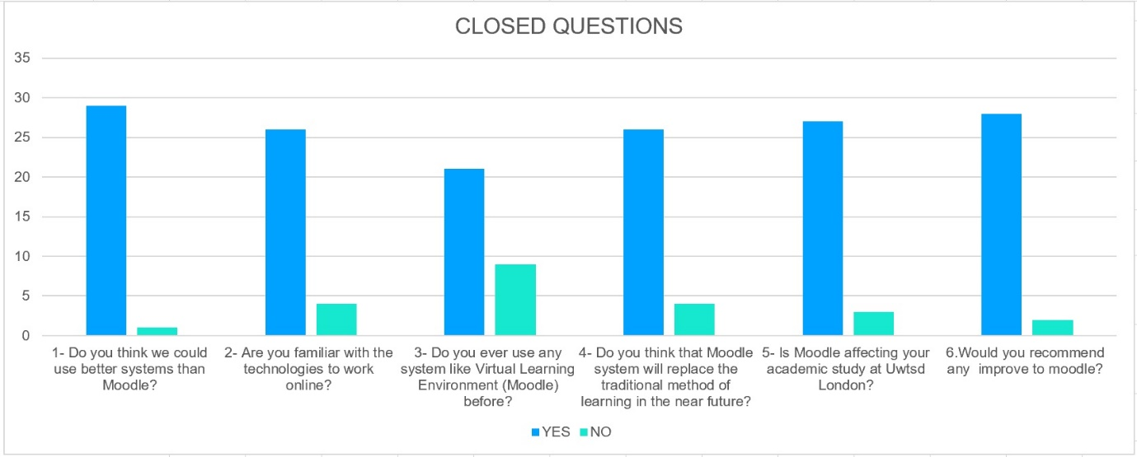
After reviewing the survey results, we see that there are different opinions divided into several of the 8 questions. In general, the students are very open to the use of digital platforms to support their studies. In this case Moodle would be the main example since all the content seen in classes can be reviewed there, also upload our assessments and see the results. It is a complete platform with a lot of information to see.
MULTIPLE CHOISE QUESTION

When reviewing the different sources in order to carry out this report, most authors of articles on the subject agree that in the coming years the trend is that students will have to adapt even more to the digital environment in order to continue studying and remain competitive in the academic and labor

6 References
Barrat, H. and Shantikumar, S., 2009. Methods Of Sampling From A Population. [online] Health Knowledge. Available at: <https://www.healthknowledge.org.uk/public-health-textbook/research-methods/1a-epidemiology/methods-of-sampling-population> [Accessed 4 May 2020].
RUCKER, M., 2017. How To Determine The Sample Size For Your Study - Thesis Writing & Dissertation | Academic Writing Help For Those Feeling Stuck. [online] Thesis Writing & Dissertation | Academic Writing Help for Those Feeling Stuck. Available at: <https://unstick.me/determine-the-sample-size-study/> [Accessed 12 May 2020].
Soilemetzidis, I., 2019. How To Run A Successful Survey And Raise Response Rates | Higher Education Academy. [online] Heacademy.ac.uk. Available at:<https://www.heacademy.ac.uk/blog/how-run-successful-survey-and-raise-response-rates> [Accessed 7 May 2020].
the Guardian. 2016. Student Surveys Are A Waste Of Everyone's Time. [online] Available at: <https://www.theguardian.com/higher-education-network/2016/jul/01/student-surveys-are-a-waste-of-everyones-time> [Accessed 10 May 2020].
Gutierrez, K., 2014. Four Ways Technology Is Changing How People Learn [Infographic]. [online] Shiftelearning.com. Available at: <https://www.shiftelearning.com/blog/bid/336775/Four-Ways-Technology-Is-Changing-How-People-Learn-Infographic> [Accessed 8 May 2020].
Appendix 1
Questionnaire

The impact of virtual learning environment impact on the students of UWTSD London

This survey is conducted as part of a research project for Digital Skills and Research Methods (BMSW 4003 Term 2)

Instructions:
- Please answer all the questions.
- Additional instructions for certain questions may be provided below those questions.
*Please note that information provided by you and your identity will be kept confidential.

- Do you ever use any system like virtual learning environment (Moodle before?

Yes

No

- Do you think we could use better systems than Moodle?

Yes

No

- Are you familiar with the technologies to work online?

Yes
No

- Do you think that Moodle System will replace the traditional method of learning in the near future?
Yes
No
- Is Moodle affecting your academic study at Uwtsd London
Yes
No
- Would you recommend any improvement to Moodle?
Yes
No
- How would you rate Moodle?
Very good, Good, Medium, Bad and Very bad
- Would you recommend Moodle to a Friend?
Definitely, Yes, Not Sure, Not and Never
Appendix 2


