Belinda Golding
1706757
Module number M4X01559
Ways of Perceiving
8th May 2018
1200 words

This year, 2018 ,is the centenary of the Representation of the People Act, which allowed some women the right to vote, which was pioneered by the steadfast and iron determination of the suffragettes. Society has developed in the last 100 years but in terms of the art world and society in general there are still large genders gaps. In an article by (The Guardian newspaper in 2017 ) studies showed that in the National Gallery of Scotland there are only 4% female artists, 20% at The Whitworth Gallery in Manchester are women, 30% of artists in the Tate are women and only 33% of artists representing Britain at the Venice Biennale are women. These figures clearly state inequality but they are shifting in the right direction especially since the Feminist Art Movement which began in the 1960s which was born out sheer frustration and disgust at women been seen as second class citizens who should stay at home to be domesticated and look after the man who was deemed to be the dominant sex.
Simone De Beauvoir (Robinson 2001) the French philosopher/feminist/social theorist was quoted to have said ‘Representation of the world, like the world itself , is the work of men. They show if from their own point of view, which they confuse with absolute truth’
The art exhibition that I am going to curate is intended to celebrate and re-address women pioneers of the Suffragette movement and also the Feminist Art Movement which began in the 1960’s. I will be showing Gillian Wearing’s statue of Millicent Fawcett, who was a leading suffragist, political leader and feminist. Judy Chicago was a pioneer and one of the founders of the Feminist Art Movement so I will be exhibiting a key piece of one of her works. Mary Beth Edelson, also a feminist pioneer in the Feminist Art Movement and the little known Renaissance female artist Plautilla Nelli, whom along with countless others has been airbrushed from art history.

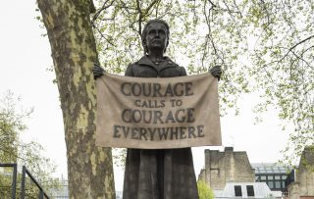
Gillian Wearing, Bronze statue at Parliament Square, London of Millicent Fawcett. (2018)

This bronze statue which in itself regardless of any subject matter is an astonishing piece of work. It is cast in bronze but it looks like tweed which is a highly skilful accomplishment. However, this statue is all about what it represents and who it is. Firstly, Gillian Wearing in creating this monumental piece of work became the first female artist to have created a statue to stand on Parliament Square. Secondly, this statue of Millicent Fawcett is the first statue of a woman to stand on Parliament Square. Thirdly and probably most crucially is Millicent Fawcett herself and exactly what she and fellow suffragettes wanted to achieve through their activism, determination and pure inspiration to stand up for what is right, to never give up on fighting for equality. Millicent Fawcett (1847-1929) was a British activist, writer, intellectual who campaigned tirelessly to improve women’s rights and opportunities to higher education.

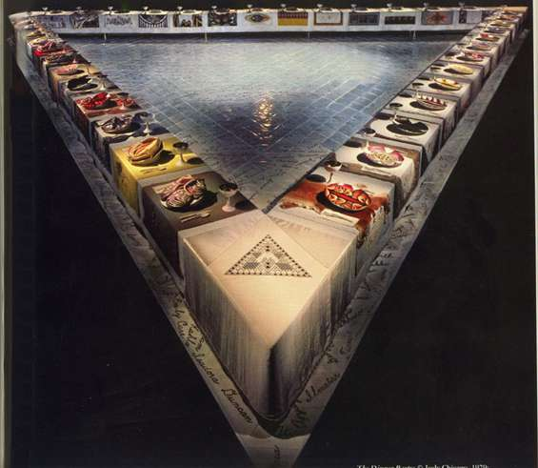
Judy Chicago (The Dinner Party) 1974-1979. Permanent display at the Elizebeth Sackler Center for Feminist Art at Brooklyn Museum, New York.

The Dinner Party is a large scale installation comprising of a rectangular table which measures 48 feet per side to triangle. It has 13 place settings on each side, totalling 39. Each place setting has an elaborately embroidered runner and napkin and goblets trimmed in gold, with hand painted china plates brightly decorated in forms that represent the vulva. Each place settings are for women throughout history all the way from Pre-history to Roman Empire, Christianity to Reformation and American to Women’s Revolution. (Chicago 1975).
The Dinner Party was proclaimed ‘the first feminist epic artwork’ The Dinner Party (1979) I agree that it is an epic piece of work in the fact that it pushed all boundaries in the male dominated art world and brings to the forefront of the public mind that there have been great female pioneers in history and still living that are eradicated from history lessons in schools and educational establishments. Linda Nochlin’s essay in 1971 ‘Why Have There Been No Great Women Artists?) answers this question in an enlightening way that gets to the core of why. As we become more educated thanks to women such as Millicent Fawcett and women of the Feminist Art Movement and Linda Nochlin we have realised that women are seen as the inferior sex incapable of anything but homemaking etc, therefore not encouraged to paint and devote time to nurture and develop their skills as men were. Also we
learn that there have been utterly tremendous women painters but because of institutional sexism in educational establishments they have been eradicated from history lessons.

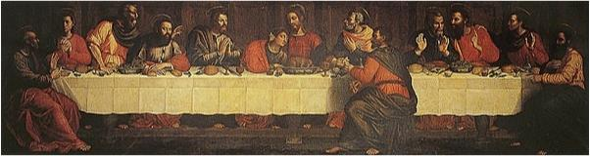
The Last Supper, Plautilla Nelli (1524-1588) Seven meter long painting, restoration due to be completed 2018 .

Plautilla Nelli (The Guardian 2017) was one the first know female painter of the Renaissance period and this painting is the first of it’s kind in the history of art by a women so I feel it fitting to go to into the exhibition. So little is known of Nelli however her male contemporaries such as Leonardo Da Vinci is a household name. Plautilla Neilli was a nun and she was self taught and most of her paintings are large scale. The Last Supper is a prime example of how women artists have been overlooked and exonerated from history until recently when this beautiful painting with all its imposing glory is being restored and will be on display at the Santa Maria Novella in Florence in 2019.
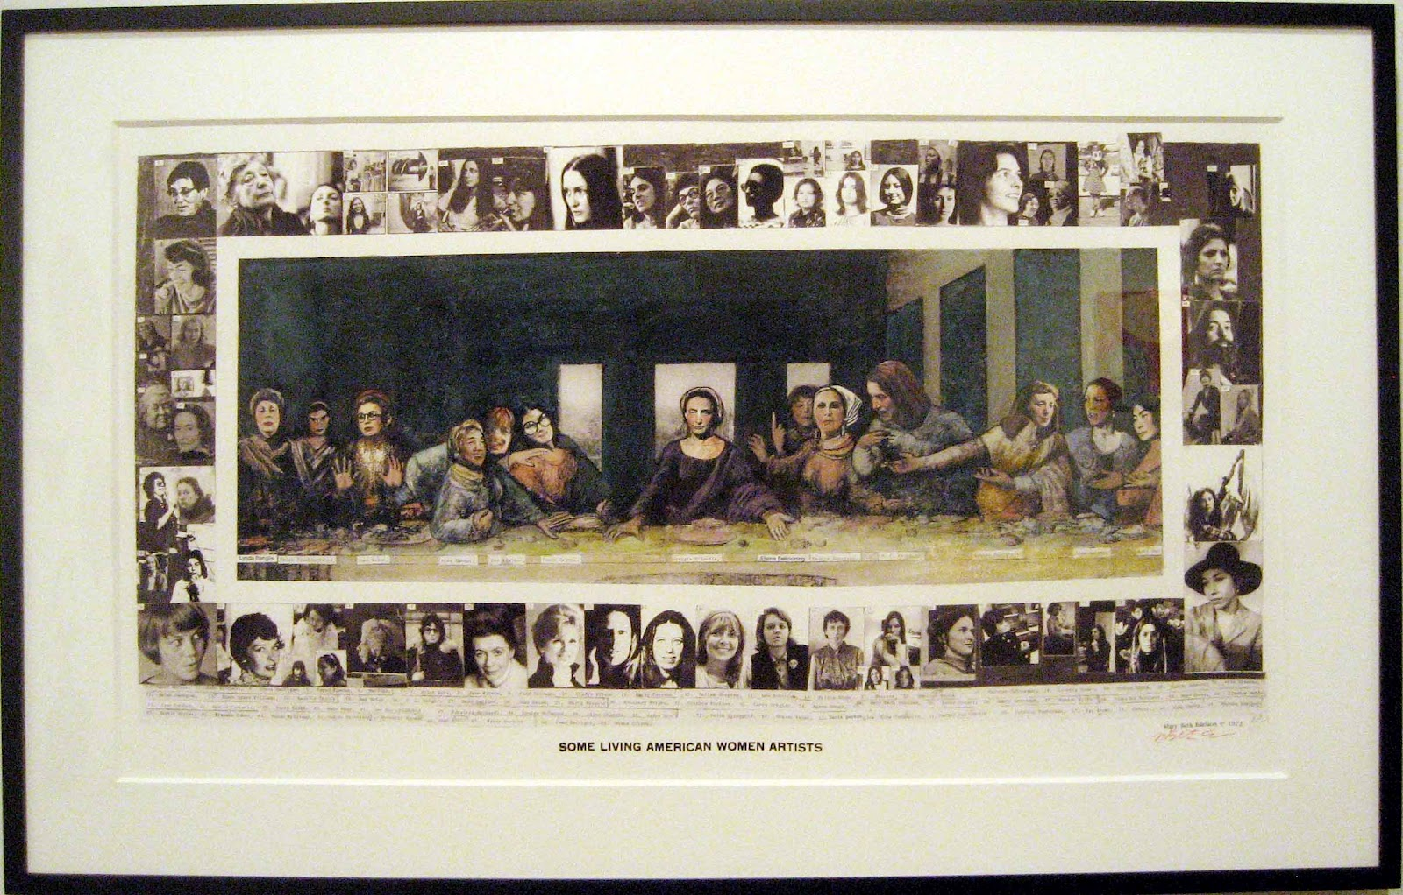
Some Living American Women Artists/Last Supper (1972) Mary Beth Edelson

Mary Beth Edelson along with Judy Chicago was also a pioneer in the Feminist Art Movement. I feel this complements the Last Supper by Plautilla Nelli but also highlights and indicates how feminism has moved on. Where Nelli’s painting depicts the original biblical scene (all male) Edelson has used collage to add women artists heads on Leonardo Da Vinci’s painting. It really challenges in such a provocative way the subordination of women in all society and particularly in religion. John The Baptist’s head is covered with Nancy Graves (American painter and sculpture) and Christ’s head is covered with Georgia O’Keefe (American painter) This really is sign of the times of how feminism is developing and along side Judy Chicago’s The Dinner Party, it has become one an iconic piece of feminist art.

I hope that the exhibition will prove to be thought provoking, educating and inspiring. Not just in terms of the technical skill of the artists but for what they stand for. We are in the midst of the third wave feminism , the first wave being when the Suffragettes steadfastly and passionately never gave up that fight to make lives better and more equal. The second began in the 1960’s with the Feminist Art Movement and now we still striving for more equality and to eradicate some still deep seated beliefs that women are the inferior sex. However I feel these pieces of work that I have chosen for my exhibition are hugely significant to represent where we are today and set the tone for more equality to be achieved.

BIBLIOGRAPHY
Chicago J (1982) Through the Flower. New York. Anchor Press/Doubleday
Robinson H (2001) Feminism-Art Theory. Massachuttes. Blackwood Publishers
The Guardian (2017) ‘How the Art World Airbrushed Female Artists from History’ February 2017
The Guardian (2017) ‘New Renaissance – How Florence is Freeing its Great Female Artists’ December 2017
Art News (1971) ‘Why Have There Been No Great Women Artists?’ Linda Nochlin

