DISSERTATION – REPORT

AN INVESTIGATION INTO THE LEADERSHIP AND MANAGEMENT, THEORY AND PRACTICE OF TESCO

STUDENT NAME: VASILKA ATANASOVA STUDENT NUMBER: 1818595
SUPERVISOR: DR TAYE OSADIYA MODULE CODE: LCBB6000

Table of Contents
Chapter 1: Introduction 4
1.1 Introduction 4
1.2 Background 4
1.3 Organisational background 5
1.4 Aim of the Research 5
1.5 Research Objectives 5
1.6 Research Questions 5
1.7 Rationale of the Study 5
1.8 Limitations of the study 5
Chapter 2: Literature Review 6
2.1 Leadership 6
2.1.1 Leadership theories 7
2.1.2 Leadership styles 7
2.2 Management 8
2.2.1 Management theories 8
2.3 Application of leadership and management 9
2.4 Issues and challenges related to management and leadership 10
Chapter 3: Research Methods and Methodology 11
3.1 Research Methodology 11
3.2 Research philosophy 11
3.3 Research Paradigm 12
3.4 Research Approach 12
3.5 Research Strategy 12
3.6 Data Collection 13
3.7 Sampling Method 13
3.8 Research Analysis 14
3.9 Ethical consideration 14
3.10 Research Timeline 14
Chapter 4: Data findings, analysis, presentation and discussion 14
4.1 Data presentation 14
4.2 Discussion of results 22
Chapter 5: Conclusion and recommendations 24
5.1 Conclusion 24
5.2 Reflection and recommendations 24
References and Bibliography 26
Appendices 28
Appendix 1: Research questionnaire 28
Appendix 2: Gantt Chart 30
Ethical Approval Form 33
Participation Consent Form 45
Participant Information Sheet 47

Chapter 1: Introduction

Introduction
Leadership and management styles are playing a major role in enhancing operations in today’s organisations. This because according to Ololube et al. (2015), good leadership and management requires patience, knowledge, skills experience and commitment. Therefore, contrary to the notion that good leaders are born, good leaders are made and developed through training and education. It has become increasingly important to understand the concepts and principles governing good leadership and management in various fields.

There are various leadership styles and management theories which have been utilised in different industries. These theories and styles vary in productivity and situation with which they are applied. Leadership theories and styles are mainly involved in guiding employees towards achieving an organisation’s objectives. Management on the other hand aims to achieve stability or consistency during operations, and in achieving order (Aamir Jalal Al-Mosawi, 2019).
This study engaged the researcher to explore the different concepts and applications of management and leadership styles as applied within organisations. It therefore used Tesco as a case study example, to collect and analyse information pertaining the research topic.

1.2 Background
Leadership and Management are interchangeable terms that are frequently used as one, but are fundamentally different from each other. Hence, Reiche BS et al. (2017) asserts that leadership plays a crucial role in the effective management of organisations. In their contribution to the discourse, Forsyth and Maranga (2018) define leadership as a social process which is designed to influence a group or directing a group towards achieving a certain specified goal.
Management on the other hand is the process that involves a number of actions that include “planning, decision making, organizing, leading, motivation and controlling” the resources of an organisation with the aim of reaching the goals of the organisation effectively and efficiently (Ciulla, 2020). It is therefore reasonable to suggest that when an effective leadership is accorded with effective management, such approach has the tendency of setting an organisation in a direction that may accelerate their chance of achieving their goals.
There are different theories and practices of leadership and management that an organisation can adopt in running their operations. The theories and practices an organisation adopts could affect a number of issues in the organisation, this includes, the performance of employees, employee retention and the performance of the organisation (Jakubik M et al., 2017). As such, an organisation should be deliberate in finding out the best theories and practices of leadership and management that allows them to achieve their goals.

1.3 Organisational background
Tesco is a well-known multinational groceries and general merchandise retailer that is based in UK. Based on the firm’s revenues, the retailer is ranked as one of the largest retailers of the world (Statista, 2022). The organisation employs more than 400,000 employees. Other subsidiaries of Tesco include Tesco Bank, Tesco Ireland, Booker Group, Tesco Mobile among other subsidiaries (Tesco, 2021). Hence, investigating the leadership and management of the organisation was critical in identifying the good theories and practices that can increase the competitive edge of the business and help eliminate the theories and practices that do not work within the organisation

1.4 Aim of the Research
The main aim of the research was to investigate the theory and practice of leadership and management at Tesco PLC.

1.5 Research Objectives
- To investigate the leadership and management theory and practice at Tesco.
- To examine the effect of Tesco’s leadership and management theory and practice on the organisation.
- To understand the best leadership and management theory and practice that can impact Tesco positively.

1.6 Research Questions
- What are the leadership and management theory and practice at Tesco?
- What is the effect of Tesco’s leadership and management theory and practice on the organisation’s performance?

1.7 Rationale of the Study
The aim of this research was to explore the leadership and management theory and practice that is found at Tesco and to examine the possible leadership and management practices that can be applied in an organisation. To evaluate the effectiveness and the impact of these practices, the study evaluated the concepts and theories related to leadership and management. Within the scope of the study is also some of the styles applied within organisations and how they influence the mode of leadership and management.

1.8 Limitations of the study
The study was limited to the leadership theory and management practice at Tesco. It therefore did not evaluate other factors which play part in enhancing organisational performance. Since the study was internally financed, there were constraints to resources which limited the amount of stationery used. Most of the communication and analysis was therefore done online. The over-reliance on the internet for communication with respondents brought delay to the research process. However most of the challenges within the study were mitigated and the study was carried out timely.

Chapter 2: Literature Review

2.1 Leadership
Leadership is the ability of a person to persuade people to seek certain defined objectives with enthusiasm (Cuilla 2020). Therefore, the nature of leadership is that of an inter-personal process where one person is in the business of influencing others and guiding employees in attaining the organisational goal (Reiche BS et al., 2017). A leader must have certain qualities which enable them to make decisive and accurate decisions which affect a group of people and their outcome. Its paramount for a leader to have qualities which allow encouraging others, strategic thinking, cross cultural communication, self-awareness and the development of others.
Leadership is also a group process where more than two persons are involved in interacting with each other. Many organisations are made up of different departments which are led by different leaders. This forms a hierarchy where different leaders work under the supervision of senior leaders. This collective has to work together to meet the overall objectives of the organisation. Some scholars hold the view that there are no known best leadership styles since leadership depends on the situation (Forsyth and Maranga, 2018). According to the authors, there is no leadership style which fits all, it is therefore important to understand the different forms of leadership which can be applied.
Leadership in an organisation is a very important function of management that guides a business to maximise efficiency and to achieve organisational goals. Leadership can help the organisation achieve its goals through several actions (Reiche BS et al., 2017). One of the actions is initiating action through communication of policies and plans to the employees which is the basis of work. Another action of leadership is motivation where the leader motivates the subordinates through non-economic and economic rewards. Leadership also provides guidance and creates confidence among the employees hence enabling the employees to perform their work effectively and efficiently (Jakubik M et al., 2017). These actions serve the purpose of helping the organisation to achieve its goals.

2.1.1 Leadership theories
The leadership functions are deep rooted in theories. Hence, these theories are grouped into behavioural theories and contemporary theories. The behavioural theories are mostly concerned with the connection between leadership behaviours and the performance of the group. The contemporary theories of leadership on the other hand focus on the significance of situational factors on the performance of the group. The leadership theories and practices include Path Goal Theory, Trait Theory, Transformational Leadership, Transactional Leadership, and Fiedler’s Contingency Model (Empson and Langley, 2015).
The path goal theory is based on the fact that a leader’s role is to offer guidance to employees by providing guidance, support and direction in order to achieve objectives. The theory pays focus to the behaviour of a leader which promotes performance, motivation and satisfaction. The trait theory, as the name suggests, is dependent on the traits and values of a leader. The theory suggests that these traits within a leader are inborn. Therefore, there are individual differences and consistencies within the traits of different leaders. Leaders and managers can make use of this theory in evaluating the position of various people within an organisation with an attempt to make the organisation stronger (Nwakpa, 2013).

2.1.2 Leadership styles
Based on literature, leadership styles can be categorised into democratic, autocratic, transformational, laissez-faire, transactional and other forms of leadership. Transformation leadership is made up of leaders who are actively involved with their employees in helping them solve practical problems. It is very useful in motivating employees by motivating them through simple activities, as opposed to the laissez-faire, where leaders avoid making practical decisions (Jamal, 2014).

The autocratic leadership style is a unidirectional form of leadership where decisions within an organisations are made from the top. This form of leadership does not offer employees the chance to raise their concerns, unlike the democratic form of leadership which is more influential. Unlike the autocratic leadership, democratic leadership seeks input from employees which creates trust and motivation among employees (Bhargavi and Yaseen, 2016).
Transactional form of leadership involves rewarding employees based on their performance. It differs slightly from transformational leadership, which mainly motivates its employees by empowering them through training. Paternalistic leadership is mainly practiced in small businesses which resemble family settings, where one person makes all the decisions regarding the business (Aydin, 2018). Different organisations practice either of these forms of leadership, depending on their size and goals.

2.2 Management
Management on the hand is an art that allows one to know what to do, when to do and able to do it efficiently and effectively in the cheapest way. Management is purposive in nature, where the person works with subordinates to ensure that the intended objectives and goals are obtained. Management also, creates a conducive environment for the employees to efficiently and effectively perform their tasks (Ducker, 2012). Hence, management focuses on effective and efficient performing of work.

Management is important in ensuring that the organisation achieves its goals through the effective arrangement, assembling and organising of production resources in an effective manner (Daft and Marcic, 2016). Hence, management ensures that the physical and human resources are well utilised for organisational productivity. Consequently, an organisation is able to reduce costs thus, maximising on profits. Management is also able to establish a sound organisation with an equilibrium, setting the organisation on the path for prosperity for the wider benefit of the society (Drucker, 2019). Therefore, effective and efficient management is a key factor for a better economy that improves the welfare of people.

2.2.1 Management Theories

Management is guided by theories, the same way leadership is. The theories of management tend to address similar concepts. Motivation of subordinates is one of the concepts that the theories of management address. The theories give the managers frameworks of how to successfully handle their responsibilities (Sibley et al., 2016). Management theories are classified into three categories namely the classical management theories, the behavioural theories, and the modern management theories.

While the classical management theory focuses on execution and maximising production, the behavioural management theory is concerned with employees, as they perceive the workplace as a social place. The modern management theory on the hand integrates the two theories as they incorporate the systems thinking and modern scientific methods (Taylo et al., 2013). Classical management theories are scientific in nature and involve the development of employees to increase motivation, which increases organisational performance.

2.2.1.1 Classical management theories

The scientific, administrative and bureaucratic models of leadership, as described by Frederick Taylor, Henri Fayol and Max Weber respectively, belong to the classical management theory. Scientific management involves the allocation of specific tasks to employees in order to perform tasks better. Allocating tasks ensures division of labour, which promotes specialisation (Hussain, HAQUE and Baloch, 2019). Unlike the scientific theory, the administrative theory considers the institution and its organisation instead of the tasks.

The administrative form of management emphasises on following a chain of command. However, even though Henry Fayol insisted on following a chain of command, he posed that employees should be treated equally. The bureaucratic leadership style is based on the development of clear rules and policies within an organisation. Similar to administrative, the bureaucratic leadership is led by authority, where hierarchy plays an important part (Kitana, 2016). Employees under the bureaucratic form of leadership have fixed roles and are expected to follow specific guidelines and rules as directed by their leaders.

2.2.1.2 Human relations theory

This approach pays attention to the theories of Abraham Maslow, Elton Mayo and the likes of McGregor Douglas. As the name of the theory suggests, it pays more attention to the human factor and therefore is focused on the motivation level and behaviour of employees, unlike the classical theory which pays more attention to the task and job. Human relations play a major role in determining the performance and competitive advantage of an organisation, and therefore the positioning and share within the market (Adebayo, 2019).

The theory on hierarchy of needs which was coined by Maslow was among the first theories which paid attention to the needs and requirements of a person. These needs include safety needs, esteem, social, psychological and self-actualisation needs which when well fulfilled promote satisfaction. McGregor’s Theory X and Y indicates the importance of the connection between employees as colleagues, with their superiors and their working environment. Based on the theory, it is important for an organisation to create a conducive working environment which supports and encourages employees to perform their tasks effectively. This environment includes tradition, culture, family and the institution as a whole.
Other theories, different from the human relations and classical theories also exist. They are referred to as contemporary theories which include the systems theory, equity theory, contingency theory, situational theory and organisational theory (Lin and Kheng, 2017). These are theories which are applied depending on situation, and change from time to time. Literature recognises that there is not a single management approach which fits all. It is therefore important to be conversant with the different approaches before applying to an organisation.

2.3 Application of Leadership and Management

Leadership and management play a major role in the performance and success of an any industry. An organisation can apply different forms of leadership or management, dependent on the goals or situation through which an organisation is currently facing. For example, when an organisation is facing a crisis due to an unforeseen event and the current management practices are unable to handle the challenges brought about by changing business environment, then a different management style can be adopted.

Bartsch et al. (2020) indicated the scarcity on literature, which links leadership styles to crises. The authors described the need for information regarding the effectiveness of either relation oriented or task oriented behaviour in leadership within a crisis such as the Covid-19 pandemic. Since different styles of leadership can have differential effects on performance, it is necessary to have a background on how leadership and management can impact the performance of employees and improve their efficiency.

Similarly, leadership and management have found application in transformation of organisations. While undergoing a change in processes of operation or production, leadership and management can assist in promoting transformation. According to Oplatka and Arar (2017), change requires intellectual stimulation, effective employee interaction and a well-built vision, which can be brought about by good leaders. For effective change, an organisation can shift from a previously applied leadership and management practice, with an aim to support transformation.
Leadership and management has also found other applications in business and organisation. For example, job satisfaction among employees was described as a major component of leadership styles by Saleem (2015). In his publication, he describes the positive impact of transformation leadership and the negative impact of transactional leadership on job satisfaction. Management and leadership has also been linked to organisational culture, a factor which has not been taken into much consideration. Ali et al. (2015) described the need for effective leadership style in creating a quality work culture which promotes both employee and organisational performance.

2.4 Issues and challenges related to management and leadership
The management and leadership of an organisation can be faced by various issues. According to Cummings et al. (2018), talent is an issue which has recurrently faced organisations. Since leadership and management style practices in an organisation determine the organisational culture, it also determines the interaction and development of employees. The lack of a good management style can hamper the development of employees and therefore the level of talent within an organisation. Selecting and retaining the appropriate talent challenges many leaders.
Communication is a major issue in ensuring effective management and leadership of employees. Many organisations lack proper infrastructure and incentives which allow efficient communication. It is not only motivation that is required to enhance organisational performance, but also communication (Rahbi, Khalid and Khan, 2017). Communication allows open interaction between employees and other professionals. Lack of proper communication depending on the management style can result in falling revenue and performance of firms. Certain leadership and management styles such as transformational and democratic promote effective communication and interaction of employees while transactional and autocratic do not.
Some management styles have been reported to cause too much pressure on employees by demanding high performance. This issue emanates from heavy workload and high expectations, which can lead to employee burn out and low productivity. In an effort to improve management and leadership, it is necessary for managers and leaders to put enough consideration on employees and their wellbeing. This can be achieved through application of proper job rotation and proper task allocation. The different management styles and theories described above can be applied depending on situation, in order to overcome the challenges and issues within organisations.

Chapter 3: Research Methods and Methodology

3.1 Research Methodology
Based on the nature of the research questions which this study aimed to answer, the research adopted Saunders research onion in describing and following the research process. This decision was influenced by Creswell’s (2009) assertion, that the plan or proposal to conduct a research should involve the intersection of philosophy, strategies of inquiry, and specific methods. On the basis of the theoretical, conceptual and philosophical framework on which the research was intended to be carried out, it was rational to follow the research onion, to ensure all aspects of the research were followed.

3.2 Research philosophy
According to Sheikh and Sultana (2016), all types of research are guided by assumptions or philosophies which define how best a researcher understands and perceives the world. It is therefore a belief that informs how data should be collected, analysed and used. Different forms of philosophies have been employed in social science including positivism, interpretivism, realism and pragmatism. The pragmatism philosophy is mainly biased towards solving practical problems rather than exploring the nature of knowledge. Positivism philosophy involves the testing of hypothesis by carrying out a research study through use of scientific techniques.
Realism on the other hand is involved with the independent beliefs in a study and the reality aspects of the real world while interpretivism is based on how people view the world based on their experiences and understanding of phenomena. The present research was underpinned under the positivism research philosophy. This is because the philosophy is good at scientifically testing of hypothesis through mathematical proof or logical finding that is backed by statistical analysis (Kumar, 2018). Due to the use of scientific methods, the philosophy helped concentrate on the most authentic information, therefore yielding relevant results.

3.3 Research Paradigm
A research paradigm is a set of common agreements and beliefs about how problems should be understood and approached. It can be categorised into three groups which are axiology, epistemology and ontology (Aliyu, 2017). The axiology paradigm is mainly concerned with the roles played by a researcher during a study, and the values involved in research. The epistemology paradigm is based on the form and nature of knowledge and the processes used by a researcher to uncover new knowledge, while ontology is mainly associated with the nature of reality and existence.
The epistemology paradigm was applied in this study, since it is based upon uncovering the knowledge underlying certain phenomenon. In this case, the paradigm was useful since it coincided with the positivism philosophy chosen above, and applies with quantitative methods (Nayak and Singh, 2021).

3.4 Research Approach
Research approach simply identifies the reasoning used by a researcher while carrying out the research. There are two ways to describe how knowledge in social science is acquired, namely the inductive and deductive reasoning. The inductive approach entails a bottom-up process which starts by making specific inferences or observations and ending with a general theory, while the deductive approach is a top down kind of process which begins with general observations, and ends up making specific statements (Khaldi, 2017).
The deductive approach was applied in this study. This is because the approach tests a theory unlike the inductive method where a research places focus on building a theory (Kamal, 2019). It was a proper approach for the study since the study aimed to explore the leadership and management styles in organisations in general, then close in to more specific and efficient methods as applied in Tesco.

3.5 Research Strategy
The research strategy determines many of the research methods to be used, including the sampling and data collection techniques. A research can take the form of qualitative, quantitative or a mixed research strategy, which combines both qualitative and quantitative research strategies. Qualitative research employs qualitative methods in collecting pure qualitative data. It offers more insights and understanding to a topic of study.
Quantitative strategies on the other hand involve the collection of first-hand quantitative data, which is data which can be converted into numerals for statistical analysis. Mixed method strategy makes use of both qualitative and quantitative methods, in collecting both sets of data. It therefore provides more information in a study than when the strategies are applied separately (Khaldi, 2017).
Quantitative research strategy was applied in this study. It was used in guiding the selection of the means of collection of first-hand data, which was converted to numerals and analysed using statistical tools (Mishra SB and Alok S, 2017). Since secondary information was collected from books, journals, and articles that are relevant to the study, it qualified for a qualitative strategy.

3.6 Data Collection
In collecting data, the data collection method that was most compatible with the philosophy and approach of this research is the use of questionnaires. Questionnaires enable the collection of data which can be numerically analysed and therefore quantitative data was collected. They were designed using closed-ended questions with multiple choice answers, which made filling in of data relatively straightforward. Drop and pick method was used where the questionnaires were dropped to the respondents to complete at their own where they were later collected from Tesco HR manager office.
Data was collected from 20 employees from various departments within Tesco. The advantage of applying this data collection method is that it was not tedious thus, did not coerce the research participants (Kumar, 2018). It also allowed for the use of large samples within the study, since analysis of quantitative data is made easy through use of software.

3.7 Sampling Method
Sampling is the process through which a researcher identifies a population relevant for study, and selects a group of individuals from that population to act as a representative (Etikan, Musa and Alkassim, 2016). Sampling has been done through many research studies to save time and resources during a study. It can be classified into probability and non-probability sampling methods, where elements in probability sampling have a known chance of being selected while in non-probability sampling, randomisation is applied which does not offer participants equal chances of being selected as a sample.
The sampling method that was used for this research method was the simple random sampling method. Simple random sampling is a probability sampling method and was considered as the best method since it provides a platform for prospective participants an equal chance to express their views on issues under study. Biasness is also eliminated with this method ensuring that the data which was collected was valid and credible (Nayak and Singh, 2021). Twenty sample respondents, who were employees working at Tesco at the time of study were used as participants.

3.8 Research Analysis
In interpreting the collected information, the software Microsoft Excel was utilised as a statistical tool. The tool was useful in data entry since it made it easy to transfer data contained in questionnaires into softcopy for analysis by software. It was also useful in cleaning and defining variables which ensured that analysis was done on authentic and clean data (Mishra SB and Alok S, 2017).

3.9 Ethical consideration
This study was carried out while observing all university guidelines, and ethical considerations governing social research. Only adult participants were selected to participate in the study, from whom consent was received in form of writing. As indicated on the questionnaire, participation for the study was completely voluntary, and participants were offered the right to withdraw consent anytime during the study. To ensure anonymity, participants were requested not to include personal information on the questionnaire. However, data collected for the study was only used in this study, and was kept secure in accordance to the Data Protection Act 2018.

3.10 Research Timeline
As estimated, the study was undertaken over a period of three months, where different activities were carried out over different periods of time. To ensure that the timeline was met, project management was required, which enabled the integration of different research methods. The research took the form of a cross sectional study, which involved the collection of data from participants on a time basis.

Chapter 4: Data findings, analysis, presentation and discussion

4.1 Data presentation
Section 1: Respondents general information
- Kindly select your age group from the list indicated below
Age group | Frequency | Percentage
20-25 | 5 | 25%
26-31 | 3 | 15%
32-37 | 6 | 30%
38-43 | 2 | 10%
44+ | 4 | 20%
Table 1: Age group
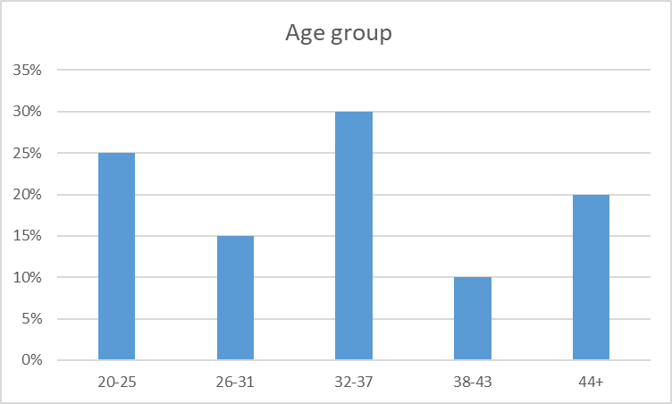
Figure 1: Age group
- Analysis on gender of the respondents

Gender | Frequency | Percentage
Male | 12 | 60%
Female | 8 | 40%
Table 2: Respondents age group
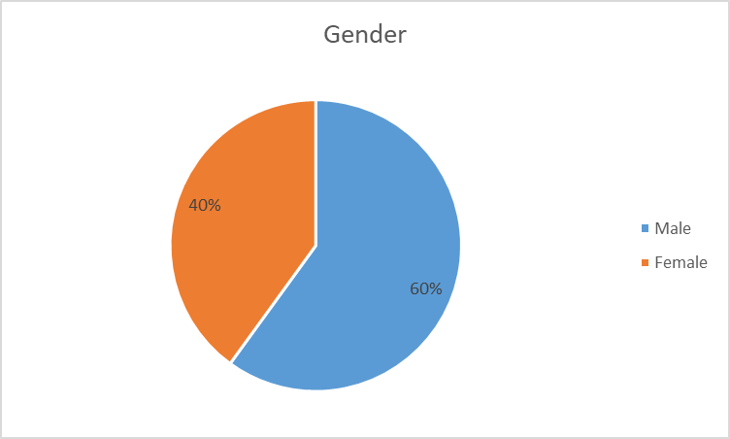
Figure 2: Gender representation
- How long have you worked at Tesco?
Period | Frequency | Percentage
Less than 3 years | 9 | 45%
Between 3 to 5 years | 7 | 35%
More than 5 years | 4 | 20%
Table 3: Period that employees have worked at Tesco

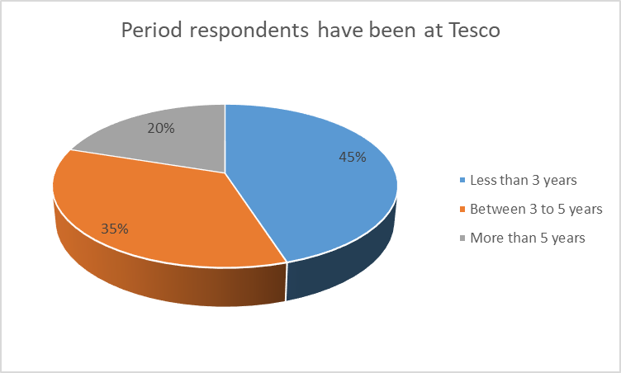
Figure3:Period that employees have worked at Tesco
Section 1 Analysis
The first part of the questionnaire was designed to collect general information on respondents, to allow an assessment on their distribution and validity of responses. From the results in table 1, it is evident that all participants were adults aged 20 years and above. The highest number of respondents (30%) belonged to the 32-37 years’ age group, followed by 25% of respondents who belonged to the 20-25 age group then 20% of respondents who were above 44 years. The 26-31 age group had 15% of participants with the last group, 38-43, having 10% respondents.
Even though the gender representation was not equally balanced to the mark, it was well represented at a ratio of male to female at 3:2, where 60% were male and 40% were female. Of these respondents, it was determined from the study that most of the respondents who worked at Tesco have been there for less than 3 years. 35% of the study participants have been working at the hotel for three to five years while 20% have been there for more than 5 years.
Section 2: Information regarding leadership and management styles at Tesco

- How would you describe the current management style at Tesco in terms of management theories?
Management style | Frequency | Percentage
Administrative | 6 | 30%
Scientific | 8 | 40%
Bureaucratic | 5 | 25%
Situational | 1 | 5%
Table 4: Management styles
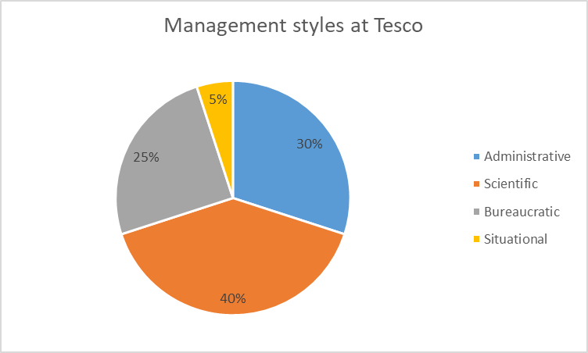
Figure 4: Management styles
Analysis
Based on the results indicated above, many respondents (40%) described the management style employed at Tesco as one based on the scientific theory. 30% of the respondents described the management style as administrative while 25% of them described it as bureaucratic. Only 5% of the respondents described the management style applied at Tesco as depending on the situation.

- What kind of leadership style is practiced at Tesco plc?

Leadership style | Frequency | Percentage
Democratic | 5 | 25%
Transactional | 3 | 15%
Autocratic | 3 | 15%
Transformational | 7 | 35%
Laissez-faire | 2 | 10%
Table 5: Leadership styles at Tesco
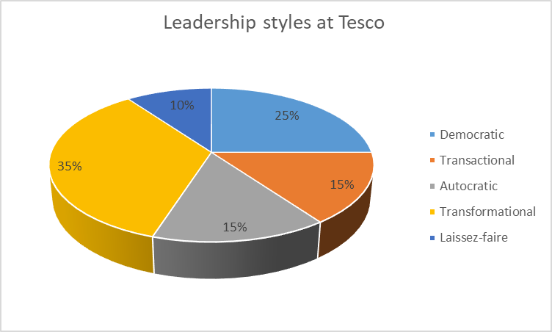
Figure 5: Leadership styles at Tesco
Analysis
In an assessment on the leadership styles practiced at Tesco, the results indicated that the management team prefers to have transformational leadership. This was indicated by 35% of respondents, followed by 25% of respondents who selected a democratic form of leadership. Transactional and autocratic forms of leadership were selected by 15% of respondents each. Laissez-faire was selected least at 10%.

- Which of the following is the major challenge or issue with the management style practiced at Tesco?

Challenge | Frequency | Percentage
Heavy workload | 5 | 25%
Poor teamwork | 3 | 15%
High performance pressure | 7 | 35%
Poor communication | 3 | 15%
Decreased performance | 2 | 10%
Table 6: Issues with current management

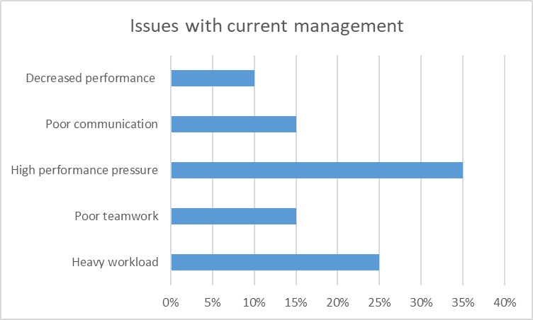
Figure 6: Issues with current management
Analysis
Figure 6 above indicates some of the challenges associated with the current management system at Tesco. Based on the figure, high performance pressure from the management was selected as the main issue by 35% of respondents, followed by 25% of respondents who selected heavy workload on employees. Lack of proper team work and poor communication equally shared views from 15% of respondents. Only 10% of respondents felt that the current management was not running well due to decreased performance.

- From the options below, which is the most important benefit of having an efficient leadership and management system?

Benefit | Frequency | Percentage
Efficient rota system | 3 | 15%
Reduced workload | 2 | 10%
Increased performance | 6 | 30%
Increased employee motivation | 5 | 25%
Increased job satisfaction | 4 | 20%
Table 7: Benefits of an efficient leadership and management system
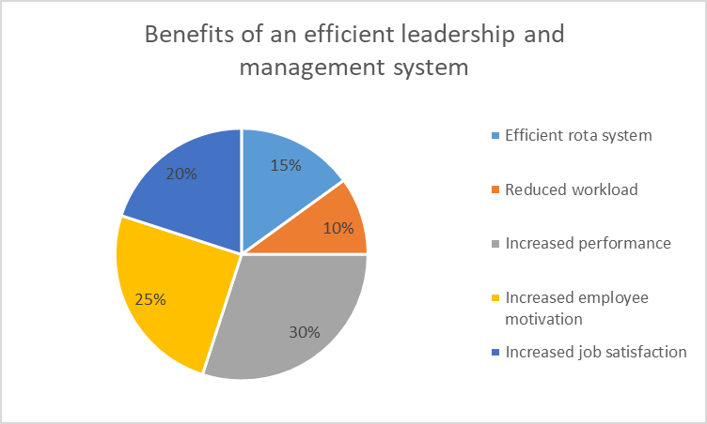
Figure 7: Benefits of an efficient leadership and management system
Analysis
An efficient leadership and management system can have various benefits to employees. As indicated on table 7, an organisation’s employees can benefit most through increased performance, as selected by 30% of respondents. 25% of participants felt that a good system would promote employee motivation while 20% selected increased job satisfaction within the workplace. An efficient rota management system was selected by 15% of respondents while reduced workload was selected by 10% of respondents.
- Which of the following is the most important advantages of a good management and leadership system within an organisation such as Tesco?

Advantage | Frequency | Percentage
Increased customer focus | 2 | 10%
Reduced cost of production | 7 | 35%
Talent management | 2 | 10%
Increased quality services | 2 | 10%
Increased operational efficiency | 3 | 15%
Improved decision making | 4 | 20%
Table 8: Advantages of a good management and leadership system

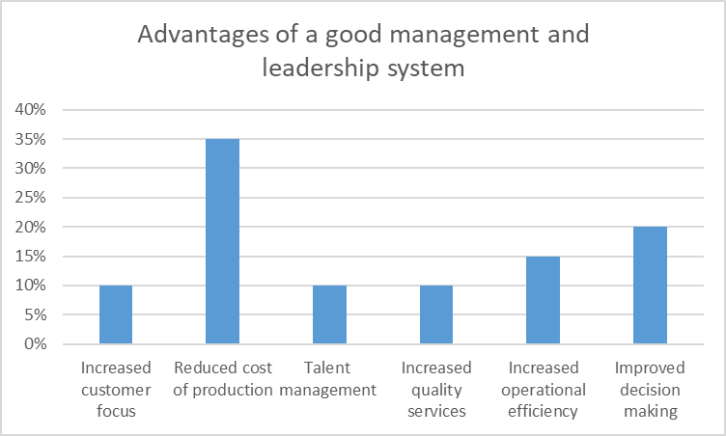
Figure 8: Advantages of a good management and leadership system
Analysis
Apart from the benefits to employees, an organisation can benefit from a good leadership and management system mainly by reducing the cost of production. This was in accordance to 35% of respondents. Following sentiments by 20% of respondents indicated that an organisation benefits from improved decision making while 15% indicated increased operational efficiency. There was a consensus on the advantages on increased customer focus, talent management and increased quality services, which was selected by 10% respondents respectively.

- How does the current management system at Tesco measure performance?

Performance measuring tool | Frequency | Percentage
360 degree feedback | 2 | 10%
Performance appraisals | 6 | 30%
Checklists | 4 | 20%
Key performance indicators | 5 | 25%
Management by objectives | 3 | 15%
Table 9: Performance measuring tools at Tesco

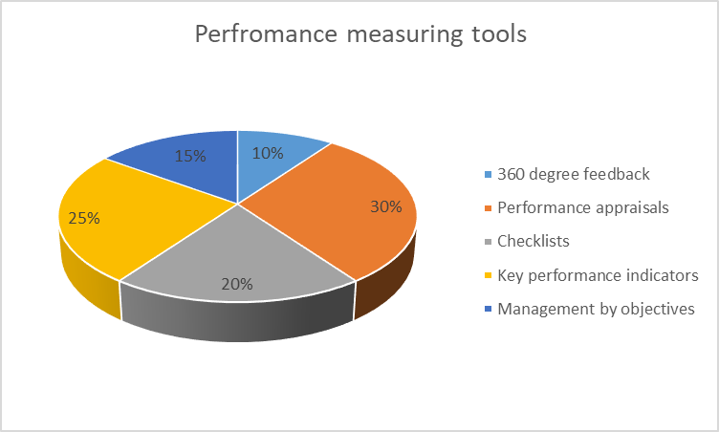
Figure 9: Performance measuring tools at Tesco
Analysis
Based on the results of the study, Tesco uses different means to measure their performance. The mainly used measuring tool according to 30% of respondents are performance appraisals, followed by key performance indicators selected by 25% of respondents. The organisations also used checklists as selected by 20% of respondents, management by objectives as selected by 15% of respondents and lastly, the use of 360-degree feedback, selected by 10% of respondents.

4.2 Discussion of results
This research was carried out while observing all the ethical concerns which pertain to social science research. Therefore, as indicated in section 1 of the results section, adult participants were used within the research, whose consent was received in form of writing. There was fair distribution of respondents in terms of their age, period worked at the company and their gender, which allows the assumption of diverse responses, indicating a wide coverage on the topic. The results obtained in this study were therefore considered unbiased and reliable, which implies that they can be generalised for the whole population.
Leadership and management are two very important concepts for a large company like Tesco, because proper application results in improved performance and a competitive advantage. In order to maintain a certain level of customer satisfaction, it is appropriate to have a capable leadership and a knowledgeable workforce. According to figure 4 in the study, the application of scientific management theory is mainly applied at Tesco’s management.
According to Tesco’s annual report 2016, the company has segmented its stakeholders into three: the primary, secondary and connected stakeholders (Muli, 2019). These stakeholders play different roles, which according to management theories, are best described by the scientific management theory. The scientific mode of management has been described to be a solution to all business problems (Nadrifar, Bandani and Shahryari, 2016). The theory influences management to make certain efforts which ensure that the interest of the workers match those of the management.

Tesco implements the scientific management style by dividing tasks between workers and the management, and training its workforce to increase efficiency at different levels. In terms of leadership styles, figure 5 indicates more reliance to transformational and democratic leadership styles. According to Hechanova and Cementina-Olpoc (2013), transformational leadership entails motivation of employees by transforming their beliefs, attitudes and values, rather than offering rewards. Transformational leadership aligns with the scientific management model since both entail the training of employees through skill and talent development.
Both transformational and democratic leadership styles practiced at Tesco entail empowering other employees, since the leaders offer employees chances to raise their opinions (Al Khajeh, 2018). Even though decentralising decision making increases the chances of poor decision making and execution, it has been known to have a positive effect on the performance of an organisation.

Recently, there have been pressures in the market caused by the recent pandemic, bringing about challenges in the company. Based on the study, leadership and management at Tesco has been described to have decreased performance, poor communication, high pressure on performance and a heavy workload. These challenges can be addressed be evaluating the right leadership and management style, depending on the objectives of the organisation (Łukowski, 2017).

The right leadership and management system can have numerous benefits for an organisation like Tesco and its employees. The study indicates that a good system can increase their performance, their motivation, their job satisfaction and even reduce their workload. According to Al-Malki and Juan (2018), the role of leadership is of importance to an organisation in ensuring that individual employees play up to a team to enhance performance. The organisation also accrues benefits such as reduced cost of production, increased quality of services, increased operational efficiency and improved decision making.
In using employees as a variable to measure how effective leadership and management at Tesco is, measuring tools such as checklists, performance appraisals, management by objectives and key performance indicators such a reviews are used. Performance indicators support Tesco’s corporate objectives by building transparency and trust (Muli, 2019). In order to maintain organisational performance and efficiency, it is necessary to have a leadership and management system which aligns to the objectives of the organisation. It is however necessary for an organisation to change and adapt depending on the situation.

Chapter 5: Conclusion, Recommendations and Reflection

5.1 Conclusion
This research aimed at investigating the leadership and management, theories and practices at Tesco. The research also examined how the current theory and practice of leadership and management at Tesco affects the organisation. The study applied a quantitative approach, where research questionnaires were used in collecting information. This information was coded and analysed in Microsoft excel, where tables and charts were used to analyse data. Simple random sampling was used in selecting twenty employees from the company. Who acted as respondents.
Based on the results of the study, transformational and democratic forms of leadership are applied within the organisation, which in comparison to their performance, have been beneficial. It is therefore advisable for the organisation to continue applying these forms of leadership. As discussed in this report, there has been an increasing interest in leadership and management due to its influence on an organisation. They can have benefits on both employees and the organisation.

5.2 Recommendations
Since an organisation like Tesco has the resources, it can implement a situational leadership approach, which can help it adapt to any situation. This form of leadership can help in times of a crisis like in the current pandemic, in ensuring that performance is maintained (Weber and Marion, 2020). Before implementing new strategies of leadership and management, the organisation can carry out studies to identify the factors which can arise while implementing the strategies, and also come up with ways through which the strategies can be transformed into operations effectively.
The organisation can also practice decentralisation when it comes to some of the decisions impacting employees. Including employees in some of the decisions can have a positive impact on job satisfaction and performance. The organisation can also practice benchmarking, which can be an important resource for the organisation to find out the ways through which other organisations carry out their leadership and management.

5.3 Reflection
This study was carried out as earlier predicted, covering the scope within the specified three months. The leadership and management concept was well covered by using Tesco in the case study. The methods applied in this study have been used and proven before in similar studies to this one. By following the quantitative approach, the study was able to include many samples within the study, which offered rich and diverse responses. Random sampling method used in the study allowed equal chances of participation to the respondents. It was however more involving to use as compared to techniques such as convenience sampling. While carrying out a similar/parallel study, a researcher can opt for non-probability sampling methods.
Questionnaires were a favourable method of collecting data in this study since they are relatively easy to use. For other research, a researcher can apply data collection methods such interviews and focus groups. The use of these methods in a qualitative study can offer more insights and understanding into the leadership and management practices within organisations.
Time was an issue during the study because respondents delayed during the filling in of questionnaires, which also delayed the picking up and analysis of the questionnaires, and the structuring is this report.
The research was however able to cover the time since a work breakdown which was designed at the beginning of research enabled every activity to be carried out at its own time. Through the research, I learnt that research is an intensive process which requires proper planning during the initial phase. For example, without proper risk, cost and time management, the project would have lagged and probably not got complete. Overall, the study was successful in fulfilling the study objectives and offering recommendations which can be applied across the industry.

Bibliography
Adebayo, O.R. (2019) evaluate the influence of classical and human relations approaches in management today.
Al Khajeh, E.H. (2018) Impact of leadership styles on organizational performance. Journal of Human Resources Management Research, 2018, pp.1-10.
Ali, N.M., Jangga, R., Ismail, M., Kamal, S.N.I.M. and Ali, M.N. (2015) Influence of leadership styles in creating quality work culture. Procedia Economics and Finance, 31, pp.161-169.
Aliyu, A.A., Singhry, I.M., Adamu, H.A.R.U.N.A. and AbuBakar, M.A.M. (2015). Ontology, epistemology and axiology in quantitative and qualitative research: Elucidation of the research philophical misconception. In Proceedings of the Academic Conference: Mediterranean Publications & Research International on New Direction and Uncommon (Vol. 2, No. 1).
Al-Malki, M. and Juan, W. (2018). Leadership styles and job performance: A literature review. Journal of International Business Research and Marketing, 3(3), pp.40-49.
Al-Mosawi, A.J. (2019) Leadership in medicine and healthcare: an overview of the emerging concepts and principles. Lupine Online Journal of Medical Sciences, 4(1), pp.344-351.
Amanchukwu, R.N., Stanley, G.J. and Ololube, N.P. (2015) A review of leadership theories, principles and styles and their relevance to educational management. Management, 5(1), pp.6-14.
Available at:
AYDIN, B. (2018) The role of organizational culture on leadership styles. MANAS Sosyal Araştırmalar Dergisi, 7(1), pp.267-280.
Bartsch, S., Weber, E., Büttgen, M. and Huber, A. (2020) Leadership matters in crisis-induced digital transformation: how to lead service employees effectively during the COVID-19 pandemic. Journal of Service Management.
Bhargavi, S. and Yaseen, A. (2016) Leadership styles and organizational performance. Strategic Management Quarterly, 4(1), pp.87-117.
Ciulla, J. B. (2020). The importance of leadership in shaping business values. In The search for ethics in leadership, business, and beyond (pp. 153-163). Springer, Cham.
Cummings, G.G., MacGregor, T., Davey, M., Lee, H., Wong, C.A., Lo, E., Muise, M. and Stafford, E. (2010) Leadership styles and outcome patterns for the nursing workforce and work environment: a systematic review. International journal of nursing studies, 47(3), pp.363-385.
Daft, R. L., and Marcic, D. (2016). Understanding management. Cengage Learning, pp2-10.
Drucker, P. (2012). Management. Routledge.
Drucker, P. F. (2019). Management cases. Harper Collins.
Empson, L., and Langley, A. (2015). Leadership and professionals. The Oxford handbook of professional service firms, 163-188.
Etikan, I., Musa, S.A. and Alkassim, R.S. (2016) Comparison of convenience sampling and purposive sampling. American journal of theoretical and applied statistics, 5(1), pp.1-4.
Forsyth B, Maranga K, (2018), The Spirit of Leadership: Past, Present and Future, Journal of leadership, accountability and ethics, Vol.15(2)
Hechanova, R.M. and Cementina-Olpoc, R. (2013) Transformational leadership, change management, and commitment to change: A comparison of academic and business organizations. The Asia-Pacific Education Researcher, 22(1), pp.11-19.
Hussain, N., HAQUE, A.U. and Baloch, A. (2019) Management theories: The contribution of contemporary management theorists in tackling contemporary management challenges. Journal of Yaşar University, 14, pp.156-169.
Jakubik M et al., (2017), Rethinking Leadership and It´ s Practices in the Digital Era, Managing the Global Economy. Proceedings of the Management International Conference, Monastier di Treviso, Italy, 24–27 May, 471–483.
Jamal, A.H. (2014) Leadership styles and value systems of school principals. American Journal of Educational Research, 2(12), pp.1267-1276.
Kamal, S.S.L.B.A. (2019) Research paradigm and the philosophical foundations of a qualitative study. PEOPLE: International Journal of Social Sciences, 4(3), pp.1386-1394.
Khaldi, K. (2017) Quantitative, qualitative or mixed research: Which research paradigm to use?. Journal of Educational and Social Research, 7(2), pp.15-15.
Kitana, A. (2016) Overview of the managerial thoughts and theories from the history: Classical management theory to modern management theory. Indian Journal of Management Science, 6(1), p.16.
Kumar, R. (2018). Research methodology: A step-by-step guide for beginners. Sage.
Lin, L. and Kheng, C. (2017) The church and management: Synthesis of a reorientation framework for management theories through a theological engagement with management science (Doctoral dissertation, ACU Research Bank).
Łukowski, W. (2017) The impact of leadership styles on innovation management. Marketing of Scientific and Research Organizations, 24(2), pp.105-136.
Mishra SB, Alok S, (2017), Handbook of research methodology, Educreation
Muli, A.N. (2019) Strategic financial evaluation and analysis of Tesco and Benedict co.
Nadrifar, A., Bandani, E. and Shahryari, H. (2016) An overview of classical management theories: A review article. International Journal of Science and Research, 5(9), pp.83-86.
Nayak, J. K., and Singh, P. (2021). Fundamentals of Research Methodology Problems and Prospects. SSDN Publishers & Distributors.
Nwakpa, P. (2013) Approaches, Skills and Styles of Leadership Required in Educational Organizations. Asian Journal of Applied Sciences, 1(5).
Oplatka, I. and Arar, K. (2017) The research on educational leadership and management in the Arab world since the 1990s: A systematic review. Review of Education, 5(3), pp.267-307.
Rahbi, D.A., Khalid, K. and Khan, M., (2017) The effects of leadership styles on team motivation. Academy of Strategic Management Journal, 16(3).
Reiche BS et al., (2017), Contextualizing leadership: A typology of global leadership roles, Journal of international business studies, Vol.48(5), p.552-572
Saleem, H. (2015) The impact of leadership styles on job satisfaction and mediating role of perceived organizational politics. Procedia-Social and Behavioral Sciences, 172, pp.563-569.
Sheikh, T. and Sultana, R. (2016) Philosophy of Research. International Journal of Advanced Engineering and Management, 1(1), pp.12-17.
Sibley et al., (2016), Parent management of organization, time management, and planning deficits among adolescents with ADHD, Journal of psychopathology and behavioral assessment, Vol.38(2), p.216-228
Statista (2022), E-Commerce net sales of tesco.com from 2014 to 2022.
Taylor, B. W., Bector, C. R., Bhatt, S. K., & Rosenbloom, E. S. (2013). Introduction to management science. Pearson.
Tesco. (2021). About. [online] Available at: https://www.tesco.com/ [accessed 18 Nov 2021].

Appendices

Appendix 1: Research questionnaire
Questionnaire
Section 1: Respondents general information
- Kindly select your age group from the list indicated below
Age group | Frequency
20-25
26-31
32-37
38-43
44+

- Kindly select your gender below
Gender | Frequency
Male
Female

- How long have you worked at Tesco?
Period | Frequency
Less than 3 years
Between 3 to 5 years
More than 5 years

Section 2: Information regarding leadership and management styles at Tesco
- How would you describe the current management style at Tesco in terms of management theories?
Management style
Administrative
Scientific
Bureaucratic
Situational

- What kind of leadership style is practiced at Tesco plc?
Leadership style
Democratic
Transactional
Autocratic
Transformational
Laissez-faire

- Which of the following is the major challenge or issue with the management style practiced at Tesco?
Challenge
Heavy workload
Poor teamwork
High performance pressure
Poor communication
Decreased performance

- From the options below, which is the most important benefit of having an efficient leadership and management system?
Benefit
Efficient rota system
Reduced workload
Increased performance
Increased employee motivation
Increased job satisfaction

- Which of the following is the most important advantages of a good management and leadership system within an organisation such as Tesco?
Advantage
Increased customer focus
Reduced cost of production
Talent management
Increased quality services
Increased operational efficiency
Improved decision making

- How does the current management system at Tesco measure performance?
Performance measuring tool
360 degree feedback
Performance appraisals
Checklists
Key performance indicators
Management by objectives

Appendix 2: Gantt Chart
 | Week  1 | Week 2 | Week  3 | Week 4 | Week5 | Week6 | Week7 | Week8 | Week9 | Week  10 | Week  11 | Week  12
Introduction
Literature review
Methodology
Data Collection
Data Analysis
Conclusion & Recommendation
Review and Submission

Ethical Approval Form

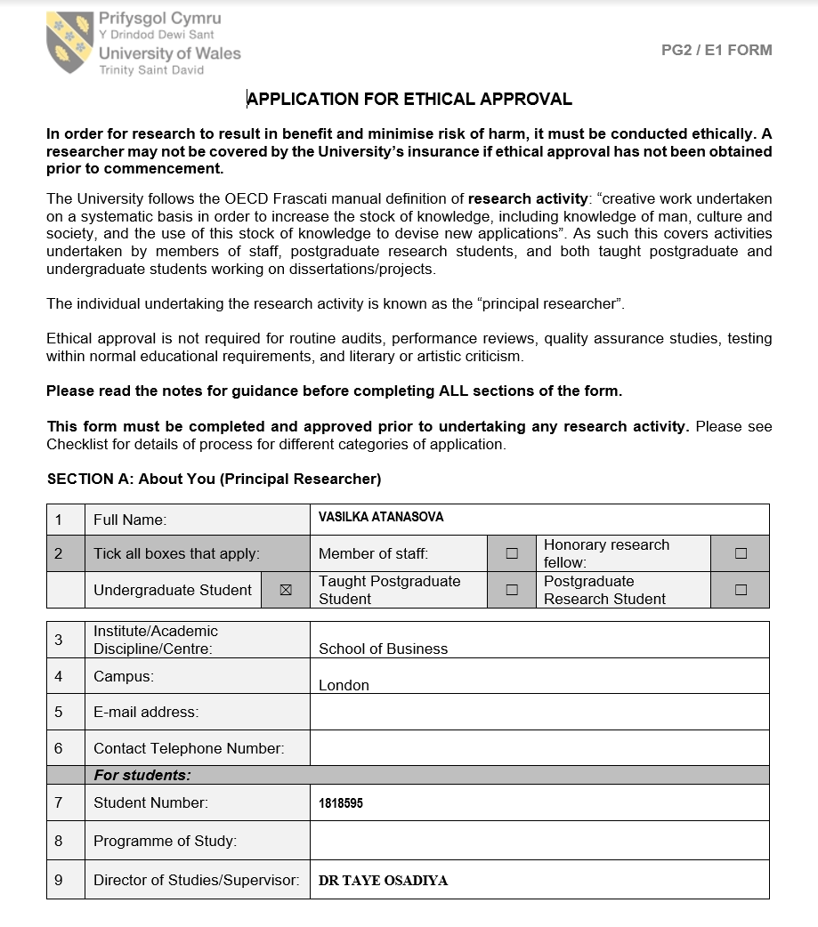
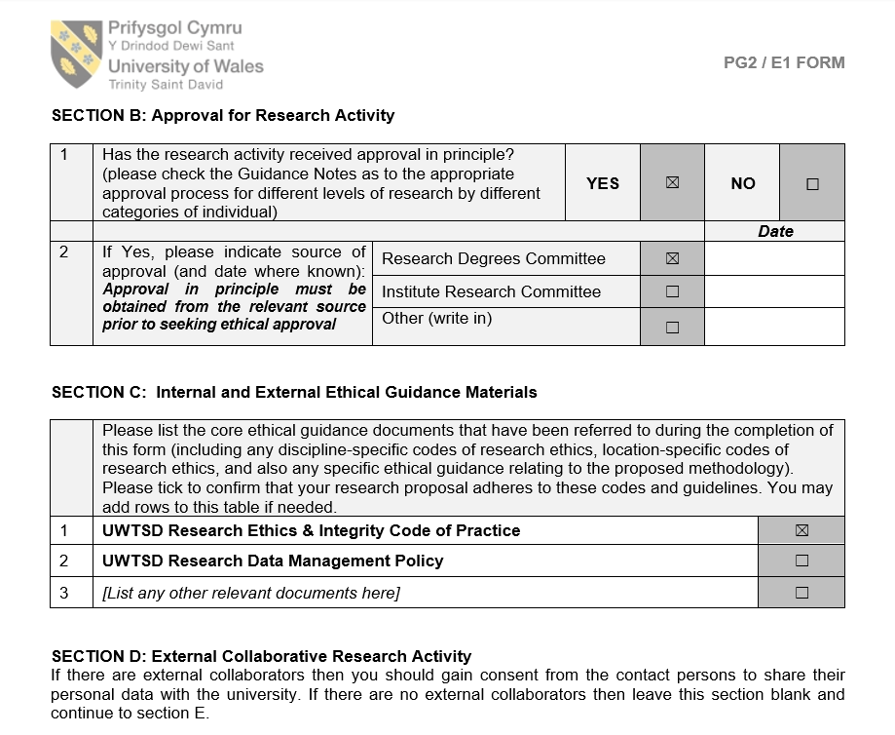
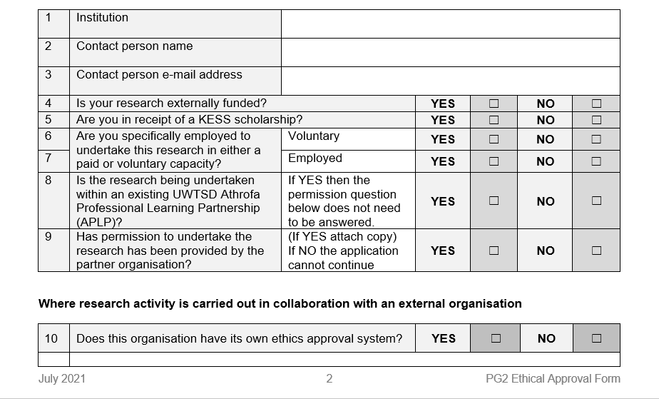
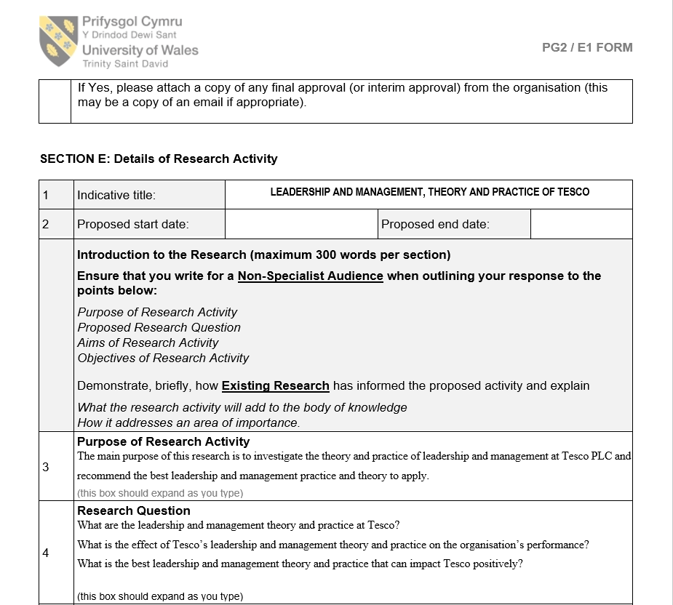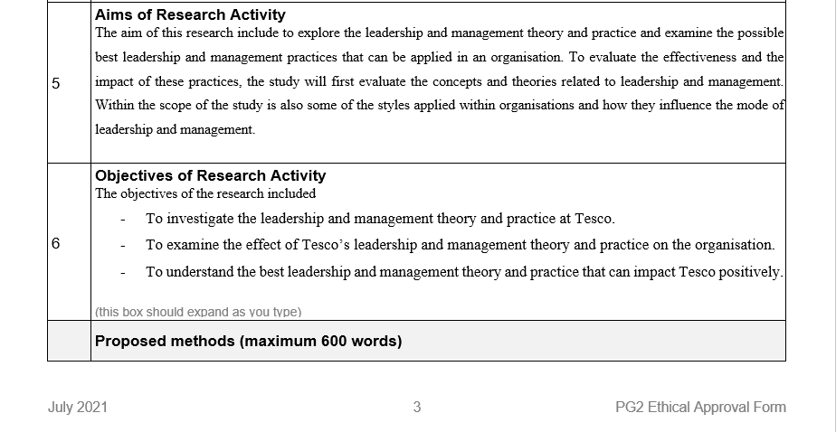
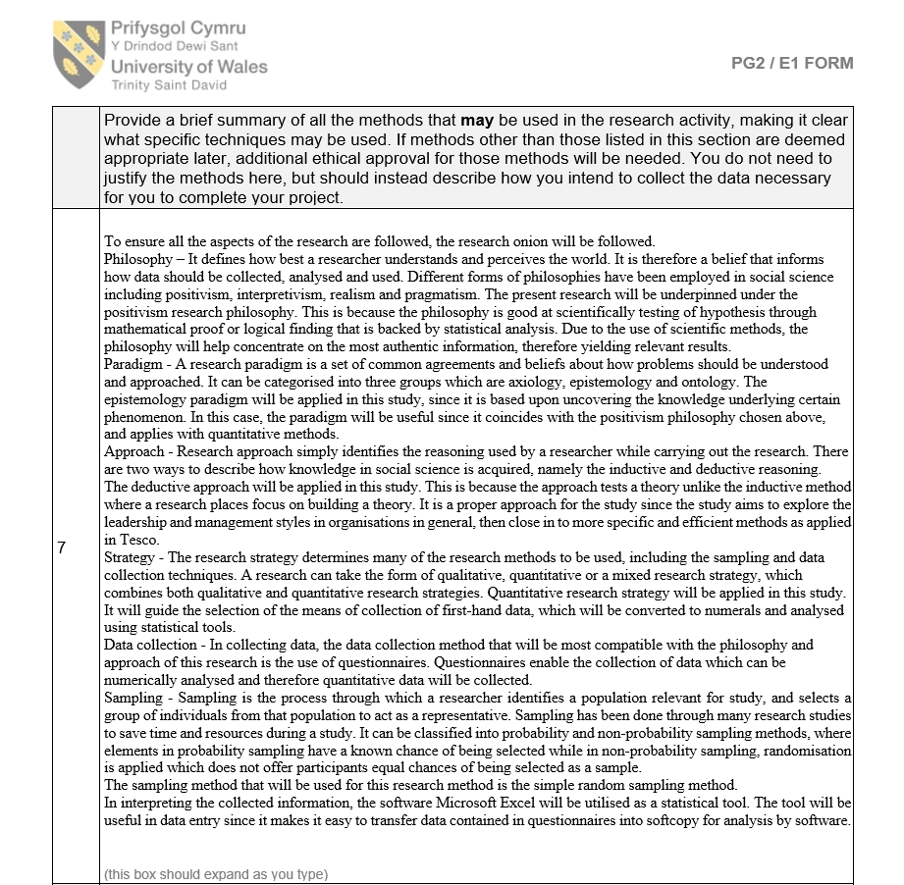
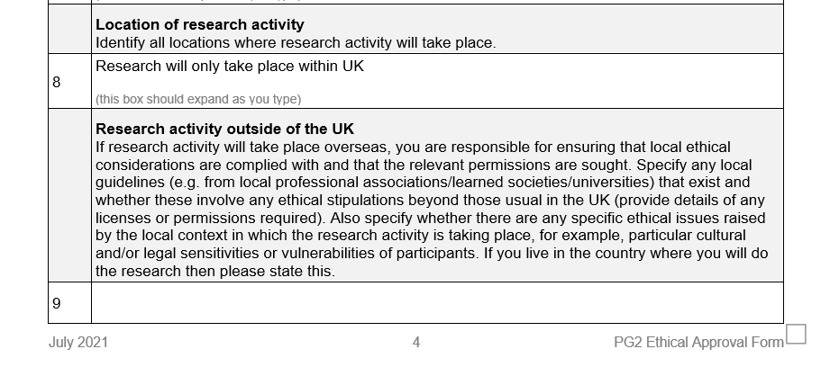
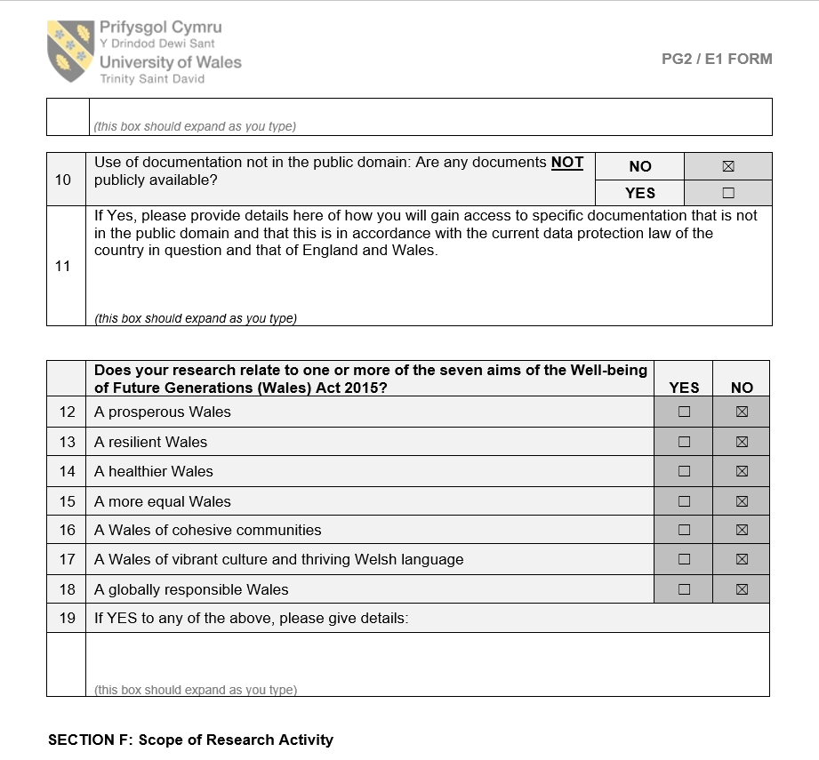
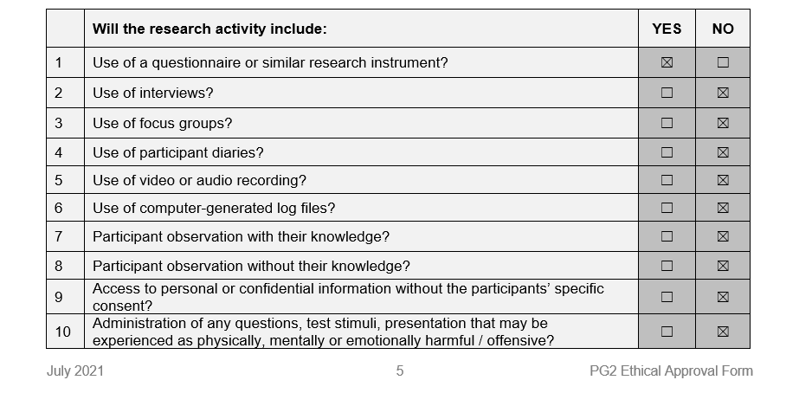
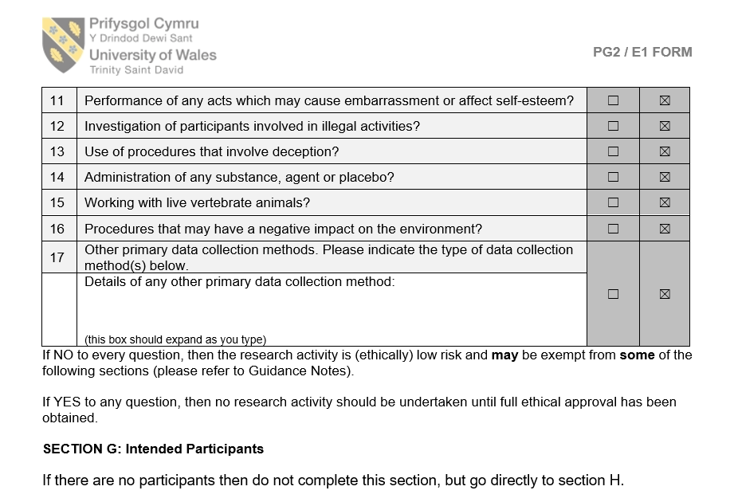
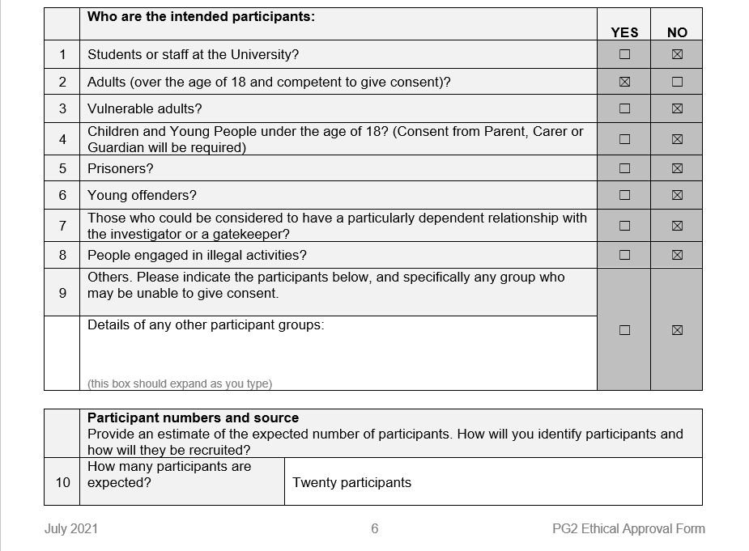
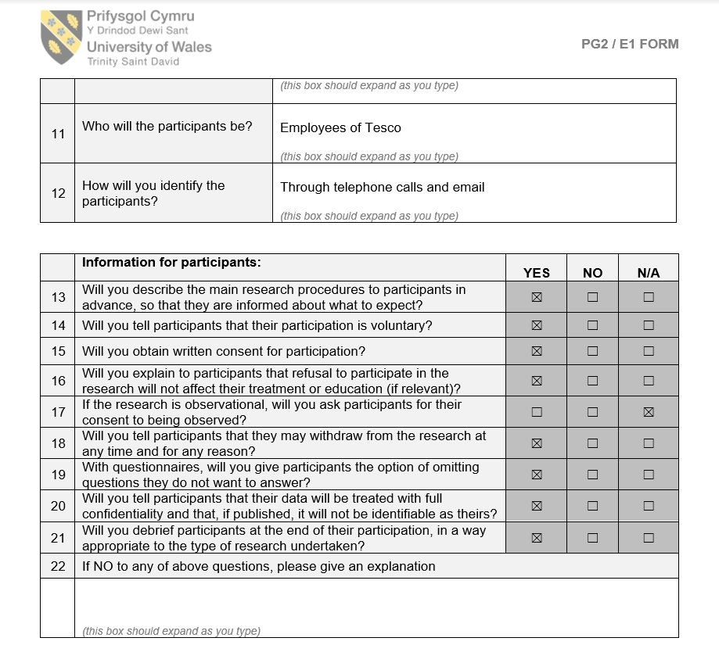
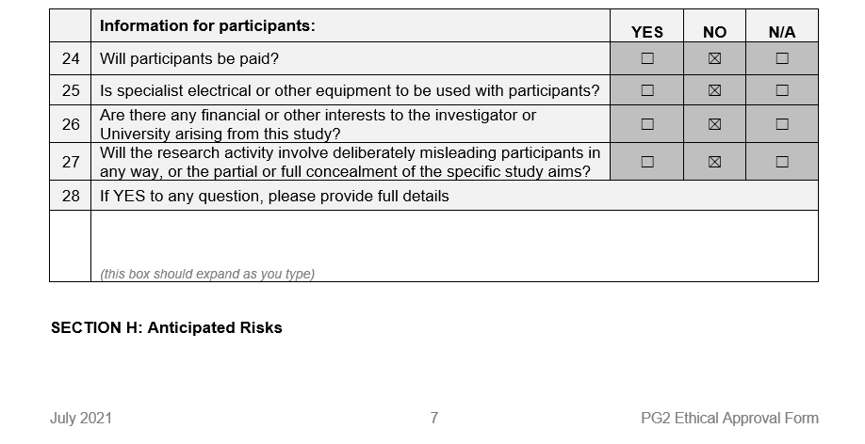

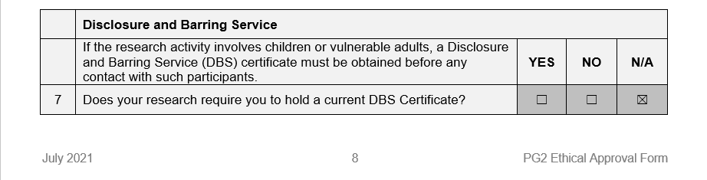
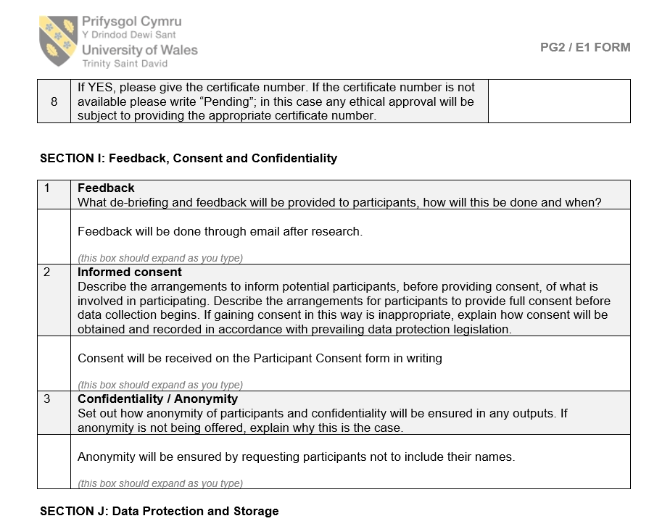
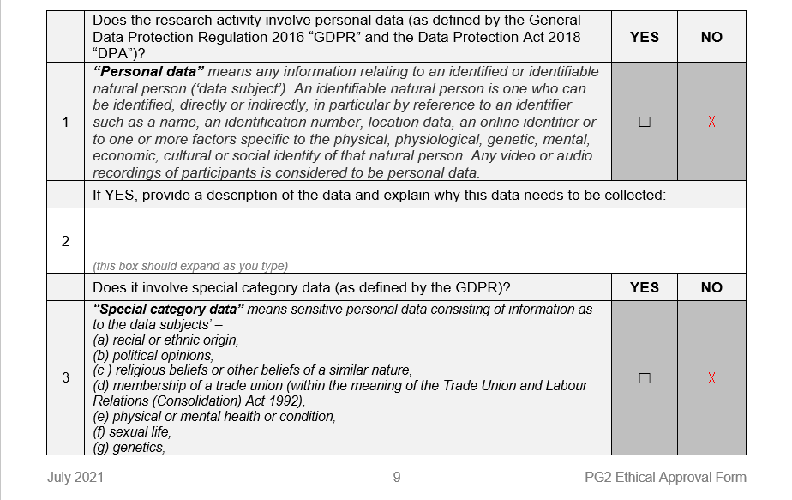
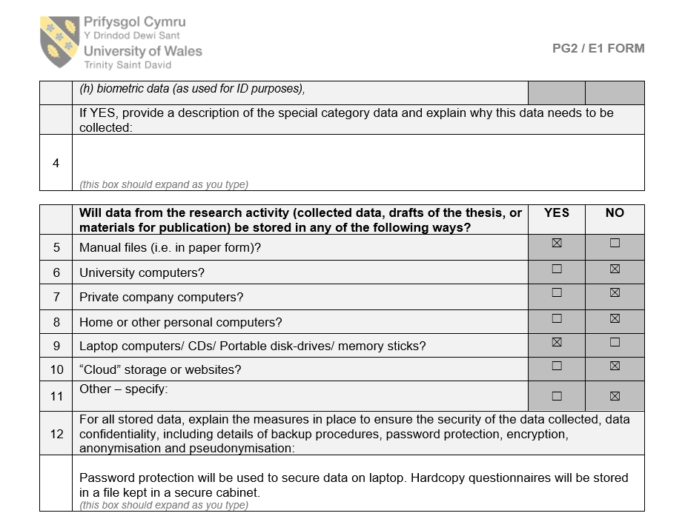
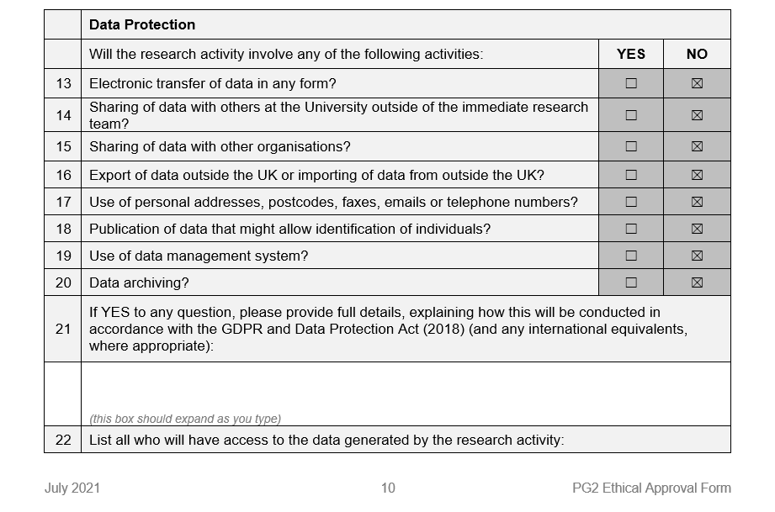
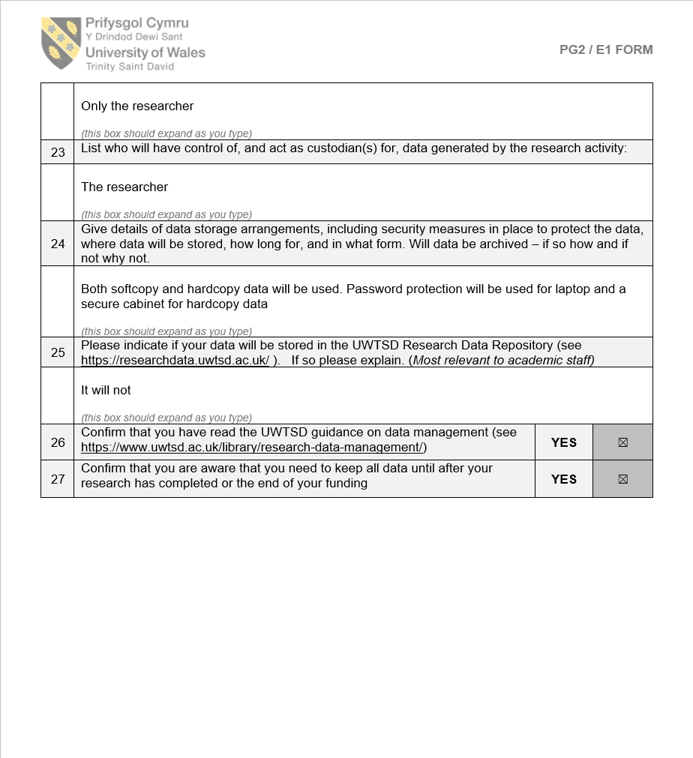



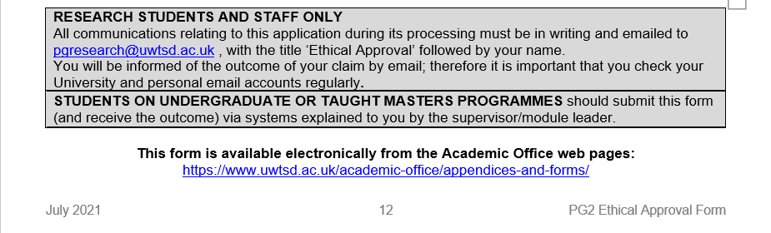

Participation Consent Form

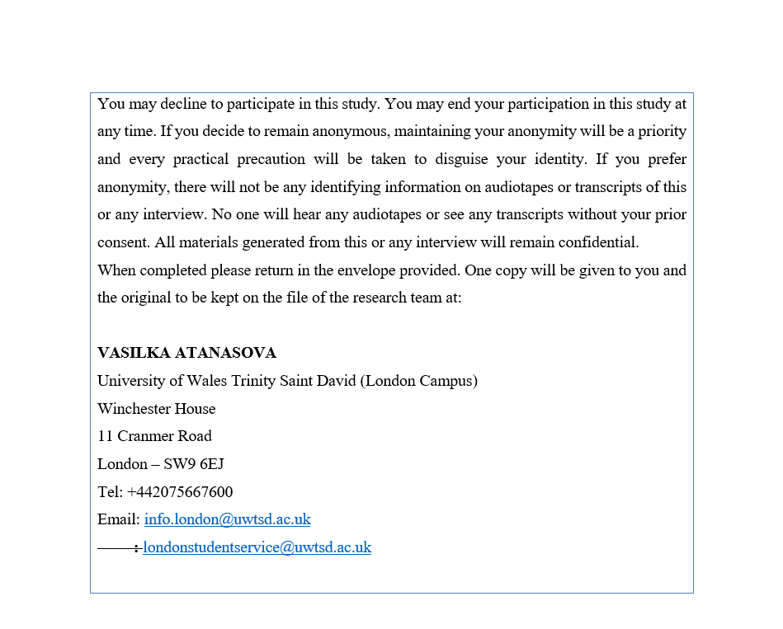

Participant Information Sheet




