Student Name: Sam Digby Student Number: 1901067

Transmission matching
(M4X02196)

Contents
Introduction 1
Research 2
Methodology 3
Results 4
Analysis 7
Torque at wheel and Tractive effort 7
Gear changing 8
Transmission efficiency 9
The highest achievable top speed in 5th 10
Conclusion 11
References 12
Appendix A

Table of Figures
Figure 1-Tractive Effort vs Engine Speed graph 4
Figure 2- Torque at Wheel vs Engine Speed graph 4
Figure 3-Pdrag vs Velocity graph 5
Figure 4-Engine Torque and Power vs Engine Speed graph 7
Figure 5-Transmission Efficiency vs Engine Speed graph 8

Table of Tables
Table 1-Maximum tractive effort for all gear ratios 5
Table 2-Maximum road speed table 6

Introduction
The use of a transmission in a vehicle is vital for everyday use. This is down to the internal combustion engine lack of ability to produce enough torque to move a vehicle without assistance from torque multiplication. In addition to this a transmission offers speed reduction to reduce the speed of the engine to save it from failures such as running out its bearings.
To calculate the effectiveness of the transmission, a chassis dynamometer is used. This piece of equipment allows the power to be calculated at the wheel and at the crankshaft. From here it can also calculate the power losses due to friction. These sets of data can be analysed and used to calculate other aspects of the transmission which this assignment covers.

Research
Chassis dynamometers are used in industry for a number of purposes ranging from testing power output to simulating drive cycles to test exhaust emissions while the vehicle is in motion. (Öberg, P., Nyberg, P., and Nielsen, L., 2013)
When used for power output testing, the rollers on the chassis dynamometer is driven by the driving wheels of the vehicle. This allows the chassis dynamometer to determine wheel speed along with power at the wheel. It is to be noted that when performing this test, selecting a test gear is important as different gear ratios can alter the torque and power outputs. This is why when testing for power output, the test gear is typically the gear ratio that is closest to 1:1.
Chassis dynamometers can also be set at a determined speed to allow testing at set speeds.
Chassis dynamometers come in a variety of forms from a large dynamometer roll that the wheel sits on to a twin roll where the wheel sits between the rolls. (Marshall, R, 1981). In addition to this the amount of roller vary from single rollers used on motorcycles to four-wheel drive chassis dynamometers. The latter being used for when all four wheels are driven or for vehicles with active traction control systems. A fan is used with rolling roads to provide a steady stream of air to allow the engine to get the air it needs to operate and to help cool down the vehicle.

Methodology
To setup the chassis dynamometer for testing, the motorcycle has its front wheel locked into place via a clamp, this is to stop the motorcycle from moving forward off the rollers. The rear of the motorcycle is strapped down to prevent it wandering on the roller during testing. An extraction system is also used to extract the exhaust gases out of the lab.
Once this has been performed, the chassis dynamometer can be setup. Information such as the following is put into the dyno to set it up so it can give an accurate result:
- Engine type (Otto, diesel or rotary)
- An estimate on the power the motorcycle is making
- Power correction
Once this data is inputted and the motorcycle is setup ready to perform the test in a safe manner, the motorcycle is driven into its test gear (In this case 5th). Once the bike is in the test gear and wheel speed is below 40Km/h the test can begin.
The bike is driven throughout its rev range until power at the wheel has peaked, this can be observed on the chassis dynamometer’s computer has it displays live recordings. Once the wheel power is recorded at its peak, the clutch is engaged and the throttle is disengaged. This action allows the chassis dynamometer to record the drag power. The clutch is engaged until the motorcycle is at a stop. Once this is done, the chassis dynamometer will calculate the power at the crank by adding the drag power to the power at the wheel. All three powers are then displayed on a graph.
The safety precautions are performed this way to ensure the safety of observers and rider as the motorcycle is driven at its limit during this test and can fail which can lead to serious if not fatal injuries.
The test (referring to data acquisition) is carried out this way because the chassis dynamometer is manufactured to recorded power in this manner. Also the whole rev range is not monitored as over revving the engine unnecessarily, once peak power is achieved puts the engine in a dangerous situation where bearings can start to spin or valve float can occur.

Results
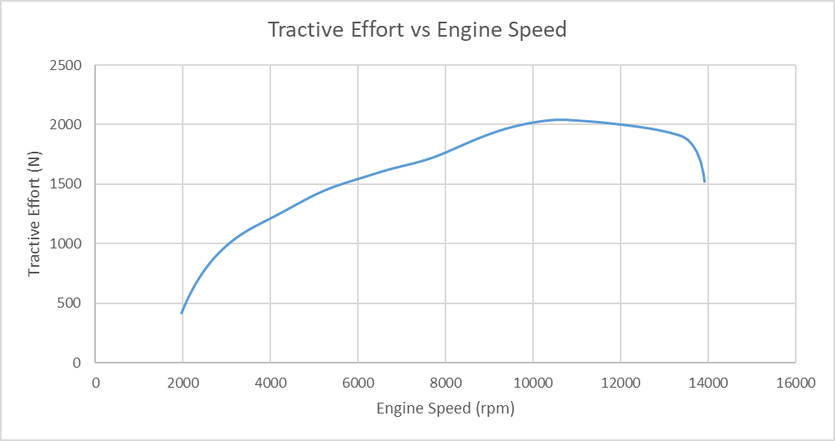
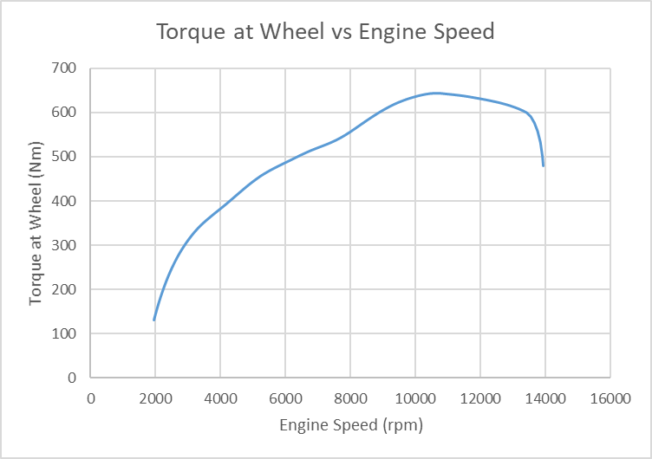
Figure 1-Tractive Effort vs Engine Speed graph
Figure 2- Torque at Wheel vs Engine Speed graph
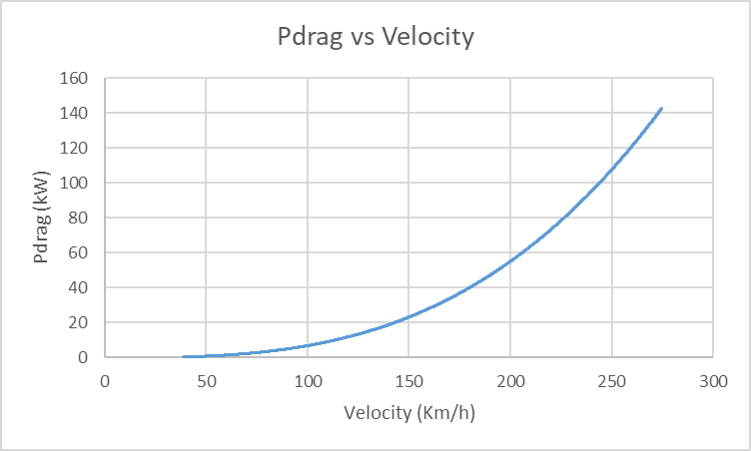
Table 1-Maximum tractive effort for all gear ratios
Figure 3-Pdrag vs Velocity graph
Table 2-Maximum road speed table

Analysis

Torque at wheel and Tractive effort
As shown in figure 2 the torque at the wheel increases until 10745rpm. From this point, the torque steadily decreases then sharply decreases further around the point where maximum power is achieved.
Tractive effort (figure 1) follows the same trend as torque at the wheel as to calculate tractive effort the following equation is used.
$$Tractive effort=\frac{Torque produced at the wheel }{Rolling radius }$$
For a vehicle to accelerate the tractive effort must be greater than the tractive resistance. Because tractive effort is directly linked to the torque output at the wheel, any form of alteration that will affect the torque will directly affect the tractive effort.
Table 1 shows the maximum achievable tractive effort in each gear. As the vehicle goes up the gears, the tractive effort decreases. This is because the gear ratios effect the amount of tractive effort produced. In higher gears, the tractive effort does not have to be as high because the vehicle is already in motion. 1st gear needs the maximum possible tractive effort because it has to overcome the static friction.

Gear changing
To make best use of the engine’s capabilities in each gear, the gear must be changed at maximum power. This is because after maximum power is achieved, for this vehicle power drops off rapidly as observed in figure 4 shown below.
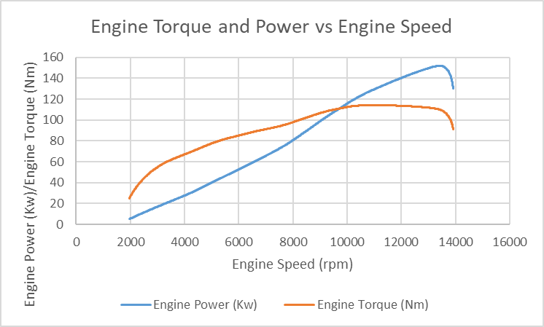
Figure 4-Engine Torque and Power vs Engine Speed graph

In addition to the previous point, it is important to change gear at peak power because the engine speed will in theory drop down to peak torque. Due to the very slightly convex nature of the power and torque curves observed in figure shown above, the theoretical optimal change point would be when the power in the next gear is greater than the power in the current gear (Frederick, R, and Dixon, B., 2020) This can also be applied when changing down in gears.

Transmission efficiency
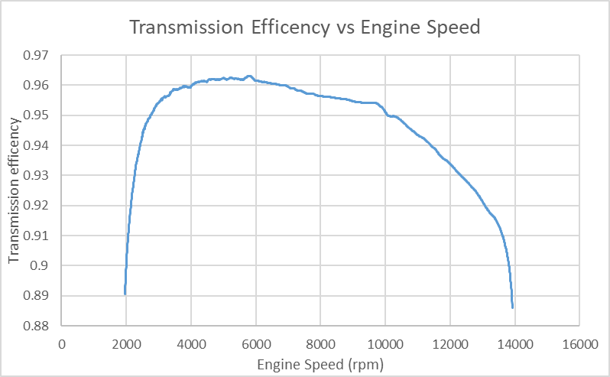
As observed in figure 5 (shown below) the transmission efficiency changes as engine speed changes.
Figure 5-Transmission Efficiency vs Engine Speed graph

This observation in the transmission efficiency is important has it is one of the variables taken into account when calculating the power and torque at the wheel. This variation in efficiency is related to two factors, the load going through the teeth of the gears and the condition of the oil.
When the engine is running and the bike is in gear, the gears are turning and are put under load due to the engine turning the main and layshafts. The load is related to engine speed. As the rpm increases, there is a higher load placed on the gears which in turn will cause more friction to be generated. This means that the transmission will not be able to work as efficiently as possible hence why the efficiency drops after around 6000rpm.
The next related factor is the condition of the oil inside the transmission. The temperature of the oil is important as there is a direct connection between oil temperature and transmission efficiency. The higher the temperature of the oil inside the transmission. The more efficient the transmission is. (Tian, S., Li, G., and Que, T.,2016) It is noted however that after the oil has reached 80ºc the efficiency changes by small increments.

The highest achievable top speed in 5th
According to table 2, the highest achievable speed in 5th is 283.2273518Km/h. This table is made with the following presumptions:
- The engine speed is 14200rpm
- There is no aerodynamic drag acting upon the bike
- There are no power losses taken into account
To take into account the last presumption, Pdrag is calculated and compared to velocity (Refer to figure 3). Knowing the values of Pdrag, it can be compared to the power available at the wheel to see if there is enough power to achieve the speed seen in table 2. The results of this is shown in appendix A.
Using appendix, A, it shows that the power at the wheel is less than the Pdrag at 269.75Km/h (engine speed =13765rpm). From this point onwards, there is insufficient power for the bike to accelerate further in its current gear. This also aligns with figure 4 which shows at this speed, the available power and torque is already reducing. At this point as previously mention in the Gear changing section, the rider would have changed up as the available torque in the next gear would be higher.

Conclusion
In conclusion, the testing of a chassis dynamometer varies from type to type. Withier be it a single roller system that was used for the test that this assignment covers or another system that requires more initial setup.
Throughout the testing, all safety precautions were followed to ensure that the testers and observers were safe.
The results of this test were to be expected apart from one set of data. This set of data being the transmission efficiency. The unexpected parts of this were that fact that the efficiency varied greatly over the test but still remained high, never falling below 85%.

References
Frederick, R. and Dixon, B. (2020) Optimizing Gear Ratio Selection for Lap Performance, Available at: https://saemobilus-sae-org.ezproxy.uwtsd.ac.uk/content/2020-01-0543/#authors (Accessed: 17th April 2020).
Marshall, R (1981) Selecting the Correct Chassis Dynamometer System, Available at: https://saemobilus-sae-org.ezproxy.uwtsd.ac.uk/content/810750/#citations (Accessed: 8th April 2020).
Tian, S., Li, G., and Que, T. (2016) Research on Transmission Efficiency of Mechanical Transmission Based on Test Bench, Available at: https://saemobilus-sae-org.ezproxy.uwtsd.ac.uk/content/2016-01-2356/#abstract (Accessed: 18th April 2020).
Öberg, P., Nyberg, P., and Nielsen, L. (2013) A New Chassis Dynamometer Laboratory for Vehicle Research, Available at: https://saemobilus-sae-org.ezproxy.uwtsd.ac.uk/content/2013-01-0402/ (Accessed: 8th April 2020)

Appendix

