

Changemakers: Building Your Own Personal Brand for Sustainable Employment
Module Code – BMHP5015_BIRM
Assignment: Online Portfolio of Set Exercises
Student Name and number: Salma Begum 2310090
Lecturer: Raheela Shaikh

Contents
Task 1: Personal Brand ...........................................................................Page 3
Task 2: Network Map and Rationale ......................................................Page 4-5
Task 3: Blog – “Rising Pressure: Understanding the Youth Mental Health Crisis in the UK” ...........................................................................................................Page 6-7
Task 4: NHS Equality, Diversity and Inclusion (EDI) Quiz ................. Page 8-9
Task 5: Letter to Myself ..........................................................................Page 10
Task 6: Gantt Chart & Explanation .......................................................Page 11-12
Task 7: Making Changes – Care Home Report ....................................Page 13
Task 8: Self-Reflection Using Gibbs’ Reflective Model .................... Page 14-15
References ........................................................................................….Page 16

Task 1: Personal Brand
My personal brand represents the qualities, values, and behaviours that shape how I present myself professionally and how others perceive me. As I work toward becoming an Occupational Therapist, my personal brand is built on compassion, empathy, effective communication, adaptability, and a strong commitment to helping others. Through my experience as a Healthcare Booking Officer, I have developed a professional identity that focuses on supporting individuals in a respectful, patient, and person-centred manner. I ensure that I communicate clearly with patients, manage bookings efficiently, and contribute to positive service experiences.
My strengths, such as resilience, teamwork, problem-solving, and patience, are essential in occupational therapy, where working closely with service users requires understanding, encouragement, and the ability to remain calm under pressure. I also value ethical practice, fairness, and confidentiality, which I demonstrate daily in my healthcare role. These qualities help build trust with both colleagues and service users.
However, I also recognise areas I need to develop further. Improving my digital literacy, public speaking, and confidence in clinical environments will strengthen my credibility and competence. As personal branding theory suggests, being aware of both strengths and development needs is key to building a strong, authentic professional identity (Peters, 1997). Goffman’s (1959) concept of self-presentation highlights the importance of aligning actions with desired perceptions, which motivates me to continually act in ways that reflect my future role.
To support my goal, I plan to engage more in CPD opportunities (Royal College of Occupational Therapists, n.d.), develop my online professional presence, and expand my knowledge of occupational therapy. By building a consistent and meaningful personal brand, I can position myself as a motivated, capable, and compassionate future Occupational Therapist.

Task 2: Network Map and Rationale
My professional and personal network includes family, friends, lecturers, colleagues, mentors, and volunteer contacts. Each part of this network plays an essential role in supporting my growth and development as I prepare for a career in occupational therapy.
Family and friends provide emotional encouragement, helping me maintain resilience and motivation during challenging academic or personal periods. Their support strengthens my confidence and helps me stay focused on my long-term goals. Lecturers and academic mentors provide guidance in areas such as professional conduct, communication, reflective practice, and the theories that underpin occupational therapy. They also help me understand what is expected in health and social care roles.
Colleagues in healthcare settings offer insight into real-world practice, multidisciplinary teamwork, and the challenges faced by professionals. Their experiences help me understand workplace expectations and improve my communication skills. Volunteers, community members, and support groups provide opportunities for me to interact with diverse individuals, enabling me to develop empathy, cultural awareness, and practical care-related abilities.
According to Ibarra and Hunter (2007), strong networks provide essential career support by offering access to knowledge, opportunities, and professional relationships. Seibert et al. (2001) also emphasise that social capital plays a significant role in career success, as individuals with broader networks often gain more career related resources and guidance.
Mapping my network highlights the support already available to me while also revealing gaps. To strengthen my progression toward becoming an Occupational Therapist, I aim to expand my network by connecting with practising OTs, attending healthcare events, joining professional associations such as the RCOT, and engaging more actively in clinical shadowing. Building these connections will enhance my employability and increase my understanding of the field.
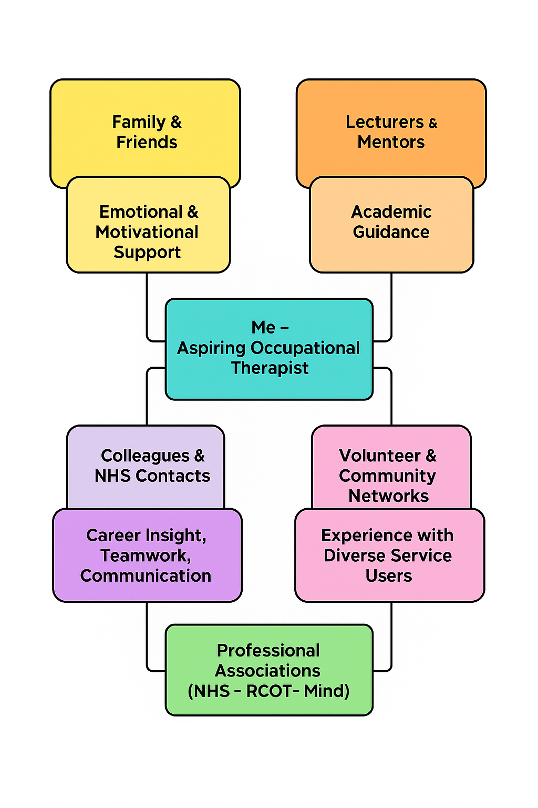
Task 3: Blog – “Rising Pressure: Understanding the Youth Mental Health Crisis in the UK”
In recent years, the mental health of young people in the UK has become a growing national concern. Increasing numbers of children and young adults are experiencing anxiety, depression, self-harm, eating disorders, and emotional distress. These challenges have been influenced by several factors, including social media pressures, academic expectations, family difficulties, financial stress, and the long-term impact of the COVID-19 pandemic. With so many different pressures affecting young people today, it is not surprising that mental health services are struggling to keep up.

(CPD Online, n.d.)

(International Bar Association (IBA), n.d.)
One of the major issues is the long waiting time for Child and Adolescent Mental Health Services (CAMHS). Many young people wait months or even years receiving assessments or treatment. During this time, symptoms can worsen, making the recovery process more difficult. Early intervention is crucial, but the current system is overwhelmed and underfunded, leaving young people and families feeling unsupported.
Another barrier is the ongoing stigma surrounding mental health. Although society has become more open about mental wellbeing, many young people still fear being judged or misunderstood. This can prevent them from reaching out to trusted adults, friends, or professionals when they are struggling. Feeling unheard or isolated can lead to increased distress and reduced self-esteem.
Schools, families, and communities play a vital role in supporting young people. Creating safe spaces where they can express their feelings openly is essential. Teachers and support staff also need training to recognise early signs of mental health difficulties, such as changes in behaviour, attendance, or motivation.
Health professionals, including Occupational Therapists, have a significant role in addressing this crisis. Occupational Therapists help young people build coping strategies, develop daily routines, manage anxiety, and engage in meaningful activities that promote wellbeing. Through therapy and creative interventions, they support young people to regain confidence, independence, and emotional balance.
The mental health crisis among young people continues to grow, but with early intervention, improved services, and supportive environments, we can help them feel more empowered, understood, and hopeful for the future.


(Care Options for Kids, n.d.)

Task 4 – NHS Equality, Diversity & Inclusion (EDI) Quiz
1. What is the primary goal of the NHS EDI Improvement Plan?
The primary goal is to create a fair, inclusive, and equitable NHS where all staff—regardless of protected characteristics—can work in an environment that enables progression, wellbeing, and high-quality patient care.
2. How does the NHS EDI Improvement Plan propose to tackle the gender pay gap?
It aims to reduce the gender pay gap by strengthening pay transparency, improving access to senior roles for women, and supporting career continuity following maternity or caring-related absences.
3. What is meant by the term ‘intersectionality’ as used in the NHS EDI Improvement Plan?
Intersectionality refers to how multiple aspects of identity (such as race, gender, disability or sexuality) interact to create compounded experiences of inequality or disadvantage within the workforce.
4. Why is it important for the NHS to create a psychologically safe work environment?
Psychological safety enables staff to raise concerns, report risks, and seek support without fear of blame, thereby improving wellbeing, teamwork, and patient safety outcomes.
5. How does the NHS EDI Improvement Plan suggest improving the experience of internationally recruited staff?
The plan promotes enhanced induction processes, cultural integration support, and equitable career opportunities to ensure internationally recruited staff feel valued and able to succeed.
6. What role does leadership play in advancing EDI objectives?
Leaders are expected to model inclusive behaviours, actively challenge discrimination, and embed fair and transparent practices across recruitment, development, and decision-making.
7. Identify one way the NHS EDI Improvement Plan aims to reduce health inequalities within the workforce.
One approach is improving access to development programmes and progression pathways for underrepresented groups to address disparities in career outcomes.
8. Why does the NHS EDI Improvement Plan emphasise collecting and analysing data on protected characteristics?
Accurate EDI data allows organisations to identify patterns of inequality, measure progress, and implement targeted interventions supported by evidence.
9. How can flexible working policies support equality and inclusion?
Flexible working enables staff with caring responsibilities, disabilities, or health needs to participate fully in the workforce, thereby promoting retention, wellbeing, and inclusion.
10. What is one strategy in the plan to combat bullying and harassment in the workplace?
The plan emphasises a zero-tolerance approach supported by clear reporting systems, early intervention, and appropriate action to protect staff and improve workplace culture.

Task 5: Letter to Myself
Dear Past, Me,
I want to talk to you about the journey you were scared to begin. Back then, you chose banking because it felt safe, familiar, and expected. But deep down, you always knew your passion was in helping people, not numbers. You doubted yourself, and you worried about going back into education after so long. I wish you had stepped into Health and Social Care sooner, because the path you were meant for was waiting all along.
But I’m proud of you, because you eventually found the courage to change direction. You enrolled in Health and Social Care, even though you were nervous and unsure. Now look at you — two years completed, growing in confidence, learning, developing new skills, and proving to yourself that you CAN do this.
You are about to begin your third year, starting Level 6, and this is a huge achievement. You’ve worked so hard and pushed through your fears. Your determination has carried you further than you ever believed possible.
To my future self — keep going. Stay focused, stay patient, and trust the process. You will secure a job as an Occupational Therapist. You are building the knowledge, resilience, and experience you need to reach your goal. One day, you will look back and be grateful that you never gave up on yourself.
Keep believing. The future you imagined is becoming real, step by step.
With pride,
Your Present Self

Task 6: Gantt Chart Explanation
The Gantt chart provides a structured visual timeline outlining the key tasks required to achieve my goal of becoming an Occupational Therapist. The chart spans the full 2026 calendar year and illustrates both the duration of each task and my current progress toward completion. This structured approach supports effective planning, time management, and monitoring of my development throughout the year.
The first major task is the completion of Level 6 coursework, which runs from January to December and is shown as the longest task on the chart. Alongside this, I have scheduled volunteer work and relevant work experience, both of which contribute to developing practical skills needed for postgraduate study. Midway through the year, tasks such as developing my CV and cover letter and applying for an Occupational Therapy master’s programme are introduced, reflecting the progression from academic study toward career preparation.
The chart also includes attendance at master’s interviews and concludes with the milestone Start Position as an Occupational Therapist, demonstrating the intended transition from study to employment. The colour-coded progress bars clearly distinguish between completed progress and planned duration, allowing easy identification of areas requiring further focus. Overall, the Gantt chart demonstrates a realistic and organised plan that supports my readiness for professional practice.
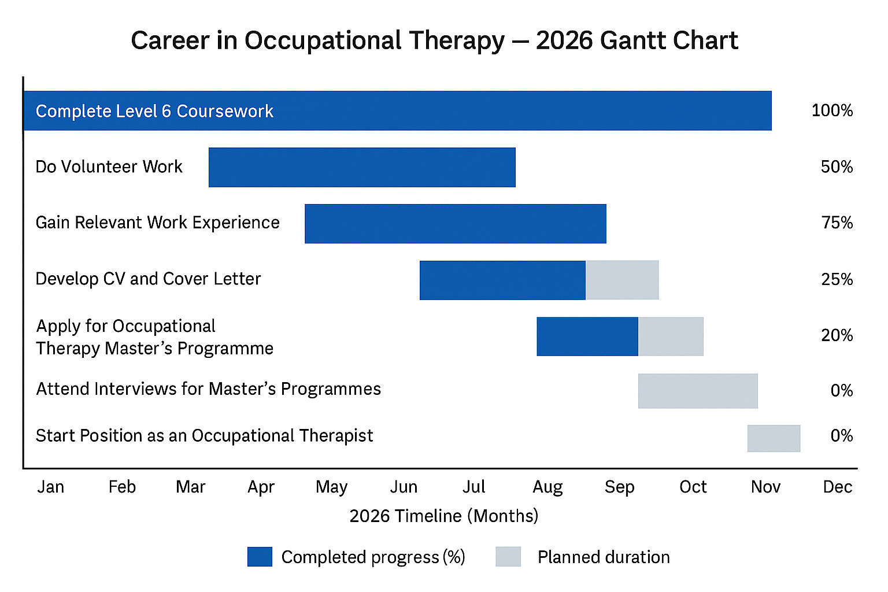

Task 7: Making Changes – Care Home Report
As a care home manager, I aim to introduce structured, person-centred activity programmes that improve residents’ overall wellbeing. Many residents experience loneliness, low motivation, or reduced independence, particularly those living with cognitive impairments or long-term health conditions. Providing meaningful activities tailored to individual interests and abilities can increase engagement, enhance mood, reduce anxiety, and support a sense of purpose.
To implement this change, I will use Lewin’s Change Model (1951).
In the Unfreeze stage, I will gather feedback from residents, families, and staff to identify current gaps in activity provision. I will also provide training to staff to help them understand the importance of meaningful engagement and the positive impact it can have on residents’ quality of life.
During the Change stage, I will introduce structured activity plans, including sensory activities, music therapy, light exercise sessions, one-to-one activities, and personalised hobbies. Staff will be encouraged to adapt activities to meet the unique needs of each resident, promoting holistic and person-centred care.
Finally, in the Refreeze stage, the new activity programme will become integrated into the daily routine of the care home. Regular evaluations, feedback sessions, and staff reflections will ensure ongoing improvement and sustainability.
Challenges may include staff resistance, lack of confidence, or concerns about time constraints. According to Kotter (1996), effective communication, strong leadership, and celebrating small successes can help reduce resistance and increase staff motivation.
Overall, implementing a person-centred activity programme promotes dignity, independence, and wellbeing, supporting the care home's aim to deliver high-quality, holistic care.

Task 8: Self-Reflection Using Gibbs’ Model
Using Gibbs’ Reflective Cycle (1988) has helped me reflect on my learning throughout this module and understand how it contributes to my personal and professional development.
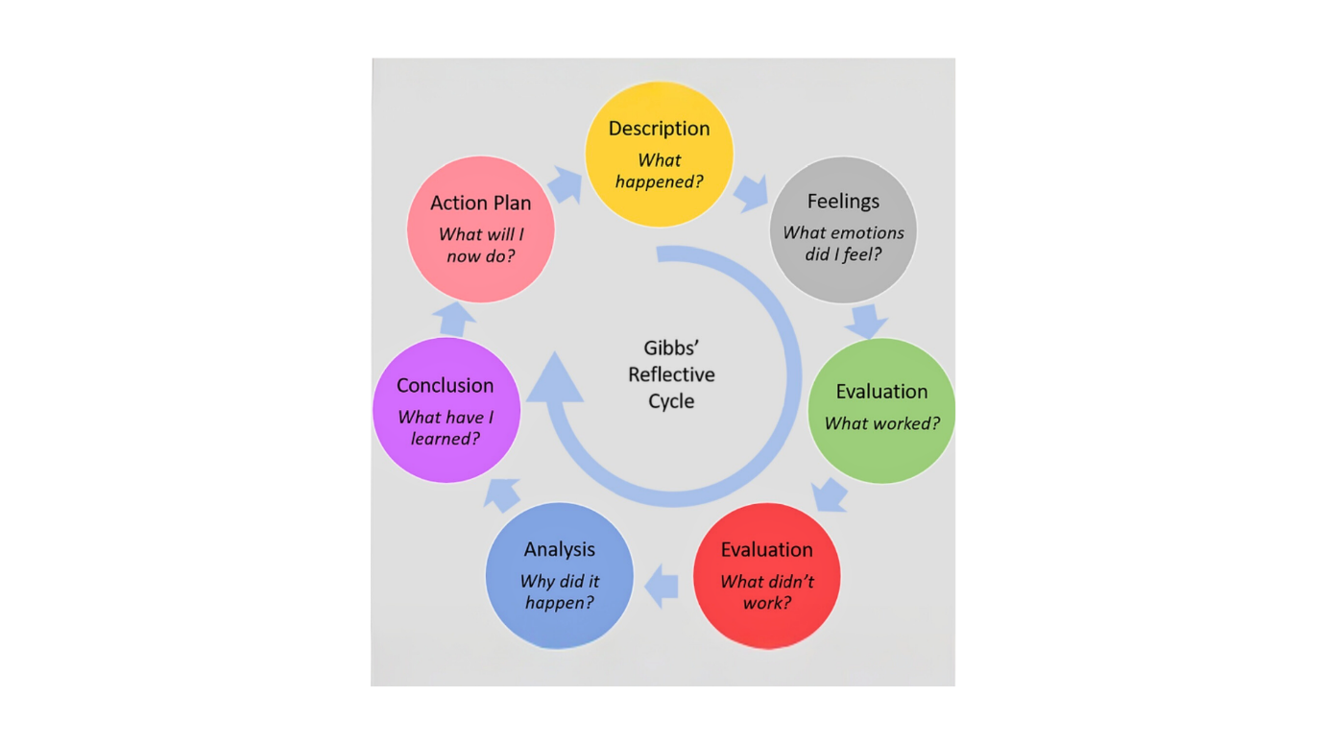 (Gibbs’ Reflective Cycle, McLeod, 2019)
Description:
The module covered personal branding, employability skills, resilience, emotional intelligence, communication, networking, and reflective practice. Each activity encouraged me to think critically about my strengths and development needs.
Feelings:
At first, I felt unsure about my skills and hesitant about the steps needed to reach my goal of becoming an Occupational Therapist. As I progressed, I gained confidence and began to recognise the strengths I already have, such as empathy, resilience, and the ability to communicate well with others.
Evaluation:
The personal brand task helped me identify characteristics that shape my identity. The network map showed me how much support I already have. The blog improved my ability to communicate complex health issues clearly. Altogether, the tasks supported my self-awareness and personal growth.
Analysis:
Understanding emotional intelligence helped me recognise how managing my emotions positively influences communication and teamwork. Learning about resilience highlighted the importance of staying adaptable, reflective, and determined in healthcare settings, particularly when supporting vulnerable individuals.
Conclusion:
This module strengthened my motivation and clarified my career goals. I now feel more prepared for occupational therapy training and more aware of the qualities needed to succeed in this profession.
Action Plan:
I plan to continue developing my communication skills, improve digital skills, engage in CPD courses, seek shadowing opportunities, and expand my network of health professionals. I will also continue using reflection to guide my ongoing professional development.

References
Care Options for Kids. (n.d.) Challenges of being an occupational therapist (online image). Available at: https://careoptionsforkids.com/blog/challenges-of-being-an-occupational-therapist/ Accessed: (14 November 2025).
CPD Online. (n.d.) Youth mental health (online image). Available at: https://cpdonline.co.uk/knowledge-base/mental-health/youth-mental-health/ (Accessed: 14 November 2025).
Gibbs, G. (1988) Learning by Doing: A Guide to Teaching and Learning Methods. Oxford: Oxford Polytechnic.
Goffman, E. (1959) The Presentation of Self in Everyday Life. New York: Anchor Books.
Goleman, D. (1995) Emotional Intelligence: Why It Can Matter More Than IQ. New York: Bantam Books.
Ibarra, H. and Hunter, M. (2007) ‘How Leaders Create and Use Networks’, Harvard Business Review, 85(1), pp. 40–47.
International Bar Association (IBA). (n.d.) COVID-19 UK pandemic inquiry set to be most expensive in history (online image). Available at: https://www.ibanet.org/Covid19-UK-pandemic-inquiry-set-to-be-most-expensive-in-history (Accessed: 14 November 2025).
Lewin, K. (1951) Field Theory in Social Science. New York: Harper & Row.
McLeod, S. (2019) Gibbs' Reflective Cycle (online image). Simply Psychology. Available at: https://www.simplypsychology.org/gibbs-reflective-cycle.html (Accessed: 6 November 2025).
NHS England (2023) NHS Equality, Diversity and Inclusion Improvement Plan. Available at: https://www.england.nhs.uk (Accessed 5 November 2025).
Peters, T. (1997) ‘The Brand Called You’, Fast Company, 10, pp. 83–90.
Royal College of Occupational Therapists (RCOT) (n.d.) About Occupational Therapy. Available at: https://www.rcot.co.uk (Accessed 5 November 2025).

