WARNING! GRAPHIC CONTENT.
Question: The Use of Death and Suffering in Advertising as a Tool for Persuasion
Course: Graphic Design
Student Name: Verine Muireall Costiniano
Student Number: P148793

Contents

ABSTRACT ………………………………………………………………………………..4
INTRODUCTION ……………………………………………………………………...5-6
CHAPTER ONE – The Guidelines ………………………………………………..…7
1.1 Guidelines ……………………………………………………………………..……..7
CHAPTER TWO – Death in Society and the Media ……………………………8
2.1 Death in the Media …………………………………………………….……….8-10
2.2 The Science of Fear ………………………………………………………………..11
2.3 How do we deal with fear? Terror Management Theory (TMT) ………12-13
2.4 Reactions According to Terror Management Theory ……………………….14
CHAPTER THREE - What Death Means in 2018 Society ………………….15
3.1 Death in 2018 …………………………………………………………..……..15-18
CHAPTER FOUR - The Components of the Perfect Advert ……………….19
4.1 The Perfect Advert …………………………………………………………………19
4.2 The Ideal Victim ……………………………………………………………….20-21
CHAPTER FIVE - How can it all go wrong? ……………………………........22
5.1 Compassion Fatigue ………………………………………………………….22-23
CHAPTER SIX - The Branding of Suffering …………………………………...24
6.1 Case Study 1 ……………………………………………………………………24-27
6.2 Case Study 2 ………………………………………………………….………..28-31
6.3 Case Study 3 ……………………………………………………………………32-35
6.4 Case Study 4 ………………………………………………………………..….36-39
CONCLUSION …………………………..…………………………………………..….40
APPENDIX ………………………………………………………………………..…41-43
BIBLIOGRAPHY ………………………………………………………………..….44-57

ABSTRACT
This research paper deals with the use of death and suffering in advertising as a method used for persuasion, by means of examining different case studies; questioning why some adverts are banned in comparison to others that propose a similar message, and/or have similar imagery, and yet allowed to be released to consumers, focusing mainly on banned adverts.

An exploration of the practical uses of said imagery in industry and the various levels of appropriation and exposure to the public will be undertaken. Debating whether using imagery of death and suffering as a means of persuasion in advertising is a fair business tactic, that plays on the empathy/ sympathy of consumers. Looking into whether it is a valid technique in funding a just cause and raising awareness in a respectful manner, or a poorly orchestrated, high production mockery of the bereavement of others for the sake of scaring consumers into submission.
INTRODUCTION
Kevin Robins (1996) states that, “to watch television in our culture is to be exposed to violence, suffering and death (Robins, 1996),” a statement that is still relevant today as the use of other peoples’ death and suffering in advertisements is somewhat of an omnipotent constant in the daily lives of the modern layman.

The reach of modern charity advertisement has expanded so much that it has escaped the confines of television, and bled into the streets, evolving to suit the environment of the bottomless pit that is the internet; a pastime which most millennials and Gen Z-ers find themselves entrapped (Fromm and Garton, 2013).

Furthermore, it has become somewhat of a social norm for people to actively ignore, and/or, avoid volunteers who ask for donations on the street (Knutsson et al., 2013), because over the years the vendors who collect donation for charity on the street have become more calculating and aggressive; obsessed with meeting quotas, instead of having donating-to-a-good-cause at the heart of the operation (Mohamed and Cheng, 2015). And as the urgency for money from donation reaches extremes, the content of advertisements become just as, if not more, extreme to match, focusing more on the image, rather than the message; opting to “…elicit attention for a brand name by jolting consumers (Belch and Belch, 2001)”.

The purpose is to raise questions surrounding the current standards set in place in the United Kingdom (UK), and to argue whether the current UK guidelines towards death and suffering should be changed due to them being either too strict, or lax; as well as briefly discussing the use of death and suffering as a persuasive tool in an ethical and practical point of view, making cases for both sides.

This study will mainly be dealing with the socio-economic impact of death and suffering being used in advertising as a means of persuasion, concentrating on the social consequences and the impact on the psyche; rather than an in-depth look into the connotations and semiotics proposed by each advertisement.

Each advertisement is used as a case study will be subject to the standards of the Advertising Standards Authority (ASA) regardless of whether the advert originally was aired in the UK, as the focus is the appropriateness of the use of death and suffering in advertisement in general, and not limited to just the UK.
CHAPTER ONE – The Guidelines

1.1 Guidelines
The organisation that enforces, regulates and creates the guidelines regarding the use of death and suffering in advertisements in the UK is the Advertising Standards Authority (ASA, 2018a) - they make sure that advertisements published in the UK adhere to the non-broadcast and broadcast code (ASA, 2018a). They manage any complaints an advert gets and decide whether an advert is pulled from the public (ASA, 2018a). This paper will be mainly dealing with section 04 – Harm and Offence, and section 05 – Children. There are two categories of code that an advert fits into: broadcast, adverts that are aired on television, and non-broadcast, in regards to paper based and internet campaigns.

For the duration of this paper, when referring to specific sections of the broadcast and non-broadcast codes, the format will be as follows:
EXAMPLE
The Kony 2012 violated section 04 of the [broadcast/ non-broadcast] code subsection 4.1 and 4.9, because…
Detailed descriptions of what each section details will only be detailed in the first instance that the rule is mentioned, and subsequent mentions will not be as thorough.
CHAPTER TWO - Death in Society and the Media

2.1 Death in the Media
Elizabeth Phelps (2013) posits that, “…fear is a universal survival mechanism (Phelps, 2013),” and that,
“…some of the most important things we can learn in life are what situations and events represent danger or threat. In humans, this type of information is often communicated through social interaction (Phelps, 2013)”
And thanks to the rise of the internet, social interaction is not limited to face-to-face conversations anymore; the internet a wide spectrum where reach is practically infinite (Arkin et al. 2013), people can exhibit their niche neutral fears or share their horror stories on a variety of platforms with the current social media boom (Burgess et al. 2009), something that many scholars attribute to the return of death to the public sphere (Zelizer, 2010).

Broadcasting platforms, such a YouTube, that make it so that anyone can submit a video without the need for a production crew, the approval of a board of directors, multiple test screenings or the need to meet strict television regulations, make the possibility of an advert featuring death more likely to go viral, thus receiving more exposure (Vonderau et al. 2010).
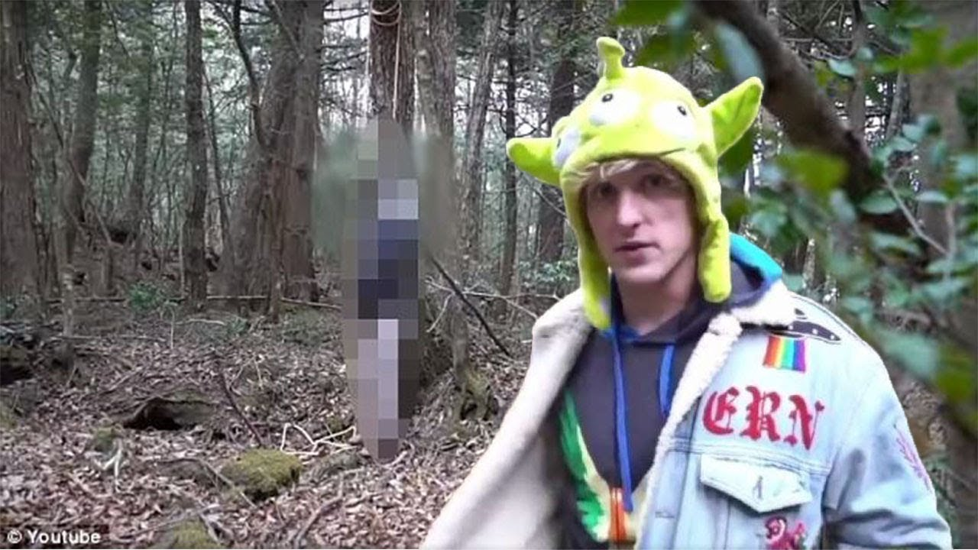
Figure 1 – still from reuploaded controversial Logan Paul video log (vlog)
For example, when popular YouTube user Logan Paul uploaded a video clearly featuring the dangling corpse of a suicide victim the recent you tube caused international condemnation (Griffin, 2018).

Folker Hanusch (2010, pp. 145) notes that:
“…old barriers to publishing graphic imagery are being eroded by a medium that allows users, on the one hand, to publish all kinds of photos without the media’s usual checks and balances. On the other hand, audiences are empowered to make a conscious decision about whether they want to see a certain image, and should therefore have less reason to complain (Hanusch, 2010, pp. 145).”

Thusly, many now agree that never before in human history have, we been more saturated with news and images of death and suffering; with the speed at which news and imagery travels in today’s parameters - the perception on death and suffering has never been broader and more diverse (Sumiala, 2012) – a continuum exists in between affirmation and denial, where the media make it possible to exhibit, exaggerate, euphemise and silence death at will (Hanusch, 2010).

We are exposed to death and suffering on a daily basis, so much so that we as a society have developed multiple social cues surrounding it and have learned to adapt around it, whilst consecutively avoiding it (Staudt and Block, 2012).

2:2 The Science of Fear
A study of mice that were exposed to a certain scent and then shocked, showed that they learned to fear the scent by association, and when the initial group of mice had offspring, their offspring exhibited the same fear, and when the offspring gave birth, three generations down they too exhibited the same fear the initial test group had, displaying possibility that not only can fear be influenced by environment, it can be hereditary (Dias and Ressler, 2014).

The same principle can be applied to the fear one develops as a child due to trauma (Field and Lawson, 2003) because the only fears that humans are born with, is the fear of falling and the fear of loud noises (Gibson and Walk, 1960) according to a study called “The Visual Cliff,” all other fears are learned, referred to as “neutral fears” in the scientific community.

The concept that fear is hereditary has not been proven in humans yet, but the possibility of a mother that is afraid of clowns and passing down that same fear subconsciously to her child is not so farfetched when you consider the studies mentioned previously.
2:3 How do we deal with fear? Terror Management Theory (TMT)
How do we, as a society, mange a learned fear of death? Terror Management Theory (TMT) proposes that while we as humans share characteristics with most, if not all, organic life, there exist a unique biological instinct that values the preservation of the self, above all else.

Studies in this vein of psychology have examined how people handle violations within their self-prescribed morality, and it suggests that when faced with thoughts of their own morality, the punishment of others who present themselves as having broken societal norm, a nationalistic response, increasingly becomes the most common reaction (Becker, 2011).

A study on TMT by Christine Ma-Kellams (2011) and Jim Blascovich (2011) details that we become convinced that our feelings of self-importance within the group will somehow live on beyond our years – even if only symbolically – after death. A parade of irrational fears that haunt us, materialises - consciously or otherwise - for reasons that cannot be predicted, controlled and/or anticipated; thus, creating an ouroboros of anxiety, the awareness of our own morality coupled with our innate desire to live (Shen, 2003).

This defensive state that acts like an insulation from the deep underlying fear of living a life only for the legacy you have built to be destroyed by a single event. Death. As such, this glamorised immortality that people strive for, the irony that thoughts of attaining immortality from the thing that terrorises them.
2:4 Reactions according to Terror Management Theory
Research in support of TMT shows that people react to being reminded of death in a plethora of ways, such as:
- ideas regarding death are increased when their worldviews are challenged (Schimel et al. 2007)
- the defences of any of the following: religion, relationship, worldview, political stance etc. prior to the reminder of death, effectively reduces the effectiveness of being reminded of morality
- preference towards well-structured and clearly presented information and environments (Landau et al. 2006)
- heightened identification towards members of their selected group, even going as far as to label themselves as more unique within their own group as well as outside of it (Vaes et al. 2010)
- increased piety in religion and the possibility to develop a belief in the supernatural, including, but not limited to, the possibility of life after death (Jong et al. 2012)
- an increase in intensity regarding anything. A heightened inclination to prove themselves, e.g. to be more aggressive towards people who are “different” from themselves, including, and not limited to, support regarding war (Landau, et al., 2004)
These multiple types of reaction will be used to identify the responses the public had to the case studies included in this study.
CHAPTER THREE - What Death means in 2018 society
3.1 Death in 2018
An expression coined by Louis-Vincent Thomas (2000) posits that death in media is simultaneously everywhere and nowhere, “obscene and absent from the scene,” meaning that while there are physical bodies to behold, imagery of ‘real’ death is nowhere (Thomas, 2000); so there exists a societal disconnect whenever the topic of death is raised, because like how images of models are likely to be photoshopped, the vox populi know death only as how the media chooses to portray it.

In Vladamir Jankélévitch (1996)’s work “La Mort”, he posits the notion of death as, “death this side of death”, the abstract eventuality of death, something that is too distant in the future that one cannot even begin to detail that far into the future, but always looming; then there is “death in the mortal instant,” this is death itself, and lastly there is “death as a mediatised death,” this is death that follows the eschatological path of reasoning, the argument of life after death (Jankélévitch, 1996).

Jankélévitch’s idea of death in the first, second and third person supports TMT because it applies the reasoning in all three perspectives, the denial of death in first perspective, the dread felt in the face of an oncoming death in second person, and of attaining immortality through the thing that terrorises them in the third person, but also goes into depth about the multiple perspectives in which society can look at death; youth, adult and elderly. In this instance, we focus on death as seen in the third person, the disconnect we feel when images of death are presented to us; the metaphorical screen that we view death through, serves as the physical screen which separates us and ‘real’ death (Jankélévitch, 1996).

The average consumer will see these representations of death, via third person, thinking, ‘there is no way I will die like in the advert, thusly, I will not die,’ and begins to disassociate, causing a ripple which consequently spreads across the masses. This disassociation manifests in 2018 as ‘meme,’ referring, but not limited to, either a collection of or a single image (Shifman, 2014), featuring the topic of death with overtones of humour to hide the existential dread that they may feel internally, followed by a caption in most cases to personalise the experience (Shifman, 2014) evident in a tweet made by user Brandon (2014) under the user name ‘UNDEADTRESOR’,
“I'm not thankful for shit. Life is a carnival of pain. I wish death would pull me into sweet oblivion. Shout out to my cat Buttons (Brandon, 2014),”
And twitter user Natal Cooper, username ‘IG97328’,
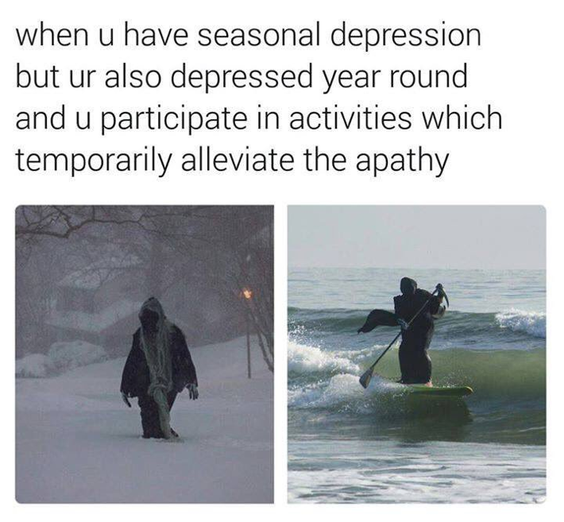
Figure 2 – example death meme
Thusly, the rise in nihilism in the 2018 consumer can be attributed to the disassociation consumers will fall back onto in order to preserve the self that TMT details. It questions, what is the ‘terror’, that consumers are hiding from? Where is this casual suicidal humour coming from?

According to DW Reports, (2017), the most likely culprit for the increase in casual suicidal humour is attributed to mass shootings in the United States of America (USA) (DW, 2017). Reports state that since 2007, the frequency and severity of mass shootings in the USA are on the rise, in recent years the Orlando Nightclub, Sandy Hook, Las Vegas and the Texas First Baptist Church to name a few (Schulman, 2017). Thomson, Stancich and Dickson (1998) state that distress from across the pacific is bleeding into the mainstream media of the UK and affecting the cultural ecosystem. Media coverage on TV news and videos on the internet makes the information more accessible, and first hand recollections of the events are posted on social media for the world to consume, planting the seed of terror that is causing the spread of fear of morality despite mass shooting not being applicable in the UK, mass death of any form can be enough to trigger memories of instances that are similar, such as Dunblane shooting 1996, the worst incident of gun-related violence to ever hit the UK (Thomson et al. 1998).

Figure 3 – Facebook live suicide
An example of death on social media includes when 12-year-old Katelyn Nicole Davis committed suicide on Facebook live in a 20-40 minute video, according to various sources, for all to see and share (Charlton, 2017).

The Office of National Statistics (ONS), between 1981 and 2016, an average of 5,175 suicides per year, of men and women 10+ years in the UK were recorded (Manders, 2018). In the last 5 years, 2012-2017, the rate of suicide has increased significantly from 5,204 suicides in 2012, to 5,821 suicided registered for 2017 and it is predicted that it will get worse (ONO, 2017). However, the visual representation of suicide is still shocking.

CHAPTER FOUR - The Components of the Perfect Advert

4.1 The Perfect Advert
Oyster Studios (2015), an advertising company that boast collaboration with brands such as Shell, Mercedes-Benz and Mitsubishi Electric attributes the perfect advert under these parameters:
- is memorable
- provides information quickly and succinctly
- is easily recalled
- doesn’t confuse or overwhelm the viewer.
- connects with its audience, their needs and desires.
- includes a clear, prominent brand logo
- features the company contact information including website
- has a clear call to action - make the next steps you would like the consumer to take incredibly obvious e.g. “To find out more call” (Studios, 2015)
These parameters will be the basis in which case studies will be chosen.
4.2 The Ideal Victim
Campaigns that capitalise on the death and/or suffering of others constitutes a unique type of advertisement that aims to arouse action on behalf of the suffered (Strahilevitz and Myers, 1998). In order to prompt the desired reaction advertisements as such attempt to manipulate the consumers’ morals to suit their needs by means of generating the feeling of taking responsibility for the suffering of others through what TMT suggests stems from a need to assert one’s self within their societal group and stand above everyone else (Becker, 2011).

Joanna Kinsey (1987) remarks that’s advertisers have long-known that the use of certain imagery depicting death and suffering is especially effective in rousing the consumers’ attention and emotional brain.

Taking all that has been said into consideration, the TMT act of selflessness that is prompted upon exposure to a targeted advertisement, warrants both a physical and social reaction (Olausson and Höijer, 2011), the act of donation equitable to pro-social behaviour (Basil et al. 2008) consumers may be more likely prompted to donate when a particular type of suffering is showcased (Bell et al. 1994). Nil Christie (1996) composites the ‘ideal victim,’ as a,
“person or a category of individual who – when hit by crime – most readily is given the complete and legitimate status of being a victim (Christie, 1996).”
Birgitta Höijer (2004) observes that generally, the ‘ideal victim,’ falls into the category of mothers, children, and the elderly, as men tend to not identify with traditional victims well (Burnett and Wood, 1988).
CHAPTER FIVE - How can it all go wrong?
5.1 Compassion Fatigue
There is such a phenomenon as caring too much to the point that you become numb; that is exactly what compassion fatigue is. Under normal circumstances, compassion fatigue is predominantly seen in nurses, but more so specifically hospice nurses, an occupational hazard, but to find compassion fatigue in an environment outside of the caregiving professing shows how much advertisement in recent years, play too heavily on what TMT equates to the self.

Susan Moeller (1999) attributes compassion fatigue to the reason why consumers have a short attention span, and the reason why trending news is no more of a trend then seasonal fashion; the downwards spiral that predicts quantity over quality, signalling the end of well-written articles in favour of more Twitter-like alerts that change as often at the minute hand on a clock.
“Compassion fatigue is not an unavoidable consequence of covering the news. It is, however, an unavoidable consequence of the way the news is now covered (Moeller, 1999).”
Compassion fatigue prompts the development of destructive behaviours when consumers engage in the preservation of the self as a crutch to keep thoughts of morality at bay, as TMT suggests, as apathy, self-inflicted isolation and bottled emotions begin to surface after too much time spent outside of the self.
CHAPTER SIX - The Branding of Suffering
These adverts were chosen based on the parameters set by Oyster Studios in chapter four. Each advert meets at least five of the parameters set.

6.1 Case Study 1: Kony 2012 (2012)
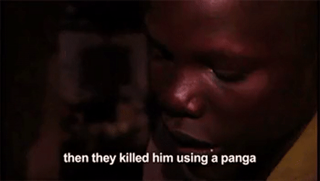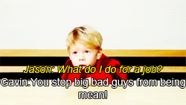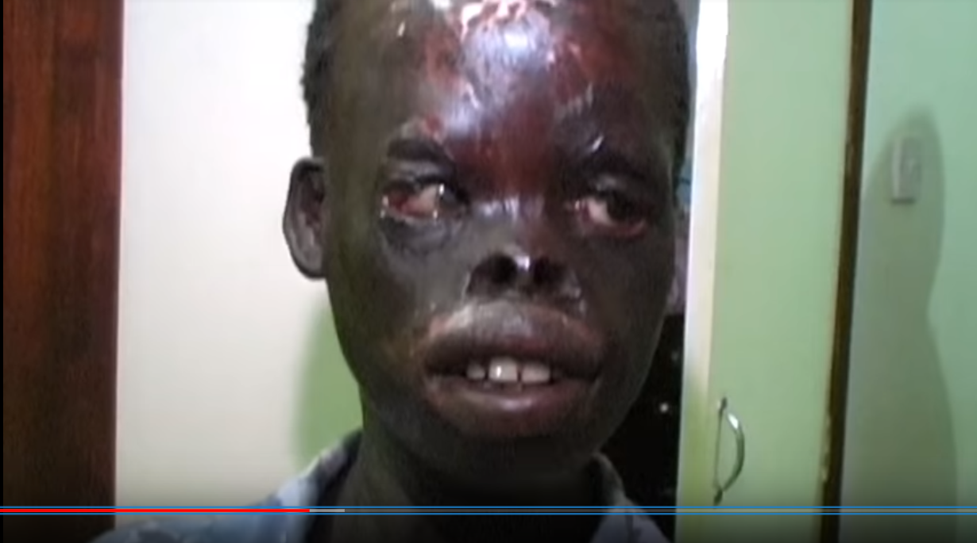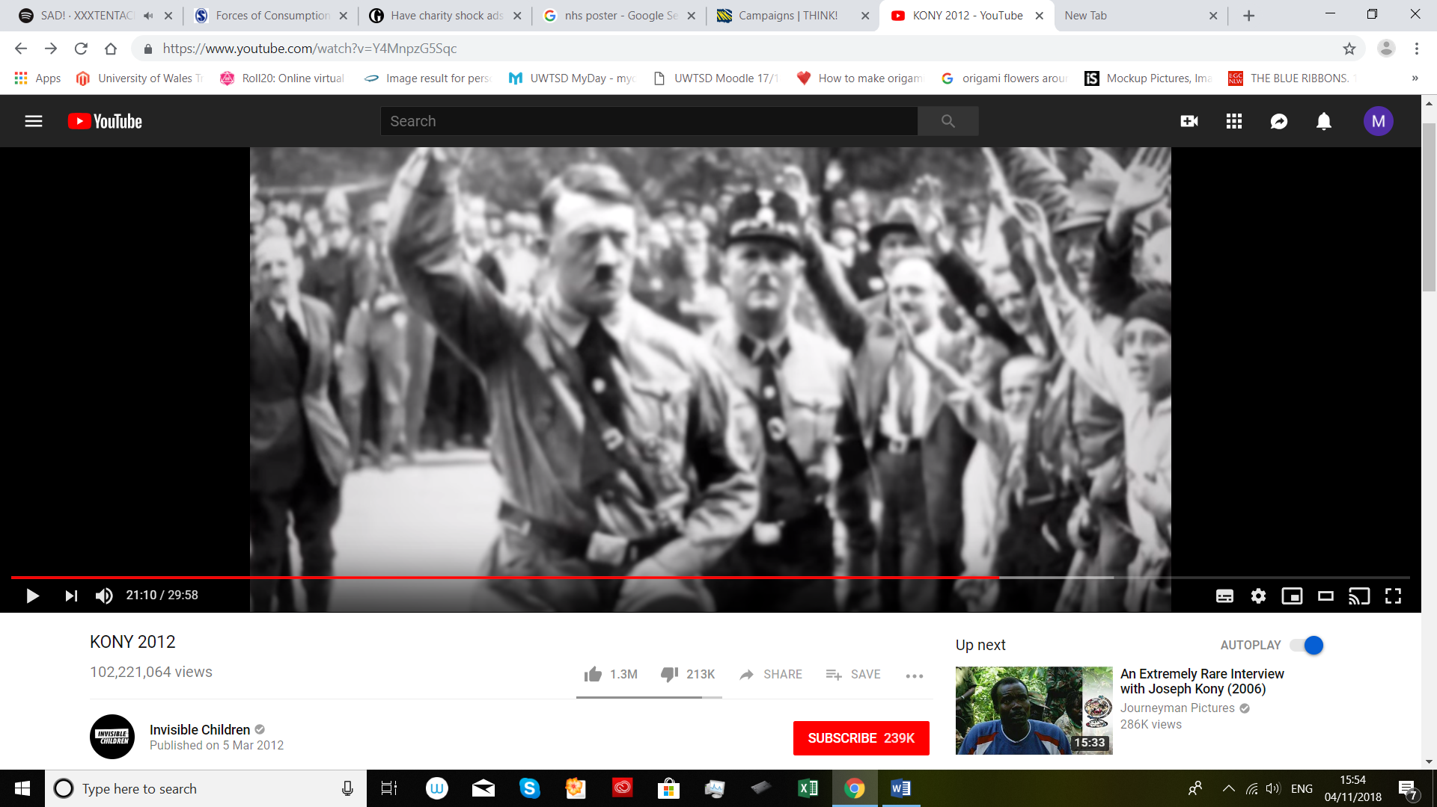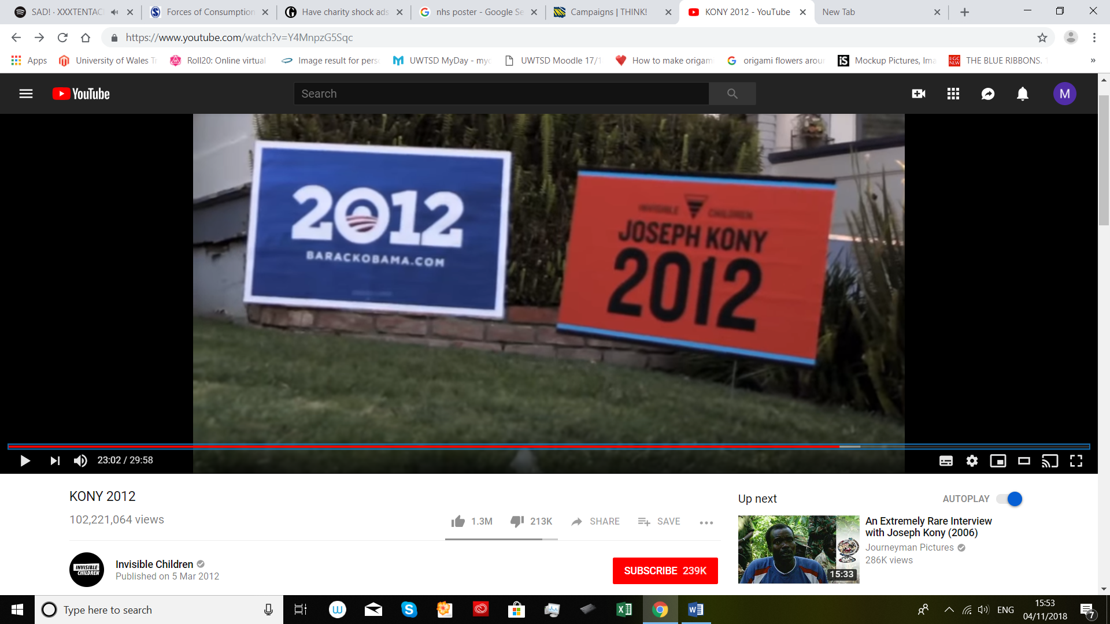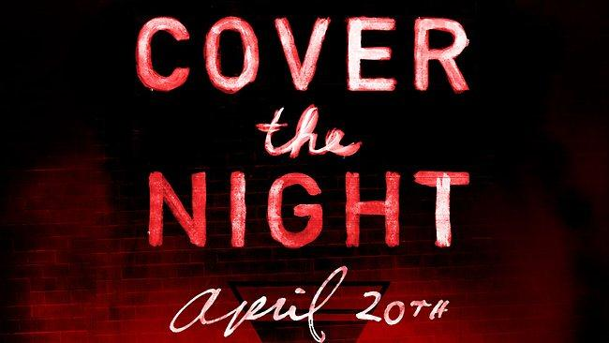
Figure 4 – stills from the Kony 2012 campaign YouTube video
The events that followed the release of the Invisible Children “Kony 2012” campaign was one that sparked great controversy to all that knew about it; the campaign was to raise awareness concerning the genocide and human rights violations being orchestrated by Joseph Kony, the leader of the militia group the Lord’s Resistance Army (Jenkins, 2012).
The reaction that came from the excessive visibility and questionably high price of ‘Kony kits’, starter packs for backers to use to raise awareness, with prices starting at $30, became one of the many the reason for many peoples’ suspicion towards the campaign (Cohen, 2012).
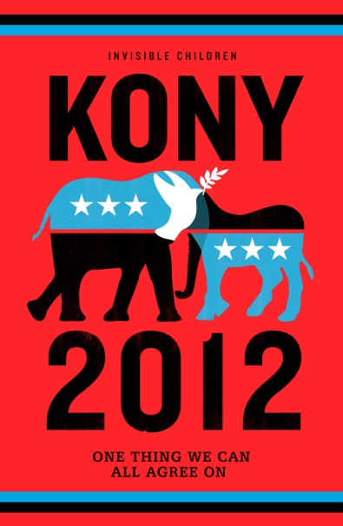
Figure 5 – Kony 2012 campaign poster
The advert itself garnered over a million views was a lengthy, by normal television standards, 30 minutes long and featured an origin story, featuring a montage of graphic images, a direct violation of section 04 sub-section 4.3 of the non-broadcast code,
“[references] to anyone who is dead must be handled with particular care to avoid causing offence or distress (ASA, 2018c),”
because after the initial air, some of the parties who had images of their deceased featured in the video spoke against giving permission for use (Patel, 2012), the establishment of a connection with the Holocaust, violates section 04 sub-section 4.1,
“[marketing] communications must not contain anything that is likely to cause serious or widespread offence…[marketing] communications may be distasteful without necessarily breaching this rule (ASA, 2018c),”
And sub-section 4.3 of the non-broadcast code,
“References to anyone who is dead must be handled with particular care to avoid causing offence or distress (ASA, 2018c),”
via a single image that had more screen time than the images relating to Kony himself and his work, an interview with co-founder Jason Russel’s son, Gavin, and then at the of the video campaign, the foundation for the Cover the Night event is set.

It would be later revealed that after support from overseas flooded the Ugandan government, Ugandan government official, Fred Opolot, clarified that the notion of the LRA being active in Uganda was false; and that the LRA had not been active in Uganda since mid-2006 after being successfully flushed out by the Ugandan Peoples Forces (Guardian, 2012), thusly a breech in section 03 – misleading advertising - subsection 3.3,
“Marketing communications must not mislead the consumer by omitting material information. They must not mislead by hiding material information or presenting it in an unclear, unintelligible, ambiguous or untimely manner (ASA, 2018b),”
Kony 2012 violated several ASA codes and as such would be banned, the references to the holocaust and comparison of Joseph Kony to Hitler were in poor taste and wholly unnecessary but was not banned because the advert has not originally been sourced from the UK, however, because Kony 2012 was not originally sourced from the UK the advert was not banned.

OBSERVATION
It would be my recommendation that the ASA include a section in the non-broadcast code that covered foreign media so that there isn’t a loophole and make the non-broadcast code as extensive as the broadcast code, since non-broadcast media is becoming the more preferred method of consumerism in recent times.

6.2 Case Study 2: McDonalds Fillet-o-fish advert, ‘Favourites’ (2017)
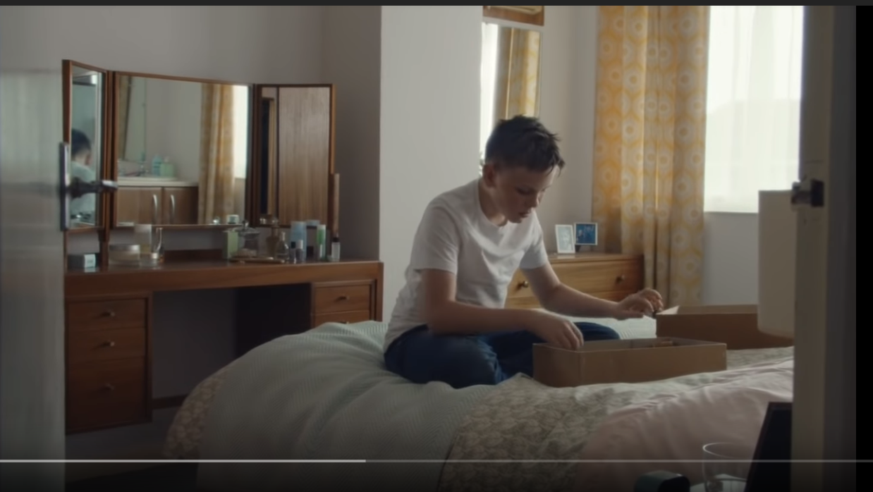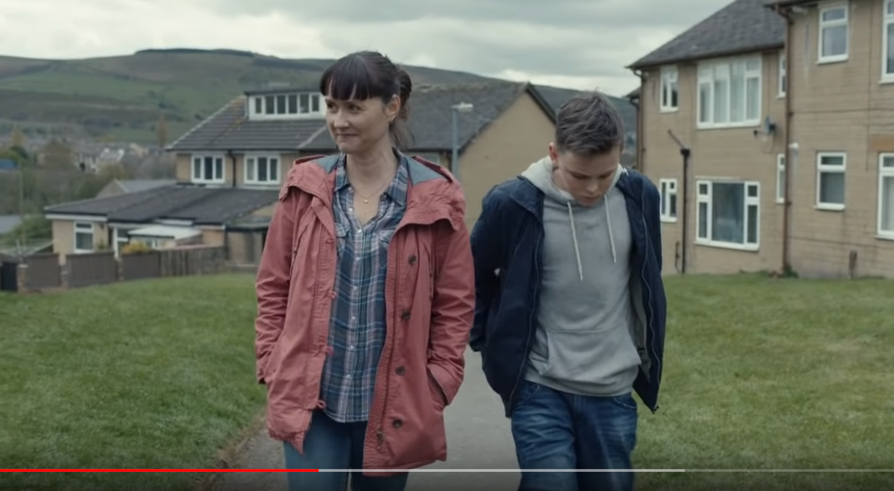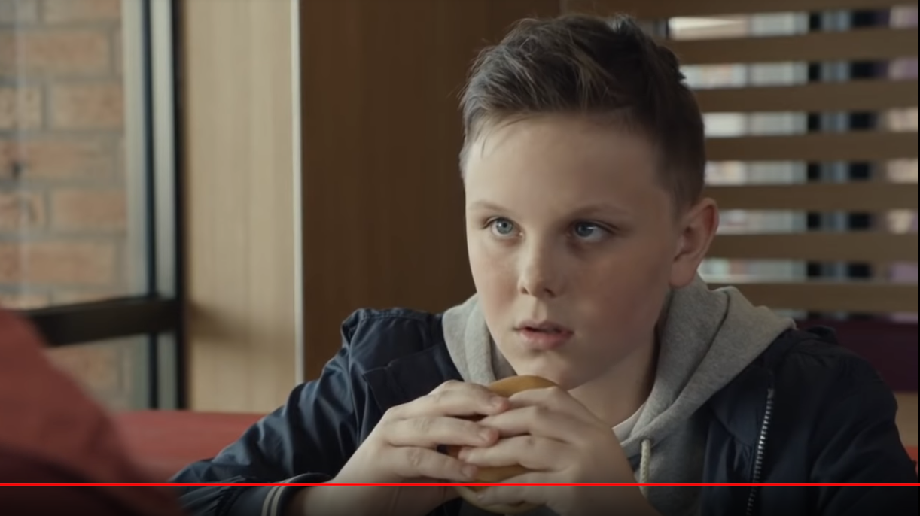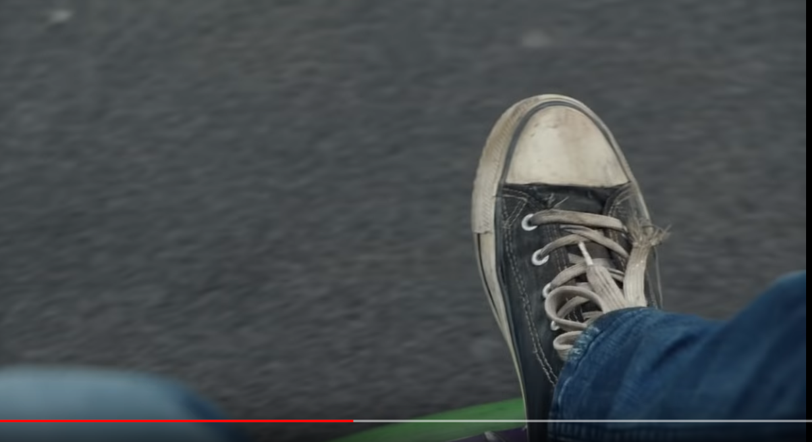
Figure 6 – stills from McDonalds filet o’ fish advert
In the middle of Spring, May 12th, 2017 fast food conglomerate McDonalds released an advert which was created in collaboration with London-based advertising agency Leo Burnett (Burnett, 2018), an agency that they have successfully worked with in the past (Macrow and Sobhani, 2018). The advert featured a young boy with his mother reminiscing about the boy’s father.

It is implied that the reason why the father was absent from his life is due to a sudden death, and when the mother is asked about the things the boy had in common with his father, the mother struggled to remember a characteristic that both father and son shared; that is until the duo entered a McDonalds establishment, the boy orders a fillet-o-fish burger, and then the mother remarks, “That was your dad’s favourite, too.”

The advertisement was scheduled to run for a minimum seven weeks (Barrie, 2017), but its final run, May 17th (Cliff, 2017), was announced only a few days after its release, May 12th (Barrie, 2017), a shocking total of 5 days the advert received exposure, it aired for less than a third of its intended run time before becoming banned all throughout the UK.

The reason why it was taken down was because of the overwhelmingly negative response it got from the UK public via social media, the social media platform of Twitter receiving the most traffic, not because it didn’t meet the ASA’s standards regarding harm and offence, but because many netizens claimed that the advert was “bad [in] taste,” (Cliff, 2017), and approached a sensitive topic in a disrespectful tone, many claiming that it was not up to code by the public’s moral standards. One tweet commenting on the advert adequately sums up the most common argument that netizens proposed by Jack Alex Turner (2017),
“I genuinely don't think I've ever seen anything as cynical and exploitative as the new @McDonalds advert. Shameless, even by their standards (Turner, 2017),”
became viral, and was featured in many online news sites, a mob of angry netizens rallying behind the tweet agreeing that the advert had gone too far in using the grief of a child over the lost parental father figure to sell something as cheap as a fillet-o-fish, trivialising the grief of the boy, and in turn, the grief of the real-life people who empathised with the boys situation.

Due to such an enthusiastic response the ASA, after being bombarded with complaints, was prompted into action. The ASA (2018g) banned the McDonalds advert after receiving 256 complaints (ASA, 2018g) challenged on the grounds of offence, however no further investigation was undertaken as McDonalds had already released a statement announcing that the advertisement would be pulled from the public domain.

In the end, the big corporation bowed its head to the pitchforks that each tweet made about the advert raised, the mob of netizens growing larger the more exposure the little advertisement got. However, not all tweets were aimed at their throats, Wes Langley (2017) tweeted messages of support and understanding,
“#VictoriaLIVE re @McDonalds ad - we think it's really cute and touching - I lost my Dad 4 years ago and it doesn't bother me (Langley, 2017)”.

OBSERVATION
The adverts itself didn’t breach any of the ASA broadcast codes, barely violating section 04 sub-section 4.1, but was banned despite this. Readily conceding to the demands of the public, may censor too may adverts on the grounds of offence, for it is nearly impossible to make an advert that will not offend anyone, especially in 2018 where consumers are more likely to complain and are more sensitive (Exline et al. 2004).

6.3 Case Study 3: Iceland Christmas advert, ‘Say hello to Rang-tan’ (2018)

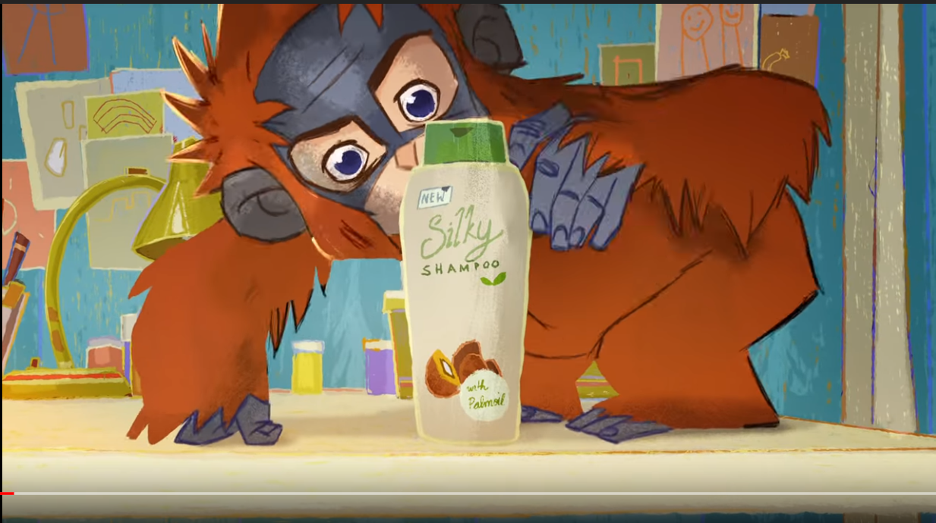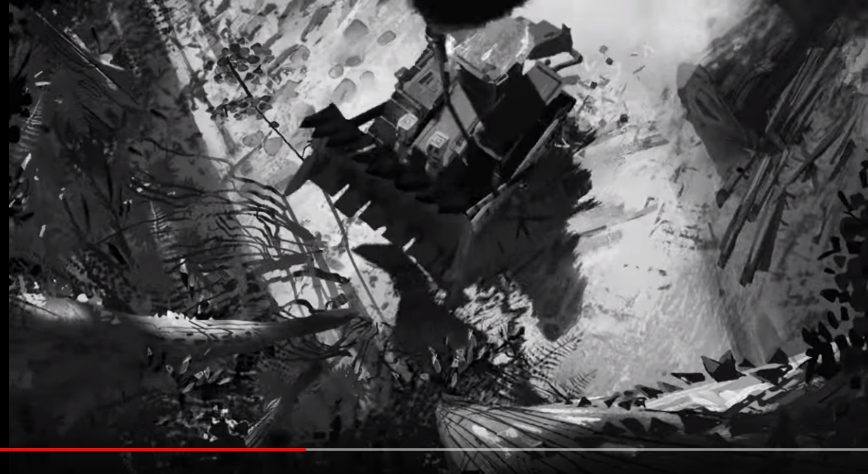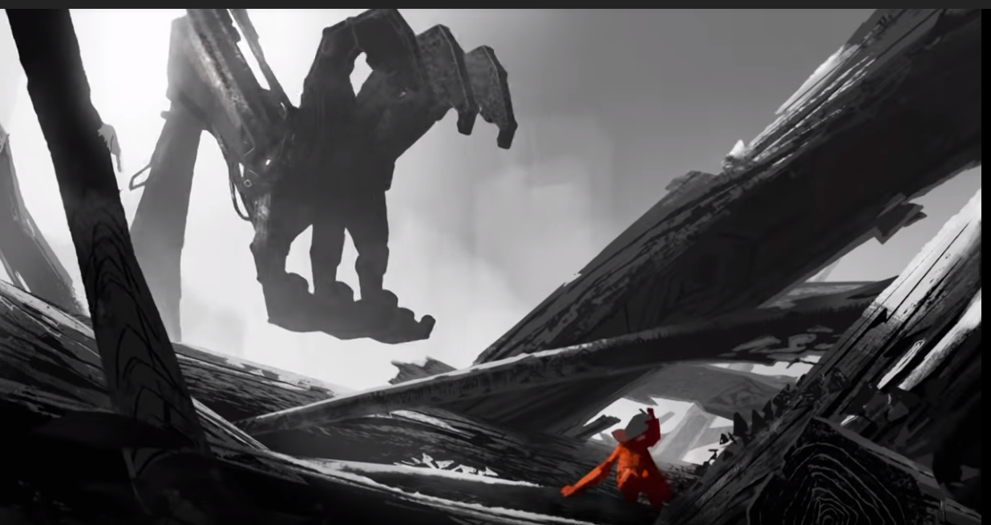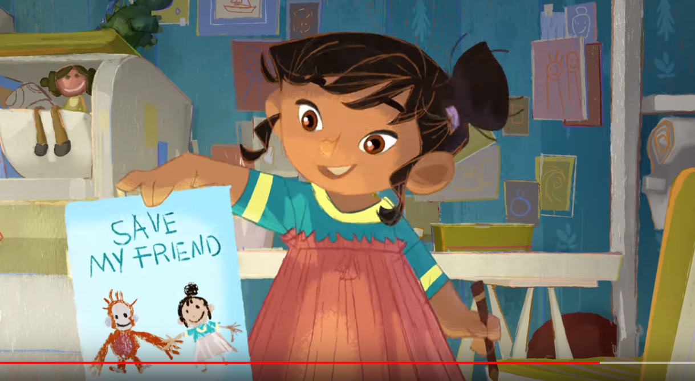
Figure 7 – stills from Say hello to Rang-tan
A more recent example would be Iceland’s 2018 Christmas advertisement that got banned before ever being broadcast to the public (Blake, 2018). The advert uses the voiceover narration, by Emma Thompson, of a rhyming poem to tell the story of a young girl who is experiencing distress over Rang-Tan, a young orangutan, messing up her bedroom.

When prompted by the little girl to give reason as to why Rang-Tan was in her room in the first place, a sequence is revealed to show the hardship that Rang-Tan and his family faces, leaving them homeless along with the narration told from the perspective of Rang-Tan that mirrors the narration of the little girl, Alexander Robertson (2018) highlights,
'There's a human in my forest and I don't know what to do...He took away my mother and I'm scared he'll take me too (Robertson, 2018).'
The advertisement ends with the little girl pledging to help save Rang-Tan and his home. The advertisement ends with the words: "Dedicated to the 25 orangutans we lose every day (Robertson, 2018)", announcing to consumers that Iceland is removing palm oil from all its own-label food by the end of the 2018 (Herbert, 2018).
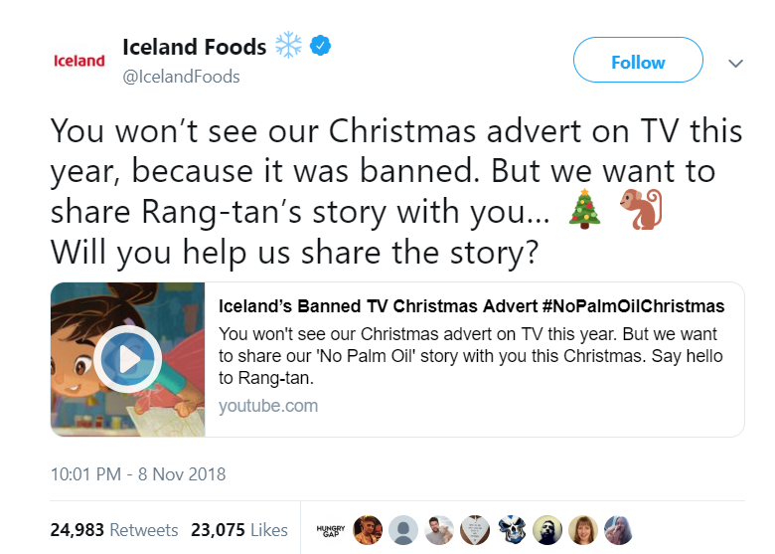
Figure 8 – screenshot of the original tweet made by Iceland Foods
The reason why the public have knowledge about the advert is because Iceland’s official Twitter account, tweeted about it and the aforementioned tweet went viral; Iceland (2018) sharing the video of the advert alongside the caption,
“You won’t see our Christmas advert on TV this year, because it was banned. But we want to share Rang-tan’s story with you… Will you help us share the story? (Iceland, 2018)”
The original tweet garnering 1.5k comments, 22k retweets and 20k likes in the first 9 hours of the tweet going live, a string of support following it. Hugh Fearnly-Whittingstall (2018) tweeted in support of the advert,
“It's a shame that Iceland’s ad about #PalmOil has been banned from TV for being “political”. Concern for the planet isn’t political, it’s #ethical! (Fearnly-Whittingstall, 2018)”

The advert was pre-maturely banned because it was anticipated to be banned on the grounds that it was too political, going against section 07 subsection 7.2.2 sub-sub-section f of the broadcast code,
“influencing public opinion on a matter which, in the United Kingdom, is a matter of public controversy (ASA, 2018f),”
And sub-sub-section g,
“promoting the interests of a party or other group of persons organised, in the United Kingdom or elsewhere, for political ends (ASA, 2018f),”
a ruling independently made by Clearcast, a company that specialises in clearing advertisements for UK commercial channels (Clearcast, 2018). One of the reasons speculated as to why the advert was have deemed to be ‘too political’, may be due to the partnership with well-known UK political party Greenpeace (Butler and Sweney, 2018) on the re-purposing of one of their animated short films as Iceland’s 2018 Christmas advert.

OBSERVATION
The advert was never formally screened by the ASA and was banned pre-maturely; self-banned on the ground of a slight technicality that was not proven to be of any validity. The ASA should have a separate section regarding the pre-screening of advertisement so that it is not left to third party companies such as Clearcast.

There is a separate section regarding children and the environment, but no section specifically dealing with animals; the bereavement on children is poor in taste when coupled with a filet o’ fish, but what about the bereavement of animals?

The representation of ‘suffering’ in advertisements is a ‘grey area’ in the codes set by the ASA, as it is not extreme enough to come under section 04 which deals with “Harm and Offence,” thusly, another section covering less graphic representations of harm is advised. The implementation of an animal-specific section in the broadcast and non-broadcast codes will make it so that uncertainties like the ones exhibited in the Rang-Tan advert are more swiftly dealt with. In this instance the verdict may have been too strict.

6.4 Case Study 4: NHS anti-smoking advert, ‘Hooked’ (2007)
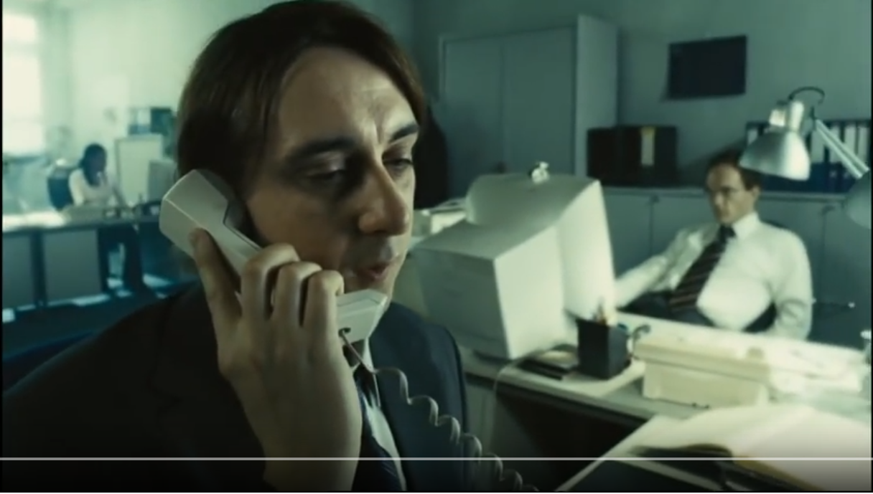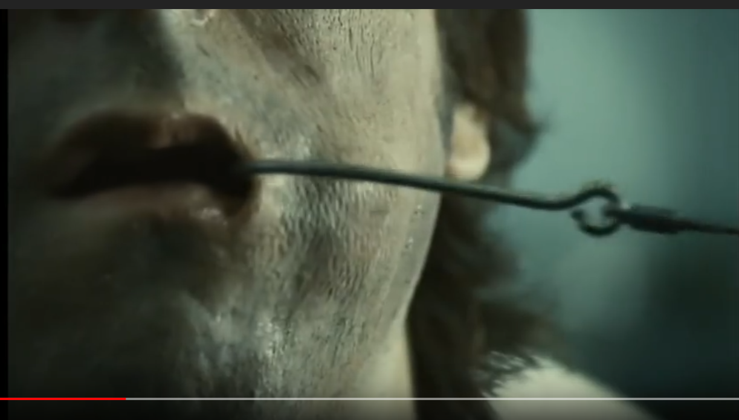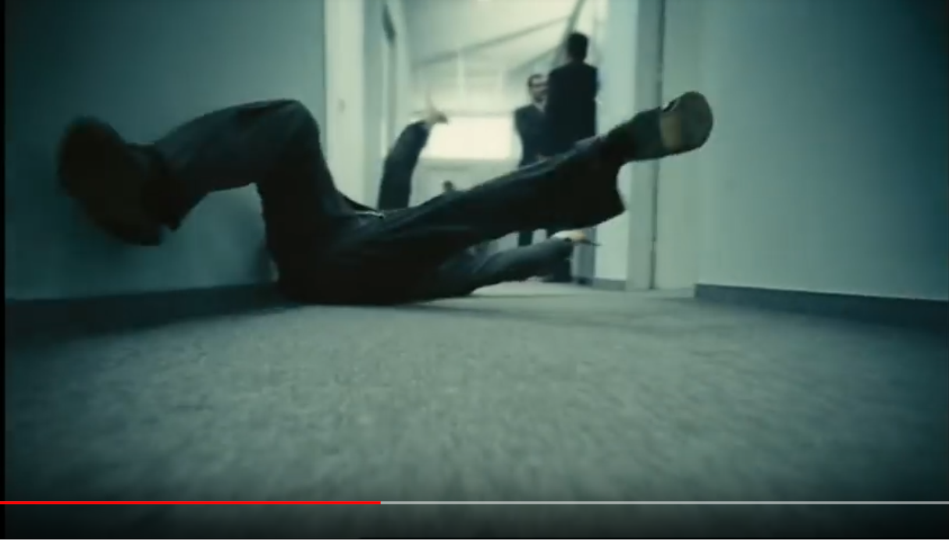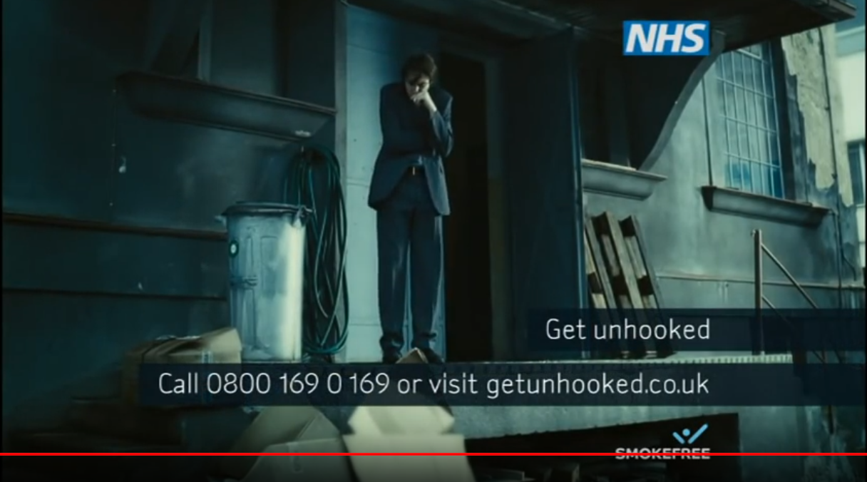
Figure 9 – stills from one in the Smoke free series of ‘Hooked’ adverts
Dan Shute (2016) managing director of advertising agency, ‘Creature’, remarks that “[whether its soft sell or not] great ads have always had something in common: people have wanted to watch them (Shute, 2016),” therefore, companies must exercise their ability to create a commotion which is hoped that the public will give a damn. ‘Hooked,’ was one such a campaign.

The anti-smoking advertisement focuses on the symbolic representation of a fishing line and hook, as a representation of the real-life feeling of feeding on an individual’s smoking addiction. The advertisement heavily played on the graphic imagery of a hook in the mouth, not piercing or drawing blood, but nearly piercing through to shock consumers. The advert had a total of 774 complaints against it reported to the ASA (Sweney, 2007).

The majority of complaints were in the vein of broadcast code section 04 sub-section 4.1,
“Advertisements must contain nothing that could cause physical, mental, moral or social harm to persons under the age of 18 (ASA, 2018e),”
Particularly referring to young children and people under the age of 18, and sub-section 4.10,
Advertisements must not distress the audience without justifiable reason. Advertisements must not exploit the audience's fears or superstitions (ASA, 2018e).”

However, despite the TV advertisements being banned, the ASA deemed the poster based version of the same campaign, although still within the same breach in the non-broadcast code regarding offence, was worthwhile for the purpose of discouraging smoking, as long as the poster were dud not appear in places where young persons frequented (Sweney, 2007).
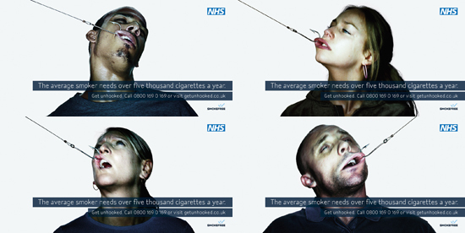
Figure 10 – posters advertisements for the ‘Get Unhooked’ campaign
The campaign was the most controversial advertisement at the time, and some research suggests that despite controversy, the campaign was also one of the most effective (Hornshaw, 2008).

Public Health minister, Caroline Flint, was quoted as by (Hall, 2006), in The Guardian, that,
"Many smokers will be considering stopping as part of their new year's resolution. These adverts highlight the controlling message of tobacco. We know 70% of smokers would like to give up (Hall, 2006)."
Studies led by Ekant Veer (2007) observes the reactions of 200 long-term smoking addicts when exposed to two different approaches of anti-smoking campaigns, the graphic approach of NHS ‘Get Unhooked’ and the gentler approach of the British Heart Foundation’s ‘Fatty Cigarettes’ campaign (Veer et al. 2007, pp. 315-325).
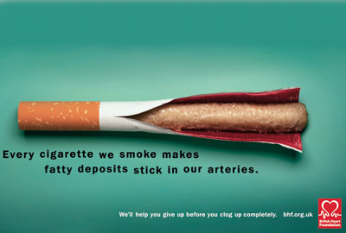
Figure 11 – posters advertisements for the ‘Fatty Cigarettes’
The study found that persons that were on the verge of quitting smoking showed a 20% increase in commitment after exposure to the high-impact imagery featured on the ‘Get Unhooked’ campaign.

However, subject who had no desire to quit were seen to have a 7% increase in a commitment to quitting when shown the lower-impact imagery of the ‘Fatty Cigarettes’ campaign. Veer et al. (2007) remarks that,
“[both] campaigns would benefit from presenting different levels of advertising which cater for the varying levels of preparedness towards quitting of the people they are targeting (Veer et al. 2007, pp. 315-325).”

OBSERVATION
Despite the TV version of the campaign being banned the ASA deemed the paper version beneficial, despite breaching some of the ASA’s non-broadcast code and approved it for exposure with come conditions attached. Selective censorship in advertising such as the one displayed in this case study, is a good example of non-biased and circumstantial decision making that would be the ideal when advertisement is being reviewed. The campaign breached some of the broadcast and non-broadcast code but was not banned outright and was looked at without too much influence by the public.

Conclusion
There are too many adverts that are being banned on the ground of offence, the specifications are too vague in some cases and the resulting outcome is that adverts that shouldn’t have been banned have been banned and advertisement that showed clear violations, are not. There are also many cases where the view of the public is put above proper procedurals to please consumers, so that less conflict is generated, a catalyst for people to abuse the system for personal gain or for the purpose of causing grief to others. And as such, the proposed course of action would be for standards to be changed and be revised as society changes. This would reduce the risk of over and under censoring. Consumers need increased and relevant education to not to take all these adverts personally. The way death is advertised plays a huge role in the public perception. This does not imply that it is acceptable to ban everything that offends, as freedom of speech applies to us all, even to the creators of these adverts, which must abide by the ASA code.

WORD COUNT: 5853
APPENDIX
Figure 1 (pp. 9) - still from reuploaded controversial Logan Paul video log (vlog)
Whatever’s Cool. (2018) Logan Pauls (Deleted Video) At Forest MUST WATCH [video]. Available at: https://www.youtube.com/watch?v=72Ir9Xp1rx0 (Accessed: 11 October 2018).
Figure 2 (pp. 17) - example death meme
Cooper, N. (2017) [Twitter] 20 February. Available at: https://twitter.com/ig97328 (Accessed 8th November 2018).
Figure 3 (pp. 18) – Facebook live suicide

Cosimi, S. (2017) Facebook e i suicidi virali, quando la realtà va più veloce della tecnologia. Available at: https://www.gqitalia.it/news/2017/01/13/facebook-i-suicidi-virali-quando-la-realta-va-piu-veloce-della-tecnologia/ (Accessed 8th November 2018).
Figure 4 (pp. 25)- stills from the Kony 2012 campaign YouTube video
Invisible Children. (2012) Kony 2012 [video]. Available at: https://www.youtube.com/watch?v=Y4MnpzG5Sqc (Accessed: 11 October 2018).
Figure 5 (pp. 26)- Kony 2012 campaign poster
Invisible Children. (2012) Kony 2012. Available at: https://gra217.expressions.syr.edu/s5g2/wp-content/uploads/sites/4/2013/09/Evernote-Camera-Roll-20130912-151656.jpg (Accessed 11 October 2018).
Figure 6 (pp. 29)- stills from the banned McDonalds filet o’ fish advert
anarchi.st. (2017) McDonald's Dead Dad Advert / Commercial [90 seconds, unedited [video]. Available at: https://www.youtube.com/watch?v=S1XM4INk8l8 (Accessed: 11 October 2018).
Figure 7 (pp. 33)- stills from Say hello to Rang-tan
Iceland Foods. (2018) Iceland’s Banned TV Christmas Advert... Say hello to Rang-tan. #NoPalmOilChristmas [video]. Available at: https://www.youtube.com/watch?v=JdpspllWI2o (Accessed: 9 November 2018).
Figure 8 (pp. 34) – a screenshot of the original tweet made by Iceland Foods
Iceland. (2018) [Twitter] 8 November. Available at: https://twitter.com/IcelandFoods/status/1060774234266484737 (Accessed 9 November 2018).
Figure 9 (pp. 37)- stills from one in the Smoke free series of ‘Hooked’ adverts
TheAdMonkey. (2007) NHS anit-smoking – hooked [video]. Available at: https://www.youtube.com/watch?v=anFK9SA5kKw (Accessed 9 November 2018).
Figure 10 (pp. 38) - posters advertisements for the ‘Hooked’ campaign
Parrak, D. (2016) NHS Smokefree “Get unhooked”. Available at: https://shockads.wordpress.com/2016/03/11/nhs-smokefree-get-unhooked/ (Accessed 9 November 2018).
Figure 11 (pp. 39)– posters advertisements for the ‘Fatty Cigarettes’
Gemma Quainton. (2013) Change makers: British Heart Foundation. Available at: https://shockads.wordpress.com/2016/03/11/nhs-smokefree-get-unhooked/ (Accessed 9 November 2018).

BIBLIOGRAPHY
Aries, P. (1974) Western Attitudes Toward Death: From Middle Ages to the Present. Baltimore: John Hopkins University Press.
Arkin, R., Oleson, K. and Carroll, P. (2013) Handbook of the Uncertain Self. East Sussex: Taylor and Francis.
ASA. (2018a) About the ASA and CAP. Available at: https://www.asa.org.uk/about-asa-and-cap/about-regulation/about-the-asa-and-cap.html (Accessed 15 October 2018).
ASA. (2018b) 03 Misleading Advertising. Available at: https://www.asa.org.uk/type/non_broadcast/code_section/03.html (Accessed 15 October 2018).
ASA. (2018c) 04 Harm and Offence. Available at: https://www.asa.org.uk/type/non_broadcast/code_section/04.html (Accessed 15 October 2018).
ASA. (2018d) 05 Children. Available at: https://www.asa.org.uk/type/non_broadcast/code_section/05.html (Accessed 15 October 2018).
ASA. (2018e) 04 Harm and Offence. https://www.asa.org.uk/type/broadcast/code_section/04.html (Accessed 15 October 2018).
ASA. (2018f) 07 Political and Controversial Matters. https://www.asa.org.uk/type/broadcast/code_section/07.html (Accessed 15 October 2018).
ASA. (2018g) Top 10 Most Complained About Ads from 2017. Available at: https://www.asa.org.uk/news/top-10-most-complained-about-ads-from-2017.html (Accessed 15 October 2018).
Barrie, J. (2017) New McDonald's advert slammed for using boy's dead father to sell burgers, The Mirror, 16 May. Available at: https://www.mirror.co.uk/news/uk-news/new-mcdonalds-advert-slammed-using-10431576 (Accessed 14 October 2018).
Basil, D., Ridgway, N. and Basil, M. (2008) Guilt and giving: A process model of empathy and efficacy. Psychology & Marketing, 25(1), pp. 1-23.
Becker, E. (2011) The Denial of Death. London: Souvenir Press Ltd.
Belch, M. A. and Belch, G. E. (2011) Advertising and promotion: an integrated marketing communications approach. 9th ed. New York: McGraw-Hill Education.
Bell, R. et al. (1994) Encouraging donations to charity: A field study of competing and complementary factors in tactic sequencing. Western Journal of Communication, 58(2), pp. 98-115.
Blake, I. (2018) NO FESTIVE SPIRIT Iceland’s Christmas advert 2018 ‘BANNED’ before it even goes on TV – but you can watch it here, The Scottish Sun, 11 November. Available at: https://www.thescottishsun.co.uk/money/3465674/icelands-christmas-advert-2018-banned-before-it-even-goes-on-tv-but-you-can-watch-it-here/ (Accessed 9 November 2018).
Brandon. (2014) [Twitter] 27 November. Available at: https://twitter.com/UNDEADTRESOR/status/537975920280502272?ref_src=twsrc%5Etfw%7Ctwcamp%5Etweetembed%7Ctwterm%5E537975920280502272&ref_url=https%3A%2F%2Fmic.com%2Farticles%2F181752%2Fwhy-does-everyone-on-the-internet-want-to-die-how-death-memes-took-over-the-web (Accessed 8th November 2018).
Burgess, J., Green, J., Jenkins, H. and Hartley, J. (2009) YouTube: Online Video and Participatory Culture. 1 ed. Cambridge: Polity.
Burnett, J. and Wood, V. (1988) A proposed model of the donation decision process. Research in consumer behaviour, 3(1), pp. 1-47.
Burnett, L. (2018) Clients. Available at: https://www.leoburnett.co.uk/clients/ (Accessed 14 October 2018).
Butler, S. and Sweney, M. (2018) Iceland's Christmas TV advert banned for being too political Supermarket’s Greenpeace film on palm oil’s impact on orangutan deemed rule breach, The Guardian, 9 November. Available at: https://www.theguardian.com/media/2018/nov/09/iceland-christmas-tv-ad-banned-political-greenpeace-orangutan (Accessed 9 November 2018).
Cheng, A., Hawton, K., Lee, C. and Chen, T. (2007) The influence of media reporting of the suicide of a celebrity on suicide rates: a population-based study. International Journal of Epidemiology, 36(6), pp. 1229-1234.
Children, I. (2018a) Crisis Tracker LRA. Available at: https://crisistracker.org/ (Accessed 11 November 2018).
Children, I. (2018b) Kony 2012. Available at: https://invisiblechildren.com/kony-2012/ (Accessed 2018 November 2018).
Christie, N. (1996) From Crime Policy to Victim Policy. 1st ed. New York: St Martin's Press.
Clearcast. (2018) CLEARCAST IN A NUTSHELL. Available at: https://www.clearcast.co.uk/ (Accessed 9 November 2018).
Cliff, M. (2017) 'It was never our intention to cause upset': McDonald's PULLS controversial advert showing a bereaved boy cheered up by a burger after losing his father following thousands of complaints, Daily Mail, 16 May. Available at: https://www.dailymail.co.uk/femail/food/article-4511698/McDonald-s-PULLS-controversial-advert.html (Accessed 14 October 2018).
Cohen, N. (2012) Why Did “Kony 2012” Fizzle Out? Available at: https://nonprofitquarterly.org/2012/04/26/why-did-kony-2012-fizzle-out/ (Accessed 11 November 2018).
Dechesne, M. et al. (2003) Literal and symbolic immortality: The effect of evidence of literal immortality on self-esteem striving in response to mortality salience. Journal of Personality and Social Psychology, 84(4), pp. 722-737.
Dias, B. and Ressler, K. (2014) Parental olfactory experience influences behaviour and neural structure in subsequent generations. Nature Neuroscience, Volume 17, pp. 89-96.
DW, W. (2017) The True Effect of Mass Shootings on Americans. Annals of Internal Medicine, 166(10), pp. 749-750.
Exley, C. (2001) The sociology of dying, death and bereavement. Sociology of Health & Illness, 26(1), pp. 110-122.
Exline, J. et al. (2004) Too Proud to Let Go: Narcissistic Entitlement as a Barrier to Forgiveness. Journal of Personality and Social Psychology, 87(6), pp. 894-912.
Fearnley-Whittingstal, H. (2018) [Twitter] 9 November. Available at: https://twitter.com/HughFW/status/1060846859755888641
(Accessed 9th November 2018).
Field, A. and Lawson, J. (2003) Fear information and the development of fears during childhood: effects on implicit fear responses and behavioural avoidance. Behaviour Research and Therapy, 41(11), pp. 1277-1293.
Fink, D., Santaella-Tenorio, J. and Keyes, K. (2018) Increase in suicides the months after the death of Robin Williams in the US. PLoS ONE, 13(2).
Flight from Death: The Quest for Immortality (2003) Directed by Patrick Shen [DVD]. USA: Transcendental Media.
Fromm, J. and Garton, C. (2013) Marketing to Millennials: Reach the Largest and Most Influential Generation of Consumers Ever. 1st ed. New York City: AMACOM.
Gardner, D. (2008) The Science of Fear: Why We Fear the Things We Shouldn't--and Put Ourselves in Greater Danger. 1st ed. Boston: Dutton Books.
Gardner, D. (2009) The Science of Fear: How the Culture of Fear Manipulates Your Brain. Reprint edition ed. New York City: Plume Books.
Gibson, E. and Walk, R. (1960) The "visual cliff". Scientific American, Volume 202, pp. 61-71.
Goldenberg, J. et al. (2001) I am not an animal: Mortality salience, disgust, and the denial of human creatureliness. Journal of Experimental Psychology: General, 130(3), pp. 427-435.
Goldstein, J. (1998) Why We Watch: The Attractions of Violent. New York: Oxford University Press USA.
Griffin, A. (2018) LOGAN PAUL: YOUTUBE STAR EXPLAINS WHY HE UPLOADED CONTROVERSIAL 'SUICIDE FOREST' VIDEO, The Independent, 1 February. Available at: https://www.independent.co.uk/life-style/gadgets-and-tech/news/logan-paul-youtube-video-suicide-forest-footage-upload-why-reason-explained-a8189296.html (Accessed 10 November 2018).
Guardian. (2012) ‘Kony 2012: the reaction’, The Guardian [blog]. 16 April. Available at: https://www.theguardian.com/politics/reality-check-with-polly-curtis/2012/mar/13/reality-check-kony-2012-reaction (Accessed 8 November 2018).
Hall, S. (2006) Graphic £7m adverts try to get smokers off the hook, The Guardian, 29 December. Available at: https://www.theguardian.com/media/2006/dec/29/advertising.smoking (Accessed 9 November 2018).
Hanusch, F. (2010) Representing Death in the News. Journalism, Media and Mortality. 1 ed. London: Palgrave Macmillan.
Herbert, P. (2018) The Realities Behind the Iceland Christmas Advert, The Times, 29 November. Available at: https://www.thetimes.co.uk/article/the-realities-behind-the-iceland-christmas-advert-x8x07c8z0 (Accessed 9 November 2018)
Höijer, B. (2004) The Discourse of Global Compassion: The Audience and Media Reporting of Human Suffering. Media, Culture & Society, 26(4), pp. 513-531.
Hornshaw, C. (2008) NHS anti-smoking adverts might be controversial but are still effective, says study. Available at: http://www.bath.ac.uk/news/2008/5/1/getunhookedad.html (Accessed 9 November 2018).
Iceland (2018) [Twitter] 8 November. Available at: https://twitter.com/IcelandFoods/status/1060774234266484737 (Accessed 14 October 2018).
Invisible Children. (2012) Kony 2012. [video] Available at: https://www.youtube.com/watch?v=Y4MnpzG5Sqc (Accessed: 11 November 2018).
Jankélévitch, V. (1996) La mort. 1 ed. Paris: Flammarion.
Jenkins, H. (2012) Confessions of an Aca-fan. Contextualising Kony 2012: Invisible Children, spreadable media, and transmedia activism. Available at: http://henryjenkins.org/2012/03/contextualizing_kony2012_invis.html (Accessed 15 October 2018).
Jong, J., Halberstadt, J. and Bluemke, M. (2012) Foxhole atheism, revisited: The effects of mortality salience on explicit and implicit religious belief. Journal of Experimental Social Psychology, 48(5), pp. 983-989.
Kinsey, J. (1987) The Use of Children in Advertising and the Impact of Advertising Aimed at Children. International Journal of Advertising, 6(2), pp. 169-175.
Knutsson, M., Martinsson, P. and Wollbrant, C. (2013) Do people avoid opportunities to donate?: A natural field experiment on recycling and charitable giving. Journal of Economic Behavior & Organization, Volume 93, pp. 71-77.
Landau, M. et al. (2006) Windows into nothingness: Terror management, meaninglessness, and negative reactions to modern art. Journal of Personality and Social Psychology, 90(6), pp. 879-892.
Landau, M. et al. (2004) Deliver us from Evil: The Effects of Mortality Salience and Reminders of 9/11 on Support for President George W. Bush. Personality and Social Psychology Bulletin, 30(9), pp. 1136-1150.
Langley, W. (2017) [Twitter] 16 May. Available at: https://twitter.com/weslangley/status/864390866739359744?ref_src=twsrc%5Etfw%7Ctwcamp%5Etweetembed%7Ctwterm%5E864390866739359744&ref_url=https%3A%2F%2Fwww.mirror.co.uk%2Fnews%2Fuk-news%2Fnew-mcdonalds-advert-slammed-using-10431576 (Accessed 14 October 2018).
Lea, L. (2017) McDonald's apologises for 'offensive' television advert, BBC, 15 May. Available at: https://www.bbc.co.uk/news/uk-39921804# (Accessed 14 October 2018).
Lissek, S. et al. (2008) Elevated Fear Conditioning to Socially Relevant Unconditioned Stimuli in Social Anxiety Disorder. The American Journal of Psychiatry, 165(1), pp. 124-132.
Macrow, A. and Sobhani, C. (2018) The secret behind our 29 year relationship with McDonald’s. Available at: https://www.campaignlive.co.uk/article/secret-behind-mcdonalds-leo-burnetts-long-lasting-advertising-union/1456547 (Accessed 14 October 2018).
Ma-Kellams, C. and Blascovich, J. (2011) Culturally Divergent Responses to Mortality Salience. Psychological Science, 22(8), pp. 1019-1024.
Manders, B. (2018) Suicide occurrences, England and Wales 1981 to 2016. Available at: https://www.ons.gov.uk/peoplepopulationandcommunity/birthsdeathsandmarriages/deaths/datasets/suicideinenglandandwales (Accessed 8 November 2018).
midgersbtfc06. (2017) [Twitter] 14 May. Available at: https://twitter.com/midgersbtfc06/status/863885929068589056?ref_src=twsrc%5Etfw%7Ctwcamp%5Etweetembed%7Ctwterm%5E863885929068589056&ref_url=https%3A%2F%2Ftwentytwowords.com%2Fparents-are-really-ticked-off-over-this-controversial-mcdonalds-ad%2F (Accessed 14 October 2018).
Mikulincer, M. and Goodman, G. (2006) Dynamics of Romantic Love: Attachment, Caregiving, and Sex. 1 ed. New York: Guilford Press.
Milligan, C. (2017) [Twitter] 16 May. Available at: https://twitter.com/andrefanc/status/864393894536019968 (Accessed 15 October 2018).
Moeller, S. (1999) Compassion Fatigue: how the media sell disease, famine, war and death. 1 ed. New York: Routledge.
Mohamed, S. and Cheng, W. (2015) Charity Definition: Different Kinds of Kindness. The World that changes the world: how philantropy, innovation and entrepreneuership are transforming the social ecosystem, pp. 59-73.
Olausson, U. and Höijer, B. (2011) The role of the media in the transformation of citizens' social representations of suffering. 1 ed. New York: Routledge.
Olsson, A., Ebert, J., Banaji, M. and Phelps, E. (2005) The Role of Social Groups in the Persistence of Learned Fear. Science, 309(5735), pp. 785-787.
ONO. (2017) Number of deaths from suicide by quarter, England, deaths registered 2001 to 2015 and provisional for 2016 to 2017. Available at: https://www.ons.gov.uk/peoplepopulationandcommunity/birthsdeathsandmarriages/deaths/adhocs/007423numberofdeathsfromsuicidebyquarterenglanddeathsregistered2001to2015andprovisionalfor2016to2017 (Accessed 25 November 2018).
Patel, K. (2012) Kony 2012: And what about Ugandans? Available at: https://www.dailymaverick.co.za/article/2012-03-20-kony2012-and-what-about-ugandans/ (Accessed 9 November 2018).
Phelps, E. (2013) Changing Fear. Virginia: Virginia Tech Carilion Research Institute.
Robertson, A. (2018) Watchdog bans Iceland's 'orangutan-friendly' Christmas advert for being 'too political' because of its stance on controversial palm oil, The Daily Mail, 26 November. Available at: https://www.dailymail.co.uk/news/article-6370843/Watchdog-bans-Icelands-orangutan-friendly-Christmas-advert-political.html (Accessed 9 November 2018).
Robins, K. (1996) Into the Image: Culture and Politics in the Field of Vision. New York: Routledge
Schimel, J., Hayes, J., Williams, T. and Jahrig, J. (2007) Is death really the worm at the core? Converging evidence that worldview threat increases death-thought accessibility. Journal of Personality and Social Psychology, 92(5), pp. 789-803.
Schulman, A. (2017) How Not to Cover Mass Shootings. Available at: https://www.wsj.com/articles/how-not-to-cover-mass-shootings-1510939088 (Accessed 8 November 2018).
Shifman, L. (2014) The Cultural Logic of Photo-Based Meme Genres. Journal of Visual Culture, 13(3), pp. 340-358.
Shute, D. (2016) Have charity shock ads lost their power to disturb? [Interview] (20 April 2016).
Solomon, S., Greenberg, J. and Pyszczynski, T. (2015) The Worm at the Core: On the Role of Death in Life. London: Random House.
Staudt, C. and Block, M. (2012) Unequal Before Death. 1 ed. Newcastle upon Tyne: Cambridge Scholars Publishing.
Stephens, M. (2007) A History of News. 3 ed. New York: Oxford University Press.
Strahilevitz, M. and Myers, J. (1998) Donations to Charity as Purchase Incentives: How Well They Work May Depend on What You Are Trying to Sell. Journal of Consumer Research, 24(4), pp. 434-446.
Studios, O. (2015) WHAT MAKES A GOOD ADVERT? Available at: https://www.oysterstudios.com/what-makes-a-good-advert/ (Accessed 8 November 2018).
Sumiala, J. (2012) Media and Ritual: Death, Community and Everyday Life (Media, Religion and Culture). 1 ed. London: Routledge.
Sweney, M. (2007) Anti-smoking ads hooked off air, The Guardian, 16 May. Available at: https://www.theguardian.com/media/2007/may/16/advertising.uknews (Accessed 9 November 2018).
Thomas, L. V. (2000) Les chairs de la mort. 1 ed. Paris: La Découverte.
Thomson, S., Stancich, L. and Dickson, L. (1998) Gun control and Snowdrop. Parliamentary Affairs, 51(3), p. 329.
Turner, J. A. (2017) [Twitter] 12 May. Available at: https://twitter.com/JackAlexTurner/status/863163198920380422?ref_src=twsrc%5Etfw%7Ctwcamp%5Etweetembed%7Ctwterm%5E863163198920380422&ref_url=https%3A%2F%2Ftwentytwowords.com%2Fparents-are-really-ticked-off-over-this-controversial-mcdonalds-ad%2F (Accessed 14 October 2018).
Vaes, J., Heflick, N. and Goldenberg, J. (2010) “We are people”: Ingroup humanization as an existential defense. Journal of Personality and Social Psychology, 98(5), pp. 750-760.
Vaes, J. et al. (2000) The Emotional Side of Prejudice: The Attribution of Secondary Emotions to Ingroups and Outgroups. Personality and Social Psychology Review, 4(2), pp. 186-197.
Veer, E., Tutty, M. and Willemse, J. (2007) It's Time to Quit: Using Advertising to Encourage Smoking Cessation. Journal of Strategic Marketing, 16(4), pp. 315-325.
Vonderau, P., Snickars, P. and Burgess, J. (2010) The YouTube Reader. ‎Stockholm: National Library of Sweden.
Williams, S. and Shiner, F. (2017) Celebrity deaths in 2017: Famous faces gone too soon from Sir Bruce Forsyth to Gogglebox's Leon Bernicoff, The Mirror, 22 February. Available at: https://www.mirror.co.uk/3am/celebrity-news/celebrity-deaths-2017-kim-jonghyun-9540486 [Accessed 8 November 2018].
Zelizer, B. (2010) About to Die: How News Images Move the Public. 1 ed. New York: Oxford University Press.

