

Assessment 1 – Reading Task Template
PART 1:
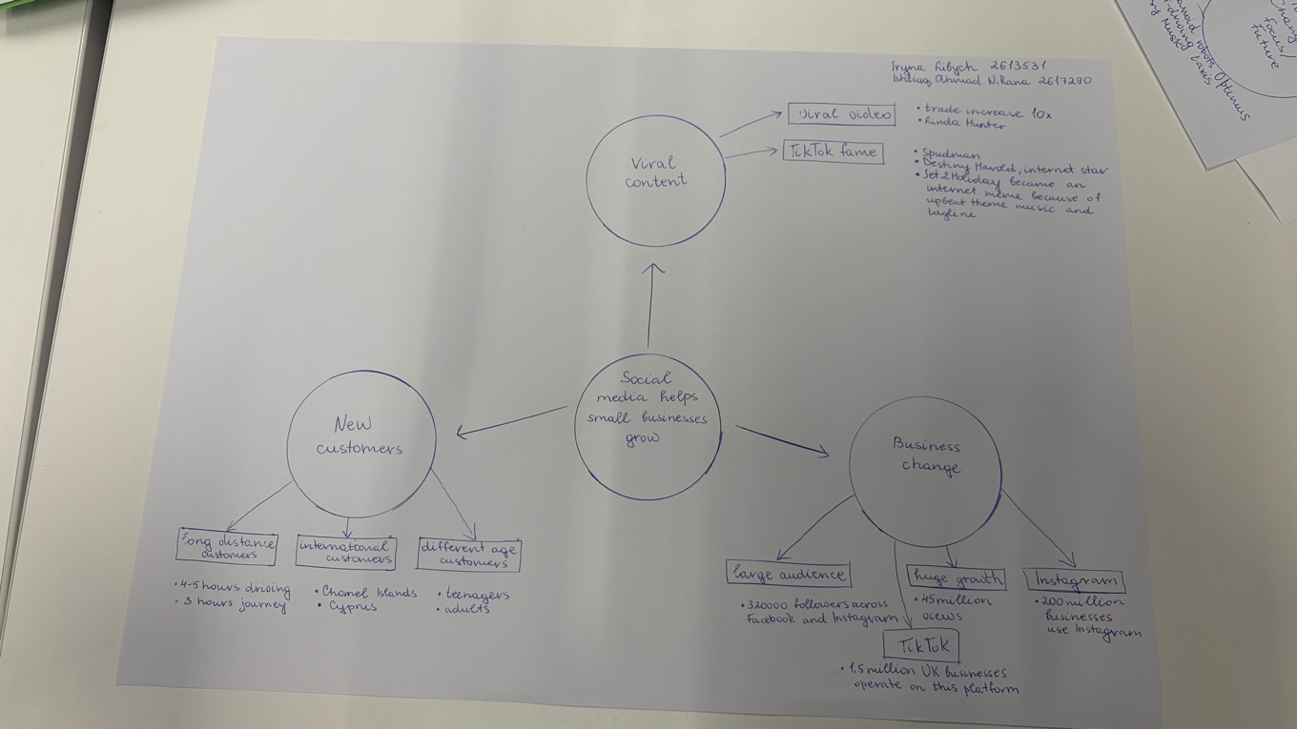

PART 2:
- What is the main idea of the whole text?
Social media helps small businesses grow and achieve much greater success; this is the main point of the text. For example, TikTok and instagram help attract new customers and enable businesses to reach a wider audience. Social media also has a significant impact on increasing sales and helps small businesses gain popularity.

- What is one key point that supports the main idea, and which specific example from the text shows this?
Social media helps businesses attract customers from different areas and that’s one of the key points. Thanks to videos on TikTok and instagram, people often learn about new products or stores. A good example of this is customers who after seeing a video about dishes from Honywood Sandwich Shop, drove three hours from another area to try what they had to offer.

- What is a different key point that supports the main idea, and which specific example from the text shows this?
We can see that another important aspect is the potential for social media to transform the way small businesses operate. Thanks to social media, businesses can sell their products online and reach a large audience, one that is significantly larger and broader than their offline audience. Take for example Linda Hunter who moved her clothing business online and began selling her products throughout the United Kingdom and even in Australia.

- Which part of the text do you think is most important, and why?
I believe that the most important part of the text is how social media can create new significant opportunities for small businesses. From this we can see that even small local stores can find customers from anywhere in the world. In my opinion this is very important because social media helps businesses grow beyond the limitations of traditional advertising.

Reflection:
- What did you find difficult in this task (including in-class components), and why was it difficult?
Overall, the assignment wasn’t too difficult for me because the materials presented in class were clear and easy to understand. Choosing which information to include in the mind map required a bit more attention and concentration. The text itself contained many examples, and I had to analyse them thoroughly and in detail in order to select the most important points.

- What helped you with this difficulty, and how did it help you?
The reading techniques we learned in previous lectures helped me complete this assignment. It was specifically my speed-reading skills and my ability to locate relevant information that made it easier for me to identify the main ideas and important details in the text. The assignments we completed in class as well as the examples provided to us also helped me create my own mind map and organise the information properly.

