The Relationship Between Brand Image and Brand Loyalty in the Case of Chanel

Dissertation Research of the Requirement of the Degree of
Master of Business Administration
University of Wales Trinity Saint David

By
Alexandra Kazandjieva

London UK
February 2023


Master’s Degrees by Examination and Dissertation
Declaration Form.
1. This work has not previously been accepted in substance for any degree and is not being concurrently submitted in candidature for any degree.
Signed: Alexandra Peneva Kazandjieva
Date: 11/01/2024

2. This dissertation is being submitted in partial fulfilment of the requirements for the degree of Master in Business Administration.
Signed :Alexandra Peneva Kazandjieva
Date : 11/01/2024
3. This dissertation is the result of my own independent work/investigation, except where otherwise stated.
Other sources are acknowledged by footnotes giving explicit references.
A bibliography is appended.
Signed candidate: Alexandra Peneva Kazandjieva
Date: 11/01/2024

4. I at this moment give consent for my dissertation, if accepted, to be available for photocopying, inter-library loan, and for deposit in the University’s digital repository
Signed (candidate): Alexandra Peneva Kazandjieva
Date:11/01/2024
Supervisor’s Declaration.
I am satisfied that this work results from the student’s efforts.
Signed: ………Tushara Balendran…………………………………………………………………..
Date: …………12/01/2024…………………………………………………………………...

Abstract

The relationship between brand image and brand loyalty is essential to brand management as it drives customer behaviour and company success. This study explores the case study of Chanel, a French luxury fashion brand, to understand the connection between brand image and brand loyalty and how Chanel fosters loyalty among its customers.
Over the decades, Chanel has established a strong and distinguished brand image using its rich heritage, iconic designs, and timeless elegance products, creating a brand image of synonyms of sophistication, exclusivity, and luxury. This glamour perception is critical in shaping customer behaviour and attitude towards the Chanel brand, strongly influencing brand loyalty.
Brand image is the foundation for brand loyalty, as it creates strong customer connections based on expectations and emotions. Chanel's brand image symbolises prestige and refined taste, attracting loyal customers who desire to be associated with Chanel's chic, iconic and seductive lifestyle and products.
Customer brand loyalty towards Chanel is supported through different strategies that reinforce and strengthen brand image. Chanel's advertising and marketing campaigns focus on interacting with customers, highlighting Chanel's values and promises, building trust, driving the emotional relationship between the brand and its customers, and nourishing brand loyalty.
Another essential element of fostering brand loyalty is the superior online and in-store customer experience designed to make every customer feel unique, valued, and appreciated. This exceptional experience is the strong emotional bond that increases customer loyalty and shapes consumer buying behaviour. Individuals who associate themselves with the Chanel brand are critical elements in advocated marketing, helping Chanel attract customers who adore being part of the Chanel community. Spreading positive word of mouth and acting as a brand ambassador in Chanel's favour helps Chanel reinforce its brand identity, enhancing brand loyalty among Chanel followers.
Furthermore, Chanel's commitment to innovation and sustainability contributes to its customer loyalty. By uniting traditions with innovative products and materials, Chanel keeps its customers engaged and excited, building brand loyalty based on exclusivity and trust.
In conclusion, the relationship between brand image and brand loyalty is crucial to Chanel's success. Elegance, luxury, sophistication, exclusivity, and exceptional customer experience are potent tools for building brand loyalty. Understanding and managing the relationship between brand image and brand loyalty has been critical in Chanel's durable success as a leading luxury fashion brand.

Contents

Chapter 1 11
1.1. Introduction 11
Figure 1: Maslow's Theory of Needs 12
1.2. Background 13
1.3. Rationale of the study 13
1.4. Research Objectives 14
1.5. Research Questions 14
Question 1 14
Question 2 15
Question 3 15
Question4 15
1.6. Dissertation outline 15
Chapter 1. Introduction 15
Chapter 2. Literature Review 15
Chapter 3. Research Methodology 15
Chapter 4. Data Analysis 15
Chapter 5. Summary, Conclusion, Recommendation and Limitation 15
Figure 2. Dissertation outline 16
Chapter 2. Literature review 16
2.1. Definition of Brand 16
2.2. Brand Image 16
Figure 3: Two models of brand building through time 17
Keller vs Aaker Brand Image View 17
Figure 4. Vital Brand Image Factors. 18
2.3. Chanel's Current Branding Strategies 19
Figure 5: Leading Luxury Fashion Brands in the U.K. 2022 by Brand Awareness 20
2.3.1. Brand Identity and Heritage 21
Figure 6: Chanel Products 22
2.3.2. Chanel Marketing Campaigns 22
2.3.3. Innovation and technology 23
2.4. Opportunities and Challenges of Chanel Implementing the Branding Strategies 24
Opportunities of Chanel Implementing the Branding Strategies 24
Challenges of Chanel Implementing Branding Strategies 25
2.5. Brand Loyalty 26
Figure 7: Luxury fashion brand loyalty ranking in the U.S. 27
2.5.1. Investigating the impact of Chanel brand image on brand loyalty 28
Keller Customer Base Brand Equity Model (CBBM) 29
Figure 7. Keller’s Customer-Based – Brand Equity Model (CBBE) 31
Aaker Brand Equity Model 31
Figure 8. Aaker Brand Equity Model 33
Marketing Funnel 33
Figure 10. Different Perspectives of Marketing Funnel 34
2.6. Consumer Behaviour 34
2.6.1 Chanel Brand Image influence consumer buying behaviour. 35
Figure 11. Five Stages of Consumer Making Decision Process 35
2.7. Aaker Brand Personality Approach 37
Figure 12. Brand Personality construct 38
2.8. Literature Gap 39
Chapter 3 39
3.1 Research Methodology 39
Figure 13: Definition of Research by Authors 40
Figure 14. Research Onion 41
3.2. Onion Layer 1: Research Philosophy 41
3.3. Positivism 41
3.4. Onion Layer 2: Research Approach 42
Figure 15. Top-down deductive approach implementation 42
3.5. Type of Investigation 43
Primary Research: Definition 43
Advantages Primary Research 43
Disadvantages of Primary Research 44
3.6. Secondary Research: Definition 44
Advantages of Secondary Research 45
Disadvantages of Secondary research 45
3.7. Time Horizon 45
Figure 16. Two types of Time Horizon 46
4.1. Sampling 46
4.1.1. Sample Size 46
4.1.2. Sampling Type 47
4.2. Sampling Method 47
4.4. Data Collection and Analysis 48
4.5. Research Ethics 48
Chapter 4. Analysis and Evaluation 48
4.1. Response Rate 48
4.2. Results 49
Discussion of findings 54
Chapter 5. Conclusion and recommendations 55
5.1. Conclusion 55
5.1.1. Objective one: To determine the current branding strategies implemented by Chanel. 56
5.1.2. Objective two: To analyse the opportunities and challenges of Chanel implementing the branding strategies. 56
5.1.3. Objective three: To investigate the impact of brand image on brand loyalty in the context of Chanel. 57
5.1.4. Objective four: To determine how Chanel's brand image influences consumer buying behaviour. 57
5.4. Recommendations 58
5.4.1. Foster Brand Advocacy 58
5.4.2. Innovate Responsibility 58
5.4.3. Engage in Social Responsibilities 59
5.5. Limitations of the research 59
5.6. Future Research 60
5.2. References 60
5.3. Appendixes 64
5.3.1 Questioner survey 64
The relationship between brand image and brand loyalty in the case of Chanel 64

Acknowledgement

I want to express my deepest gratitude to my supervisor, Tushara Baledram, for her invaluable support, patience, and guidance throughout the entire process of completing my dissertation. Her dedication and professionalism have been inspirational for me. Tushara's experience and knowledge in marketing allowed me to gain deep knowledge and finish this research in its final form.

During the research process, Tushara encouraged me and supported me in establishing the confidence to persist and push myself beyond my academic limits. She was always available to help give moral support and feedback with constructive criticism. Tushara's mentorship is incredible, and I feel lucky to have worked with such a leader.

I am also grateful to the University of Wales Trinity Saint David (UWTSD) faculty and staff in London for providing a unique environment with the necessary resources and facilities that significantly contributed to the successful realisation of this dissertation.

Lastly, I would like to express my gratitude to my son and friends for their persistent support, constant belief in my abilities and encouragement through this academic journey. That has been an essential driving force to reach this milestone.

.

"Fashion changes, but style endures." —Coco Chanel.

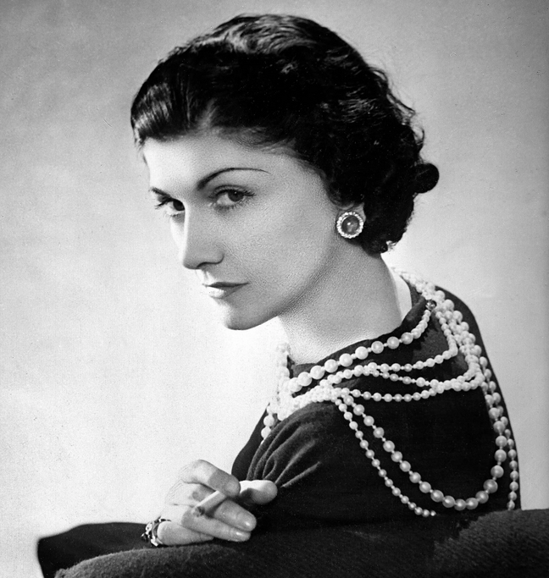

Chapter 1

Introduction
How have luxury brands like Chanel, Cartier, Hermes, Tiffany, Vacheron Constantin, Prada, and Ferrari succeeded? What is their successful strategy, and how do they sustain and continually grow their desirability and power over all those years? The answer is through getting so close to their customers, sharing the same values and vision about luxury.
Luxury is close to art, exclusivity, and rare materials. Luxury products symbolise icons of beauty, high quality of life and culture. Has anyone ever seen Rolls Roice or Chanel on discount channels? Luxury is the culture that anyone connected with the brand must follow, from the craftsman to the sales associate and from the CEO to the company's concierge. Luxury is a different mindset.
In the 21st century, shopping gives people accomplishment. Shopping has become modern society's new mantra for psychological and emotional reasons. However, purchasing products or services became an affirmation of the psyche of modern customers. Through their shopping, customers express their personalities, desires, and needs.
Maslow (1954) intended a Hierarchy of needs framework that explained how people set and prioritise their needs and goals categorised into five levels. Maslow's theory suggests that individuals can progress in the hierarchy of needs, building each level upon the previous one. It is imperative to understand that not everyone may reach the last level- self-actualisation, as the fulfilment of needs is different for any individual based on level of motivation and personal circumstances. The top three pyramid levels show what buying luxury brand products means for prospective customers. When the first two picramide levels -psychological needs and safety are reached together with increasing personal income, individuals intend to spend more from their income on buying luxury products to satisfy personal needs placed at a prominent level in Maslow's pyramid.

Figure 1: Maslow's Theory of Needs
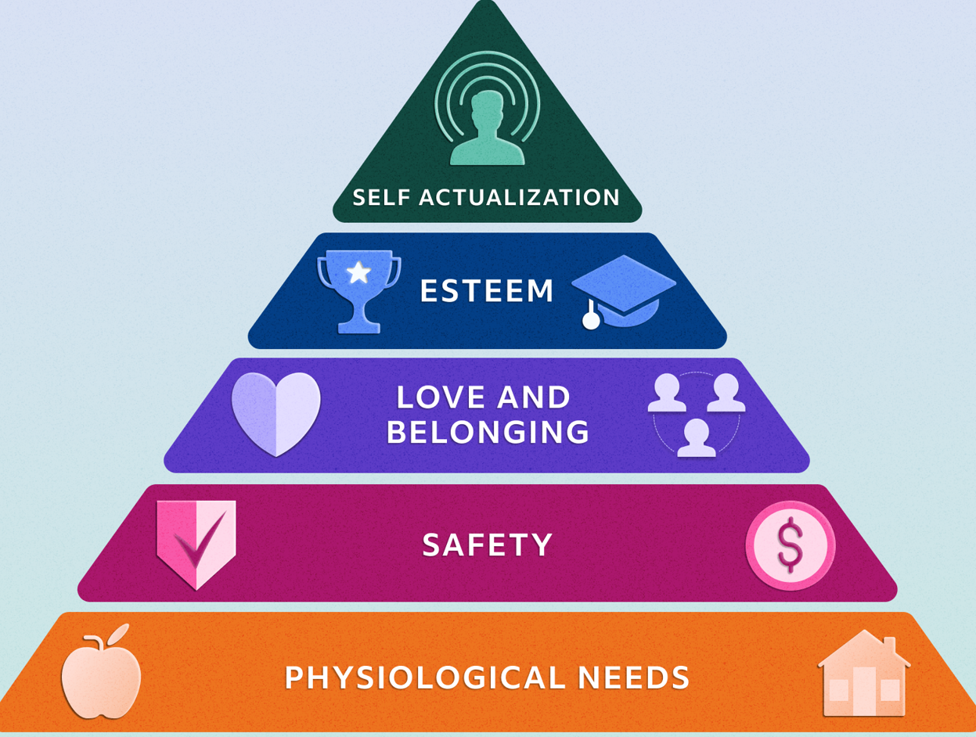
Source: (Herrity, 2022)
Luxury fashion is a part of the worldwide retail industry, specialising in selling high-end products distinguished from other market products by high inclusivity, high quality, and incomparability. The luxury retail experience differs from other retail experiences in many aspects, from the atmosphere and design of the boutiques to the customer experience and visual display of items. In the last decade, the luxury retail industry has grown vastly and expects to increase from $ 354.8 billion in 2023 to $ 418.9 billion in 2028 at a CAGR of 3.4% (Statista, 2023).
Since founded in 1909 by Coco Chanel, Chanel has become one of the most recognised and famous luxury brands worldwide, valued at approximately 15.3 billion U.S. dollars in 2022 (Sabanoglu, 2023). For more than a hundred years, Chanel has created a strong, globally recognised brand offering different designs of clothes, perfume, pieces of jewellery and accessories with many iconic products that represent the history, spirit, exclusivity, and style of Chanel, such as Chanel N0.5 perfume, black and white tweed Chanel suit and 2.55 Chanel handbag. In 2023,hanel is third after Porche and Louis Vuitton for luxury and premium brands worldwide (Brand Finance, 2023).
  - Background
Brand image applies to the associations and perceptions with a particular brand in consumers' minds, and according to Mao (2010), "brand image plays a vital role in building up a brand" (Anas Zia1, 2021). Chanel has precisely situated its brand image to raise a sense of prestige, luxury, and class. High-end boutiques, elegant packaging, and the iconic Chanel logo with opposed letters C, known to stand for "Coco Chanel", further enhance the brand image as a symbol of exclusivity and sophistication. Campbell (1993) stated that "brand image can be explained as the mixture of the consumer insights and convictions about a brand" (Alhaddad, 2014).
On the other hand, brand loyalty is the degree to which customers are dedicated and committed to advocating and paying for a specific brand. Brand loyalty can be seen as a measure of consumer attachment and faithfulness, often originating in long-term relationships and repeat purchasing. Brand loyalty for business is vital as it can attract new customers, minimise the cost of marketing and increase brand trust. Chanel has successfully led brand loyalty by sequentially delivering its brand guarantee of opulence, prestige, and elegance. Chanel's diligence and high-quality craftsmanship contributed to brand loyalty as Chanel products are known for their finest materials and attention to even the most minor details. Chanel's dedication to quality has built trust among customers willing to invest in ultimate luxury products and benefit from Chanel's aura of prestige and exclusivity surrounding the brand. In the early 20th century, "Coco" Chanel revolutionised women's fashion by creating Chanel suits and iconic little black dresses that continued inspiring customers with timeless style, heritage, tradition, and sophistication.
Customer behaviour is a part of human life. It is about how consumers behave in different situations, such as sellers, buyers, users, or influencers. It is a discipline dealing with how and why consumers purchase or do not purchase goods and services (Ling, 2014). Using technology, marketers can increase consumer motivation to engage, consume and promote the brand.
  - Rationale of the study
The study aims to investigate the relationship between brand image and loyalty and better understand how Chanel customers perceive and establish long-term loyalty and commitment. Brands are no longer just products or symbols; in the 21st century, brands represent a sense of customer identity and emotional connection. Brands become customer DNA. These are the unique assets for businesses that generate high revenue, repeat purchases and, most importantly, brand loyalty.
Understanding the factors contributing to customer loyalty in the luxury fashion industry can help companies refine their brand strategies and marketing efforts while maintaining a competitive advantage in the market.
With this study, researchers will gain clarity on the effectiveness of Chanel's branding strategies and identify potential areas for improvement. Furthermore, this study can discover vital elements of Chanel's brand image that strongly impact and play a critical role in brand loyalty. For example, factors like exclusivity, quality, design, or brand personality may crucially influence customer loyalty in the case of Chanel. Overall, this study's findings can be a reference for other luxury fashion brands looking to strengthen customer relationships through enhanced brand image by providing practical implementations.
  - Research Objectives
The study aims to analyse the opportunities and challenges for Chanel's implementing branding strategy by investigating how essential elements and factors of brand image build and maintain brand loyalty in the context of Chanel and how customer interaction and experience with the Chanel brand shape brand image and contribute to brand loyalty.
Brand image is a vital antecedent of customer commitment to loyalty. The study has the following objectives:
- To determine the current branding strategies implemented by Chanel.
- To analyse the opportunities and challenges of Chanel implementing the branding strategies.
- To investigate the impact of brand image on brand loyalty in the context of Chanel.
- To determine how Chanel's brand image influences consumer buying behaviour.
  - Research Questions
The study focused on answering the following objectives questions that can serve as a starting point for dissertation proposal:

Question 1
What are the current branding strategies implemented by Chanel?

Question 2
What are the opportunities and challenges of Chanel implementing the branding strategies?

Question 3
What is the impact of brand image on brand loyalty in the context of Chanel?

Question4
How does Chanel's brand image influence consumer buying behaviour?

Dissertation outline

Chapter 1. Introduction
Chapter one includes an introduction of the study topic with company background information. Furthermore, include the study's research rationale that encouraged the author to study in this area. The research objectives and questions are at the end of the chapter one.

Chapter 2. Literature Review
The literature review chapter will highlight brand image, loyalty, and consumer behaviour, including theories, models, and other literature work. This part will describe Chanel's current brand strategies, opportunities, and challenges—critically analysing Keller's and Aaker's brand equity models.

Chapter 3. Research Methodology
The most significant part of the research is the research methodology, described in Chapter Three, which elaborates on the research design. Furthermore, research onion, time horizon, the type of research with advantages and disadvantages, data collection method, sampling method, and data analysis method will be presented. All methodologies will be described and evaluated in this chapter.

Chapter 4. Data Analysis
Chapter five includes data analysis and funding of the research survey, including tables and charts, with the help of Ms Excell/SPSS. The primary data only will be discussed in this chapter with responses from participants of this research.

Chapter 5. Summary, Conclusion, Recommendation and Limitation
Finally, chapter five contains the conclusion drawn from the entire research, including the study's conclusion with future recommendations and limitations of the research.

Figure 2. Dissertation outline

Chapter 2. Literature review

Definition of Brand
According to Kotler & Keller," a brand can take on personal meaning to consumers and is a promise between the firm and the consumer" (Kotler & Keller, 2016). The Cambridge Dictionary defines a brand as "a type of product made by a particular company and sold under a particular name" (Cambridge Dictionary, 2023). A brand is a mark left in consumers' hearts and minds, creating a distinctive sense of meaning and feelings. To build a strong brand image, companies focus on ethical practices, sustainability, and social responsibility, maintaining a solid brand identity. American Marketing Association describe a brand as "a name turn sign symbol or design or combination of them intended to identify the goods or services of seller or group of sellers and to differentiate them from those of competitors" (Kotler & Keller, 2016).

Brand Image
Brand image is not only the company's product or service. Based on reputation, customer service, and values, a brand is the business's greatest asset, as, in the 21st century, the brand dictates the whole business, not only the marketing side.
According to Alhaddad, brand image "can be seen in all the definitions of marketing and plays the most important role in creating the strong roots of the brands" (Alhaddad, 2014). A well-designed brand image helps a company differentiate from competitors, establishing a solid perception of value and a strong emotional connection with customers. A brand is built on trust and value. Customers can benefit from added brand values that can be tangible, symbolic, or intangible, as the following diagram illustrates.

Figure 3: Two models of brand building through time
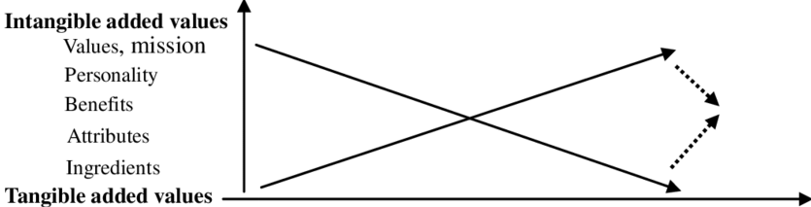
Source: Kapferer (2008)

Furthermore, brand image is a significant asset that drives the customer loyalty stage when it takes work to switch to another brand, laying a solid foundation for long-term relationships and business success. Aaker (1991) states, "Brand image creates value in a variety of ways, helping consumers to process information differentiating the brand generating creases too by giving positive feelings and providing a basis for extensions." (Isoraite, 2018).

Keller vs Aaker Brand Image View
Kevin Lane Keller and David Aaker are two brand management gurus; each owns its objectives and view on a brand image that differs in certain aspects while providing valuable insights into a brand image.
"Modern marketing" is often connected with Keller's name, emphasising the importance of brand image as an essential tool for business success. Philip Keller focuses on establishing a solid positive brand image for achieving specific marketing objectives. Keller believes that consumer perception and behaviour are essential factors driven by brand image, suggesting that a brand must create a unique position in the market, as a strong brand image can help a company attract customers, increase market share, and command premium pricing. Furthermore, Keller underlines the vital role of brand image in creating customer loyalty. He also suggests that companies should continuously make significant efforts to deliver and keep a brand promise to strengthen customer loyalty and raise the brand image.
On the other hand, David Aaker, known as "the father of modern branding", takes a more profound approach to brand image. For Aaker, brand personality is significant for building brand image and is the foundation of brand identity elements, including brand mission, vision, and personality traits. Aaker argues that brand image should match customers' desires, values, and aspirations. He states that brands must deeply understand customers and create an image that connects with their emotions and needs. Aaker's brand identity model focuses on creating a brand image that connects emotionally with customers, leading to solid brand advocacy and loyalty. The construction of brand identity proposed by David Aaker is a creditable reference value to customers' understanding of a brand image.
In terms of objectives, both Aaker and Keller agree that a positive brand image can help businesses achieve their objectives, including:
- Differentiation: Keller and Aaker agreed that a strong brand image can attract customers and help businesses stand apart from competitors, creating a unique market position.
- Customer loyalty: Keller and Aaker admit that a positive brand image can encourage customer loyalty. A favourable brand image creates trust and emotional connection, leading to consistent returning customers.
- Premium Pricing: Price cannot be seen only as a number; pricing decisions include factors the brand should consider, such as the marketing environment, the customers, and competitors. Keller highlights that brands that add meaning and value to customer purchases can enable brands to "adopt price-quality inferences" using price as an indicator of quality (Kotler & Keller, 2016).

Figure 4. Vital Brand Image Factors.

Source: Autor concept
Both Keller and Aaker models offer valuable insights as they approach brand image from different angles. Aaker's model focuses more on developing strategic brands, while the Keller model emphasises the intensity of the consumer-brand relationship. Both models also have their respective limitations. Understanding all differences and nuances between both models will help marketers build and manage a successful brand image. Furthermore, marketers need to consider using one of the models, a combination of models or both as a brand management toolkit.
"When it comes to luxury fashion users, brand awareness of Chanel is at 94% in the U.K." (Kunst, 2023). Chanel has built its brand image over one hundred years and has many positive aspects to consider, such as:
- Chanel history: The story of Gabriele “Coco” Chanel -the brave woman who changed the entire fashion industry by introducing dresses and trousers, shocking the world with her vision of giving women the freedom to be free in their clothing. The human brain can remember stories more than facts, and it is remarkable how Chanel used Coco Chanel's story as a powerful communication channel across all touchpoints to build a strong brand image. The story of Coco Chanel is authentic and motivated and inspires customers to share its story by buying and wearing Chanel products.
- Iconic designs: Chanel's little black dress, Chanel No5 perfume, and the iconic handbag symbolise luxury and style, still inspiring the fashion industry.
- Brand logo: Double C has been an all-product symbol of Chanel immortality and has become one of the world's most recognised and profitable logos.
- Brand colours: Black and white match the Chanel logo associated with class and elegance. Black is the primary colour inspired by Chanel, from the little black dress of 1926 until today. In 1926, when women's dress was colourful and tacky, Chanel's little black dress broke the limitation of using black and the traditions of using only bright colours. White is a colour of simplicity and innocence. Simple is everlasting in Chanel logo colours and can be called a classic.

Chanel's Current Branding Strategies
"As markets change, marketing theories must also change to accommodate them" (Heding & Bjerre, 2020). If market theories change, marketers need to change their business strategies to succeed in the field. Businesses spend millions planning and developing brand activities. Often, the most successful brands change their strategies regardless of changes in time, consumer preferences, consumer needs and culture, hoping to find the holy grail of branding management. Luxury fashion brands use strategic branding to build customer loyalty and differentiate their products from competitors. According to Kotler &Keller, "Branding is the process of endowing products and services with the power of a brand. It is all about creating differences between products" (Kotler & Keller, 2016).
To successfully apply a differentiation strategy, businesses need to know who their strategic customers and competitors are. Chanel's differentiating approach for branding the products is to offer better products than competitors at the same or even higher price. Differentiation’s strategy aims to achieve a competitive advantage and attract strategic customers who value the products, genuinely appreciate exclusive products, and are ready to pay enough for Chanel products to portray their social status, royalty, and celebrity status. Key customers are a critical success factor in the luxury fashion industry, where rivals are one of the world's most potent, well-established companies. Chanel's branding strategy is miles away from strategies such as” my brand is better than your brand.” Chanel's strategy is focused on” must-have product positioning,” superior customer experience and exceptional products.
Figure 5 below shows that Chanel's leading competitors in the United Kingdom for 2022 are Louis Vuitton, Gucci, Prada, Cristian Dior, and Burberry (Kunst, 2023).

Figure 5: Leading Luxury Fashion Brands in the U.K. 2022 by Brand Awareness
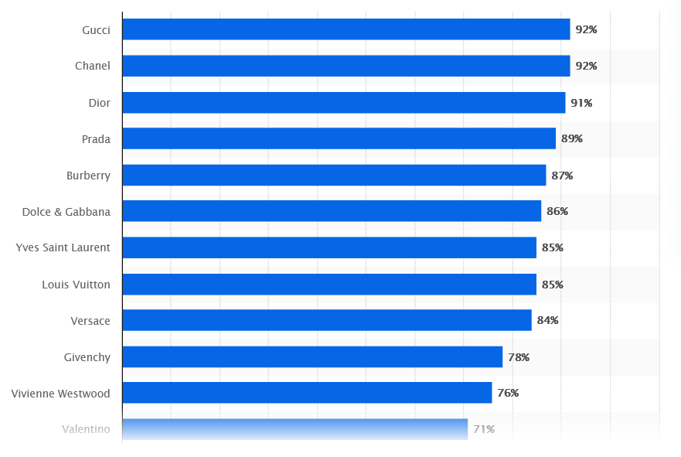
Source: (Kunst, 2023)
Brand recognition is the heart of brand success; consumers often connect with a well-established brand as they trust it and are willing to buy a product. Understanding customers' desire and motivation to buy luxury products, Chanel successfully applied branding strategies to establish brand value and convince customers that Chanel products are meaningful and different from other luxury brands. Customers see Chanel products as unique, authentic, and genuine, like who they are- which is one of Chanel's successful current branding strategies. Chanel's current branding strategies combine tradition, modernity, innovation, and nostalgia, including portraits of heritage and values, brand position, and marketing efforts. Chanel's target market is individuals from different geographic and demographic segments who identify with glamorous lifestyles and motives and can afford premium-priced products. Chanel focuses on all gender groups who want to project the image of elegance, class, social status, and luxury. The straightforward way customers manifest social class and belongings to a luxurious class group is to show their wealth.
However, it is imperative to analyse Chanel's current branding strategy to assess its effectiveness in today's fashion market.

Brand Identity and Heritage
Chanel's opulent heritage and legacy are vital for company branding strategies, emphasising the brand history of Gabrielle "Coco" Chanel. The rich heritage history is continuously integrated and celebrated into Chanel product launches in its marketing campaigns, creating a sense of trust, exclusivity, and glamour in customers' minds. The heritage and storytelling approach is essential to Chanel's branding strategy for encouraging new clients and loyal customers to buy Chanel products. The incredible life of Coco Chanel continues to inspire millions of customers around the globe. Telling a brand story about legendary lady Coco Chanel, who still has power over fashion today, can shorten the distance between the brand and customers for better communication. Every customer knows the famous Coco Chanel phrase, "Always look your best" (Leigh, n.d.) Like Coco Chanel, brand customers used Chanel products for self-expression, showing glamour status through high-quality fabric, class, and confidence. Chanel is not pushing hard to sell products; building trust is also about the story of Coco Chanel- the woman who changed fashion with her ambitions, passion, and innovative ideas.
Since 1921, Chanel's No.5 perfume, with its iconic package, has been one of the most globally recognised and top-selling products. Marilyn Monroe, Catherine Deneuve, and Nicole Kidman are some of the most famous and notable women in history who wore Chanel No.5. Chanel does not need celebrities to sell the product. Chanel builds incomparability and value in a brand. Celebrities and wealthy people in the world are in love with Chanel products as superiors have a different mindset. Hollywood stars, princesses and even the late Queen Elisabeth II (Dunn, 2023) made it Chanel's No5 everlasting elegance icon. In the United Kingdom, 2.05 million women used Chanel No.5 (Statista, 2023).
Chanel's revolutionary design and principles continue to inspire and influence customers, defining Chanel's identity and creating strong customer brand loyalty.

Figure 6: Chanel Products

Sources: Author of research inspired by Chanel

Chanel Marketing Campaigns
Chanel fashion shows are a well-designed marketing approach reinforcing Chanel's image as a trendsetter and fashion authority. Opulent places like Grand Palais-Paris (2017), Temple of Dendur (2018), and Tomas Street, Manchester (where on the 7th of December 2023, will host multimillion pound Chanel Metiers d'Art 2023/2024) are some of the places hosting Chanel fashion shows. The messages Chanel sends to the consumer are about mastery of exclusivity and prestige. Chanel's marketing campaigns are not aggressive and relate to actual people, evoking a sense of elegance and aspiration.
Chanel's branding strategy is a form of art and creativity, rare materials, and exquisite craftsmanship. Chanel's branding strategy is creative, selling cultural advancement and a higher quality of life. Chanel customers see the products as icons of beauty and symbol of culture, as that is people's dreams. Chanel's branding strategy is not to sell the products. The idea is for customers to chase the brand. How can we compare Picasso and Van Gogh? It is not very sensible to compare Chanel and Hermes. Their heritage, traditions, history, and even their boutiques are different; customers cannot even think of a comparison.
With its marketing campaigns, Chanel is not seeking to build consumer awareness. Chanel's strategy is to create advocacy and influence consumers to buy and repurchase a product, as advocacy is a more influential factor for substantial and long-term brand loyalty. Customers believe more in friends and family words than in brand ads. Chanel's marketing campaign is about customers' context – who they are and what they will achieve, focusing on customer perspective. Chanel stands out from other luxury fashion brands by using a marketing campaign to tell a story, and customers take notes. Customers love Chanel because the brand is different. Chanel's brand gives them the personality they deserve -prestige, power, glamour, and status. That resonance in Chanel's marketing campaign connects deeply with customers, showing that it is a people-centric brand united under passion and spirit.

Innovation and technology
Traditions and innovation are in harmony with Chanel's marketing efforts. Chanel successfully maintains its rich history of reaching various audiences while adapting to the 21st-century digital landscape. Chanel is often associated with elegance and craftsmanship while demonstrating a forward-thinking approach by including innovation and technology in customer experience and product design.
For any brand, mass products that create solid revenue are perfumes and cosmetics. In Fashion magazines, YouTube and other social media, most ads are for perfumes and cosmetics. Not many customers can afford to pay $5000 for a new ready-to-wear Chanel suit, but £37 is an affordable price for Chanel lipstick. To engage with independent young Gen Z customers, Chanel invented the Lip Scanner app, where customers can try virtually and select colours.
Chanel has adopted innovative technology with Chanel's new Soho beauty showroom. That is a digital platform where customers using their smartphones with confidence can experience online expert personalised service. That is a new way for customer experience to combine the power of face-to-face physical retail through innovative technology. Giving a fresh look at the customer shopping experience, Chanel states that the brand is ready to test, innovate and learn. Chanel's innovative strategy is part of strategic branding management for creating brand loyalty among new and existing customers.

Opportunities and Challenges of Chanel Implementing the Branding Strategies
"Chanel has always been a pioneer of modernity, defining trends in luxury and beauty for more than 100 years" (Chanel, 2018). Chanel succeeded by combining a solid brand image and effective branding strategies. The luxury fashion market evolves by implementing branding strategies. Chanel needs to identify opportunities and challenges to maintain a strong leadership position and think about strategic branding strategies for the future.

Opportunities of Chanel Implementing the Branding Strategies
- Global Reach
Global expansion is one of the opportunities for the brand. Chanel could still expand to emerging markets like Africa, India, and Latin America by carefully tailoring brand strategies with its core value to local preferences. That can help to increase market share by attracting new customers and influencing loyal customers to repeat purchases. Leveraging the Chanel brand across different markets and connecting with diverse consumer segments is an opportunity to raise Chanel brand recognition and increase market share and revenue.
- Sustainability's
Chanel must improve sustainability following the growing consumer demand for ethically and sustainably produced luxury goods. Using eco-friendly product materials and improving its supply chain's ethical practices and transparency will help Chaneel attract new customers, improve its reputation, and strengthen customer relationships, targeting and attracting new eco-friendly customers.
- Strong Brand Identity
With a rich heritage and strong brand identity, Chanel has a firm foundation for implementing branding strategies. She continuously uses strategies built on their DNA with invaluable brand experience and long-term value creation.
- Customer value and strategic customers
Understanding customer value is critical for creating strong brand loyalty and is a vital success factor. Critical success factors (CSFs) "are those product features that are particularly valued by a group of customers and, therefore, where the organisation must excel to outperform competition" (Johnson, et al., 2005). Chanel's opportunity is to personalise its branding strategy to Chanel's strategic customers, satisfying their needs as they have the power to influence purchases. Sometimes, strategic customers are not the product users but may be involved in the overall purchase decision.
- Strategic capabilities
Chanel can develop strategic capabilities that customers appreciate and are difficult for competitors to imitate. Chanel needs to consider building dynamic capabilities in business dynamic conditions. SWOT analysis will help Chanel managers to understand and be more beneficial to use the strengths, weaknesses, opportunities and threats a business faces.
- People
People in an organisation are another opportunity for Chanel as they are the most crucial asset in any business that can benefit the brand with a competitive advantage over rivals. For strategic purposes, managers must manage the development of dynamic capabilities as people are responsible for daily activities and must be aware of what they do regarding Chanel's strategic capabilities.

Challenges of Chanel Implementing Branding Strategies
- Diversity and inclusivity
Chanel must take more initiative in creating diversity and inclusivity inside the business and its products. Diversity and inclusivity in the workplace can also attract customers, leading to brand loyalty. Chanel is more focused on women's products and does not offer men's fashion products that are different from other luxury brands. Furthermore, Chanel must open its image to new modern customers who do not fit the ideal woman in Chanel stereotypes. Inclusion and diversity must be more involved in Chanel's ideal for women, as the lack of those leading factors can badly impact customer loyalty and brand image.
- Technology
Digital transformation is another side of giving customers an excellent experience. Chanel is still behind its competitors in e-commerce capabilities. Chanel needs to invest more in future digital transformation to meet the expectations of developed customers who prefer online shopping and the digital experience.
- Managing Strategic Change
Resistance to change during the COVID-19 pandemic is another genuine issue that Chanel needs to consider. While most luxury brands went into e-commerce trading, Chanel stuck to traditional retail shopping, with an 18% sales drop for 2020 after closing physical shops. (Bloomberg, 2021). Change is always stressful, even for well-established brands, but Chanel needs to care about its customers. That was a successful strategy to stick to Chanel's conventional roots. Only time will tell.
- Authenticity
Authenticity is an obstacle as Chanel must carefully and strictly select influencers who align with its values and possess the same glamorous style and class. Influencers must be genuine Chanel lovers and not just promoting for financial gain. Customers are susceptible, and they may switch to another brand.
- Substitute
Competitors are other challenges but can provide opportunities. Chanel continuously needs to innovate its branding strategies to maintain its edge and differentiate itself from competitors in the eyes of the customers. Chanel must continue delivering high-quality products and satisfying customer experiences to stay ahead of its competitors.

Brand Loyalty
The tendency of a consumer to repeat their purchases of a service or product from a specific brand refers to brand loyalty. Even luxury brands like Chanel should not take customer loyalty for granted as customer loyalty never goes out of style, representing solid preferences and emotional commitment over brand competitors. Brand loyalty is not only repeating purchasing a product or service; it is an intense and strong emotional attachment. Loyal customers can be brand ambassadors when the brand knows how to empower them.
According to Statista, Chanel is ranked second in luxury fashion brand awareness in the U.S. and fifth in luxury fashion brand loyalty (Statista, 2023).

Figure 7: Luxury fashion brand loyalty ranking in the U.S.
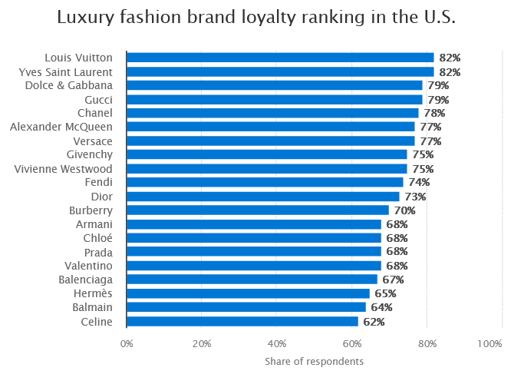
Source: (Statista, 2023).
Customers easily choose and act on the product or service that will deliver the highest value for their benefit rather than the company's benefit. According to Kotler &Koller, loyalty is “a deeply held commitment to rebuy or patronise a preferred product or service in the future despite situational influences and marketing efforts having the potential to cause switching behaviour” (Kotler & Keller, 2016).
The Cambridge Dictionary defines brand loyalty as "the habit of always buying a product with the same name, made by the same company." (Cambridge Dictionary, 2023) Emotional connection, trust, and positive customer experience drive repeat purchases.
Brand loyalty is essential for company success, leading to sustainable competitive advantage by keeping customers happy and increasing market share through creating value as the foundation of the marketing concept. Some tangible and intangible factors contribute to the manifestation of brand loyalty through customer perception of quality. Isong (2007) states that customers can see, observe, touch, and evaluate tangible values as physical ones. (Tuan, 2021) On the opposite side are intangible values, including word of mouth, brand storytelling and overall brand experience. When marketers provide and increase relatively excellent value factors to their customers, they gain further loyalty (Tuan, 2021).
It is essential for businesses to understand the importance of a balance between tangible and intangible factors as they differ depending on the target audience; for example, some customers may prefer product quality as a tangible factor, while intangible factors like the brand story may inspire others more. Understanding and maintaining both factors that lead to brand loyalty is crucial for any company in any industry.

Investigating the impact of Chanel brand image on brand loyalty
Chanel consistently delivers exceptional products with high-end quality that surpass customer expectations, directly contributing to customers' trust and loyalty. Personalisation, outstanding and effective customer service, and excellent product quality boost loyalty by making customers feel valued. Coco Chanel said, "When my customers come to me, they like to cross the threshold of some magic place; they feel satisfaction that is perhaps a trace vulgar but delight them: they are privileged characters incorporated into our legend. For them, this is a far greater pleasure than ordering another suit. Legend is the consecration of fame" (Picardie, 2013).
Chanel's brand image is associated with luxury, elegance, prestige, and sophistication, vital in stimulating brand loyalty among its customers. Brand value, position, and personality are essential to consumer brand associations and perceptions. Chanel's commitment to even small quality details, classic design and craftsmanship has attracted loyal customers since 1910. Chanel's marketing and communication strategies help create strong brand loyalty through various touchpoints, including fashion shows, brand collaboration, and advertising campaigns. With consistent visual identities like store design, logo, and packaging, Chanel sends messages across all touchpoints that emotionally touch customers, strengthening and evoking their loyalty. Clear communication, delivering products on time, product customisation and delivering after purchasing high-quality customer service is part of Chanel's job, keeping customers happy and maximising customer lifetime value. Following the rule of 80-20, Chanel can focus on the most profitable customers as that can reduce costs and increase customer satisfaction, leading to customer loyalty.
One of the most crucial aspects of Chanel's brand loyalty strategy is customer association with prestige and high social status. A certain level of abundance and prosperity is a signal after owning and wearing Chanel products. This feeling has created an appetite among consumers to associate themselves with the brand and be part of its magnificent lifestyle. As a result of owning Chanel products, customers exhibit a sense of prestige and pride, nourishing brand loyalty. That is why creating value is of supreme importance. Entering the brand store, customers do not want a bag; they dream of a Chanel bag. Customers want a Chanel one.
Chanel's excellent reputation as a luxury brand that delivers superior products from premium materials attracts customers who respect craftsmanship and value quality and are likelier to lay the foundations of trust and brand loyalty. By leveraging desirability, attractiveness and scarcity, Chanel reinforces its brand image and cultivates brand loyalty. For example, Chanel often releases limited edition collections, creating exclusivity and urgency among customers. These collections often sell out shortly from loyal customers who want to own Chanel's rare and unique limited-edition products.

Keller Customer Base Brand Equity Model (CBBM)
According to Kotler & Keller, satisfaction is “a person's feelings of pleasure or disappointment that result from comparing a product or service perceived performance (or outcome) to expectations” (Kotler & Keller, 2016). Keller Pyramid shows how brands can shape customer attitudes towards products or services. In other words, customers' value depends on customer perception of the brand. The pyramid highlights all stages, from brand awareness to brand loyalty.
- Identity. In the first level of the Keller Pyramid, customers identify and recognise the brand, such as name, logo, and colours; the idea is for customers to connect and become aware of the brand. For example, Chanel has distinguished itself from its rivals with white and black colours and a double “C” slogan. After seeing this logo, customers recognise that it represents the Chanel brand.
- Brand Meaning. This means how well the brand product/service satisfies customers' needs, including all benefits and values associated with a brand. Brands should know how customers talk about it, focusing on key performance indicators: price, brand characteristics, brand image and service effectiveness. For example, Chanel is known for its style and luxurious image. Due to its reputation for quality and exclusivity, customers perceive Chanel as a high-end luxury brand using only the finest materials.
- Brand Response. This level focuses on how customers associate, feel, and react to the brand, measuring customers' preferences, purchases, and attitudes toward the brand. Customer attitudes help Chanel sell high-quality products at a high price and lower cost. Chanel seeks to create high customer satisfaction following high brand response as a customer-centred brand. For example, Chanel customers are enthusiastic and loyal to a brand, willing to pay a premium price, and actively anticipate when a new product is launched.
- Resonance. The top of the pyramid is the most challenging level, which not many brands can reach, representing the relationship between customers and the brand. That is a long-term relationship any brand wants to build with each customer to make them repeat purchases and become brand advocates. Chanel satisfying customers' needs and wants is essential for the company's survival and profitability. Delighted customers are willing to buy more products, are less sensitive to price and competitors' products, stay long, and advocate to other customers. For example, Chanel has created strong brand relationships over one hundred years. Chanel engages customers through many events and initiatives, encouraging a sense of loyalty and belonging among its customers. Excellent pre-purchase, purchase and after-purchase customer service, engagement via social media platforms, and inviting loyal customers as guests in Chanel events are great tactics for creating an emotional connection with customers. Those tactics can be implemented to assist in creating and maintaining resonance.

Figure 7. Keller’s Customer-Based – Brand Equity Model (CBBE)
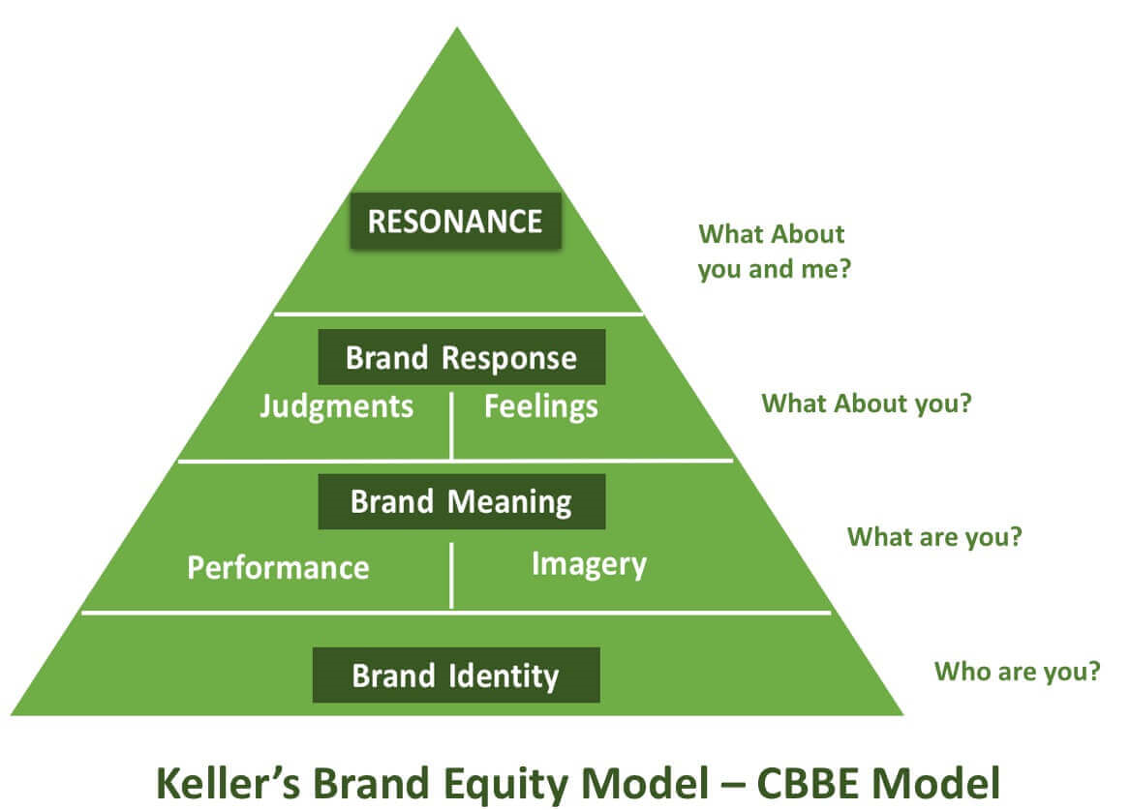
Source: (Qualtrics. XM, 2023).

Aaker Brand Equity Model
For any business to succeed, brand loyalty is a game changer. Brand loyalty is critical for today's competitive luxury fashion environment; loyalty is vital for long-term success, from retaining existing customers to attracting new ones. Satisfied customers can increase revenue and word-of-mouth marketing, as a brand that masters the art of advocacy is the king of future customers and market share.
In contrast to Keller's emotional connection to brand equity, Aaker's model is simple – all about recognition, seeing brand equity as a combination of brand awareness, brand association, and brand loyalty. Branding must be delivered by touchpoints along the customer journey to provide brand recognition. Understanding and measuring brand equity will help marketing professionals improve public perceptions of the company and increase customer loyalty.
Chanel successfully is using some elements of the Aaker’s brand identity model to build customer loyalty, such as:
- Brand as a product. Chanel is not just a product but a mixture of elements that distinguish it from its competitors, creating a unique identity in consumers' minds. Entire perception and experience with Chanel products, including product quality, packaging, product design, and customer service, encompasses the brand as a product. Chanel established trust, loyalty, and emotional connection with customers, making it more than a physical product.
- Brand as an organisation. In this context, the brand represents the entire company, including products, company values, mission, vision, culture, and reputation, establishing a distinct company identity, building credibility, and possessing relationships with a target audience. The strong bond is built on delivering promises while creating a positive, unique customer experience and stakeholders.
- Brand as a person. Aaker suggests looking at the brand as an individual's unique personality, characteristics, and values. Chanel's brand can be associated with elegance, confidence, sophistication, and luxury. This marketing approach makes Chanel customers show their unique personality rather than just buying products.
- Brand as a symbol. Chanel's brand as a symbol represents specific associations, aspirations, and values. Chanel's iconic logo, double “C” letters, evokes a sense of elegance: luxury and opulence. The Chanel logo is a visual language the brand uses to communicate with customers to create strong brand loyalty. Customers who own or wear Chanel products can express their affiliation and associate themselves with the brand values, vision and lifestyle Chanel represents.
Aaker brand loyalty model is built by developing positive brand attitudes, encouraging emotional connections, and stimulating active engagement with the brand. By focusing on those factors, brands can cultivate loyal customers who repeat their purchases and promote a brand to others.

Figure 8. Aaker Brand Equity Model
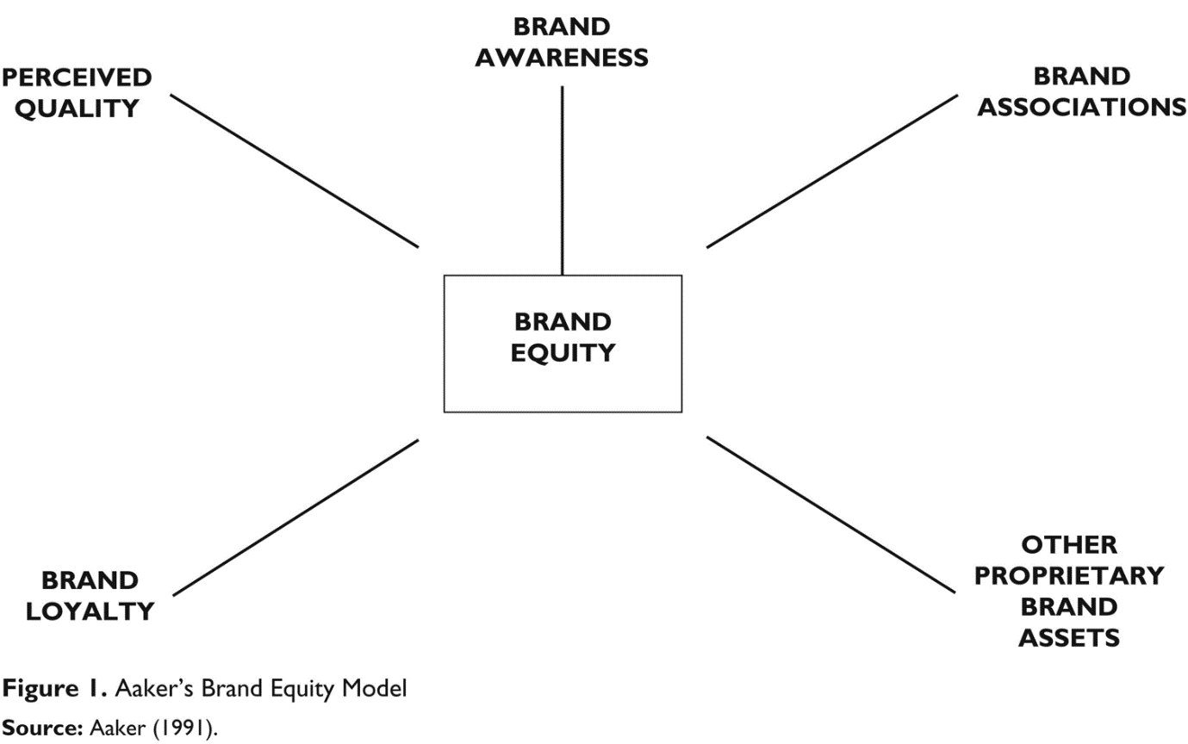Source: (Sharma, 2016).

Marketing Funnel
The marketing funnel identifies all steps in potential target customers' decision process, from awareness to loyal customers. Consumers travel through all stages before becoming loyal customers or even brand advocates. The marketing funnel underlines the importance of retaining and cultivating existing customers rather than only attracting new customers. Chanel's customer relationship capital is satisfied customers, as the customer base is vital for any business to survive.
To stimulate brand loyalty, it is vital to cultivate a strong brand image associated with customer aspirations and values, influencing brand loyalty and repeat purchases. Customers who have positive attitudes toward the brand and feel valued and happy with their purchases are likelier to become Chanel brand advocates, influencing other buying decisions.
In conclusion, Chanel has built strong brand loyalty through its solid image, highlighting elegance, exclusivity, high-quality products, strategic partnership, effective brand communication, and limited-edition collections.
Figure 9 shows all the essential steps in convenience and attracting customers using the different perspectives of the marketing funnel.

Figure 10. Different Perspectives of Marketing Funnel
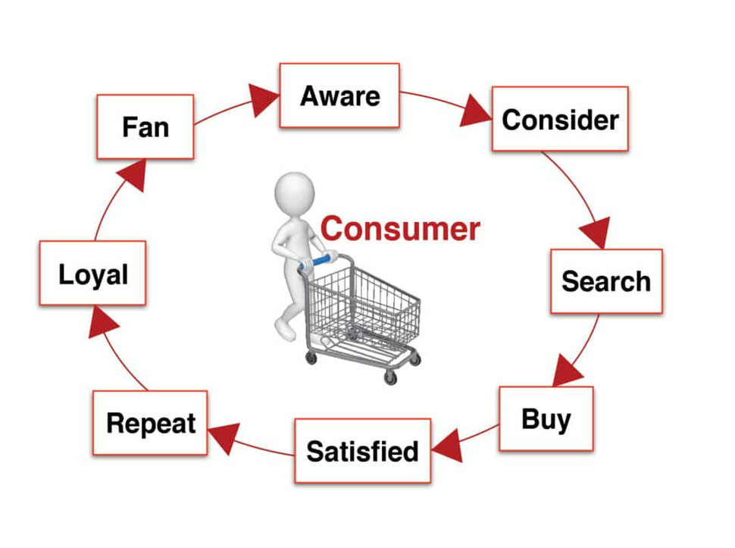
Source: (Robertson, n.d.)

Consumer Behaviour
Consumer behaviour examines factors influencing individual decision-making when pursuing or using products, services, or experiences, including pre-purchase, purchase, and post-purchase situations. It is difficult to predict human behaviour, and how people act one day can differ from how they will respond to others. Companies operate in a highly competitive environment, and for better planning and effective strategy, businesses must consistently invest in consumer behaviour research. "Consumer behaviour can be thought of as the action, reaction and consequences that take place as the consumer goes through the decision-making process, reaches a decision, and then puts a product to use." (Ling, 2014).
Some definitions help better understand how consumers behave in different situations and which factors significantly influence consumer choices through all purchasing decision processes. "Consumer behaviour is a mental and physical act of individuals, household or other decision-making units concerned with ultimate consumption involving the acquisition, own production, use and, in some cases, the dispossession of product and service" (Ling, 2014).

2.6.1 Chanel Brand Image influence consumer buying behaviour.
The buying process starts long before the actual purchase, and marketers need to fully understand and recognise the consumer buying decision process to develop plans and activities that encourage and reach customers at all decision stages. Depending on their needs, some customers do not always pass the five stages; they may skip or reverse some.

Figure 11. Five Stages of Consumer Making Decision Process

Source: The author of the report
- Needs Recognition: The first step arises from external or internal stimuli. The internal stimuli of buying Chanel products can be brand reputation, quality, iconic design, and personal style expression. External stimuli are seen in Chanel ads in magazines, or a friend's new bag can inspire the possibility of purchase.
- Information search: Consumers engage in an information search before purchasing, but everything depends on product category and buyers' characteristics. Consumers' search behaviour varies between in-store and online forms. For example, Chanel's website and social media platforms provide much information about the collection, brand, and products with pictures and descriptions. In Chanel boutiques, customers can directly interact with the products, ask questions, experience the Chanel luxury environment, and be advised by well-trained and knowledgeable sales representatives.
- Evaluation of Alternatives: Satisfying customer needs is the first drive, followed by the benefits of purchasing Chanel products, and the third attribute that delivers benefits is considering excellent value for money. All these decades, Chanel positioned itself as an evoked set in customers’ minds when the need for luxury and sophisticated products arose. With the fast-growing internet and social media, customers easily share experiences and opinions about products or services, trying to know which product/service is better. Chanel can use social media platforms to become a future part of new and existing customer sets, even if they do not immediately need Chanel products.
- Purchase decision: Brand reputation and personal affinity are the first and most crucial factors for purchasing Chanel products. The fourth stage is money time, but customers can stop purchasing because of a bad experience, negative feedback, or degree of perceived risk. Chanel products as a customer purchase's final choice show the nature of the customer's self-identity and" as the purchasing of luxury fashion brands is performed to construct one's identity" (Loussaef & Damay, 2019) According to Chandon, Laurent, &Valette-Florence (2017) and Grossman &Shapiro (1988), "owning luxury items makes it possible to signal status and power" (Loussaef & Damay, 2019).
- Post-Purchase Evaluation: The final stage is where customers feel satisfied or dissatisfied with a purchase. Post-purchase evaluation can vary among individuals, influencing future repeat purchases and brand engagement.
Cognitive dissonance appears when individuals ' beliefs, values, and attitudes do not align with customer decisions or behaviours. For example, adverse reactions or criticism from family, friends or colleagues may create cognitive dissonance and make the customer question their decision. Chanel marketer's job is to reinforce customer focus on the product's positive aspects, emphasising emotional satisfaction and luxury experience. Some customers never experience cognitive dissonance as owning Chanel products provides customers with a sense of high achievement, personal satisfaction, and status. When customers feel satisfied with their purchases, they quickly become repeat buyers, explore other products, and engage with Chanel through social media, influencing others to buy Chanel products.

Aaker Brand Personality Approach
Jennifer Aaker (daughter of David Aaker), in 1997, in the Journal of Marketing Research, posted Brand Personality dimensions defining brand personality as a "set of human characteristics associated with the brand" (Aaker, 1997). Brand personality dimensions clarify and determine how Chanel's brand image influences consumer buying behaviour—human personality psychology inspires brand personality framework. In marketing management, brand perspectives are how and why consumers choose brands with specific personalities based on uniqueness. "For consumers, brands with a brand personality are appealing because they serve as a means of identity/self-constructual and self-expression" (Heding & Bjerre, 2020). Remember that consumers will switch to another brand if they lose connection with brand identity.
Brand managers can effectively use the brand personality approach. From the consumer's perspective, brand personality means the concept of self-description. Self-expression has a social dimension as consumers are inspired by reference groups for brand consumption and use the brand to prove belonging to certain reference groups.
Chanel's brand personality expresses timeless elegance, exclusivity, and sophistication; like a physical product, the brand connects emotionally with consumers. Consumes on the same level are more likely to establish a strong brand connection that directly affects their buying behaviour. Using the Aaker brand personality framework, Chanel's brand personality is implemented as competence in the luxury fashion industry. Chanel's leader and expert position in delivering high-quality products and ambitious standards influence consumer buying behaviour as consumers trust in Chanel's ability to deliver excellence consistently.
A robust set of traits that a specific consumer segment enjoys is an essential source for the benefits of a brand. Businesses should accurately define their brand personality to connect with the right customers. For example, Chanel created a glamorous and sophisticated brand personality, attracting high spending and a wealthy customer base. Chanel products can only be found in some places and sold in selective stores. For example, in London, UK, Chanel products can be found in Selfridges, Chanel's retail shops on New Bond Street, Covent Garden, and Harrods. Chanel positioned its products as glamorous and upper-class products with unaffordable prices, and in Chanel ads, models express power and status. That is a small example of factors that make Chanel a sophisticated brand.
Chanel's brand personality raises luxury and a high-standard image with glamorous and high-class products. Customers are more likely to purchase and buy products like their personality or group. Chanel's brand image gives a customer a sense of prestige and exclusivity. By owning Chanel products, customers may express their social standards and wealth. Other customers may appreciate Chanel's attention to detail and brand heritage when purchasing Chanel products. Emotional connection to the Chanel brand is essential in the purchase decision. Two sources of brand personality can affect consumer buying behaviour: direct and indirect. Person-based characteristics like the founder of Chanel -Coco Chanel directly transfer its threats to the Chanel brand. Coco Chanel's personality helps promote a specific Chanel brand personality to customers. Indirect sources of brand personality that customers can experience are tangible, functional, or physical aspects of a brand, giving the customers a clue about the brand personality.
Overall, consumer behaviour in Chanel is strongly influenced by the brand image, brand story, sophistication, first-class shopping experience and solid emotional bond.
There are some weaknesses of the personality model, such as:
- Cultural context: Aaker's model is created from a Western cultural perspective. Chanel operates globally with diverse cultures and diverse markets. The model may not fully capture all nuances and artistic versions that may impact Chanel's personality perception in other regions around the globe.
- Limited scope: Five dimensions create brand personality: sincerity, excitement, competence, sophistication, and ruggedness. Chanel's personality might contain unique traits or additional dimensions that the model does not sufficiently capture.

Figure 12. Brand Personality construct

Source: (Heding & Bjerre, 2020)
A few main aspects need to be considered when discussing consumer behaviour concerning Chanel:
- Brand perception
- Purchasing motivation
- Product selection
- Shopping experience

Literature Gap
In this study, Chanel is a perfect example of the relationship between brand image and brand loyalty. There is much research on the relationship between brand image and brand loyalty, and many researchers have explored the area. However, there still needs to be a knowledge gap regarding specific studies examining Chanel. There is a need for more empirical research to understand the dynamic of the relationship between brand image and brand loyalty, as Chanel is one of the world's leading luxury brands with a solid brand image and a loyal customer base.
One potential knowledge gap lies in exploring and investigating the role of brand authenticity and how this perception of authenticity influences and builds brand loyalty in Chanel's case. Chanel's iconic designs with solid brand heritage strongly contribute to the image of authenticity, and more research is needed to examine how this perception influences word of mouth, customer loyalty, and consumer buying behaviour.

Chapter 3

Research Methodology
Research Methodology is a systematic approach and technique to search for knowledge and information on a specific topic with strategies and processes used to gain and evaluate data academically. “A method is a technique for collecting and analysing data” (Collis & Hussey, 2009). The research process that encompasses a body of methods is called methodology. The research word consists of two: Re-search = look/check again. That means systematically and consistently checking the information and collecting data for new or existing knowledge. Research is responsible for correcting existing data and errors and adding information and knowledge to specific topics. The research data can be primary or secondary. Primary data is data collected from a source like a survey, personal experience, interview, or focus group, while secondary data is existing data collected in previous research and available on the internet, books, journals, magazines, or hard copy. The research process is systematic and intensive to gain data objectively and scientifically.

Figure 13: Definition of Research by Authors
Redman & Mori | “Research is a systematic effort to gain new knowledge.”
W. S. Monroes | “Research may be defined as a method of studying problems whose solutions are to be derived partly or wholly from facts.”
J. Francis Rummel | “Research is an endeavour/attempt to discover, develop and verify knowledge. It is an intellectual process that has developed over hundreds of years, ever-changing in purpose and form and always researching for truth.”
Source: (Pandey & Pandey, n.d.)
The main aim of the research is to collect data and collect truth that has not been discovered yet or is hidden using scientific procedures.
One of the most popular models researchers use for designing and conducting research is the” Research Onion,” developed by Saunders in 2007 (Phair & Warren, 2021). Research onion helps researchers, like white onion, leaf by leaf, to make the best decision when developing research methodology. Each layer represents a separate aspect of the research process. The different layers of the research onion and their definitions are presented in Figure 9.

Figure 14. Research Onion
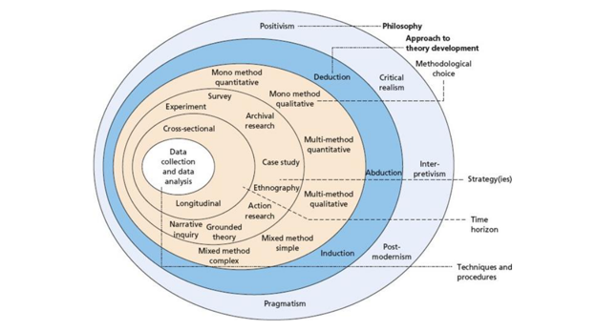
Source: (Melnikovas, 2018).

3.2. Onion Layer 1: Research Philosophy
The first layer of the research onion is the foundation and contends three main research philosophies: positivism, interpretivism and pragmatism. The nature of the research and objectives determine the choice of the research philosophy. These three philosophies can be taken as starting points for understanding the point of philosophies.

3.3. Positivism
Positivism philosophy underlines the importance of only one reality. The researchers cannot include personal viewpoints or opinions; they must avoid influencing research outcomes or processes and maintain a neutral position. Knowledge can be achieved only through empirical research based on observation and measurement. According to Walliman (2001), “Knowledge is delivered from positive in formation because every rationally justifiable assertion can be scientifically verified or is capable of logical or mathematical proof” (Collis & Hussey, 2009). Positivism suits psychology, economics, natural science, and sociology research, where prediction, measurement, and control involve large-scale experiments and statistical analysis of quantitative and qualitative data and surveys. Choosing positivism as a research philosophy depends on the nature of the research, context, and objectives under investigation. For positivists, knowledge can only be meaningless, accurate, or false.
Positivism has some advantages for research, like objectivity, which reduces the impact of researcher bias because positivism's credibility allows for verification and future development of knowledge. Lack of subjectivity is one of the disadvantages of positivism as it prioritises objectivity without overlooking the cultural and social factors that shape human behaviour. Another main criticism of positivism is that “it is impossible to separate people from the social contexts in which they exist” (Collis & Hussey, 2009).
The researcher will use positivism to investigate the impact of brand image on brand loyalty in the case of Chanel to discover objective insights and determine empirical evidence to support research findings. The positivist approach can accommodate a scientific foundation for understanding and evaluating the impact of brand image on customer loyalty in the context of Chanel and direct evidence-based decision-making processes in Chanel management strategies.

Onion Layer 2: Research Approach
The second layer of the research onion is the research approach, a methodological framework developed by Saunders (2018), which involves identifying meaningful fundamental relationships and interconnections with data collection. One of two approaches can be used: deductive or inductive approaches.
The deductive approach involves” developing a hypothesis (or hypotheses) based on existing theory, and then designing a research strategy to test the hypothesis” (Business Research Methodology, 2023). The deductive approach often involves experiments, surveys, and statistical analysis, including collecting numerical data and using statistical techniques for analysing collected data and drawing conclusions. The deductive research approach is top-down, as the conclusion must result logically from the premise, as shown in Figure 10. That means the researcher is moving from a more common-compelling theory to a more specific- the implementation of that theory but evaluated with collected data.

Figure 15. Top-down deductive approach implementation
THEORY
HYPOTHESIS

OBSERVATION

COMFIRMATION

Source: The author of the research
Conversely, the inductive approach is associated with broader theory and generalisations. Using an inductive approach, one must build a framework or theory based on the empirically collected data. In the inductive approach, the researcher starts with observations and then moves to general propositions. Textual analysis, interviews and observations characterise the inductive approach. Researchers analyse the data to develop new concepts or theories.
Inductive and deductive research approaches can be used independently but can also exist together in some studies. Designing the research and choosing and applying suitable methods and techniques are critical aims of this research.
Although research is essential for academic and business activities. In this study, the researcher will use a deductive approach to begin with a hypothesis and then test and validate it through collected and analysed data. There are some advantages of using the deductive approach:
- Clear structure and focused methodology
- Effortless way to explain the relationship between concepts and variables.
- Data support the hypothesis as conclusions based on logical reasons.
Disadvantages of the deductive approach:
- Limited scope of creativities.
- The deductive approach begins with a predicted pattern.

Type of Investigation

Primary Research: Definition
Any research first taken from the researcher is primary research and relies on direct data collection to answer research questions or to address specific research objectives rather than on data someone else collected before. “The generation of new data to address a specific research question using direct methods such as interviews or indirect methods such as observation. Data is collected specifically for the study and has not previously been interrupted by a source other than the researcher” (Jupp, 2006). Primary research for this study is collected via a questionnaire survey with volunteer participants in Chanel shops in central London.

Advantages Primary Research
Primary research is essential in scientific, academic, and professional research, providing numerous benefits. Primary research helps researchers collect data aligned with their specific research objectives. Here are some advantages and disadvantages with justification for primary research:
- Increase data accuracy. Using primary research, researchers can directly collect data from target sources, ensuring the reliability and accuracy of the collected data.
- A tailored data collecting method. Primary research allowed researchers to develop research questions and collect methods to research specific objectives.
- New knowledge. Primary research allows researchers to gain new knowledge, explore undiscovered aspects, generate genuine hypotheses, or validate existing theories (LinkedIn , 2023).

Disadvantages of Primary Research
- Costly and time-consuming: Primary research required considerable time and resources -planning, designing the questions, organising the interview process, and analysing collected data.
- Limitation of sample size and representation: Researchers used specific samples of the population that did not fully represent all target populations, leading to carefully considering the chosen sampling method to ensure the collected data reflected the phenomenon of interest.
- Participant cooperation and ethical issues: Maintaining participant cooperation and keeping participants engaged in the research process may be a problematic challenge affecting data collection competencies and quality. Researchers need to ensure that all ethical rights and confidentiality of participants are respected. (Driscoll, 2011).

Secondary Research: Definition
Secondary research refers to information collected in previous research; in other words, using and analysing data that already exists and has been collected for other purposes from someone else. Statistical analysis, case studies, content analysis and literature reviews are small examples of secondary data sources. Credible sources where secondary data is used are educational institutions, government, academic journals, libraries, businesses, or consultancies. In nature, secondary research can be qualitative and quantitative, often using previously published data. Secondary data is collected via a literature review using various academic and credible sources with reliable, suitable, and adequate data.

Advantages of Secondary Research
- Cost and time effective: Compared to primary research, secondary research is time and cost-effective as the data already exist and is easy to access, saving researchers resources and time.
- Large-size samples: Researchers can analyse and search data from larger sample sizes than primary research by publishing data in publicly available databases.
- Data validations and historical analysis: Secondary research holds data for a long, allowing researchers to observe and evaluate how data changes over time, providing reliability and validation (Taherdoos, 2021).

Disadvantages of Secondary research
- Data quality and reliability: Researchers do not have control over the data collection process, which may raise concerns about data quality adaptability to their specific topic.
- Updates and potential data gap: The secondary data does not always provide up-to-date information, which can create a gap in findings in certain areas.
- Data availability: Researchers face difficulties reaching sources of information as most have restrictions and required permissions for access. When researchers compare and combine datasets, definitions and formatting can create difficulty for conducting analysis (Brady T. West, 2016).
When conducting research, researchers strictly need to consider the type of information that will answer the research questions and choose between primary or secondary research. Combining both methods can benefit a robust and comprehensive research objectives or questions analysis.

Time Horizon
The other layer of the research onion is the time horizon, which defines the time frame used for the research and can vary depending on the nature of the research and the specific objectives of the study. Figure 11 represents two time horizons in the research.
The cross-sectional horizon, where data is collected in one period, provides “short time collection, where the data is collected at a certain point” (Melnikovas, 2018). This type of research is used to explore and analyse the characteristics or relationships at a particular moment. One of the cross-sectional time horizon limitations is the lack of information between variables and changes that occur over time in data. Diverse types of samples can be chosen each time in the cross-sectional horizon. Factors such as biases may affect cross-sectional studies, making it essential for researchers to design their study accurately and clarify the results.
Researchers use longitudinal time horizons when collecting data over an extended period. According to Saunders (2007),” The time horizon is not dependent on a specific research approach or methodology” (Anon., n.d.). A longitudinal time horizon is required following data collection, which is costly and time-consuming. In the longitudinal time horizon, the same samples participate in data collection.

Figure 16. Two types of Time Horizon
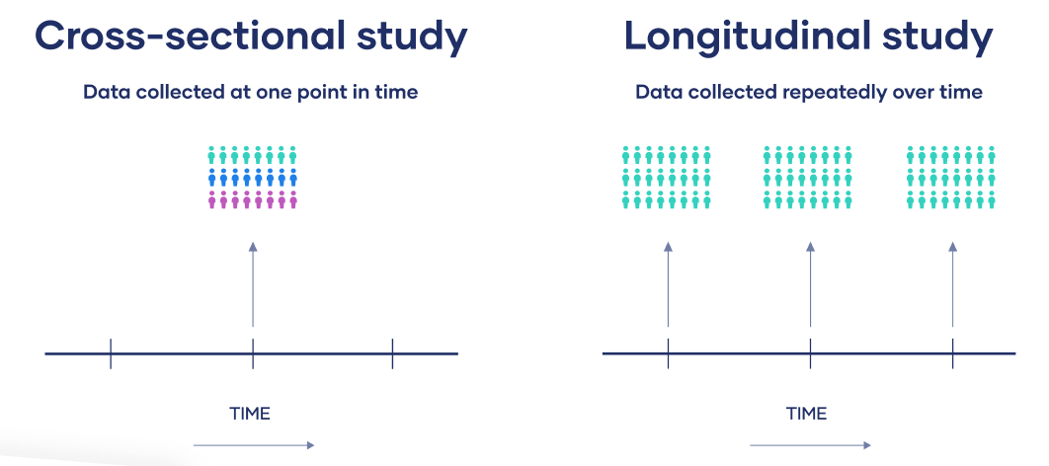
Source: Internet

Sampling
Intrac (2017) states, “Sampling is a process that enables information to be collected from a small number of individuals or organisations within a project or programme and then used to conclude the wider population.” (Simister, 2017). The main aim of the sampling is to collect data and sample representative of the population as much as possible while efficiently using the resources. There are different sampling methods with their strengths and limitations, such as random sampling, systematic sampling, quota sampling, cluster sampling, etc.

Sample Size
“Sample size related to the size of the population under consideration” (Collis & Hussey, 2009). Determining the proper sample size is critical in designing a research study, as a simple size directly impacts the validity and reliability of the research findings and the conclusions drawn from the collected data. For this study, the researcher will use fifty individuals from the population of London, UK. Participants who have not answered all questions will be removed from the data set to avoid errors.

Sampling Type
The choice of sampling method depends on the characteristics of the research and population, cost constraints and time. The goal is to make valid conclusions and summaries based on the findings, as proper sampling is critical for the validity and reliability of research findings. The deliberate sampling method, also known as nonprobability, will help the researcher analyse and evaluate the relationship between brand image and brand loyalty in the case of Chanel in this study. “When population elements are selected for inclusion in the sample based on easy access, it can be called convenient sampling.” (Kothari, 2004). The advantages of the nonprobability sampling method are that it is less costly and gives faster results; the time for the research is only 16 weeks. According to Kothari, the disadvantage of nonprobability sampling is that there is always a “danger of bias, as sampling error cannot be estimated in this sampling method”, according to Kothari (Kothari, 2004).

Sampling Method
The choice of data selections depends on addressing research questions about collecting, organising, and evaluating data to make informed decisions. Data collection includes several steps:
- Determines the objectives and specific questions that need to be answered.
- Data need to be relevant, dependable, and valid.
- Select a method for data collection.
- Increase the representativeness and remove errors.
- Organising and structuring data in a format suitable for analysis.
- Evaluate, analyse, and give meaningful meaning and recommendations or decisions based on findings.
The paper-based survey method with twelve closed-ended questions mixed with dichotomous questions and multiple-choice questions is the data collection method the researcher used for this study. The responders will have 3-5 minutes to answer survey questions. The advantages of the selected method are:
- A convenient way for collecting quantitative data.
- Convenience location. The survey was conducted in Chanel shops in Selfridges, Sloane Street, and New Bond Street, London, UK.
- Close-ended questions keep the survey short and to the point.
- Less consuming time.
- Easy to create and provide statistical data.
The disadvantages of the paper-based survey are the requirement of higher human labour and financial investment for travelling.

4.4. Data Collection and Analysis
The next to last step in the research onion process is to analyse collected data using statistical methods and techniques that answer research questions. Researchers may use and test various decision models, theories, and hypotheses to strengthen and interpret the research conclusion. According to Kaul, data analysis is “studying the organised material to discover inherent facts. The data are studied as many angles as possible to explore the new facts. “ (Pandey & Pandey, n.d.). Collected quantitative data will be analysed and visualised in charts and graphs using Microsoft Excel.

4.5. Research Ethics
It is essential to look at and highlight research ethics such as:
- Participants will not be forced into taking part in the research.
- Participants will not be offered any material or financial rewards to induce them to take part in the research.
- Participants will be informed about the purpose of the research and how much time it will take.
- Anonymity and confidentiality will be offered to all participants.
- Participant's dignity will be taken into consideration.

Chapter 4. Analysis and Evaluation

Response Rate
All fifty volunteer participants received and filled in all survey questions in the researcher's presence. The response rate is incredibly positive as all voluntary participants contribute to 100 % satisfaction in answering survey questions for analysing and marking very positive data.

Results
Table1. Are you familiar with the Chanel brand?

Table 1 shows that all participants are familiar with the Chanel brand, showing that while conducting the research, the Chanel brand was famous in customers' minds.

Table 2. How often do you purchase Chanel products?

Table 2 shows that 28% of the respondents purchased Chanel products once per month, fifteen% purchased them every few months, and a small percentage of only 7% bought Chanel ones per year. Most customers shop for Chanel products once per month, with minimum percentages of shoppers buying Chanel ones yearly.

Table 3. On a scale of 1 to 5, how many stars rate your perception of the Chanel brand image?

Table 3 represents customer satisfaction with the Chanel brand image, showing that 94% of customers rate Chanel with five stars, and only 6% out of 50 respondents in the survey give a four-star review.
Table 4. How likely are you to recommend Chanel products to others?

Table 4 shows that 47 of 50 survey responders agreed to recommend Chanel products to others. Only three individuals are likely to recommend Chanel products to others.

Table 5. How important is the Chanel brand image for purchasing their products?

Table 5 shows that the level of agreement that Chanel brand image is essential for customer purchasing is high- 46 of 50 responders strongly agreed that Chanel brand image is significant and relay when doing their purchasing their product purchases, three individuals voted that Chanel brand image is somewhat important, and only one individual vote that Chanel brand image is not so crucial for their purchases.

Table 6. Have you ever switched to another brand due to dissatisfaction with Chanel?

Table 6 shows that 48 of 50 survey participants never switched to another brand due to dissatisfaction with Chanel, and only two said they switched to another brand due to dissatisfaction with Chanel.
Table 7. How much do you rely on Chanel's brand image when purchasing?

Table 7 shows again that 30 out of 50 rely on the Chanel brand image when purchasing products; an equal number of 7 participants said that they usually or rarely rely on the Chanel brand image. Only 4 participants said that they never rely on the Chanel brand image when purchasing Chanel products.

Table 8. How does the Chanel brand image compare to other luxury brands?

Table 8 represents participants' answers about how the Chanel brand image compares to other luxury brands 28 50 participants answered that Chanel is doing much better than other luxury brands,16participants think that the Chanel brand is better than other luxury brands, 5 participants think that Chanel is the same as others luxury brands and only one participant voted that Chanel is worse than other luxury brands.
Table 9. What attributes or characteristics come to mind when considering the Chanel brand?

Table 9 shows how participants answered when asking, “What attributes or characteristics come to mind when considering the Chanel brand?”. Participants had to choose- all included in the answer, and twenty-one voted for all included in (high quality, style, glamour, and luxury). Another high number of participants, 14, voted for style when considering the Chanel brand. Nine participants voted for luxury, and three voted for high quality and glamour.

Table 10. How satisfied are you with the consistency of Chanel's brand image over time?

Table 10 shows another high number of participants, forty, who said they were delighted with the consistency of the Chanel brand image over time, while seven participants voted satisfied. Only three said they were dissatisfied with the Chanel brand image over time.
Table 11. How would you rate your loyalty towards the Chanel brand?

Table 11 shows that 41 50 participants are incredibly positive towards the Chanel brand. Seven were only positive, and only two of the participants voted neutral.

Table 12. To what extent does Chanel's brand image, along with your values and aspirations?

Table 12 shows that thirty-seven individuals strongly agreed with their values and aspirations about the Chanel brand image values, nine participants agreed, three neither agreed nor disagreed, and only one disagreed with the Chanel brand image and its values and aspirations.

Discussion of findings
Statistical results showed that most customers are satisfied with the Chanel brand image and are willing to recommend and advocate for the Chanel brand to others. Statistical results prove that brand image significantly influences customer perceptions, leading to satisfaction, long-term relationships, and solid brand loyalty. In confirmation, there is a positive connection between brand image and brand loyalty in the context of Chanel; the more satisfied customers feel, the more brand loyal they are, without any doubt to recommend Chanel to others. Brand image and customer satisfaction significantly affect brand loyalty and predict consumer buying behaviour.
Brand personality, a concept developed by Aaker (1997), refers to characteristics and human-like traits associated with a particular brand. Aaker's five dimensions help understand the brand's emotional connection and consumer perception. Study findings prove that Chanel customers who characterise themselves by attributes such as uniqueness, luxury, high standard of lifestyle and quality are likelier to indicate higher brand loyalty. The study also indicates that an emotional connection between Chanel customers and brand loyalty is a crucial driver of brand loyalty. As Chanel products represent sophistication, elegance, and timeless style, they can create a sense of identity and belonging among customers, leading to powerful emotional bonds and expanding brand loyalty. This loyalty may come from the belief that owning Chanel products mirrors their exquisite taste and refined social status. Identity is part of Chanel's branding strategy. That stimulates how consumers react and behave in luxury fashion as identity creates a sense of comfort, pleasure, and reassurance. Chanel's brand identity creates a deep, authentic brand image that customers value.
With their exclusivity and high social status, Chanel products influence consumer perceptions that those who share the same values may be more loyal to the brand as it matches their self-expression and self-image. Research indicates that consistently delivering superior customer service, high-quality products, and ethical practices from the Chanel brand creates trust in the brand and leads to brand loyalty. Customers who trust Chanel are likelier to repeat purchases, advocate for Chanel, and stay loyal long-term.
The research results show that even small numbers of participants are not happy with the Chanel brand, and Chanel managers need to investigate and analyse the areas of improvement for establishing lifetime brand loyalty. Listening to customers is essential but a small part of building strong brand loyalty. Understanding the customer's point of view is vital for the Chanel brand.

Chapter 5. Conclusion and recommendations

Conclusion
Brand image and loyalty are essential to building a prosperous and sustainable brand. This study aimed to explore, critically analyse, and evaluate the relationship between brand image and brand loyalty in the case of Chanel, a worldwide leader in the luxury fashion industry. By examining key factors contributing to Chanel’s brand image and its impact on brand loyalty, researchers and decision-makers can gain valuable insights into Chanel’s brand strategies for fostering long-term customer loyalty. The more positive and powerful these factors are in consumers' minds, the more powerful and positive brand loyalty is established.

Objective one: To determine the current branding strategies implemented by Chanel.
In conclusion, the research aims to determine the current branding strategies implemented by Chanel. Findings highlight that Chanel applies essential branding strategies such as heritage and legacy, quality, iconic brand symbols, and exclusivity to position Chanel as a leading luxury fashion brand with solid worldwide recognition. Chanel established and maintained its iconic brand symbols and exceptional quality products, contributing to brand world recognition and a distinct image. Moreover, Chanel leverages its rich heritage and legacy to establish a unique brand identity, continuously influencing brand followers.

Objective two: To analyse the opportunities and challenges of Chanel implementing the branding strategies.
This research section aims to analyse and evaluate the opportunities and challenges of Chanel's implementation of branding strategies. With its different branding strategies, Chanel established its unique position in the global fashion industry, facing some opportunities and challenges the research found highlighted.
Chanel's brand heritage and equity present solid opportunities to attract new customers who appreciate the brand legacy and build long-term customer loyalty. Chanel's strong brand aspiration and recognition are opportunities to expand into emerging markets and grow the luxury consumer segment. Moreover, the research highlights that through digital channels, Chanel can engage with younger tech consumers to enhance brand awareness, create a personalised brand experience, and reach a wider audience.
There are opportunities, but Chanel should also overcome some challenges when implementing branding strategies. Maintaining exclusivity is a vast challenge Chanel faces. Creating benefits that consumers cannot find from competitors, Chanel needs to find the right content to communicate and build brand value, creating crucial points of differentiation in the consumer journey, from consideration to conversion.
Another challenge the research found is evolving consumer preferences. Chanel should consider consumer preferences to meet the evolving demand of its target audience while staying loyal to Chanel's brand essence. However, challenges such as digital brand management, competition from the latest brands focusing on the youngest consumer and fake products must be addressed strategically.
The literature review covered the second objective with interpretations and analyses of Chanel's opportunities and challenges.

Objective three: To investigate the impact of brand image on brand loyalty in the context of Chanel.
Brand image and brand loyalty are essential for company success and prosperity, particularly in the luxury fashion industry. Research findings highlight factors contributing to building a positive and strong brand image in Chanel customers' minds in this highly competitive luxury fashion industry. In Chapter 4, there is evidence that through timeless fashion style and elegance, Chanel's image makes customers loyal to Chanel's brand by creating strong emotional bonds, fostering trust, and reinforcing perceptions of exclusivity and luxury. Chanel's brand communications strategies, brand reputation, and deep understanding of customers' aspirations contribute to solid and long-term brand loyalty, allowing Chanel to manage its brand image strategically. In the case of Chanel, the brand image evokes emotions and a sense of sophistication, luxury, and exclusivity, fostering a sense of belonging and loyalty towards customers. Trust in Chanel is growing through consistent delivery of adherence to brand values, long-standing reputation, and high-quality products. A solid emotional connection with Chanel customers is cardinal in fostering brand loyalty. The third objective is accepted and testified from the support and results of this study.

Objective four: To determine how Chanel's brand image influences consumer buying behaviour.
Several factors, including brand image, are solid influencers for consumer buying behaviour, and the fourth objective aims to determine and critically evaluate how Chanel's brand image influences consumer buying behaviour. After understanding the concept of brand image and consumer buying behaviour in a literature review, a questionnaire survey was delivered to capture and analyse data, finding a positive relationship between brand image and consumer buying behaviour. Chanel's aspirational appeal successfully influences consumer buying behaviour, as customers associate themselves with Chanel's prosperous and glamorous brand image and project particular lifestyles with their purchases. Chanel’s fashion shows, brand advertising and social media influence consumer buying behaviour, making them repeat purchases, make new purchases and become brand advocates. By creating Chanel preferences over other luxury fashion brands in the consumer's mind, Chanel's perceived quality and value brand image strategy encourages consumer buying behaviour. Analysing and evaluating the influence of Chanel’s brand image on consumer buying behaviour allows the brand to manage its image and communicate effectively through all touchpoints to meet its target audience's expectations and desires continuously.
The study of Chanel highlights the relationship between brand image and brand loyalty. Chanel's well-tailored brand image, encompassing rich heritage, branding strategies, and commitment to high-quality products and customer service, has built a loyal customer base; the research shows that Chanel satisfies most of its customer's needs with the characteristics of the products. “Product and service quality, customer satisfaction, and company profitability are intimately connected. Higher levels of quality result in highest levels of customer satisfaction, which support higher price and often lower cost” (Kotler & Keller, 2016).
The solid emotional connection established through the brand image and the customer perception of consistent, high-quality product delivery and value has resulted from solid customer brand loyalty towards Chanel. Trust is critical in building long-term relationships between brands and customers as it nourishes a sense of credibility and reliability. The findings indicate that consumers who perceived Chanel as a trustworthy brand were likelier to advocate and stay loyal for the long term.
Maintaining and increasing Chanel's brand image will remain vital in sustaining brand loyalty. By consistently situating its brand image with customer persistence and expectations, Chanel can reinforce its position in the luxury fashion market by cultivating durable customer relationships.

5.4. Recommendations
Based on the conclusion, the researcher can give the following recommendations.

5.4.1. Foster Brand Advocacy
Brand advocacy is essential in fostering brand loyalty and driving business success. In the case of Chanel, the worldwide luxury fashion brand, bringing up brand advocates can increase brand affinity, leading to stable long-term customer relationships. Chanel should consistently interact with its customers at all touchpoints, including social media, to build trust and reinforce brand loyalty. Chanel should understand customer point of view to interact closely with its customers. “Listening to customers is crucial to customer relationship management” (Kotler & Keller, 2016). Another way to foster brand advocacy is by encouraging customers to share their experiences with Chanel products and service providers on social media platforms. Building a strong brand community is a source of feedback and inspiration for innovation and improvement in the products/services, creating efficiency and marketing effectiveness. “The more connected a member of the community was, the greater the likelihood he/she/it would spend more” (Kotler & Keller, 2016). This survey showed that real-life experience and word-of-mouth marketing will create a sense of Chanel community, connecting customers worldwide and boosting active brand loyalty and advocacy.

5.4.2. Innovate Responsibility
Innovate Responsibility is another way Chanel can build strong brand loyalty, starting with educating customers about the importance of responsible consumption and its positive impact. Based on the research results, Chanel should provide information about recycling and product care, fostering shared responsibilities and building long-term loyalty. Maintaining transparency in all aspects of Chanel operations, including product development and manufacturing, will help boost trust in customers with the same value-responsible practices.

5.4.3. Engage in Social Responsibilities
In the 21st century, engaging in social responsibilities and showing that businesses care about the environment and people are essential to fostering brand loyalty and strengthening Chanel's image. Millennials and Gen Z show preferences to buy from companies engaging in social responsibilities, companies that invest in environmental causes or stand up for people's rights and social justice. Chanel should embrace these trends to continue revenue growth and boost brand loyalty.
Corporate Social Responsibilities (CSR) can influence consumer behaviour, vital for business success. Regarding customer relationships, Chanel should know that trust and loyalty go hand in hand and need to be more engaged and proactive, showing care about the environment and stakeholders.

Limitations of the research
When it comes to researching the relationship between brand image and brand loyalty in the case of Chanel, this study has the following limitations:
- Sample size: This study was conducted with a limited number of participants, which can affect the results of the findings as a small sample size does not accurately represent the entire target population of Chanel customers.
- Timeframe: Considering the limited time of 16 weeks, it is not enough to understand and analyse the relationship between brand image and brand loyalty in the case of Chanel. The relationship between brand image and loyalty can change over time, influenced by market trends and other external factors that may affect and change consumer perception and attitude towards the Chanel brand. This research measures short-term brand loyalty; however, exploring and understanding long-term brand loyalty and considering factors such as customer lifetime value, repeat purchase behaviour, and customer advocacy are essential for Chanel.
- Research design: The research design uses quantitative data instead of mixed methods, which may lead to biases or misunderstanding variables that could influence the relationship.
Considering these limitations and research areas for improvement will help expand the knowledge and understanding of the relationship between brand image and brand loyalty in the case of Chanel, as well as contribute to various areas of branding and consumer behaviour.

Future Research
In the case of Chanel, future research on the relationship between brand image and brand loyalty could explore and help future researchers in several areas. Here are a few potential areas for future research:
- Comparative analysis: The findings of this research are specific to the Chanel brand and the luxury industry and need to consider that different industries and brands will need to be explored in another research. Future research investigating comparative studies with other luxury fashion brands would provide evidence and identify essential differences and competitive advantages contributing to brand loyalty.
- Cross-cultural analysis: The study did not consider participants' nationalities; future research will be of interest to explore and evaluate the relationship between brand image and brand loyalty cross-culturally in the case of Chanel, as “cultural factors can influence brand image and brand loyalty “ (Ries, et al., 2015). Future research can analyse how cultural values, norms and preferences form the relationship between brand image and brand loyalty in different regions.
- Online and social media influence: With the rise of online platforms and social media booms, studying the impact of digital channels and online brand image on brand loyalty has become essential. Future research could examine how social media engagement, influencer marketing and online brand image affect brand loyalty in the context of Chanel.

References
Aaker, D., (2022). Building Strong Brands with Modern Strategies And Stories (w/ David Aaker) [Interview] (9 March 2022).
Aaker, J., (1997). Dimensions of Brand Personality. Journal of Marketing Research, 34(3), pp. 347-350.
Alhaddad, A. A., 2014. The effect of brand image and brand loyalty on brand equity. International Journal of Business and Management Invention, 5(3), pp. 28-30.
Anas Zia1, S. Y. F. M., 2021. Investigating the Impact of Brand Image and Brand Loyalty on Brand Equity: the Mediating Role of Brand Awareness. International Journal of Innovation, Creativity and Change., 15(2), pp. 1091-1103.
Anon., n.d. [Online].
Bloomberg, (2021). Chanel Reports 18% Sales Drop for 2020 as Covid Closed Shops. [Online]
Available at: https://www.bloomberg.com/news/articles/2021-06-15/chanel-posts-18-sales-drop-for-2020-as-pandemic-closed-shops#xj4y7vzkg
[Accessed 25 November 2023].
Brady T. West, J. W. S., 2016. How Big of a Problem Is Analytic Error in Secondary Analyses of Survey Data? [Online]
Available at: https://journals.plos.org/plosone/article?id=10.1371/journal.pone.0158120
[Accessed 29 November 2023].
Brand Finance, 2023. Brand Finance Luxury & Premium 50 2023. [Online]
Available at: https://brandirectory.com/rankings/luxury-and-premium
[Accessed 18 November 2023].
Business Research Methodology, 2023. Deductive Approach (Deductive Reasoning). [Online]
Available at: https://research-methodology.net/research-methodology/research-approach/deductive-approach-2/
[Accessed 27 November 2023].
Cambridge Dictionary, n.d. Cross-section. [Online]
Available at: https://dictionary.cambridge.org/dictionary/english/cross-section
[Accessed 30 November 2023].
Cambridge Dictionary, 2023. Brand. [Online]
Available at: https://dictionary.cambridge.org/dictionary/english/brand
[Accessed 22 November 2023].
Cambridge Dictionary, 2023. Brand Loyalty. [Online]
Available at: https://dictionary.cambridge.org/dictionary/english/brand-loyalty
[Accessed 17 November 2023].
Chanel, 2018. Report to Society, Paris: Chanel.
Collis, J. & Hussey, R., 2009. Business Research. A Practical Guide For Undergraduate and Postgraduate Students. Third edition ed. New York: Palgrave Macmillan.
Driscoll, D. L., (2011). Introduction to Primary Research: Observations, Surveys, and Interviews. In: W. C. http://wac.colostate.edu/books/, ed. Writing Spaces: Readings on Writing. s.l.:Parlor Press, pp. 153–170.
Dunn, A., (2023). A touching letter from Queen Elizabeth II reveals her love of Chanel No. 5 perfume. [Online]
Available at: https://www.tatler.com/article/touching-letter-from-queen-elizabeth-ii-reveals-her-love-of-chanel-no-5-perfume
[Accessed 24 November 2023].
Heding, T. & Bjerre, C. F. K. a. M., 2020. Brand Management. Third Edition ed. New York: Routledge.
Herrity, J., (2022). Maslow’s Hierarchy of Needs: Applying It in the Workplace. [Online]
Available at: https://www.indeed.com/career-advice/career-development/maslows-hierarchy-of-needs
[Accessed 16 November 2023].
Isoraite, M., (2018). Brand image theoretical aspects. Integrated Journal of Business and Economics, 2(1), pp. 116-118.
Johnson, G., Scholes, K. & Whittington, R., (2005). Exploring Corporate Strategy. Seventh Edition ed. Harlow: Pearson Education Limited.
Jupp, V., (2006). Primary Research. In: F. Edition, ed. The Sage Dictionary of Social Research Methods. London: Sage, pp. 2–4.
Kothari, C. R., 2004. Research Methodology. Methods and Techniques. Second Revised Edition ed. New Delhi: New Age International (P) Ltd., Publishers.
Kotler, P. & Keller, K. L., 2016. Marketing Management. 15 ed. Harlow: Pearson Education Limited.
Kunst, A., (2023). Chanel brand profile in the UK 2022. [Online]
Available at: https://www.statista.com/forecasts/1352008/chanel-luxury-fashion-brand-profile-in-the-uk
[Accessed 23 November 2023].
Kunst, A., (2023). Most well-known luxury fashion brands in the UK in 2022. [Online]
Available at: https://www.statista.com/statistics/1345432/most-well-known-luxury-fashion-brands-in-the-uk/
[Accessed 24 November 2023].
Leigh, T., n.d. Frenchie Friday: 6 Lessons from Coco Chanel. [Online]
Available at: https://schoolofselfimage.com/frenchie-friday-6-lessons-from-coco-chanel/
[Accessed 25 November 2023].
Ling, P., (2014). Introduction to Consumer Behaviour. In: Consumer Behaviour in Action. Victoria(South Melbourne ): Oxford University Press, pp. 3–6.
LinkedIn, 2023. How can you use primary research findings to improve your future studies? [Online]
Available at: https://www.linkedin.com/advice/0/how-can-you-use-primary-research-findings-improve-your
[Accessed 12 December 2023].
Loussaef, L. U. I. & Damay, C., 2019. How does access to luxury fashion challenge self-identity? Exploring women's practices of joint and non-ownership. Journal of Business Research, 102(0), pp. 263-272.
Melnikovas, A., 2018. Towards an Explicit Research Methodology: Adapting Research Onion Model for Futures Studies. Journal of Future Studies, December, 23(2), pp. 29-44.
Melnikovas, A., 2018. Towards an Explicit Research Methodology: Adapting Research Onion Model for Futures Studies. Journal of Futures Studies, 23(2), pp. 29-44.
Pandey, D. P. & Pandey, D. M. M., n.d. RESEARCH METHODOLOGY: TOOLS AND TECHNIQUES. First ed. Buzau: Bridge Center.
Phair, D. & Warren, K. (2021). Saunders’ Research Onion: Explained. [Online]
Available at: https://gradcoach.com/saunders-research-onion/
[Accessed 12 November 2023].
Picardie, J., (2013). Coco Chanel's The legend and the life. London: HarperCollins Publishers.
Qualtrics. XM, 2023. Keller vs Aaker Customer-Based Brand Equity Models. [Online]
Available at: https://www.qualtrics.com/uk/experience-management/brand/keller-vs-aaker/?rid=ip&prevsite=en&newsite=uk&geo=GB&geomatch=uk
[Accessed 5 December 2023].
Ries, A. et al., 2015. The Brand Challenge. First Edition ed. London: Kogan Page Limited.
Robertson, G., n.d. Consumer Behavior: Today's consumers must be won over. [Online]
Available at: https://beloved-brands.com/consumers-behavior/
[Accessed 23 November 2023].
Sabanoglu, T., (2023). Brand value of Chanel worldwide from 2017 to 2022. [Online]
Available at: https://www.statista.com/statistics/1010860/chanel-brand-value-worldwide/
[Accessed 20 November 2023].
Sharma, R., (2016). Effect of Celebrity Endorsements on Dimensions of Customer-based Brand Equity: Empirical Evidence from Indian Luxury Market. Journal Of Creative Communications, 11(3).
Simister, D. J. a. N., 2017. Sampling, Oxford: Intrac.
Statista, (2023). Luxury fashion brand rankings in the U.S. [Online]
Available at: https://www.statista.com/insights/consumer/brand-profiles/2/15/luxury-fashion/united-states/#contentBox3
[Accessed 12 December 2023].
Statista, 2023. Luxury Goods: in-depth market analysis. [Online]
Available at: https://www.statista.com/study/61582/luxury-goods-in-depth-market-analysis/
[Accessed 11 November 2023].
Statista, (2023). Perfume for women brands of Chanel in Great Britain 2015-2021, by number of users. [Online]
Available at: https://www.statista.com/statistics/305095/leading-chanel-perfume-and-eau-de-toilette-brands-for-women-in-the-uk/
[Accessed 24 November 2023].
Taherdoos, H., (2021). Data Collection Methods and Tools for Research; A Step-by-Step Guide to Choose Data Collection Technique for Academic and Business Research Projects. International Journal of Academic Research in Management (IJARM), 10(1), pp. 10-38.
TATT, K. E., (2010). Factors Influencing Consumer Buying Behaviour of Luxury Branded Goods, Malaysia: University Sains Malaysia.
Tuan, V. K. (2021). Tangible and Intangible Values with the Mediating Role of Perceived Quality in Customer Loyalty to Vietnamese Enterprises. HONG KONG JOURNAL OF SOCIAL SCIENCES, Volume 58, pp. 470–471.
Wijaya, B. S., (2013). Dimensions of Brand Image: A Conceptual Review from the Perspective of Brand Communication. European Journal of Business and Management, 5(31), pp. 55-57.

Appendixes

Questioner survey
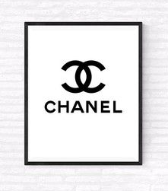

The relationship between brand image and brand loyalty in the case of Chanel

* 1. Are you familiar with the Chanel brand?
- Yes
- No

* 2. How often do you purchase Chanel products?
- One per month
- Every few mounts
- One per year
- Never

* 3. On a scale of 1 to 5, how many stars rate your perception of the Chanel brand image?
1. | 2. | 3. | 4. | 5.

* 4. How likely are you to recommend Chanel products to others?
- Likely to Recommend
- Never Recommend
- Always Recommend

* 5. How important is the Chanel brand image for purchasing their products?
- Extremely important
- Somewhat important
- Not so important
- Not at all important

* 6. Have you ever switched to another brand due to dissatisfaction with Chanel?
- Yes
- No

* 7. How much do you rely on Chanel's brand image when purchasing?
- Always
- Usually
- Sometimes
- Rarely
- Never

* 8. How does the Chanel brand image compare to that of other luxury brands?
- Much better
- Better
- About the same
- Worse
- Much worse

* 9. What attributes or characteristics come to mind when considering the Chanel brand? You can choose all of them.
- Luxury
- Glamour
- Style
- High quality
- All included in

* 10. How satisfied are you with the consistency of Chanel's brand image over time?
- Very satisfied
- Satisfied
- Dissatisfied
- Very dissatisfied

* 11. How would you rate your loyalty towards the Chanel brand on a scale of 1 to 5?
- Very positive
- Positive
- Neutral
- Negative
- Very negative

* 12. To what extent does Chanel's brand image, along with your values and aspirations?
- Strongly agree.
- Agree
- Neither agree nor disagree
- Disagree
- Strongly disagree.

