

A new performance management approach – case study SainCo company

Student name: Lucia Preguza
Student ID: 2111861

Module name: Managing Performance
Module code: LCMB7013
Lecturer name: Rexon Nting
Submission date: 04.05.2022

Table of Contents
1. Abstract………………………………………………………………3
2. Introduction………………………………………………………….4
2.1 The relation between Performance Management and HRM……….5
2.2 The Performance Appraisal and Performance Management………..7
2.3 Autocratic management style – SainCo case study…………………9
2.4 Autocratic management style and its influence on employee engagement and involvement…………………………………………………………10
2.5 Impact of modern PMs on employee involvement- SainCo company case study……………………………………………………………………...11
3. Concepts and Theories of Performance Management directing to SainCo company…………………………………………………………………12
3.1 Impact of performance management system on HRM practices……14
3.2 Modern purpose to Performance Management……………………...15
3.3 Benefits and Disadvantageous of approaching practices and concepts in different organizations – SainCO case study…………………………………………………………………….16
4 Involvement of Lines Managers in Performance Management……….17
4.1 Organizational and employee concern related to the SainCo……….18
5. Recommendations……………………………………………………19
6. Conclusion…………………………………………………………….20

- Abstract
Many modern firms emphasize the performance management in the organization, as a means of create higher measures of job performance. Producing performance additions may be the best realized by orientate the performance management system to assist staff engagement. The key aspect discussed is to evaluate the link between Performance Management and HRM as well as their impact on organization’s performance. This assignment will present the following point of view of autocratic management style which is followed by the SainCo company, as well as analysis and introduction of this model in the organization, as well as followed by modern approach to performance management.
Another point of view suggests however, the impact of autocratic traditional management style and its influence on employee involvement and engagement. Therefore, the author introduced a model of engagement management that assimilate the main structure of the paper and propose a new alternative for evaluating about how to manage employee involvement to realize high management performance at the work.
However, the involvement of lines managers in performance management and their fundamentally role and function in the performance management of the organization. Complementary to this organizational and employee concern related to the SainCo company. The research data is considered from sources like books, journal articles, websites publication and research papers as well.

- Introduction
The role of the Human Resource (HR) purpose in the organization is best described in recognize the essential purposes to be execute in the firms (Torrington, et al., 2004). This suggestion express, that part of the HR basis is like version for objective and intention, that are elementary support for organization productivity. However, Human Resource Management (HRM) is a plan of action, that motivate high involvement management (HIM) that can assurance organizational performance (Wood, 1999).

The employees are the prominent producers of merit in firms, as well positive performance management is important for a firm’s productivity and success (Amstrong, 2014). It can see that, to achieve goals and objectives in the organization the employees need to motivation and support from mangers. As an example of new knowledge, plans and ideas that are basic for employment performance in the organizations (Ashdown, 2018).
Management performance has the possibilities to refine the performance of firms achieving the cultural change, a centre on performance management can propose real recognitions for each company as well as individual capability (Amstrong, 2014). A strategic management is essential for the organization’s employment as well supporting the Human Resources (HR) scheme through actions plan, to progress organizational effectiveness (Amstrong, 2009).
The most important objective of performance management is to appreciate the employee goals through with firm objectives. However, to appreciate the individual development and skills of staff through manager’s help, as well to support the organization’s goals (Torrington, et al., 2020). With regard to Torrington et al. (2004) the performance management cycle is organized in four levels:
- Examining.
- Planning.
- Progressing.
- Rewarding.
Managing the performance and ability of employees in the company is introduced and demonstrated in several stages:
- Setting standards to evaluate the performance
- Adopt the new standards according to the needs or requirements
- Employee performance analysis based on methods and schemes
- Comparison with imposed standards
- Proceeds corrective actions (Geet, et al., 2009).
Therefore, the firmness of performance management application for organizational performance will be controlled by management culture, which company adopts ( Chakraborty & Ray, 2014). The people management well - being, are those of employment engagement that proceed from a positive condition and attitude to work, to improve job role satisfaction and departmental effects (Turner, 2019).
Performance management is indispensable to employment, through informal and formal activity as well helps them orient their employees, strategic objectives and resources in the firm (Caruth & Handlogten, 1997). Performance management as well motivate organizations to recompense and accept their employees and appreciate for hard work. Furthermore, the capability to share feedback and training can be a major role in employee retention (White, 2021).
As a Human Resources Consultant, the purpose of this paper is to investigates the processes of performance management, towards competitive advantage in the place of human resource management performance and other outcomes. Performance and development of goal settings, measurement, appraisal and feedback in the organizations. As well as motivating and recognizing employees at work, towards organizational and employee concerns. The role of line manager in managing performance, business strategy, commitment and improvement flexibility and continue with international, environmental and sustainability issues to the human resource management related to the organization SainCo.

  - The relation between Performance Management and HRM
Performance management is an important direction of organizational success, because is the solution operation through which duties is practised, it is considered an important pillar of managing human capital (Gurman & Saks, 2011). The expression performance management was first presented by Dr Aubrey Daniels in 1980 into management literatures. This definition continues the practise, as well as observing the necessity to influence employee actions of performance management (Adler, 2018). Performance management’s objectives is to make a condition where the employees can perform and produce the highest standard work (Varma & Budhwar, 2019).
Even though performance evaluation is the principal point of performance management, the entire process continued to all organizational practices and policies that interact to provide employee performance (Amstrong, 2007). This associative viewpoint constituted an arrangement proposal to strategic human resource management, which demonstrate that influence of HR scheme. The performance management process provided a possibility for the implementation of all HR strategies (Sims & Bias, 2021)
Managing the performance of the employee is one of the main purposes of HR, and all managers utilizes performance management structure to appraise the actions of their employees in each company (Marr & Gray, 2012). Moreover, a strategic human resource management responsibility, are the following:
- Interviewing
- Recruiting
- Hirring and development the employees (Amstrong, 2022).
HRM is the beginning of all management actions in the firms, human resources managers are first focused on providing the organization with the right employees for the right job in achieving the company’s success (Torrington, et al., 2020). Human resource management is important in enhance employee and organizational performance, all the practices need to be objective on their proposal and application of any organization’s strategy or values (Sims & Bias, 2021).

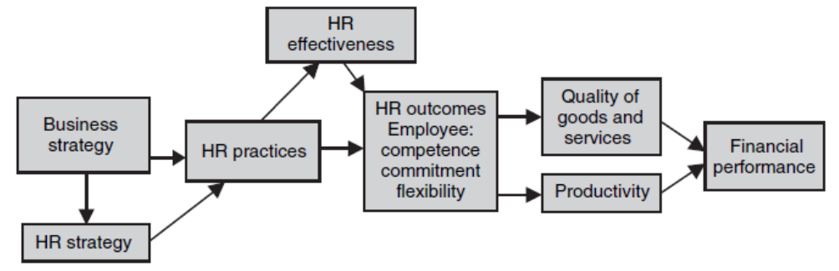
Figure 1.1 The Relation between HRM and Performance Management
Source: (Khan, 2018).

The relationship between HRM and performance is shown in Figure 1.1, is considered the connection from employment procedure to managerial performance sustained by business measure in the organization. Strategic performance management is a general perspective to helping organizations to realize their objectives, it is usually used to introduce to the activity of managing and consider organizational performance (Khan, 2018). It would as well assist to motivate employees:
- Make sure that they have the correct ability
- Development resources to reach the task and level that are look for them
- Ensure that employees have the capacity for achieving their objectives (CIPHR, 2019).

2.2 Performance Appraisal and Performance Management
The most important purpose of performance appraisal (PS) was to assess control over the employee’s activities, through actions carried out within the company and the management of promotions and rewards (Murphy, et al., 2018). With regard to Rao (2004) argued that PS provides good occasions for management performance. These presents different ways, in which the employee performance can be structured:
- Activity evaluations.
- Key result areas (KRAs).
- Key performance areas (KPAs).
- Target recognitions.
- Future plans.
- Goal positions.
PS is an arranged way of assess staff performance, as well benefit to examine the abilities and ability on staff in the organization and future progress (Khan, 2018). Performance appraisal process as shown in figure 1.2, demonstrated the objectives and process of an appraisal, to establish the purpose and success for the company.
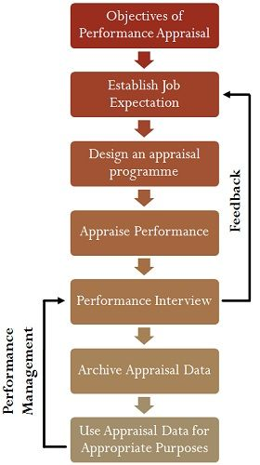

Figure 1.2 Performance Appraisal Process
Source: (S, 2018).
HR departments expend a lot of effort and time into improve their management performance processes in the organization (CIPD, 2020). The HR department will be concerned with ensuring and implementing good practices within the company and equally caring with the business conditions for performance management (Ashdown, 2018). The management as well needs to improve collaboration and communication, which is required for a good business performance.
Performance management provides managers with a program that they can follow to maintain, plan and monitor a satisfactory performance improvement process for their employees in productivity of company as well (Cadwell, 2002). A successful performance management model is necessary for employees perform, and to confirm its objectives and contributes are initiated by the organization (Pettinger, 2013). The performance management process it is a scheme according to which managers and employees work together as shown in figure 1.3, have possibility to give and receive feedback.
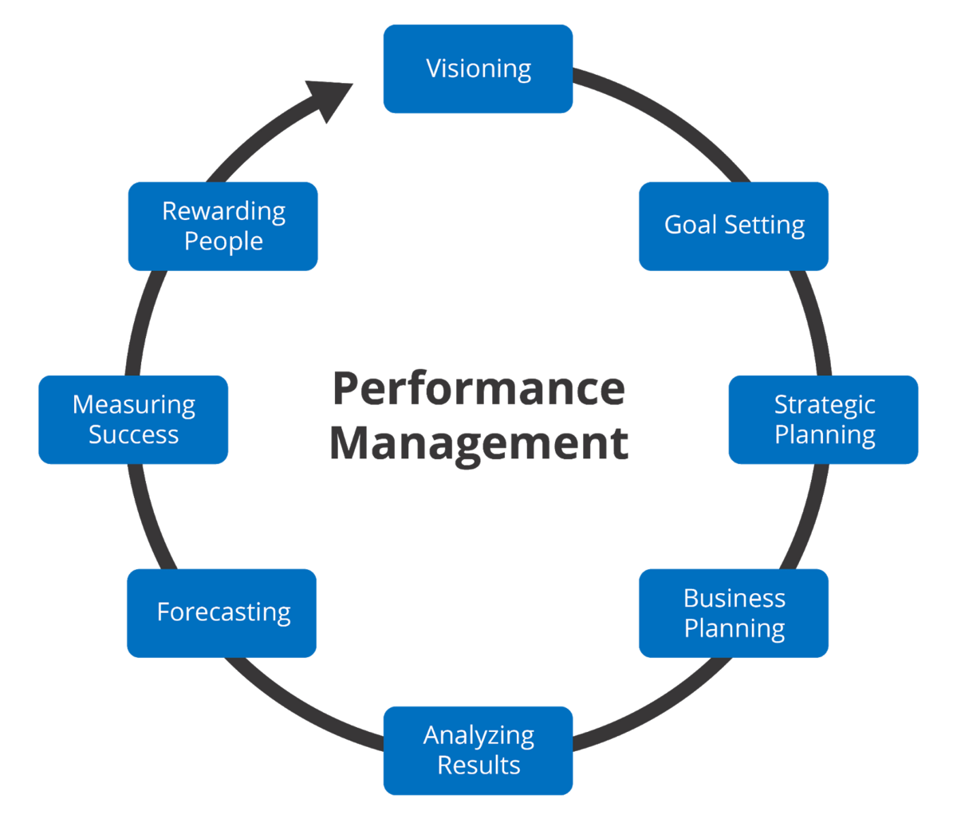
Figure 1.3 Performance Management Process
Source: (mondayblog, 2021).

  - Autocratic management style – SainCO case study
Autocratic management style opined Bhati et al. (2012) is known for management control over all decisions made in the company and for little contribution from the employees. Autocratic leadership, often known as authoritarian leadership, autocratic leadership engage absolute control over employees. Autocratic leaders agree alone, only gives orders to employees and expect them to take the out. In order to inspire, leaders use their control to determine on the proper remuneration (Gosling, et al., 2012). With regard to Bhati et al. (2012) the autocratic management style usually involves one manager to make all the decisions of his subordinates.
As explained by Gosling et al. (2012) authoritarian management style is represented when the goals and functions of the organizations are performed without any communication and management relationship, as well as is tension on employees. Typically, autocratic management style is based on their own judgments, the management make their own plans and ideas. Autocratic management style it is usually used in companies when there is no time for discussion and communication between employees, because a faster result is needed to meet the company’s requirements (Bhati, et al., 2012).
As well autocratic management style has some strengths and weaknesses as shown in figure 1.4, that contributes on performance management in the organizations.

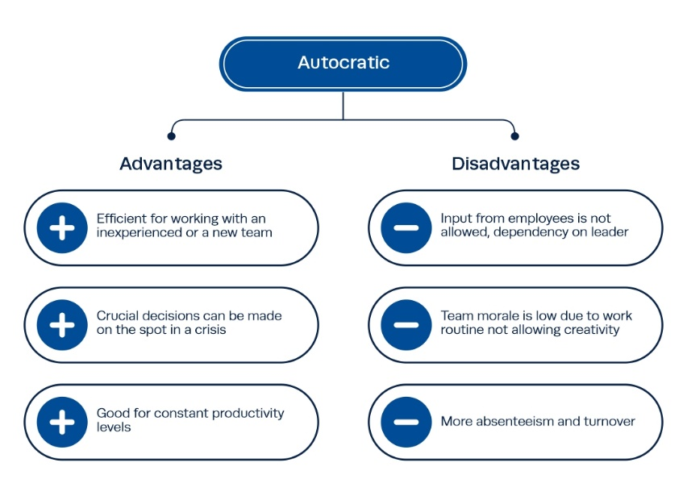

Figure 1.4 Advantages and Disadvantages of Autocratic management style
Source: (Institute Project Mnagement, 2021).
SainCo company may improve management performance by authorize the employees to extend their full potential by substitute from traditional performance management to permanent performance. Therefore, to engage the employees on the decisions and requirements that are set on the organization, to establish a working relationship between managers and employees.
2.4 Autocratic management style and its influence on employee engagement and involvement
Employee stimulation is important in essential as is primarily the procedure on which result anticipate. Dedicated and motivated staff are more original and usually come up with good design and inspiration as well. Specified the importance of staff engagement to firm is principal for managers to prepare specific that detachment (Gurman & Saks, 2011). Such employees enhance more involved and engaged, as well making part of increasing success in the organization, and for that the signification between engagement and involvement is important (Shaheen & Farooqi, 2014).
Based on the ideas of Lasadro (2019) the autocratic management style is less involved in employee evaluation because more important are the organization’s success and productivity as well. A traditional autocratic management style contributes to a lower level of employee motivation and engagement. On the other hand, autocratic styles include intimidations, threats and coercive tactics which discourages employee involvement and engagement in the organization (Lasadro, 2019).
Authoritarian style has a negative impact on staff involvement, is significantly correlated with commitment and hardiness. Authoritarian leaders accentuate that their control over the employees is decided and cannot be dispute (Zhao & Sheng, 2019). As identified by Mitonga-Monga et al. (2012) the autocratic management style, increase the lower satisfaction and stress at the work, as well expand negative affect on employee relationship. As shown autocratic management style introduce a toxic culture in the organization.

2.5 Impact of modern PMS on employee involvement- SainCo company case study
With regard to Hooper & Newlands (2016) the performance management system (PMS) arguments the staff performance by independent purposes that are attained from organizational ideas and connecting strengths gap, thus increasing staff capability levels in the organization. Modern PMS perspectives relate to employee involvement to decrease defiance and increase receiving of plans and goals because the employees help set expectations (Wilton, 2013).
Based on the ideas of Avan et al (2020) the employee perceptivity of the exactitude of PMS between the arrangement of the staff and firm’s goals in the organization are followed by:
- Performance level and skills.
- Transparency about the objective.
- Clear relationship of objectives with organization needs.
After examining the employee perceptivity on the PMS in the organization, will follow the performance appraise against design standards in the company as well:
- Systematic assessment about entertainment in the company.
- Assistance of staff evolution as well as evaluation of staff strengths in the company as well.
- Introduction to the organization the clear relationship between performance and performance management procedure results like rewards and appreciation for employee motivation at the work (Avan, et al., 2020).

As a HR consultant I will introduce PMS of SainCo company employees, that will help to follow some questions:
- To analyse performance issues in the SainCo company?
- How will performance be measured?
- How the system will impact the relationship between the managers and the employees?
- How PMS will inspire employees?
- What issues can occur in the SainCo company after the introduction of the PMS?

- Concepts and Theories of Performance Management directing to SainCo company
Management theories are concepts that represent the management strategies, introduced in organizations, which may incorporate instruments as guidelines and frameworks that can be applied in modern organizations (GOEL, 2012). Management theories usually try to explain the success in the company, as well decrease it to the survival of strategic potentials (Nothnagel, 2008). Hence, managers will usually implement the theory that is close to the organization’s culture.
According to the System Management Theory, the performance of an organization turns on few elements: interdependence, synergy and interrelations connecting with several subsystems (Kessler, 2013). For the company performance employees are the most important, and other business units and workgroups. As well SainCo company can implement the theory System Management in the organization, in mind may assist start-ups in initiate a clear management and acquire stronger responsibility of performance from employees.
The performance management process is considered to establish a performance relation between and employee and manager as shown in figure 1.5. Performance management model (PCER) is for encourage the performance management process. As well this model is utilized to:
- Produce a performance idea.
- Coach for profitable realization of the idea.
- Complete the performance assessment (Nothnagel, 2008).
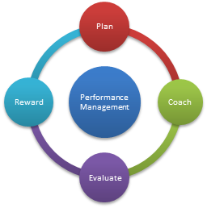

Figure 1.5 Performance Management Model (PCER)
Source: (PCER, 2021).

The plan of this model is related to the evaluation of the manager on the employee performances.
- The manager formulates opinions for the employees in order to achieve success.
- Managers assess the employee self- evaluation.
- At the end is the reward for all hard working in the organization (GOEL, 2012).

As a Human Resources Consultant, I will advise SainCo company to implement this PCER model, because it is very effective in terms of motivation and support at work, as well the company will only gain on organizational performance because is implementing new plans and strategies in determining and evaluating employees in the SainCo company.

3.1 Impact of performance management system on HRM practice
HR practices can make immediate influence on staff attributes such as commitment, engagement skill and motivation as well. Therefore, if the employees have these attributes, the organizational performance will improve as well, because they work together all the time. HR can contribute to intensify organizational performance by impart awareness on the performance proceeds, affecting the company and its staff as well as the development of a high-entertainment work system (Amstrong & Taylor, 2020). HR practices have a directly impact on employee motivation, work structures and jog design as well, as shown in figure 1.5. Then again Human Resources Management assume to have an important and unique impact on collective competence. The fully correlation would be between increasing production or add on increases in incomes (Amstrong, 2022)
High-performance work system (HPWS) is part of HR practices that assist skill enhancement, employee involvement and motivation (Amstrong, 2009). As identified by Amstrong (2014) HRM practice makes an impact on company performance on few propositions:
- That HR practice can create a directly influence on staff attributes like, motivation, commitment and ability.
- If staff meet these aspects, then the performance of the organization in term of productivity will improve.

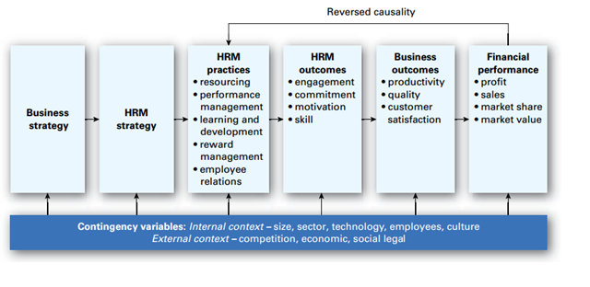
Figure 1.5 Impact of HRM on organizational performance
Source: (MPF, 2019)
  - Modern purpose to Performance Management – SainCo study case
Modern performance management is a method that is individual and unique to company and its culture. The most successful and productive organizations of course use this model that brings a special and unique culture for their employees. For SainCo this is the most successful model for implementation in the organization ( Buytendijk, 2009). Modern approach to performance management focused on the employee performance and potential. Modern methods look forwards to enhance strengths and control weaknesses in management performance of the organization (Kumar & Meenaski, 2009).
Modern approach is based on combine performance analysis by consider the performance of interior process. The most prosperous organizations are being operate more by what they see in their company than what they see to the others ( Buytendijk, 2009).
With regard to Saxena (2009) principles of management in a modern approach are:
- Organizing
- Planning
- Leading
- Controlling
- Co-ordinating.
SainCo company is an autocratic management style and for future changes in success and productivity, the new model may be the unique and successful change for the company.

  - Benefits and Disadvantageous of approaching practices and concepts in different organizations – SainCO case study
According to Bewster et al. (2021) approaching the process and the practices in the organizations can be identifying the work responsibility, establishing and authority. Each organisation uses the closest theory for performance management. However, an individual practices is advantageous or disadvantageous for an organization as well as depends on business culture. The change can benefit to carry on with industry trends, by building it more attractive to future consumers and keep current consumers in the organizations (Saxena, 2009).
In the implementing of concepts and practices the staff can gain new opportunities, knowledge and experience which is a great chance for SainCo productivity and success. Recognition movement takes place through the operation when employees have individual information that is precious to other employees (Hardina, 2014). Thus, changes takes when practices and concepts are introduced in the organizations. The effect is, the implementation of concepts and practices in the organization can result in staff attitudes come about positive.
Disadvantageous of approaching practices and concepts in the organizations can be essential and may regularly create complex provocation. Changes can change the culture and goals of the company, changes may consequence in less coherence in staff (Hardina, 2014). The disadvantageous for SainCo company it could be the slower adaptation of employees to the theories and practices imposed in organization.

- Involvement of Line Managers in Performance Management
Managers are that people that who are planning, controlling, motivating and organizing things for employees benefit and company as well. Line managers look for change possibility and manage their employment part (Dance, 2018). Their fundamentally role is to introduce procedures and systems, maintain and control merit and categorize the employees. Line mangers as well have a direct responsibility for the company, implementing company plan and enhance employee performance and of course leadership is one of the most important key for this (Amstrong, 1998).
Performance management method are utilized to increase staff performance in order to increase organizational performance. Line managers introduce performance system method with purpose to achieve:
- Feedback.
- Performance appraisal.
- Coaching
- Goal – setting.
Line managers are the best people who can make performance management in the company, all the efforts and skills lead to discussion and commitment to employee goals. Based on the ideas of Amstrong (2007) that more leadership for managing recompense should be assign to line managers. Therefore, line mangers develop performance assessments for all employee and give recommendations on department of enhancement. The most important areas in which line managers have influence for recompense are:
- Total recompense.
- Decisions.
- Performance managing and communicating.
Line managers have different reward needs, it depends on the work profile of the employer and of course on the work department. Contribute line managers with the process to recompense the best performance it’s a change of the culture from authoritarianism to high performance (Amstrong, 2007).

4.1 Organizational and employee concern related to the SainCo
Human Resource Management (HRM) experts play a main function to ensuring the safety and health of their employees, as well their needs at work within the organization. (Sims & Bias, 2019). Organizational concern in the organizations are all the issues that cover a number of units and departments, as well as influence the entire company. However, all these concerns require team support in evaluating and solving them (Pace, 2002). Organizational concern in companies is manifested by the need and desire to help organizations, which stems from a sense of commitment and obligation to the organization (Buchanan, et al., 2013).
Then again, impression management is manifested in the requirement to demonstrate the right position for employees, in order to obtain organizational rewards (Pettinger, 2013). Based on the ideas of Men & Cercic (2021) the organizations can define different category of organizational issues and concerns, here are some of them:
- There is no clear direction in the organization.
- Difficulty to combine numerous personalities in the work team.
- Poor feedback and communication from managers and employees.
- Lack of realization, etc.
Perhaps, when the employee actions in the company do not coincide with the objectives of the organization, either the actions or the goals of the employees must change for productivity and future success (Fredericken, et al., 2015). Employee concerns all the time influence productivity, negatively or positively. With regard to (2020) the employees have different concerns when in different conditions:
- Pay increase guidelines.
- Benefits plan.
- Salaries and compensation.
- Too much management in the company.
- Over-work hours.
- Workplace conditions, etc.

For SainCo company organizational concern and employee concern can be big issues for the future of the company as well, but to implement a good plan and ideas can be a big opportunity and realise for resolving all the concerns that are in the company. After examining organizational and employee concern, the most effective is to make plan or a strategy that company can implement on. The most appropriate would be the new model which shows us a clear and exact strategy. This modern approach is certainly the best for establishing professional relationship in the company and focusing on organizational concerns and employee concerns as well.

5. Recommendations
Firms have been regularly exploring for a successful performance management system. Considering organizational performance management has different way of uses. Based on the findings of Amstrong (2009) it can be argued that the organization embrace controlling and monitoring activities, maximizing organizational purposes, expanding the success of the enhancement performance, disciplining and rewarding as well. At this moment is some of the recommendations I will suggest for SainCo company, like as a Human Resources Consultant to get a success performance management in requirement to successfully reach the company objectives:
- Obtain the staff commitment is principal as it will ameliorate the staff performance, and will help to build up staff’s morality as well in the future progress of the SainCo company.
- Established identification of high-level production, by the management essential.
- Established a professional relationship managers and employee performance, which only brings benefits and success to the company.
- Management has to offer the possibility to the staff to require in proposal method.
- Implementations of activities developed by the human resources department, to introduce new values, goals and objectives related to management performance in the SainCo organization.
- Analysis of each employee shares, the weaknesses and the parts to be performed will be identified and discussed for a better improvement.
- The employees could be rewarded with several awards after the evolution of performance and commitment in the SainCo company as well, and like that is increasing the motivation of employees.

Individual performance, is to evaluate progress opposed to communicate performances purposes for teams of staff (Amstrong, 2007). In summary, can be understood that a productive PMS establish, that managers and staff appreciate each other beliefs, as well as they are introduced into the organization’s plans and future relationship employment in the organization. And it can implement in SainCo company a good communications and feedback as well between leaders and employee.

- Conclusion
To conclude, the performance management plays a big role in the evolution and performance of SainCo company. A few organizations are influenced on developing of performance management. However, the performance management is an evaluative aspect of managerial success (Amstrong, 2014). Therefore, the performance management system that, are also discussed here. After examining the employee engagement and employee involvement, it can be said with certainty that employees are the engine and support of the company as well.
It has been shown that, the managing performance system has an important role in supporting and evolving the organizations performance as well. Many authors have introduced managing performance such as employment strategy, performance appraisal and feedback as well as improved performance (Amstrong, 2014). Modern challenges confronting organizations have conduct many of them to modify action on their performance management system, as demonstrated by SainCo company as well. To illustrate, the intense levels of commitment are positive for employers, and can be considered good leadership process. However, the relation to commitment is frequently insufficient and it can be changed in employee concern in the organization.
Change the autocratic style to new performance management approach in approval of employees and the prosperity of the company, and this can bring positive changes in the organizations. In summary, this paper can precis that the managing performance becomes one and only method of significant the staff’s actions, but as well an important employment tool to loop staff goals and activities of the organization performance as well.

References
Buytendijk, F., 2009. Organization As Network: A Modern Approach to Performance Management. Business Performance Management Magazine, 7(1), p. 4.
Chakraborty, K. & Ray, . N., 2014. Handbook of Research on Strategic Business Infrastructure Development and Contemporary Issues in Finance. 1nd ed. Bhutan: IGI Global.
Adler, R. W., 2018. Strategic Performance Management Accounting for Organizational Control. 2nd ed. Otago: Taylor&Francis.
Amstrong, M., 1998. Managing People A Practical Guide for Line Managers. 1nd ed. London: Kogan Page Limited.
Amstrong, M., 2007. A Handbook of Employee Reward Management and Practice. 2nd ed. London: Kogan Page Limited.
Amstrong, M., 2009. Armstrong's handbook of performance management: an evidence-based guide to delivering high performance. 4nd ed. London: Kogan Page.
Amstrong, M., 2014. Armstrong's Handbook of Performance Management An Evidence-Based Guide to Delivering High Performance. 5nd ed. London: Kogan Page.
Amstrong, M., 2022. Armstrong's Handbook of Performance Management An Evidence-Based Guide to Performance Leadership. 4nd ed. London: Kogan Page Incorporated.
Amstrong, M. & Taylor, S., 2020. Armstrong's Handbook of Human Resource Management Practice. 15nd ed. London: Kogan Pge.
Ashdown, L., 2018. Performance Management: A Practical Introduction. 2nd ed. London: Kogan Page Limited.
Avan, S. H., Habib, N. & Akhtar, C. S., 2020. Effectiveness of Performance Management System for Employee Performance Through Engagement. Sage Journals, 10(4), p. 215824402096938.
Bewster, C., Parry, E. & Morley, M. J., 2021. The Oxford Handbook of Contextual Approaches to Human Resource Management. 4nd ed. Oxford: Oxford University Press.
Bhati, N. et al., 2012. The Impact of Autocratic and Democratic Leadership Style on Job Satisfaction. International Business Research, 5(2), pp. 192-211.
Buchanan, J. O., Bryan, L. K. & Thompson, L. F., 2013. Using Industrial Organizational Psychology for the Greater Good: Helping Those who Help Others. 1nd ed. New York: Routledge.
Cadwell, C. M., 2002. Performance Management. 1nd ed. Kansas: AMACOM.
Caruth, D. L. & Handlogten, G. D., 1997. Staffing the Contemporary Organization A Guide to Planning, Recruiting, and Selecting for Human Resource Professionals. 2nd ed. London: Quorum.
CIPD, 2020. Performance management: an introduction: Understand how to build an effective approach to performance management, including the tools that can support it. [Online]
Available at: https://www.cipd.co.uk/knowledge/fundamentals/people/performance/factsheet#gref
[Accessed 25 Aprill 2022].
CIPHR, 2019. What does an effective performance management strategy look like?. [Online]
Available at: https://www.ciphr.com/advice/an-effective-performance-management-strategy/
[Accessed 15 Aprill 2022].
Dance, A., 2018. A Pragmatic Introduction to Middle Manager Fundamentals: Part 1 - Role and Function. 1nd ed. London: eBookit.com.
Fredericken, E. D., Witt, S. L., Patton, W. D. & Lovrich, N. P., 2015. Human Resource Management: The Public Service Perspective. 2nd ed. New York: Taylor&Francis.
Geet, S. D., Deshpande, A. D. & Deshpande, A. A., 2009. Human Resource Management. 4nd ed. Maharashtra: Nirali Prakashan.
GOEL, D., 2012. PERFORMANCE APPRAISAL AND COMPENSATION MANAGEMENT: A MODERN APPROACH. 2nd ed. Geneva: PHI Learning.
Gosling, J., Sutherland, I. & Jones, S., 2012. Key Concepts in Leadership. 1nd ed. New Delhi: Sage Publications.
Gurman, J. A. & Saks, A. M., 2011. Performance management and employee engagement. Human Resources Management Review, 21(2), pp. 123-136.
Hardina, D., 2014. Innovative Approaches for Teaching Community Organization Skills in the Classroom. 2nd ed. New York: Taylor&Francis.
Hooper, M. J. & Newlands, D. J., 2016. The Global Business Handbook: The Eight Dimensions of International Management. 3nd ed. Lille: Taylor&Francis.
Institute Project Mnagement, 2021. 10 Leadership Styles and How to Identify Your Own. [Online]
Available at: https://www.projectmanagement.ie/blog/leadership-styles/
[Accessed 25 Aprill 2022].
Kessler, E. H., 2013. Encyclopedia of Management Theory. 2nd ed. California: Sage Publication.
Khan, Y. H., 2018. Strategic Human Resource Practices and its Impact on Performance towards Achieving Organizational Goals. Business Ethics and Leadership, 2(2), pp. 66-73.
Kumar, A. & Meenaski, N., 2009. Organizational Behaviour: A Modern Approach. 1nd ed. New Delhi: Vikas Publishing House Pvt Limited.
Lasadro, F., 2019. Fostering Creativity and Innovation Creating a Sustainable Innovation Environment in the United Arab Emirates. 2nd ed. Dubai: Springer International Publishing.
Marr, B. & Gray, D., 2012. Strategic Performance Management. 1nd ed. Oxford: Taylor&Francis.
Men, L. R. & Cercic, A. T., 2021. Current Trends and Issues in Internal Communication: Theory and Practice. 3nd ed. Zagreb: Springer International Publishing.
Mitonga-Monga, J., Coetzee, . M. & Cilliers , F. V. N., 2012. Perceived leadership style and employee participation in a manufacturing company in the democratic republic Congo. African Journal of Business Management, 6(15), pp. 5389-5398.
mondayblog, 2021. How to create a winning performance management process. [Online]
Available at: https://monday.com/blog/project-management/performance-management-process/
[Accessed 25 Aprill 2022].
MPF, 2019. What impact HRM can make on performance?. [Online]
Available at: https://monalikarunarathna.blogspot.com/2019/05/what-impact-hrm-can-make-on-performance.html
[Accessed 25 Aprill 2022].
Murphy, K. R., Cleveland, J. N. & Hanscom, M. E., 2018. Performance Appraisal and Management. 3nd ed. Limerick: Sage Publications.
Nothnagel, K., 2008. Empirical Research Within Resource-Based Theory: A Meta-Analysis of the Central Propositions. 1nd ed. Frankfurt: Gabler Verlag.
Pace, R. W., 2002. Organizational Dynamism Unleashing Power in the Workforce. 1nd ed. London: Qourum Books.
PCER, 2021. Performance Management Model (PCER). [Online]
Available at: https://employees.tamu.edu/talent-management/performance-management/pcer.html
[Accessed 24 Aprill 2022].
Pettinger, R., 2013. Organizational Behaviour Performance Management in Practice. 2nd ed. Abingdon: Taylor&Francis.
Rao, T., 2004. Performance Management and Appraisal Systems: HR Tools for Global Competitiveness. 1nd ed. New Delhi: Sage Publications.
Saxena, P., 2009. Principles of Mnagement: A Modern Approsch. 2nd ed. New Delhi: Global India Publications PVT LTD.
Shaheen, A. & Farooqi, Y. A., 2014. INTERNATIONAL JOURNAL OF MULTIDISCIPLINARY SCIENCES AND ENGINEERING. Relationship among Employee Motivation, Employee Commitment, Job Involvement, Employee Engagement: A Case Study of University of Gujrat, Pakistan, 5(9), pp. 12-18.
Sims, R. R. & Bias, S. K., 2019. Human Resources Management Issues, Challenges and Trends: Now and Around the Corner. 4nd ed. Washington: Information Age Publishing Incorporated.
Sims, R. R. & Bias, S. K., 2021. Human Resource Management and Etichs: Responsabilities, Actions, Issues and Expirience. 9nd ed. London: Information Age Publishing, Inc.
S, S., 2018. Difference Between Performance Appraisal and Performance Management. [Online]
Available at: https://keydifferences.com/difference-between-performance-appraisal-and-performance-management.html
[Accessed 25 Aprill 2022].
Torrington, D., Hall, L., Taylor, S. & Atkinson, C., 2004. Fundamentals of human resource managment. 1nd ed. Harlow: Pearson Education Limited.
Torrington, D., Hall, L., Taylor, S. & Atkinson, C., 2020. Human Resource Management. 11nd ed. Harlow: Pearson Education Limited.
Turner, P., 2019. Employee Engagement in Contemporary Organizations Maintaining High Productivity and Sustained Competitiveness. 1nd ed. Leeds: Spring International Publishing.
Varma, A. & Budhwar, P. S., 2019. Performance Management Systems An Experiential Approach. 3nd ed. New York: SAGE Publication.
White, D., 2021. Importance of Performance Management in an Organization. [Online]
Available at: https://www.techfunnel.com/hr-tech/importance-of-performance-management-in-an-organization/
[Accessed 15 Aprill 2022].
Wilkinson, A., Donaghey, J., Freeman, R. B. & Dundon, T., 2020. Handbook of Research on Employee Voice. 2nd ed. Northampton: Edward Elgar Publishing.
Wilton, N., 2013. An Introduction to Human Resource Management. 2nd ed. California: Sage Publications.
Wood, S., 1999. Human resource management and performance. International Journal of Management Reviews, 1(4), pp. 367-413.
Zhao, R. & Sheng, Y., 2019. Open Journal of Social Scencies. The Effect of Leadership Style on Employee Engagement: The Moderating Role of Task Structure, 7(7), pp. 404-420.

