Tom Clement
PCET
ECPT6007
Curriculum Development Project
Digital Game Innovation



MODULE CODE: ECPT6007

ASSESSMENT COMPONENT: Curriculum Development Project

STUDENT NAME: Tom Clement

STUDENT NUMBER: 2106402

Final word count: 4173

Use of Generative AI in Assessment

(Lecturer to indicate Yes or No against each element)

RESEARCH | For this assessment, you can use Generative AI to support you in research, including searching for bibliography, using tools to summarise, compare and interrogate materials. | Yes ☒  No ☐
STRUCTURE | For this assessment, you can use Generative AI to support you in structuring your submission, including creating a draft argument structure, identifying parts and headings, etc. | Yes ☒  No ☐
PROOFREADING | For this assessment, you can use Generative AI to check your own text/creation for grammatical and syntactical mistakes, including rephrasing of your own work within specific standards. | Yes ☒  No ☐
WRITING | For this assessment, you can use Generative AI to create text for submission. | Yes ☐  No ☒
CREATIVE | For this assessment, you can use Generative AI to create creative materials, such as images. | Yes ☐  No ☒
PROGRAMING | For this assessment, you can use Generative AI to create and check code. | Yes ☐  No ☒
NONE | For this assessment, you are not allowed to use any type of Generative AI support. This includes research support, structure support, writing/proofreading support and creative support. | Yes ☐  No ☒

AI Acknowledgement
I confirm that I have not used any AI tools in the research and creation of this assignment.
I confirm that I have not presented any AI generated materials as my own work.
I confirm that I have copies of my drafts, notes, and other resources I used, which I may be asked to provide in evidence.

Introduction
What & Who?
The curriculum proposed, has been created for the inclusion in the Creative Music Technology (CMT), Bachelor of Arts (BA) degree programme, taught at the University of Wales Trinity Saint David (UWTSD), during the second year of the course (Level 5), to an average class size of around 9 students.

A brief overview of the curriculums content includes the creation of an industry facing portfolio, with chance for further student skill development and expansion within the Level 6, 3rd year of the course during the “Independent Project” or “Final Portfolio” modules. The curriculum will also look to provide expansion of subject-specific skills and industry employability skills for students undertaking this proposed curriculum.

“Digital Game Innovation” was chosen for the curriculums title as it embodied the overarching content of the curriculum. Within this curriculum, students will be introduced to several transferable skills and knowledge for working within various areas of the music industry, primarily focusing on working as an audio engineer within the ever-expanding gaming industry.

The portfolio will consist of 3 two-minute music tracks, 12 synthesized foley sound effects, a 3D or 2D character model and environment produced in the game development software engine Unity, and finally a 1500 word write up as an overview and justification for their work, providing incite to their created brief overviewing their chosen game/music genre.
The write up will ultimately tie their music and sound effects to their designed character model and setting, giving markers the necessary information to assess the students learning and skills.

This portfolio has been designed showcase various transferable skills for working within the game and digital media industry. These skills include music engineering, writing, coding, working with Unity and the application of audio within the software. The focus on technology runs in tandem with the core purpose of the CMT course as well as seeks to uphold and strengthen the Welsh Government (2019). Digital 2030 A strategic framework for post-16 digital learning in Wales 2019.
The marking scheme of this curriculum will follow the standardized UWTSD “Assessment Marking Criteria” (Levels 3-7) framework, a copy of the Level 5 criteria will be included in appendices. This framework is a required across UWTSD courses, as well as retains a consistent assessment benchmark across the CMT programmes other modules.

Why?
The decision to design this curriculum to be taught to Level 5 students logistically appeared to be the most efficient, and appropriate level to introduce students to the content of the proposed curriculum. From personal experience having taken on the course, I believe that the contents of the curriculum are very much achievable for Level 5 students and would look to be an engaging unit of work and experience for learners.

Verbal feedback from current students during placement in the department has been considered in identifying the gap present that this curriculum seeks to respond to. These students have expressed interest into curricula activity based around creating music for the games industry, as well as Level 6 students who have taken on games audio development for their Independent Projects. Students have expressed that some level of focus on the games industry would have been beneficial to their studies prior to their 3rd year.
This experience and feedback have led to identify the lack of focus, absence and demand of a module that directly focuses on creating music and developing skills for and around the gaming media industry, and in response to this, has resulted in the creation of this curriculum.

By identifying this gap in the programmes curriculum, Digital Game Innovation seeks to provide a module that supports students learning, offering experience in music production, foley creation, Unity software, coding and producing. Resulting in an industry facing portfolio that may open opportunities for employment for learners, or alternative avenues where these skills may be transferred such as interactive exhibits, and media creation.
Examples of the modern use of Unity or Blender can be found across various game styled creations used in music videos or promotional viualisers, as seen on creative social media outlets such as YouTube and Tiktok, where various indie creators have used their skills in 3D game design to create visualisers for music promotional assets, examples have been included in the appendices under “Visual Examples.”
Level 5 students on the CMT course, are in an optimum position in the overall timeline of the course to be introduced to the skills and industry knowledge provided through the 10-week module created having many skills taught during the first year such as various writing and recording techniques during the “Studio Engineer” module, as well as their extensive use of Digital Audio Workstations (DAW) production methods also developed in the first year, this curriculum would allow students a chance to further develop and hone their skills in expansion to their previous learning.

Where?
The Dynevor campus Mac Labs at UWTSD was chosen as a location as it has the necessary facilities and location for the delivery of this module. The Mac Labs offer a both a class lecture space, as well as access to the Mac computers which are pre-loaded with the required software, Unity and DAWs students will need to complete this curriculum. Dynevor also has access to the microphones; audio interfaces and cables needed for students to record the required foley sound effects for their projects.
The campus is also accessible for students with Alternative Learning Needs (ALNs) such as physical disabilities, as the site has wheelchair access ramps as well as lifts to the class floor. Consideration of these ‘long-term’ impairments must be displayed as to uphold the Welsh Government (2017). Professional Standards for Teaching and Leadership. “Demonstrating commitment to learners, their learning, safety and well-being” and the “Value and promotion of diversity, equality of opportunity and inclusion.” As well as upholding these standards this aims to be compliant to the UK “Disability Discrimination Act 2010.”

When?
Choosing to start the course at the beginning of the second semester was purposefully considered as it follows a similar module taken in the first semester of Level 5 “Sound for Moving Screen”, this module teaches student the skills to write music and create foley for media such as film, television or advertisements. The proposed curriculum would expand on this learning while having more responsibility for their creations producing their own game character brief and music pieces/sound effects prompted by their game genre of choice, i.e. if their character were a Knight in a fantasy setting, they would produce music and effects appropriate to the setting. Students will also expand on the foley skills learnt during their previous module while recording or synthesizing their 12 sound effects. The choice to include 12 sound effects offers students the chance to develop their skills in not just music production, but sound manipulation and audio production. 12 sound effects were chosen as students would have a small library of effects to showcase within industry work portfolios.

The largest contrast to the “Sound for Moving Screen” module within the “Digital Game Innovation” curriculum, is being centered around learning about the games industry, over traditional film and media production, as well as introducing new skills working with Unity, transferable skills to other software such as Blender.

In summary, the core rationale for the creation of the curriculum, was in direct response to provide inclusion of games audio to the existing curriculum, derived from student feedback received, there is certainly a demand and potential need for this addition which hopes to effectively address within the Digital Game Innovation curriculum. Further developing students’ abilities, learning and in expansion of the "Sound for moving screen.”

Theoretical concepts and effective student learning

While creating the initial development of this module the “Driscoll Model of Reflection” (1994) framework was utilised to identify the gap in the curriculum, and what action was needed to be taken in constructing the core fundamentals of the programme.

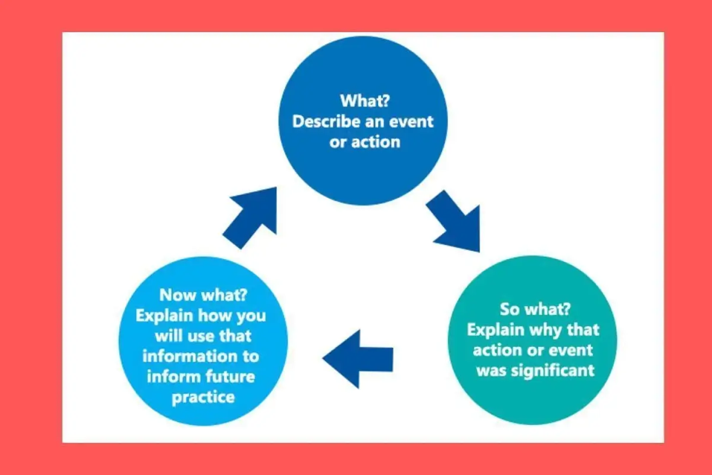
Fig. 1 Driscoll Model of Reflection, The Student Helpline (Source: thestudenthelpline.io)

A summary of the Driscoll Model of Reflection frameworks uses in the curriculum design:

What? – Self-reflection and student feedback regarding the gap and desire for transferable skills working with games development, audio and industry knowledge and employable skills.

So what?
The feedback identified the gap in the curriculum engaging me to develop the 10 week scheme of work, where students are taken through an introduction into working within the game industry as an audio developer, as well as the skills required to work in and create a functional body of work in the form of their portfolios, giving feedback from both their assignments and workshop participation.

Now what? – Acted on findings by creating a programme that bridges this gap. Creating lesson plans to ensure that the scheme of work would be achievable and realistic and measurable aims, objectives, and goals.

To develop the scheme of work, existing curriculum development models were considered and used in the formation content of the course. Selecting objectives, the organisation of learning, considering students’ needs and well-being to uphold Welsh Government (2017). Professional Standards for Teaching and Leadership. Such as “commitment to learners well-being and learning”.

The Taba Model was considered at first as it was stated by ‘educarepk.com’ to “Emphasizes teacher involvement and a grassroots approach.” An appropriate model to use for my initial concept.
However, after further research the “Process model” was settled on which as stated on the University of Derby’s website, has “emphasis on the active roles of teachers and learners, emphasis on learning skills and emphasis on life skills” all of which were strengths I considered most important regarding my identified curriculum.

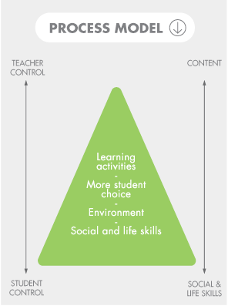e
Fig. 2 Process Model. ResearchGate (Source: researchgate.net)
The “emphasis on the active roles of teachers and learners” of this model was ideal for the half lecture, half workshop, 1:1 support approach that was chosen for most of this scheme of work. This approach allows lecturers to first communicate the required information to students, then allow students to take responsibility for their own learning upholding the Welsh Government (2017). Professional Standards for Teaching and Leadership. “The professional learner & Rights of learners.”
While lecturers’ still take on an active roll through 1:1 support and formative assessment feedback.
The “emphasis on learning skills and life skills” in this model was particularly useful while considering what students would achieve by the end of the programme. As the curriculum at its core provides insight for students to working within the gaming industry, providing the skills necessary is a key objective for the curriculum.

Application of the process model was as follows:
Social and life skills – Providing students with transferable skills for employment working within the games industry. Including coding, games development, industry knowledge, music production, creating and working to a brief, time management skills, foley work and peer assessment.
Environment – Dynevor Mac Labs to provide students with the most appropriate and facilitated learning space available, suited for this curriculum.
More student choice – Allowing students to have the independence to create their own game and character brief as well as take on an independent learning approach during workshop hours.
Learning activities – Creating a variety of objective based activities which would trickle down in support of the other areas of the process model, included practical activity creating 3 tracks, 12 foley sound effects, 3D or 2D model and environment and literature activity producing their 1500 write up.

Considering the 4 conceptions of curriculum, the process model provides insight to the “official curriculum” and “observed curriculum”, while the industry ready portfolio and transferable skills into other areas of the music industry provides the “hidden curriculum” and “curriculum-as-experienced” by students.

While developing the lesson plans for the curriculum, “Mazlows hierarchy of needs” (1943) was considered, taking students hierarchy of needs into account, scheduling in strategically placed breaks into lessons after a potentially stressful section such as the opening lectures to give student the opportunity to attend to their physiological and psychological needs. Mazlows hierarchy can also be considered in the approach lecturers take while communicating to students, providing a safe and friendly environment that helps students to build self-esteem and belonging.

Aims and objectives of the course

The use of Blooms Taxonomy of action verbs (1956). Was applied to create several measurable aims and objectives for this curriculum.
Aims:
- To define and outline the goals of this module.
- Examine industry examples.
- To identify areas of employment within the gaming industry as musicians.
- Discuss the need for musicians within the gaming industry.
- Discover new skills coding and working within Unity.
- Extend students’ knowledge of foley creation and song writing.
- To develop student relationships though peer review.

Objectives:
- To summarise student learning via their portfolios.
- Apply and combine learnt skills in Unity and Foley Workshops.
- To create, construct and compile an industry facing professional portfolio.
- To assess and evaluate learners’ abilities in feedback for further self-development.
- For students to analyse their own work within the reflective write up.

Ultimately, the core outcome of the course is to provide learners with the skills needed moving forward in their academic paths, employable jobs withing the gaming and music industry.

Professional standards and benchmarking

Several Welsh Government (2017). Professional Standards for Teaching and Leadership have been considered for practitioners to uphold while running this proposed curriculum.
All of which are in line with the educational body UWTSDs professional standards expectations of practitioners, code of conduct and the Welsh Government (2017) Standards. It is important for practitioners to uphold these professional standards to provide the best service and most effective and impactful teaching experience for learners.

During sessions, lecturers will be expected to “demonstrate commitment to learners, their learning, safety and well-being” carried out by 1:1 support during workshops, while providing scheduled breaks to maintain student well-being. Issues or concerns students may have following tasks set during sessions or external issues can be discussed after the session if required.
The professional standard of “value and promote diversity, equality of opportunity and inclusion” must be considered by lecturers in their own teaching approach in creating a safe and fair teaching environment. ALNs must be considered session to session attenuating the approach when necessary. The Dynevor campus has been chosen to be accessible for any students with physical disabilities. The 1:1 student focus during workshop hours can also provide support for any students with alternative neurological learning needs.
“Demonstrate dignity, courtesy and respect towards others” must also be carried out by both practitioners and students. Lecturers must be professional in their approach and delivery, while making sure to address any misconduct, bullying, prejudice or discrimination in class, creating a respectable and safe environment for students. This behavior management will also uphold the UWTSD code of conduct maintaining “professionalism, care for each other, respect for others and respect for the university environment.”
To display “understanding the importance of Welsh culture and language as a bilingual nation” when appropriate, examples of Welsh industry developed games will be included within lecturers such as the Unity created game “Maid of Sker (2020)”, by Wales Interactive. Inclusion of the Welsh language may be implemented into session resources such as Welsh translations for key words or headings, or by completing the lesson by saying thank you in Welsh.
The professional standard to “maintain and update knowledge of my subject(s) and how best to teach and assess them” can be carried out individually by practitioners making sure to keep their knowledge up to date. This has been considered in the up to date reading list and examples used within the curriculum. As well as this students’ will also be provided the most up to date version of the Unity software to work with.
By creating a lesson plan for each session and understanding of the curriculums focus on formative assessment will uphold to “plan and deliver effective learning, teaching and assessment.”
Finally, by offering 1:1 support for student as well as being conscious of how practitioners speak to students will be considered to “build positive and collaborative relationships.”

Benchmarking against existing educational bodies has also been considered to maintain quality within the curriculum and to maintain UWTSDs standards.
Research into the course content of both Bath Spa University (BSU) “Creative Music Technology Games and Interactive Media” BA (3 Year programme) and Leeds Beckett University (LBU) “Sound and Music for Interactive Games” MSc (1 year programme), has been carried out as to compare the content of work maintaining a standard delivery of knowledge providing equal opportunities and room for progression.
The choice to research these educational bodies curricula was intended to match a BA course at the same level of the proposed curriculum, as well as an MSc to design a curriculum where the skills learnt could benefit students who wish to further their learning taking on an MSc post degree.

Starting with the BA much of the course’s overview provides students with similar skills to that of the proposed “Digital Game Innovation” curriculum. Focusing on foley recording and synthesis, and music composition within gaming. However, this BA also focuses on “dialogue / voice over recording” something a later rendition of the proposed curriculum could implement.
The first year focuses on building the foundations, seeks to provide students with “practical and interpretive skills” much like the initial few weeks of the “Digital Game Innovations” scheme of work. Year two aims to take the skills learnt in the first year of the course and apply them “into the professional arena” this aligns with the curriculums aims to observe the gaming industry, provide students with insight into the industry then applying their taught skills via the creation of their portfolios. The third year of the course seeks to “combine interactive audio and professional game design in dedicated projects” aligning much with the core aims and objectives of the proposed curriculum “professional facing portfolio.”

The choice to research an MSc within the surrounding area of the curriculum, was to gauge the skills and level of the content taught to the level 5 students. Is the level of work suitable for students at this stage? And does it align with further educational opportunities for students who wish to continue work specialising in game audio and development.
From this research the designed curriculum would be a great starting point for students looking to take on this MSc. Here students build “development and management of audio for games” as well as “critically analyse information relating to sound and music for interactive games” developing experience and skills. The skills taught during the proposed BA curriculum would be a good opportunity to provide students with the building blocks to achieve the base skills for this MSc.
Notably the MSc also seeks to “be part of a supportive community, engaging in critical debate with classmates and giving and receiving peer feedback” something that follows perfectly with the peer review opportunities of the proposed curriculum.

Examining these educational bodies has proven to be a useful insight into confirming the choices of the curriculum, while leaving room for future development and amendments. Statistics would have been useful to observe however, none have been shared online as of 2024.

Timetable for curriculum

Creating a timetable for this curriculum aims to balance duration of learning time, delivery and quality of content, while still retaining realistic objectives and outcomes.
Consideration to the timetable of other modules on the CMT course aided greatly in the detailing and approach in how the course builds up over the 10-week duration.

A 10-week programme was chosen as it falls in line with the timetable of many other modules taught on the CMT course,
The choice to run the sessions once a week for an average of 5 hours a day also follows a similar timetable to existing modules on the CMT course, by having the session once a week also provides students the time to attend other modules they may have running at the same time as this curriculum.
5-hour sessions were considered to allow enough time to effectively deliver information, workshop time, adequate 1:1 support and allow students appropriate well-being breaks.
A short 15-minute break was included after information intensive lecturers to strategically give students the chance to retain energy and align to Mazlows hierarchy of needs. This also follows into the hour lunch break. Students are entitled to a mid-day lunch break.

The course builds up in difficulty over the 10-weeks starting with an introduction and overview of the course, making the aims, objectives and outcomes of the programme clear, while using formative assessment to gauge students’ level and understanding. Later weeks seek to providing students with the necessary skills to complete the module, evolving mid-way to a more independent learning approach as students begin to consider and construct their portfolios. The last few weeks have been purposely left to independent 1:1 support workshops to allow students time to finish their work, having access to facilities and any support required.

Scheme of Work/Timetable:

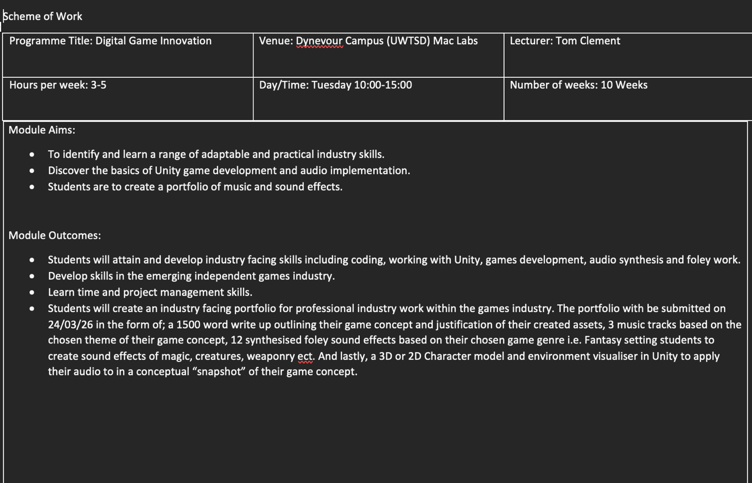
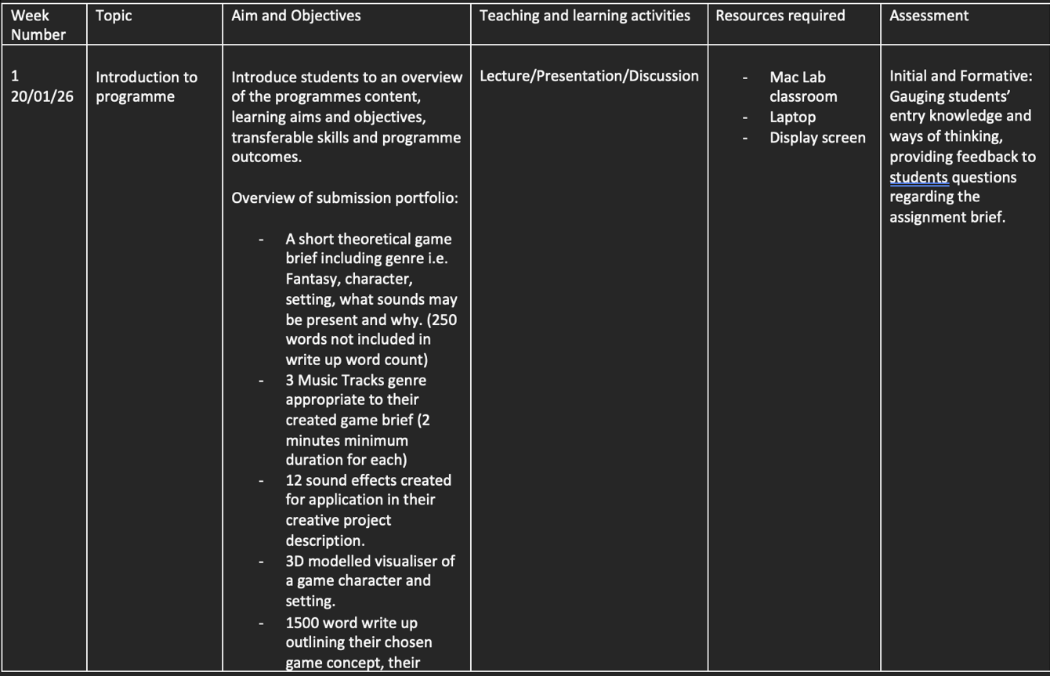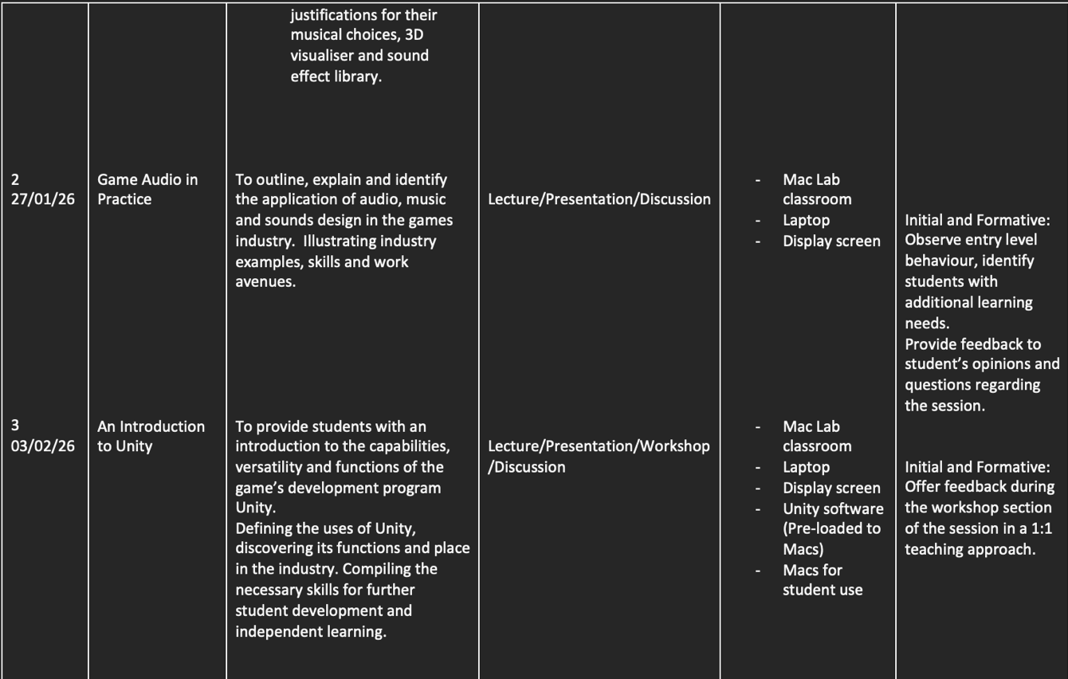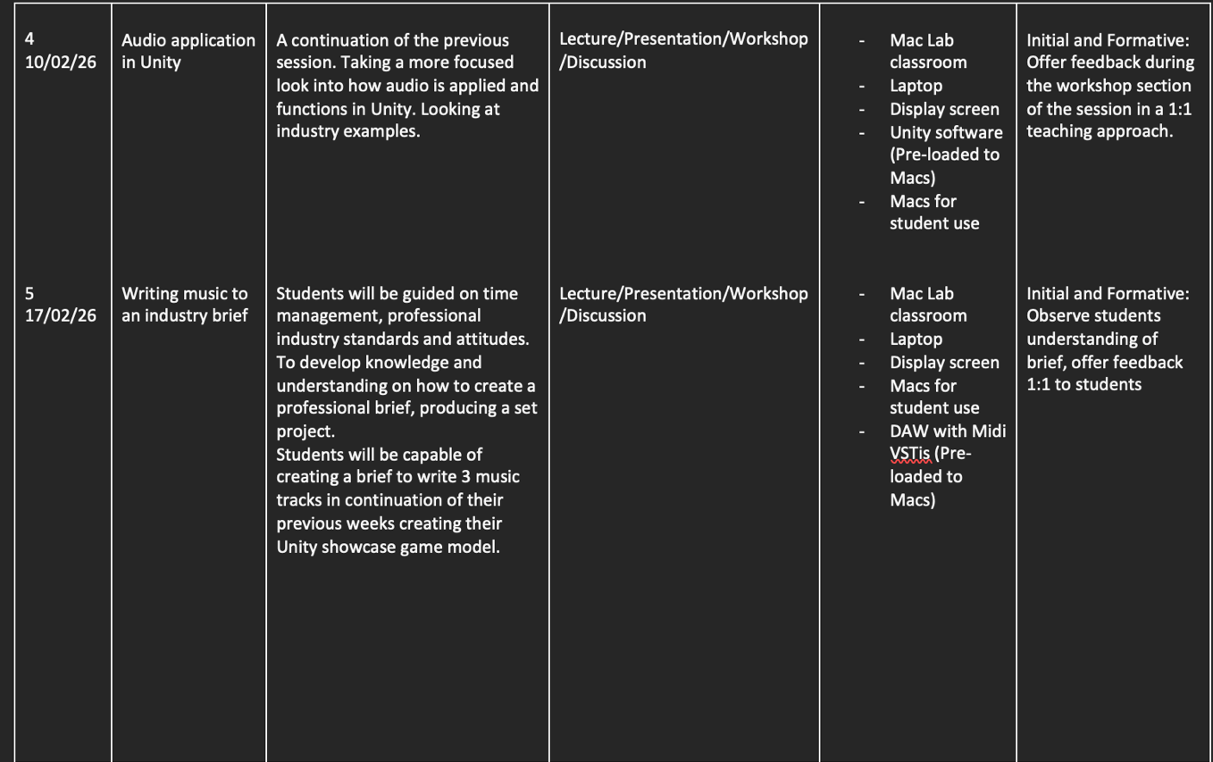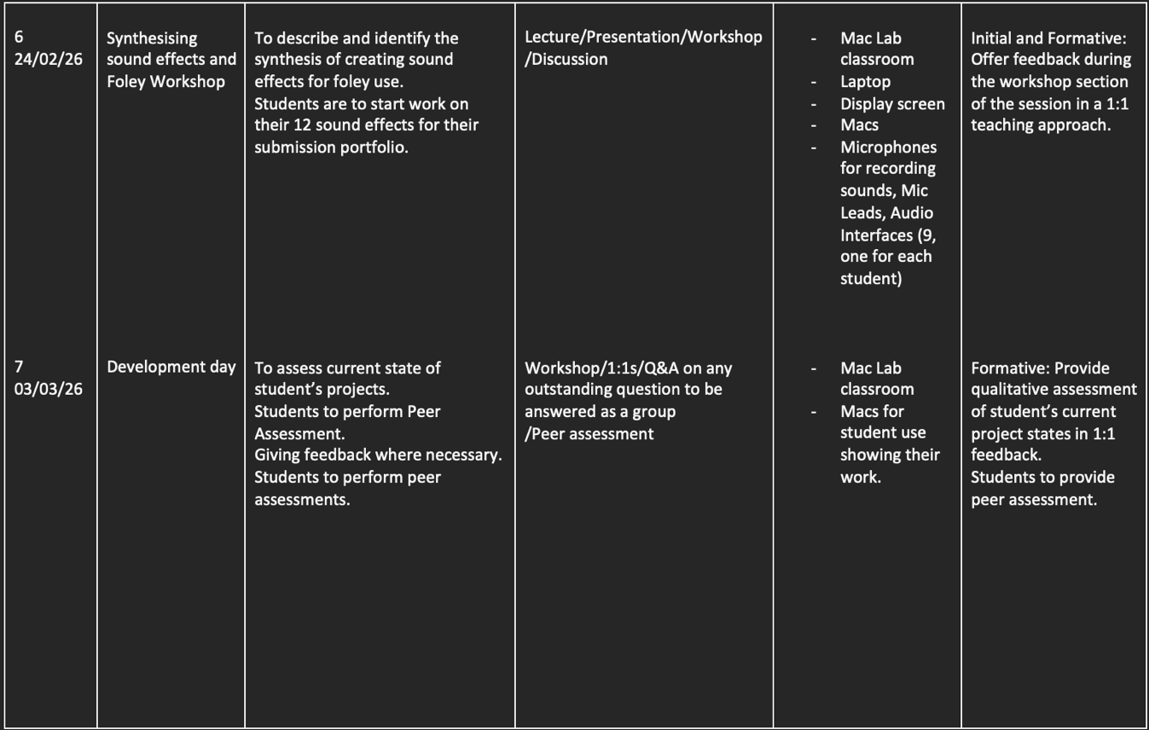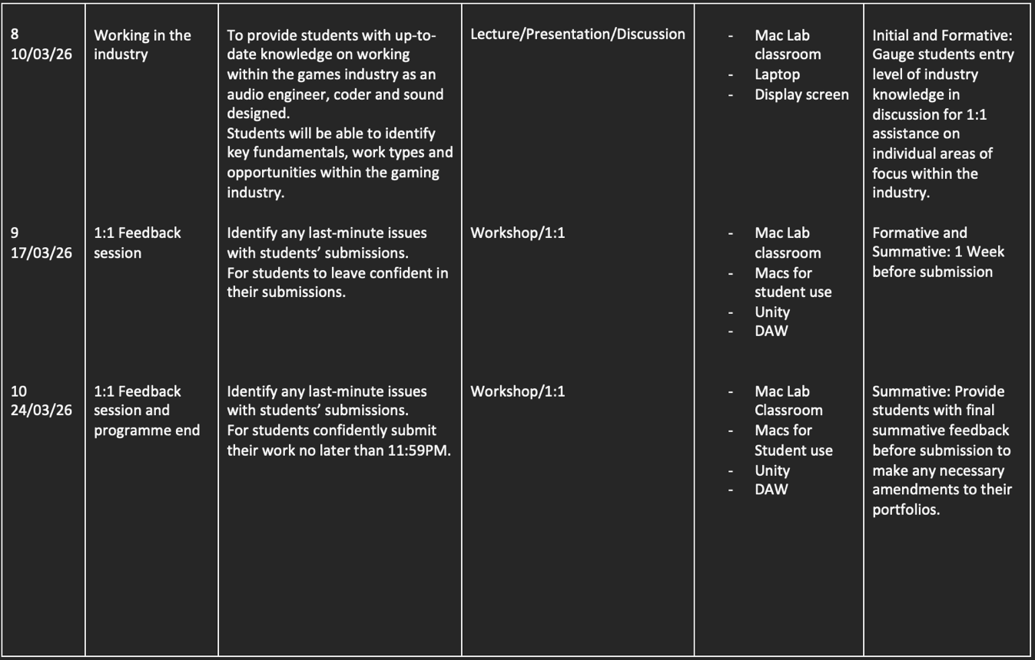
Fig. 3-8. Timetable of curriculum (2025). Tom Clement. (Source: Tom Clement)

Assessment strategies

Identifying which assessment strategies to apply through the scheme of work was relatively intuitive. Having previously discussed assessment strategies with the staff on the CMT team regarding the other modules on the programme, they consistently brought up a focus on formative assessment though the initial stages of the courses, ending with summative assessment.
Initial assessment of student’s abilities and levels is used to baseline entry level behavior and learning through lectures to assess appropriate support needed during workshop session. As well as this initial assessment will also help practitioners to identify any ALNs present students may have while taking initial information in during lectures. While formative assessment monitors student progression through the course, providing feedback during 1:1 support. Class discussion, self-assessment and observation of students work during week 7s peer assessment and Q&A.

As displayed within the lesson plans of this curriculum, example:

Week 1: At the end of the session Formative assessment will be done to: At the end of the session.
Students to provide peer assessment.
Formative and Summative: 1 Week before submission
Summative: Provide students with final summative feedback before submission to make any necessary amendments to their portfolios.
- Engaging directly with students
- Direct Observation
- 1:1 feedback
- Encourage self-assessment

Within the last few weeks of the course, summative assessment will be utilised to provide feedback and evaluate students’ overall development and achievement. Ultimately, summative assessment will be used to evaluate learners’ portfolios giving useful and constructive feedback.

Recommended reading

As a strong believer in giving students the means to take responsibility for their own learning and further development “demonstrate commitment to learners, their learning.” A further reading list has been accumulated to sign post students to, providing relevant course related documentation and resources.
Included in the appendices provides both written and video resources for recommended reading on Unity, Blender, foley, Welsh Game Industry examples, sound synthesis and writing music for video games. All of which contribute to students learning in expansion to their class learning providing opportunity for further skill development.

The choice to include video resources in accompaniment to traditional written examples was in consideration of learners who may have ALNs such as Attention-Deficit/Hyperactivity Disorder (ADHD), Dyslexia, Autism Spectrum Disorder (ADS) and other neurological ALNS that may pose a struggle with reading or attention span while reading, in an aim to be more inclusive, equative and considerate to learners.

Development of skills

Aimed to effectively consider students development of skills through the courses included content, reading list and structure of the course. The information taught to students was chosen to provide a strong introductory starting point for working with audio in the games industry, teaching transferable skills practiced in the creation of their professional facing portfolios.

Further reading allows students who choose to continue and expand their studies to take responsibility for their learning and develop their skills how they seek to. While the timetable/structure of the course building in difficulty offers opportunity for students to effectively develop their skills, teaching and demonstrating the skills to students, then allowing them time to hone their skills independently during workshops.

Skills taught during this course can be further developed from previous modules and expanded in future modules such as the 3rd year Level 6 Independent Project or Professional Portfolio modules, where much of the skills applied in this curriculum can be transferred and used in these modules.

Expansion and continuation of further learning and development of skills can be applied most effectively in educational opportunities students have post-graduation such as, the LBU “Sound and Music for Interactive Games” MSc. Here students can use their learnt skills during the course applying them to a master’s level course focused directly on the curriculums content. This can open stronger opportunities for students looking to develop their skills for employment in the gaming industry.

Conclusion

In conclusion, during the timeframe of the curriculum as proposed within the 10-week timetable, students will realistically be taught, to develop and apply the skills necessary in creating an industry facing portfolio, while learning and developing transferable industry skills within the gaming and surrounding music industry.

Appendices:

Lesson Plan 1:



Lesson Plan

Topic: An Introduction to Unity |  | Class: Level 5 Creative Music Technology
Date: 03/02/26 | Length of lesson: 5 hours |  | Number of students: 9
Resources required:

- Mac Computers
- Presentation Monitor
- PowerPoint
- Access to Mac Lab teaching space
- Unity Pre-installed on Macs
- Laptop

Aim of Lesson:

To provide students with an introduction to the capabilities, versatility and functions of the game’s development program Unity.

Defining the uses of Unity, discovering its functions and place in the industry. Compiling the necessary skills for further student development and independent learning.

Learning Outcomes – The Learners Should Be Able To:

- Retain basic knowledge and skills in working with the program Unity
- Understand the functions of Unity
- Consider their concept for the modules 3D / 2D Visualiser snapshot

Previous student knowledge required for the session:

Students will not have to have any previous knowledge prior to this session. However, any existing knowledge working in Unity would benefit students.

Anticipated difficulties (if applicable):

- Macs not workings
- Unity software not being installed correctly (failing upon boot)
- Presentation screen failing

Professional Standards (where are these being met within the session)

Demonstrating commitment to learners, their learning, safety and well-being:

Focusing particularly on maintaining students’ well-being, as this session may be daunting for students to start, by providing 1:1 support during the workshop of the session students can be provided with 1:1 support on any issues or concerns they have following the information and task set during the lecture section of the session.
Well-being breaks have been considered and included in the lessons schedule at anticipated times where students are most likely to need a break i.e. post lecture section being potentially intensive for some students.

Value and promote diversity, equality of opportunity and inclusion:

The way in which this session was designed to be executed including the information students will receive was consciously made with the potential ALNs students within the class may face, as well as this all-student proposed 3D / 2D Model Snapshot concepts will be green lit by lecturers during the session to assure all students are creating portfolios of equal quality.

Demonstrate dignity, courtesy and respect towards others:

This will be met in by practitioners remaining professional and respectful to others in their delivery and approach.

Understanding the importance of Welsh culture and language as a bilingual nation:

Examples of Welsh developed Unity games will be used during the lecture to represent Welsh culture and value of Welsh industry work.

Maintain and update knowledge of my subject(s) and how best to teach and assess them:

By providing students with up-to-date knowledge, coding techniques in Unity as well as using the most current version of Unity.

Plan and deliver effective learning, teaching and assessment:

As evidenced in practitioner lesson plan.

Build positive and collaborative relationships:

By offering 1:1 support for student as well as being conscious of how practitioners speak to students.

Lesson Detail:

Stage | Focus | Strategy | Time
Introduction  Development  Plenary/conclusion | Lecture  Short Break  Workshop/1:1  Lunch break  Discussion | Lesson will begin with a PowerPoint presentation driven lecture on Unity as a game development engine. Here students will be given examples of existing works as well as premade 3D / 2D visual snapshots to give students a visual example of what is expected of them.  Wellbeing break, as the lectures content may be intensive for some students at 10am.  Chance for students to open Unity and explore the example models or begin to experiment with the software. 1:1 support will be provided in a carousel manner to support students’ needs and address any concerns.  Wellbeing break  Here the lecture will be concluded with a group discussion of the sessions content, as well as be open to students presenting any work they have begun to develop or brainstorm with their peers, here peers can provide feedback on their concepts. | 1 hour  15 minutes  1 hour  45 minutes  1 hour lunch  1 hour

Assessment Strategies: when and how are they included within the lesson?

Formative Assessment:

- Engaging directly with students
- Direct Observation
- 1:1 feedback
- Encourage self-assessment

Informal reflection (to be completed after the session)

N/A

Lesson Plan 2:

Lesson Plan

Topic: Game Audio in Practice |  | Class: Level 5 Creative Music Technology
Date: 27/01/26 | Length of lesson: 4 hours |  | Number of students: 9
Resources required:

- Laptop
- PowerPoint
- Presentation Monitor
- Access to Mac Lab teaching space
- Macs for students
- Unity
- Example audio

Aim of Lesson:

To outline, explain and identify the application of audio in Unity, music and sounds design in the games industry. Illustrating industry examples, skills and work avenues.

A real-time demonstration of applying audio in Unity.

Learning Outcomes – The Learners Should Be Able To:

- Retain knowledge and skills in the application and function of audio in Unity
- Begin to consider their approach to creating their 3 tracks for this module’s portfolio

Previous student knowledge required for the session:

Students will not have to have any previous knowledge prior to this session. However, any existing knowledge working in Unity would benefit students.

Anticipated difficulties (if applicable):

- Forgetting laptop
- Presentation screen failing
- Unity software and examples not working

Professional Standards (where are these being met within the session)

Demonstrating commitment to learners, their learning, safety and well-being:

A well-being break have been considered and included in the lesson schedule.
Well-being checks and commitment to individual students needs and learning can be further developed in 1:1 support during the workshop of the session.

Demonstrate dignity, courtesy and respect towards others:

This will be met in by practitioners remaining professional and respectful to others in their delivery and approach.

Understanding the importance of Welsh culture and language as a bilingual nation:

Examples of Welsh music applied in the Unity project examples will be used during the lecture to represent Welsh culture and value of Welsh industry work.

Maintain and update knowledge of my subject(s) and how best to teach and assess them:

By providing students with up-to-date knowledge, audio techniques in Unity as well as using the most current version of Unity.

Modern examples of existing audio design in the games industry will be presented for further context.

Plan and deliver effective learning, teaching and assessment:

As evidenced in practitioner lesson plan.

Build positive and collaborative relationships:

Communicating in a friendly manner as well as attempting to get students involved in the demonstrative section of the session may improve learner engagement and help build class relationships, developing a positive and friendly environment.

Lesson Detail:

Stage | Focus | Strategy | Time
Introduction  Development  Plenary/conclusion | Lecture  Demonstration  Short break  Workshop  Discussion | This part of the session is quite content heavy, so a PowerPoint lead lecture may be the best approach to communicate information to students in the most effective way.  A real-time demonstration of the use and application of audio within Unity will be shown to students to observe the process of working with and applying audio within Unity.  A short break for student’s well-being and motivation.  Opportunity for students to test out provided example audio in Unity to familiarize themselves with the software and application of audio in Unity.  A brief group discussion to conclude the session will provide students with the chance to engage in a potential Q&A answering any questions they may have moving forward in the independent formation of their portfolio or any of the information and techniques covered during the session. | 40 minutes  50 minutes  15 minutes  1 hour  15 minutes

Assessment Strategies: when and how are they included within the lesson?

Formative Assessment:

- Engaging directly with students
- Direct Observation
- 1:1 feedback
- Encourage self-assessment

Informal reflection (to be completed after the session)

N/A

UWTSD Level 5 Assessment Marking Criteria:
Level 5
In accordance with the Framework for Higher Education Qualifications, at the end of Level 5 students will be expected to have developed sound knowledge and critical understanding of the well-established concepts and principles in their field of study, and of the way in which those principles have developed. They will have learned to apply those concepts and principles more widely outside the context in which they were first studied, including, where appropriate, the application of those principles in an employment context. They will have knowledge of the main methods of enquiry in the subject area, and ability to evaluate critically different approaches to problem solving. They will possess an understanding of the limits of their knowledge, and how this influences their analyses and interpretations. They will be able to use a range of established techniques to initiate and undertake critical analysis of information, and to propose solutions to problems arising from that analysis. They will be able to effectively communicate information, arguments and analysis in a variety of forms to specialist and non-specialist audiences, and deploy key techniques of the discipline effectively. They will be able to undertake further training, develop existing skills and acquire new competences that will enable them to assume significant responsibility within organisations. They will have the qualities and transferable skills necessary for employment requiring the exercise of personal responsibility and decision-making.

Level 5 | FAIL | MARGINAL FAIL | SATISFACTORY  (3rd / Pass) | GOOD  (2.2 / Pass) | VERY GOOD  (2.1 / Merit) | EXCELLENT  (1st / Distinction) | EXCEPTIONAL  (1st / Distinction)
Category | 0-29% | 30-39% | 40-49% | 50-59% | 60-69% | 70-84% | 85-100%
Engagement with literature (including reading, referencing,  academic conventions and  academic honesty) | Little or no evidence of reading and/or reliance on inappropriate sources.  Views and findings mostly unsupported and non-authoritative.  Referencing conventions used incoherently or largely absent. | Poor engagement with essential reading. No evidence of wider reading. Reliance on inappropriate sources, and/or indiscriminate use of sources. Heavily reliant on information gained through class contact. Inconsistent and weak use of referencing. | Engagement with a limited range of mostly relevant and credible sources. Some omissions and minor errors.  Referencing conventions evident though not always applied accurately or consistently. | Engagement with an appropriate range of literature, including sources retrieved independently. Some over-reliance on texts. Referencing may show minor inaccuracies or inconsistencies. | Engagement with a wide range of literature, including sources retrieved independently.  Selection of relevant and credible sources. Very good use of referencing, with no/very few inaccuracies or inconsistencies. | Engagement with an extensive range of relevant and credible literature. Consistently accurate application of referencing. | Exceptional engagement with an extensive range of relevant and credible literature. High-level referencing skills consistently applied.
Knowledge and understanding (Sound knowledge and critical understanding of the well-established concepts and principles in their field of study; knowledge of the main methods of enquiry in the discipline.) | Major gaps in knowledge with unsatisfactory, uncritical understanding of the subject matter. Much irrelevant material. Substantial inaccuracies. Significantly flawed understanding of the main methods of enquiry in the discipline. | Fragmentary knowledge, with only superficial critical understanding. Some significant inaccuracies and/or irrelevant material. Incomplete or partially flawed understanding of the main methods of enquiry in the discipline. | Limited but adequate knowledge and critical understanding of the well-established concepts and principles within the subject area, with a few gaps in the selection of material. A narrow critical understanding of the main methods of enquiry. | Knowledge is reasonably detailed and accurate. A good critical understanding of the well-established concepts and principles and the main methods of enquiry, with minor gaps in the selection of material. | Knowledge is reasonably extensive. Exhibits very competent critical understanding of the well-established concepts and principles of the subject and the main methods of enquiry. Breadth and depth of knowledge. | Excellent, detailed knowledge and highly critical understanding of the well-established concepts and principles of the subject and the main methods of enquiry. | Exceptionally detailed knowledge and outstanding critical understanding of the well-established concepts and principles of the subject and the main methods of enquiry. May go beyond established theories.
Cognitive and intellectual skills  (Critical evaluation and analysis of concepts and principles; argument and judgement; the limits of their knowledge, and how this influences their analyses and interpretations.) | Wholly or almost wholly descriptive work. Little or no critical evaluation and analysis of concepts and principles.  Failure to develop arguments, leading to illogical or invalid judgements. Unsubstantiated generalisations or opinion, made without use of any credible evidence. | Largely descriptive work, with superficial use of critical evaluation and analysis of concepts and principles. Weak development of arguments and judgements. Information accepted uncritically, uses generalised statements made with scant evidence and unsubstantiated opinions. Ideas sometimes illogical and contradictory. | Limited attempt at critical evaluation and analysis of concepts and principles, tending towards description.  Some evidence to support arguments and judgements but these may be underdeveloped, with a little inconsistency / mis-interpretation or failure to fully recognise limits of knowledge. | Some critical evaluation and analysis of concepts and principles, though descriptive in parts.  An emerging awareness the limits of their knowledge and ability to use evidence to support the argument though with some tendency to assert/state opinion rather than argue on the basis of reason and evidence.  Mostly valid arguments and logical judgements. | Sound critical evaluation and analysis of concepts. Is selective in the range of evidence used and synthesises rather than describes. Ability to devise arguments that show awareness of different stances, and use evidence convincingly, to support appropriate and valid judgements. | Excellent critical evaluation and analysis of concepts and principles leading to logical, evidence-based, reasoned arguments and judgements. Explicit recognition of other stances and a strong awareness of the limits of their knowledge.  A capacity for independent thought and ability to ‘see beyond the question’, suggesting some grasp of the broader field and wider concepts. | Outstanding critical evaluation and analysis of concepts and principles. Uses evidence exceptionally well to connect ideas, and support highly logical and persuasive, arguments and judgements. Evidence of independent thought and ability to ‘see beyond the question’, suggesting a clear grasp of the broader field and wider concepts. Perceptive recognition of the limits of their knowledge, and how this influences their analyses and interpretations.
Practical skills  (Apply underlying concepts and principles more widely outside the context in which they were first studied; use a range of established techniques; propose solutions to problems arising from analysis.) | Limited or no use of established methods, materials, tools and/or techniques.  Little or no appreciation of the context of the application.  Limited understanding of the application of theory to practice or making appropriate links between the two.  Very weak problem-solving skills outside the context in which they were first studied. | Rudimentary application of established methods, materials, tools and/or techniques but without consideration and competence. Flawed appreciation of the context of the application.  Weak understanding of the application of theory to practice, with only occasional evidence of making appropriate links between the two. Weak problem-solving skills outside the context in which they were first studied. | An adequate awareness and mostly appropriate application of established methods, materials, tools and/or techniques.  Basic appreciation of the context of the application. Theoretical knowledge and understanding applied in practice, but not always making logical links between the two.  Can identify problems and propose basic solutions outside the context in which they were first studied. | A good and appropriate application of established methods, materials, tools and/or techniques.  Clear appreciation of the context of the application. Mainly consistent, accurate and logical application of theory to practice, making appropriate links between the two.  Can identify problems and propose mostly appropriate solutions outside the context in which they were first studied. | A very good application of a range of established methods, materials, tools and/or techniques.  Very good consideration of the context of the application, with perceptive insights. Consistent, accurate and logical application of theory to practice, making appropriate links between the two. Can identify problems and propose appropriate solutions outside the context in which they were first studied.  Evidence of some creativity. | An advanced application of a range of established methods, materials, tools and/or techniques.  The context of the application is well considered, and insightful.  Consistent, accurate and logical application of theory to practice, making well-developed links between the two. Can identify problems and propose excellent, creative solutions outside the context in which they were first studied. | Exceptional levels of application and deployment skills using established methods, materials, tools and/or techniques. Consistent, accurate and logical application of theory to practice, making highly developed links between the two. Can identify routine and non-routine problems and propose quite sophisticated, creative solutions outside the context in which they were first studied.
Transferable skills for life and professional practice  (Effectively communicate in a variety of forms  to specialist and non-specialist audiences; the qualities and transferable skills necessary for employment requiring the exercise of personal responsibility and decision-making.) | Communication medium is inappropriate or misapplied.  Work is poorly structured, disorganised and/or confusingly expressed. Very weak use of language and/or very inappropriate style. Failure to work effectively as part of a group. Little or no evidence of the skills for employment requiring the exercise of personal responsibility and decision-making. | Communication medium is poorly designed and/or not suitable for the audience.  Work is poorly presented in a disjointed manner. It is loosely, and at times incoherently, structured, with information and ideas often poorly expressed. Weak use of language and/or inappropriate style. Flawed approach to group work, meeting only partial obligations to others. Limited evidence of the skills for employment requiring the exercise of personal responsibility and decision-making. | Can communicate in a suitable medium for the audience but with some room for improvement.  Mostly ordered presentation and structure in which relevant ideas / concepts are reasonably expressed. Work may lack coherence in places. Can work as part of a group, meeting most obligations to others but perhaps with limited involvement in group activities.  Demonstrates the basic skills for employment requiring the exercise of personal responsibility and decision-making, with some areas of minor weakness. | Can communicate effectively in a suitable medium for the audience, but may have minor errors.  Mostly coherent, organised work, in a suitable structure and is for the most part clearly expressed. Can work effectively independently and/or as part of a team, with clear contribution to group activities.  Demonstrates the skills for employment requiring the exercise of personal responsibility and decision-making, with some areas of strength and some of minor weakness. | Can communicate well, confidently and consistently in a suitable medium for the audience.  Work is coherent, fluent, well-structured and organised. Can work very well autonomously and/or as part of a team, with very good contribution to group activities.  Demonstrates very good skills for employment requiring the exercise of personal responsibility and decision-making, with just occasional minor weakness. | Can communicate professionally confidently and consistently in a suitable medium for the audience.  Work is coherent, very fluent and is presented proficiently. Can work autonomously with initiative. Where relevant can work professionally within a team, showing leadership skills as appropriate, and meeting obligations. Demonstrates excellent skills for employment requiring the exercise of personal responsibility and decision-making and an appetite for further development. | Can communicate with an exceptionally high level of professionalism, highly suitable for the audience.  Work is exceptionally coherent, very fluent and is presented professionally. Can work exceptionally well within a team, showing leadership skills. Demonstrates exceptional skills for employment requiring the exercise of personal responsibility and decision-making and an appetite for further development.

Student further reading resources

Wales Interactive – “Maid of Sker” (2020): https://www.walesinteractive.com/maidofsker

Unity – “Working with Audio Components”:
https://learn.unity.com/tutorial/working-with-audio-components-2019-3

Unity – “Preparing your own character”:
https://docs.unity3d.com/530/Documentation/Manual/Preparingacharacterfromscratch.html

Visual Examples

Great Big Story – “The Magic of Making Sound”:
https://www.youtube.com/watch?v=UO3N_PRIgX0&t=63s

Zectro - “A Guide to Making Video Game Music”:
https://www.youtube.com/watch?v=dMkTdYmOgiQ

Max Novak – “How to make a 3D Music Video in Blender | My Full Process in 10 minutes”:
https://www.youtube.com/watch?v=0o6Pj5-8PdE

Polyfjord – “2003 Beats per minute, visualized in Blender”
https://youtube.com/shorts/VTWKNBzSEss?si=_pCu7MJ-cXo_BLZc

ROFEU –
“Dess. (ft. LØ) Breathe In, Breathe Out (Rofeu remix) [Official visualizer]”
https://www.youtube.com/watch?v=UiOLcTcc9fg

List of Figures

- The Student Helpline (2024). Driscoll Model of Reflection. [online] Writing Help - The Student Helpline. Available at: https://thestudenthelpline.io/blog/driscoll-model-of-reflection.php.
- ResearchGate. (n.d.). Figure 4.1-The Product and Process Models of Curriculum Development. [online] Available at: https://www.researchgate.net/figure/The-Product-and-Process-Models-of-Curriculum-Development_fig3_282655161.
- Timetable of curriculum (2025). Tom Clement.

Reference List

- Bathspa.ac.uk. (2021). Creative Music for Games and Interactive Media - Bath Spa University. [online] Available at: https://www.bathspa.ac.uk/courses/ug-cmt-games-and-interactive-media/ [Accessed 12 May 2025].

- www.derby.ac.uk. (n.d.). The process model. [online] Available at: https://www.derby.ac.uk/online/course-taster/international-postgraduate-certificate-education-ipgce-online/the-process-model/.

- Gulzar, A.A. (2021). Taba Model of Curriculum Development . [online] Educare. Available at: https://educarepk.com/taba-model-of-curriculum-development.html.

- Leedsbeckett.ac.uk. (2025). Leeds school of Arts. [online] Available at: https://www.leedsbeckett.ac.uk/courses/sound-music-interactive-games-msc/ [Accessed 08 May 2025].

- Leedsbeckett.ac.uk. (2025). Leeds school of Arts. [online] Available at: https://www.leedsbeckett.ac.uk/courses/sound-music-interactive-games-msc/.

- McLeod, S. (2025). Maslow’s hierarchy of needs. [online] Simply Psychology. Available at: https://www.simplypsychology.org/maslow.html.

- Snehnath Neendoor (2025). Five Popular Curriculum Development Models You Should Know - Hurix Digital. [online] Digital Engineering & Technology | Elearning Solutions | Digital Content Solutions. Available at: https://www.hurix.com/blogs/popular-curriculum-development-models-you-should-know/#2 [Accessed 07 May 2025].

- The University of Edinburgh (2024). What? So what? Now what? [online] The University of Edinburgh. Available at: https://reflection.ed.ac.uk/reflectors-toolkit/reflecting-on-experience/what-so-what-now-what.

- This document sets out the standards of conduct that are expected of students at UWTSD. (n.d.). Available at: https://www.uwtsd.ac.uk/sites/default/files/2024-01/UWTSD-Student-Code-of-conduct-2021.pdf.

- UK Government (2015). Equality Act 2010. [online] Gov.UK. Available at: https://www.gov.uk/guidance/equality-act-2010-guidance.

- ‌www.gov.wales. (2022). Digital strategy | GOV.WALES. [online] Available at: https://www.gov.wales/digital-strategy-overview. [Accessed 01 May 2025]

- Welsh Government (2019). Digital 2030 A strategic framework for post-16 digital learning in Wales 2019. [online] Available at: https://www.gov.wales/sites/default/files/publications/2019-06/digital-2030-a-strategic-framework-for-post-16-digital-learning-in-wales.pdf.

- ‌Welsh Government (2017). Professional Standards for Teaching and Leadership. [online] Hwb. Welsh Government. Available at: https://hwb.gov.wales/api/storage/19bc948b-8a3f-41e0-944a-7bf2cadf7d18/professional-standards-for-teaching-and-leadership-interactive-pdf-for-pc.pdf.

- ‌ Wales Interactive. (2020). Maid of Sker | Wales Interactive. [online] Available at: https://www.walesinteractive.com/maidofsker.

‌

