Engine control systems testing

University of Wales Trinity Saint David
School of Engineering
Motorsport engineering
Oliver godon
P150782
23/4/18
Engine control systems
Andrew gibson

Table of Contents
Abstract 3
1 Introduction 1
1.1 Aims 1
2 Background research 2
3 Methodology 3
4 Results 4
5 Discussion 5
6 Conclusion 6
7 References 6

Abstract
In this assignment you shall see that this is a report for the control system testing on two different engines, the Motronic and the LE3 this report includes a full insight to what was done and how it the testing was conducted, with the testing being done with ignition on and off to get the different figures needed. Then both test whilst running at certain temperatures, e.g 30 degrees, 40 degrees. Also going to be going through some schematics from the testing, evaluating the findings.

Introduction
In this assignment, testing on the Vauxhall omega motronic engine and the LE3 engine was conducted within two four-hour sessions in groups of four or five people, the testing being done is on the ignition and the fuel injection systems. Once the testing is complete the task then is to write up the findings and show a good understanding of the job at hand and evaluate the findings. Then chose an engine and discuss something that would improve the engine system that is required.

Aims
- To analyse and evaluate the operation of different types of Electronic Ignition & Electronic Fuel Injection Systems using standard and dedicated test equipment.
- Discuss an improvement for one of the engines and reasoning.
- Evaluate the schematics from the testing.

Methodology
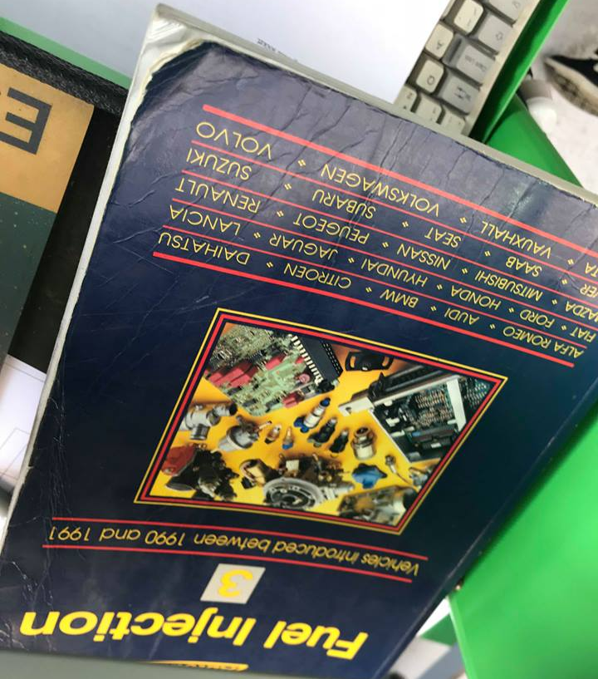
When starting the testing in our groups, the first engine to test was the motronic. With the ignition off we tested every single pin and then with the ignition on did the same checking the voltage. Then using the book for testing the engine (see pages used below) fuel injection 3, testing the throttle potentiometer, air flow sensor, coolant temp sensor, air temp sensor, idle speed control valve and the injector valves. From the book first up was the coolant temperature sensor, to test the resistance in ohms, we disconnected the senor multi plug, then unscrewed the sensor and connected the ohmmeter bet the sensor and terminals to measure the resistance. All the test from the book were done with the engine temp at 19 degrees Celsius.
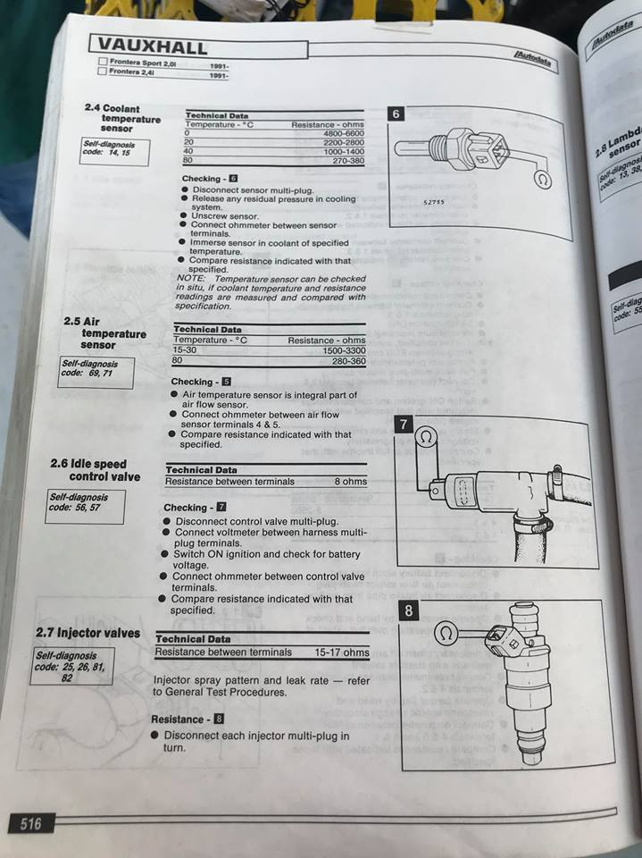
Next up was the air temp sensor, doing this require us to connect the ohmmeter to the air flow sensor between terminals 4 and 5.
For the idle speed control valve, started off by disconnecting the valve multi plug, then connecting the voltmeter and switching the ignition on to check for battery voltage, then switch to the ohmmeter connecting between the terminals and compare the resistance to what’s specified in the book.
The fourth test from the book was the injector valves, disconnecting each in turn and check the resistance in each valve.
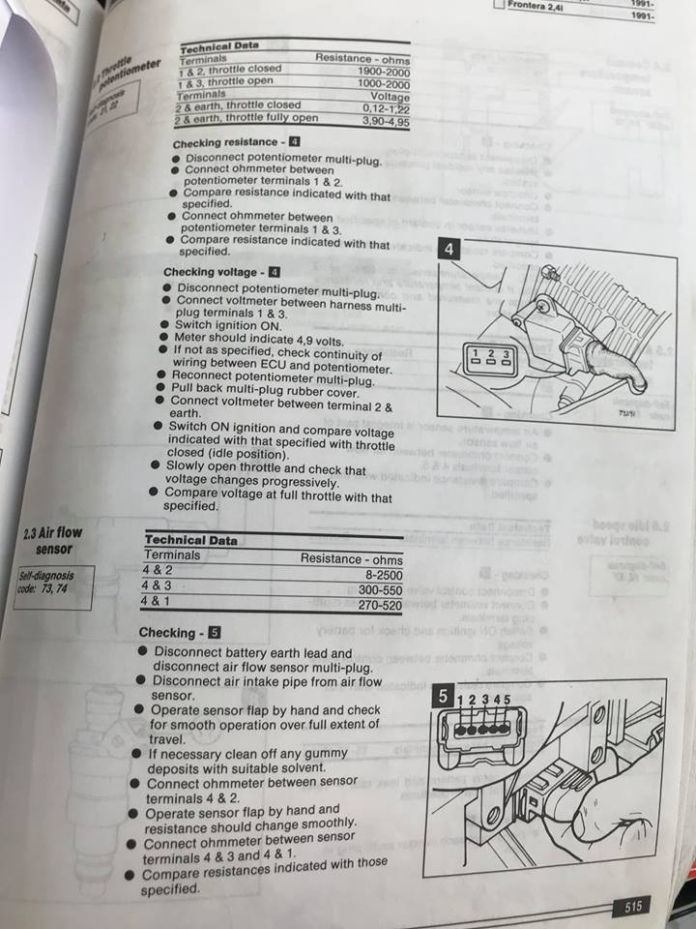
up next in the book was the throttle potentiometer, we tested the resistance in ohms by disconnecting the potentiometer and connecting the ohmmeter between terminals 1 and 2 and leaving the throttle closed the switching to terminals 1 and 3 and opening the throttle. Once this was completed we than switch to the voltmeter, to test the voltage, connecting the voltmeter to an earth on the rig, and also connecting to terminal 2 testing with throttle closed and then with throttle fully open.
Lastly from the book was the air-flow sensor, disconnecting the sensor and testing between terminals 4 and 2, 4 and 3, 4 and 1, compare data to that stated in the book.
Now that the testing from the book is done, its time to use oscilloscope to test the ohms and voltage on pin 45, milliseconds on pin 16 and lambda sensor pin 28 and charcoal canister solenoid (pcv) being pin 5, testing these at certain temperatures (see results page for the table). Testing pin 44 at 20 degrees and 80 degrees only.
Le3-
First of all with the le3 engine test was we recorded the cold cranking at 19.8 degrees first injection phase is 14.5m/s.
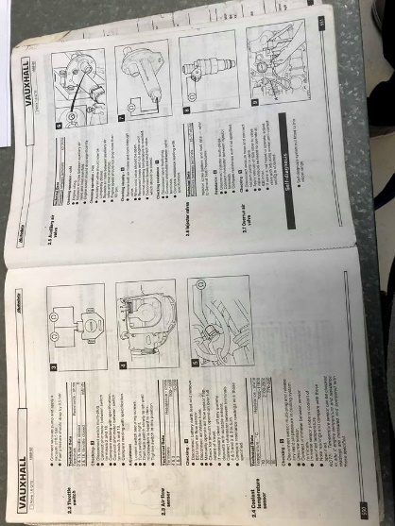
We tested each pin 1 to 15 of the ecu onto of the engine ignition on and off and the same for the ecu on the bottom of the engine. (table will be on the results page).
Then from the book we tested the throttle switch, coolant temp sensor, flux air valve and the injector valves.
For the throttle switch, we disconnected the multi plug and connect the ohmmeter between switch terminals 2 and 18. Compare to the books figure then switch from terminal 2 to 3 and compare the readings again.
Next was the coolant temp sensor, which we did by disconnecting the multi plug and release and residual pressure in coolant system, connect ohmmeter between sensor terminals and then immerse sensor probe into coolant to determine the temperature. Compare readings to the book.
Thirdly was checking the resistance in the auxiliary air valve by disconnecting the multi plug and connecting the ohmmeter to the valve terminals and noting the readings and compare to the book.
And finally, for the tests from the book was the injector valves which were done one by one by disconnecting them in turn and check the resistance by connecting the ohmmeter.
Then connect the oscilloscope to the engine we tested pins 8 in ohms and voltage and tested pin 3, doing this at certain temperatures in the same way the motronic test was conducted.

Results and analysis
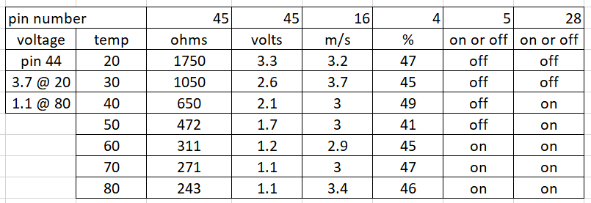
motronic-
cold crank being at 16.5 degrees injection on time is 27.9 m/s.

Static tests with the ignition switch on confirmed to us that the following earth points on this engine which are pins 2, 14, 19, 24, 26, 42 and 55. With the addition of a hand out diagram in lecture it helped show us what points we need on the ecu of the engine and its auxiliary’s that shouldn’t be operating or have a voltage value at it such as pin 7 the load signal for the air-flow meter as the vehicles ignition is only switch on but when the engine is turned on or in operation there’s a value. Pin 28 (lambda) shows a voltage reading of 0.42v usually lambda sensors produce about 0.9 volts when the fuel mixture is rich and about 0.1v when the fuel mixture is lean. This is because the ignition is on the lambda reads 0.42v which tells the engine control system to enrich the fuel, so it can begin to start the engine. NTC 1 which is Pin 44 is the air temp sensor showed an output of 3.75v which is correct for cold conditions. NTC (negative temperature coefficient) where colder the temperature means higher the resistance values or voltage reading will be and higher the temperature the less the resistance and voltage reading shall be. Pin 45 is also being a NTC (negative temperature coefficient) or also allocated as NTC 2 typically known as the CTS (Coolant temperature sensor) and operates in the same manner as the NTC 1. with the reading that we got was also being quite similar at 3.7v. Pin 48 and 49 is the output for the crankshaft sensor and is not in operation as the vehicles engine ignition is only on and the engine is not in operation there is no voltage values. Pin 48 which is the Octane plug and pin 53 being the throttle potentiometer also have very minor voltage readings due to the fact that the vehicle is not in operation or running at this time. below is a list of all the pins from the motronic tested for voltage with ignition on. This will support the statements made above.
ECU Pins | Ignition On
1 (Negative side of coil) | 12.3v
2 (Earth) | 0.04v
3 (Control circuit for fuel pump) | 12.18v
4 (Pulsed side of rotary idle valve) | (9.86v
5 (Pulsed side of tank vent valve) | 12.15v
6 (4WD ECU – A/T ECU – fuel tell-tale lamp) | 11.41v
7 (Load signal output from air-flow meter) | 0.34v
10 (Earth) | 0v
12 (5v supply for air flow meter & throttle potentiometer) | 5.09v
13 (Diagnostic socket supply) | 10.2v
14 (Earth) | 0.03v
16 (Pulsed side of injectors (bank of two) | 12.1v
17 (Pulsed side of injectors (bank of two) | 12.1v
18 (Permanent live – keep alive memory) | 12.1v
19 (Earth) | 0.01v
22 (Engine tell-tale warning light) | 0.95v
24 (Earth) | 0.04v
26 (Earth) | 0.09v
27 (Ignition feed) | 12.2v
28 (Output from lambda sensor) | 0.42v
32 (Output to on-board computer) | 11.4v
36 (Control circuit for supply for auxiliary’s and ECU) | 0.34v
37 (Supply to ECU & on-board computer) | 12.1v
40 (A/C) | 0.07v
41 (A/C) | 0.07v
42 (Earth for manual transmission only) | 0.03v
44 (Output from NTC 1) | 3.75v
45 (Output from NTC 2) | 3.7v
46 (Octane plug input) | 0.2v
48 (Output from crankshaft sensor) | 0.07v
49 (Output from crankshaft sensor) | 0.11v
53 (Output from throttle potentiometer) | 0.65v
55 (Earth for diagnostic socket) | 11.05v
On to the schematics that’ll you’ll find the link for in the references page.

First one we shall be talking about is pin 16 (acceleration), as you’ll able to see the schematic shows that when accelerating there’s an initial spike in voltage this is to give the engine the power it needs to initially go! Onto the deceleration schematic. This is also on pin 16 you see the minor oscillations and then a sudden drop and dwell before spiking again. Then we have pin 16 at 80 degrees, which shows a big drop an dwell before spike up to 60 volts.

Next is the Lambda sensor (pin 28) as it shows in the table it drops frequently about 0.6 volts from 0.8 to 0.2 volts it does this every 2m/s.

Onto pin 4 which is idle at 80 degrees Celsius, in-between spikes there is dwell but when it does spike it stays up and for a few m/s. from 0 volts to 15-20 volts.
Pin 1, the spark duration being 1.47m/s with a back emf of 129.2 volts.
Pin 49 being the speed sensor showing loads of oscillations spiking from 10 volts down to -10 volts. Every 0.1 m/s.
Pin 27 (supply from ignition) and pin 2 (earth return), these two show the reverse drops/ oscillations to each-other.
Pin 1 and pin 53 showing very similar results schematic wise anyway, 53 looking like a more in depth look into what is happen on pin 1, pin one being the negative side of the coil and pin 53 being the throttle potentiometer.
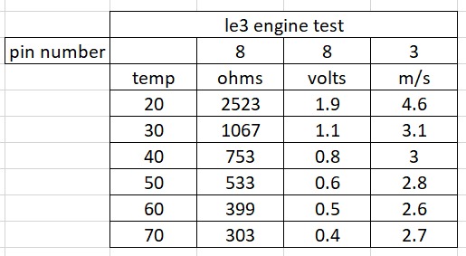
The le3-
On the right you shall see the le3 testing at different temperatures and the pin testing on both ecu’s ignition on and off.

Bothe ecu’s showing when the ignition is on power from the battery is there at a few pins this is so the engine is ready to fire up/ initial start-up.
Pin 12 on the top ecu being the battery, this is an assumption as I can’t remember if this is a fact or not.
Onto the schematics for the le3.
The link in the references will lead you to the schematics just like the motronic.
First one we cover is the secondary voltage, across o.7m/s a big spike of voltage happens going up to 12Kv.
Next up is the acceleration (pin 3) with equal spacing of the dwells and spikes in the pattern showing how often it revs.
Amp, pin 3 is supply and pin 2 is earth. This is similar to one from the motronic with the opposite going on in dwell and oscillations.

Discussion
With the LE3 being the more advanced engine. So, the question of improving one of the engines control systems/ the running on the efficiency. The motronic engine being the older engine so then this engine will be the easiest to upgrade. So, the choice of upgrade will be on the motronic. The system itself is out dated nowadays, so maybe not one upgrade is enough but if you were to do one upgrade id pick, is the ignition timing, with the system already having an ignition time of 0.2 milliseconds, I think this can be improved because that time relies on the mixture strength, the mixture of fuel and air, so if we replaced the sensor that controls the mixture and the sensor of the ignition timing the engine will only ever run better and smoother.

Conclusion
In conclusion for this assignment I think I have shown that I have a decent understanding of the subject and the task in hand, in Hien sight more research and knowledge could have been helpful from my part as research was difficult to come by, but as a whole this assignment shows that the in a group I was able to complete the testing and collect all the data required and have been able to show and analysis these results.

References
For the schematics follow the link below:
https://uowtsd-my.sharepoint.com/:f:/g/personal/ogordon_150782_student_uwtsd_ac_uk/Ej9tI1FpPNBFsS30i-pnZXMB-1tcOXTKWPQosKPdVegUDw?e=UKjG0z
(ME-Motronic engine management, bosch, n/a, edition 1999, technical instruction)
http://birta.bhs.is/~kristjang/netgeymsla/ME-Motronic_seinni.pdf

