Application Development
Shamuel Hashan
Web Development
1803153
Lecturer: Kemi Ademoye

Contents
Introduction 3
Application Development Concepts 3
Software requirements specification 4
Design 4
Implementation 5
10
Evaluation 11
References 21

Introduction

This report will be covering the web development trends and will discuss responsive websites in more detail. The report will then show the requirements that was specified for the website and show that being input in the website. After, it will show the website being evaluated.

Application Development Concepts

There is a higher demand for application development skills. There have been many more website development trends rising in recent years. There has been lots of development trends for web development. Examples of some of the web development trends are:
- Chat bots in websites,
- Voice optimization in websites
- Artificial intelligence in websites
- Responsive website designs for mobile users.
- API first development
- Motion user interface

Responsive web design is when the design of website changes as the screen size orientation or platform changes. The website should automatically switch to suit the users screen size when the user does change the screen size. The website should have a fluid and flexible layout for any screen size. This is important for most websites to have since, according to Sonia Gregory from Fresh Sparks mobile devices are used for 60% of the searches online. (Gregory, 2019)
Previously, website developers would have had to build multiple sites to suit different screen sizes. Making the website responsive will eliminate the need for that, which would then make making websites more efficient.
Web development tools that are used to help make the website more responsive are flexible grids and layouts.
Media queries is another web development tool used to make the website more responsive. These allows the web developer to change the website design depending on the device of the user.
Flexible grids are columns that rearrange automatically so it can fit the users screen.
Images can also be made to be flexible to make the website responsive.
Responsive websites can be very beneficial to businesses as it can increase the number of customers visiting the website.

Software requirements specification

The website had some requirements that it had to meet. For example, it had to be browser independent. I will test this by testing the website on various browsers such as google chrome and Firefox.
The website should also be responsive. It should be mobile user friendly. It should look good, feel good and be easy to use on mobile phones and other screens such as tablets. I will test this by seeing how the website looks on different screen sizes.
It also must have a form of interactive function that is created using JavaScript.
The website will also need to use consume a JavaScript web API.

Design

The website should include various features to help make the website look at feel better.
It should have a navigation bar that drops down into a burger bar when for mobile users. It should highlight the page you are on and highlight the page the mouse is hovering over. It should also send you to another page when you click on the links.
The website will also feature YouTube videos. I used JavaScript to code a YouTube Iframe API. I will be using this so I can display videos from YouTube on the website. This was used in most of the pages. I styled it so there is a border around the video.
The website will be using the OMDB API. The user will enter a name of the movie into the search bar and it should show them the poster of the movie, the year it was released and the films IMDB rating. The OMDB API script was coded in the JavaScript.
The website also used a form. The website asks the user to rate the film between 1 and 10. It provides a text box for where the user should enter the number. If the user does not enter a number that is between 1 and 10 then the website should ask the user to enter a number between 1 and 10 again. This was used in the MCU page, DCEU page, Monsterverse page and the Dark Universe page.
The website also used rows to help with the layout.

Implementation

Home page
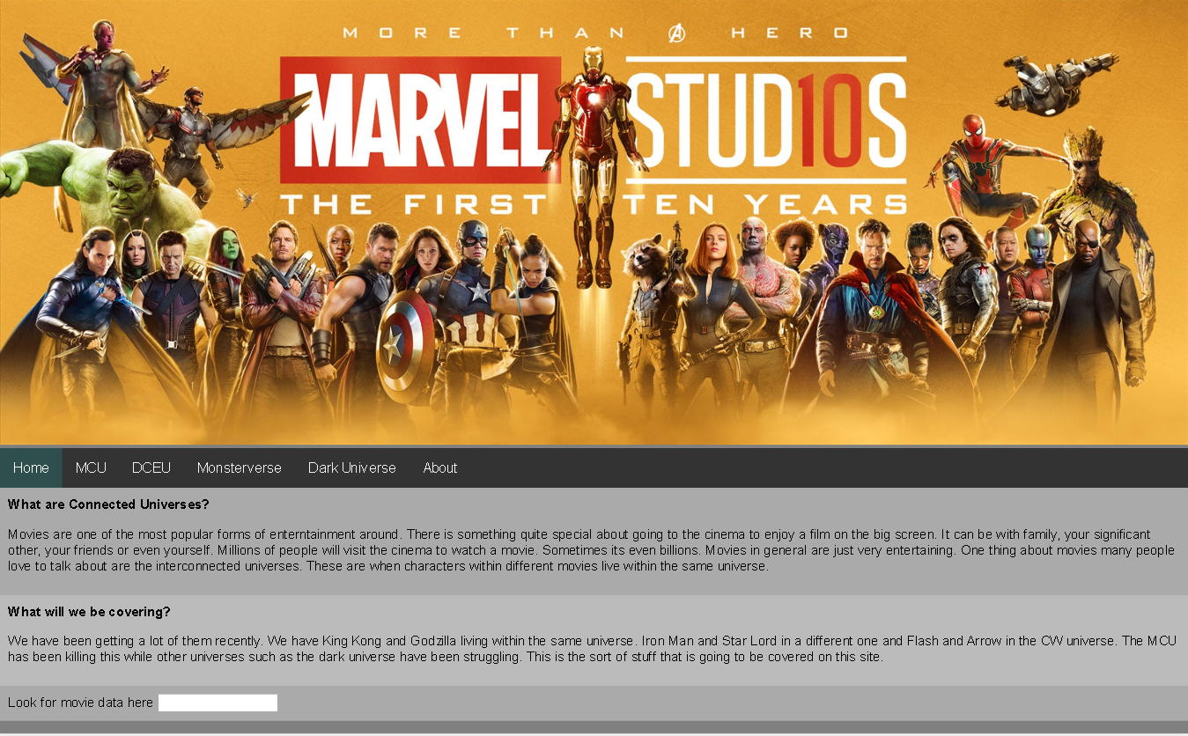

MCU page
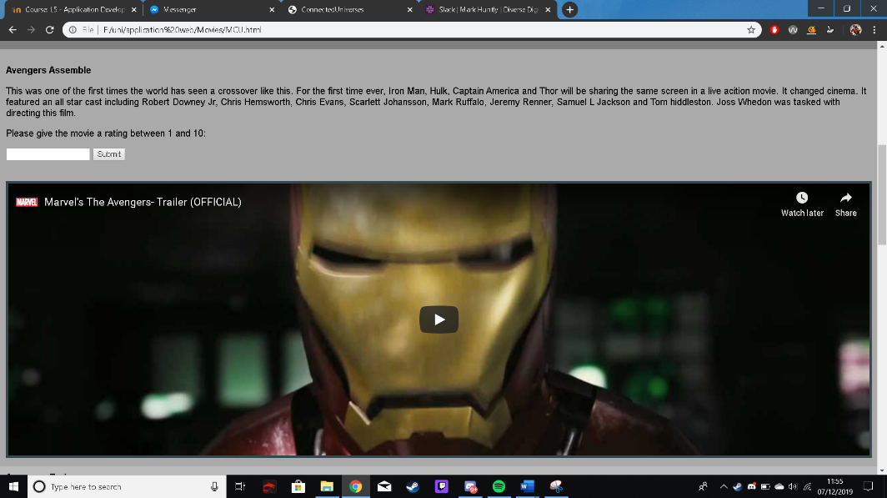
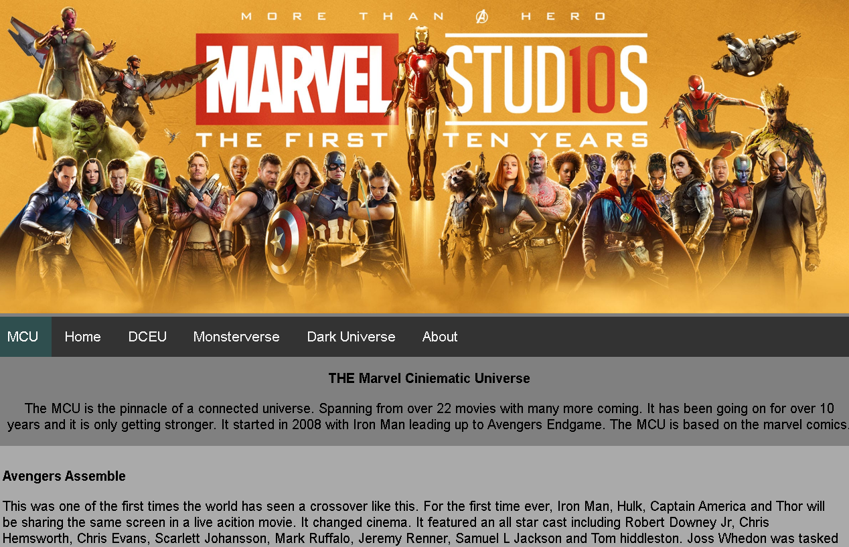

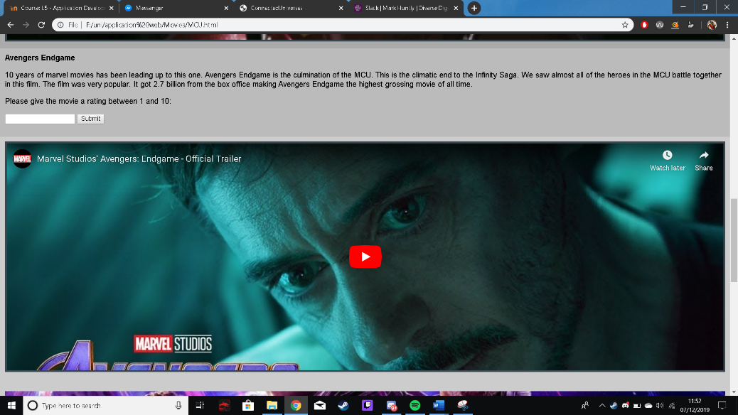
DCEU page
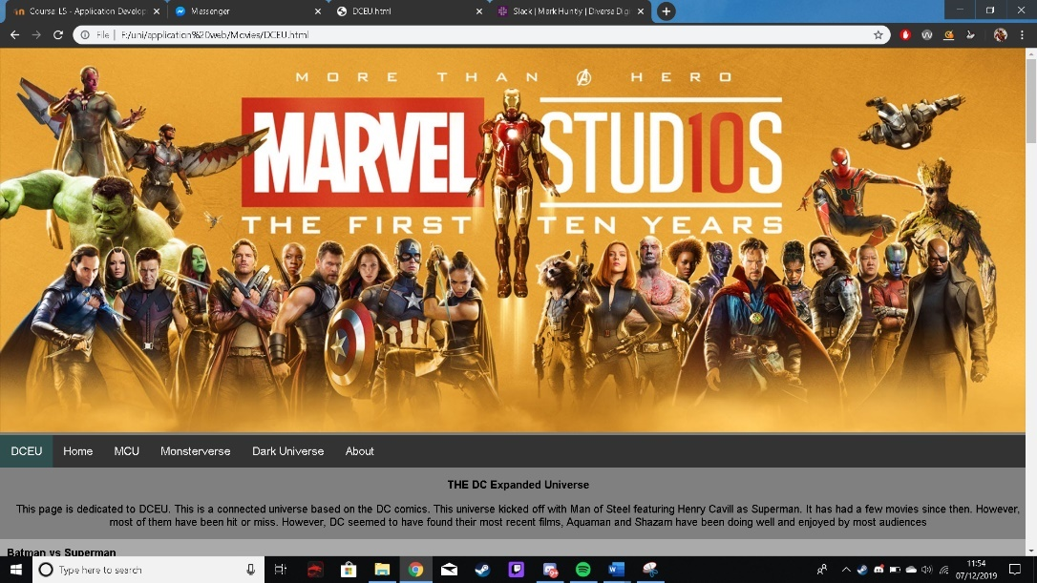
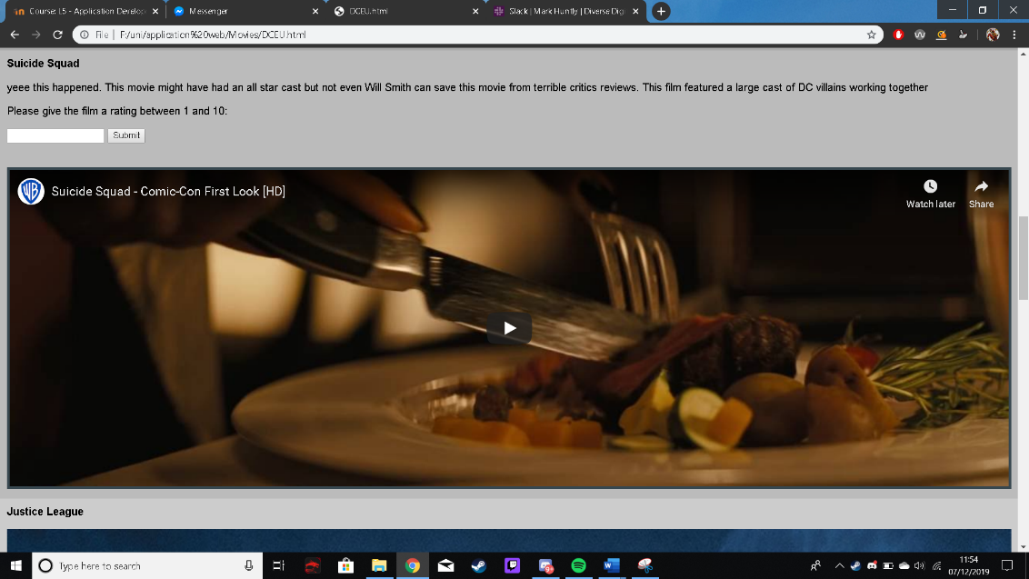
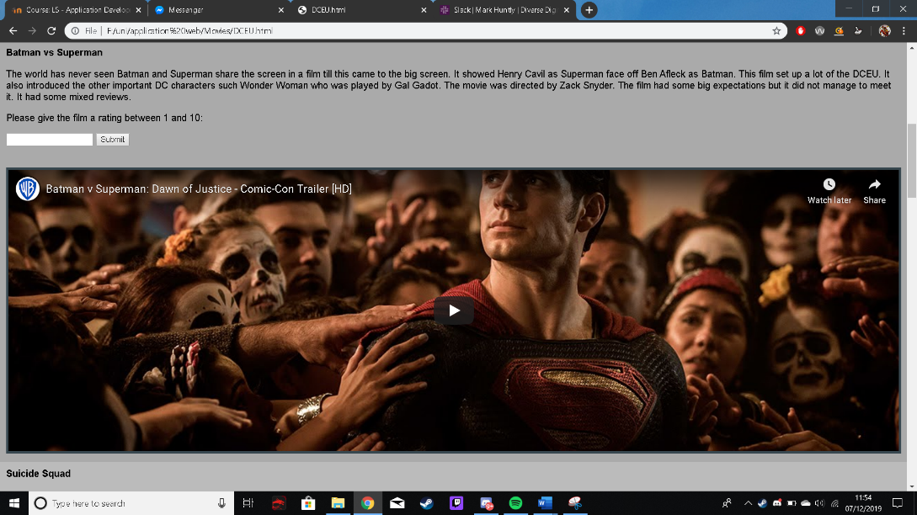
Monsterverse page
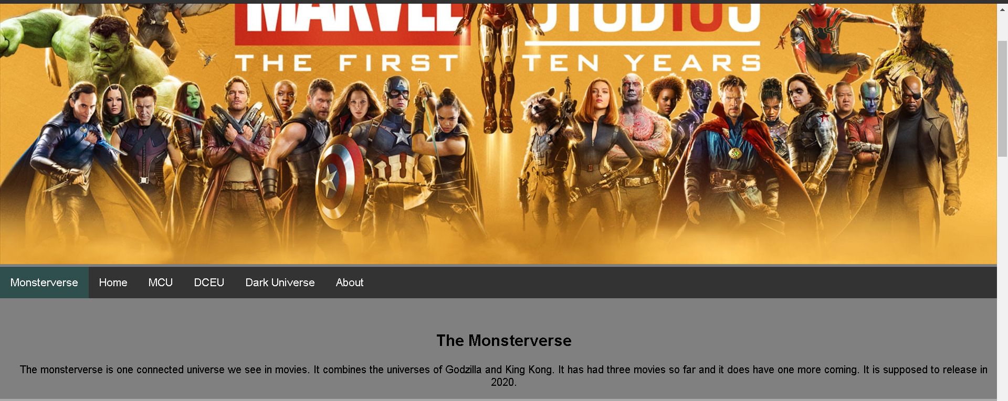
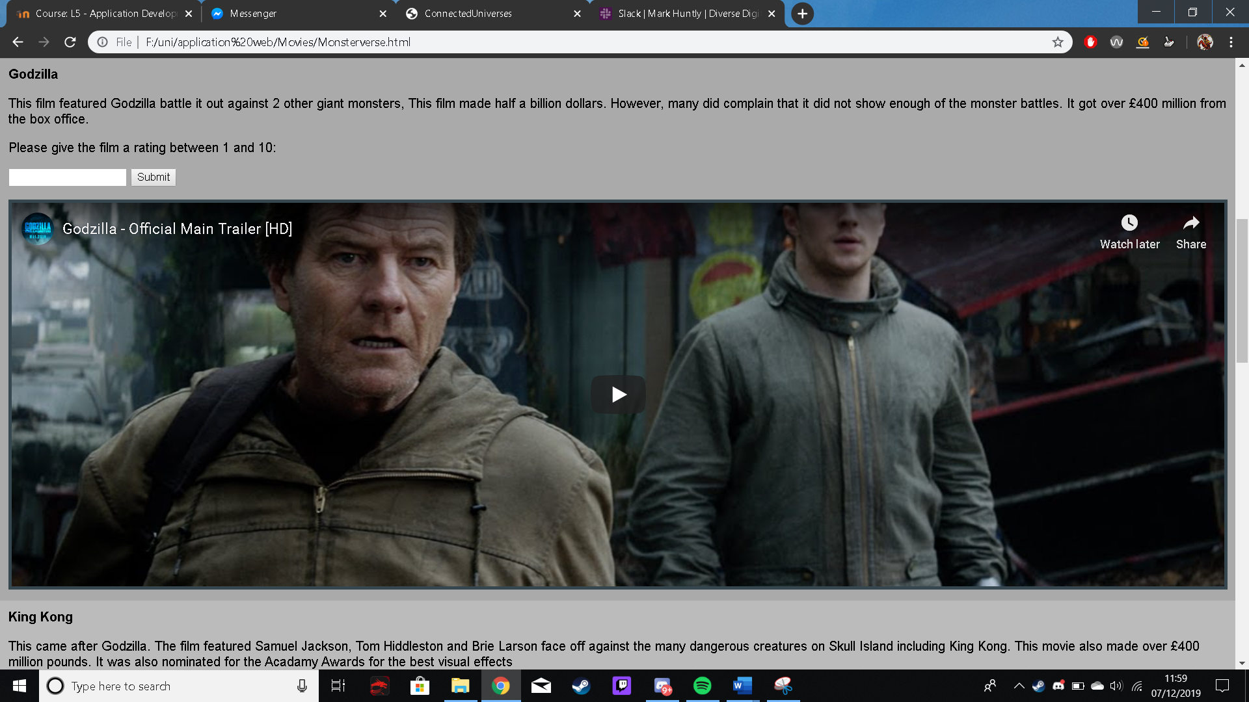
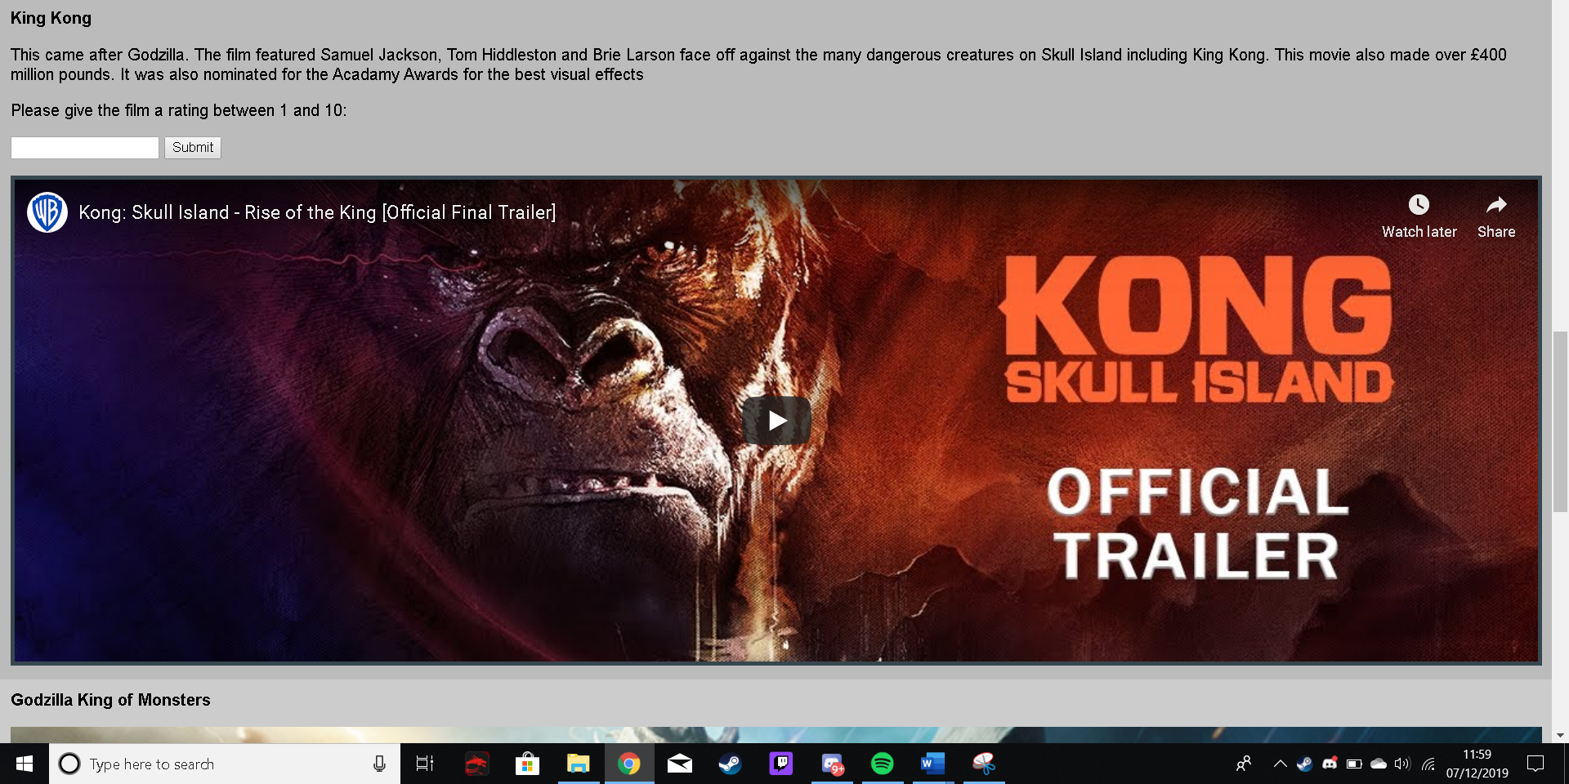
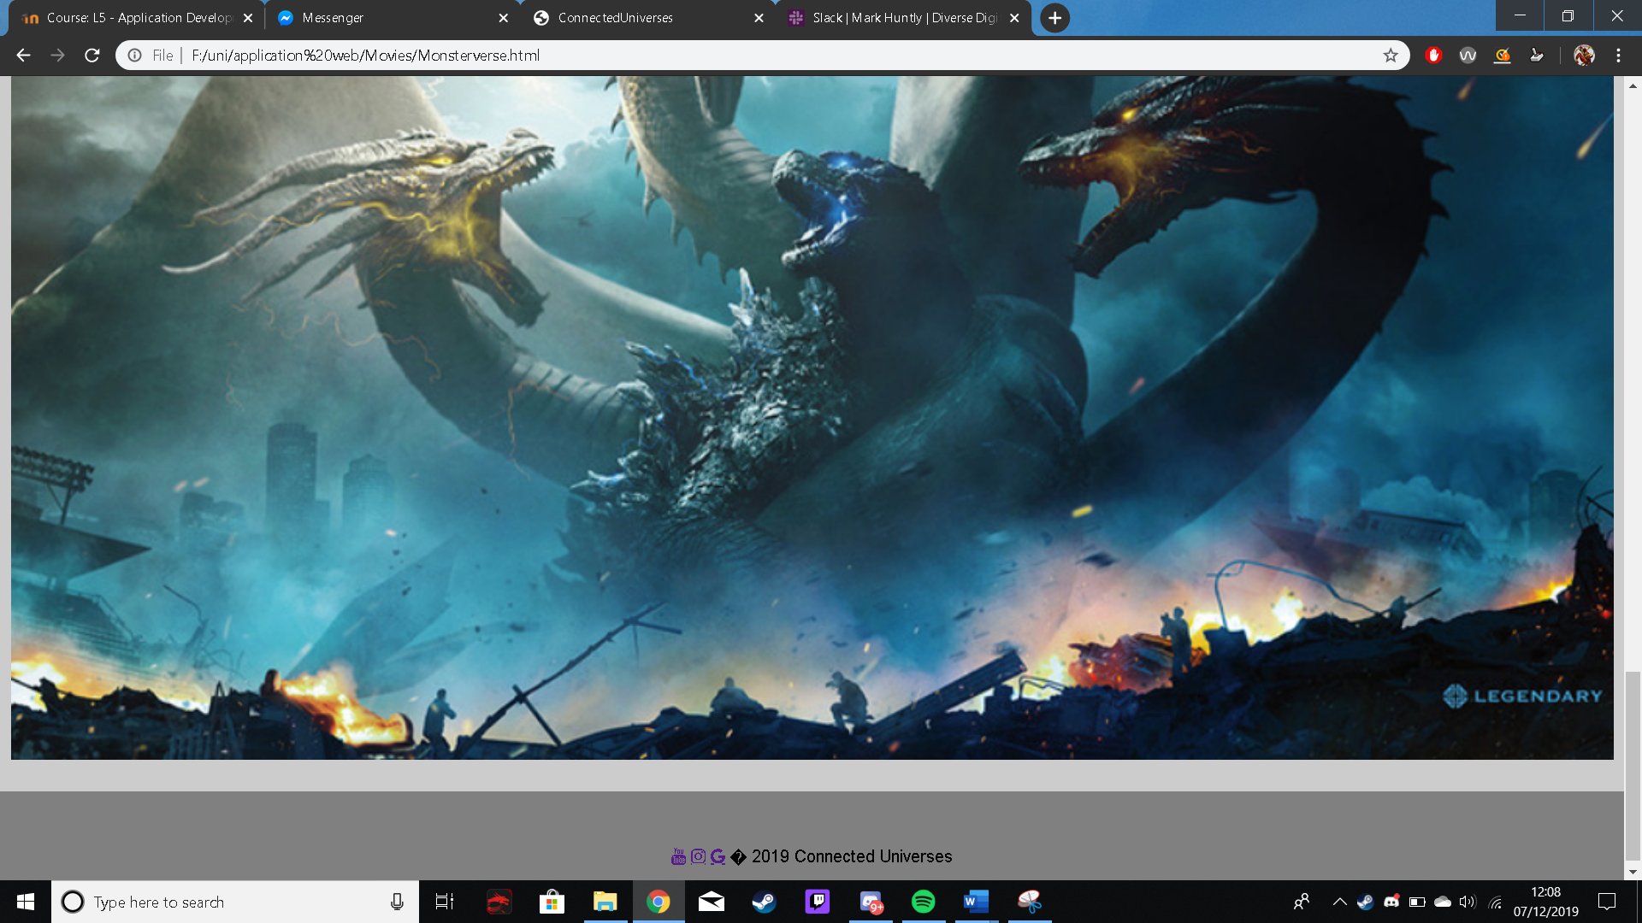

Dark universe page
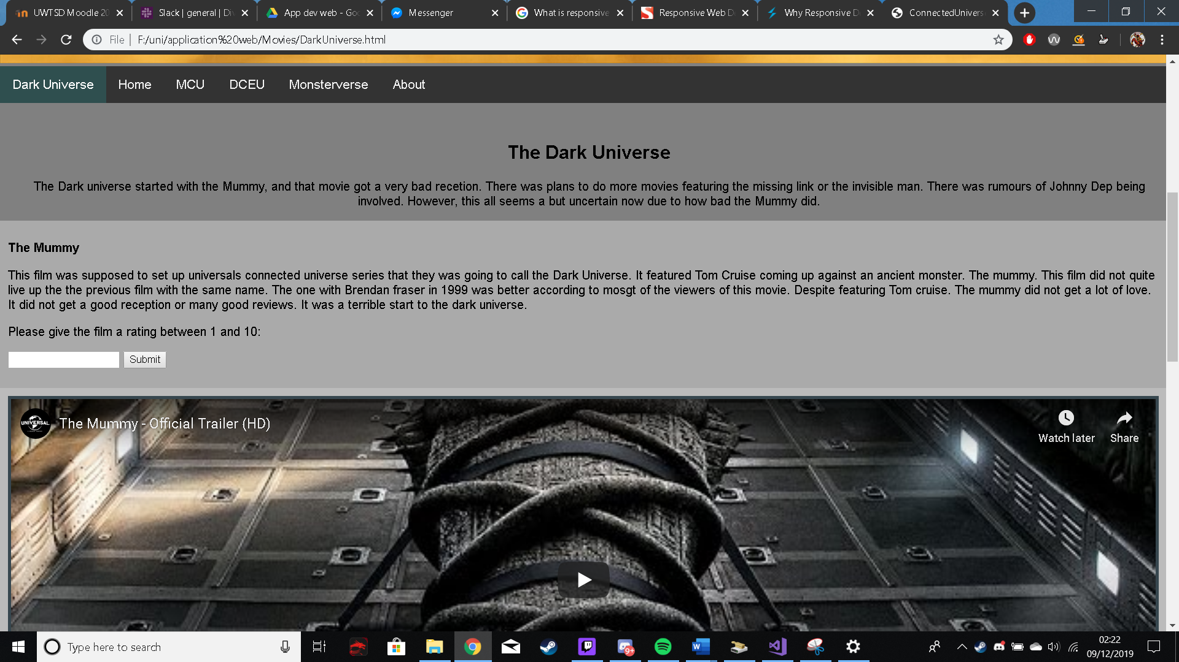

About page
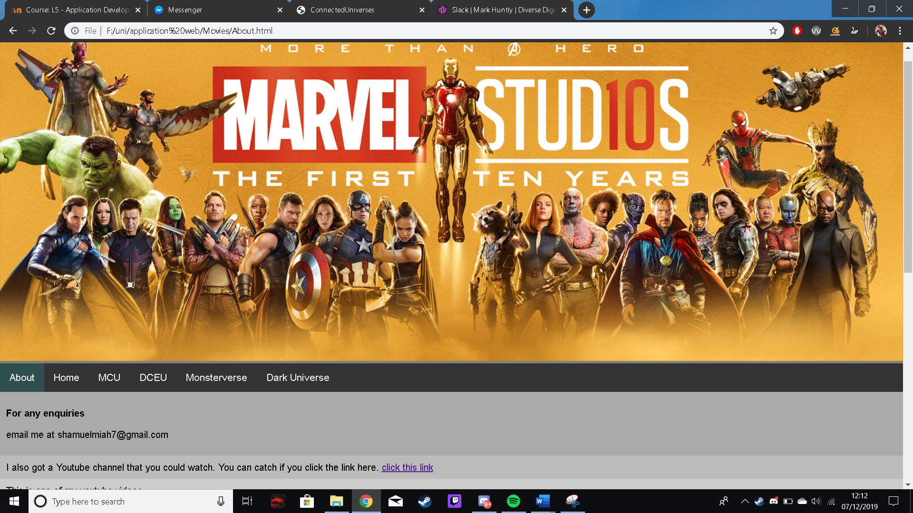

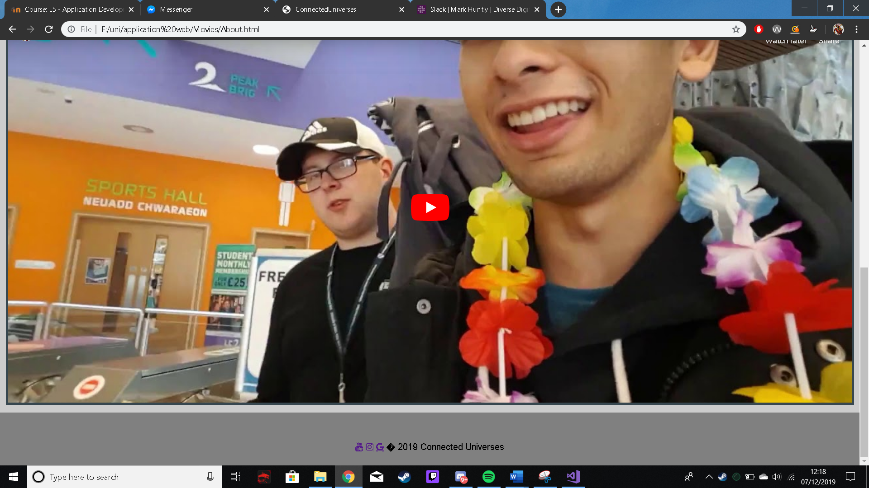

Evaluation

  - Software verification and validation

Testing nav bar on home page
Test No. | Purpose | Action | Expected result | Actual result | Test Result | Fix
 | Test to see if the link to the MCU page on the nav bar works | Click on MCU page | Send user to MCU page | Sent user to MCU page | Success
 | Test to see if the link to the DCEU page on the nav bar works | Click on DCEU page | Send user to DCEU page | Sent user to DCEU page | Success
 | Test to see if the link to the Monsterverse page on the nav bar works | Click on Monsterverse page | Send user to Monsterverse page | Sent user to Monsterverse page | Success
 | Test to see if the link to the Dark universe page on the nav bar works | Click on Dark universe page | Send user to Dark universe page | Sent user to Dark universe page | Success
 | Test to see if the link to the About page on the nav bar works | Click on About page | Send user to About page | Sent user to About page | Success
 | Test to see if it collapses into a burger bar when on a mobile phone screen size. | Switch to a mobile screen size, | The nav bar should collapse into a burger bar | The nav bar switched into a burger bar | Success

Testing nav bar on MCU page
Test No. | Purpose | Action | Expected result | Actual result | Test Result | Fix
 | Test to see if the link to the Home page on the nav bar works | Click on Home page | Send user to Home page | Sent user to Home page | Success
 | Test to see if the link to the DCEU page on the nav bar works | Click on DCEU page | Send user to DCEU page | Sent user to DCEU page | Success
 | Test to see if the link to the Monsterverse page on the nav bar works | Click on Monsterverse page | Send user to Monsterverse page | Sent user to Monsterverse page | Success
 | Test to see if the link to the Dark universe page on the nav bar works | Click on Dark universe page | Send user to Dark universe page | Sent user to Dark universe page | Success
 | Test to see if the link to the About page on the nav bar works | Click on About page | Send user to About page | Sent user to About page | Success
 | Test to see if it collapses into a burger bar when on a mobile phone screen size. | Switch to a mobile screen size, | The nav bar should collapse into a burger bar | The nav bar switched into a burger bar | Success

Testing nav bar on DCEU page
Test No. | Purpose | Action | Expected result | Actual result | Test Result | Fix
 | Test to see if the link to the MCU page on the nav bar works | Click on MCU page | Send user to MCU page | Sent user to MCU page | Success
 | Test to see if the link to the Home page on the nav bar works | Click on Home page | Send user to Home page | Sent user to Home page | Success
 | Test to see if the link to the Monsterverse page on the nav bar works | Click on Monsterverse page | Send user to Monsterverse page | Sent user to Monsterverse page | Success
 | Test to see if the link to the Dark universe page on the nav bar works | Click on Dark universe page | Send user to Dark universe page | Sent user to Dark universe page | Success
 | Test to see if the link to the About page on the nav bar works | Click on About page | Send user to About page | Sent user to About page | Success
 | Test to see if it collapses into a burger bar when on a mobile phone screen size. | Switch to a mobile screen size, | The nav bar should collapse into a burger bar | The nav bar switched into a burger bar | Success

Testing nav bar on Monsterverse page
Test No. | Purpose | Action | Expected result | Actual result | Test Result | Fix
 | Test to see if the link to the MCU page on the nav bar works | Click on MCU page | Send user to MCU page | Sent user to MCU page | Success
 | Test to see if the link to the DCEU page on the nav bar works | Click on DCEU page | Send user to DCEU page | Sent user to DCEU page | Success
 | Test to see if the link to the Home page on the nav bar works | Click on Home page | Send user to Home page | Sent user to Home page | Success
 | Test to see if the link to the Dark universe page on the nav bar works | Click on Dark universe page | Send user to Dark universe page | Sent user to Dark universe page | Success
 | Test to see if the link to the About page on the nav bar works | Click on About page | Send user to About page | Sent user to About page | Success
 | Test to see if it collapses into a burger bar when on a mobile phone screen size. | Switch to a mobile screen size, | The nav bar should collapse into a burger bar | The nav bar switched into a burger bar | Success

Testing nav bar on Dark Universe page
Test No. | Purpose | Action | Expected result | Actual result | Test Result | Fix
 | Test to see if the link to the MCU page on the nav bar works | Click on MCU page | Send user to MCU page | Sent user to MCU page | Success
 | Test to see if the link to the DCEU page on the nav bar works | Click on DCEU page | Send user to DCEU page | Sent user to DCEU page | Success
 | Test to see if the link to the Monsterverse page on the nav bar works | Click on Monsterverse page | Send user to Monsterverse page | Sent user to Monsterverse page | Success
 | Test to see if the link to the Home page on the nav bar works | Click on Home page | Send user to Home page | Sent user to Home page | Success
 | Test to see if the link to the About page on the nav bar works | Click on About page | Send user to About page | Sent user to About page | Success
 | Test to see if it collapses into a burger bar when on a mobile phone screen size. | Switch to a mobile screen size, | The nav bar should collapse into a burger bar | The nav bar switched into a burger bar | Success

Testing nav bar on About page
Test No. | Purpose | Action | Expected result | Actual result | Test Result | Fix
 | Test to see if the link to the MCU page on the nav bar works | Click on MCU page | Send user to MCU page | Sent user to MCU page | Success
 | Test to see if the link to the DCEU page on the nav bar works | Click on DCEU page | Send user to DCEU page | Sent user to DCEU page | Success
 | Test to see if the link to the Monsterverse page on the nav bar works | Click on Monsterverse page | Send user to Monsterverse page | Sent user to Monsterverse page | Success
 | Test to see if the link to the Dark universe page on the nav bar works | Click on Dark universe page | Send user to Dark universe page | Sent user to Dark universe page | Success
 | Test to see if the link to the Home page on the nav bar works | Click on Home page | Send user to Home page | Sent user to Home page | Success
 | Test to see if it collapses into a burger bar when on a mobile phone screen size. | Switch to a mobile screen size, | The nav bar should collapse into a burger bar | The nav bar switched into a burger bar | Success

Testing rating form
Test No. | Purpose | Action | Expected result | Actual result | Test result | Fix
 | Check if it allows the user to enter a number between 1 and 10 | Enter a number between 1 and 10 like 8 in the text box | It should say “THANKS FOR YOUR INPUT.” | It said  “THANKS FOR YOUR INPUT.” | Success
 | Check if the website asks you to make sure you enter a number between 1 and 10 | Enter “good” in the text box | It should say “Enter a number between 1 and 10.” | It said to “Enter a number between 1 and 10.” | Success

Testing responsiveness of pages
Test No. | Purpose | Action | Expected Result | Actual result | Test result | Fix
1 | Too see if the home page is responsive | Switch to mobile view in home page | The website should still look neat and tidy and fit the mobile screen | The website was responsive | Success
2. | Too see if MCU page is responsive | Switch to mobile view in MCU page | The website should still look neat and tidy and fit the mobile screen | It was not responsive. The content was all over the place. | Fail | Switched  <meta charset="UTF-8">  To  <meta name="viewport" content="width=device-width, initial-scale=1.0">
3. | Too see if the DCEU page is responsive | Switch to mobile view in DCEU page | The website should still look neat and tidy and fit the mobile screen | The website was responsive | Success
4. | Too see if the Monsterverse page is responsive | Switch to mobile view in Monsterverse page | The website should still look neat and tidy and fit the mobile screen | The website was responsive | Success
5. | Too see if the Dark universe page is responsive | Switch to mobile view in the Dark universe page | The website should still look neat and tidy and fit the mobile screen | The website was responsive | Success
6. | Too see if the About page is responsive | Switch to mobile view in the about page. | The website should still look neat and tidy and fit the mobile screen | The website was responsive | Fail | Switched  <meta charset="UTF-8">  To  <meta name="viewport" content="width=device-width, initial-scale=1.0">

YouTube IframeAPI test
Test No. | Purpose | Action | Expected result | Actual result | Test Result | Fix
 | Test to see if the video plays | Click play | Video should play | Video played | Success
 | Test to see if the video goes Fullscreen | Click the full screen icon | Video should go Fullscreen | Video did not go full screen | Fail | Added <allowfullscreen> inside the iframe.
 | Test to see if the video is responsive. | Switch to mobile view | Video should still change size to fit into the page. | Video changed size to fit into the page. | Fail | Added  style="width:100%; to the code
  - Reflection

I believe the website was done quite well. It met all the requirements that was mentioned in the requirements specification. The website functions well on chrome and Firefox.
The website is also mobile user friendly. It looks good on different screen sizes, functions well and feels very fluid to use. There are also various forms that allow the user to interact with the website that was created using JavaScript. It also has a consumer API on the website.
In the future, maybe the website could have more cinematic universes added to it.

References

Bibliography
8 Web Development Trends Every CTO Should Expect in 2020. (2019, November 26). Retrieved from Core dna: https://www.coredna.com/blogs/web-development-trends
Glassman, N. R. (2014). One Site Fits All: Responsive Web Design. Journal of Electronic Resources in Medical Libraries, 90.
Gregory, S. (2019, August 01). Why Responsive Design is Important and Google Approved. Retrieved from Fresh Sparks: https://freshsparks.com/why-responsive-design-is-important/
Kirkwood, J. (2018, Febuary 26). 11 powerful examples of responsive web design. Retrieved from Inside Desgin: https://www.invisionapp.com/inside-design/examples-responsive-web-design/
Nene, A. R. (2017). Responsive Web Design. Internal Journal of Engineering and Computer Science .
Responsive Web Design - What It Is And How To Use It. (2011, January 12). Retrieved from Smashing Magazine: https://www.smashingmagazine.com/2011/01/guidelines-for-responsive-web-design/

