ACCA4031 Assignment Tasks
Task 1:
Part A:
The world of e-commerce has seen the emergence of numerous website builders designed to cater to online businesses. Some of the popular ones include OpenCart, Zen Cart, Magento, Big Cartel, and Squarespace. Each of these platforms provides unique features and benefits to cater to different needs and budgets.
- OpenCart is an open-source platform that offers various features to create an online store, including website design, payment processing, and inventory management. It is suitable for small to medium-sized businesses looking for a flexible and scalable platform.
- Zen Cart is another open-source e-commerce platform that offers various customization options to create a unique online store. It is ideal for businesses that require a user-friendly platform with features such as website design, payment processing, and inventory management.
- Magento is a popular e-commerce platform that offers a wide range of features, including website design, payment processing, and inventory management. It is a highly customizable platform that caters to businesses of all sizes, from small to large enterprises.
- Big Cartel is a website builder designed for artists, makers, and creatives. It offers a range of templates and features to create an online store that showcases unique and creative products.
- Squarespace is a website builder that offers various features to create an online store, including website design, payment processing, and inventory management. It is an easy-to-use platform suitable for businesses that require a professional-looking online store.
In summary, businesses should research and evaluate the features and benefits of each e-commerce website builder before making a decision. The choice depends on various factors, including business size, budget, and specific requirements.
Part B:
https://sites.google.com/d/1-PEPNRWjskg9h2di-K75h4TwBzz9pQbB/p/15wlqhkt44Gh8OrjWDzZx3JlictTVlkJv/edit

Task 2:
Here are some points for a mind map on contemporary software applications used in business/organization operations:
- Customer feedback and survey software (SurveyMonkey, Typeform)
- Time tracking software (Toggl, RescueTime)
- Virtual assistant and chatbot software (Chatfuel, ManyChat)
- Appointment scheduling software (Calendly, Acuity Scheduling)
- Expense management software (Expensify, Receipt Bank)
- Inventory management software (Fishbowl Inventory, TradeGecko)
- Electronic signature software (DocuSign, HelloSign)
These software applications are designed to address specific business needs and tasks, from managing customer feedback and scheduling appointments to tracking time and expenses, and ensuring secure and efficient digital signatures. They offer a range of features and integrations to streamline operations and save time and resources.
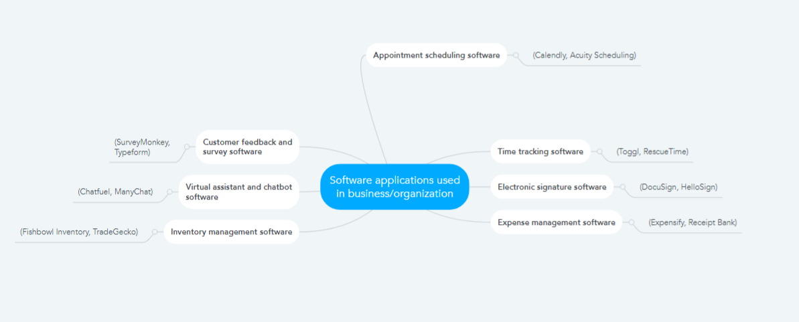
Task 3:
Part a
Contemporary office applications are essential tools for businesses for creating, storing, analyzing, and presenting information and data. Some popular office applications include:
- Microsoft Word: A word-processing software that allows users to create and edit documents with a wide range of formatting options. It includes collaboration tools and cloud storage integration.
- Microsoft Excel: A spreadsheet software that allows users to analyze data, create charts and graphs, and perform calculations. It includes collaboration tools and cloud storage integration.
- Microsoft PowerPoint: A presentation software that allows users to create professional-looking presentations with a variety of design options. It includes collaboration tools and cloud storage integration.
- Apple Pages: A word-processing software for Mac users that includes templates, collaboration tools, and cloud storage integration.
- Google Docs: A cloud-based word-processing software that includes real-time collaboration and cloud storage integration.
- Google Sheets: A cloud-based spreadsheet software that includes real-time collaboration and cloud storage integration.
- LibreOffice: A free, open-source office suite that includes a word processor, spreadsheet, and presentation software.
- OpenOffice: A free, open-source office suite that includes a word processor, spreadsheet, and presentation software.
These office applications have different features and capabilities, but all of them are essential for businesses to create, store, analyze, and present information and data.
Part b
In this task I tested some business-related features of Canva, which is a freely available Office Application. Canva is a graphic design tool that can be used to create professional-looking designs quickly and easily. I created a brochure for a product launch and tested the following features:
- Templates: Canva offers a wide range of templates that can be used to create professional-looking designs quickly. I chose a product launch brochure template and customized it with my content.
- Collaboration: Canva offers real-time collaboration, which allows multiple users to work on the same design simultaneously. I invited a colleague to collaborate on my design, and we both made changes in real-time.
- Design Elements: Canva offers a variety of design elements, such as icons, photos, and illustrations, that can be used to add visual interest to a design. I added design elements to my brochure to make it more engaging.
- Branding: Canva allows you to upload your brand assets, such as logos and colors, so you can maintain consistency across all your designs. I uploaded my company's logo and colors to my brochure design.
- Sharing: Canva allows you to share your designs with others by providing a link or sending an email invitation. I shared my brochure design with my colleagues so they could review it before the product launch.
Canva is a user-friendly and feature-rich application that can be used to create professional-looking designs quickly and easily. Its real-time collaboration feature makes it a great tool for teams that need to work together on design projects.
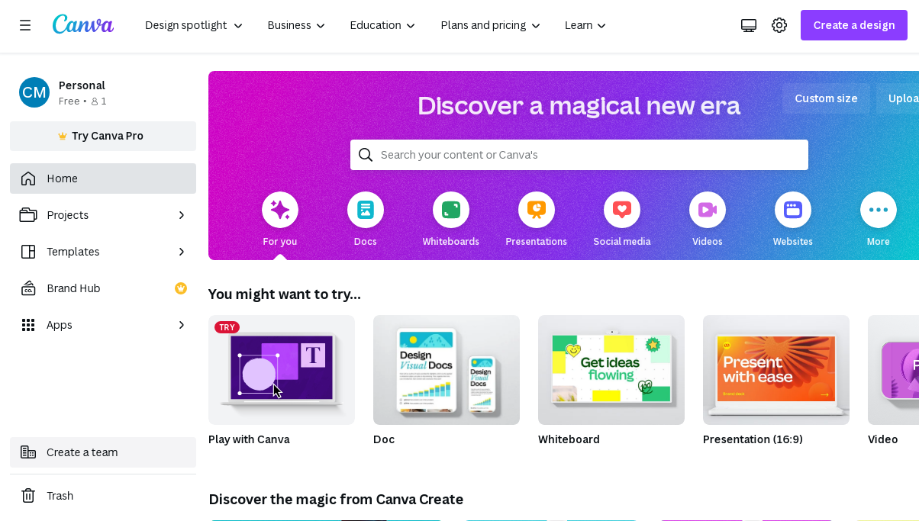
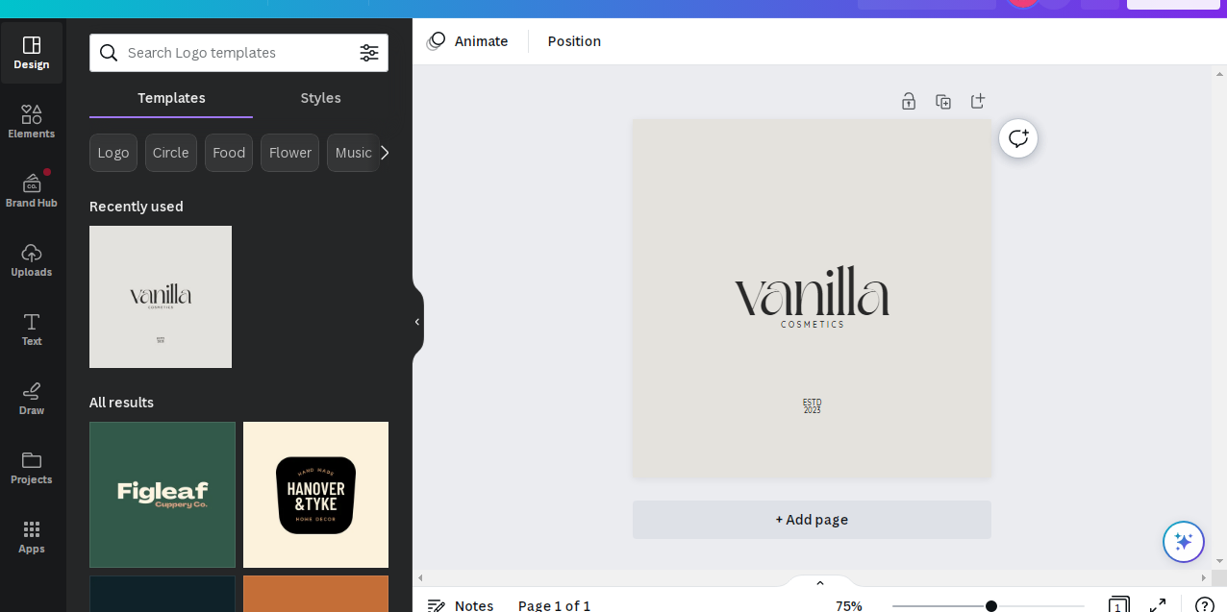
Task 4:
Digital dashboard and data analytics software provide businesses with a quick and efficient way to analyse and interpret complex data, providing insights to make informed decisions. Some key features of contemporary digital dashboard/data analytics software include:
- Real-time data: Allows businesses to access data as it's generated, giving them a real-time understanding of what's happening in their business.
- Data visualisation: Displays data in an easy-to-understand visual format, such as charts, graphs, and maps, making it easier to identify patterns and trends.
- Customisation: Enables businesses to customise the dashboard to meet their specific needs, including choosing which data to display, how it's displayed, and how it's sorted.
- Integration: Integrates data from multiple sources, including social media, CRM software, and other databases, to provide a comprehensive overview of business operations.
- Accessibility: Provides remote access to data from anywhere, on any device, allowing businesses to make informed decisions on-the-go.
I chose ClicShop e-commerce website for this task. Dashboard Poster for ClicShop e-commerce website is given below,
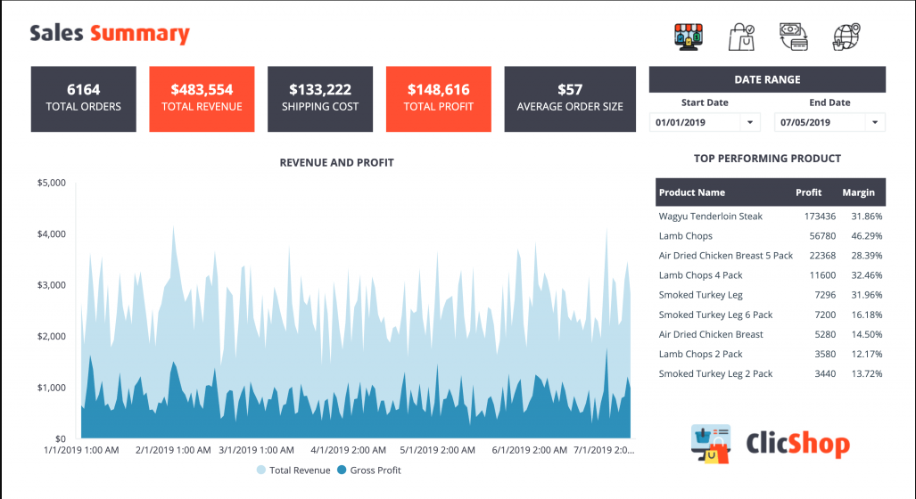

Task 5:
Part a
There are several contemporary applications for communication, collaboration, and project management, each with its unique set of features. Some of the popular applications in this category are:
- Asana: Asana is a web-based project management tool that allows users to create and assign tasks, track progress, and collaborate with team members. Its key features include a simple interface, customizable dashboards, team calendars, and integrations with other tools such as Slack and Google Drive.
- Trello: Trello is a visual collaboration tool that uses boards, cards, and lists to help teams manage projects and workflows. Its key features include customizable boards, drag-and-drop functionality, team task assignments, and integrations with popular applications such as Google Drive and Slack.
- Zoom: Zoom is a video conferencing application that has gained immense popularity in recent times. Its key features include high-quality video and audio, screen sharing, virtual backgrounds, and recording options.
Part b
In this task I choose to test the communication and collaboration features of Slack, a popular messaging application used by many businesses and organizations. I created a new team and invited some team members to test the application's features. Here are some screenshots and brief descriptions of my experience:
- Creating a new channel: I created a new channel to discuss a particular project and added the team members who were working on it. The process was straightforward, and the channel appeared on the sidebar.
- Sending messages: I sent messages to the team members in the channel, and they were notified immediately. The messaging interface was user-friendly, and I could also attach files and images to my messages.
- Integrations: Slack integrates with several third-party applications such as Google Drive and Trello, making it easy to access files and information from other tools.
My experience with Slack was positive, and I can see why it is a popular choice for communication and collaboration in many organizations.
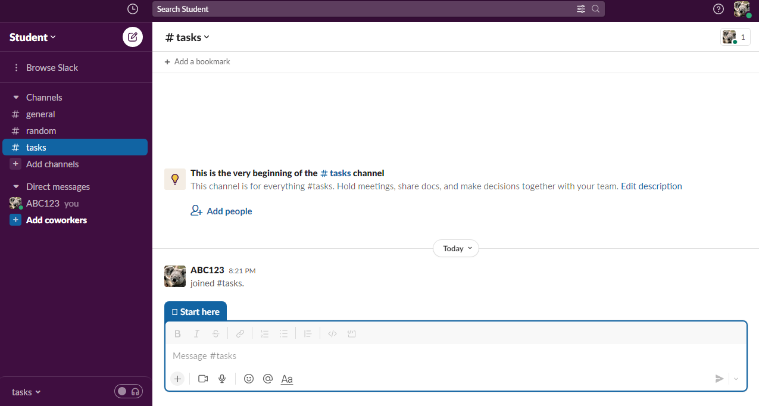
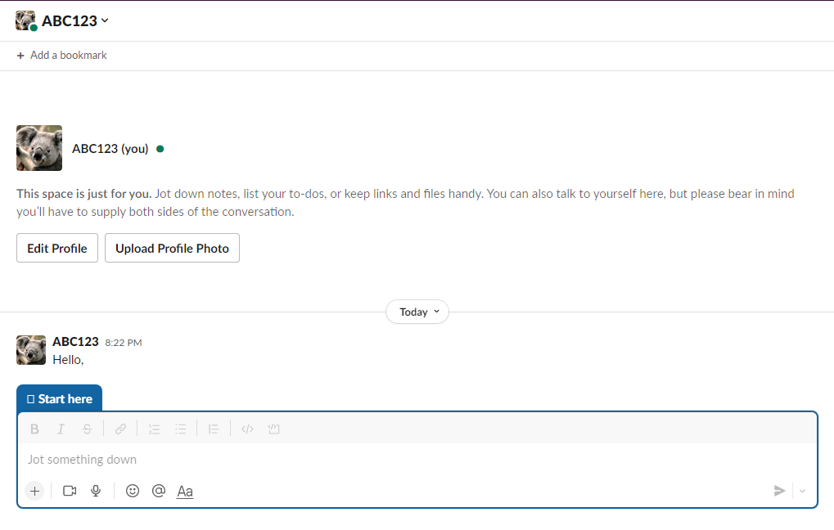

References:
"OpenCart Review: Pros, Cons, and Alternatives" on FinancesOnline: https://reviews.financesonline.com/p/opencart/
Squarespace Review on TechRadar: https://www.techradar.com/reviews/squarespace-ecommerce
Microsoft PowerPoint Features: https://support.microsoft.com/en-us/office/powerpoint-features-by-version-974c6111-4f0f-4efa-a7ac-5706cacef6ef
Asana: https://asana.com/
Trello: https://trello.com/
Zoom: https://zoom.us/
Slack: https://slack.com/

