
University of Wales Trinity and Saint David London Campus
BCs Cloud Computing Level 4
Student name: Ofeliya Artin Kazazyan
Student ID: 1907555
Subject: Information Engineering ACCC4004_LON
Lecturer: Anupam Mazumdar
Date: 11.05.2020

Table of Contents
1.Short Description 3
‘Employees 3
‘EmployeeJobTitles’ 3
‘EmployeeHoliday’ 3
‘EmployeeBankDetails’ 3
‘Courses’ 3
‘CompanyBranches’ 3
‘Registration Form’ 3
‘MedicalHistory’ 3
‘Navigation Form’ 3
2 Relationship Diagram 4

1.Short Description

‘Login Form’- which is for the user to enter his Username and password very simple model, with two buttons added one is the ‘Login’ button and ‘Close’ button.
‘Employees’ -is where a new staff can be added or just to check valuable information for some employee in particular. Here there are three buttons available: ‘Add Record’ , ‘Delete Record’ and ‘Close Form’ .
‘EmploymentHistory’ – in this section an information about employees and the branch changes they had with four buttons: ‘Add Record’, ‘Save Record’ ‘Find Record’ and ‘Delete Record’.
‘EmployeeJobTitles’ – here you could look up for salary / per hour of any member of staff and the course they are in. Three buttons included: ‘Add Record’ ‘Find Record’ and ‘Print Form’ to print forms if needed.
‘EmployeeHoliday’ – where all the data from employee absence is stored, holidays available can be set, absence id show the staff which was absent , with the following dates , reason why the staff is missing and the days left from the paid leave and bank details record to make payments to the staff. There are four buttons ‘Add Record’, ‘Delete Record’, ‘Find Record’ and ‘Print’.
‘EmployeeBankDetails’ – this is where all the employee bank records are stored plus employee id so it can be understandable who is this payment going to be for. Four buttons added ‘Add Record’, ‘Delete Record’, ‘Close Form’ and ‘Print’.
‘Courses’ – to store the information from courses taken by employees, duration of course and course name (type). Three buttons created ‘Add Record’ ‘Delete Record’ and ‘Close Form’.
‘CompanyBranches’- is where more branches can be added. Three buttons added ‘Add Record’ ‘Save Record’ ‘Delete Record’ ‘Print’ and ‘Close Form’.
‘Registration Form’- Where a person can register as a new employee by adding details such as first name last name, must create username and password and add email in order to register. There are three buttons here ‘Add Record’ ‘Delete Record’ ‘Refresh’.
‘MedicalHistory’- where all the medical information of the employees can be stored info such as – GP name, GP address and all the emergency contacts needed, the employee id Is also needed so it be linked with the specific staff member. Two buttons here ‘Add Record’ and ‘Delete Record’.
‘Navigation Form’ – this is where you can navigate through all of the forms queries and tables easily.

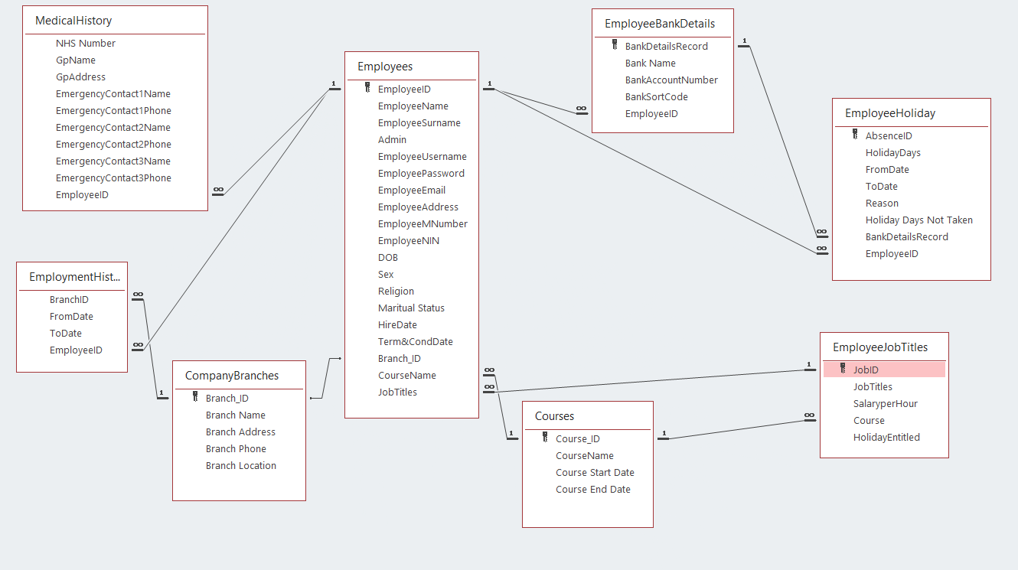
2 Relationship Diagram

Created relationships between the entities – which happens when the main primary key of the parent entity is added to the primary key of another entity.
Description of how the tables are related – ‘Employees’ is the main table it has been linked with ‘one to many’ because all the information stored in the other tables are connected to the employees of the company.

Primary key is to make connections between data from multiple tables and merge the data in a way that makes sense. The primary code is unique and identifies a record in a table.
Where foreign key is a field in the table where is primary key in another table. The foreign key can allow multiple null values to be stored.

