19/12/2025
NCE

Module Name: Network and Cybersecurity Essentials
Module Code: ACCA4024
Student Name: Anthony Mathias
Student ID: 2429335
Group 2
Lecture’s Name: Amit Naik

Table of Contents
Introduction 2
Task 1: Identification of Threats 3
Task 2: Security Policies 4
Task 3: Migration Measures 7
Task 4: Monitoring & Response 9
Task 5: Training & Awareness 10
Conclusion 13
References 14
Appendices 15

Introduction
The ever-evolving global internet - and remote work in a globalised world - has expanded organisational attacks across the globe. Cyber security is no longer a secondary technological priority of business but a primary concern for enterprises that range from treasurable entities for all the wrong reasons. Financial services companies are a significant target to cyber-attacks as they house vast amounts of personal credentials and liquid assets from clients, while operating in a regulatory environment that inevitably create exploitative holes amidst competing needs. Moreover, cyber-attacks come in various forms with various risk potentials for finances, operations, reputations, and national security.
This is a report requested directly by the board of directors of FinSecure Ltd. (FSL), a mid-size financial services company that have faced multiple recent hacking attempts such as, email & SMS phishing attacks, unauthorized access on it’s local network, and other questionable breaches from various potential attackers. Thus, a clear, systematic solution is undoubtedly necessary to guide the company toward increased cyber security effectiveness. The overarching goal of this report is to implement a worthwhile solution based on the FSL situation. The specific objectives upon which the entire report will be structured around are as follows: 1. Potential internal and external threats, 2. A compilation of security policies based on relative good practices 3. Mitigation efforts against such threats that are realistic 4. Network monitoring with an incident response plan 5. A formal employee training and awareness program.
The overall objective of this report is to provide recommended conclusions that create added safety for FSL to protect systems to improve the confidentiality, integrity, and availability of information assets.

Task 1: Identification of Threats
External Threats:
FinSecure Ltd facing multiple external threats that are having significant impact on the organisation, the attacks consist of phishing attacks [1] via email and SMS with the intentions of stealing confidential credentials, ransomware [2] that has the ability to encrypt sensitive financial data to then be used as blackmail for financial extortion, and (DDoS) distributed denial of service attacks [3] which overwhelms their servers and routers with packets causing them to be out of service during office hours. Advance persistent threats (APTs) from well-established organisations intentionally targeting clientele data, while the significant threat of malware and unscreened exploits/bugs of unsecure software create a risk to network integrity, the rise of remote work increases the likelihood of attacks as it broadens vulnerabilities through unsecure residential home networks and personal devices.
Internal Threats:
Insider risks can be categorised under internal threats, whether these risks arise from malicious corporate misconduct such as employees deliberately exfiltrating confidential data for personal gains or compensation. [4] However internal threats are most commonly unintentional and are the result of corporate negligence or accidental behaviour such as mishandling of corporate or personal data like weak password practices, repetitive password combinations across multiple databases or failure to properly secure credentials. [5] Additionally assigning unnecessary privileges to users without prior briefing enables unauthorised access to sensitive material, significantly increasing the chances of exposure to outside sources, intentionally or unprofessionally it's still poses a threat to the organization. the lack of comprehensive security education increases the susceptibility of employees falling victim to social engineering and unknowingly handing over confidential data or credentials to fraudulent actors. poor device management habits and non-compliance or refusal to follow security polices poses FSL in a position of further exposure to data leaks or policy violations.
Use diagram to categories threats

Task 2: Security Policies
To appropriately address the security breaches and align them with industry standards, FinSecure should utilise the following five main security polices to secure its organisation and pre-emptively prevent any further attacks. These polices are built around a framework such as the NIST Cybersecurity Framework to ensure a dynamic, in-depth defence strategy.

Acceptable Use Policy (AUP):
To appropriately address the security breaches and align them with industry standards, FinSecure should utilise the following five main security polices to secure its organisation and pre-emptively prevent any further attacks. These polices are built around a framework such as the NIST Cybersecurity Framework to ensure a dynamic, in-depth defence strategy. [6]

This policy directly categorises the appropriate use case for FSL's data and information assets, consisting of networks, systems and secure data. It is vital for mitigating any risks from device vulnerability and remote work.
The AUP will:

Directly prohibit any use of unauthorised software (shadow IT) and immediately block and notify any attempts to access malicious or high-risk websites from within corporate devices. [7]

enforcing a mandatory mandate to only use company-approved, encrypted communication software to transfer work-related data.

impose a requirement that all personal devices used for work purposes are checked and comply with FSL's mobile device management standards, ensuring they are secure and up to security standards.
Password Policy:
A secure password policy is the first defence mechanism against unauthorised access in personal or work accounts, and identity theft from phishing attacks.

Secure requirements: Password must have a minimum of 12 characters, combining uppercase, lowercase, numbers and symbols. [8]

Prohibition of duplicates: Passwords cannot and will be flagged for reuse across multiple FSL databases and systems with the extension of personal accounts

Storage mandate: Passwords under any circumstances must not be written down or stored in plain text. The only permissible storage method should be company-approved password managers which is the ideal method for generating and storing passwords and credentials.
Access Control Policy:
Based on the core principles of limited privileges, this policy directly ensures and regulates that users only have permitted access to the resources necessary and related to their job role.

Role-Based Access Control: All system and database access will only be granted under the conditions of pre-defined roles, e.g data analyst, cyber security branch, and not granted per individual request.

Frequent access reviews: Managers are obligated to conduct a mandatory quarterly review of their colleagues' and collaborators' access rights to various systems.

Immediate Revocation: Prior granted access for employees of the organisation changing roles or leaving the company will be revoked on their final day, effective immediately, which is all inside a streamlined automated system used by the HR department.
Data Handling and Classification Policy:
This policy acts as a protective measure to adequately secure the confidentiality and integrity of sensitive financial data by grouping it and categorising it in levels of severity solely based on how sensitive the material is.

Four-tier classification: data will be placed within a hierarchy under the classifications of public, internal, and confidential [9]

Incident Response Policy:
A well put together policy confirms a swift corelated response to critical security breaches, thus decreasing operational down time and reputational damage.

The policy is in a six-phase structure as a response mechanism: preparation, identification, containment, education, recover and reflection.

Well defined roles within the incident response team (IRT) provides communication clarity for all within the organisation, including IT, Legal and Communication roles and identifies internal and external clients

A full analysis after the initial incident is mandatory to find the root-cause, which is needed to update policies and tighten up security.
When used together these policies work as a governing body, as they uphold security principles into executable rules. Directly targeting FSL vulnerabilities from phishing and unauthorised access. [10]

Task 3: Migration Measures
Implementation of Policies to Mitigate Threats:
To directly combat the threats identified, FinSecure should implement a plethora of interconnected security polices listed below as solid mitigation measures against threats. Each policy delivers a strategic set of instructions into actionable tasks and control, directly confronting specific vulnerabilities within the organisation.

- Implementation of the Acceptable Use Policy (AUP)

The AUP policy will counteract threats from device proliferation and unsecure remote work from home devices, this is implemented by enforcing permissible use of FSL IT assets. The policy will involve:

Execution and acknowledgment: The policy will be enforced digitally through the companies intranet as a way of creating a private network only accessible to those within the organisation. All staff personnel must comply and complete an acknowledgement form prior to accessing networks or systems, this form is non-negotiable and establishes clarity via contractual agreement.

Enforcing the policy from a technical aspect: Network Access Control (NAC) is a solution that will be configured to enforce the AUP rule such as intercepting access to high-risk unsecure websites also known as malware domains, and placing restrictions on personal devices connected to the corporation’s networks.

Frequent review: The AUP is on a strict schedule to be revised bi-annually to acknowledge arising technologies such as new shadow IT applications and innovating remote work sequences.

2. Implementation of the Password & Access Control Policy
This method combines the use of two policies to directly mitigate theft of sensitive credentials and unauthorised access by rolling out the principle of least privilege and a multi layered authentication measures.
Two-factor authentication (2FA) is then implemented to add an additional layer of security, requiring users to provide two or more verification factors to gain access to their accounts, even if they are off the organisation’s network and using a VPN or personal networks. This ensures that even if one factor is compromised, unauthorized access is still prevented. [11]

Automated user provisioning and deprovisioning processes are also put in place to ensure that user access is granted and revoked in a timely and accurate manner, further reducing the risk of unauthorized access. The integration of AI-powered threat detection systems is embedded within the HR departments systems, automatically revoking the rights upon termination of job roles.

3. Implementation of the Data Handling and Classification Policy
Implementation of the data handling and classification policies are also in place to mitigate the possibility of unintentional data exposure and leaks of confidential information, which is defined by the different types of data and the appropriate security controls for each, ensuring that sensitive information is protected according to its level of importance.

Data discovery and classification processes are crucial for understanding what information exists within an organisation and how it should be managed. So, understanding this aspect the software will then thoroughly scan through repositories such as servers and cloud storage platforms to identify any unstructured data that might be at risk. Additionally, it labels data in categories such as public, internal, confidential, and restricted, based on the sensitivity and regulatory requirements.
Encryption Mandates will be based on classification measures that will be technically controlled when applied correctly. All sensitive confidential data will be encrypted on both ends using AES-256 and in transit using TLS 1.3+. Email protocols will be specifically configured to intercept external transmission of unencrypted data. [12]
Transparent handling workflow procedures will incorporate unique labels and handling regulations, e.g., "Do not forward," "Printing is prohibited," to act as a guide to employee behaviour and what is expected from the company.
4. Implementation of the Incident Response Policy
Implementation of the incident response policy will ensure the mitigation of any attacks and have a successful impact, a formal a incident response (IR) is done within a methodological framework, where it contains the threat, disarms it and moves towards the recovery and reflection process.
IR playbook development creates specific playbooks for the sole purpose of threat scenarios that have been brought to FSL awareness, such as "phishing containment" and "ransomware isolation." These create a step-by-step playbook for the IR department to follow.
A roadmap of these mitigation measures will be rolled out in a 6-month phase, starting with the AUP and Password Policy for quick success, followed with the Access Control and Data Classification, then to be developed in a IR table-top exercise.

Task 4: Monitoring & Response
Monitoring: A recurring, multi-layered monitoring system is an essential requirement for early detection of any security incidents that might arise. This will be done through a security information and event management (SIEM) system, such as Microsoft Sentinel. The SIEM will effectively combine and correlate logs from all corporate IT assets, including firewalls, intrusion detection systems (IDS), servers, and endpoints. From this, it will be configured by using an automated alerting system to flag anomalies and potential signs of threats, such as multiple failed login attempts from an unusual location or a sudden spike in network traffic, or established connections from unknown malicious IP addresses. Or established connections from unknown malicious IP addresses. Another factor is that endpoint detection detection and response (EDR) software will be utilised widespread throughout company devices to observe for malicious activity and churn out forensic capabilities. Frequent vulnerability scans and penetration tests will commence to pre-emptively identify and patch weaknesses before they can have any effects.
Response Plan:
After an incident, there's a protocol in place to implement a plan following the NIST SP 800-61 framework, allowing structured and effective reaction to the incident. A flowchart (Displayed in Appendix) will illustrate a clear six-phase process.
Preparation: setting defined roles in the IR team and giving them the resources, combined with the tools and authority necessary, needed for them to effective response to an incident as early as possible. [13]
Identification: Utilising the SIEM/EDR alert framework to confirm security events.

Containment: enforcing short-term measures such as isolating an infected machine, then long-term measure implements permanent methods such as blocking the attacker's IP address, to counteract damage.

Recovery: restoring all the affected systems and devices from clean backups that were uploaded to the cloud and returning back to normal operations

Task 5: Training & Awareness
In today's innovative professional workspace, cybersecurity mindfulness and comprehensive training are vital components for safeguarding corporate assets and confidential data. As a part of FSL's commitment obligations to maintain a strong security force 24/7, employees at every level within the corporate hierarchy are obligated to go through and complete a structured cybersecurity introduction course within their first month of active employment, ensuring a secure environment is maintained. FSL's exposure to social engineering and human error can only be neutralised if all active employees, regardless of their subordinate or superior roles, are thoroughly trained and educated continuously in safe cybersecurity practices. This programme is easily accessible through a secure learning management system and is tied to unique job roles to enable relevance and maximise possible impact.
The program is constructed with two core elements: A mandatory curriculum to follow and a recurring targeted awareness task, both of which operate simultaneously to confirm that cybersecurity knowledge becomes a core value of FSL work culture.

Mandatory Programme:
To propose a solid foundation, all staff members are obligated to complete the cybersecurity introduction, as cited in the previous paragraph. Elaborating more on the introduction, its purpose is to deliver a secure Learning Management System unique to staff members' roles within the company. This ensures that each and every staff member receives the current relevant information for their specific job task. The introduction consists of several key modules:
General Awareness Module: The base section of this introduction module introduces employees to core cybersecurity principles, such as CIA Triad (Confidentiality, Integrity, Availability), and points out common threats like phishing, social engineering and malware. Additionally, this module will give clarity and understanding to employees within FSL.

Acceptable Use and Data Handling:
Role-Specific Deep Dives: Aligning with the general awareness module, employees are obligated to engage with the specific training relevant to their department. A brief example would be, staff members in the financial department will be trained on security measures regarding invoice fraud, business email compromise (BEC) and the importance of intercepting fraud transfer requests securely. In parallel the HR department will be trained on how to protect and encrypt employees personal identifiable credentials (PIC) and implement a secure onboarding/offboarding procedure. The full proficiency of this department assists cybersecurity content to be more relevant and uniquely applicable to daily tasks within the office.
Policy Acknowledgment: After the full completion of the training modules, staff members are obligated to digitally sign an agreement confirming that they have understood and agree to comply with FSL's security policies. This measure not only acts as an acknowledgment of the security content but also makes a formal record of compliance. [14]
Full completion of this mandatory program is essential and non-negotiable for all employees to be granted access to the company's IT assets and other resources. To confirm that full participation and compliance is met, FSL will set a 100% compliance goal, raising necessary awareness of arising threats, and superiors will receive an automated report tracking their department's progress.
Recurring Awareness:
To maintain full confidentiality and security, FSL will implement a recurring awareness campaign throughout the year. This will include several components designed to strengthen the training process, raise awareness of arising threats and encourage mindful proactive security attitude.
Simulated phishing Campaigns: Every quarter staff members will receive a simulated phishing attack in their inbox to test their awareness. These simulations are constructed to mimic the most recent tactics used by cybercriminals, such as impersonating CEO emails or phishing attack disguised as HR representative updates. Staff members who fail the simulation by clicking the fraudulent links will automatically be enrolled into a short module revising the contents again. These exercises will be track by every department within the organisation and the output results will be used as data to identify vulnerable areas the need additional resources. Most importantly these simulations are constructed as an learning opportunity, without disciplinary measures to those individuals who unfortunately fail the exercise. [15]
Monthly Security Bulletins: To maintain a constant flow of useful cybersecurity information, FSL will compose and send out monthly newsletters that go over specific topics to raise awareness such as "Identifying Smishing", "Safe Remote Work Tips" or any recent cybersecurity threats that are uniquely relevant to the specific department like finance or HR. These bulletins also act as a reminder of core polices are protocols.
Annual Refresher & Updated Training: Employees will be obligated to complete a 30-minute revised training session every work year. The course will be constantly updated on new emerging threats, review any documented or undocumented security changes to polices and strengthen key cybersecurity principles. The training curriculum will be updated every working year, ensuring that staff members are well informed of the latest risks and threats within the cybersecurity field.
Security Champion Network: To further propagate a secure culture of security, FSL will deliver a security champion network within each respected department. Volunteers from each department will undergo further additional training upon request and act as an advisor, assisting their colleagues in retaining information about the best security practices. These security champions will also provide important, constructive feedback to the security department regarding the effectiveness of the awareness program, confirming the that training stays relevant and practically applicable.
Evaluation & Reinforcement:
The overall success of the training and awareness program is dependent on the continuously evaluation of a variety of different Key Performance Indicators (KPIs):

The click through rate of Phishing simulations (with a goal of _<5%)

Completion rate of training (with a goal of 100% compliance)
Frequent employee feedback surveys to understand engagement and effectiveness.

Strong reinforcement will play a positive role in encouraging staff members. Department teams with the highest performance in phishing simulations or the highest training completion rates shall be recognised throughout the company’s communication.
Ultimately, the constructed comprehensive training and awareness program is structured to transform employees from being in a place of vulnerability within FSL's security field to being in a position of being well informed and proficient. With adequate training, frequent reinforcement and active engagement, FSL will impose a security-aware culture that encourages staff members to conceal and protect confidential information and lower risks effectively.

Conclusion
This report has illustrated a comprehensive approach to reinforce the cybersecurity situation of FinSecure LTD is facing at the moment. Through a detailed audit of FinSecure's day-to-day operating environment, this report has displayed that cybersecurity is not only a technical issue but also a strategic business necessity.

The abstract identification of both external and internal threats puts a spotlight on the vast amounts of attacks FSL faces in their day-to-day operations, including phishing, ransomware, unauthorised access, insider compromissions and vulnerabilities introduced through remote working.

To acknowledge these risks, the report proposed multiple core security polices to implement aligned with the best practices of the NIST cybersecurity framework. Polices such as Acceptable Use, Password Management, Access Control, Data Classification and Incident Response were all displayed as a collective governance framework to follow and enforce as rules within the organisation.

The mitigation and implementation measures illustrated how these polices can be easily operational by the means of technical control such as two-factor authentication, network access control, encryption and structured incident response playbooks.

Furthermore, the training and awareness program outlined the roles of employees as a vital defence force against threats, by implementing cybersecurity education into the onboarding process of a new hire into the company and reoccurring awareness activities sent to inboxes. significantly reducing the possibility of human error should the threat occur again.

References

[1] | A. K. Jain and B. B. Gupta, “A survey of phishing attack techniques, defence mechanisms and open research challenges,” vol. 16, p. 527–565, 2021.
[2] | A. Kharraz, W. Robertson, D. Balzarotti, L. Bilge and E. Kirda, “Cutting the Gordian knot: A look under the hood of ransomware attacks,” p. 279–294, 2016.
[3] | P. Chen, L. Desmet and C. Huygens, “A study on advanced persistent threats,” vol. 12, p. 1–10, 2014.
[4] | C. Cummings, S. Misra, D. Upton and S. Sarma, “Insider threat modeling and simulation,” 2012.
[5] | P. Inglesant and M. Sasse, “The true cost of unusable password policies: Password use in the wild,” 2010.
[6] | National Institute of Standards and Technology (NIST), “Framework for Improving Critical Infrastructure Cybersecurity,” 2018.
[7] | SANS Institute, “Acceptable use policy,” 2020.
[8] | R. Shay et al, “Can long passwords be secure and usable?,” p. 2927–2938, 2016.
[9] | S. Khan, R. Albarghothi and A. Ghorbani, “Data classification: A systematic review and future research directions,” vol. 130, p. 106463, 2021.
[10] | P. Cichonski, T. Millar, T. Grance and K. Scarfone, “Computer Security Incident Handling Guide,” 2012.
[11] | A. Ometov et al, “Security and privacy for multi-factor authentication systems,” vol. 56, pp. 42–48,, 2018.
[12] | E. Barker and A. Roginsky, “Recommendation for Transitioning the Use of Cryptographic Algorithms and Key Lengths,” 2019.
[13] | F. Menges and G. Pernul, “A security architecture for endpoint detection and response,” vol. 78, p. 37–50, 2018.
[14] | T. Puhakainen and M. Siponen, “improving employees’ compliance through information systems security training,” vol. 34, p. 757–778, 2010.
[15] | M. Jensen, J. Dinger, T. Wright and J. Thatcher, “Training to mitigate phishing attacks,” vol. 34, p. 597–626, 2017.

Appendices
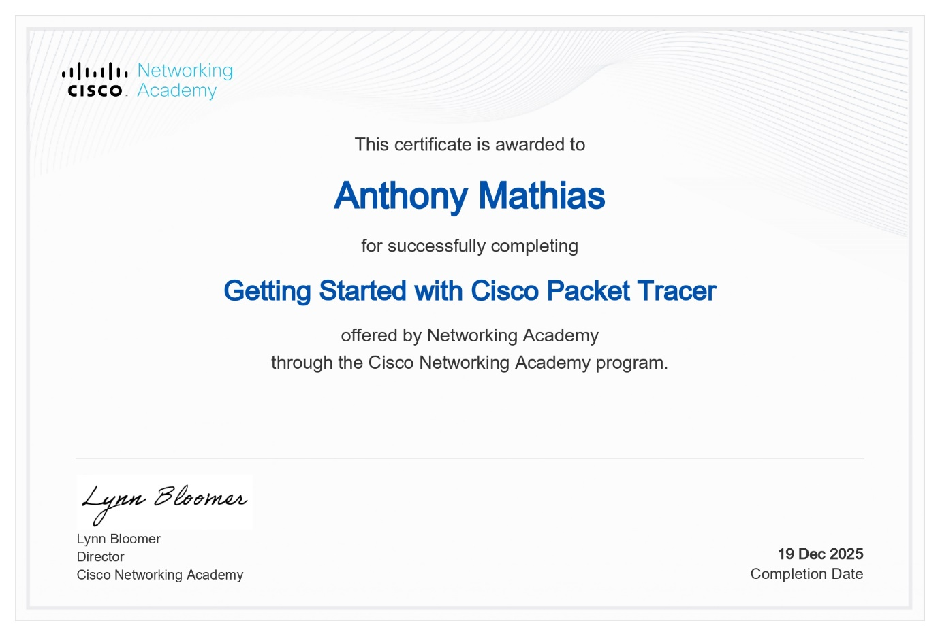
Cisco Certificate

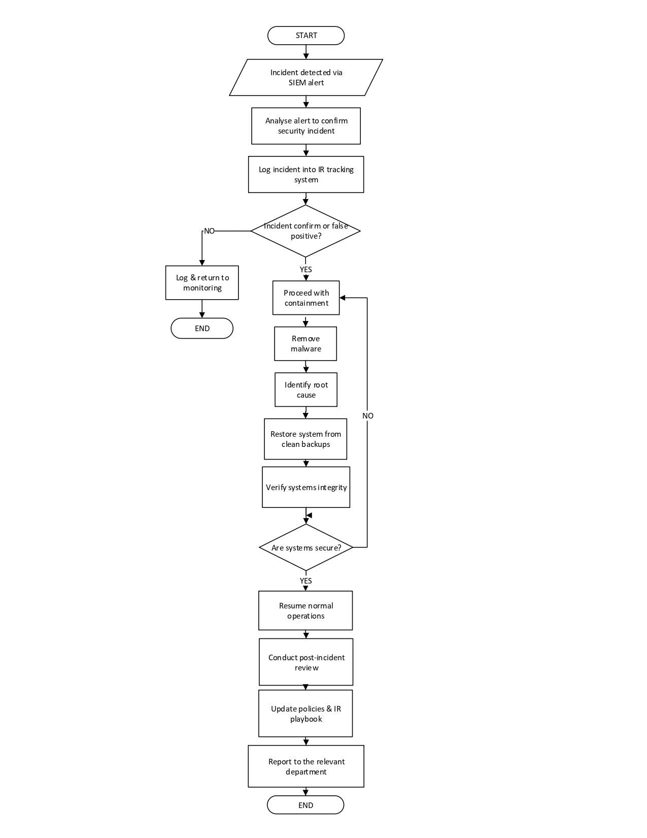
FSL Incident Response FlowChart

Board of Directors’ Proposal PowerPoint Presentation.
Link: Finsecure ltd proposal presentation.pptx


