
Assignment 2:
Operating Systems
CertHE Computing Skills for Workplace

Computer Architecture and Operating Systems. ACCA4022_LON
DR. Redhwan Al-Amri (Lecturer)
University of Wales Trinity Saint David
(London Campus)
Student Name: Tatiana Zaneva
Student Number: 2436814
Group: 02
Date: 17/12/2025

Table of Contents
Introduction 1
1. Key functions of general Operating Systems 1
Systems 1
1.1 Process and Processor Management 1
1.2 Memory Management 3
1.3 File System Management 4
1.4 Security and Protection 5
2. Use of Windows OS CLI commands. 7
3. Use of Linux OS CLI commands. 15
4. Use of Windows OS scripts. 20
Script: System Health Check 20
Key Features Demonstrated 22
5. Use of Linux OS scripts. 23
Script: Log File Analyzer 23
Key Features Demonstrated 25
Conclusion 26
References 27
Appendices 29
Tutorial Activity on OS Types from OS Tutorial 1 29
1. LinkedIn Learning course: 29
2. Cisco Network Academy: 30
3. Cisco Network Academy : Operating Systems Basics 32

Introduction
This report explores fundamental concepts of modern Operating Systems and demonstrates practical skills in both Windows and Linux environments. It examines essential OS functions such as process management, memory management, file systems and system protection. The report also presents the use of command-line tools in Windows PowerShell and Linux Bash, showing how commands can help users manage and analyze their systems. In addition, simple scripts are created to automate basic tasks. The final sections include a short conclusion, references in IEEE style, and appendices with evidence of online learning activities and tutorial engagement. [1] [2]

Key functions of general Operating Systems
Operating Systems (OS) are the main software that control how a computer works. They manage hardware, run applications, and provide a user interface. All modern systems such as Windows, macOS and Linux share several core functions. These include process and processor management, memory management, file system organization and system protection. Understanding these functions is important because they show how an OS keeps the computer stable, secure and efficient. The following sections explain each key function with simple examples from Windows 10/11.

Process and Processor Management

One of the main responsibilities of an OS is to manage processes. [2] A process is a running program, and the computer may run hundreds of them at the same time. The OS decides how much CPU time each process receives. This ensures that the computer stays responsive even when many programs are open.
Windows provides a tool called Task Manager, [3] where users can see all active processes. It shows CPU usage, memory usage, disk activity and more.

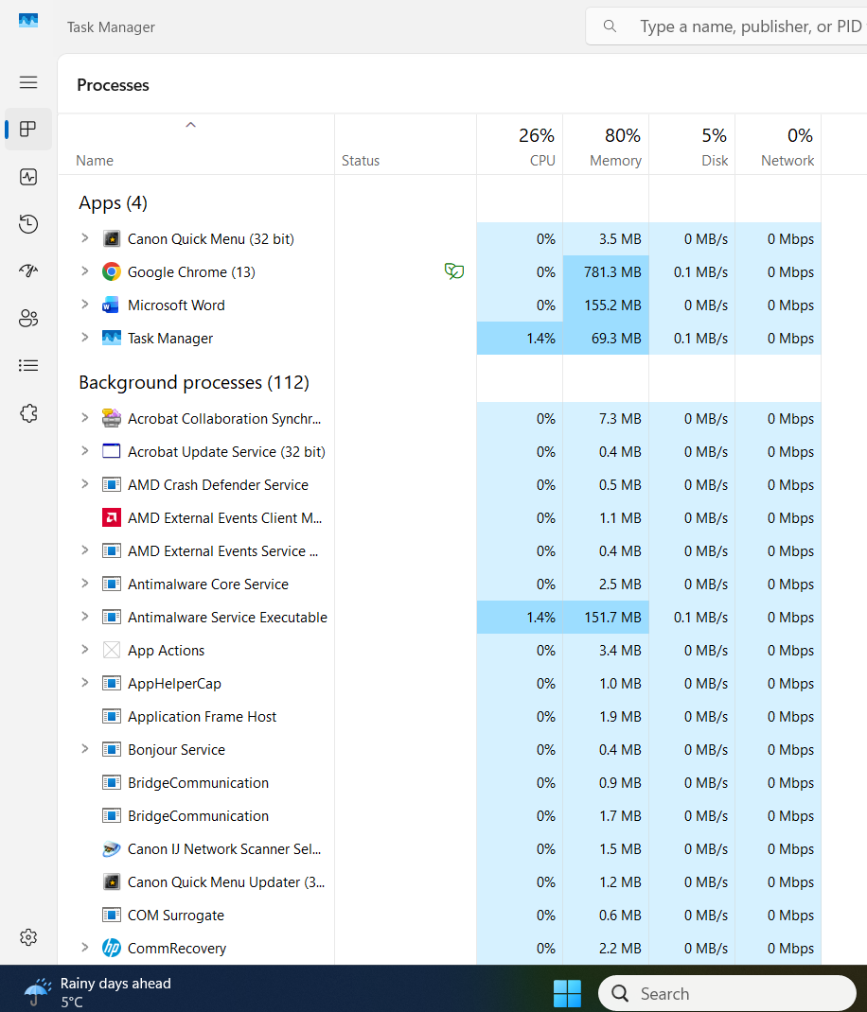
The OS uses a scheduling algorithm to select which process runs next. This avoids conflicts and ensures fairness. Even when an application stops responding, the OS can terminate it safely. Without proper process management, the computer would freeze or crash often.

Memory Management
Memory Management ensures that each application receives the memory it needs. [4] The OS tracks how much RAM is being used and by which processes. When RAM is full, the OS uses virtual memory, [2] (a page file on the disk) to avoid crashes.
In Windows, memory usage can again be seen in Task Manager → Performance → Memory.
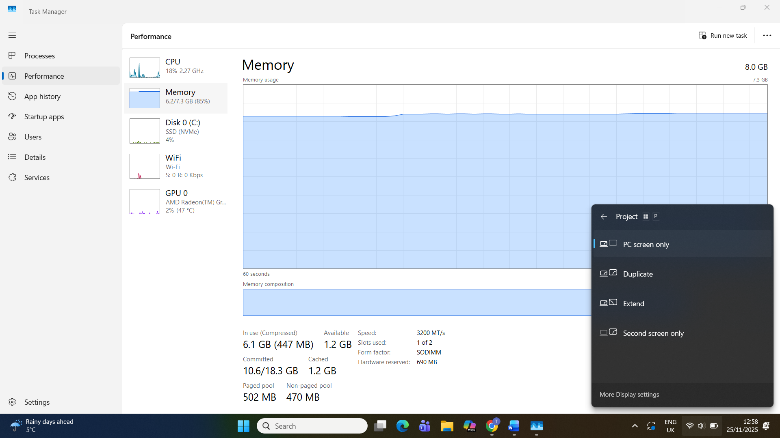
Memory Management includes:
- Allocating RAM to applications
- Moving inactive data to virtual memory
- Preventing one program from accessing another program’s memory
- Freeing memory when programs close
Without these protections, programs could overwrite each other’s data or cause system errors.

File System Management
File System Management controls how files are stored, organised and accessed. Different OS types use different file systems:
- Windows → NTFS
- Linux → EXT4
- USB drives → FAT32 or exFAT [5]
The OS keeps track of file names, permissions, creation dates, and folder structures. [2]
In Windows, users can view file system information by opening File Explorer and checking disk Properties.
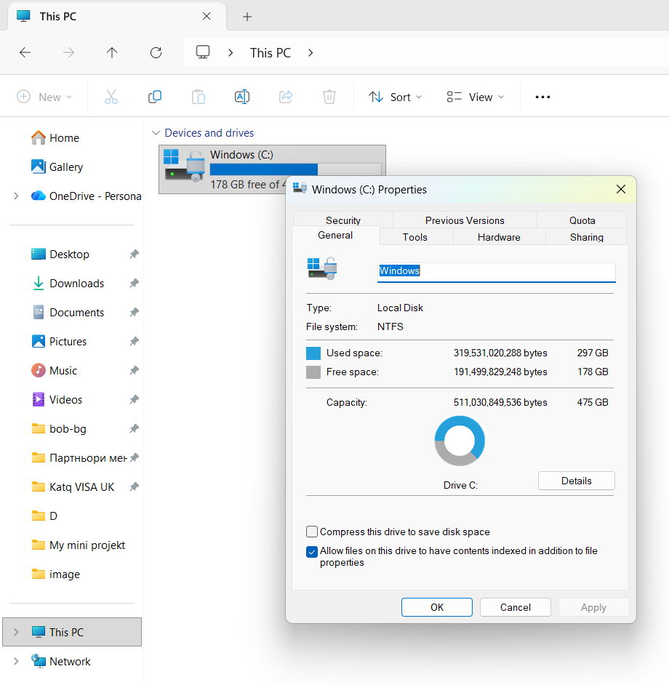
This function ensures that files open correctly, programmes load quickly, and data is not lost.

1.4 Security and Protection

Modern OSs include many built-in security features. [1] These protect the system from viruses, unauthorised access and accidental damage. Examples include:
- User account control (UAC)
- File permissions
- Windows Defender / Firewall
- Encryption (BitLocker)
In Windows, Device Security and Virus Protection can be seen in Windows Security settings. [2]

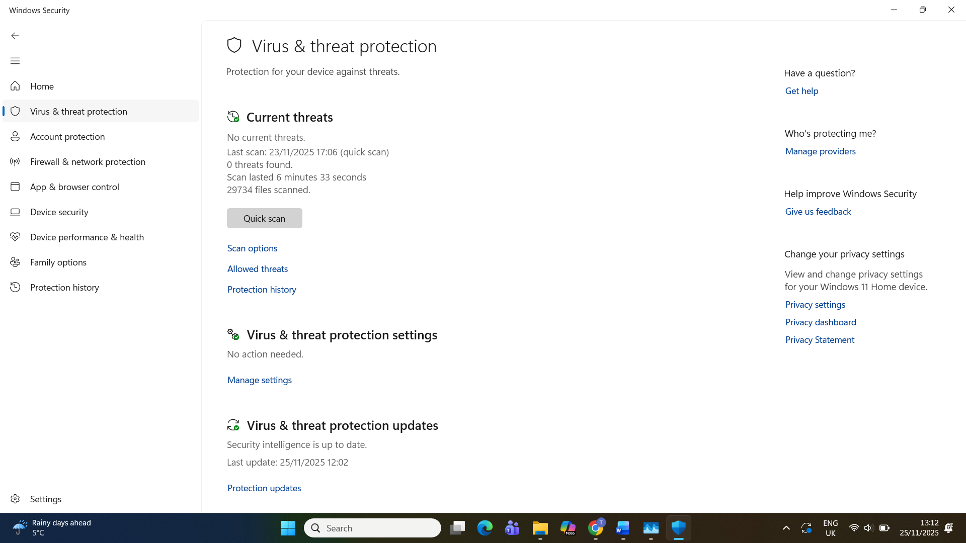
Security ensures that only authorised users access the system and that data stays safe. Without OS-level protection, malware could damage files or steal information.

2. Use of Windows OS CLI commands.

This section demonstrates the use of ten Windows PowerShell commands. Each command was executed on a Windows 10/11 system, and screenshots were taken to show the results. PowerShell is a powerful tool for system administration, monitoring and automation. [6] The commands below help users check system information, manage files, monitor processes and test network connectivity.

Command 1: Get-ChildItem
This command lists files and folders in the current directory. It is similar to using File Explorer but through the command line.

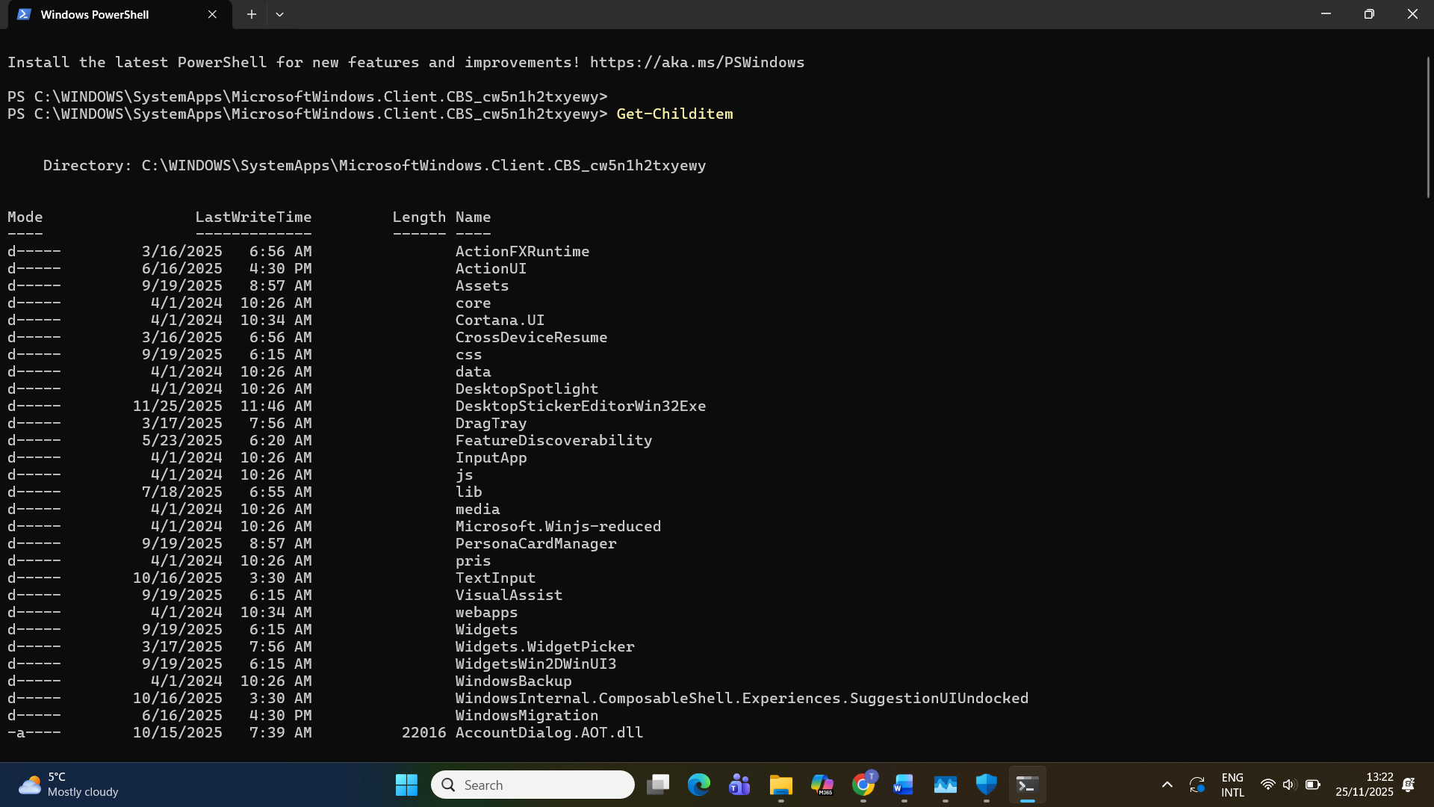

Command 2: Get-Process
This command displays all running processes, including CPU and memory usage. It helps users monitor application behaviour.
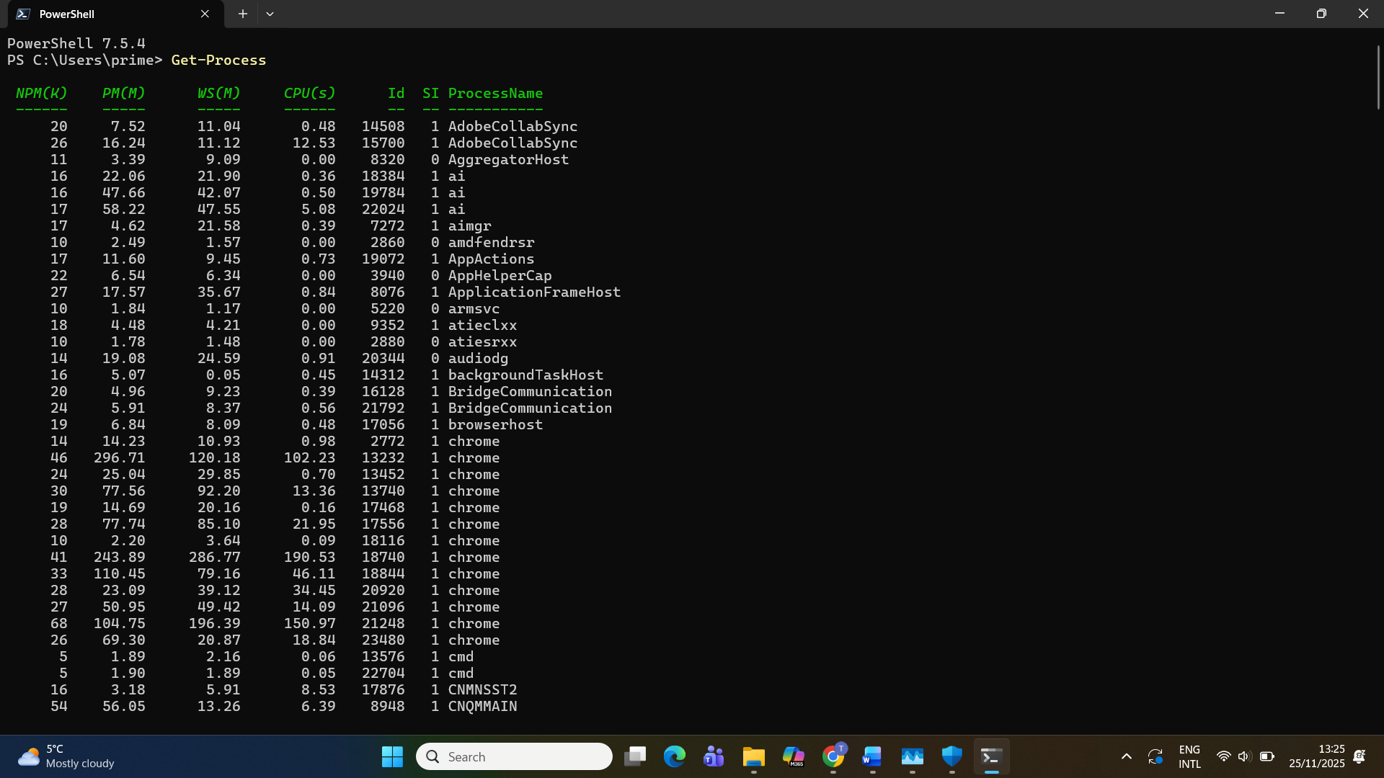
Command 3: Get-Service
This command lists all Windows services and their status (Running, Stopped, etc.). It is useful for checking essential background services.
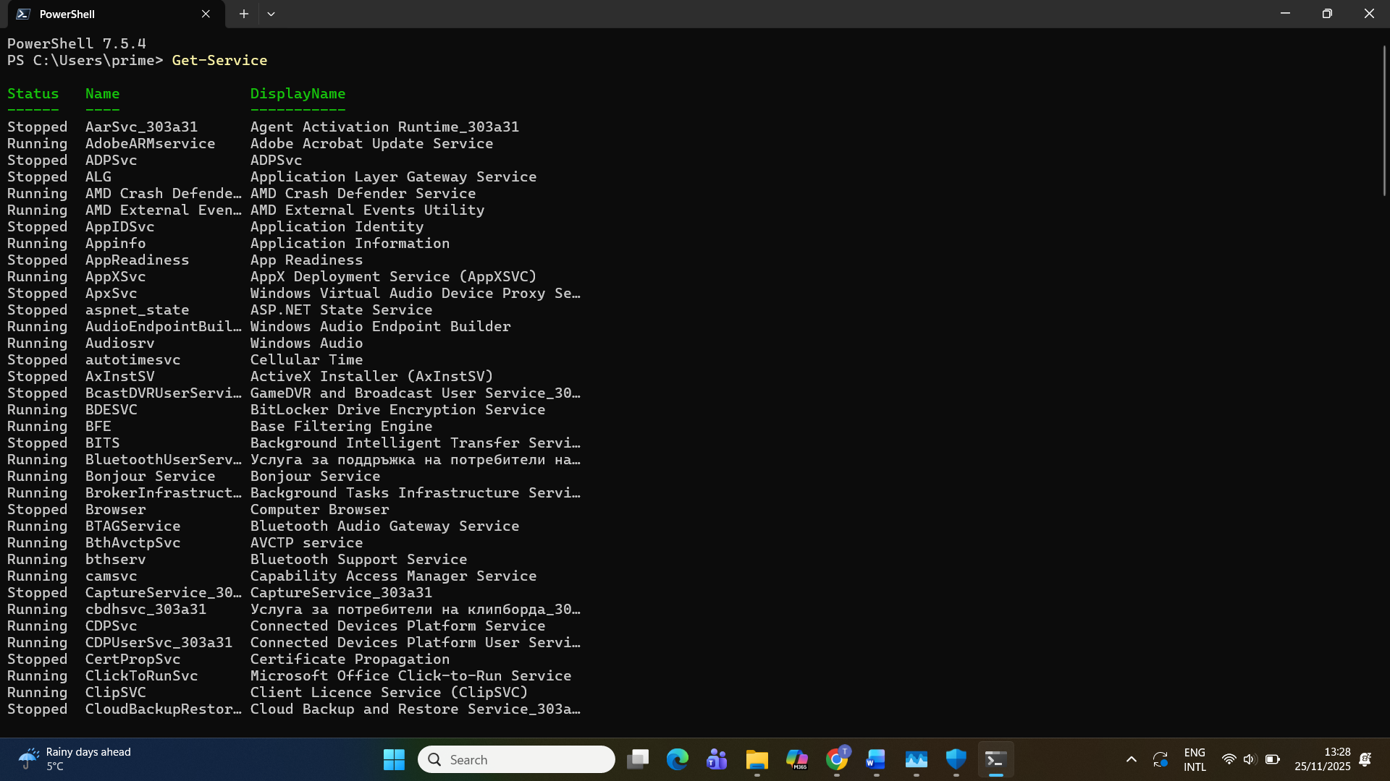

Command 4: Get-Date
This command shows the current system date and time. It is simple but often used in scripts and logs.

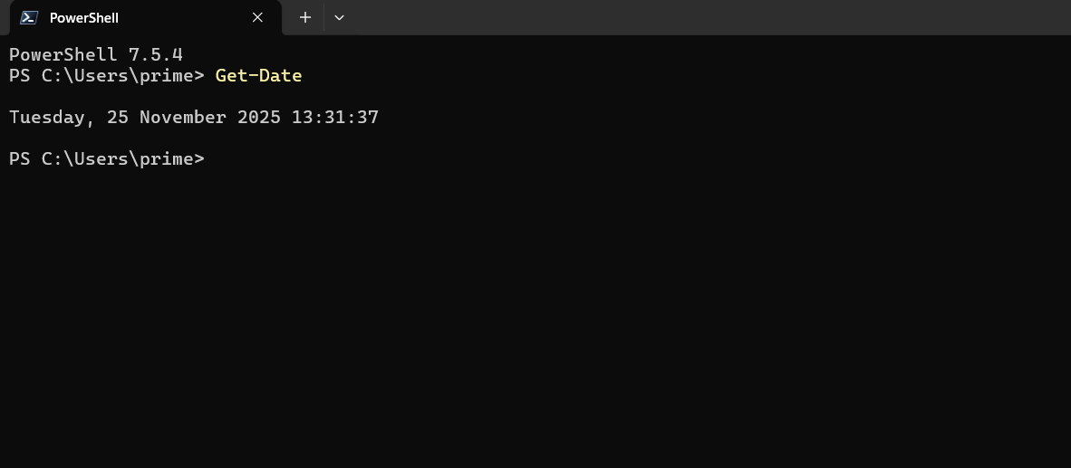

Command 5: Test-Connection google.com
This command tests the network connection by sending ICMP packets (similar to ping). It helps diagnose internet problems.
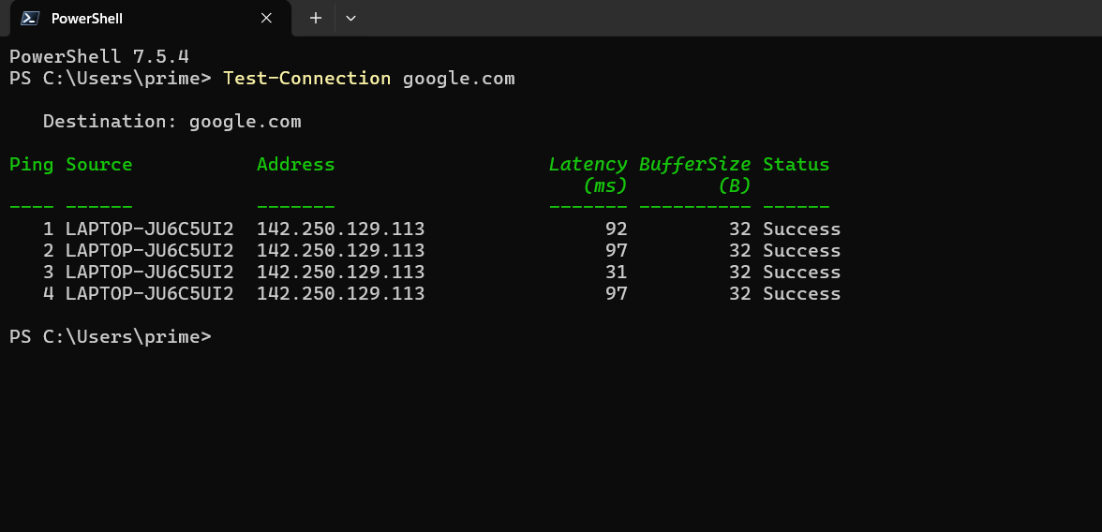

Command 6: Get-NetIPAddress
This command displays IP configuration details, including IP address, gateway and network interface.

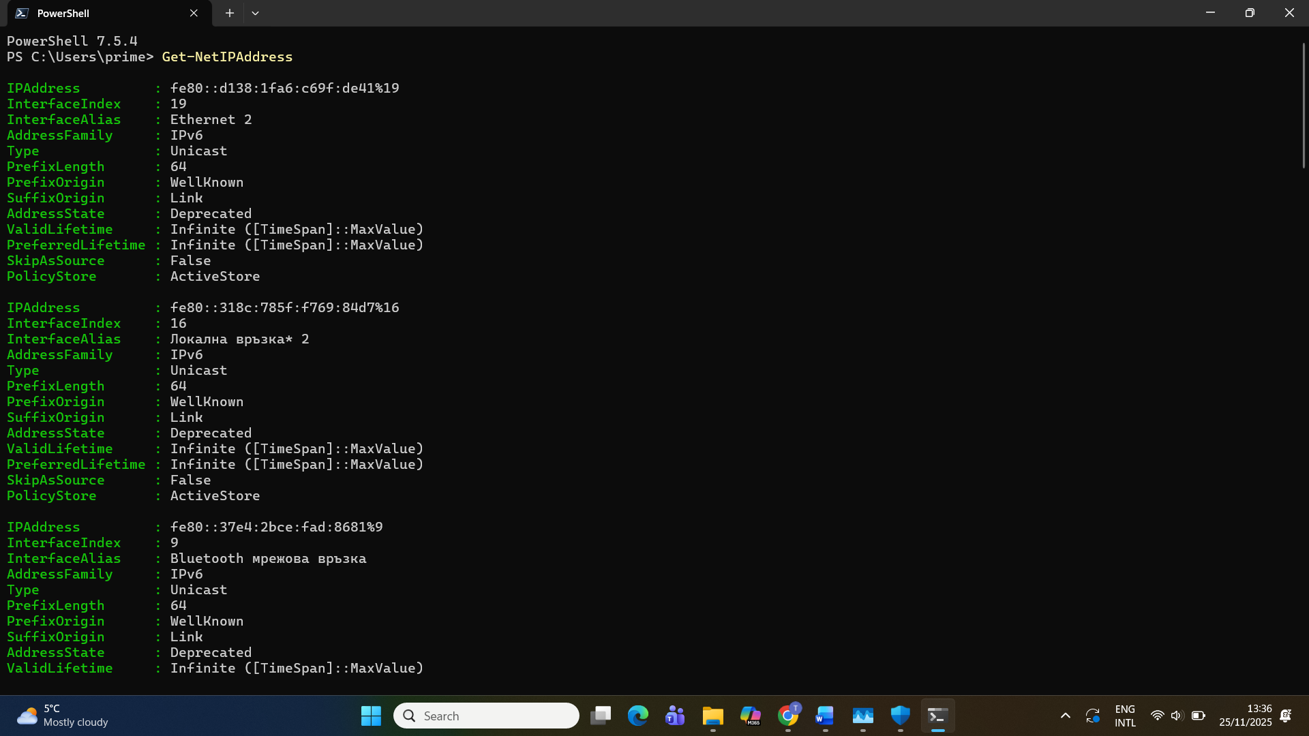

Command 7: Get-ComputerInfo
This command provides detailed system information, such as OS version, BIOS, hardware and updates.

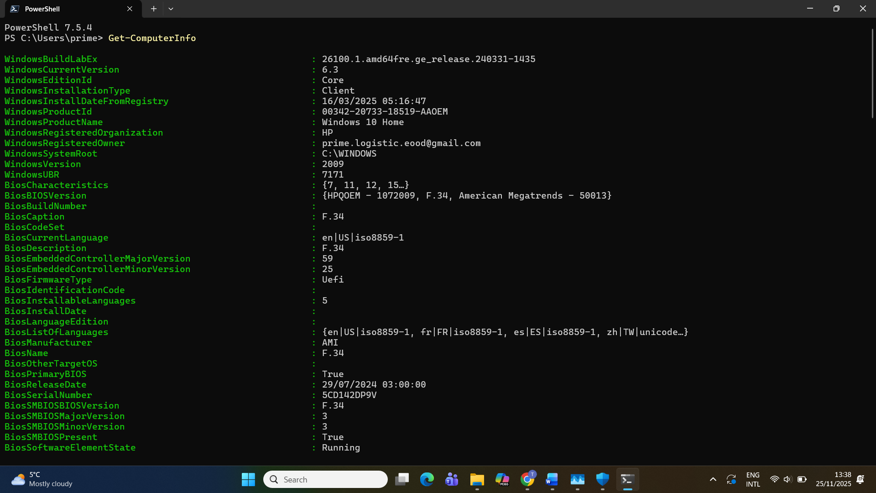
Command 8: Clear-Host
This command clears the PowerShell window. It is helpful for keeping the console clean while working.

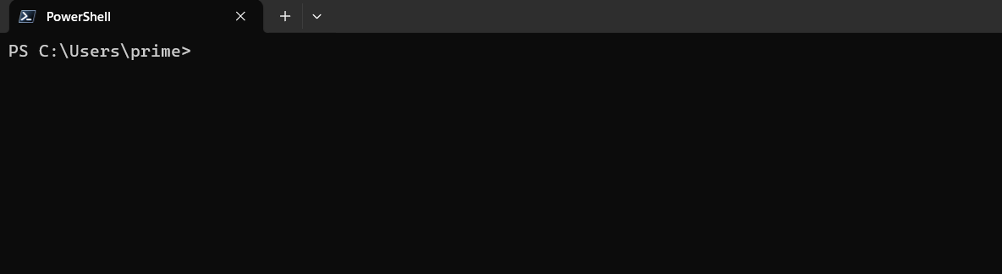

Command 9: Get-EventLog -LogName System -Newest 10
This command displays the 10 most recent system events. It is useful for identifying system errors or warnings.

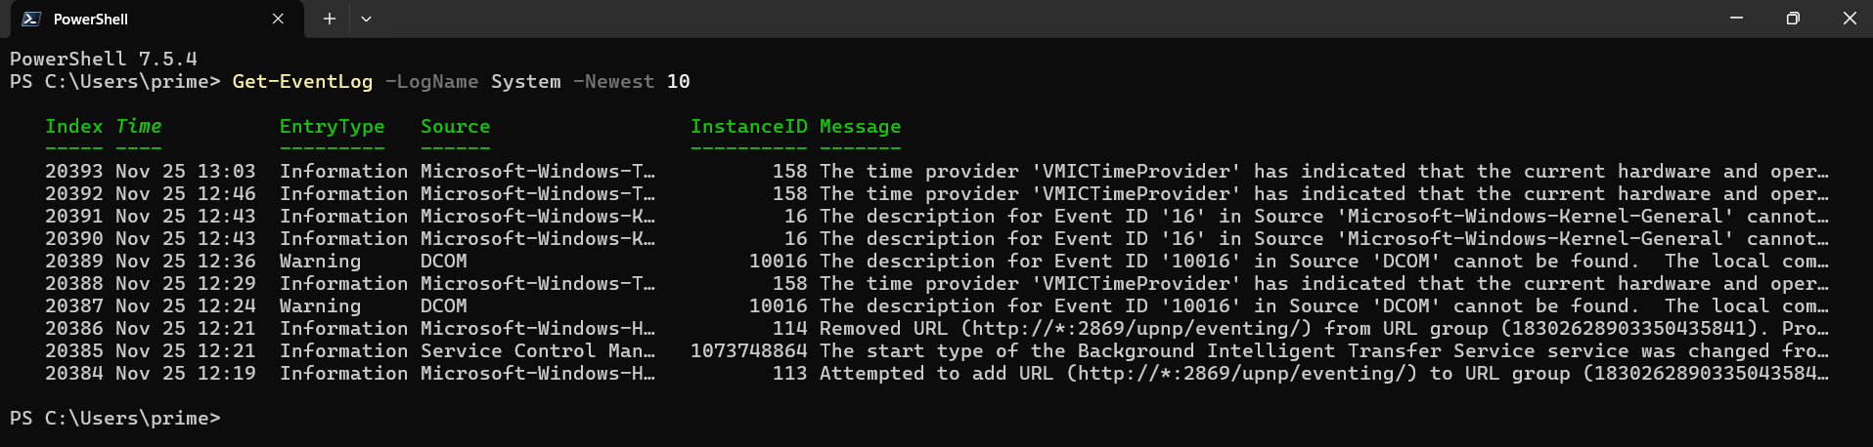

Command 10: Get-LocalUser
This command lists all local user accounts on the computer, which helps with user management and security.

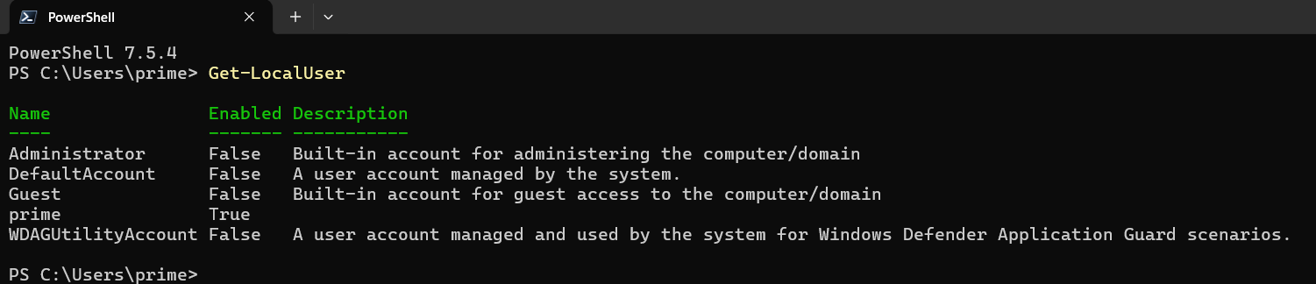

3. Use of Linux OS CLI commands.
This section demonstrates the use of ten Linux Bash commands. All commands were executed inside an Ubuntu virtual machine running in Oracle VirtualBox on my Windows laptop. [7] Using a virtual machine provides a safe and realistic environment for learning Linux, because it works like a real operating system without affecting the main computer. The terminal was used to run each command, and screenshots were taken to show the results. The explanations below describe what each command does and why it is useful. [8]
Command 1: ls
The ls command lists the files and folders inside the current directory. It helps the user see what items are available and is often the first command used when navigating in Linux.
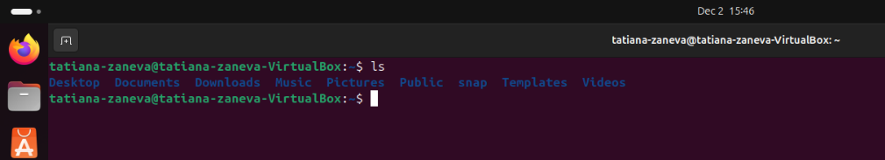
Command 2: pwd
The pwd command shows the current working directory. It helps the user know their exact location in the file system.
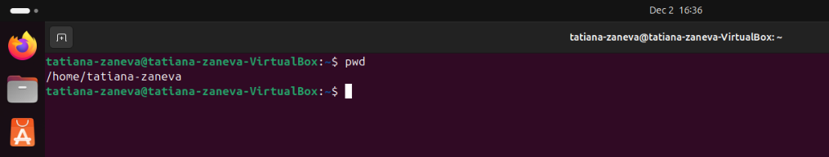
Command 3: whoami
This command displays the username of the current logged-in user. It is useful when working on systems with multiple accounts or when checking permissions.
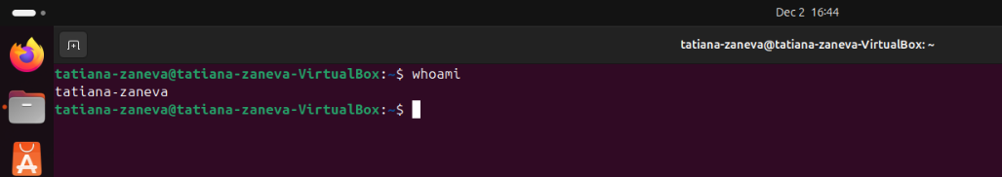
Command 4: hostname
The hostname command prints the name of the computer. This is helpful when working with networks or identifying a system inside a virtualised environment.
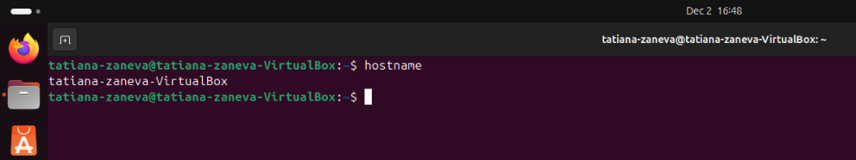

Command 5: date
This command shows the current date and time. It is often used for checking system time settings or adding timestamps to logs and scripts.
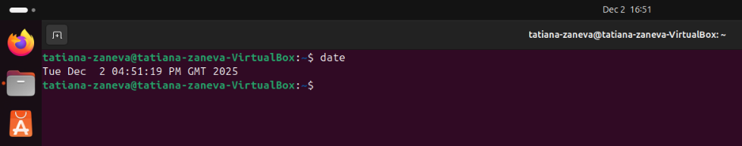
Command 6: mkdir demo
The mkdir command creates a new directory named demo. Creating folders is essential for organising files and structuring projects.
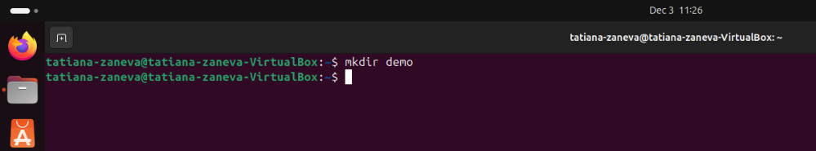
Command 7: touch notes.txt
This command creates an empty file named notes.txt. It is a quick way to prepare new files before adding content.
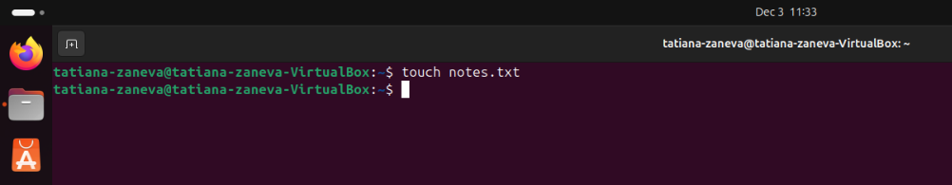
Command 8: echo "Hello Linux" >> notes.txt
The echo command prints text, and using >> appends the text to a file. Here it was used to write a short message into notes.txt. This is useful for adding notes or logging information.
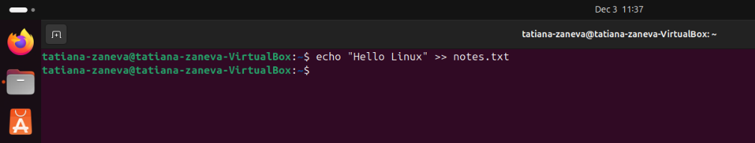
Command 9: cat notes.txt
The cat command displays the content of a file directly in the terminal. It allows quick reading of text files without needing a graphical editor.

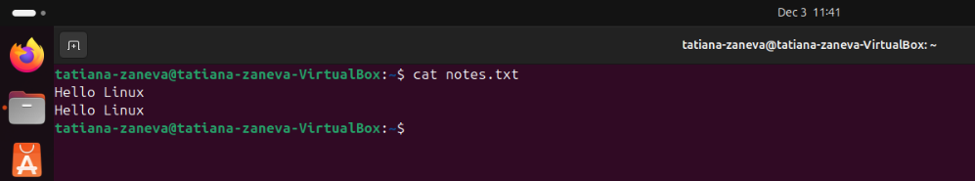
Command 10: free -h
This command shows the amount of RAM that is free and used on the system. The -h option makes the information easier to read. It is helpful for monitoring system performance.
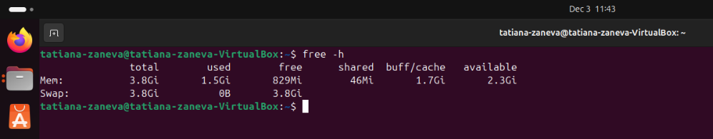

4. Use of Windows OS scripts.
This section demonstrates the use of PowerShell scripts in Windows. [6] PowerShell is a powerful automation tool that allows users to perform system tasks more quickly and with fewer manual steps. Scripts are commonly used for checking system health, managing files, and collecting information. Below are simple examples of scripts that were created and executed. Screenshots were taken after each script was run.

Script 1: Create a Folder Automatically

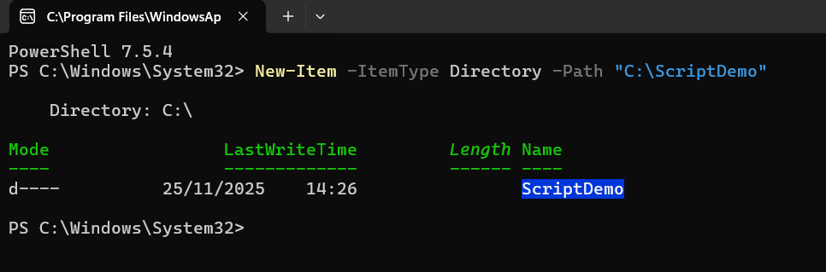
This script creates a new folder called ScriptDemo on the C: drive. It is useful for preparing directories for backups, projects, or file organisation.

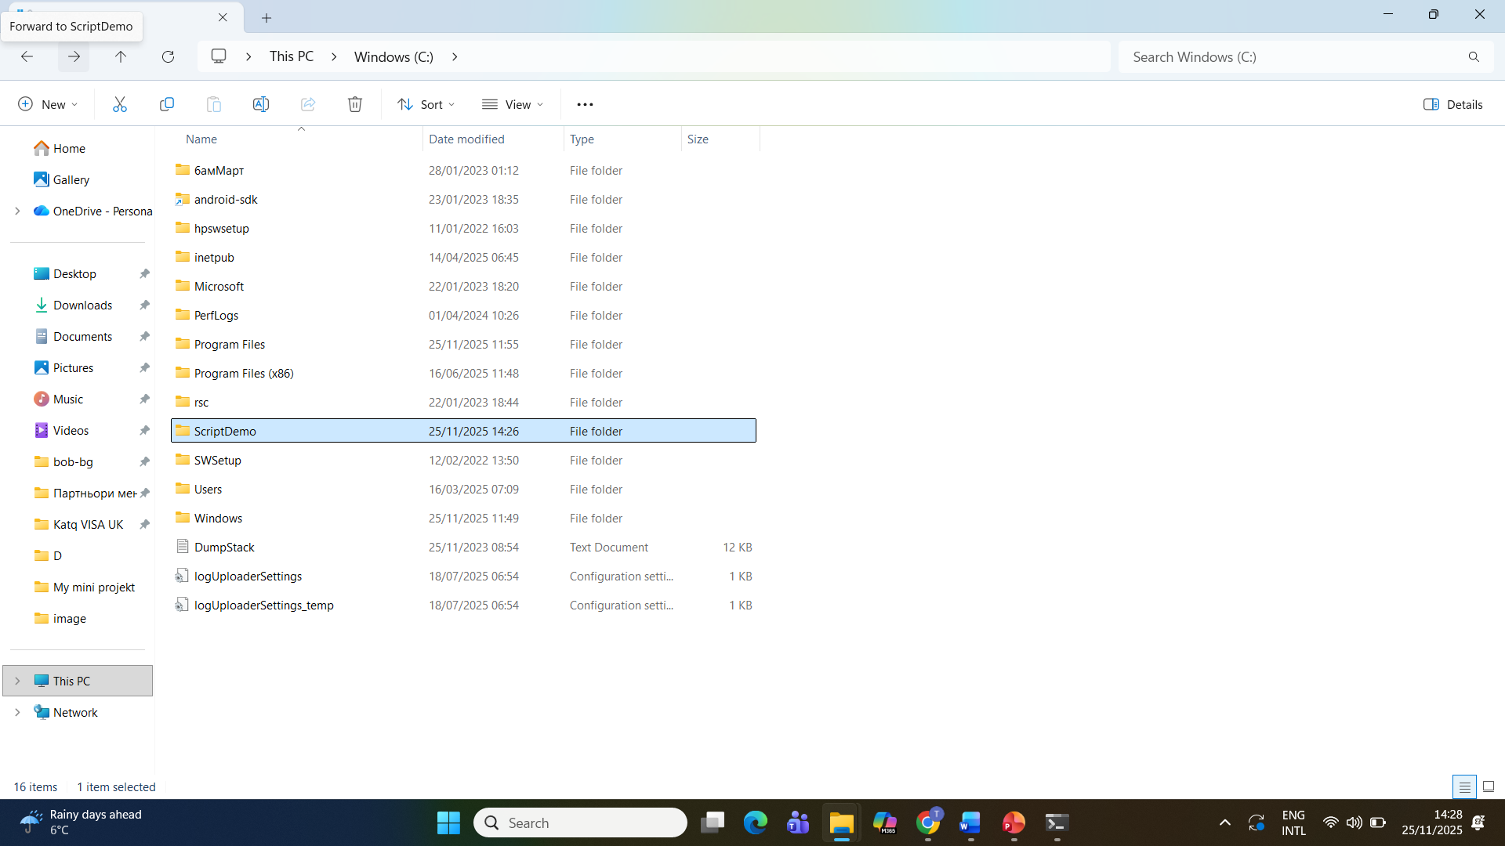

Script 2: Export Running Processes to a Text File

This script lists all running processes on the system and saves the information into a text file. It is helpful for troubleshooting performance problems, checking CPU usage, or keeping a log for later review.
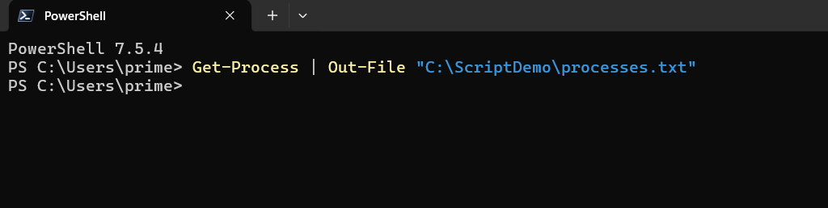

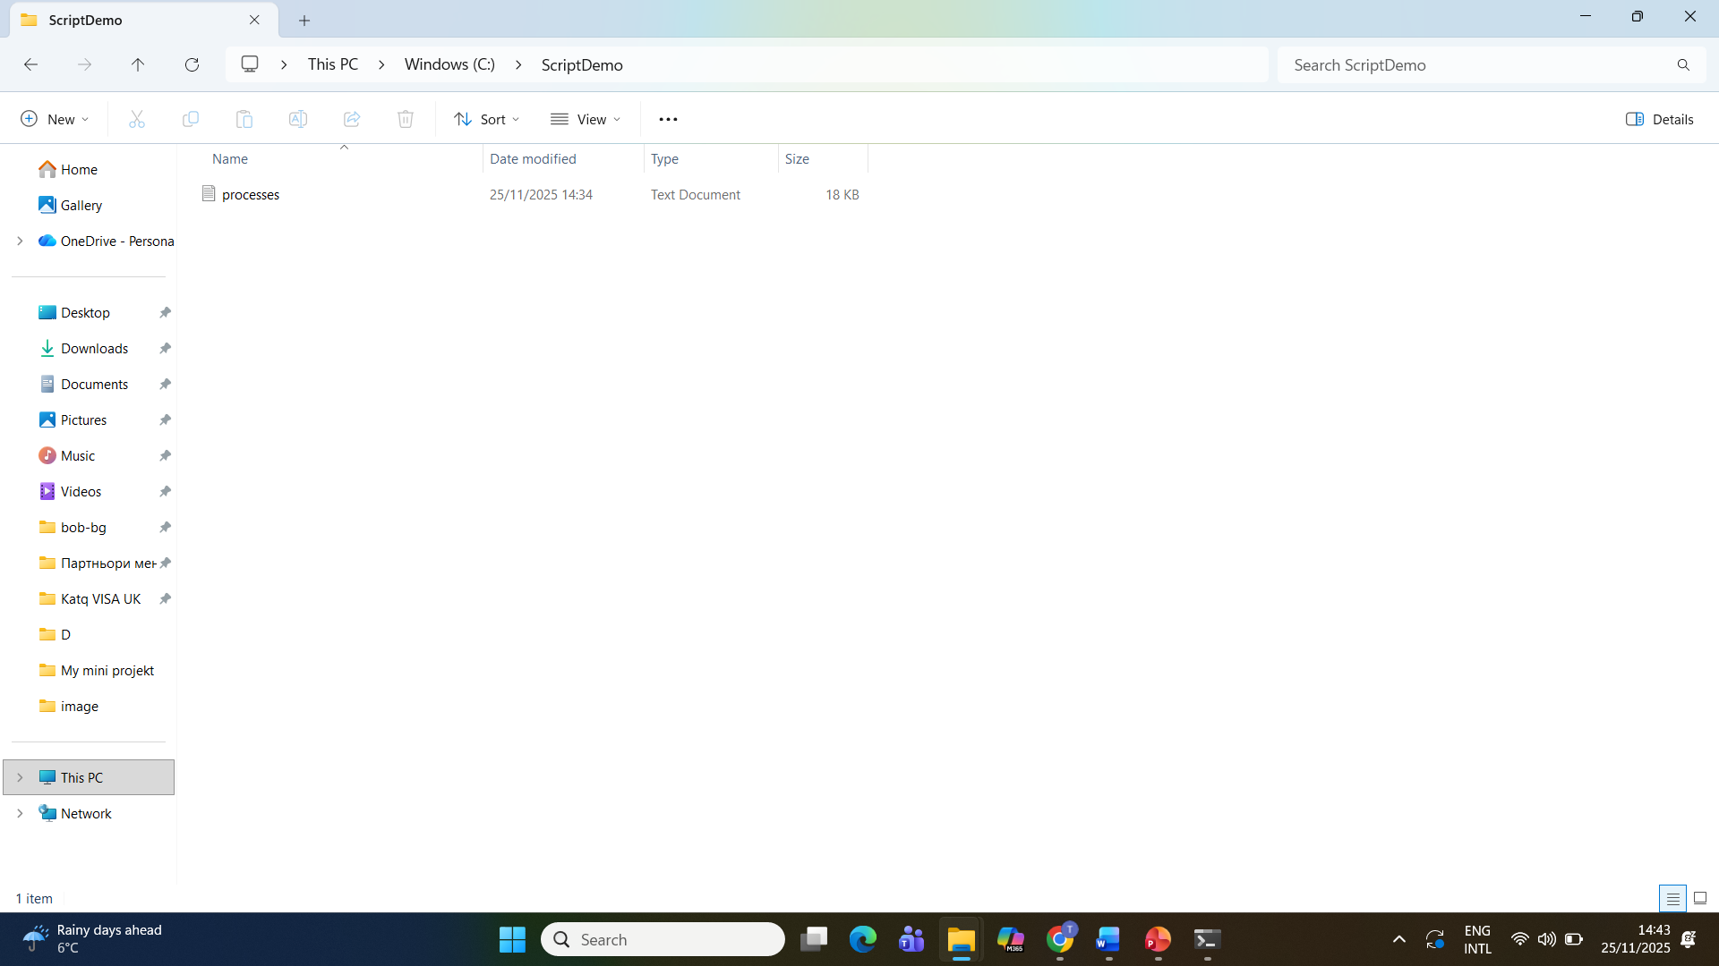

Script 3: Display Only Running Services
This script filters Windows services and shows only those that are currently running. It helps users understand which background tasks are active and whether important system components are functioning correctly.

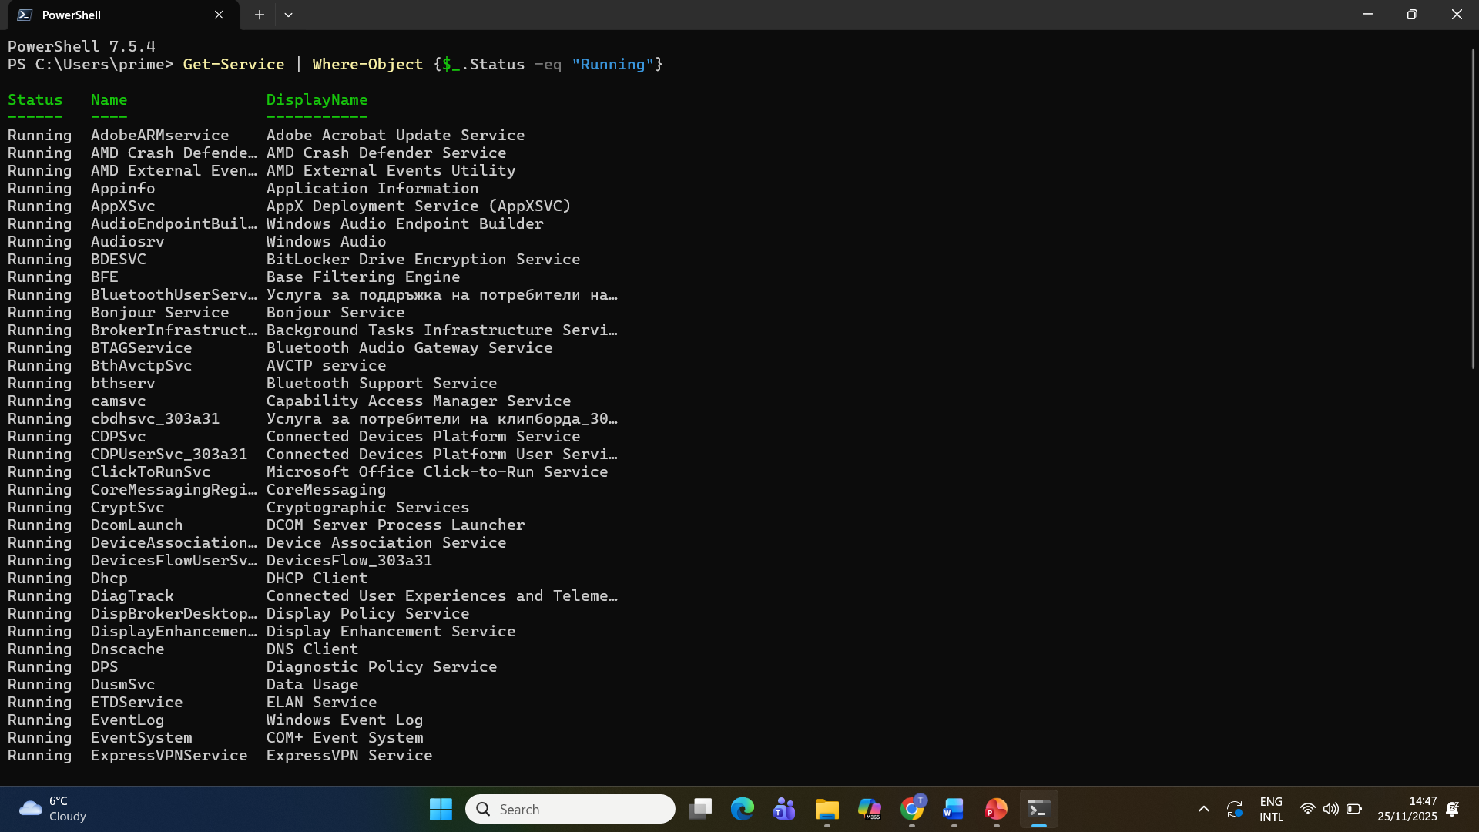
Key Features Demonstrated
- Automation: Scripts run tasks automatically without manual clicking.
- Filtering & output: PowerShell can filter system data and export it into files.
- System monitoring: Scripts help check the health of processes and services.
- File management: Scripts can create folders, move files, and generate logs.
These examples show how everyday administrative tasks can be simplified using PowerShell. Even basic scripts are useful for organising the system and improving efficiency.

5. Use of Linux OS scripts.
This section demonstrates the use of three Bash scripts in a Linux environment. [8] All scripts were created and executed inside an Ubuntu virtual machine running in Oracle VirtualBox on my Windows laptop. Using a virtual machine is safe and practical because it provides a controlled environment where Linux can be tested without changing the main system. Each script shows a different feature of the Bash scripting language. Screenshots were taken while creating, saving and running the scripts.
Script 1: Create a Folder Automatically
File name: createfolder.sh
This script creates a new directory called demo_folder in the current location. The mkdir command makes the folder, and the echo line prints a confirmation message on the screen. Such a script could be used when setting up the same folder structure for projects or backups on different systems.
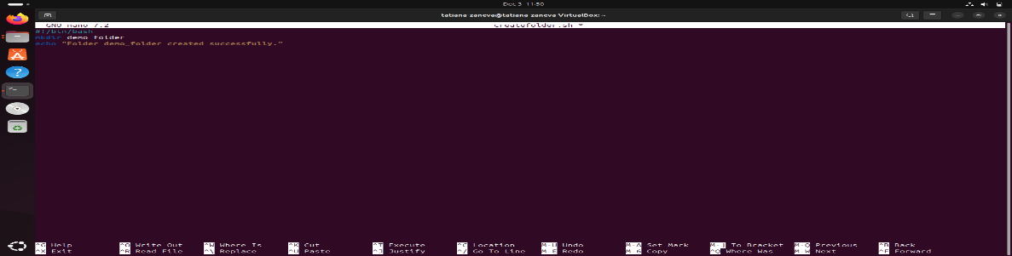
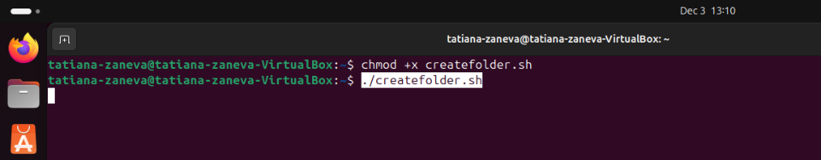
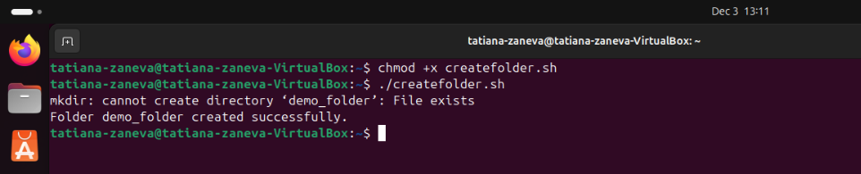
Script 2: Save System Information to a File
File name: systeminfo.sh
In this script, the uname -a command collects detailed system information, including the kernel version and architecture. The output is redirected into a text file called systeminfo.txt. This is useful for documenting the configuration of a machine or for sending system details to technical support.

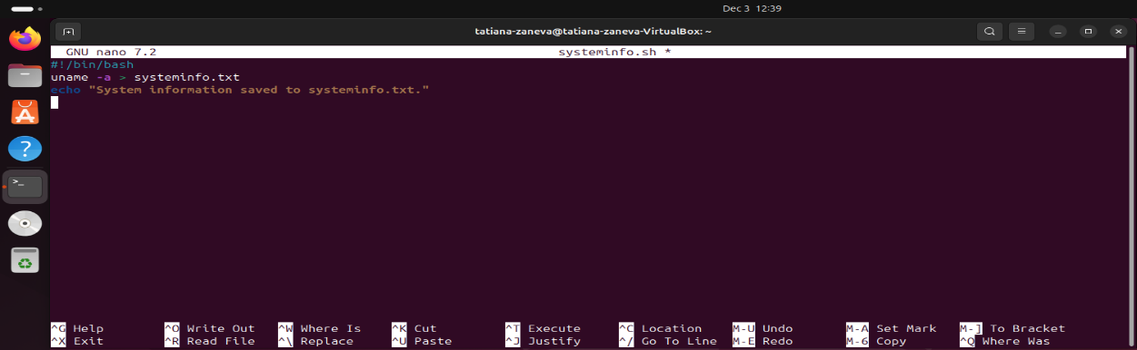

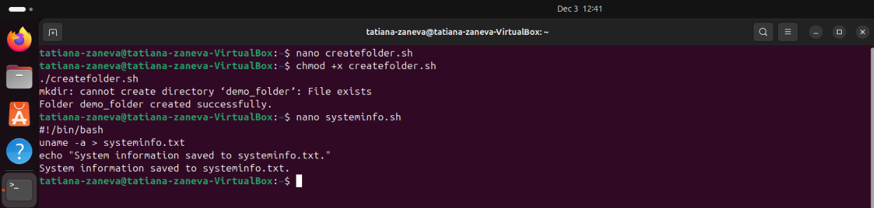

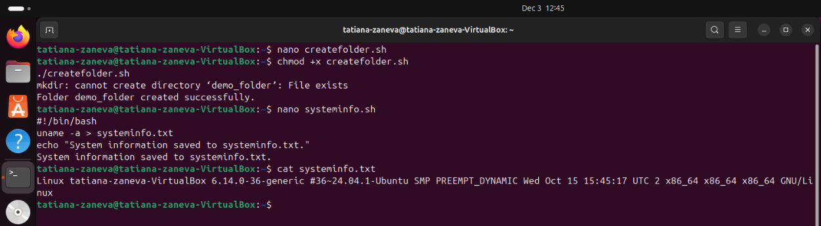
Script 3: Check Disk Usage
File name: diskusage.sh
This script uses the df -h command to show disk usage in a human-readable format. It displays how much storage is used and how much is available on each mounted partition. This is important for monitoring system performance and ensuring there is enough space for software or updates. Running it from a script makes it easy to repeat the check at any time.
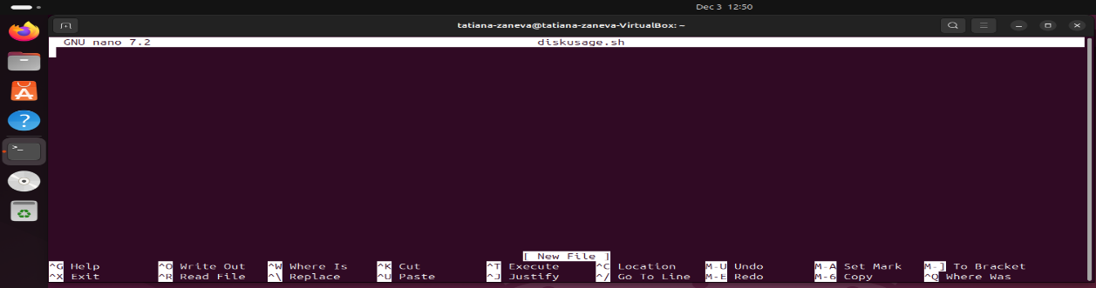

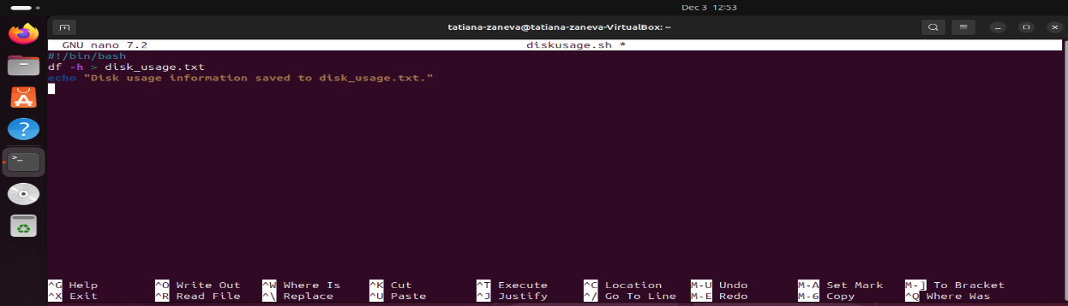

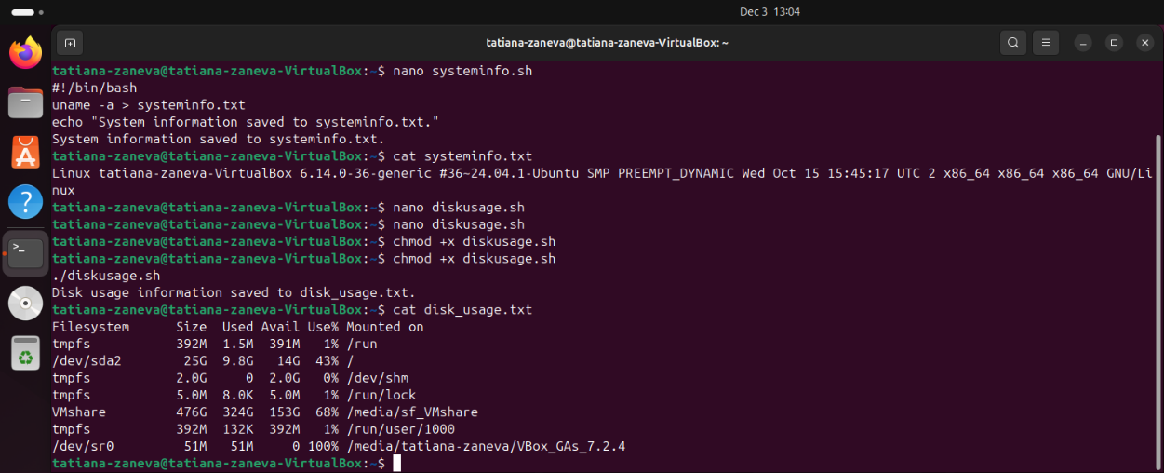

Conclusion
This report explained the key functions of modern Operating Systems and demonstrated practical skills in both Windows and Linux environments. [2] The tasks showed how an OS manages processes, memory, files and system security. The use of Windows PowerShell and Linux Bash commands highlighted how command-line tools can support monitoring, troubleshooting and system control. [6] Simple scripts were also created to automate routine tasks, such as creating folders, checking system information and reviewing running services. Overall, the activities improved understanding of how Operating Systems work and showed the importance of CLI tools for efficient system administration.

References

References

[1] | A. Silberschatz, P. Galvin and G. Gagne, Operating System Concepts, Hoboken: Wiley, 2018.
[2] | A. Tanenbaum, "Modern Operating Systems: Design and Implementation Aspects," ACM Computing Surveys, p. 1–35, 2019.
[3] | TechRepublic, "How to use Windows 10's Resource Monitor to track memory usage," [Online]. Available: https://www.techrepublic.com/article/how-to-use-windows-10s-resource-monitor-to-track-memory-usage/. [Accessed 27 August 2025].
[4] | OpenStax, "6.4 Memory Management - Introduction to Computer Science," [Online]. Available: https://openstax.org/books/introduction-computer-science/pages/6-4-memory-management. [Accessed 27 August 2025].
[5] | University of Bologna (cs.unibo.it), "File Systems," [Online]. Available: http://www.cs.unibo.it/~sangio/SO_currentAA/Luc_SO/FileSystem/File_Systems1.pdf. [Accessed 26 August 2025].
[6] | Varonis, "Windows PowerShell Scripting Tutorial For Beginners," [Online]. Available: https://www.varonis.com/blog/windows-powershell-tutorials. [Accessed 28 August 2025].
[7] | Hostinger, " Bash Scripting for Beginners + Downloadable Free Cheat Sheet," [Online]. Available: https://www.hostinger.com/tutorials/bash-scripting-tutorial. [Accessed 29 August 2025].
[8] | DataCamp, "How to Write a Bash Script: A Simple Bash Scripting Tutorial," [Online]. Available: https://www.datacamp.com/tutorial/how-to-write-bash-script-tutorial. [Accessed 29 August 2025].
[9] | AITS-TPT, "UNIT-I Operating Systems Functions," 26 August 2025. [Online]. Available: https://aits-tpt.edu.in/wp-content/uploads/2022/06/Operating_System-min.pdf.
[10] | Britannica, "Operating system (OS) | Definition, Examples, & Concepts," 26 August 2025. [Online]. Available: https://www.britannica.com/technology/operating-system.
[11] | UTC, "Chapter 8: Memory Management," [Online]. Available: https://www.utc.edu/sites/default/files/2021-04/2800-lecture8-memeory-management.pdf. [Accessed 26 August 2025].
[12] | MBIT, "Operating System Concepts, 8th Edition," [Online]. Available: https://www.mbit.edu.in/wp-content/uploads/2020/05/Operating_System_Concepts_8th_EditionA4.pdf. [Accessed 26 August 2025].
[13] | GeeksforGeeks, "How to Monitor System Activity in Linux | top Command," [Online]. Available: https://www.geeksforgeeks.org/linux-unix/top-command-in-linux-with-examples/. [Accessed 26 August 2025].
[14] | Testbook, "Process Management in Operating System - Learn Details Here!," [Online]. Available: https://testbook.com/operating-system/process-management-in-operating-system. [Accessed 27 August 2025].
[15] | Turing, "How to Use the Linux Free Command," [Online]. Available: https://www.turing.com/kb/how-to-use-the-linux-free-command. [Accessed 27 August 2025].
[16] | OpenStax, "6.5 File Systems - Introduction to Computer Science," [Online]. Available: https://openstax.org/books/introduction-computer-science/pages/6-5-file-systems. [Accessed 27 August 2025].
[17] | GeeksforGeeks, "df command in Linux with Examples," [Online]. Available: https://www.geeksforgeeks.org/linux-unix/df-command-linux-examples/. [Accessed 27 August 2025].
[18] | man7.org, "top(1) - Linux manual page," [Online]. Available: https://man7.org/linux/man-pages/man1/top.1.html. [Accessed 27 August 2025].
[19] | GeeksforGeeks, "System Protection in Operating System," [Online]. Available: https://www.geeksforgeeks.org/operating-systems/system-protection-in-operating-system/. [Accessed 27 August 2025].
[20] | Fiveable, "OS Security and Access Control | Cybersecurity and Cryptography Class Notes," [Online]. Available: https://library.fiveable.me/cybersecurity-and-cryptography/unit-5. [Accessed 28 August 2025].
[21] | PDQ, "10 PowerShell commands every sysadmin should know," [Online]. Available: https://www.pdq.com/blog/top-powershell-commands-to-know/. [Accessed 28 August 2025].
[22] | Active Directory Pro, "50 Basic Windows Commands with Examples," [Online]. Available: https://activedirectorypro.com/windows-cmd-commands/. [Accessed 28 August 2025].
[23] | NinjaOne, " How to Automate Repetitive Tasks with PowerShell," [Online]. Available: https://www.ninjaone.com/blog/how-to-automate-tasks-with-powershell/. [Accessed 28 August 2025].
[24] | Tom, " Essential PowerShell Commands for Beginners," [Online]. Available: https://medium.com/tomtalkspowershell/essential-powershell-commands-for-beginners-613bfa9cef82. [Accessed 29 August 2025].
[25] | It's FOSS, "Bash Scripting Tutorial for Beginners," [Online]. Available: https://itsfoss.com/bash-scripting-tutorial/. [Accessed 29 August 2025].
[26] | A. Silberschatz, P. Galvin and G. Gagne, Operating System Concepts, Hoboken: Wiley, 2018.

Appendices

