

BA (Hons) Leadership and Management

Student Name: Oliviu Munteanu
Student Number:2411169
Course Name: Understanding and Engaging stakeholders LCLM5001
Lecturer Name: Nadeem Mirza

Executive Summary
The involvement of stakeholders has been crucial for the development of the new wearable product of the company. The stakeholders have been divided into both internal and external groups. They have been listed according to their roles and responsibilities. The stakeholders can be involved in conflicts. Thus, their engagement, communication plans, and mapping have been devised. As the project manager, there has been the key responsibility to handle their conflicts so that they can combine to figure out the desired project outcomes.
In the field of technological adoptions, especially in the health care sector, understanding the challenges is extremely crucial in terms of developing a recommendation plan that can impact the performance of the organisation through a successful product launch. Thus, a complete knowledge of the internal and external business environment is significant, as it helps in developing SMART objectives for the project to achieve success.

Table of Contents
1. A brief introduction 3
1.1. Overview of the company 3
1.2. Outline of the project 3
2. Conduct a situational analysis of the chosen organisation 4
2.1. Application of the situation tools to create SMART Objectives for the project 4
3. Identification of the key stakeholders 7
3.1 Internal and external stakeholder identification 7
3.2 Significance of the stakeholders in the project by utilising the RACI Matrix 9
3.3 Benefits as well as challenges they face 12
3.3.1 Theoretical underpinning 12
3.3.2 Benefits 14
3.3.3 Challenges 15
4. Critical explanation of the process as the project manager to engage these key stakeholders and evaluation of methods 17
4.1 Engagement plan 17
4.2 Explanation of role and responsibilities as a manager to manage conflict 18
4.3 4C’s model engagement 19
5. Recommendations and evaluation of the impact of stakeholder engagement on business performance 21
5.1. Impact of stakeholder engagement on business performance 21
5.2. Recommendations 23
5.2.1. Developing a stronger feedback system for the stakeholders to ensure transparent communication 23
5.2.2.Developing strategic partnerships with Healthcare professionals and Technology experts 23
5.2.3. Investing in stakeholder education and awareness initiative 24
6. Conclusion 25
References 27

1. A brief introduction

1.1. Overview of the company
ConvaTech Group PLC is considered to be a British medical products and technology company situated in London, UK. It was established in 1978 and has been known across the UK for decades as a chronic care medical device provider. It employs more than 10,000 individuals and has earned an annual revenue of $2.89 billion and sells in 100 countries (Convatec Group, 2025). It operates in a highly innovative yet competitive environment where the vision revolves around providing trusted medical solutions to people suffering from chronic conditions.
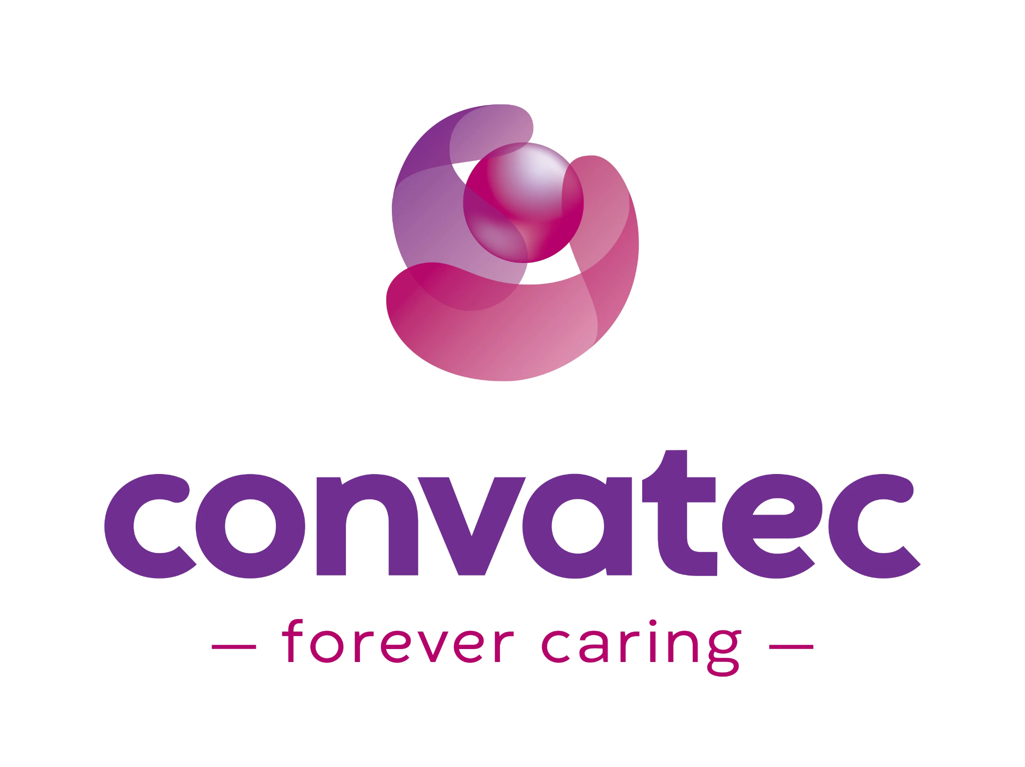
Figure 1: Company Logo
(Source: Convatec Group, 2025)

1.2. Outline of the project
Digital technologies have created enormous solutions for patients to monitor their health, provide personal care, and ensure overall well-being. Thus, the organisation is focusing on preparing the launch of a new wearable device that not only measures heart rate but also maintains oxygen saturation and sleep patterns of the subjects. Thus, the report focuses on the launch of the product in the market within 6 months through effective project management and strong stakeholder engagement strategies (Christopher, Payne and Ballantyne, 2013). As an appointed manager, it is extremely crucial to coordinate with the stakeholders to ensure that the device makes a successful launch in the marketplace.

2. Conduct a situational analysis of the chosen organisation

2.1. Application of the situation tools to create SMART Objectives for the project
Strengths | Strong R&D and proven medical device experts.
Weakness | High production cost and lengthy approval process.
Opportunities | Drawing demand for Digital health and remote monitoring.
Threats | Intense competition and rapid technological changes.
Table 1: SWOT Analysis
(Source: Self-developed)
Political | Supportive health policies.
Economic | Economic shifts like inflation affect prices.
Social | Rising interest in wellness devices.
Technological | Rapid innovation boosts product potential.
Environmental | Demand for eco-friendly production.
Legal | Strict data and safety rules.
Table 2: PESTEL Analysis
(Source: Self-developed)
Objective | Specific | Measurable | Achievable | Relevant | Time-bound
Ensuring successful product development and testing | Finalising device hardware, software and user interface features for accurate heart rate, oxygen saturation and sleep pattern tracking. | Tracking prototype performance indicators, number of tests completed and percentage of issues solved during the trials. | Collaborating with the research and development team, engineers and clinical testers for completing all stages of quality and safety testing (Torok, Sam and Hebert, 2024). | Successful development helps in engineering, and the device has reliability and prepares the organisation for a smooth launch. | End of fourth month.
Enhancing stakeholder engagement for launch | Developing a structured engagement plan by involving internal teams, suppliers, regulators, health professionals and consumer groups. | Measuring the number of engagement meetings, surveys, workshops and feedback sessions conducted. | Using existing communication resources and assigning a dedicated engagement ring for managing stakeholder introduction. | Effective stakeholder involvement improves product readiness and mitigates the risk for ensuring strength in market acceptance (Christopher, Payne and Ballantyne, 2013). | End of the second month.
Strengthening communication and marketing readiness | Creating integrated communication plans during digital campaigns, awareness sessions, educational content and launching the materials (Ellis, Gibbs and Rein, 1991). | Monitoring the number of campaigns launched, engagement rates and social media Analytics. | Coordinating with the Marketing, design and health education team for preparing campaign assets. | Improving communication is crucial for ensuring consumer awareness and securing early adoption for the variable device. | End of the third month.
Ensuring regulatory and compliance approval | Preparing all the required documentation, safety test summary, clinical data and rays assessment report for submission to relevant authorities. | Tracking approval progress, number of documentation rounds and compliance check completion rates. | Pairing with regulatory Experts and legal Advisors for ensuring documentation meets standards (Youssef, Blanchard and Hammad, 2024). | Regulatory approval is crucial for launching the legal health device in the market. | Completion by the end fourth month.
Achieving high customer satisfaction at launch | Conducting pre-launch user testing, gathering feedback and refining features based on the requirements of consumers and usability data (Hertzum, 2022). | Measuring customer satisfaction scores, the number of better test participants and the feature improvement percentage. | Using customer feedback to make data-driven improvements and working closely with the quality and UX team. | High satisfaction at launch improves brand trust and supports long-term market success. | Completing initial User experience testing by the end of the third month and making final improvements by the end of 5th month.
Table 3: SMART Objectives
(Source: Self-developed)

3. Identification of the key stakeholders

3.1 Internal and external stakeholder identification
Stakeholders' names | Roles | Responsibilities
Internal
Product development team | Their role has been to develop and design new products of medical substances, such as new wearable health devices, so that the company can get competitive advantages and the existing ones can also be improved. | They have the responsibility to translate any clinical need into product categories (Convatec Group, 2025).
Marketing team | The team has the role of promoting and positioning the products of Convatec, such as new wearable health devices, in the UK market. | They have the responsibility to conduct the analysis of the UK healthcare market and research regarding the competitors (Aksoy et al., 2022).
Sales department team | They drive the core sales and establish relationships with the provider of healthcare. | They manage several key accounts involving clinics. Hospitals and distributors (Convatec Group, 2025). They provide demonstrations of the product, in this case, the new wearable health device, to the healthcare professionals and patients.
Research and Development Team | They take the role to innovate new immersive technologies, conduct clinical investigations, and support the involvement of regulatory compliance. | They conduct clinical research and scientific studies for new wearable health devices.
External
Patients and carers | They have the role of being the end user. They accept the products under several segments of the Convatec Group, such as new wearable health devices. | They provide the major feedback on the effectiveness and usability of the product.
Healthcare professionals | They are the clinicians who use, prescribe, and evaluate the products of the company. | They recommend the product based on the needs of the patients (Roshangarzadeh, Kim and Shahrokhi Tehrani, 2025).
Regulators | The regulatory bodies, such as the UK Government (Medicines and Healthcare products Regulatory Agency), the European Union Authorities, and others, have the role of approving medical devices and products and ensuring the compliance of the company with regulations of health and safety (UK Government, 2025). | They review and approve the submission of the products of the company.
Investors | They provide financial capital so that the company can be facilitated in operations, and they oversee corporate governance. | They have the responsibility of evaluating the performance as well as the growth strategy of the company (Convatec Group, 2025).
Table 4: Stakeholder names, roles, and responsibilities
(Source: Self-Developed)

3.2 Significance of the stakeholders in the project by utilising the RACI Matrix
Project activity | Product development team | Marketing team | Sales department team | Research and Development Team | Patients and carers | Healthcare professionals | Regulators | Investors
The identification of the marketing needs and definition of the | R | C | C | C | C | C | I | I
The development of the idea and the creation of prototypes of the new wearable health device | R/A | I | I | C | C | C | I | I
Technological progress and device engineering | R | I | I | A | I | C | C | I
Trials by users and validation by clinical teams | C | I | I | R/A | C | C | C | I
Regulatory approvals | C | I | I | R/A | C | C | C | A
Branding | C | I | I | R | I | I | C | A
Launch of the product | I | C | R/A | I | I | C | I | I
Post-marketing support | R | I | C | C | C | C | A | R
Surveillance and final batch production with further decision | I | I | C | I | I | I | I | C
Table 5: RACI matrix inclusion or the assessment of the importance of the stakeholders
(Source: Self-Developed)
In the RACI matrix, R signifies responsibility, A signifies accountability, C signifies the consulted aspect, and I signifies the informed aspect (Ashcroft et al., 2017). The stakeholder engagement in the new project, such as the development of the new wearable health device by the company, can be beneficial for the long-term operational growth and sustenance in the UK market. Therefore, their importance based on the inclusion of the RACI matrix needs to be analysed so that they can have a strong influence on the new product development and marketing.
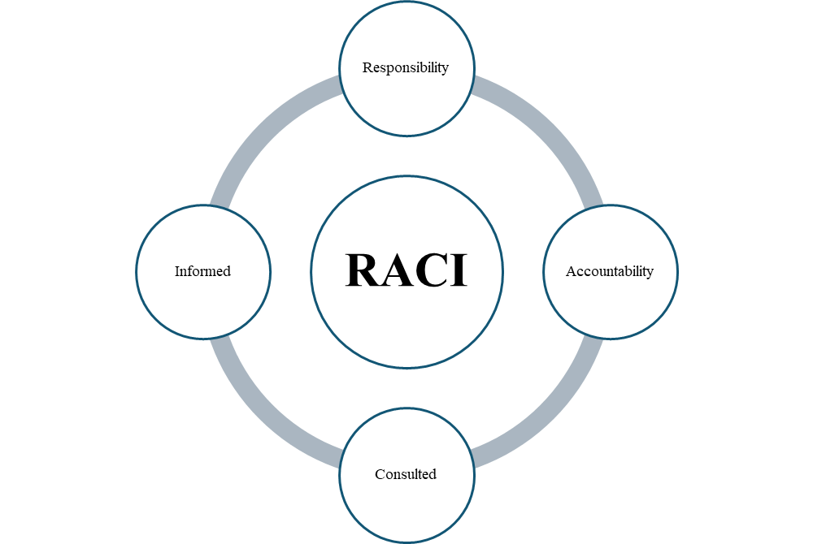
Figure 2: The RACI matrix
(Source: Self-Developed)

3.3 Benefits as well as challenges they face

3.3.1 Theoretical underpinning
The theory of stakeholders, which is renowned as the Freeman stakeholder theory, can be applied in this situation (Twala and Kekwaletswe, 2019). This has been emphasised in the creation of the core organisational value based on the involvement of all stakeholders of any company. This is therefore focused on the inclusion of the role of the stakeholders of any company, rather than deciding the provision of the importance to only shareholders.
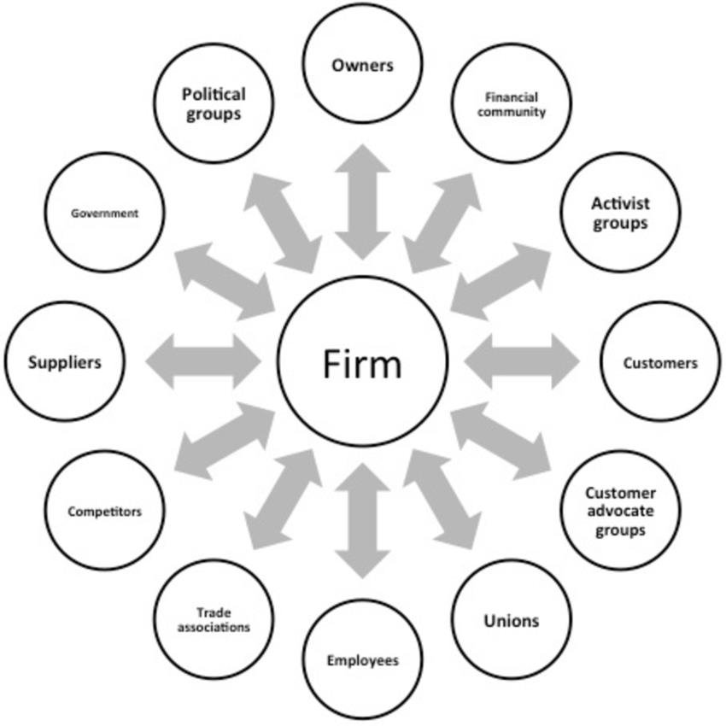
Figure 3: The stakeholder theory suggested by Freeman
(Source: Twala and Kekwaletswe, 2019)
Based on this theory, it can be argued that the companies can succeed by the creation of value for stakeholders, and in this case, Convatec Group can also get the core benefit of the project facilitation of the inclusion of a new wearable health device that can be helpful in tracking oxygen levels and heart rate alongside sleep patterns.
Another theory which can be engaged to determine the benefits the engaged stakeholder can get in the project management is the stakeholder silence theory suggested by Mitchell, Wood, and Agle. They indicated that the importance of the self is dependent on the urgency, power, and legitimacy (PLU) (Almeida, Rocha, and Fonseca, 2019). This can help to explain the challenges when any influential stakeholder can demand attention or create a conflict, which can exert pressure on the deliverables or the timeline of the project.
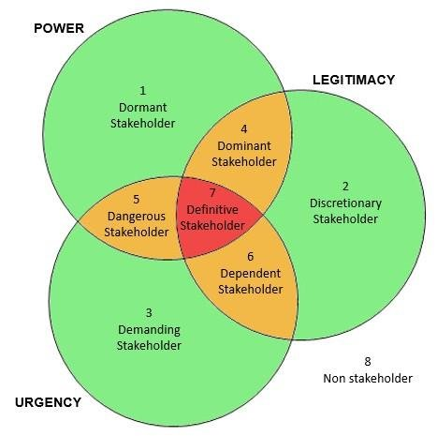
Figure 4: Analysis of the stakeholder salience based on the division of urgency, power, and legitimacy
(Source: Almeida, Rocha and Fonseca, 2019)

3.3.2 Benefits
The product development team can provide the benefit of providing technical expertise, which can help convert user needs into functional product development for this project, the new wearable device, which can help patients track vital information (Convatec Group, 2025). The marketing team can help to shape the position of the brand so that there is strong demand for the product at the launch. The sales department can provide the insights which can help the company to analyse the requirements of the customers and the products that the competitors have already launched. The research and development team can identify the innovative sensors along with more applicable algorithms so that this can improve the accuracy compared to the ones the competitors have launched in the market, and the patients can co-create the device improvements based on the user testing (Yang, 2024). The healthcare professional may influence the core acceptance among the medical communities, parents, and users, thus costing the credibility of the device. The UK governmental regulatory bodies can provide structural guidance to the company so that it can help prevent any future recall of the product (UK Government, 2025). The investors invest the financial capital so that their confidence can influence the market credibility of the company.
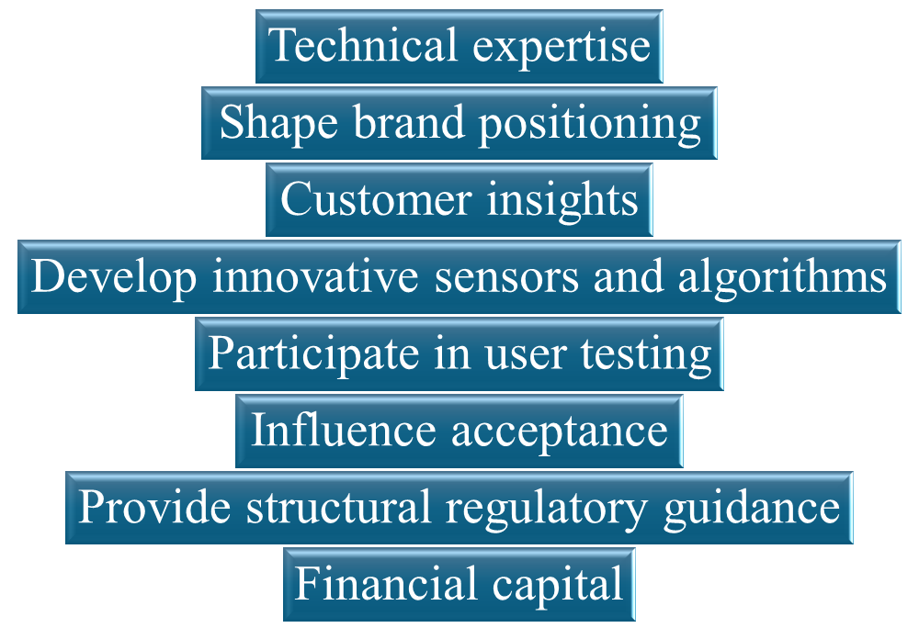
Figure 5: Listing of all benefits
(Source: Self-Developed)

3.3.3 Challenges
Apart from the key benefits, in this core project, the stakeholder may also face several challenges, which can hamper their engagement in the project. The team of product developers can face the issue of the high pressure of workload, as the project only has 6 months to be launched to the customers (Palacio et al., 2022). The marketing team may face the concern of the marketing deadline-based conflicts with the developmental pace of the product development team. The sales department can determine the core challenge of sales urgency evaluation, and they may also demand features that can increase the cost or extend the deadline of the project, which can impact the recognition and reputation of the company. Clinical testing delay may occur, which can be faced by the research and development experts of the company. The conflicting feedback may impact the launch and the marketing of the device, which can be gained from the users of the product (Kaygan and Kaygan, 2025). The healthcare professional may face the issue of product acceptance and the lack of an effective strategy to communicate about the device. The regulatory approvals may be delayed due to any issue, which can imply a challenge for the UK governmental regulatory bodies. The investors, though, have high expectations; they can face the risk of dissatisfaction.
Stakeholder mapping:
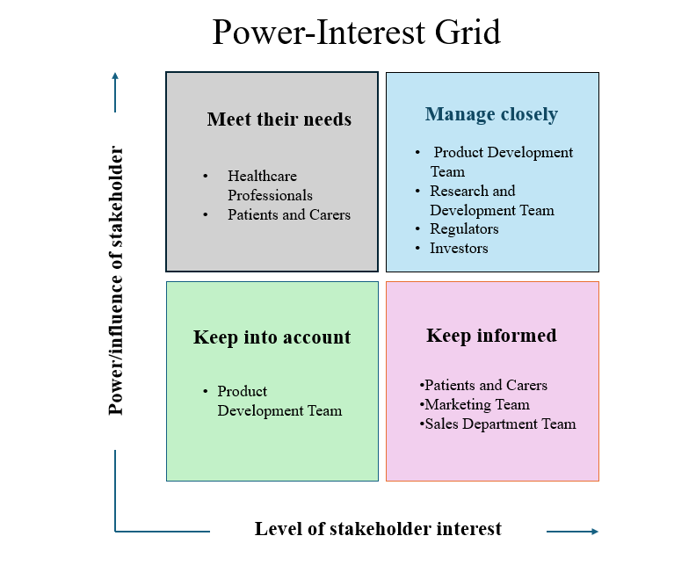
Figure 6: Mapping of Stakeholders Based on Mendelow's Matrix
(Source: Self-Developed)
Communication plan
Stakeholders | Information | Method of communication | Frequency
Product development team | The requirements of the final product | Meetings | Weekly
Marketing team | Features of the product, campaign information | Audits, meetings | Monthly, weekly
Sales department team | Product specification and strategy of pricing | Sales briefing | Monthly
Research and Development Team | Technological updates, the outcomes of testing. | Review sessions | Regular
Patients and carers | Usability information | Testing sessions, surveys | Regular
Healthcare professionals | Clinical feedback | Advisory meetings, audits | Quarterly
Regulators | Complaint documentation | Meetings | Annually
Investors | Project progress information | Reports | Monthly, quarterly
Table 6: Communication Plan
(Source: Self-Developed)

4. Critical explanation of the process as the project manager to engage these key stakeholders and evaluation of methods

4.1 Engagement plan
Stakeholder name | Current level | Desired level
Product development team | Supportive | Leading
Marketing team | Neutral | Supportive
Sales department team | Neutral | Supportive
Research and Development Team | Supportive | Leading
Patients and carers | Unaware | Supportive
Healthcare professionals | Neutral | Supportive
Regulators | Neutral | Supportive
Investors | Supportive | Leading
Table 7: Engagement Plan
(Source: Self-Developed)

4.2 Explanation of role and responsibilities as a manager to manage conflict
As the manager of this particular project, the inclusion of the creation of a harmonised project management environment can be crucial when the situation requires engagement with the stakeholders, so that the project can achieve the desired outcomes and reach the milestone of the production of a new wearable device and be launched within 6 months. The role of the project manager is to anticipate, manage, prevent and resolve the major conflicts which can arise among the group of stakeholders (Voola et al., 2024). As the project has involved multiple stakeholder diversifications, such as marketing, sales, research and development, as well as external stakeholders such as patients and healthcare professionals, the conflict can be determined as one of the inevitable aspects; therefore, effective conflict resolution can be done based on the early identification of the source of the conflict so that the conflict cannot trigger the project's success point (Ashcroft et al., 2017). This can be done based on the proper communication, engagement and mapping plan of the stakeholders. Moreover, the responsibility and the role of the project manager are to establish the responsibilities and a clear role so that there would not be any ambiguity in the role. This may cause conflict in cross-functional projects; in this case, the devising of the new wearable device for the patients by Convatec Group.
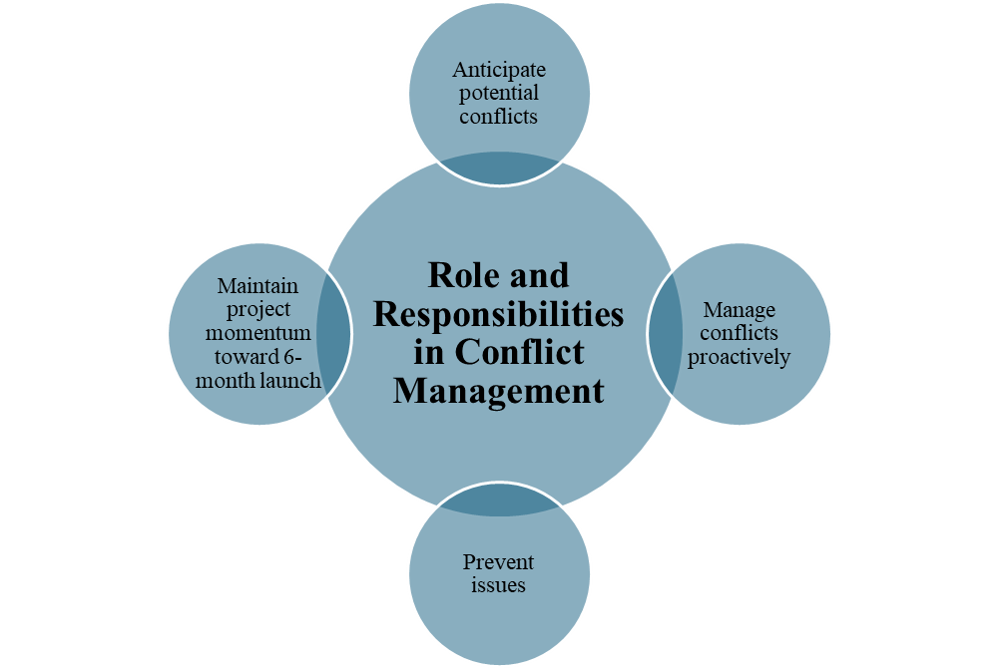
Figure 7: Role and responsibilities identification
(Source: Self-Developed)

4.3 4C’s model engagement
Communication: The 4C model implements several core aspects which can help stakeholders to be engaged effectively within the project (Thornhill-Miller et al., 2023). In this project, to determine the faster launch of a new wearable device developed by the production team of the company, proper communication between cross-functional stakeholder groups is needed. In the key context of the product launch, uncertainties can occur related to the medical compliance, technological feasibility, or the readiness analysis of the market. Therefore, the responsibility of the project manager is to mitigate the conflicts among the stakeholders by developing clear engagement, communication, and collaboration strategies so that this can ensure proper information flow and proactive communication among the stakeholders to reduce the gaps in interaction.
Coordination: The stakeholder conflict can be mitigated based on the proper strategy development for the coordination of the several personnel engaged in the project. The conflict can occur at the time of the management of cross-functional workflows, and the synchronisation of the project timeline with the role definition may involve ambiguity (Salybekova et al., 2023). Thus, the project manager needs to facilitate the interdepartmental meetings and ensure the clarification of roles as well as responsibilities by dividing the stakeholders into internal and external groups. Conflict management can also be done based on aligning the product readiness evaluation with the sales information analysis, which can reduce the tension between the technical team and the sales and marketing teams.
Cooperation: On the contrary, there is a basic need for cooperation among every stakeholder group in this particular project. Cooperation is conflict management, referring to the assessment of the commitment of persons to support the goal attainment of any project. In this project of launching the wearable device by the company, the conflict may occur at the time when the marketing or sales department needs any extra feature that can push the cost of the project for Convatec Group or can threaten the extension of the project deadline (Ashcroft et al., 2017). Therefore, conflict management is to be done by the project manager based on facilitating the responsibilities of creating the environment related to psychological connectedness, where each stakeholder can be inspired to give their feedback and raise their concerns.
Collaboration: Another aspect which is also significant for the project is the manner in which to handle the conflict in collaboration (Angus and Newton, 2020). Joint ownership issues or conflicts may occur when there is a lack of shared decision-making during the development of a new product and its market launch. Thus, project management can mitigate the conflicts among the stakeholders by facilitating the co-creational space, which can help to combine all the stakeholder groups for this particular product development and share their ideas to refine the accuracy of the device, meet the project outcomes, and gain maximised consequences. Mo
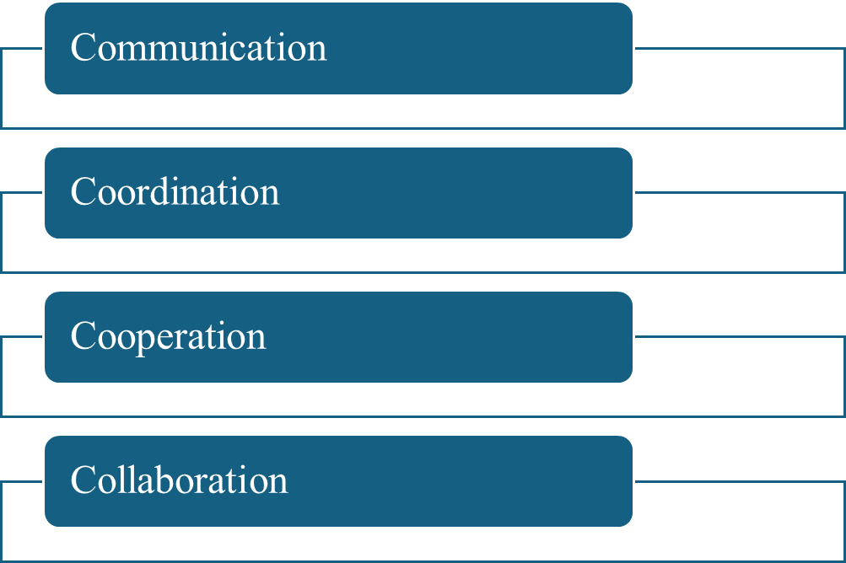
Figure 8: 4C model
(Source: Self-Developed)

5. Recommendations and evaluation of the impact of stakeholder engagement on business performance

5.1. Impact of stakeholder engagement on business performance
In the situation of healthcare innovations, for launching a new wearable health device that is designed to track heart rate, oxygen levels, and sleep patterns, it is crucial to maintain stakeholder engagement. Engaging stakeholders like regulatory bodies, suppliers, employees, technological partners, and healthcare professionals helps in ensuring high quality of the product in terms of meeting the market expectations (Youssef, Blanchard and Hammad, 2024). This directly influences the operational efficiency in terms of providing the business with long-term performance. It can be observed that stakeholder engagement is extremely crucial in terms of enhancing the effective decision-making process and providing company benefits. This helps in ensuring that the employees have a return on debt, provides better performance, and helps in finding early risk for future development (Christopher, Payne and Ballantyne, 2013). This results in enhancing team motivation as well as increasing organisational productivity.
Another significant factor is of supplier and manufacturer's reach that plays a central role in ensuring stronger stakeholder engagement. It helps in understanding the product delays in terms of providing strategies that help in increasing the performance. Furthermore, it also reduces costs in terms of improving effective supply chain optimisation. Furthermore, enhancing stronger relationships with the suppliers also helps in enhancing the credibility of the brand in terms of allowing new partners to join the team (Torok, Sam and Hebert, 2024). Thus, it can be understood that regulatory compliance is important for the healthcare industry in terms of adopting any kind of new product. Hence, it is significant to engage with the stakeholders for managing the industry standards, medical procedures, and compliance for further development.
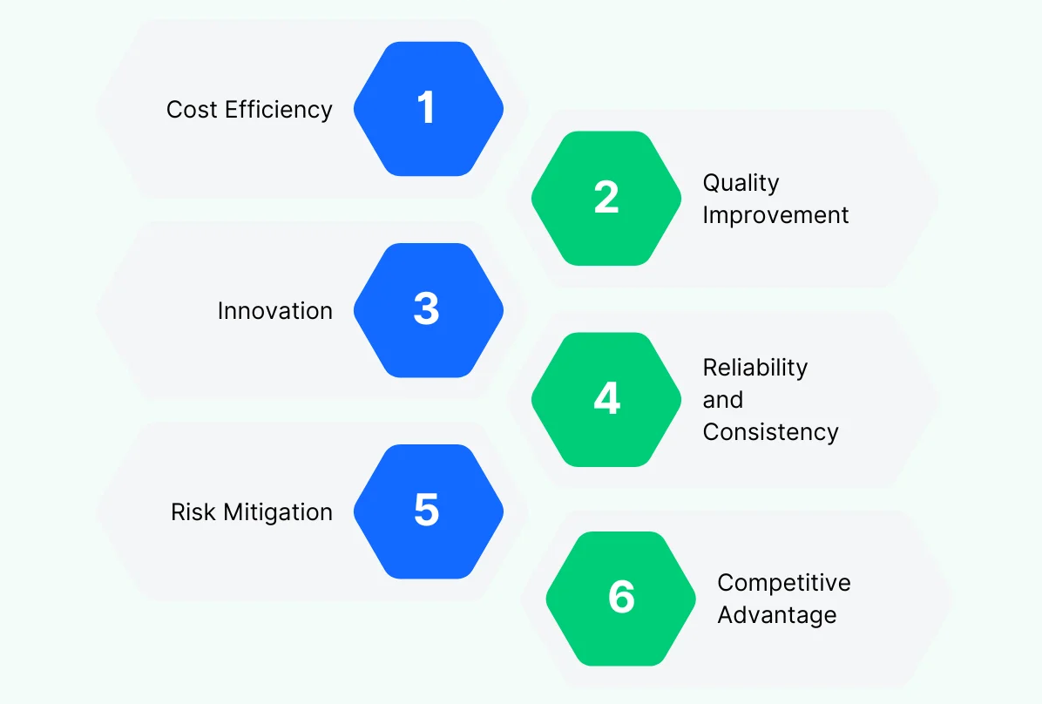
Figure 9: Significance of developing stakeholder relationships
(Source: Torok, Sam and Hebert, 2024)
It can be stated that healthcare professionals mainly focus on the accuracy of providing effective healthcare services. Therefore, it is crucial to take feedback from the employees in terms of understanding whether the medical device will be reliable and can help in gaining competitive advantages. This will result in gaining enormous consumer trust in terms of increasing the credibility of the brand. Furthermore, collections of feedback also help in shaping the brand image in terms of ensuring consumer loyalty. Therefore, considering the above statements, stakeholder engagement not only impacts the business performance massively but also helps in ensuring the successful launch of the product (Emmanuel, 2025). Furthermore, it maintains that innovations go through ethical strategies that motivate employees as well as consumers. Therefore, the reputation of the company continuously revolves around choosing proper stakeholders for launching products based on technological adoption.

5.2. Recommendations

5.2.1. Developing a stronger feedback system for the stakeholders to ensure transparent communication
Ensuring transparent communication is extremely crucial for maintaining feedback systems, especially while developing stakeholder relationships. This is often done by deploying platforms through which stakeholders and company members can communicate with each other, which can help them to share their own experiences. Furthermore, a continuous feedback loop can help in identifying the technical issues by enabling the company to adapt quickly to the requirements of the consumers (Ellis, Gibbs and Rein, 1991). These systems will help in ensuring consumer trust and developing transparent communications with an open dialogue that will increase brand loyalty and form stronger relations.
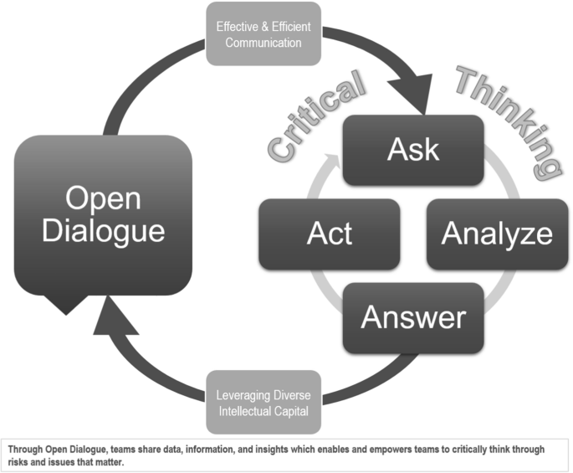
Figure 10: Importance of open dialogue in enhancing transparent communication
(Source: Torok, Sam, and Hebert, 2024)

5.2.2.Developing strategic partnerships with Healthcare professionals and Technology experts
The organisations can ensure formal partnerships with healthcare providers, technological companies, and wellness centres to support the launch of new products successfully. These partnerships can help in ensuring collaborative development for understanding the advanced future health requirements. Furthermore, working closely with the experts will help in ensuring credibility and understanding the importance of innovation in technology (Zamiri and Esmaeili, 2024). Long-term partnerships will also help in increasing the reputation of the organisations in the marketplace and will reach a wide number of professional healthcare settings for providing additional revenue.
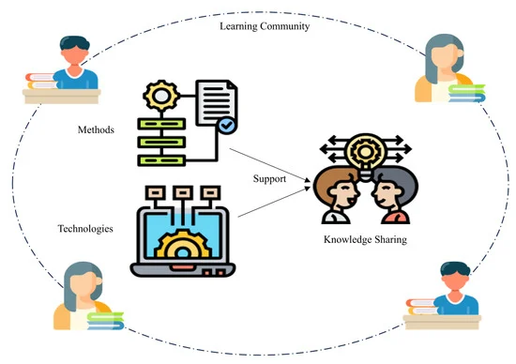
Figure 11: Ensuring credibility among stakeholders through technology
(Source: Zamiri and Esmaeili, 2024)

5.2.3. Investing in stakeholder education and awareness initiative
Developing awareness and knowledge can help the community to achieve long-term success, as the organisation is required to educate its staff members through awareness campaigns for understanding the requirements of technological adaptations in healthcare devices. Educating stakeholders through an effective leadership strategy can also reduce misinformation and maintain trust among each other (Basir et al. 2025). Furthermore, training the employees can help in ensuring better customer satisfaction rates through enhanced service quality. Through this, consumer awareness can be driven, which will boost the confidence of the brand in terms of contributing to long-term competitive advantages.
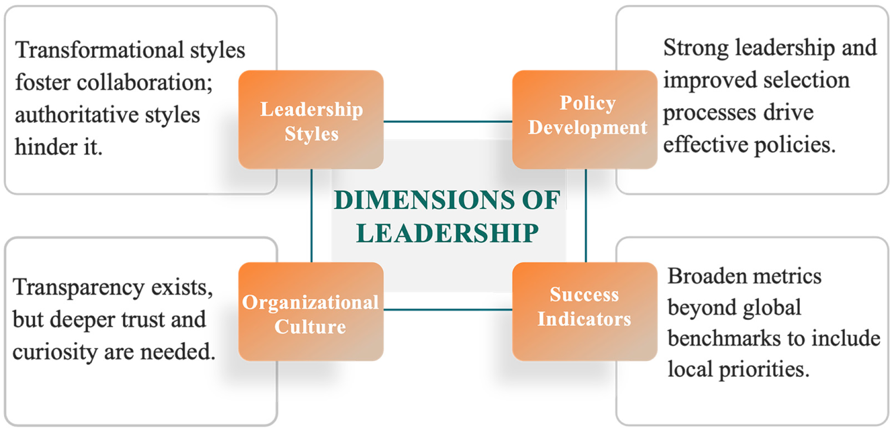
Figure 12: Ensuring stakeholder relationships through effective leadership strategy
(Source: Basir et al. 2025)

6. Conclusion
The launch of the new wearable health device provides a significant opportunity for the organisation to enhance its position in the UK marketplace. The project focused on the application of SWOT and PESTEL analysis with SMART objectives for understanding the internal capabilities, external challenges, and specific actions required for the launch of the products. However, identifying key strengths has provided an understanding of technological requirements, which is a crucial organisational resource that helps in developing priorities among the team. On the other hand, addressing weaknesses like external stress has prepared the team for managing the risk in the future. Mapping and analysis stakeholders provide further goals of involvement. Inputs from the internal teams, regulatory bodies, suppliers, and healthcare professionals help ensure the accuracy of the product in terms of transparent communication. These engagements have developed a stronger foundation for the successful launch of the product in the marketplace as per the demands of the consumers.
Therefore, it can be observed that a well-prepared stakeholder engagement strategy helps in impacting the performance of the business massively for achieving long-term organisational growth. Furthermore, stronger engagement provides a contribution towards regulatory compliance, which enhances customer satisfaction and grants credibility. However, the critical factors like safety and trust are required to be considered for making the launch of the product successful. Therefore, providing recommendations like continuous feedback systems, proposed future practice, and strategic partnerships through investing in education campaigns can help in improving collaborations for achieving competitive advantages. Furthermore, the study also focused on the launch of the products within six months through transparent relationships with the stakeholders to ensure the success of the project.

References
Aksoy, L., Banda, S., Harmeling, C., Keiningham, T.L. and Pansari, A. (2022) ‘Marketing’s role in multi-stakeholder engagement,’ International Journal of Research in Marketing, 39(2), pp. 445–461. Available at: https://doi.org/10.1016/j.ijresmar.2021.09.014.
Almeida, L.F. de, Rocha, T.V. and Fonseca, M.R. da (2019) ‘Corporate Communication Actions in Response to Crises: Empirical Evidence in Food Fraud in Brazil.’ Available at: https://doi.org/10.18461/ijfsd.v10i5.30.
Angus, S.D. and Newton, J. (2020) ‘Collaboration leads to cooperation on sparse networks,’ PLOS Computational Biology. Edited by D. Wodarz, 16(1), p. e1007557. Available at: https://doi.org/10.1371/journal.pcbi.1007557.
Ashcroft, J., Roy, C., Alison, M. and Michael, S. (2017) The relational lens: understanding, measuring and managing stakeholder relationships. Cambridge: Cambridge University Press.
Available at: https://www.mdpi.com/2227-7102/15/6/769 (Accessed: December 8, 2025).
Basir, N., Sani, S.I.A., Yusoff, N.M.R.N., Mohamed, S.B. and Kamarudin, N.H. (2025) ‘Digital transformation in education: A strategic framework for future learning environments’, Education Sciences, 15(6), p.769.
Christopher, M., Payne, A., and Ballantyne, D. (2013) ‘Relationship Marketing: Creating Stakeholder Value’, Saint Louis: Taylor and Francis.
Communications of the ACM, 34(1), pp.38–58. doi:10.1145/99977.99987
Convatec Group (2025) Pioneering trusted medical solutions to improve the lives we touch. Available at: https://www.convatecgroup.com/ (Accessed: December 8, 2025).
Ellis, C.A., Gibbs, S.J. and Rein, G.L. (1991) ‘Groupware: Some issues and experiences’,
Emmanuel, M. (2025) ‘Resistance from Local Stakeholders or Misinformation’, Researchgate. Available at: https://www.researchgate.net/profile/Mayowa-Emmanuel-2/publication/392627810_Resistance_from_Local_Stakeholders_or_Misinformation/links/684b802cbc28f5215e945f93/Resistance-from-Local-Stakeholders-or-Misinformation.pdf
Hertzum, M. (2022) Usability testing: A practitioner's guide to evaluating the user experience. Springer Nature. https://books.google.com/books?hl=en&lr=&id=fYlyEAAAQBAJ&oi=fnd&pg=PR1&dq=Conducting+pre+launch+user+testing,+gather+feedback+and+refining+features+based+on+the+requirements+of+consumers+and+usability+data.&ots=ngu-gJ-PF5&sig=VHrdklVPQWgyg4CorWv6qCIaNHI
Kaygan, H. and Kaygan, P. (2025) ‘Clients and carers: Healthcare professionals’ roles in medical device development processes in SMEs,’ The Design Journal, 28(2), pp. 213–231. Available at: https://doi.org/10.1080/14606925.2024.2420152.
Salybekova, F.M., Almetov, N.S., Karbozova, G.K., Suyuberdieva, A.A., Kudaibergenova, M.R. and Nazarova, G.Z. (2023) ‘Role of the integration of the 4C model in the professional training of foreign language teachers,’ Frontiers in Education, 8, p. 1125728. Available at: https://doi.org/10.3389/feduc.2023.1125728.
Torok, M., Sam, L. and Hebert, J. (2024) ‘Translating a Culture of Quality to Clinical Research Conduct: Expanding the Clinical Development Quality Framework’, Therapeutic Innovation & Regulatory Science, 58(3), pp.404-414. Available at: https://link.springer.com/article/10.1007/s43441-023-00610-5 (Accessed: December 8, 2025).
UK Government (2025a) Medicines and healthcare products regulatory agency. Available at: https://www.gov.uk/government/organisations/medicines-and-healthcare-products-regulatory-agency (Accessed: December 8, 2025).
UK Government (2025b) Product recalls and alerts. Available at: https://www.gov.uk/guidance/product-recalls-and-alerts (Accessed: December 8, 2025).
Yang, Y. (2024) ‘Application of wearable devices based on artificial intelligence sensors in sports human health monitoring,’ Measurement: Sensors, 33, p. 101086. Available at: https://doi.org/10.1016/j.measen.2024.101086.
Youssef, A., Blanchard, N.L. and Hammad, T.A. (2024) ‘Strategic partnerships in pharmacovigilance: business, legal, and regulatory domains’, Clinical Therapeutics, 46(5), pp.424-428. available at: https://www.sciencedirect.com/science/article/pii/S0149291824000742 (Accessed: December 8, 2025).

