

Module: Sustainable Logistics Operations

Programme: HND Logistics and Supply Chain Management

Student: Jodi Emanuelli

Student Number: P093663

Lecturer: Ged Edwards

Table of Contents

1. OBJECTIVES iii
2. INTRODUCTION 1
3. MAIN BODY 2
3.1 Sustainability .2
3.2 Packaging ……………………………………………………………………………………….3
3.3 impact of logistical operations on environment .3-5
3.4 impact of logistical operations on society ………….................……………..6-7
3.5 impact of logistical operations on economy .……….................…………….7-8
4. CONCLUSION 9

II

1. Objectives

The aim of the report is to:

- Define the concept of sustainability
- Evaluate the impact of packaging on the economy, society and environment
- Assess and critically evaluate the impact of logistical operations on the environment, economy and society

III
2. Introduction
“Logistics is the process of planning, implementing, and controlling procedures for the efficient and effective transportation and storage of goods, including services and related information, from the point of origin to the point of consumption. The goal of logistics is to successfully meet customer requirements.” (TechTarget, 2017).
The key areas representing the major components of distribution and Logistics can also be identified as logistical operations. These include transport, warehousing, inventory, packaging and information several areas from production, packaging, warehousing and distribution, and these can be identified as logistical operations.
The logistics industry is experiencing rapid growth and is a crucial component of any successful business. Logistics no longer has a focus purely on transportation, but has developed into a multi-functional, strategic and global field.
There are a range of both positive and negative impacts of logistical operations on the environment, society and the economy.

1
3. Main Body
3.1 Sustainability
“Sustainability focuses on meeting the needs of the present without compromising the ability of future generations to meet their needs. The concept of sustainability is comprised of three pillars: economic, environmental and social - also known informally as profits, planet and people” (Investopedia, 2017). All logistical operations, in some way, have an impact on the environment, the economy and society.
Environmental impact can be described as the “Possible adverse effects caused by a development, industrial, or infrastructural project or by the release of a substance in the environment” (BusinessDictionary, 2017).
Economic impact relates to “A macroeconomic effect on commerce, employment, or incomes produced by a decision, event, or policy” (BusinessDictionary, 2017).
Social impact refers to “The effect of an activity on the social fabric of the community and well-being of the individuals and families” (BusinessDictionary, 2017).
Success is achieved globally when the three interrelated spheres of sustainability are employed. This results in the preservation of natural resources, a protected environment and the safeguarding of the economy. When the three spheres of sustainability are ignored, the impact on the environment, society and economy is negative and has long term damaging effects.

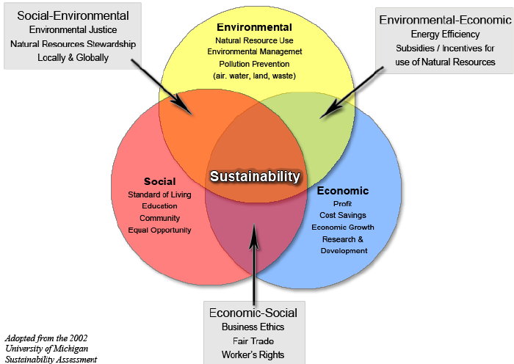
(Researchgate, 2017)
2
3.2 – Packaging
Packaging is an integral part of logistics and affects most activities within an industry. The design of packaging and its suitability for delivery has a positive and negative impact on effective transportation of products from beginning to end.
The competitive market and the breadth of logistics, has ensured that packaging is a main factor affecting customer’s decisions and choices in the current market.
To ensure the successful flow of productivity and distribution, storage support, transport support and cost reduction need to be considered. The quality of packaging will affect safe distribution. Ensuring that products are methodically organised aids transportation and consequently has a positive impact on finance and distribution. Effective and space saving packaging will support cost reduction.
Greater competition in the current market exists, as more and more businesses are operating globally, and this effect has heightened the correlation between logistics and packaging.

3.3 – Impact of logistical operations on the environment
The volume of packaging has had a range of impacts on the environment. These include the effect of the raw materials used, production of the packaging, distribution and transport of the package, the use of the packaging and the impact of waste.

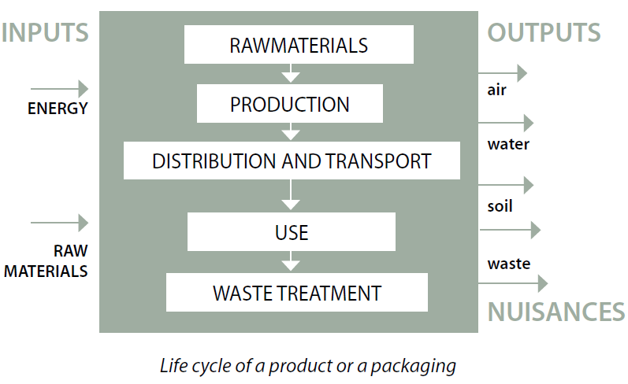
(PreventPack, 2017)

3
Energy is utilised when the raw materials used in packaging are removed from minerals, manufactured from chemicals or taken from natural substances. Additionally, energy is needed for the production of packaging and this energy is frequently obtained from the burning of fossil fuels. This creates a negative impact on the environment, as it could produce water and air pollution. The burning of fossil fuels releases carbon dioxide, consequently contributing to the greenhouse effect and increases global warming. Fossil fuels, non-renewable energy reserves, are limited in supply and are irreplaceable.
The distribution of packaging has a significant impact on the environment, from the point of transportation of raw materials, transportation of finished packed goods to the transportation of waste. “The environmental impact of transportation is significant. Transportation is a major use of energy, and it burns most of the world’s petroleum. This creates air pollution, including nitrous oxides and particulates, and is a significant contributor to global warming through carbon dioxide emissions. In fact, transportation is the fastest-growing contributor to carbon dioxide emissions” (Elsevier Ltd, 2014)
Transportation and its increasing levels of motorisation and congestion, is becoming progressively linked to environmental issues. Activities related to transport contribute to local, global, regional and national environmental problems, for example, noise, emissions, climate change, smog and acid rain. The impact of transportation activities includes the direct harmful effects from noise and emissions. Indirectly, the impacts include the effects certain engines have on respiratory and cardio vascular problems. The cumulative impacts of transportation on the environment, are frequently unpredicted and impact on an ecosystem. For example, climate change is the cumulative impact of natural and human factors.
In my opinion, although transportation is a vital component of industry, there are negative impacts, but these are slowly being addressed, and ways forward for further improvements, such as automated vehicles and more sustainable resources are being considered. This has already been considered and a decrease in energy consumption from transport is beginning to show. “A shift in economic activity away from heavy, energy intensive industries accounts for the decrease in the industry sector’s share”(Gov.UK, 2017).

4
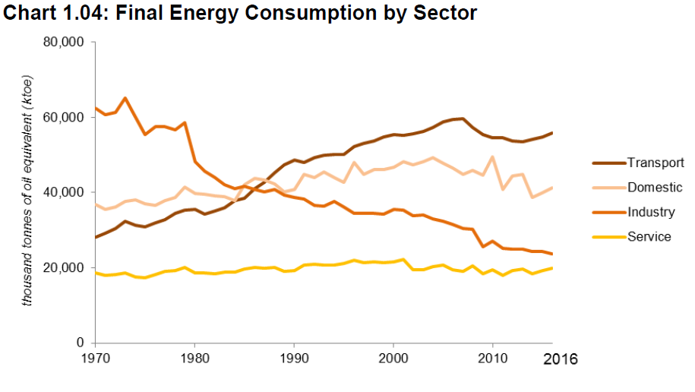 (Gov.UK, 2017)

The disposal of waste has an impact on the environment and usually ends up in massive landfill sites. These landfills provide industries with the means to dispose of packaging waste correctly. However, landfills have a negative impact on nature, for example, encroaching on animal habitats. It should be noted that some waste will eventually decompose and have no negative impact on the environment. Nevertheless, not all waste will decompose and this will often produce explosive gases which contributes to the greenhouse effect. “Methane gas is naturally produced during the process of organic matter decay. The Environmental Protection Agency records that the methane expelled during the decomposition of organic matter in unmanaged landfills has the potential of trapping solar radiation 20 times more effective than carbon dioxide” (ConserveEnergyFuture, 2017).
Ground water contamination from leaks, is the main environmental issue resulting from the use of landfills. The hazardous wastes left in landfills invariably leads to the deterioration of ground water, which permeates the soil, reaches waterways and ultimately infiltrates domestic water.
The soil and land where landfills are sited can result in it becoming unusable and can affect nearby land areas due to the spread if chemicals over time. Damages to the soil over time affects its quality and fertility, and thus unbalancing the land ecosystems.
It is my opinion that, although waste has many negative impacts on the environment, and the waste left, when burned, can release carbon dioxide, recent developments have supported catching the energy that is produced and then using it for electricity.
“Modern advances have been available to capture the energy being produced in incineration and utilize it to generate electricity. The end result is an intricate method of reusing items to reduce the need of future waste” (Resource Recoveries and Recycling, 2017).

5
3.4 – Impact of logistical operations on Society
The environmental and economic impacts of logistical operations also have an influence on society. Society is growing and the demand for packaging is increasing.
Packaging is an important part of life today if customers are to acquire the desired consumer goods. Packaging has a positive impact, as it meets human needs in an effective way.
Packaging can impact on consumer behaviour, for example, the use of colour in packaging to attract consumer attention and increase marketing. Branded packaging can also impact on consumer behaviour, as a brands image is associated with the style of packaging and this branded packaging differentiates a business from its competitors. Companies usually use comparable colour and design packaging for similar types of products, for example, black, silver and gold for luxury products. “Brands that aim to present an edgy look will often pair bright colors with black, which also implies an appearance of energy and sophistication, according to the Design Force website” (Chrons, 2017).
Secure packaging of a product can prevent breakages during shipping and ensure the consumer has a positive experience. This reduces the possibility of costly returns, loss of custom and promotes the notion of quality to the customer. The use of creative and colourful design together with sustainability in product packaging will strengthen the consumer’s high opinion of the product. However, if product packaging is not authentic in terms of sustainability, this could result in distrust between companies and consumers over being ‘green-washed’.
Society today is very aware of the need to protect the environment. As a result, sustainable packaging has become very popular with the consumer due to it being eco-friendly and attractive. Consequently, sustainable packaging can have a major influence on consumer buying decisions. Therefore, using recycled or recyclable materials is an advantage for both industries and the environment. However, in my opinion consumer’s expectations of a company are for them to act responsibly, in terms of social and environmental issues, as well as making a profit.
“More than one in five (21%) of the people surveyed said they would actively choose brands if they made their sustainability credentials clearer on their packaging and in their marketing” (Unilever 2017)
As producers vie to attract customers, over packaging of products can result which has a negative impact on the environment, economy and society. Producers need to take responsibility for limiting the waste of resources and contributing to overused landfills as a result of unnecessary packaging. The product is sold at a higher price

6
due to the cost of over packaging and, frequently, the packing cost is higher than the cost of the actual product. Therefore, over packaging protects the product, but the disadvantages outweigh the advantages, as costs increase and this results in a negative impact on both society and the environment.

3.5 – Impact of logistical operations on Economy
“Some people may not be aware of the economic value of packaging, simply because they are not in the packaging conversion industry, nor in the packaging supply chain, nor in the retail industry, and so they do not appreciate the role packaging plays in getting product to them. But without packaging, the Gross Domestic Product (GDP) of a country would significantly reduce in value” (WorldPackagingOrganisation, 2017).
It is my opinion that, products cannot be transported from source to consumer without the correct packaging. Packaging needs to be made up of specific materials, suit the product, ensure safety of the product during transportation and have a positive influence on the customer buying decision. Ultimately, packaging contributes to the gross domestic product of the country. The total packaging sales therefore, provide a pointer of the strength of a country’s economy.
“The UK Packaging Manufacturing Industry has annual sales of £11 Billion and employs some 85,000 people – representing 3% of the UK’s manufacturing workforce. It is a major contributor to the UK GDP” (ThePackaging federation, 2017).
Supplementary financial costs, for the public and private sector stakeholders, are created from recycling and these can result in elevated priced products or the additional costs related to waste management. A great deal of time and financial outlay is devoted to gathering and processing recycled goods. Nevertheless, although the cost of recycling is far greater than using landfills for waste, advocates of recycling maintain that the benefits to health and the environment prevail over the costs.
The cost of recycling has a negative impact on the economy, but the ever growing recycling scheme can be instrumental in creating employment opportunities.
Additionally, recycling supports communities and businesses circumvent the costs, financial and environmental impacts, supplementary to both landfills and the use of incinerators

7
The recycling of goods can also have an impact on the cost associated with transportation. The shape of a package and the effective storage and transportation is vital as the “more product stored or transported in a given cubic capacity, the more the associated unit costs, as well as the environmental impact may be reduced” (The Handbook of logistics and distribution management, 2014). To enable reuse, packaging, such as pallets, require two-way transportation. As a result, many industries have created a range of packaging that meets transit requirements, but does not justify the costs incurred in returning the packaging to its starting point. Therefore the packaging is utilised on only one occasion and then transported to, for example, the landfill site. Thus, the consumer has transported the product from the retail store to the point of use and then rejects the packaging. “For logistics, the problem manifests itself in the form of reverse logistic” (The Handbook of logistics and distribution management, 2014).
However, I believe that, by increasing a products lifecycle through reverse logistics, this creates greater employment opportunities and revenue.
In the first instance, companies can retrieve defective equipment and parts which are either salvaged or refurbished and thus reclaims value out of the defective parts. Secondly, the packaging and defective materials are collected and recycled thereby generating scrap value back for the company.
“The 2016 REI Report includes updated information about the number of recycling jobs, wages, and tax revenue. The report shows that recycling and reuse of materials creates jobs, while also generating local and state tax revenues. In 2007, recycling and reuse activities in the United States accounted for:
- 757,000 jobs
- 36.6 billion in wages; and
- 6.7 billion in tax revenues” (EPA, 2017)
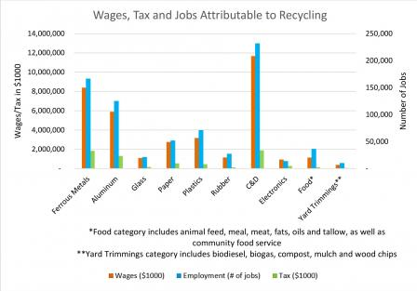 (EPA, 2017)
8
4. Conclusion

Acting sustainably, preserving natural resources, protecting the environment and safeguarding the economy, will ensure that future generations will have ability to meet their needs, as well as society today being able to do the same. The logistics industry is experiencing development on a rapid scale, and is a vital part of any successful industry. Research acquired for this report demonstrates that there are a range of both positive and negative impacts of logistical operations on the environment, society and the economy. However, it can be argued that the many positive aspects far outweigh the long-term damaging effects and that acting sustainably is more beneficial globally.

9
References
Anon, (2017). https://www.researchgate.net/figure/255965716_fig1_Figure-1-The-Three-Spheres-of-Sustainability (Accessed 21 Nov. 2017).
BusinessDictionary.com. (2017). What comes after those ellipses? http://www.businessdictionary.com/definition/environmental-impact.html (Accessed 20 Nov. 2017).
Conserve Energy Future. (2017). Renewable & Non-Renewable Energy Sources - Conserve Energy Future. https://www.conserve-energy-future.com/ (Accessed 24 Nov. 2017).
Eattie, A. (2017). Sustainability. Investopedia. https://www.investopedia.com/terms/s/sustainability.asp (Accessed 20 Nov. 2017).
Elsevier.com. (2017). Elsevier | An Information Analytics Business | Empowering Knowledge. https://www.elsevier.com/ (Accessed 23 Nov. 2017).
Environmental-Economic-and-Social-Components-of-Sustainability (Accessed 21 Nov. 2017).
Gov.uk. (2017). Cite a Website - Cite This For Me. https://www.gov.uk/government/uploads/system/uploads/attachment_data/file/633503/ECUK_2017.pdf (Accessed 23 Nov. 2017).
http://www.worldpackaging.org/i4a/pages/index.cfm?pageID=3357 (Accessed 24 Nov. 2017).
Kermisch, C. and Taebi, B. (2017). Sustainability, Ethics and Nuclear Energy: Escaping the Dichotomy. Sustainability, 9(3), p.446.
Kivimaa, P. (2007). The determinants of environmental innovation: the impacts of environmental policies on the Nordic pulp, paper and packaging industries. European Environment, 17(2), pp.92-105.
McKinnon, A. (2015). Green logistics. London, United Kingdom: Kogan Page Limited.
Oki, Y. and Sasaki, H. (2000). Social and environmental impacts of packaging (LCA and assessment of packaging functions). Packaging Technology and Science, 13(2), pp.45-53.
Packagingfedn.co.uk. (2017). The Packaging Federation – www.packagingfedn.co.uk. http://www.packagingfedn.co.uk/ (Accessed 24 Nov. 2017).

10
Preventpack. (2017). Biopackaging. http://www.preventpack.be/dossier/biopackaging (Accessed 25 Nov. 2017).
Releases, P. (2017). Report shows a third of consumers prefer sustainable brands. https://www.unilever.com/news/Press-releases/2017/report-shows-a-third-of-consumers-prefer-sustainable-brands.html (Accessed 25 Nov. 2017).
Rushton, A., Croucher, P. and Baker, P. (n.d.). The handbook of logistics and distribution management.
Smallbusiness.chron.com. (2017). How Does Packaging Affect Consumers? Available at: http://smallbusiness.chron.com/packaging-affect-consumers-70612.html (Accessed 24 Nov. 2017).
Soapboxie. (2017). The Environmental, Economic, and Social Components of Sustainability. https://soapboxie.com/social-issues/The- Thwink.org. (Accessed 21 Nov. 2017).
The Three Pillars of Sustainability. http://www.thwink.org/sustain/glossary/ThreePillarsOfSustainability.htm (Accessed 21 Nov. 2017).
Touch, J. and Touch, J. (2017). 2015 Cone Communications/Ebiquity Global CSR Study. Cone Communications | Cone | Cone PR | Cone Inc | PR Agency | Boston | NYC. http://www.conecomm.com/research-blog/2015-cone-communications-ebiquity-global-csr-study (Accessed 24 Nov. 2017).
US EPA. (2017). Recycling Economic Information (REI) Report | US EPA. https://www.epa.gov/smm/recycling-economic-information-rei-report (Accessed 24 Nov. 2017).
Worldpackaging.org. (2017). The Economic Role of Packaging - World Packaging Organisation. http://www.worldpackaging.org/i4a/pages/index.cfm?pageID=3357 (Accessed 24 Nov. 2017).

11

