Title: Crafting a Sustainable Haven: The Essence of Our Boutique Hotel in Vibrant Brighton, England
Your name: Melis Shaban
Your student ID number 2212035
The module title: Entrepreneurship BMIH5001
Your lecturer’s name. Charlotte Joyner
Wordcount: 2173

In the ever-changing world of hospitality, we believe in offering more than just a place to stay. Our vision for a boutique hotel in Brighton, England goes beyond luxury accommodations; it's about creating unique experiences that resonate with your personal preferences while embracing sustainability and community engagement. In this context, a comprehensive report by (Deloitte (2021) on the future of hospitality highlights the opportunities to recover and thrive in the new normal, emphasizing the importance of innovative approaches in the industry.
Brighton: A Seaside Gem with Creative Vibes: Picture this – nestled on the south coast of England, Brighton is a haven known for its eclectic charm, cultural diversity, and the soothing sounds of the sea. From the iconic Brighton Pier to the regal Royal Pavilion, the city is a treasure trove for tourists seeking vibrant beachfronts and a dynamic cultural scene. What sets Brighton apart is its spirit of inclusivity and creativity, providing the perfect backdrop for a boutique hotel that not only offers luxury but immerses guests in the unique soul of Brighton.
Customer Segments: We're all about catering to the eco-conscious, the experience seekers, and those with a community-minded heart (Hospitality Net, 2019). With Gen Z reshaping hospitality and travel preferences (Johnston, n.d.), we've noticed a growing desire for sustainable travel experiences. We believe this aligns perfectly with Brighton's environmentally conscious ethos.
Value Proposition: Our boutique hotel in Brighton, England is more than luxury; it's a sustainable haven immersed in community spirit. Hillsdon's insights (2022) into the evolving hospitality industry align with our commitment to combat climate change actively.
We've chosen renewable energy wisely, utilizing solar panels and exploring wind turbines, capitalizing on Brighton's natural resources. Energy-efficient systems, including LED lighting and smart climate control, comprehensively reduce our carbon footprint.
This focus on renewable energy not only aligns globally but underscores our commitment to a greener, more sustainable hospitality experience, resonating with Brighton's ethos.
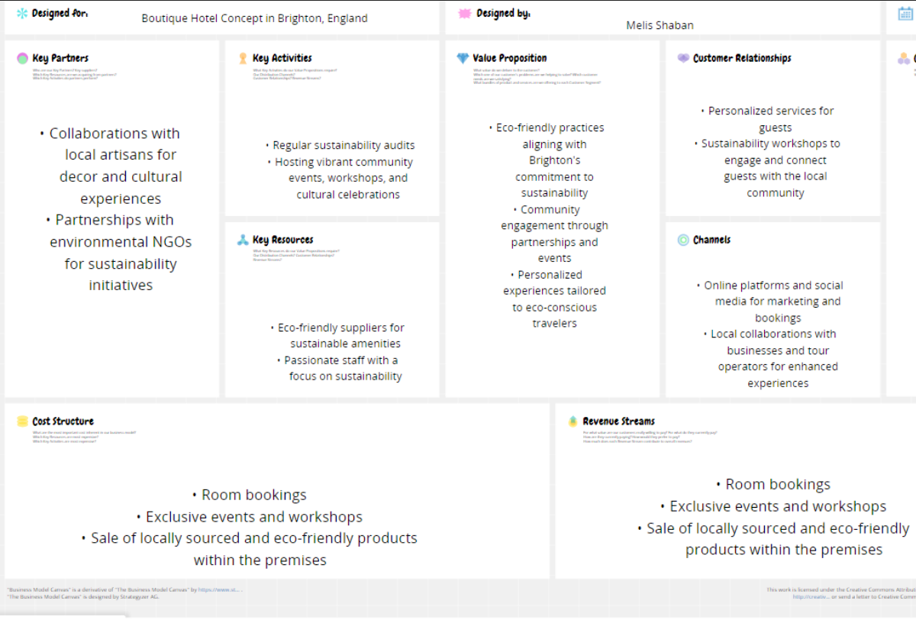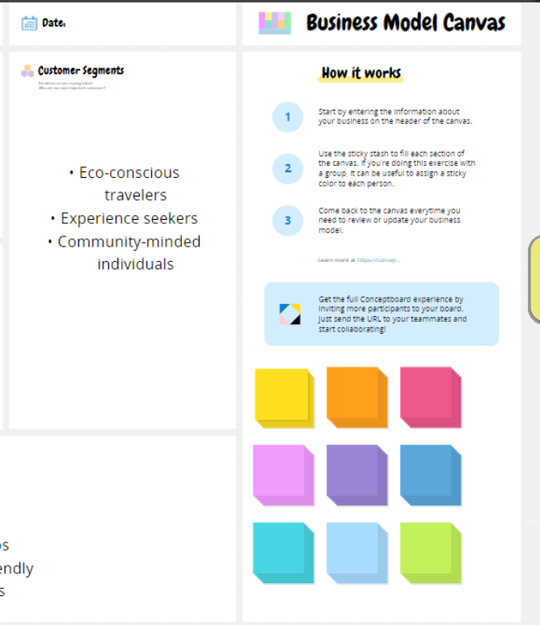
Appendix: (Conceptboard)
Our online presence is more than a gateway; it's a digital invitation to a sustainable escape. The user-friendly website offers a glimpse into our eco boutique hotel's unique offerings. Offline, meaningful local partnerships with businesses, tour operators, artisans, and environmental NGOs enrich Brighton's cultural and environmental fabric.
Customer Relationships: Expect personalized service and sustainability workshops. Our guest-centric approach connects you not just with the environment but also with the heartbeat of the local community. It's an immersive experience that lingers long after you've left.
Revenue Streams: Diversification and Local Vibes: Our revenue streams go beyond room bookings. Exclusive events, workshops, and locally sourced, eco-friendly products contribute to a diverse income, making your stay not just a moment but a meaningful contribution to the local economy.
At Eco Harmony Retreats, we are committed to forging meaningful connections within the vibrant community of Brighton. Our vision includes establishing partnerships with local businesses that share our values of sustainability and community engagement. One potential collaboration is with the Green Tourism Business Scheme (Green Tourism, 2013), a national sustainable tourism certification scheme. By aligning ourselves with their rigorous criteria covering energy and water efficiency, waste management, and biodiversity, we aim to contribute to the larger eco-friendly network. Additionally, we aspire to source high-quality, local produce from establishments such as FARM Café, an independent café and farm shop in Brighton's North Laine, known for its commitment to non-intensive, slow-rearing farming practices. This not only ensures the freshness and taste of our offerings but also supports the local farming community.
We are also exploring collaboration opportunities with the Brighton & Hove Food Partnership (Brighton and Hove Food Partnership, n.d.), a non-profit organization dedicated to promoting healthy eating, local food production, and reducing food waste. Our goal is to participate in community initiatives, such as their community vegetable plot in Preston Park, emphasizing our commitment to sustainability (Green Traveller, n.d.).
Sustainably Yours – Regular Audits and Community Celebrations: Sustainability audits and community events are at the heart of our activities. Just as Brighton pulsates with cultural celebrations, our hotel hosts events that entertain and foster a sense of belonging among guests and the local community.
Nurturing Bonds with Artisans and NGOs: Picture collaborations with local artisans for decor, cultural experiences, and partnerships with environmental NGOs. It's not just about offering a place to stay; it's about contributing positively to the cultural and environmental tapestry of Brighton (KITRINIARIS, 2022).
Balancing Finances and Sustainability: Yes, there's an initial investment in renewable energy, eco-friendly infrastructure, and staff training. But it's a strategic investment, aligning with global trends towards sustainability and ensuring we stand as leaders in responsible tourism.
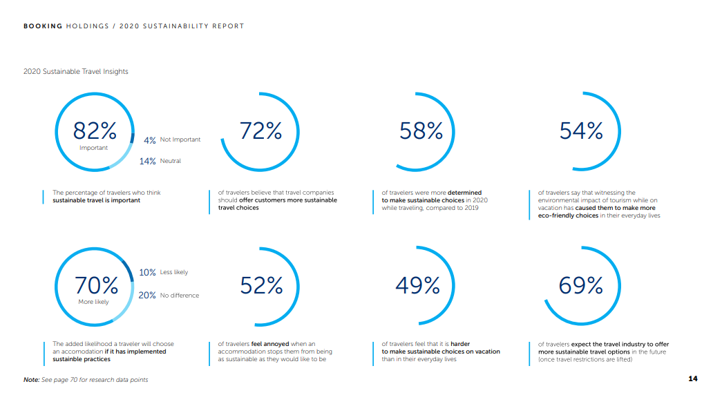
Appendix: (Sustainability Report 2, n.d.)
A Boutique Retreat Woven into Brighton's Fabric: In conclusion, our boutique hotel concept isn't just a vision; it's a harmonious blend of luxury, sustainability, and community engagement. We've shared details on location, size, staffing, and finances because we're not just dreaming – we're ready to make this a reality. As conscious travel choices become crucial, we're here to redefine norms of hospitality and contribute to Brighton's identity as a seaside haven with a creative pulse.
- Customer Relationships:
Choice: Personalized service and sustainability workshops.
Modern travelers are seeking more than just a place to rest their heads. They want meaningful experiences. At our boutique hotel, expect to be treated as an individual, not just a guest. We're hosting sustainability workshops to engage you, creating a connection not just with the environment but with the heartbeat of the local community.
- Revenue Streams:
Choice: Diversifying revenue through room bookings, events, workshops, and local product sales.
Sustainability isn't just about being eco-friendly; it's about creating a sustainable business model. Drawing inspiration from the success of "Acre Baja" in Mexico, which generates revenue from its farm-to-table concept, we're ensuring that our income streams are as diverse as the experiences we offer. Your stay with us becomes a contribution not only to your memories but to the sustainability of the local economy.
- Key Resources:
Choice: Eco-friendly suppliers and a skilled staff passionate about sustainability.
Sourcing locally isn't just a buzzword; it's a commitment to reducing our carbon footprint. The success of "The Scarlet Hotel" in the UK showcases the effectiveness of sustainable practices in hospitality. Our team is not just staff; they're passionate individuals dedicated to ensuring your experience is not just memorable but aligned with our values of sustainability and community engagement.
- Key Activities:
Choice: Regular sustainability audits and vibrant community events.
Sustainability isn't a one-time effort; it's a commitment. Regular sustainability audits ensure we stay true to our eco-friendly practices. We're not just providing accommodation; we're fostering a sense of community. Imagine events that not only entertain but also make you feel like you belong – that's what we have in store for you.
- Key Partnerships:
Choice: Collaborations with local artisans and environmental NGOs.
Supporting the local economy and contributing to environmental initiatives are more than just checkboxes for us. T Our partnerships are not just about business; they're about enriching the cultural and environmental landscape of Brighton.
- Cost Structure:
Choice: Initial investments in renewable energy, eco-friendly infrastructure, and staff training.
Sustainability is an investment in the future. Think about "Soneva Fushi" in the Maldives, known for its sustainable practices. Our initial investment isn't just about today; it's about positioning ourselves as leaders in responsible tourism. It aligns with global trends, ensuring long-term cost-effectiveness and a positive impact on the world we live in.
Driving Factors for Success and Justifications
Choosing Brighton as our location isn't just strategic; it's heartfelt. Brighton's cultural richness, commitment to sustainability, and vibrant community align with the very essence of our venture. Additionally, resources from Brighton & Hove City Council (www.brighton-hove.gov.uk) support our commitment to understanding and contributing positively to the local ecosystem.
The increasing demand for sustainable travel experiences, personalized service, and community engagement serves as a strong foundation for our concept. We're not just following trends; we're setting new standards in hospitality (Airbnb, 2023).
We've meticulously analyzed similar hotels in Brighton to ensure that Eco Harmony Retreats stands out by offering a unique blend of luxury, sustainability, and community immersion. It's not just about competition; it's about carving our niche in a market we deeply understand.
Personal Entrepreneurial Characteristics and Motivations:
Considering the traits of the entrepreneur, the drive to establish EcoHarmony Retreats comes from a love of sustainable living and a want to support the hospitality sector. According to Burns (2022), the Sustainable Entrepreneurship Model emphasizes the development of both economic and social-environmental value, which is consistent with the principles of the entrepreneur. Furthermore, the knowledge from Rickman's 2005 book, "The Small Business Start-Up Workbook," which offers a detailed roadmap for launching the company of one's dreams, has been essential in influencing the entrepreneurial path. The creation of a strategic plan for EcoHarmony Retreats has been made possible thanks in large part to this extensive resource. The desire to positively impact people's perceptions and experiences of travel serves as the driving force behind the motivation.
Choosing Brighton for Eco Harmony Retreats goes beyond strategy; it's a deep-rooted decision. The city's cultural richness, arts scene, and commitment to sustainability align perfectly with our vision. Brighton's diverse, inclusive community suits our boutique hotel, embracing not just the landscape but the spirit of the place.
As Eco Harmony Retreats weaves into Brighton's fabric, we're mindful of the city's support for local businesses. Vibrant markets echo the strong community, and our local partnerships aim to be integral, contributing to Brighton's economic and cultural vitality.
Entrepreneurial Insights from Industry Evolution:
Drawing on industry evolution and entrepreneurship, EcoHarmony Retreats navigates its strategic course with inspiration from the work of Agarwal and Braguinsky (2020). The research presented in "Industry Evolution and Entrepreneurship" explores the contributions of Steven Klepper to industrial organization, strategy, technological change, and entrepreneurship. By integrating insights from this scholarly work, EcoHarmony Retreats aims to leverage a deeper understanding of industry dynamics, strategy formulation, and the interplay between entrepreneurship and technological evolution. This perspective enhances the entrepreneurial approach, ensuring that the business model is adaptive and resilient in the face of evolving industry landscapes.
The hospitality industry is experiencing a paradigm shift, and we are positioned at the forefront of these transformative trends. The discerning traveler of today seeks more than a mere getaway; they desire experiences that resonate with their values. The rising demand for sustainable travel experiences is not just a trend but a societal shift towards responsible and conscious living.
Moreover, the desire for personalized service is no longer a luxury; it's an expectation. Travelers want to feel a personal connection with their accommodations, and our commitment to personalized experiences ensures that every guest becomes part of a unique narrative crafted just for them. In an era where travel is not just a journey but a reflection of personal values, Eco Harmony Retreats stands as a beacon, offering an authentic and meaningful escape.
Competitive Landscape:
Analyzing the competitive landscape in Brighton's hospitality sector has been an insightful journey. While there are notable accommodations catering to various preferences, Eco Harmony Retreats differentiates itself by weaving together luxury, sustainability, and community immersion in a way that is unparalleled.
By carefully studying the offerings of similar hotels in the area, we have identified unique opportunities to stand out. Whether through curated local experiences, exclusive events, or our focus on sustainability workshops. Navigating the complex regulatory landscape requires a nuanced understanding of governmental initiatives. The UK's Department for Business, Innovation & Skills (gov.uk, 2016) has been instrumental in providing valuable insights into policies that shape the hospitality industry. Understanding and aligning with these policies is integral to our commitment to sustainable and responsible business practices.
Personal Entrepreneurial Characteristics and Motivations:
As an entrepreneur, my journey into the realm of sustainable hospitality stems from a profound passion for responsible living and a deep-seated commitment to making a positive impact. The Sustainable Entrepreneurship Model is not merely a theoretical framework for me; it's a guiding principle that aligns seamlessly with my personal values.
Motivated by a vision to inspire positive change in the way individuals perceive and experience travel, Eco Harmony Retreats is more than a business venture; it's a mission. It's a commitment to creating economic, social, and environmental value. It's about showcasing that business success and responsible practices can coexist, and indeed, one can amplify the other.
In this journey, my entrepreneurial characteristics of resilience, adaptability, and a visionary outlook come into play. It's not just about building a successful boutique hotel; it's about contributing to a shift in the industry towards a more sustainable and mindful future. The motivation to tread this path is not driven solely by financial success but by the belief that businesses can be a force for good, enriching the lives of individuals and the communities they touch.
As I navigate through the complexities of entrepreneurship, I am guided by the conviction that the success of Eco Harmony Retreats goes hand in hand with the positive impact it creates. It's about fostering a new paradigm in hospitality—one where luxury, sustainability, and community engagement harmoniously coexist, creating a haven that not only welcomes guests but leaves an indelible mark on their hearts.

References:

Agarwal, R. and Braguinsky, S. (2020). Industry Evolution and Entrepreneurship: Steven Klepper’s Contributions to Industrial Organization, Strategy, Technological Change, and Entrepreneurship. Strategic Entrepreneurship Journal, 9(4), pp.380–397. doi:https://doi.org/10.1002/sej.1179.

Airbnb (2023). Vacation Rentals, Homes, Experiences & Places - Airbnb. [online] Airbnb. Available at: https://www.airbnb.com/.

Anon, (2024). The Scarlet Hotel: Cornwall’s luxury seaview eco-hotel & spa. [online] Available at: https://www.scarlethotel.co.uk/.

Brighton and Hove Food Partnership. (2024). The Brighton & Hove Food Partnership is all about food. [online] Available at: https://bhfood.org.uk/.

Burns, P. (2022). Entrepreneurship and small business : start-up, growth and maturity. London: Red Globe Press An Imprint Of Macmillan Education Limited.

Conceptboard. (n.d.). Unnamed board. [online] Available at: https://app.conceptboard.com/board/8q3u-tm2a-eyui-phhq-zbk0 [Accessed 31 Jan. 2024].

Deloitte (2021). The future of hospitality Uncovering opportunities to recover and thrive in the new normal. [online] Available at: https://www2.deloitte.com/content/dam/Deloitte/ca/Documents/consumer-industrial-products/ca-future-of-hospitality-pov-aoda-en.pdf.

emerald1.cbre.com. (n.d.). *. [online] Available at: https://www.cbre.com/insights/reports/a-check-in-on-the-hotel-sectors-esg-initiatives.

gov.uk (2016). Department for Business, Innovation & Skills. [online] GOV.UK. Available at: https://www.gov.uk/government/organisations/department-for-business-innovation-skills.

Green Tourism (2013). Promoting sustainable business tourism | Green Tourism - Green Tourism. [online] Green-tourism.com. Available at: https://www.green-tourism.com/pages/home.

‌Green Traveller. (n.d.). Green Brighton. [online] Available at: https://www.greentraveller.co.uk/green-brighton [Accessed 31 Jan. 2024].

Hillsdon, M. (2022). Slow to Wake up to Climate change, Hotels Sector Vows to Tread More Lightly. Reuters. [online] 8 Aug. Available at: https://www.reuters.com/business/sustainable-business/slow-wake-up-climate-change-hotels-sector-vows-tread-more-lightly-2022-08-08/.

‌Hospitality Net (2019). Hospitality Net – Home. [online] Hospitality Net. Available at: https://www.hospitalitynet.org/.
Hospitality Net. (n.d.). What Cop27 means for hotels and hospitality in 2023 | By Aaron Belton. [online] Available at: https://www.hospitalitynet.org/opinion/4113923.html.

Johnston, I. (n.d.). Council Post: How Is Gen Z Reshaping Hospitality And Travel? [online] Forbes. Available at: https://www.forbes.com/sites/forbesagencycouncil/2023/11/30/how-is-gen-z-reshaping-hospitality-and-travel/?sh=4f7d503bbce0.

Rickman, C.D. (2005). The small business start-up workbook : a step-by-step guide to starting the business you’ve dreamed of. Oxford: How To Books.
Small Business. (n.d.). Advice and ideas for UK small businesses. [online] Available at: https://smallbusiness.co.uk/.

Soneva.com. (2022). Available at: https://soneva.com/foundation/.
Sustainability Report 2. (n.d.). Available at: https://www.bookingholdings.com/wp-content/uploads/2021/03/BKNG-Sustainability-Report-2020-.pdf.
‌THE HOTEL OF THE FUTURE. (2016). Available at: https://www2.deloitte.com/content/dam/Deloitte/us/Documents/consumer-business/us-cb-the-hotel-of-the-future.pdf.
Visit Brighton (2019). Visit Brighton - The Official Brighton and Hove Tourist Information Site. [online] Visitbrighton.com. Available at: https://www.visitbrighton.com/.

www.brighton-hove.gov.uk. (n.d.). Brighton & Hove City Council. [online] Available at: https://www.brighton-hove.gov.uk/.

www.wessex.ac.uk. (n.d.). Sustainable Tourism 2024. [online] Available at: https://www.wessex.ac.uk/index.php?option=com_chronoforms5&view=form&Itemid=6037&chronoform=Abstract&conf=sustainable-tourism-2024 [Accessed 17 Jan. 2024].

