

STRATEGIC ARCHITECTURE FOR DIGITAL-FIRST FINANCE ━━━━━━━━━━━━━━━━━━━━━━━━━━━━━━━━━━━━━━━━━━━━━━━━━━
A Comprehensive Security Framework Design for FinSure Bank (FSB)

Abstract
This report architects a strategic information systems security, governance, and regulatory compliance framework for FinSure Bank (FSB), a rapidly expanding digital-first financial services provider operating across European and United Kingdom jurisdictions. With over 90% of infrastructure externally hosted and a growing BYOD workforce, FSB requires transformation from its fragmented, ad-hoc security posture to a mature governance model. Through comparative evaluation of ISO/IEC 27001, NIST CSF, COBIT 2019, ITIL 4, SABSA, and CSA STAR, this report identifies their complementary integration potential and proposes a bespoke, multi-layered architecture. The design incorporates the IIA Three Lines Model for governance, CNAPP for cloud workload security, and CASB/DLP controls for BYOD management, aligned with GDPR, PSD2, DORA, and FCA mandates. A critical academic analysis demonstrates why cybersecurity regulations must continuously evolve, engaging with counterarguments regarding regulatory fatigue and prescriptive overreach to conclude that dynamic standards remain essential for operational resilience.

Author: Daniel Hriscu 2127929
Date: March 2026
Module Code: ACCA7028
Submission Date: 02/04/2026
Lecturer: DR. Vijeyananthan Thayananthan
University: University of Wales Trinity Saint David
Campus: Birmingham
Table of Contents
1. Introduction 2
2. Operational Assumptions and Contextual Baseline 2
3. Research on IT Security and Governance Frameworks 2
3.1. The ISO/IEC 27000 Series 2
3.2. The NIST Cybersecurity Framework 2
3.3. COBIT 2019 3
3.4. ITIL 4 and the Service Value System 3
3.5. SABSA 3
3.6. CSA STAR Framework 3
3.7. Comparative Critique of Frameworks 3
4. Strategic Architecture, Design, and Implementation for FSB 5
4.0. Design Methodology 5
4.1. Compliance Architecture 6
4.2. Governance: The Three Lines Model and IGSF 6
4.3. Cloud-Native Application Protection Platform (CNAPP) 7
4.4. Securing BYOD and Data (CASB & DLP) 8
4.5. Insider Threat Prevention 9
4.6. Contingency Planning (BCP and DRP) 9
4.7. SLA Management and Phased Implementation 10
5. Academic Critique: The Necessity of Dynamic Regulations and Standards 11
5.1. The Evolving Threat Landscape 11
5.2. Compliance Versus Security Efficacy 11
5.3. Counterarguments and Rebuttals 12
6. Conclusion 12
References 13
Appendix: Index of Supplementary Documentation 15
Appendix A: Security Architecture Design Document 15
Appendix B: Security Maturity Assessment 15
Appendix C: Risk Register & FAIR Quantitative Analysis 15
Appendix D: Compliance & Framework Integration Mapping Matrix 15
Appendix E: BYOD & Cloud Services Acceptable Use Policy 15

1. Introduction
FinSure Bank (FSB) epitomises the modern digital-first financial services provider: experiencing hyper-growth while offering banking, savings, loans, and investment services across multiple jurisdictions, with over 90% of core systems hosted on cloud platforms [1]. This distributed infrastructure, combined with a Bring Your Own Device (BYOD) operational model and an expanding mobile-banking customer base, creates systemic concerns regarding data privacy, identity theft, and advanced cyberattacks. Despite handling highly sensitive financial records and personally identifiable information, FSB currently lacks comprehensive security policies, unified governance frameworks, and regulatory compliance controls. Its fragmented approach is devoid of formal risk management or structured compliance auditing, generating mounting concerns around GDPR compliance, fraud management, and insider threat mitigation.
This report delivers a comparative evaluation of enterprise IT security frameworks, architects a bespoke, multi-layered security and governance design for FSB with specific implementation mechanisms for cloud-native security and BYOD management and provides an academic critique analysing the critical necessity for continuously evolving cybersecurity regulations, engaging with opposing scholarly perspectives to demonstrate how dynamic regulatory environments foster operational resilience.

2. Operational Assumptions and Contextual Baseline
FSB is modelled as a mid-sized, rapidly scaling digital challenger bank comparable to Monzo or Revolut, managing millions of active accounts [1] and allocating approximately 13.2% of its IT budget to information security [2]. Operating a multi-cloud posture where traditional perimeter security is obsolete, FSB is subject to GDPR, PSD2, FCA guidelines, and DORA [3]. Current security maturity sits at Level 1–2, requiring a structured roadmap to Level 4 (Managed and Measurable).

3. Research on IT Security and Governance Frameworks
Establishing a unified security posture requires synthesising governance, service management, and tactical security models, as no single framework sufficiently addresses the complexity of a cloud-first financial institution.

3.1. The ISO/IEC 27000 Series
The ISO/IEC 27001:2022 standard [28] provides the prescriptive requirements for establishing an Information Security Management System (ISMS) and remains the only certifiable standard in the family. The 2022 revision restructured Annex A from 14 domains into 4 thematic groups (Organisational, People, Physical, Technological), streamlining control selection for cloud-native environments [28]. ISO 27002 provides detailed implementation guidance, while ISO 27017 and 27018 deliver cloud-specific security controls and PII protection respectively critical for FSB’s externally hosted infrastructure.

3.2. The NIST Cybersecurity Framework
The NIST CSF provides a flexible taxonomy for managing cybersecurity risk. Version 1.1 [4] established five core functions, Identify, Protect, Detect, Respond, and Recover, while CSF 2.0 [31], released in February 2024, introduced a sixth: Govern, which establishes organisational cybersecurity risk management strategy and policy. This addition creates notable overlap with COBIT 2019’s governance objectives (Section 3.3), reinforcing the need for deliberate integration rather than siloed adoption. Unlike ISO 27001’s management-system orientation, the NIST CSF excels in technical execution and incident response orchestration [5], making it particularly effective for meeting DORA’s ICT incident management requirements.

3.3. COBIT 2019
COBIT 2019 serves as the premier framework for enterprise IT governance, explicitly separating governance (board-level evaluation of strategic options) from management (executive planning, building, and monitoring) [27]. Its five governance objectives (EDM01–EDM05) provide structured board accountability; critically, EDM03 (Ensured Risk Optimisation) directly governs how FSB’s board sets risk appetite for cloud outsourcing [27]. COBIT integrates seamlessly with ITIL 4 and NIST CSF, making it particularly suited for digitally evolving organisations.

3.4. ITIL 4 and the Service Value System
ITIL 4’s Service Value System (SVS) describes how organisational components work together for value creation, centred on the Service Value Chain: Plan, Improve, Engage, Design and Transition, Obtain/Build, and Deliver and Support [6]. For FSB, the “Design and Transition” activity is particularly consequential: every new cloud service onboarded must pass through a security design authority that validates alignment with the ISO 27001 ISMS before entering production, ensuring that rapid digital expansion does not bypass security governance.

3.5. SABSA
SABSA is the only reviewed framework that is explicitly architecture-driven, aligning security with business objectives through its six-layer model: Contextual, Conceptual, Logical, Physical, Component, and Operational. At the Contextual layer, FSB’s business requirement for frictionless mobile banking defines the security attributes; at the Logical layer, these translate into specific trust relationships and access control policies for the BYOD architecture. SABSA ensures security is viewed as a business enabler, providing the architectural blueprint to justify security investments to the board.

3.6. CSA STAR Framework
The CSA STAR programme addresses cloud-specific risks through the Cloud Controls Matrix (CCM), tackling multi-tenancy, data segmentation, and shared responsibility challenges [7]. CSA STAR certification complements ISO 27001 by mapping general ISMS requirements directly to cloud-specific operational controls [8], providing the granularity that traditional frameworks lack for FSB’s 90% externally hosted environment.

3.7. Comparative Critique of Frameworks
A purely additive approach, adopting every framework, risks governance confusion and excessive compliance overhead. ISO 27001 and NIST CSF serve fundamentally different purposes [5]: ISO 27001 formalises governance but is criticised for prescribing “what” without addressing live breach response, while NIST CSF’s six-function model (five operational functions plus Govern) excels in incident response orchestration. For FSB, ISO 27001 anchors the governance baseline while NIST CSF drives tactical response playbooks. Crucially, NIST CSF’s non-certifiable status means it cannot serve as independent audit evidence for regulators. Under the FCA’s oversight regime and DORA’s third-party risk requirements, FSB benefits materially from ISO 27001 certification, making it non-optional regardless of NIST’s technical superiority in incident response.
COBIT 2019’s governance-management separation makes it ideal for board-level accountability under the FCA’s SM&CR, but it provides limited technical detail, precisely the gap that ITIL 4’s SVS fills by translating governance objectives into service management workflows [9]. SABSA functions as the overarching architectural philosophy, while ISO 27017/27018 and CSA STAR CCM supply the granular cloud-specific controls that SABSA’s model lacks.
Critically, ISO 27001 and CSA STAR present significant audit overhead if pursued as independent certifications. FSB should pursue integrated auditing where CSA STAR CCM controls map directly to ISO 27001 Annex A, reducing duplication while maintaining both cloud-specific and general ISMS assurance. Similarly, while both COBIT and SABSA claim to align security with business strategy, they serve complementary rather than redundant functions: COBIT governs the “what” through process objectives, while SABSA architects the “how” through attribute profiling, both are necessary for a coherent governance-to-implementation chain.
Table 1: Comparative Framework Analysis for FSB
Framework | Primary Focus | Key Strength | Key Limitation | FSB Application
ISO 27001 | ISMS Management | Certifiable; global recognition | Limited incident response depth | Governance baseline; GDPR/PSD2 anchor
NIST CSF | Technical Risk Mgmt | Actionable 5-function model | Non-certifiable; US-centric | Tactical playbooks; DORA incident mgmt
COBIT 2019 | IT Governance | Board-level accountability | No technical implementation | Executive governance; SM&CR alignment
ITIL 4 | IT Service Mgmt | Operationalises governance | Not security-native | Service delivery; COBIT translation
SABSA | Security Architecture | Business-aligned; layered | No control catalogue | Architectural philosophy
CSA STAR | Cloud Security | Cloud-specific CCM controls | Cloud-only scope | Cloud workload assurance
This analysis demonstrates that the proposed architecture must adopt a deliberately layered integration strategy: SABSA as the architectural philosophy, COBIT 2019 for executive governance, ISO 27001 as the certifiable ISMS backbone, ITIL 4 for service management, NIST CSF for tactical risk and incident response, and CSA STAR CCM for cloud-specific control assurance. A comprehensive regulatory-to-framework traceability matrix is provided in the supplementary Compliance & Framework Mapping document.

4. Strategic Architecture, Design, and Implementation for FSB

4.0. Design Methodology
The architecture follows a structured top-down methodology aligned with the SABSA lifecycle. Business requirements and regulatory obligations are mapped to security attributes at the strategic layer, cascading through the governance layer (COBIT 2019 and Three Lines Model), the management layer (ISO 27001 ISMS and ITIL 4 SVS), and into the technical implementation layer (CNAPP, CASB/DLP, PAM, BCP/DRP). Every technical control traces directly to a business objective or regulatory mandate. The detailed technical specifications for each architectural layer are provided in the supplementary Security Architecture Design Document. A risk-based prioritisation model ensures that controls addressing the highest-impact threats, cloud misconfiguration, insider exfiltration, and ransomware, are deployed first, maximising risk reduction per pound invested within FSB’s 13.2% security budget allocation [2]. The qualitative likelihood and impact ratings in Table 2 could be further refined using the FAIR (Factor Analysis of Information Risk) methodology, which provides a quantitative, probabilistic model for translating risk assessments into financial terms, enabling more defensible prioritisation of security investments (see supplementary Risk Register for full FAIR quantitative analysis).
However, this multi-framework integration strategy carries inherent limitations that must be acknowledged. Maintaining six concurrent frameworks generates significant governance overhead: each requires dedicated expertise for interpretation, and mapping audit evidence across overlapping standards (e.g., ISO 27001 Annex A controls mapped simultaneously to CSA CCM and NIST subcategories) introduces complexity that risks inconsistency. Operationally, ‘framework fatigue’, where practitioners become overwhelmed by competing terminologies and duplicative control requirements, can undermine the very coherence this architecture seeks to achieve. The phased implementation timeline (Section 4.7, Table 4) deliberately mitigates these risks by sequencing framework adoption, but cannot eliminate the ongoing resource burden, which demands sustained investment in cross-trained personnel and integrated GRC tooling.

Table 2: FSB Key Risk Assessment Matrix
Threat / Risk | Likelihood | Impact | Primary Control | Framework Mapping
Cloud misconfiguration | High | Critical | CSPM (agentless scanning) | CSA CCM, ISO 27017, NIST PR.IP
Insider data exfiltration | Medium–High | Critical | CASB + DLP + PAM | ISO 27001 A.9, NIST PR.AC, DORA Art. 9
Ransomware / extortion | High | Critical | CWPP + BCP/DRP + SOC | NIST DE.CM, RS.RP, ISO 27001 A.16
BYOD data leakage | Medium | High | Secure Enclave + MAM + DLP | ISO 27001 A.6.2, GDPR Art. 32
Regulatory non-compliance | Medium | High | IGSF + Continuous Auditing | COBIT 2019, DORA, PSD2 SCA, GDPR
Third-party/vendor breach | Medium | High | SLA controls + CIEM + audit | FCA SYSC 8, DORA Art. 28–30, ISO 27036

4.1. Compliance Architecture
GDPR Articles 25 and 32 [10] require persistent AES-256 encryption and content-aware DLP across PII-bearing environments, with automated 72-hour breach notification workflows. PSD2 mandates risk-based MFA and secure API gateways for Open Banking data sharing [3]. DORA requires periodic Threat-Led Penetration Testing (TLPT) and introduces Union-wide oversight of Critical ICT Third-Party Providers [11]. Critically, the proliferation of AI and machine learning in financial services introduces novel data protection challenges: GDPR’s requirements for automated decision-making transparency (Article 22) and DORA’s mandate for ICT risk management of emerging technologies require FSB to implement explainability controls and algorithmic audit trails as AI adoption accelerates.

4.2. Governance: The Three Lines Model and IGSF
FSB’s Integrated IT Governance and Security Framework (IGSF) combine COBIT 2019 and ISO 27001 [9], operationalised through the IIA Three Lines Model. The First Line (operational management) owns daily security controls and cloud configurations. The Second Line (CISO and compliance) provides independent oversight, drafts policies, and monitors regulatory adherence. The Third Line (internal audit) delivers objective assurance to the board regarding governance efficacy.
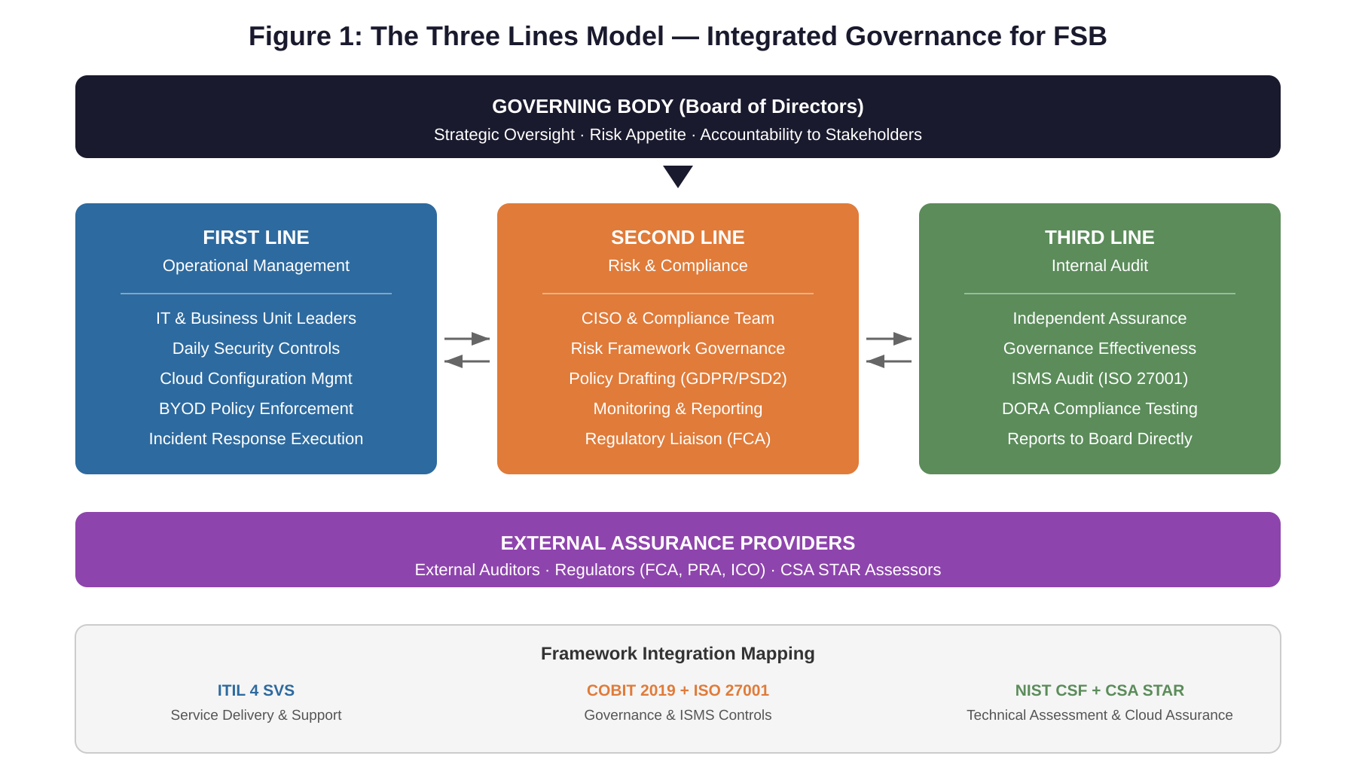
Figure 1: The Three Lines Model , Integrated Governance Structure for FSB

4.3. Cloud-Native Application Protection Platform (CNAPP)
With 90% of infrastructure in the cloud, FSB will implement a CNAPP integrating three pillars: Cloud Security Posture Management (CSPM) deployed agentlessly for continuous configuration monitoring; Cloud Workload Protection Platform (CWPP) providing agent-based runtime protection and vulnerability management; and Cloud Infrastructure Entitlement Management (CIEM) enforcing least privilege across multi-cloud identity matrices.
The architectural trade-off between agentless CSPM (broader visibility, lower operational overhead) and agent-based CWPP (deeper runtime protection, higher deployment complexity) justifies deploying both: CSPM provides immediate visibility during Phase 1, while CWPP addresses the runtime threat gap that agentless scanning cannot cover. However, single-vendor CNAPP platforms carry vendor lock-in risk, which FSB mitigates through the contractual exit strategy specified in Section 4.7 and by ensuring all configurations remain exportable in standardised formats.
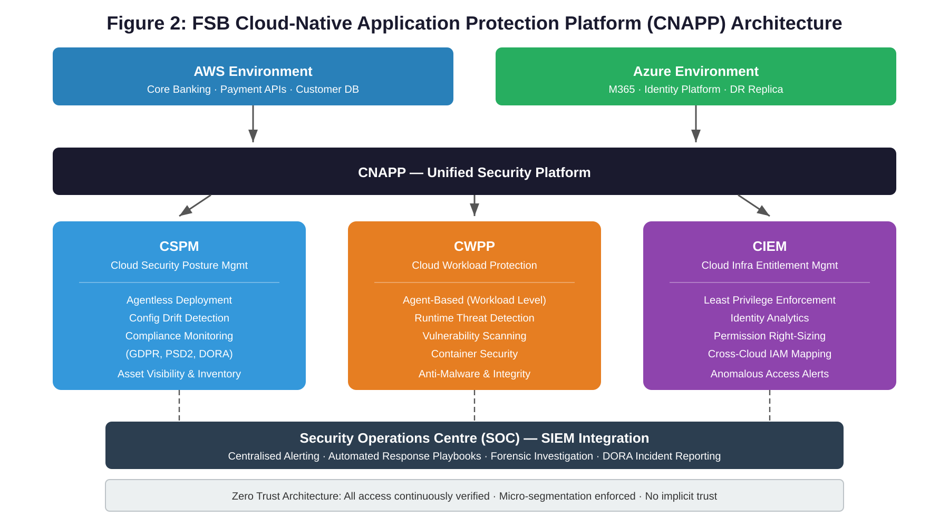
Figure 2: FSB Cloud-Native Application Protection Platform (CNAPP) Architecture

4.4. Securing BYOD and Data (CASB & DLP)
FSB’s BYOD policy enforces secure enclave technology and Mobile Application Management (MAM) to create isolated, encrypted work containers on personal devices [12]. A CASB provides visibility into Shadow IT and detects anomalous behaviour such as mass data downloads [13], while synergistic DLP classifies and protects sensitive data, automatically blocking unauthorised transfers and alerting the SOC [14].
The secure enclave approach represents a deliberate compromise: full Mobile Device Management (MDM) would grant FSB control over personal devices but raise significant employee consent issues under GDPR Article 6, whereas the enclave model confines corporate control to the work container alone. This balances security requirements against employee privacy, a tension that intensifies as BYOD adoption scales. Ethically, monitoring personal devices raises concerns around proportionality and the Menlo Report’s principle of Respect for Persons: FSB must ensure that CASB behavioural analytics and DLP content inspection remain confined to corporate data within the enclave, with transparent policies informing employees of monitoring scope. The accompanying BYOD acceptable use policy mandates that enrolled devices must not be jailbroken or rooted, corporate data must not be stored outside the encrypted enclave, and employees must report device loss within 24 hours to enable remote container wipe (see supplementary BYOD Acceptable Use Policy for complete policy specification).
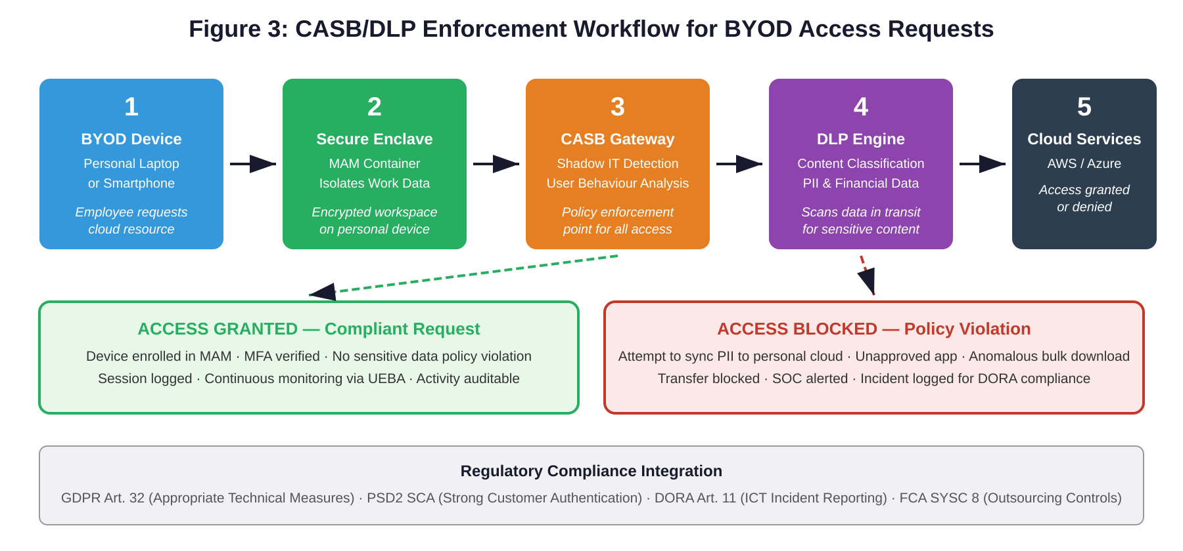
Figure 3: CASB/DLP Enforcement Workflow for BYOD Access Requests

4.5. Insider Threat Prevention
Every user and device is treated as untrusted by default under Zero Trust principles, requiring continuous verification for every access request [15]. Privileged Access Management (PAM) enforces Just-In-Time access elevation with formal approval workflows [16], complemented by continuous access reviews to prevent permission creep [17].
Zero Trust is architecturally expensive and operationally disruptive if implemented monolithically. Yeoh et al. [29] identify critical success factors including executive sponsorship, phased rollout, and cultural change management. FSB’s maturity roadmap (Figure 4) deliberately sequences Zero Trust implementation: MFA and micro segmentation in Phase 1, continuous adaptive access in Phase 3, and full Zero Trust maturity by Phase 4, avoiding overwhelming the organisation during initial deployment. A detailed 12-domain Security Maturity Assessment accompanies this report as supplementary documentation.

4.6. Contingency Planning (BCP and DRP)
FSB’s cloud infrastructure will be architected across geographically dispersed availability zones with mathematically defined recovery targets. Core banking carries an RTO of 2–4 hours and near-zero RPO via active-active replication [18][19][20]; payment processing APIs require 1–2 hours RTO with automatic failover ensuring PSD2 SCA continuity.
Table 3: FSB Recovery Objectives by System Criticality
System / Function | RTO Target | RPO Target | Recovery Strategy
Core Online Banking | 2–4 hours | Near-zero | Active-active replication across geo-dispersed AZs
Payment Processing APIs | 1–2 hours | Near-zero | Hot standby with automatic failover; PSD2 SCA continuity
Customer Database / PII | 4–8 hours | < 15 minutes | Synchronous replication; encrypted backups; GDPR Art. 32
Internal Collaboration | 8–24 hours | < 1 hour | Azure geo-redundant backup; lower criticality tier
SOC / SIEM Platform | 2–4 hours | < 30 minutes | Multi-region deployment; DORA incident reporting continuity
The critical cost-performance trade-off lies between active-active replication (near-zero RPO but significantly higher cloud spends) and asynchronous replication (cheaper but accepts data loss). Core banking warrants the premium given regulatory and reputational consequences of data loss, while internal collaboration tools do not justify equivalent investment.

4.7. SLA Management and Phased Implementation
Under FCA SYSC 8 [21], FSB’s cloud SLAs must include guaranteed uptime metrics with financial penalties, unequivocal audit rights for FSB and regulators, strict data localisation for GDPR compliance, and documented exit strategies to prevent vendor lock-in.
Table 4: Phased Implementation Timeline
Phase | Key Deliverables
Phase 1 (Months 0–6) | Establish IGSF governance structure; deploy CSPM for immediate visibility; implement MFA across all access points. Prioritises high-impact, lower-cost controls (CSPM is typically included in cloud platform licensing; CASB can leverage existing M365 E5 licensing) [2]. Requires dedicated CISO appointment and 2 FTE security engineers.
Phase 2 (Months 6–12) | Deploy full CNAPP (CWPP + CIEM); roll out CASB/DLP for BYOD; begin ISO 27001 certification preparation. Requires expansion to 5 FTE security team with dedicated cloud security architect.
Phase 3 (Months 12–18) | Achieve ISO 27001 certification; implement PAM and continuous access reviews; execute first DORA-mandated TLPT. Requires internal audit capability (1 FTE or outsourced) and organisation-wide security awareness training.
Phase 4 (Months 18–24) | Target Level 4 maturity; pursue CSA STAR certification via integrated audit with ISO 27001; establish continuous improvement cycle. Requires Security Operations Centre staffing (3 FTE analysts or Managed Security Service Provider contract).
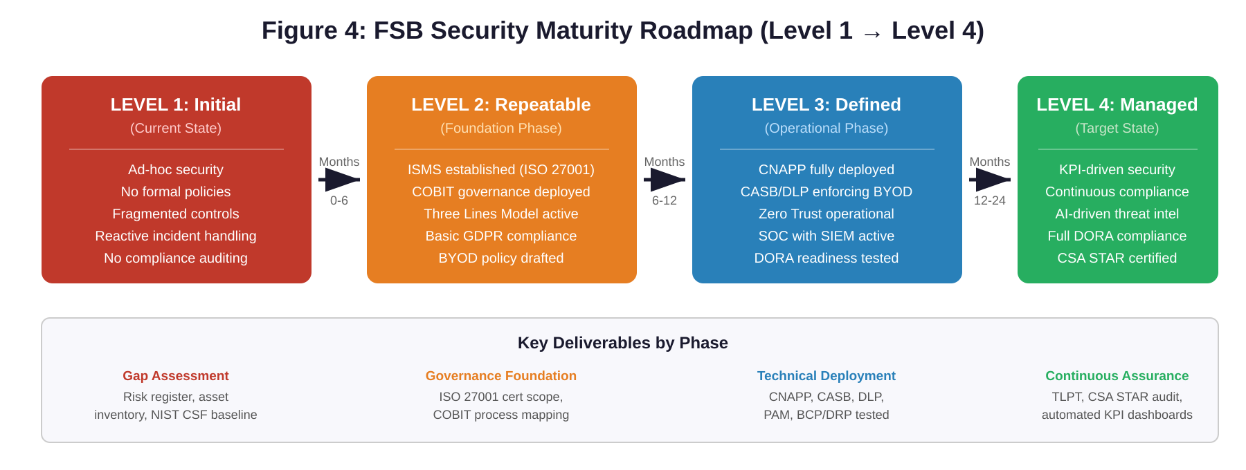
Figure 4: FSB Security Maturity Roadmap , Phased Implementation from Level 1 to Level 4

5. Academic Critique: The Necessity of Dynamic Regulations and Standards
FSB’s security architecture must not be viewed as a static achievement. A critical analysis of academic, economic, and industry literature underscores why regulations and standards must be constantly updated, while also engaging with scholarly arguments that challenge this position.

5.1. The Evolving Threat Landscape
The financial sector faces escalating threats, with the IBM Cost of a Data Breach Report documenting a global average breach cost of $4.88 million in 2024, with financial services averaging $6.08 million , the second highest across all industries [23, Figure 5]. Academic research identifies a marked increase in attack sophistication driven by AI weaponisation: threat actors leverage generative AI for automated spear-phishing and deepfake technology to bypass biometric authentication [24]. Ransomware-as-a-Service has produced multi-layered extortion tactics [22], while API exploitation in open banking and cloud misconfigurations represent emerging vectors that static regulations cannot address [25]. Continuous iteration mandates modern defensive paradigms including Zero Trust and AI-driven anomaly detection [15].

5.2. Compliance Versus Security Efficacy
Academic meta-reviews consistently demonstrate that mandating specific controls does not inherently guarantee risk reduction; efficacy depends on implementation quality [26]. Static regulations exacerbate this by allowing compliance to become performative. Corallo et al. [30] provide empirical evidence that ISO 27001 implementation generates measurable value only when organisations treat certification as continuous improvement rather than a point-in-time achievement. This dynamic is compounded by technical debt: rapidly launching digital services without integrated security architecture directly increases vulnerability, and static regulations inadvertently encourage debt accumulation as organisations build to outdated baselines. Evolving regulations such as DORA force continuous refactoring by mandating rigorous operational resilience testing [11], raising the floor progressively and compelling institutions to shift from reactive compliance to proactive resilience [26].

5.3. Counterarguments and Rebuttals
The case for dynamic regulation must be tested against three substantive counterarguments. First, regulatory fatigue: Buckley et al. [32] argue that compliance costs are fundamentally regressive, rapidly changing regulations impose disproportionate burdens on scaling institutions like FSB, where compliance expenditure represents a significantly higher proportion of revenue than for established incumbents. Frequent regulatory change can paradoxically reduce security by forcing constant re-engineering of controls rather than maturing existing ones. However, principles-based frameworks such as DORA’s proportionality principle mitigate this by scaling requirements to institutional size, and the cost of non-compliance (GDPR fines of up to 4% of global turnover) far exceeds adaptation costs.
Second, prescriptive overreach: Buocz, Pfotenhauer, and Eisenberger [33] demonstrate that rigid, prescriptive regulation creates ‘regulatory chill,’ discouraging innovation by forcing resources toward compliance rather than development. They advocate regulatory sandboxes as mechanisms to reconcile safety with innovation. Yet for the financial sector specifically, the asymmetric risk profile, systemic contagion from a single bank failure, justifies more prescriptive mandates, as evidenced by DORA’s specific TLPT requirements that go beyond generic guidance.
Third, regulatory lag: regulation inherently trails threat evolution, by publication, the threat landscape has moved. As Syed et al. [26] document, the gap between prescribed defences and actual threats is structurally inevitable. This is conceded, but it strengthens the case for continuous updates, as each regulatory iteration narrows the gap even if it cannot eliminate it entirely. The alternative, static regulation, guarantees an ever-widening gap.

6. Conclusion
FSB’s transformation into a leading digital financial provider demands an equally aggressive transformation in security, governance, and compliance. Through strategically integrating COBIT 2019 via the Three Lines Model, ISO 27001’s ISMS lifecycle, ITIL 4’s service delivery, and SABSA’s business-aligned architecture, FSB establishes a unified security posture. The deployment of CNAPP for cloud workloads, CASB/DLP for BYOD, and a phased Zero Trust implementation, supported by mathematically rigorous recovery targets and bespoke cloud SLAs, secures the bank’s operations within a 24-month maturity roadmap. The ethical imperatives articulated by the Menlo Report, Respect for Persons, Beneficence, Justice, and Respect for Law, further underscore that technological innovation must not outpace privacy protections, particularly as fintech entities leverage AI and Big Data to process sensitive consumer information. Enterprise cybersecurity is a continuous state of adaptation; by embracing dynamic regulatory standards and maintaining critical awareness of both their necessity and their limitations, FSB can decisively protect its digital assets.

References
[1] Revolut Ltd., "2024 Annual Report and Consolidated Financial Statements," London, United Kingdom, 2024. [Online]. Available: https://assets.revolut.com/pdf/annualreport2024.pdf
[2] G. Arcuri, L. Ferretti, M. Andreolini, and M. Colajanni, "Cybersecurity policy, ESG and operational risk: A virtuous relationship to improve banks’ performance," International Review of Economics and Finance, vol. 99, 2025, Art. no. 103847.
[3] European Parliament and Council, "Directive (EU) 2015/2366 on payment services in the internal market (PSD2)," Official Journal of the European Union, L 337, pp. 35–127, Dec. 2015.
[4] National Institute of Standards and Technology, "Framework for Improving Critical Infrastructure Cybersecurity, Version 1.1," NIST, Gaithersburg, MD, USA, Apr. 2018.
[5] T. R. McIntosh et al., "From COBIT to ISO 42001: Evaluating cybersecurity frameworks for opportunities, risks, and regulatory compliance in commercializing large language models," Computers & Security, vol. 144, 2024, Art. no. 103964.
[6] AXELOS, ITIL Foundation: ITIL 4 Edition. London, United Kingdom: TSO, 2019.
[7] Cloud Security Alliance, "Cloud Controls Matrix (CCM) v4.0," CSA, Seattle, WA, USA, 2021.
[8] Cloud Security Alliance, "CSA Security, Trust, Assurance and Risk (STAR) Program Overview," CSA, Seattle, WA, USA, 2023.
[9] M. Iskandar, I. Setiono, and B. Sugiantoro, "Integrating COBIT 2019 and ISO/IEC 27001 for strengthening IT governance and information security," Journal of Theoretical and Applied Information Technology, vol. 102, no. 11, pp. 4734–4745, 2024.
[10] European Parliament and Council, "Regulation (EU) 2016/679 on the protection of natural persons with regard to the processing of personal data (GDPR)," Official Journal of the European Union, L 119, pp. 1–88, May 2016.
[11] European Parliament and Council, "Regulation (EU) 2022/2554 on digital operational resilience for the financial sector (DORA)," Official Journal of the European Union, L 333, pp. 1–79, Dec. 2022.
[12] K. Downer and M. Bhatt, "BYOD security: A study of human dimensions," Informatics, vol. 6, no. 2, p. 16, 2019.
[13] A. Singh, A. Chatterjee, and A. Satapathy, "An improved smart contract-based BYOD security control framework," Alexandria Engineering Journal, vol. 107, pp. 395–410, 2024.
[14] R. Palanisamy, A. Norman, and M. T. Mat Kiah, "Compliance with bring your own device security policies in organizations: A systematic literature review," Computers & Security, vol. 98, 2020, Art. no. 101998.
[15] Z. Adahman, A. W. Malik, and Z. Anwar, "An analysis of zero-trust architecture and its cost-effectiveness for organizational security," Computers & Security, vol. 122, 2022, Art. no. 102911.
[16] M. Kassou, S. Bourekkadi, and S. Khoulji, "Insider threat mitigation: Systematic literature review," Ain Shams Engineering Journal, vol. 15, no. 12, 2024, Art. no. 103094.
[17] R. Mocanu, A. Castelltort, and A. Laurent, “Towards continuous access certification in identity governance: A systematic approach to preventing privilege creep,” Computers & Security, vol. 129, 2023, Art. no. 103218.
[18] N. K. Thalji and A. Aldowah, "Disaster recovery techniques in cloud computing: A systematic literature review," IEEE Access, vol. 11, pp. 23222–23245, 2023.
[19] ISO/IEC, "ISO 22301:2019 , Security and resilience , Business continuity management systems , Requirements," Geneva, Switzerland, 2019.
[20] A. Y. Alreemy, D. Chang, R. Walters, and G. Wills, "Critical success factors for information technology governance," International Journal of Information Management, vol. 36, no. 6, pp. 907–916, 2016.
[21] Financial Conduct Authority, "FG16/5: Guidance for firms outsourcing to the ‘cloud’ and other third-party IT services," FCA, London, United Kingdom, Jul. 2016.
[22] M. A. Ferrag et al., "Deep learning for cyber security intrusion detection: Approaches, datasets, and comparative study," Journal of Information Security and Applications, vol. 50, 2020, Art. no. 102419.
[23] IBM Security, "Cost of a Data Breach Report 2024," IBM Corporation, Armonk, NY, USA, 2024. [Online]. Available: https://www.ibm.com/reports/data-breach
[24] M. I. Alghamdi, "Cybersecurity threats in FinTech: A systematic review," Expert Systems with Applications, vol. 238, Part A, 2024, Art. no. 122071.
[25] C. Itodo and M. Ozer, "Multivocal literature review on zero-trust security implementation," Computers & Security, vol. 143, 2024, Art. no. 103919.
[26] R. Syed, M. Syed, and A. Anwar, "Evidence-based cybersecurity policy? A meta-review of security control effectiveness," Journal of Cyber Policy, vol. 9, no. 1, pp. 1–25, 2024.
[27] S. De Haes, W. Van Grembergen, A. Joshi, and T. Huygh, "COBIT as a framework for enterprise governance of IT," in Enterprise Governance of Information Technology, 3rd ed. Cham, Switzerland: Springer, 2020, pp. 125–162.
[28] ISO/IEC, "ISO/IEC 27001:2022 , Information security, cybersecurity and privacy protection , Information security management systems , Requirements," Geneva, Switzerland, 2022.
[29] W. Yeoh, M. Liu, M. Shore, and F. Jiang, "Zero trust cybersecurity: Critical success factors and a maturity assessment framework," Computers & Security, vol. 133, 2023, Art. no. 103412.
[30] M. Corallo, M. Lazoi, and M. Lezzi, "Information security and value creation: The performance implications of ISO/IEC 27001," Computers in Industry, vol. 142, 2022, Art. no. 103744.
[31] C. Pascoe, S. Quinn, and K. Scarfone, “The NIST Cybersecurity Framework (CSF) 2.0,” NIST CSWP 29, National Institute of Standards and Technology, Gaithersburg, MD, USA, Feb. 2024. [Online]. Available: https://doi.org/10.6028/NIST.CSWP.29
[32] R. P. Buckley, D. W. Arner, R. Veidt, and D. Zetzsche, “Building fintech ecosystems: Regulatory sandboxes, innovation hubs and beyond,” Washington University Journal of Law & Policy, vol. 61, pp. 55–98, 2020.
[33] T. Buocz, S. Pfotenhauer, and I. Eisenberger, “Regulatory sandboxes in the AI Act: Reconciling innovation and safety?” Law, Innovation and Technology, vol. 15, no. 2, pp. 357–398, 2023.

Appendix: Index of Supplementary Documentation
To fully satisfy the practical design and implementation requirements of this framework, several supplementary documents have been produced and uploaded via the secondary Moodle submission link. Each appendix has been developed as a standalone, professionally structured deliverable to demonstrate the practical application of the theories, frameworks, and methodologies discussed.

Appendix A: Security Architecture Design Document
Layered SABSA data flows, detailed CNAPP/Zero Trust deployment models, and specific network security zoning. This document provides the full technical blueprint for FSB's proposed security architecture, translating the strategic vision into implementable design artefacts.

Appendix B: Security Maturity Assessment
A 12-domain capability assessment mapping FSB's current Level 1 (Initial/Ad Hoc) state to the target Level 4 (Managed & Measurable) state across the 24-month transformation roadmap. Each domain includes current-state findings, target-state objectives, and the specific initiatives required to bridge each maturity gap.

Appendix C: Risk Register & FAIR Quantitative Analysis
A detailed, probabilistically modelled risk register translating cyber threats into Annual Loss Expectancy (ALE) using the Factor Analysis of Information Risk (FAIR) methodology. This quantitative approach provides the financial justification for the proposed security investments and enables data-driven prioritisation of risk mitigation efforts.

Appendix D: Compliance & Framework Integration Mapping Matrix
A granular traceability matrix mapping GDPR, PSD2, and DORA regulatory requirements directly to ISO 27001, NIST CSF, and CSA STAR technical controls. This matrix demonstrates full regulatory coverage and provides FSB with a unified compliance reference to streamline audit preparation and evidence gathering.

Appendix E: BYOD & Cloud Services Acceptable Use Policy
A formal, deployable corporate policy governing secure enclave usage, privacy considerations, and employee responsibilities for Bring Your Own Device (BYOD) and cloud service access. This policy document is ready for adoption and includes enforcement mechanisms, incident response obligations, and acceptable use definitions aligned with FSB's regulatory obligations.

