University of Wales Trinity Saint David
BA (Hons) Business Management
DATA HANDLING AND BUSINESS INTELLIGENCE
COMPONENT 2
COURSEWORK ESSAY
Student ID-2131059
Student Name-Ovidiu Muresan
Lecturer Name-Amitave Banik
Submission-20.12.2023

Table of Contents
Part 1 3
RRP vs. Year 4
Vlookup Booking Id + If Refund 5
Room type Pie Chart 6
Part 2 7
Male and female students 7
Qualified and unable to qualify students 7
The mean and median of qualified students 7
Specific example of Clustering with SPSS 8
Data mining and text mining methods 8
Advantages and disadvantage of SPSS and Excel 10
Reference List 12

Part 1
Data analysis is at the heart of a data analyst's job, and Microsoft Excel, a widely used spreadsheet tool, is often put to work in this capacity. This research aims to determine, with the use of previously collected booking data, whether the average cost of reserving a hotel room would increase between 2017 and 2021. Pre-processing the dataset is the first step in initiating the analytic process. In the pre-processing step, the data are cleaned, processed, and structured in preparation for future analysis (Bharadiya, 2023). To achieve this purpose with Microsoft Excel, you may make use of technologies like Pivot Tables and the VLOOKUP function. Pivot Tables are functionality inside the Microsoft Excel software that enables users, including students, to efficiently condense large information into a concise and comprehensible table. We may find regularities and trends, and in this case we may calculate the typical cost of lodging bookings. By picking the complete dataset, heading to the "Insert" tab, and then clicking the "PivotTable." button, a learner may construct a pivot table. When adding the PivotTable, the user may either make a new worksheet or utilise an existing one, and they will be prompted to define the range of cells that contain our data. Users may then add the columns they want summarised and choose the appropriate aggregate function after the PivotTable has been created; in this case, the "Price" function was selected for the "average" column since it is the most applicable to our needs (Ghelani, 2023). By placing the "Year" column in the "Rows" box, it is possible to arrange the data in chronological order.
Another tool that could come in helpful for early data processing is Excel's VLOOKUP function. In this method, we may search for a given value in a table and potentially discover it in another column. We may utilise the VLOOKUP function to add the "Region" column to our present PivotTable. This may be done by comparing the "City" columns in two distinct tables that contain data on the regions. A new table containing the appropriate geographic and demographic information must be constructed before the VLOOKUP function can be utilised (Jalil and Hwang, 2019). The next step is to use the function to discover the city in our data; then, we will know exactly where it is. As soon as we obtain the regional data, we can drag the "Region" column into the "Columns" box and update our PivotTable appropriately. Ultimately, Microsoft Excel is a strong tool for data preparation and analysis, and its numerous features may assist us in attaining our aims. By using Pivot Tables and the VLOOKUP tool, it is possible to analyse if there has been a temporal fluctuation in the average cost of hotel reservations. In addition, it has shown the use of the VLOOKUP function in order to include a column named "Region" into our PivotTable (Badwan et al. 2023). These improvements may allow the efficient and intelligent analysis of massive datasets, which in turn could influence decision-making.
The PivotChart tool in Microsoft Excel may be used to analyse the probable association between RRP and the calendar year. The PivotChart shows the facts in a visual format that is both clear and brief. In order to generate a PivotChart, it is necessary to manually choose the data from the Hotel Reservation dataset on an individual basis. The subsequent procedure entails navigating to the "Insert" tab and thereafter opting for the "Charts" option from the drop-down menu next to "PivotChart" (Abusweilem and Abualoush, 2019). A "Create PivotChart" dialogue box will open, letting us to pick the appropriate chart type. In this instance, a line chart may perform a good job of depicting the trend over time.

RRP vs. Year
The "Year" column may be added to the Axis (Categories) field after the PivotChart has been created, and the "Average price of room reservation" column can be added to the "Values" field. The PivotChart will display each of these groups separately. To display the average price over time, we need to modify the dataset by switching the aggregation function from Sum to Average (Tavera Romero et al. 2021). In order to personalise the PivotChart to our specifications, we may add elements like a chart title, axis names, and data labels. The aesthetics of the chart may be enhanced by altering its colour scheme and layout.
To form inferences regarding the price growth from 2017 to 2022, a trendline may be added to a PivotChart. With the aid of the trendline, we can more clearly examine the general trend in the data and establish whether or not prices are growing or dropping over time. To add a trendline to a chart, we may right-click on the data series and pick "Add Trendline." from the menu that displays. Subsequently, the selection of a preferred trendline type and the specification of any desired preferences are made (Moreno et al. 2022). Finally, we utilised a PivotChart in Microsoft Excel to analyse how each year associated with the RRP. Because of this, we were able to identify whether there has been an increase or drop in price over time. We may be better able to draw inferences from the data provided in the chart if we add a trendline to it.
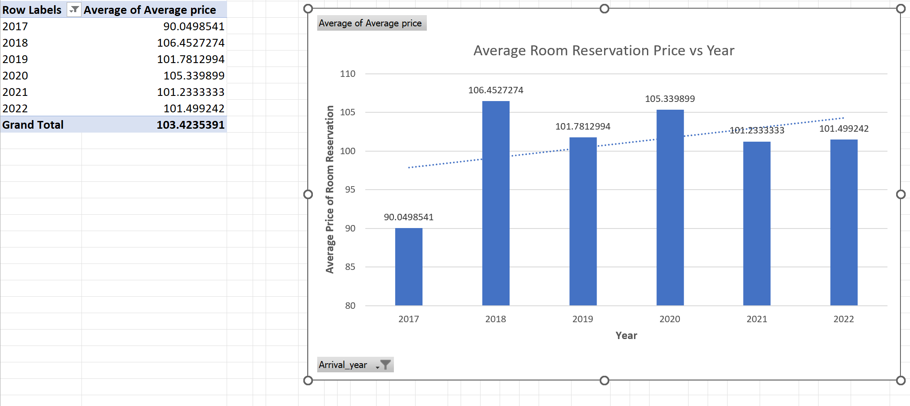
Average room reservation

Vlookup Booking Id + If Refund
Microsoft Excel's VLOOKUP feature is excellent for finding information using a particular value, like a reservation ID. The numerical inputs provided by the user will be searched inside the first column of the table, and subsequently, the corresponding value from the selected column will be retrieved. In order for the VLOOKUP query to function correctly, it is necessary to have a table that includes booking IDs and corresponding refund information (Baruti, 2023). This table may be made on the "Data" sheet, a dedicated page for such purposes. Cell E1 of the database "Vlookup Booking Id + If Refund" includes the booking ID that may be used for a search. Then, write the following formula into the cell where the refund information should be displayed:
Equals ('Vlookup Booking Id + If Refund')!
E1, Data!
A1:S36276, 2,0)
For a refund, use the following formula: "Vlookup Booking Id + If Refund."
The reservation number may be found in the "E1" field. Data!A1:S36276 on the Data sheet comprises the booking IDs and refund information (Cristobal-Salas et al. 2019). When the booking IDs are in the first column, a value of 0 indicates that an exact match is not required, whereas a value of 2 specifies the precise column number that holds the refund information. For example the sake of argument that the hotel provides a 50% return policy for guests who need to cancel their bookings (Olszak, 2022). Our VLOOKUP formula may make use of the IF function to assess whether or not the reservation has been cancelled in line with this policy. If you cancel your reservation, you will obtain a refund equivalent to 50 percent of the booking amount. We merely return 0 in all other instances.
The revised equation might include these components:
Utilise the provided formula in order to get the ultimate outcome. The formula provided calculates a value based on the result of a VLOOKUP function. The VLOOKUP function searches for a certain value in a range of cells in the 'Data' sheet, and returns a corresponding value from the same row in a different column. In this case, the formula checks whether the value in cell E1 of the 'Vlookup Booking Id + whether Refund' sheet, when looked up in the range A1:S36276 of the 'Data'
The formula "VLOOKUP('Vlookup Booking Id + If Refund'!E1,Data!A1:S36276,9,0)" is used to get the current booking status from column 9 of the Data sheet. In the context of the given task, the formula 0.5*VLOOKUP('Vlookup Booking Id + If Refund'!E1,Data!A1:S36276,16,0) is used to modify the values in column 16 of the Data sheet. This modification occurs only when the booking status is identified as "cancelled," resulting in a 0.5 increment in the cost of the booking. In the event that the booking status is not marked as "cancelled," a value of 0 will be returned (Božič and Dimovski, 2019). This collection of functions may be used in concert with one another to determine the refund amount for a certain booking ID.
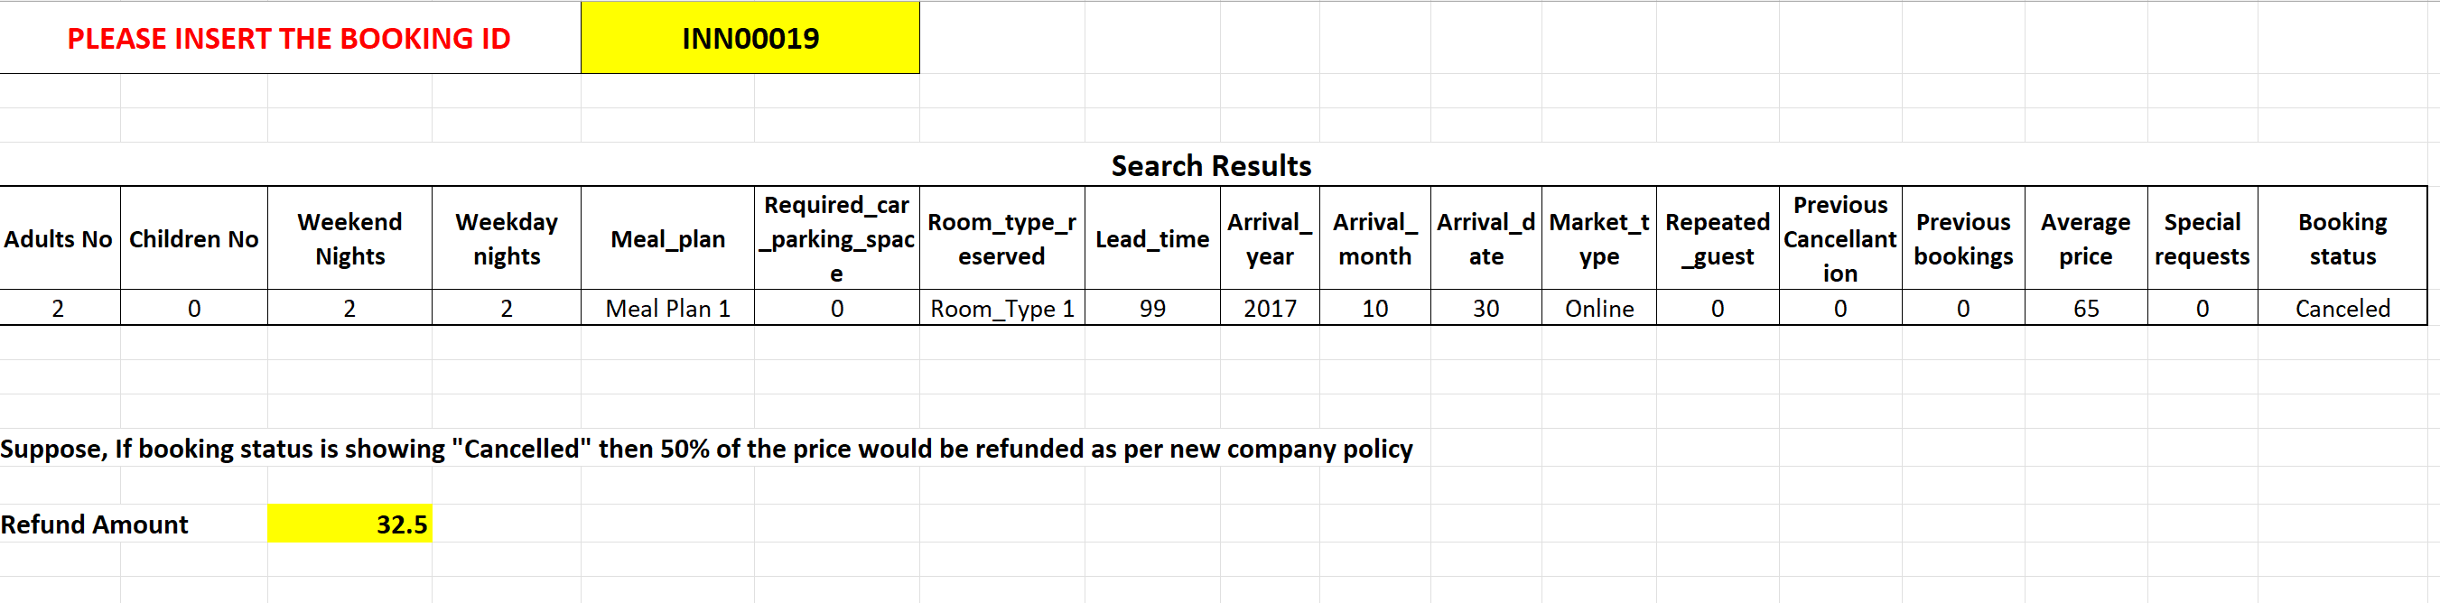
Vlookup

Room type Pie Chart
We can create a pie chart illustrating the distribution of room types by counting how many occurrences of each room type there are in our data set using the COUNTIF function in Microsoft Excel. We'll create a pie chart based on the percentages we get from the counts.
- Access the formulas by selecting the room type data column from the ribbon's "Formulas" tab.
- The COUNTIF function may be found in the "Insert Function" menu. Just choose it and click "OK"!
- Select the desired room type from the "Range" drop-down option to narrow your search. In the "Criteria" section, you may choose between several room kinds (such as "Room Type 1"). Select "OK" to activate the function.
- Above step must be performed again for each unique room type in the database.
- To find out what share of rooms belong to whatever category, just add up the rooms in each group and divide by the total number of rooms. Using the specified formula is one method for accomplishing this goal"=COUNTIF(range,criteria)/COUNT(range)".
- Individual will need to provide names to the different room categories and pasted percentages into a new column.
- Select the "Charts" submenu in the "Insert" section of the ribbon to insert a pie chart.
- Pick the proper kind of pie chart and adjust its elements as needed (by adding labels to the data, switching the colours, etc.).
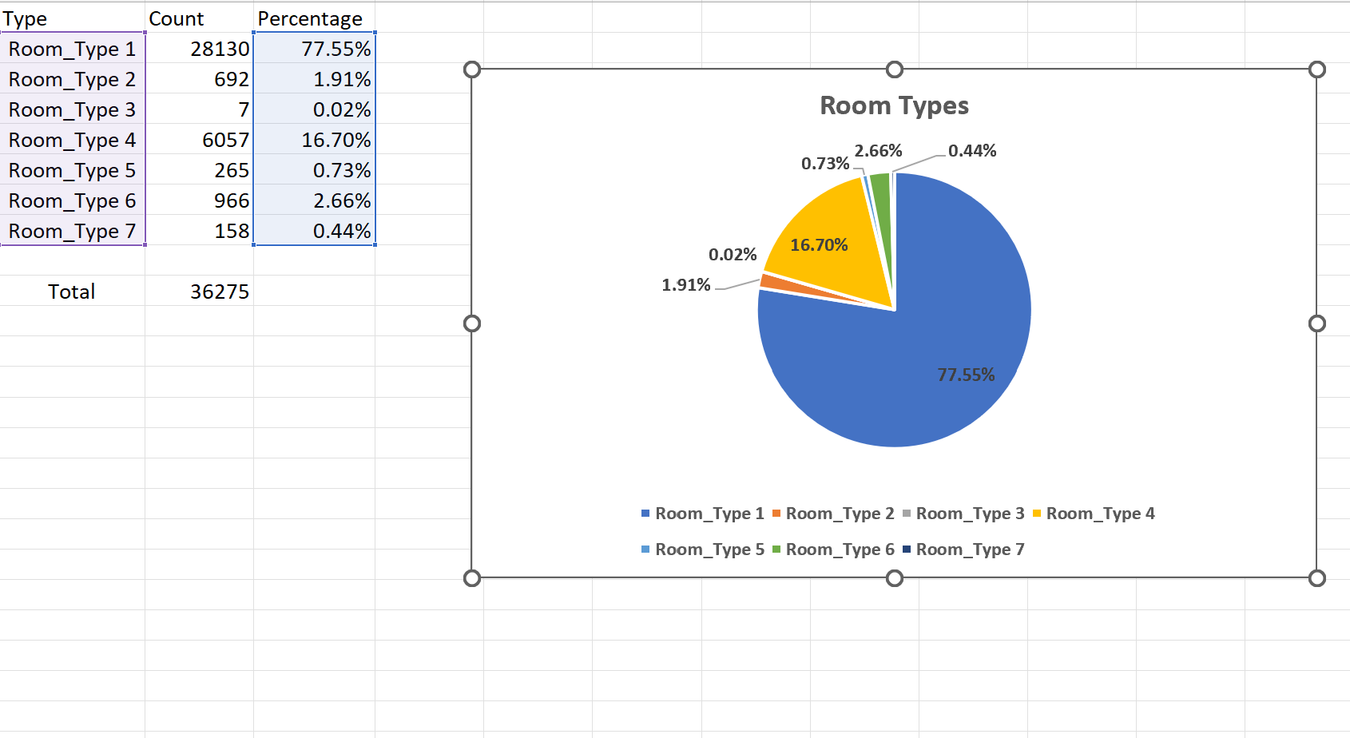
Room types

Following the aforementioned steps, we will get a pie chart representing the room type composition of our dataset. The resulting pie chart will illustrate the distribution of room types within the dataset, with the size of each slice representing the frequency with which that kind of room appears in the data (Richardson et al. 2020). This graphic assistance may help guests better understand the hotel's room inventory and find the most popular room types.

Part 2

Male and female students
The COUNTIF function in Microsoft Excel may be used to determine the proportion of male and female students who filled out the survey. Using the data in the "Gender" and "Male" columns, the total in the "Female" column may be determined. Using the SUMPRODUCT function, you can determine how many students participated in the survey. To get the percentage of male to female students, just divide the number of male or female students by the total number of students. Double that number once you get it (Park et al., 2020). At long last, we'll have enough data to create a graphic illustrating how each gender is represented in the student population.
The percentage of male and female students who participated in the survey is shown separately in the final pie chart. This graph may provide light on the sex distribution of the student body and highlight any gaps between boys and girls in terms of performance.
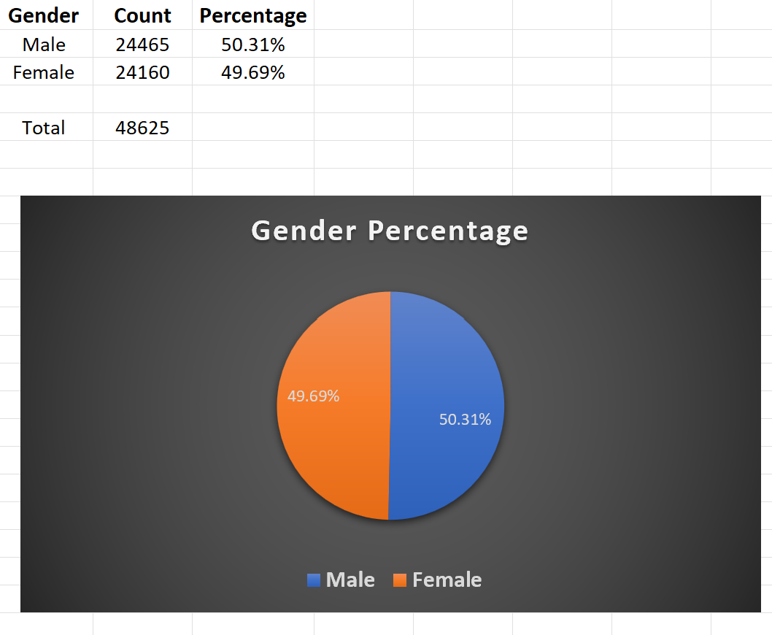
Gender percentage

Qualified and unable to qualify students
The SUMPRODUCT function in Excel allows us to determine the percentage of students who qualify for free or reduced-price lunches. I started by selecting the column that detailed who showed up for lunch. The number of students in each category may then be calculated using the formula =SUMPRODUCT((range="qualify")+(range="do not qualify")). After acquire the data, it may divide by the total number of students to get the percentage of students who fall into each category (Kher and Hira, 2020). The percentage of students who qualify for reduced-cost or free lunches may be shown in a pie chart. This pie chart may be useful for an analyst contemplating the potential impact of students' socioeconomic backgrounds on their performance on the pre- and post-tests.
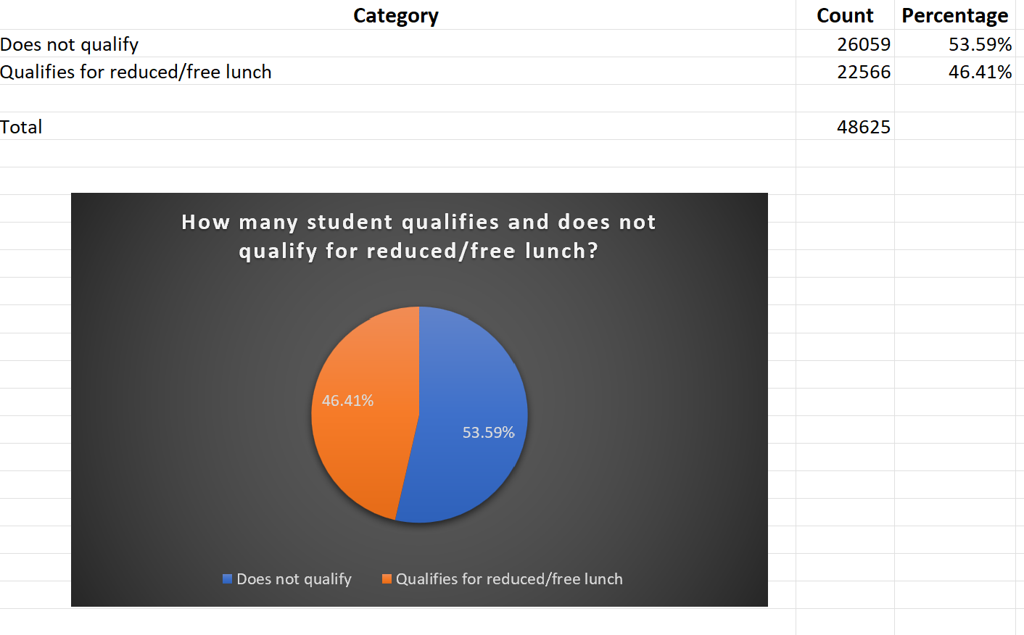
Students qualified for free lunch

The mean and median of qualified students
To calculate the mean and median scores of students who get free or reduced-price lunch vs those who do not, the SUMPRODUCT function may be used. Next, we can use the AVERAGE function to get the average across all groups. Assuming all numbers are larger than 0, the MEDIAN function may be used to locate the midpoint.
Students' pre- and post-test mean and median discrepancies
According to Cheng et al. (2020), the use of the AVERAGE and MEDIAN functions enables the determination of the extent of variation in students' scores between the pre- and post-tests, along with the calculation of the average and median alterations in such scores. After obtaining the mean and median scores from the pre-test and post-test, the calculation of the discrepancy between these two sets of scores allows for an assessment of the magnitude of the differences.
Clustering in SPSS: A Concrete Example
Here, the number of cluster is 2

Descriptive Statistics
 | N | Minimum | Maximum | Mean | Std. Deviation
Student_No | 2133 | 14 | 31 | 22.80 | 4.229
Pretest | 2133 | 22 | 93 | 54.96 | 13.563
Posttest | 2133 | 32 | 100 | 67.10 | 13.987
Valid N (listwise) | 2133

Quick Cluster

Initial Cluster Centers
 | Cluster
 | 1 | 2
Zscore(Student_No) | 1.23046 | -1.37070
Zscore(Pretest) | -2.35609 | 2.80497
Zscore(Posttest) | -2.29518 | 2.35206

Iteration Historyª
Iteration | Change in Cluster Centers
Iteration | 1 | 2
1 | 2.307 | 2.569
2 | .061 | .054
3 | .024 | .023
4 | .015 | .014
5 | .011 | .011
6 | .003 | .003
7 | .003 | .002
8 | .004 | .004
9 | .001 | .001
10 | .001 | .001
a. Iterations stopped because the maximum number of iterations was performed. Iterations failed to converge. The maximum absolute coordinate change for any center is .001. The current iteration is 10. The minimum distance between initial centers is 7.416.

Final Cluster Centers
 | Cluster
 | 1 | 2
Zscore(Student_No) | .65914 | -.62249
Zscore(Pretest) | -.81788 | .77240
Zscore(Posttest) | -.82717 | .78117

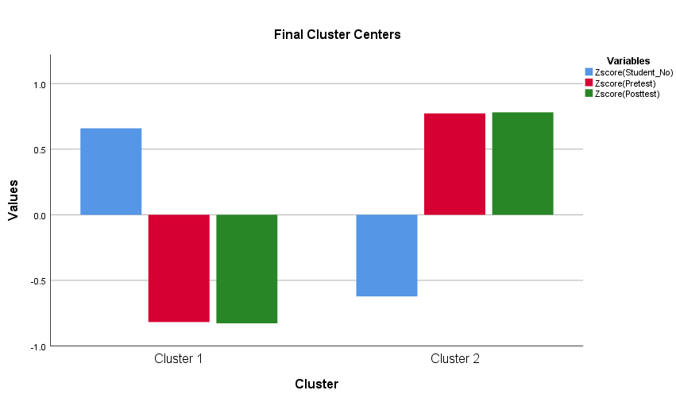
Final Cluster Centers for two clusters

ANOVA
 | Cluster |  | Error |  | F | Sig.
 | Mean Square | df | Mean Square | df | F | Sig.
Zscore(Student_No) | 875.193 | 1 | .590 | 2131 | 1483.947 | .000
Zscore(Pretest) | 1347.484 | 1 | .368 | 2131 | 3660.206 | .000
Zscore(Posttest) | 1378.252 | 1 | .354 | 2131 | 3896.597 | .000
The F tests should be used only for descriptive purposes because the clusters have been chosen to maximize the differences among cases in different clusters. The observed significance levels are not corrected for this and thus cannot be interpreted as tests of the hypothesis that the cluster means are equal.

Number of Cases in each Cluster
Cluster | 1 | 1036.000
Cluster | 2 | 1097.000
Valid |  | 2133.000

“Data mining and text mining methods”
Common data mining examples
Rule Mining is a data mining approach used to discover patterns of relationship among elements inside a given dataset. By using association rule mining techniques, a retail establishment may effectively discern patterns of co-occurrence between items, such as bread and butter, that are often bought in conjunction. Retailers may use this knowledge to their advantage by effectively grouping or strategically arranging similar products.
Clustering refers to the process of categorising data components based on their shared characteristics. Clustering may be used by a car dealership to effectively categorise buyers seeking family-friendly vehicles into distinct groups (Bordeleau et al. 2020). By discerning these demographic segments, the dealership can optimise its marketing strategies to cater to them more efficiently.
Data categorization is the process by which information is organised into meaningful groupings via a series of procedures. The use of classification techniques in the identification of fraudulent transactions might potentially provide advantageous outcomes for credit card firms. The use of this information by the organisation might potentially enhance its ability to safeguard clients from fraudulent activities.
Regression analysis is the prediction of the relationship between two or more variables within a given dataset. As an example, a real estate firm may use regression analysis to forecast the selling price of a residential property based on factors such as its geographical location, total area, and number of bedrooms. This information has the ability to enhance the company's pricing decision-making process and enable more precise price quotations for prospective customers.
Time series analysis is a statistical technique used to investigate data that has been gathered over a significant duration of time (Ahmad et al. 2020). Time series analysis may be used by a retail establishment to examine the variations in company performance throughout different seasons or to provide forecasts on future outcomes. This information may be used by management to enhance resource allocation and workforce scheduling.
Five of the most common text mining examples
Sentiment analysis is conducted to ascertain the inherent emotional tone of a given textual composition. Restaurants may use sentiment analysis as a means to gauge the favourable or unfavourable connotations included in client feedback. This information might potentially be used by the restaurant to enhance its menu and services.
Named Entity Recognition (NER) refers to the process of recognising and categorising nouns, such as names, localities, and companies, within a given text (Bharadiya, 2023). Using Named Entity Recognition (NER), news outlets may automatically extract key details from news stories and summarise them according to the most frequently cited subjects.
Topic modelling is the main focus of our attention. Topic modelling is used for its intended goal of automatically finding broad themes present in a given text corpus. Topic modelling is a regularly used approach in numerous fields, including market research, with the objective of examining consumer input and identifying the core problems that require addressed in order to enhance customer satisfaction.
The objective of this technique is to categorise texts into meaningful classifications. Text categorization is a technique that may be used by a customer care staff to effectively allocate incoming calls and emails to the appropriate departments, such as invoicing or technical assistance (Badwanw et al. 2023).
The objective of information extraction is to automatically retrieve information from unstructured text. For instance, a legal organisation may use information extraction software to analyse incoming papers from clients, identifying significant terms and then alerting them of any potential concerns or advantageous circumstances.

Advantages and disadvantage of SPSS and Excel
Advantages of Excel
- The data analysis tool has a user-friendly interface that facilitates straightforward data processing.
- Efficient and streamlined data processing.
- The system is designed to accommodate a diverse array of data types.
- Proficient in the creation of impactful pivot tables and graphs.
Disadvantage of Excel
- The capacity for statistical data analysis is restricted.
- Not good enough for advanced data analysis projects.
- Regarding large data sets, not much assistance is available.
- Almost no ways of collaborating and exchanging files (Moreno et al. 2022)
Advantages of SPSS
- High-quality statistical analytic skills.
- Effectively manage massive amounts of data.
- Instruments for cleaning and organising data
- Appropriate for use in multivariate studies.
Disadvantage of SPSS
- There is a significant learning curve for new users.
- High-priced, legally-licensed software.
- There's a chance that you'll require some knowledge of computer programming syntax.
- Not even good enough for simple data entry.
For instance, if a researcher is conducting a large-scale study with complex statistical analysis requirements, SPSS is the best alternative due to its ability to handle vast datasets and wide statistical analysis abilities. However, if a researcher is dealing with a small dataset and has to immediately generate simple visualisations and pivot tables, Excel is the superior alternative due to its user-friendly interface and fast data manipulation capabilities.

Reference List
Abusweilem, M. and Abualoush, S., 2019. The impact of knowledge management process and business intelligence on organizational performance. Management Science Letters, 9(12), pp.2143-2156.
Ahmad, S., Miskon, S., Alabdan, R. and Tlili, I., 2020. Towards sustainable textile and apparel industry: Exploring the role of business intelligence systems in the era of industry 4.0. Sustainability, 12(7), p.2632.
Badwan, N., Al-Zoubi, L. and Al-Khazaleh, S., 2023. Financial Risk Management in the Supply Chain Using Business Intelligence and Big Data. International Journal of Management and Business Research, 7(1), pp.1-27.
Baruti, R., 2023. Analysis and Implementation of a Business Intelligence QlikView application for logistic and procurement management. Sews Cabind case for the shortage problem (Doctoral dissertation, Politecnico di Torino).
Bharadiya, J.P., 2023. Machine learning and AI in business intelligence: trends and opportunities. International Journal of Computer (IJC), 48(1), pp.123-134.
Bordeleau, F.E., Mosconi, E. and de Santa-Eulalia, L.A., 2020. Business intelligence and analytics value creation in Industry 4.0: a multiple case study in manufacturing medium enterprises. Production Planning & Control, 31(2-3), pp.173-185.
Božič, K. and Dimovski, V., 2019. Business intelligence and analytics use, innovation ambidexterity, and firm performance: A dynamic capabilities perspective. The Journal of Strategic Information Systems, 28(4), p.101578.
Cheng, C., Zhong, H. and Cao, L., 2020. Facilitating speed of internationalization: The roles of business intelligence and organizational agility. Journal of Business Research, 110, pp.95-103.
Ghelani, D., 2023. A PERSPECTIVE STUDY OF NATURAL LANGUAGE PROCESSING IN THE BUSINESS INTELLIGENCE. INTERNATIONAL JOURNAL OF COMPUTER SCIENCE AND TECHNOLOGY, 7(1), pp.20-36.
Jalil, N.A. and Hwang, H.J., 2019. Technological-centric business intelligence: Critical success factors. International Journal of Innovation, Creativity and Change, 5(2), p.1499.
Kher, A.A. and Hira, S., 2020. An Approach to Identify Product Purchase Processing Time by Applying Business Intelligence in Steel Coated Production. Bioscience Biotechnology Research Communications, 13(14), pp.28-31.
Moreno, C.V., Rodriguez, C., Puente, F.G., Petrlik, I., Lezama, P. and Pomachagua, Y., 2022, December. Business Intelligence Architecture to Improve Decision Making. In 2022 14th International Conference on Computational Intelligence and Communication Networks (CICN) (pp. 7-15). IEEE.
Olszak, C.M., 2022. Business intelligence systems for innovative development of organizations. Procedia Computer Science, 207, pp.1754-1762.
Park, Y., El Sawy, O.A. and Hong, T., 2020. Digital transformation to real-time enterprise to sustain competitive advantage in the digitized world: The role of business intelligence and communication systems. Korea Business Review, 24(0), pp.105-130.
Richardson, J., Sallam, R., Schlegel, K., Kronz, A. and Sun, J., 2020. Magic quadrant for analytics and business intelligence platforms. Gartner ID G00386610.
Tavera Romero, C.A., Ortiz, J.H., Khalaf, O.I. and Ríos Prado, A., 2021. Business intelligence: business evolution after industry 4.0. Sustainability, 13(18), p.10026.

