



Transient Thermal Diffusion Model using the Finite Difference Method
Author: Sion Evans (P150600)
Advanced Computational Methods - M6X00408
Lecturer: Dr Arnaud Marotin
School of Engineering
27/01/2020

Table of Abbreviations

Abstract
PDE = Partial Differential Equation
FDM = Finite Difference Method
FEA = Finite Element Analysis
FVM = Finite Volume Method
$F_{0}$ = Fourier’s Number
$α$ = Thermal Diffusivity (m².s⁻¹)
K = Thermal Conductivity (W$.m^{-1}$.$k^{-1}$)
$T$ = Temperature ( $k$)
t = Time (s)
$ρ$ = Density (Kg/$m^{3}$)
$c$ = Specific Heat (J.kg¹.K⁻¹)
$σ$ = Standard Deviation
$f$ = Function
A = Area ($m^{2}$)
H = Grid Spacing (m)
$∆t$ = Time-step (s)
$∇$ = Nabla

The finite difference method is used to discretise partial differential equations and solve them. The transient 2D heat diffusion equation is solved using the explicit method. This process in translated into MATLAB where the problem is solved in matric form and plotted onto a heat map for analysis.

Contents
1. Introduction. 3
1.1 Partial Differential Equations 3
1.2 The Constitutive Equation of The Problem. 4
1.3 The Initial and Boundary Conditions Implemented. 5
2. Finite Difference Method. 6
2.1 Taylor Series 6
2.2 Explicit Method 7
3. Details of the Finite Difference Model Script. 8
3.1 User Input Allocation 8
3.2 Boundary Conditions Allocation 8
3.3 Explicit Time-Step Limit 9
3.4 Explicit Thermal Diffusion Equation 9
3.5 Illustration of the Simulation 10
4. Analysis of the code results. 11
4.1 Grid Spacing 11
4.2 Time-step 13
4.3 Tolerance 15
5. Limitations & Suggested Improvements to the Model. 16
5.1 Limitations of the Model. 16
5.2 Suggested Improvements 17
6. Conclusion. 17
7. References 17
8. Appendices 18

1. Introduction.
Understanding the dissipation of heat energy and its fundamental qualities is crucial to implement systems that manipulate these qualities to work favour of a design. In recent years, engineers have encountered an ever-growing number of problems with heat exchange through materials. To arrive at successful solutions to such problems, the technique of simulating continuous physical systems was developed using mathematical models knows as partial differential equations (PDEs). PDEs have been used through the ages to analytically solve equations, this was how Joseph Fourier developed the heat equation back in 1822.
However, most realistic problems represented by PDEs are far too complex to be solved analytically due to complex geometries, nonlinearities and complicated boundary conditions. Resulting in the development of various numerical methods to computationally solve complex PDEs (Gennady V. Miloshevsky, 2006).
The use of such numerical models dates to early 1950’s, stimulated by the emergence of computers. The enhancement of high-speed digital computers so too has the use of numerical models enhanced to become a valuable tool used across many branches of science to provide fast and cost-effective solutions. Presently various solution methods include Finite Difference Method (FDM), Finite Element Analysis (FEA) and Finite Volume Analysis (FVM) to solve heat, mass and momentum transfer PDEs. Each method has its own advantages depending on the physical nature of the problem at hand meaning there is no best method for all problems. For problems involving irregular geometries FEM is known to be more flexible due to the region near the boundary being able to divide into subregions. However, this comes with a more complicated process, whereas FDM models are simple and fast to create with an acceptable accuracy and it can be used from 0ne-, Two- and Three-dimensional problems. FDM has become comparable to FEM in dealing with irregular geometries while still maintaining the simplicity of the standard FDM. (M. Necati Özisik, 2017).
This report aims to implement an FDM model in MATLAB to solve the 2-dimensional transient thermal diffusion equation throughout an aluminium plate. The dimensions such as height, length, time step and grid spacing will be determined by the model user. Allowing the model to be usable for many scenarios

1.1 Partial Differential Equations
Equation 1 is an example of a PDE applied to heat problems:
$A\frac{∂^{2}ϕ}{∂x^{2}} + B\frac{∂^{2}ϕ}{∂x∂y} + C\frac{∂^{2}ϕ}{∂y^{2}} + D\frac{∂ϕ}{∂x} + E\frac{∂ϕ}{∂y} + Fϕ + G(x, y) = 0:$ [Eq.1]
Where x and y are independent variables, A - F are known functions of the independent variables and the dependant variable ϕ denotes a specific dependant variable, in this case temperature. PDEs can be classified into Three main categories: elliptic, parabolic and hyperbolic (Mingham, 2010). This PDE (Eq.1) at the $Xo, Yo$is classified as:
$$Elliptic if, B2 - 4AC < 0,$$
$$Parabolic if, B2 – 4AC = 0,$$
$$Hyperbolic if, B2 – 4AC > 0.$$

1.2 The Constitutive Equation of The Problem.
The diffusion equations governing the physical process of heat conduction are derived by combining a conservation statement with a constitutive law relating to mass flux (K. W. Morton, 2005). Assuming no change in density and specific heat, the energy conservation equation for heat conduction can be written as:
$ρc\frac{∂T}{∂t} = -\frac{∂qx}{∂x} -\frac{∂qy}{∂y} -\frac{∂qz}{∂z} = -∇ ⋅ q$ [Eq.2]
Fourier’s law is the relationship between the heat fluxes and the temperature gradients. The parameter K denotes the ‘thermal conductivity’ (Simpson, 2017).
$q = -K∇T$ [Eq.3] Combining the two equation gives:
$\frac{∂T}{∂t} = ∇\left(k∇T\right)=\frac{∂}{∂x}\left( α\frac{∂T}{∂x} \right)+\frac{∂}{∂y} \left( α\frac{∂T}{∂y} \right)+\frac{∂}{∂z} ( α\frac{∂T}{∂z} )$ [Eq.4]
Where the thermal diffusivity ($α$) $=\frac{K}{pc}$. [Eq.5]
If the thermal diffusivity does not vary in space and there is no internal energy, equation [4] simplifies to:
$\frac{∂T}{∂t} = α (\frac{∂^{2}T}{∂x2}+\frac{∂^{2}T}{∂y^{2}} +\frac{∂^{2}T}{∂z^{2}} )$ (Simpson, 2017) [Eq.6]

The problem under consideration is a 2-dimensional aluminium plate, therefore the constitutive equation can be written as:
$\frac{∂^{2}T}{∂x^{2}}+\frac{∂^{2}T}{∂^{2}y^{2}}=\frac{1}{α}.\frac{∂T}{∂t}$ [Eq.7]

The 2-dimensional transient heat diffusion equation this report aims to solve is parabolic (M. Necati Özisik, 2017).

1.3 The Initial and Boundary Conditions Implemented.
The initial condition of the plate is a temperature of 0◦ across the entire plate with a known Dirichlet North boundary represented by a gaussian distribution, that experiences a temperature ranging from 10-60-10◦C along the x direction of the plate. Illustrated in (Fig.1). the internal section of the plate is described as Neuman boundary conditions where the PDE is used to calculate the unknown temperature. At the East, West and South edges there is no heat flow from these edges to the atmosphere surrounding the plate due to perfect insulation, the outward gradient temperature is = 0.
Gaussian distribution is known by a bell-shaped curve where it is assumed there is an equal number of measurements above and below the mean value (kaneko, 2008). Meaning the mean, median and mode figures are all the same. The standardization can be accomplished by subtracting the centre of the distribution (Xo) from a given element within the distribution (X) and subtracting by the standard deviation (𝜎), shown in [Eq.12].
$T\left(x\right)=A.e^{\frac{-{\left(X-Xo\right)}^{2}}{2σ^{2}}}$ [Eq.8]
Which can be transposed in terms of 𝜎 to get:
$σ=\frac{\sqrt{-{\left(1-Xo\right)}^{2}}}{2.log\left(\frac{T}{A}\right)}$ [Eq.9]
Aluminium properties:
- Conductivity ‘K’ = 143 W${.m}^{-1}$.$k^{-1}$
- Density ‘ρ’ = 2.8e3 Kg.$m^{-3}$
- Specific Heat ‘c’ = 795 J.kg¹.K⁻¹
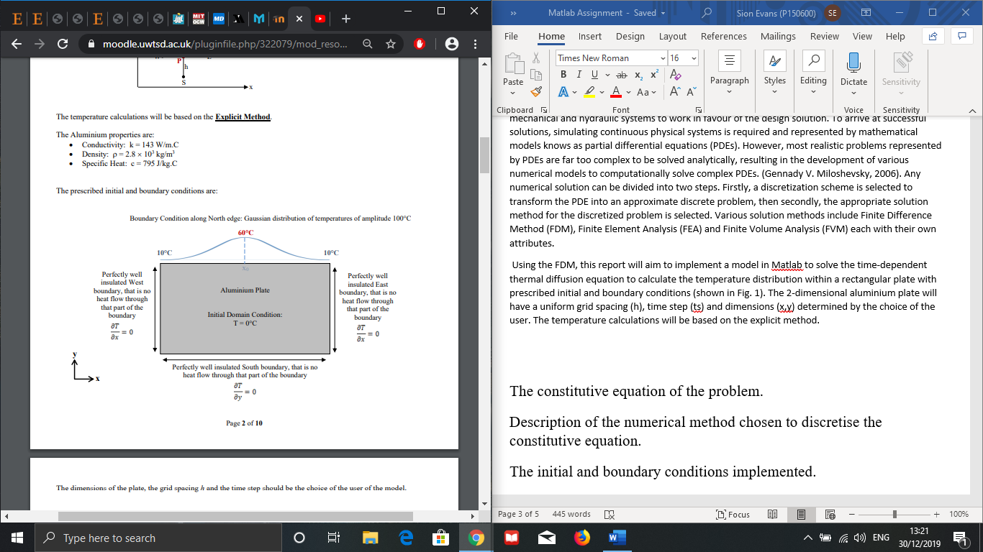
Figure 1. Diagram showing the initial and boundary conditions of the aluminium plate under consideration.

2. Finite Difference Method.
The finite difference method is one of many numerical methods used for obtaining solutions to PDEs, in this case equation [7]. The idea of the FDM is to replace continuous derivatives with difference formulas in an array of points throughout the mesh (nodes), involving the discrete values associated with said position in the mesh by forward, backward and central differences, according to Taylor series expansion (3.1) (Recktenwald, 2011). The number of nodes is selected by the user of the FDM model and directly effects the solution, As the numerical solution is only known at a finite number of nodes within the physical domain of the mesh. This mesh is made up of a system of equations that can be solved by matrix algebra techniques using a computer, with respect to the initial and boundary conditions (2.3). Using various combinations of nodes in the difference formulas results in different schemes that are implemented depending on the stability, convergence accuracy and speed required. Such schemes include Explicit method, Implicit method, Crank-Nicolson method (combined). Each scheme has its own advantages that are used in response to the problem specifics. For the transient problem at hand, the explicit method (3.2) is used for approximations associated with space (h) and time (t).

2.1 Taylor Series
The interpretation of Taylors theorem states that if a function f(x) and the values of its derivatives at point xo are known, then this function can be written in an infinite sum of other functions called the Maclaurin series:
$f\left(x\right)=f\left(x_{0}\right)+f^{'}\left(x_{0}\right).\frac{{\left(x-x_{0}\right)}^{1}}{1!}+f^{''}\left(x_{0}\right).\frac{{\left(x-x_{0}\right)}^{2}}{2!}+f^{'''}\left(x_{0}\right).\frac{{\left(x-x_{0}\right)}^{3}}{3!}+f^{\left(4\right)}\left(x_{0}\right).\frac{{\left(x-x_{0}\right)}^{4}}{4!}+⋯$
[Eq.10]
In the finite difference model, the F(x) values at the grid point Xo are known and the PDE being solved is replaced with difference approximations. This is done by interpreting equation 6 differently where both Xo and $Xo+h$ are grid points within the mesh and $f\left(Xo\right) and f(Xo+h)$ are known (Mingham, 2010). Thus, allowing equation [6] to rearrange to finite difference approximations that include errors known as $O\left(h^{n}\right)$. These approximations are made in forward backwards and central point shown in figure 2. That is:
$f\left(x_{0}+h\right)=f\left(x_{0}\right)+h.f^{'}\left(x_{0}\right)+\frac{h^{2}}{2!}f^{''}\left(x_{0}\right)+\frac{h^{3}}{3!}f^{\left(3\right)}\left(x_{0}\right)+⋯$
Which is used to create the forward difference method (Eulers scheme) of $f(Xo)$ given by:
$f^{'}\left(x_{0}\right)≈\frac{f\left(x_{0}+h\right)-f\left(x_{0}\right)}{h}$ [Eq.11]
Similarly, the backwards approximation can be constructed using equation [12] to give equation [13]
$f\left(x_{0}-h\right)=f\left(x_{0}\right)-h.f^{'}\left(x_{0}\right)+\frac{h^{2}}{2!}f^{''}\left(x_{0}\right)-\frac{h^{3}}{3!}f^{\left(3\right)}\left(x_{0}\right)+⋯$ [Eq.12]
$f^{'}\left(x_{0}\right)≈\frac{f\left(x_{0}\right)-f\left(x_{0}-h\right)}{h}$ [Eq.13]
Where the approximation is in order $O(h^{n})$ where the error gets smaller as h gets smaller and is proportional to the time-step length (R. W. Lewis, 1996). This can be shown for forward [11] and backward [13] approximations by the following:
$Ef≡f^{'}\left(x_{0}\right)-\frac{f\left(x_{0}+h\right)-f\left(x_{0}\right)}{h}$
$=-\frac{h}{2!}f^{''}\left(x_{0}\right)-\frac{h^{2}}{3!}f^{\left(3\right)}\left(x_{0}\right) +⋯$ [Eq.14]

$Eb≡f^{'}\left(x_{0}\right)-\frac{f\left(x_{0}\right)-f\left(x_{0}-h\right)}{h}$
$=\frac{h}{2!}f^{''}\left(x_{0}\right)-\frac{h^{2}}{3!}f^{\left(3\right)}\left(x_{0}\right)+⋯$ [Eq.15]
However, these two approximations can be combined to create an improved one known as the central approximation given by:
$$f^{'}\left(x_{0}\right)≈\frac{f\left(x_{0}+h\right)-f\left(x_{0}-h\right)}{2.h} [Eq.16]$$

The central difference approximation is accurate to order $O(h^{2})$ and is considered more accurate than forward and backward for small values of h (R. W. Lewis, 1996).

2.2 Explicit Method
The explicit method and is typically used to solve transient thermal equation, as it allows the unknown temperature ($T_{P}^{'})$ to be determined from the known temperature, at the previous time-step. This is shown in [Eq.10]. Thermal diffusion [Eq.7] is represented in finite-difference form by using central differences to discretize $\frac{∂^{2}T}{∂x^{2}}+\frac{∂^{2}T}{∂^{2}y^{2}}$ and forward differences to discretise$\frac{∂T}{∂t}$ (R. W. Lewis, 1996).

At the point P,
$$\left\{\begin{matrix}\frac{∂^{2}T}{∂x^{2}}=\frac{T_{O}^{n}-2.T_{P}^{n}+T_{I}^{n}}{h^{2}} \\ \frac{∂^{2}T}{∂y^{2}}=\frac{T_{E}^{n}-2.T_{P}^{n}+T_{W}^{n}}{h^{2}} \\ \frac{∂^{2}T}{∂z^{2}}=\frac{T_{N}^{n}-2.T_{P}^{n}+T_{S}^{n}}{h^{2}}\end{matrix}\right. [Eq.17]$$
Where,
$\frac{∂T}{∂t}=\frac{T_{P}^{n+1}-T_{P}^{n}}{∆t}$ [Eq.18]
$T_{P}^{n}=T_{P}\left(t\right)$ - temperature evaluated at time-level t and point P.
$T_{P}^{n+1}=T_{P}\left(t+∆t\right)$ - temperature evaluated at time-level t + Δt and point P.

For a 2D problem (mention internal energy) substituting equations [17] and [18] into the thermal diffusion equation [7] gives:
$\frac{1}{F_{0}}T_{P}^{n+1}=T_{N}^{n}+T_{S}^{n}+T_{E}^{n}+T_{W}^{n}-\left(4-\frac{1}{F_{0}}\right).T_{P}^{n}$ [Eq.19]

Where Fourier’s Number ${(F}_{0})=\frac{α.∆t}{h^{2}}$. [Eq.20]
Abiding the following stability criterion $0<F_{0}≤\frac{1}{4}$ for a 2D transient problem.
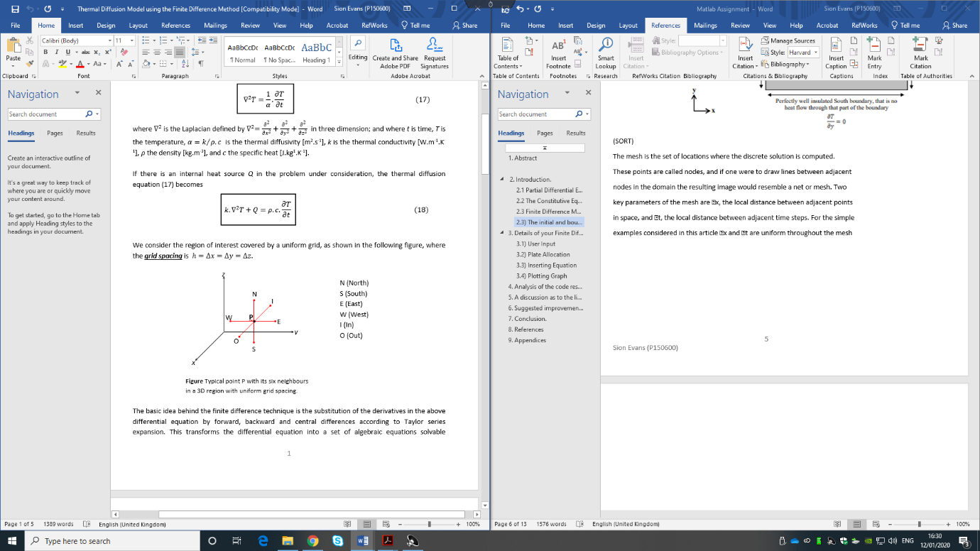

Figure 2. Schematic diagram of nearby node coordinates within the grid of interest.

3. Details of the Finite Difference Model Script.

3.1 User Input Allocation
The first stages of the code are concentrated on creating a stable input procedure for the model user to determine their ‘x, y, h’ and ‘tstep’ values. Stability in this area of the code is essential for the rest of the code to function. This is done by allocating the user input value as ‘0’ and then using a while loop to determine conditions that guide the user to enter usable data. This can be seen in table 1 where conditions such as ‘isnan (x)’ ‘x<=0’ and ‘x>= 50’ are set and while these conditions are true, MATLAB will prompt the user the enter the correct data. ‘Isnan’ and ‘str2double’ are functions within MATLAB that are used to identify whether an array is not a number and to convert strings to numerical arrays so that letters cannot be inserted in the place of numbers.
x=0;
while isnan(x) || x<=0 || x>50
s=input('Enter length(x) in SI units: ', 's');
x=str2double(s);

end

Text box 1. User input Allocation

3.2 Boundary Conditions Allocation
Once the user input feature of the code is working and stable, the physical geometry of the problem under consideration must be input into MATLAB using the initial and boundary conditions (2.4). To begin the temperature throughout the plate is represented by allocating a matrix of zeros, where the matrix size is determined by the x, y and h dimensions set by the user. The number of ‘0’s in the y direction is determined by $\frac{y or x}{h}+1$, where ‘$+1$’ represents the node at the boundary edge of the plate in the x and y dimension. Now that the ‘plate’ size has been allocated, the number of nodes in the direction of columns and rows is determined using the size function. Now equation [9] is used to create the gaussian distribution boundary condition on the upper north edge of the plate using a for loop.

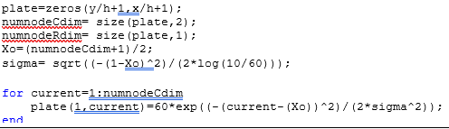
Text box 2. Initial & boundary conditions input

3.3 Explicit Time-Step Limit
One major limitation of the explicit method is its maximum allowable time-step (Section 3.), therefore the maximum time-step must be calculated and input into the FDM model to inform the user of this limitation and prompt them to input a value <= max time step. This is done re-arranging equation [20] using the stability criterion (0.25) to calculate the maximum allowable time-step. Using the max time-step calculated, the process described in (4.1) is repeated to allow the user to enter the time-step of the problem whilst considering the stability limitation. The num2str function is used to display the maxtstep as a numerical value so the user can comply.
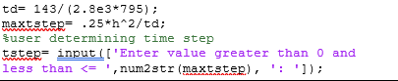

Text Box 3. Stability criterion input

3.4 Explicit Thermal Diffusion Equation
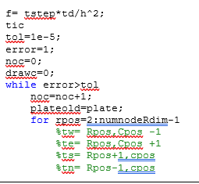
The next step was to input the discretised equation [11] derived in in section 3.1. The first stage of inserting the equation, is to allocate Fourier’s number with respect to the user defined time-step and grid spacing. Before MATLAB can solve the thermal diffusion equation it must first understand what the definition of equilibrium is. The definition of equilibrium is determined by inserting a maximum allowable tolerance and telling MATLAB to keep iterating through the equation while the error is greater than the tolerance.

Text box 4. Allocation of Fourier’s number, tolerance and discretized function coordinates
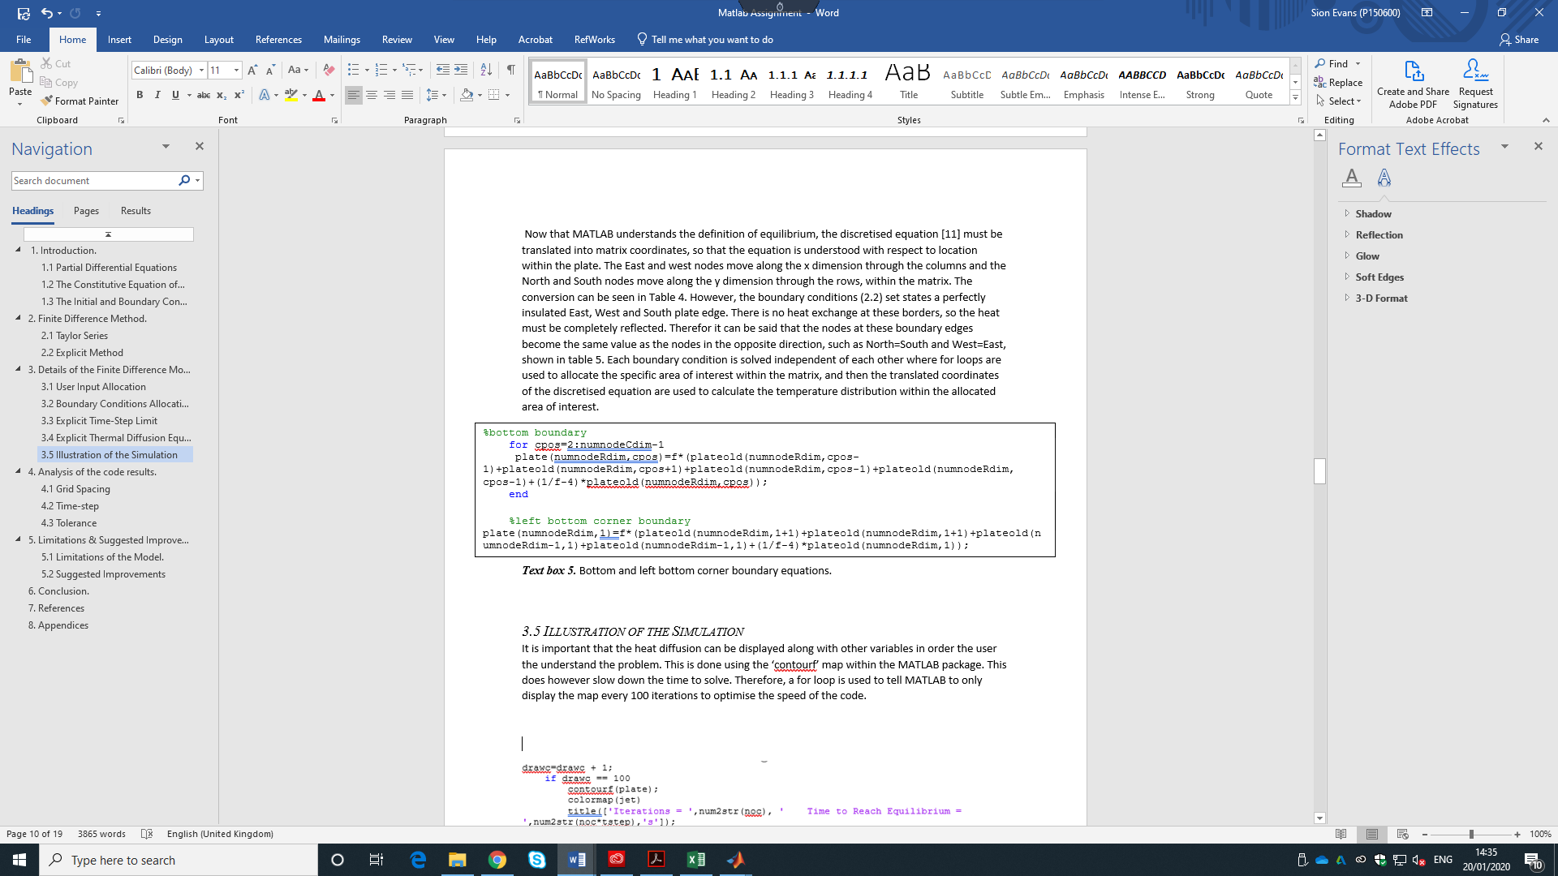
Now that MATLAB understands the definition of equilibrium, the discretised equation [11] must be translated into matrix coordinates, so that the equation is understood with respect to location within the plate. The East and west nodes move along the x dimension through the columns and the North and South nodes move along the y dimension through the rows, within the matrix. The conversion can be seen in Table 4. However, the boundary conditions (2.2) set states a perfectly insulated East, West and South plate edge. There is no heat exchange at these borders, so the heat must be completely reflected. Therefor it can be said that the nodes at these boundary edges become the same value as the nodes in the opposite direction, such as North=South and West=East, shown in table 5. Each boundary condition is solved independent of each other where for loops are used to allocate the specific area of interest within the matrix, and then the translated coordinates of the discretised equation are used to calculate the temperature distribution within the allocated area of interest. Mention error=absmaxmax
Text box 5. Bottom and left bottom corner boundary equations.

3.5 Illustration of the Simulation
It is important that the heat diffusion can be displayed along with other variables in order the user the understand the problem. This is done using the ‘contourf’ map within the MATLAB package. This does however slow down the time to solve. Therefore, a for loop is used to tell MATLAB to only display the map every 100 iterations to optimise the speed of the code.

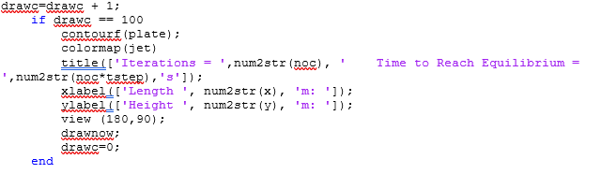

Text box 6. Diffusion mapping input.

4. Analysis of the code results.
This section concentrates on the effect certain independent variables have on the model simulation. To assess the effects of these variables, test conditions are determined and fixed in order to create a fair test. The test conditions are as follows:
Variable | Value
Length | 5m
Height | 5m
Grid Spacing | 0.1m
Time-step | Maximum allowable
Tolerance | 1e-5

Table 1. Test conditions used for the code analysis.

The variables being analysed are grid spacing, time-step and tolerance. The results of each analysis can be found under the following sub-headings.

4.1 Grid Spacing
Grid Spacing | Iterations | Time to solve | Time to Equilibrium | Reached Equilibrium
2.50 | 2 | 0.21 | 48,644 | yes
1.25 | 40 | 0.51 | 243,200 | Yes
0.625 | 160 | 1.52 | 243,200 | Yes
0.20 | 1310 | 11.62 | 203,050 | Yes
0.10 | 4550 | 42.53 | 172,900 | Yes
0.05 | 15,400 | 168.01 | 138,600 | Yes
0.01 | 221,850 | 1308.22 | 66,555 | no

Table2. Grid spacing analysis results.

Graph 1. Grid spacing vs time to equilibrium

Graph 2. Grid spacing vs iterations.

It can be seen clearly in table on that as grid spacing increases, the number of iterations is lowered by a factor of 100 as the grid spacing is increased from ‘0.1 – 1.25’. This substantial decrease in iterations is due to the fact there are considerably less nodes within the matrix, resulting in substantially less approximations.
However, the same cannot be said for the time to reach equilibrium. In graph 1 the time to reach equilibrium can be seen to increase exponentially with the grid spacing from ‘138,600-243,200’. Once the grid spacing reaches half the size of the plate dimension the time to equilibrium drops considerably and does not follow the same trend as the other points. This can be explained using equation [11, 12] where the error is shown to have a linear relationship with the size of the grid spacing. That is, the lower the grid spacing the lower the error. The increase in estimated equilibrium time occurs due to this increase in error, resulting in inaccurate time values and anomalies such as the sudden time decrease displayed between grid spacing ‘1.25-2.5’. There is also a minimum allowable grid spacing for the simulation to reach equilibrium. Shown by the dotted line in graph 1, for any grid spacing lower than (find point at which it doesn’t work) equilibrium is not reached

4.2 Time-step

Time Step (s) | Iterations | Time to solve (s) | Time to Equilibrium (s) | Reached equilibrium
1 | 105,020 | 34.46 | 105,012 | yes
6 | 23,390 | 8.58 | 140,340 | yes
11 | 13,843 | 4.61 | 152,273 | yes
18 | 8998 | 3.18 | 161,964 | yes
23 | 7252 | 2.64 | 166,796 | yes
30 | 5733 | 2.08 | 171,990 | yes
38 | 4648 | 1.88 | 176,624 | yes

Table 2. Time-step results.

Graph 3. Time-step vs number of iterations.

Graph 4. Time-step vs time to reach equilibrium.
Table 2 shows the number of iterations decreasing as the time-step in increased. This exponential decrease is shown in the trend of graph 3, with the largest drop of ’81,730’ iterations between time-steps ‘1 & 6’. The trend in graph 4 is more linear than exponential where the time to reach equilibrium increases as the time-step is increased. This increase in time to equilibrium and decrease in iterations is due to the errors associated with the forwards approximation scheme, where increasing the time-step is said to increase the error linearly. Therefore, it can be said that the time to equilibrium increases linearly as the error increases.

4.3 Tolerance
Tolerance | Iterations | Time Taken | Time to Equilibrium | Reached Equilibrium
1.00E-01 | 157 | 0.19 | 5966 | no
1.00E-02 | 1050 | 0.5 | 39,900 | no
1.00E-03 | 2220 | 0.9 | 84,360 | no
1.00E-04 | 3386 | 1.3 | 128,668 | yes
1.00E-05 | 4648 | 1.72 | 176,624 | yes
1.00E-06 | 5716 | 2.08 | 217,208 | yes
1.00E-07 | 6882 | 2.51 | 261,516 | yes
1.00E-08 | 8048 | 2.85 | 305,824 | yes
1.00E-10 | 10618 | 3.68 | 403,484 | yes
1.00E-11 | 11812 | 4.05 | 448,856 | yes
1.00E-13 | 14217 | 4.74 | 540,246 | yes
1.00E-15 | 16,808 | 5.59 | 638,704 | yes
1.00E-20 | 16,808 | 5.59 | 638,704 | yes

Table.3 Tolerance analysis results.

Graph 5. Tolerance vs time to equilibrium.

The tolerance input into the code is what MATLAB defines as equilibrium, where the calculations and promted to keep iterating until the error is less than the tolersnce. Graph 5 shows the time to reach equilibrium and tolerance to have a linear relationship where time increases as the tolerance decreases.
The dotted line on the graph represents the toleranec at which the simulations succesfully reach equilibrium. The FDM model does not reach equilibrium for simulations with a tolerance less that ‘1e-4’. This is due to the fact that MATLABs definition of equilibrium is met before the model has time to finish solving the heat diffusion. The time to reach equilibrium increases in a linear fashion as the tolerance is decreased. Between tolerances ‘14-4 and 1e-15’ the relationship can be said to be indirectly proportional. However, the time to reach equilibrium does not change after a tolerance less than 1e-15 is used. This statement is true for any tolerance less than 1e-15 and suggests MATLABs maximum limit of measurment.

5. Limitations & Suggested Improvements to the Model.

5.1 Limitations of the Model.
All be it that the finite difference and explicit methods are used and relied upon across the industry, they are not without their limitations.
- FDM models find it difficult to effectively calculate the solution of problems with arbitrarily shaped complex geometries, due to the interpolation between the boundaries and the interior points (M. Necati Özisik, 2017).
- The main disadvantage of the explicit method is that once $α$ and h are determined there is a maximum allowable time-step with a size $∆t$ which can never exceed the stability criterion value that is imposed [Eq. 20] due to the truncation errors associated with forward approximation.
- There will theoretically also be a minimal allowable time-step than can be entered into the FDM model
- There are also limitations in the grid spacing variable and the tolerance of the calculation. For a grid spacing less than 100x the size of the plate, the FDM model did not converge on an equilibrium value.
- Moreover, equilibrium will not be me if its definition is more than 1e-4.
- MATLAB fails to measure equilibrium to a tolerance less than 1e-15.
- The contour map can be difficult to read when the calculations finishes close to equilibrium.

5.2 Suggested Improvements
- The minimum allowable grid spacing needed for the FDM model to work can be allocated in the grid spacing, user input section of the code to ensure that the model user is prompted to enter a grid spacing value within the range of usable values.
- Perhaps using another numerical method would be beneficial. Finite Element Analysis was considered more difficult to set-up and more time consuming, however since the progression of computers the FEM is much easier to apply to a problem.
- The script could also be improved by writing a script that identifies whether equilibrium was reached or not and then display this message to the user to minimise any human reading errors.
- To further the analysis of the MATLAB script, actual analytical data regarding heat diffusion through a plate, with no internal energy supply, would be beneficial to validate the simulation in order to determine its accuracy. However, the conditions set in the constituent problem would be very difficult to create.
- In place using the item that variables are allocated to, they could be typed in as vectors to reduce the computational cost as the computer would not have top search for the vector that is allocated to a letter. The down side of this is it is more work in terms of writing the script.

6. Conclusion.
The script completed the objectives set and successfully simulation of heat diffusion was achieved in MATLAB within reasonable time. The MATLAB script can operate with a wide variety of data depending on the requirements of the user. The script is stable and recognises limitations of the finite difference method, such as a minimum tolerance requirement, minimum & maximum grid spacing and a maximum time-step. Through analysis of the code, relationships between time-step, grid spacing, tolerance and the time to solve has is determined. The accuracy of the simulation is high at low valued of h and time-step however the computational cost is high. The decision regarding the accuracy to time expenditure compromise is decided by the user of the script.

7. References
Gennady V. Miloshevsky, V. A. S. M. B. P. A. H. P. C. J., 2006. Application of finite-difference methods to membrane-mediated protein interactions and to heat and magnetic field diffusion in plasmas. Journal of Computational Physics, Volume 212, pp. 25-51.
K. W. Morton, D. F. M., 2005. Numerical Solution of Partial Differential Equation. 2nd ed. New Year: Cambridge University Press.
kaneko, j. j., 2008. Clinical Biochemistry of Domestic Animals. 6th ed. s.l.:Elsevier.
M. Necati Özisik, H. R. O. M. J. C. R. M. C., 2017. Finite Difference Methods in Heat Transfer. 2nd ed. Boca Raton: CRC Press.
Mingham, p. D. M. C. &. P. C. G., 2010. Introductory Finite Difference Methods for PDEs. Manchester: Mingham & Ventus Publishing.
R. W. Lewis, K. M. H. R. T. K. N. S., 1996. The Finite Element Method in Heat Transfer Analysis. west sussex: John Wiley & Sons Ltd.
Recktenwald, G. W., 2011. Finite-Difference Approximations to the Heat Equation. Mechanical Engineering Department Portland State University, pp. 1-27.
Simpson, G., 2017. Practical Finite Element Modelling in Earth Science Using MATLAB. 1st ed. s.l.:john Wiley & Sons Ltd.

8. Appendix (A) – Heat Bell Curve Script
%length Dimension Input
x=0;
while isnan(x) || x<=0 || x>50
s=input('Enter length(x) in SI units: ', 's');
x=str2double(s);

end
%height Dimension Input
y=0;
while isnan(y) || y<=0 || y>50
s=input ('Enter height(y) in SI units: ', 's');
y=str2double(s);

end
%Grid Spacing Dimension Input
h=0;
while isnan(h) || h<=0 || h>=y || h>=x || rem(x,h)~=0 || rem(y,h)~=0
s=input ('Input grid spacing value >0 and divisable by x,y: ', 's');
h=str2double(s);
end
%Plate Zeros
plate=zeros(y/h+1,x/h+1);
numnodeCdim= size(plate,2);
numnodeRdim= size(plate,1);
Xo=(numnodeCdim+1)/2;
sigma= sqrt((-(1-Xo)^2)/(2*log(10/60)));

for current=1:numnodeCdim
plate(1,current)=60*exp((-(current-(Xo))^2)/(2*sigma^2));
end

td=143/(2.8e3*795);
maxtstep=.25*h^2/td;

%user determining time step
tstep= input(['Enter value greater than 0 and less than <= ',num2str(maxtstep), ': ']);
while isempty(tstep) || tstep<=0 || tstep>maxtstep
s=input(['Enter value greater than 0 and less than <= ',num2str(maxtstep), ': ']);
tstep= str2double(s);
end

f= tstep*td/h^2;
tic
tol=1e-5;
error=1;
noc=0;
drawc=0;
while error>tol
noc=noc+1;
plateold=plate;
for rpos=2:numnodeRdim-1
%tw= Rpos,Cpos -1
%te= Rpos,Cpos +1
%ts= Rpos+1,cpos
%tn= Rpos-1,cpos
for cpos=2:numnodeCdim-1
plate(rpos,cpos)= f * (plateold(rpos-1,cpos) + plateold(rpos+1,cpos) + plateold(rpos,cpos+1) + plateold(rpos,cpos-1) + (1/f-4)* plateold(rpos,cpos));
end
end

%left side boundary
for rpos=2:numnodeRdim-1
plate(rpos,1)=f*(plateold(rpos+1,1)+plateold(rpos-1,1)+plateold(rpos,1+1)+plateold(rpos,1+1)+(1/f-4)*plateold(rpos,1));
end

%right side boundary
for rpos=2:numnodeRdim-1
plate(rpos,numnodeCdim)=f*(plateold(rpos-1,numnodeCdim)+plateold(rpos+1,numnodeCdim)+plateold(rpos,numnodeCdim-1)+plateold(rpos,numnodeCdim-1)+(1/f-4)*plateold(rpos,numnodeCdim));
end

%bottom boundary
for cpos=2:numnodeCdim-1
plate(numnodeRdim,cpos)=f*(plateold(numnodeRdim,cpos-1)+plateold(numnodeRdim,cpos+1)+plateold(numnodeRdim,cpos-1)+plateold(numnodeRdim, cpos-1)+(1/f-4)*plateold(numnodeRdim,cpos));
end

%left bottom corner boundary plate(numnodeRdim,1)=f*(plateold(numnodeRdim,1+1)+plateold(numnodeRdim,1+1)+plateold(numnodeRdim-1,1)+plateold(numnodeRdim-1,1)+(1/f-4)*plateold(numnodeRdim,1));

%right bottom corner boundary
plate(numnodeRdim,numnodeCdim)= f*(plateold(numnodeRdim,numnodeCdim-1)+plateold(numnodeRdim,numnodeCdim-1)+plateold(numnodeRdim-1,numnodeCdim)+plateold(numnodeRdim-1,numnodeCdim)+(1/f-4)*plateold(numnodeRdim,numnodeCdim));

error=max(max(abs(plateold-plate)));

drawc=drawc + 1;
if drawc == 100
contourf (plate);
colormap(jet);
title(['Iterations = ',num2str(noc), ' Time to Reach Equilibrium = ',num2str(noc*tstep),'s']);
xlabel(['Length ', num2str(x), 'm: ']);
ylabel(['Height ', num2str(y), 'm: ']);
view (180,90);
drawnow;
drawc=0;
end

end
toc
contourf(plate);
colormap(jet)
title(['Iterations = ',num2str(noc), ' Time to Reach Equilibrium = ',num2str(noc*tstep),'s']);
xlabel(['Length ', num2str(x), 'm: ']);
ylabel(['Height ', num2str(y), 'm: ']);
view (180,90);
drawnow;

Appendix (B) – Linear Heat Distribution Code
%length Dimension Input
x=0;
while isnan(x) || x<=0 || x>50
s=input('Enter length(x) in SI units: ', 's');
x=str2double(s);

end
%height Dimension Input
y=0;
while isnan(y) || y<=0 || y>50
s=input ('Enter height(y) in SI units: ', 's');
y=str2double(s);

end
%Grid Spacing Dimension Input
h=0;
while isempty(h) || h<=0 || h>=y || h>=x || rem(x,h)~=0 || rem(y,h)~=0
s=input ('input grid spacing value >0 and divisable by x,y: ', 's');
h=str2double(s);
end
%plate dimension
plate= zeros(y/h+1,x/h+1);
numnodexdim= size(plate,2); %No nodes x
numnodeydim= size(plate,1); %No nodes y
plate(:,1)=50; %temp left side
plate(1,:)=linspace(50,0,numnodexdim); %temp change top plate
plate(numnodeydim,:)=linspace(50,0,numnodexdim); %temp change botoom plate

td= 143/(2.8e3*795);
maxtstep= .25*h^2/td;

%user determining time step
tstep= input(['Enter Time-Step greater than 0 and less than < ',num2str(maxtstep), ': ']);
while isempty(tstep) || tstep<=0 || tstep>maxtstep
s=input(['Enter Time-Step greater than 0 and less than < ',num2str(maxtstep), ': ']);
tstep= str2double(s);
end

f= tstep*td/h^2;
tic
tol=1e-11;
error=1;
noc=0;
drawc=0 ;
while error>tol
noc=noc+1;
plateold= plate;
for xpos= 2:numnodexdim-1
for ypos= 2:numnodeydim-1
plate(xpos,ypos)= f * (plateold(xpos-1,ypos) + plateold(xpos+1,ypos) + plateold(xpos,ypos+1) + plateold(xpos,ypos-1) + (1/f-4)* plateold(xpos,ypos));
end
end

error = max(max(abs(plateold-plate)));

drawc= drawc + 1;
if drawc ==150
contourf(plate);
colormap(jet);
title(['Iterations = ',num2str(noc), ' Time to Reach Equilibrium = ',num2str(noc*tstep),'s']);
xlabel(['Length ', num2str(x), 'm: ']);
ylabel(['Height ', num2str(y), 'm: ']);
set(gca,'xtick',[], 'ytick',[]);
drawnow;
drawc=0;
end

end
toc
contourf(plate);
colormap(jet);
title(['Iterations = ',num2str(noc), ' Time to Reach Equilibrium = ',num2str(noc*tstep),'s']);
xlabel(['Length ', num2str(x), 'm: ']);
ylabel(['Height ', num2str(y), 'm: ']);
set(gca,'xtick',[], 'ytick',[]);
drawnow;
drawc=0;

