Name: Sarah Ali
Student number: 2119052
Module name: ‘Hotel Placement Research Project,’ BMIH6008.
Project Supervisor: Maggie- Lan Zhang
Date:

Title: Examining staff shortages and retention challenges in the Hospitality Industry: The impact of rising insurance costs on workforce and work experience opportunities post-Covid-19.

A.I Acknowledgements
In this assignment A.I grammerarly.com has been used to proofread my work spelling. To support my research paper, I have used google scholar, Ted Talk and You tube to research bibliography.
I confirm that I have not presented any AI generated text as my own work. I confirm I have copies of my drafts, notes, and other resources I used before, and after the use of AI tools which I may asked to provide in evidence.

Executive Summary
Staff shortage, retention challenges, impact Covid-19, rising insurance cost Understanding employees and employers in the hotel industry, as well as diving into issues affected by the industry post covid nineteen. The Maldron Hotel recruitment drive imposes employee well-being and bonuses as well as other health benefits.
Analysing research from other scholars on Retention and strategies within hotels. Employees' training and certifications within their roles. Employing strategies why is it more complicated to offer work experience placements since Covid-19 pandemic impact on the hospitality sector? Rising costs also affect the shortage of staff in the hotel and hospitality industry.

Contents
introduction 4
2 Literature Review 5
2.1 Impact of turnover 6
2.2 factors lead to staff shortage 6
2.3 how to increase the staff retention. Solutions provided job satisfaction, 7
3 Methodology 8
3.1 Benefits 10
3.2 Techniques 10
4 Case Study 3000 10
4.1 Map (Google, 2024) 11
4.2 The Maldron Hotel (2024), Overview of amenities 12
4.3 Staff Shortage 12
4.4 Retention Challenges 13
4.5 SWOT Analysis 13
5 Pestel 15
6 The Maldron Hotel United Kingdom part of the Dalata Groups (2024) screen shot of half of 2024, financials. 17
6.1 17
7 Conclusion 17
8 Reflective writing, era CYCLE. 20
8.1 ERA 23
9 Bibliography 30

introduction

The aims and objectives of this report research past and present issues of the biggest challenges in the hotel industry being Staff shortage, Employee retention challenges, and the impact of the pandemic, Covid 19. Rising employee and liability insurance costs.
COVID-19 issues still affecting the hospitality Industry see a plunge in the rise of high Insurance costs impacting the hoteliers and the younger generation of employees in the UK struggling for placement as hoteliers. A liability of Insurance Cost implemented to employ work experience students becomes an extra cost. This reflects making it easier for most of the Hotel and Hospitality Industry not to take students on employment training. The few that are willing to pay the increasing cost one being the Maldron Group of Hotels and another the Marriott Hotel group these are just some of the Hotel groups that still have the intention to employ train and strengthen the retention cycle. Premier Inn Hotels is part of the Whitebread group amongst the Hoteliers that found it a rising cost to deal with, affecting students who are not able to have the taste of the hotelier work experience in 2023.
Moreover, high employee turnover negatively affects the quality of services and customer satisfaction. Researching past findings on issues with retention labour challenges and staff shortages. Most people have considered the lack of personnel resources since recent studies have revealed that there is not enough data to hire work-experience students and provide opportunities given the growing financial effect of COVID-19.

Literature Review

This studies the typical list of issues researched relating to employee high turnover in the hotel industry from its investigation in the UK hotel sector paramount because this industry has been experiencing a higher level of staff crisis. Asia, England, and the Americas regard key issues of Employee retention, Impact on staff shortage, and Impact on Insurance. Employers' liability insurance due to Covid-19. The workforce outlook is analysed through more recent Studies and past placement completed at the Maldron Hotel Newcastle, how other hoteliers have looked at current research and applied in theory to impact staff shortage (Seo. J, 2022). The hospitality industry's current problems with retention are poor knowledge of roles and responsibilities,' future becoming dependable and applying more pressure on existing staff and HR roles leading to retention with leadership style have significant effects, Andriani, L., & Rizky, G. (2024). Impact on staff shortage, according to Dogru, T., McGinley, S., Sharma (2023).
Employee turnover dynamics in the hospitality industry, the Impact of US and Asias economic challenges since COVID-19, was similar traits experienced a high expense rate, and rise of employers' insurance costs. These are some impacting areas of career progression, and economic turnover also discussed by Yao, T., Qiu, Q. & Wei, Y., (2019), Chatzoudes, D. and Chatzoglou, P., (2022). Factors affecting employee retention and proposing an original conceptual framework.
The Marriott (2021), Hotels human rights policy upholds the elimination of discrimination practices with respect to all aspects of employability and aligns with Maldron Group of Hotels UK, (Dalata Group, 2024) Policy, trends in theory all hoteliers could also provide a bonus to retention. The significance of the demands covered by knowledge and theory by Agarwal, P., (2021). "Shattered but smiling: Human resource management and the wellbeing of hotel employees during COVID-19" staffing challenges.

Impact of turnover
Performance evaluation has been an important topic of concern for tourism and hospitality industry. Practitioners as well as academic researchers agree the impacts on retention and staff shortage through surveys the most common factor is pay. Pay package, and health benefits being a tangible factor, (Tan, Y. et al. 2025). The research aligns with similar attributes to employees and stakeholders' economy at large, an organization taking accountability to make a positive impact, to the turnover climax, by diversity, providing equality being ethical, (Jayawardena, C., Et al, 2013). The concepts in Asia according to recent research by Jung, H.S. and Yoon, H.H., (2015), Le, L.H. et al (2023), high employee turnover rates in hotels jeopardize the survival and growth of these businesses in addition it could be weakening the credits and decreasing worker loyalty and cohesiveness.
Further trends known to exist from International Trends, Canada shows strong retention rates, earlier international trends forced Canada to take measures to ensure its future in the hotel industry. Since then, Canada has recovered from the COVID-19 pandemic and resumed its steady growth trajectory (Statistics, 2024). Other International growth recovered slowly as highlighted by recovery from Covid-19 and also other major issues as mentioned by Miah, M. and Hafid, N., (2019), job satisfaction being one, training and motivation from the hotel employees of Malaysia, other Internationally showed inadequate employee motivation, skills amongst common issues as mentioned by, Peshave, M.A. and Gujarathi, R. (2014) that Impact of employment practices adopted by hotels on the productivity of its employee's study between Pune and Hyderabad cities, similarities focuses on the importance of relationship from HR and staff employed in their hotels and the importance of training and retaining the staff trained to lead to saving time and money.

factors lead to staff shortage
Many factors contribute to this issue including low wages with unpaid breaks, long working hours, an elevated level of job insecurity also stressful working conditions and insufficient opportunities of career growth. Causes of High Employee Turnover in the Jobs of the Hospitality Industry contribute to high turnover rates this hybrid method benefits from the ability to be more flexible in addressing complex operational issues and linking hotel employees to provide more correct results in cost-benefit analysis (Yadav, A. and Dhar, R.L., 2021). Suggesting important insurance policy implications impact and factors of high Insurance cost within hospitality (Tan, Y. et al. 2025). UOW (2023), guidance to student placement insurance considered like normal employees if the employer does not have liability insurance, then such placement insurance. Risk assessment required which could be a factor of cost and time needed for training and covering RA, and health safety for the hoteliers (Cheng, S.C and Kao, Y.H, 2022).
After Covid 19, people are travelling more adding the pressure on hotelier raised to a challenge of staffing issues, customer service and increasing profit. Which concludes investing in students to offer and keep within their hotel. (Abdelazim, A., 2023).

how to increase the staff retention. Solutions provided job satisfaction,
One of the biggest challenges in the hotel industry affecting employee retention is the high turnover rates, 'Keystone Hospitality Property Development' (2022). Investing in employees is key to long-term goals, Job satisfaction in career preference drivers is the most recognized act in hospitality in the USA, Magnini, V.P. et al. (2024), explain understanding hospitality labour shortages is a crucial factor. The hospitality Industry overlooks the educational work experience possibility giving employees an insight into the hotel world. With the issues coming out of the pandemic everyone is conscious of uncertainty and savings. In May 2022 statistics, a survey completed by the American Hotel & Lodging Association (AHLA) found almost half of hotelier’s experience staff shortages. Developing employee's knowledge of required structured areas of work could lead to a higher retention rate. Supplying employees with great benefits packages for all such as Bonuses, Health benefits, Health insurance, Retirement plans regular training using efficiency in the communication part of corporate, (Bibi, S. et al, 2022).
Khuong, M.N. and Minh Phuong, N.T. (2024) Positive behaviours in key areas to enhance employee working to a healthier workforce positive mindset is to be able to be sustainable, and green in working ethics for staff but another drive of behaviours in the workplace according to Kim, B.P., Murrmann, S.K. and Lee, G., (2009), negative impacts of organizational gender work satisfaction stress and pressure affecting hotels include job satisfaction are more pronounced for female employees, even though male employees reported larger levels of these factors. Moderating effects of gender and age organizational levels of hierarchy within department management exist in the hotel industry, In context to employees' roles of gender pay in hotel employment and the roles that play a huge part in employee retention the stress level increase in lower level titles and job satisfaction among hotel employees decrease and is a leading concern affecting retention in the hospitality industry as within departments of management younger generations demanding career prospects and self-value according to, Jung and Yoon, (2015 ).
Focus on the mindset to change improving employee economic show is one key method discussed by Yao, T., Qiu, Q. and Wei, Y., (2019). In Evidence-based HRM, 'Effectiveness is key consequently HRM,' analysing employee retention and motivation found that the 'moderating effect is in employee generations,' recognized in the Global Forum for Empirical Scholarship (Lee et al, pp. 385-402, 2022).
Marriot Hotels framework " Within our managed workforce, we continually strive to build our internal pipeline of talent, helping associates develop the knowledge and skills they need to build lifelong careers within our company, in addition to maintaining fair employment principles, we also support associate wellbeing through our signature TakeCare culture. TakeCare focuses on three distinct employee pillars," (Marriott Serve 360, pp. 2021). Marriotts (2021), 'Life Long' being the key attribute to Marriott's employee support as changes are ongoing employees have that strength and support needed, reflects the career possibility discussed by Tavitiyaman, P., So, C. Y. A. and Chan, O. L. K. (2023), Mindsets toward 'technology adoption and training support in engagement, and retention'.

Methodology

The Premier Inn Hotel (2022), owned by the Whitbread company where in Darlington my placement completed, In the second year of Placements, it was not suitable to complete the placement at Premier Inn Hotels this was due to Rising Insurance costs not covered for placement students as this was also a form of employment for employers hiring students as employees if potentially the student was suitable for a vacancy at the placement hotel. This was part of the placement being completed at the Maldron Hotel, Dalata Group of companies who exist to continue to take on students and if a vacancy was open a student was in a place to apply (Maldron Hotel 2024), and (Agmapisarn, C and Khetjenkarn, S. 2024). For future growth and development of the hospitality industry challenges that exist in the industry of staff issues from seasonal and peak times affecting high turnover rates are amongst the rising cost of Insurance affecting unsustainable rises in premiums (Seo. J, 2022). The Maldron Hotel however has continued to outshine and continue with the rising costs of insurance not affecting employment. At the Maldron Hotel (2023), the Hotel focuses on innovation using A. I intend to focus on revenue. The latest technologies used by the Maldron Hotel such as digital services experienced by a positive review explain the luxurious stay, (Sedar, Trip Advisor review, 2020). The current review using the experience a visitor explains was not very good he left a 1-star rating, with the robotic waiter, this can theoretically show how not always using robotics as a means is to everyone's taste for the latest technology advancement for the hotel, (Review by Seaside 2024). YouTube (2023, Robotic waiters that are named Annabeth are used to deliver service and follow commands input by A. I technology at the Maldron Hotel. Reviews such as 'Trip Advisor', (2024) and Google (2024), show customers prefer this method as it has been used as social media boasting by visitors receiving a service by a robot. Customers notice that the Service and amenities being delivered by the robot make no judgment and humans' facial expressions can be read which is unpleasant to experience as a customer. This represents how as new challenges arise, opportunities open in the hospitality industry Visitors' experience reflects on hotel brands, and employees' behaviour and expressions trend should resemble the basic factors of a friendly personality, non-judgemental, energy and positivity to deliver a high standard of service posing with communication skills, (Ionita, M.E., 2016) and (Rivaldo, Y., 2021).

Statistics collected by the Economic Impact of Hospitality in the UK, "Hospitality being the third largest employer in the UK, with 3.5 million people working in the sector," provides financial stability and jobs for vast people in the UK providing surrounding economic boost. The industry growth by 2027, is creating more jobs and a profit, (UK, Hospitality. 2024). Canada Statistics (2023), In Canada the aftermath of impacts of covid was a fast recovery “In May, only five months into the year, the Canadian hotel industry reported its highest performance since September 2022. In May 2023, the average hotel occupancy was 69.2%, which was 9.3% higher than the previous May. The ADR across the country was $197.10, up 15% from May 2022.

Demand for hotel rooms exceeded the pre-pandemic demand in May for the seventh consecutive month. Compared to May 2019, demand for rooms was up by 3% and ADR by 18%. Across the border, in the United States, demand was down 2% compared to 2019, while in the United Kingdom, it was only up by 1%”.

Career preference drivers in technology to gain Staff and overcome retention issues is the future, currently, employers and stakeholders can see the advantages of utilizing technology in customer service, as it gives workers a sense of "a can do" attitude and makes them feel comfortable doing tasks quickly, particularly during peak hours of the day (Shin et al. 2019), (Morosan, C. and Bowen, J.T., 2022),
agree with aspects of practices, Wang, P.Q. (2024) and Kossivi, B., Xu, M. and Kalgora, B. (2016).

Benefits
the cooperate delivers principle values the culture of the workplace controls the way employees behave amongst themselves as well as with others.
Limitations, insufficient opportunities for growth, working conditions, hours long or short.

Techniques
Nain. A, (2018), Intense challenges, various skills training keeping it up-to-date following policies and procedures.
Hotels can promote competitive salaries and discounts benefits and retirement packages, investments in shares, and paid time off creating a positive workplace culture can improve employees' morale reduce stress promote teamwork and collaboration.

Case Study 3000

The Maldron Hotel Newcastle boasts of Maldron Hotel Newcastle Splash, (2019) is a 4- star Luxury Hotel opened its door to the public in 2019, The Splash Youtube described it as ‘the perfect location for a corporate stay, business meeting or weekend away’. Whilst others might say its popularity is using modern advanced technology. The Maldron Hotel which is perfectly situated in the heart of Newcastle’s busiest city centre. (Zhou, X et al, 2024) A study of the factors that affect employee performance in the UK hotels. Pandemic Covid-19 affecting retention of Generation Z employees in the hotel industry. The positive for some of the people is central access for work as it central to the Railway, bus, Tube and is great opportunities for University Students as a student accommodation on its site. The Newcastle University is also within traveling distance from this Hotel, which made it easier to hire students part time for term time holidays. This is discussed by, ‘The Glass Door’, popular area where students can leave feedback for others to read if they were thinking about working at the Maldron group of Hotels, “Maldron Hotels has an employee rating of 3.6 out of 5 stars, based on 148 company reviews on Glassdoor which indicates that most employees have a good working experience there. The Maldron Hotels employee rating is in line with the average (within one standard deviation) for employers within the Hotel and travel accommodation industry (3.6 stars)” (Glassdoor, 2024).
Experiencing a positive working environment at the Maldron Hotel in 2024, attitudes reflect the heart of hospitality people, fairness, service, celebrating employee milestones and birthdays along with recognition of good reviews this reminded me of past learning of Walt Disney’s caring culture relationship values unconsciously and consciously he was a leader that was followed and shaped his own company that many can relate to and some should add these values if not already in the hotel industry such as mutual trust, relationship building a caring culture, ‘Making People Happy’,( 2016).
The Maldron Hotel, (2023) could address this issue in a few ways, including by increasing employee pay and benefits, providing training and development opportunities, fostering a positive and encouraging work environment, and praising and rewarding the efforts and accomplishments of their employees (Kwok, L. 2022).

Map (Google, 2024)

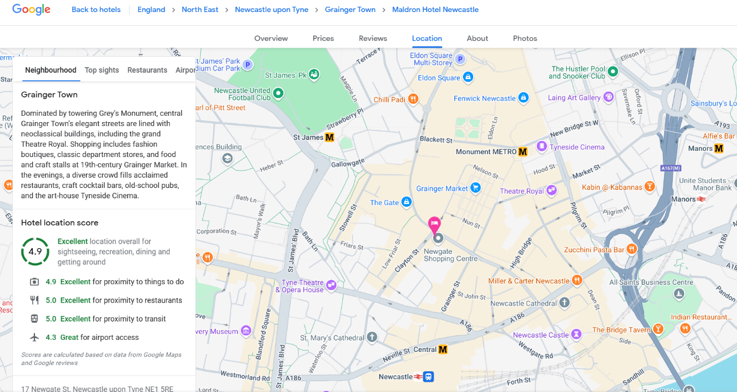

The Maldron Hotel (2024), Overview of amenities

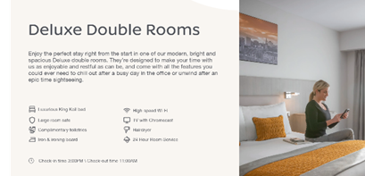

Staff Shortage
Theme findings, The Maldron Hotel in staff shortage are doing something right as they have a recruitment style to hire employees. The gap is in the high level of retention which could be a factor of the revenue and income of profits the hotel makes, this would be interesting theme for shareholders, Ionita, M.E., (2016). Turnover rate of employees in the hotel sector is over 70% (Liu-Lastres et al, 2023). Analysis of the success techniques of the employee motivation in use in the Maldron Hotels Chain agrees with these issues. A high level of job satisfaction and engagement can help to retain top talent and foster a positive work culture which can lead to increased employee commitment, loyalty, and productivity (Jayawardena, C. et al. 2013).

Retention Challenges

The Maldron Group of Hotels retention challenges from reviews an issue more of is overtime the pressure of work and collaborating with coworkers. How well the pay is for the employees for the role at work. Job security as branded as high employee turnover affects employee’s security of not knowing. High employee turnover rates can be costly for the hotel industry due to time and cost associated, (Glassdoor.com, 2024), and Ionita, M.E., (2016) researched in employee issue in Dublin, Maldron Hotel.

SWOT Analysis

Strength,

- Staff, Glassdoor.com (2024) rated 3.6 out of five stars, based on 148 company reviews on Glassdoor,
- Complimentary reviews Anonymous employee (2024), review ‘Really accommodating for Students’, ease of working part- time due to education.
- Trainee course to become a manager.
- Location of its Maldron Hotel in Newcastle, central to touristic attractions and plenty of competitors in the hospitality industry around the centre to the Maldron compete with.
- Large Hotel with 278 Rooms.
- Parking is re-imbursed if guest is staying at hotel.
- Eco Certified
- Gym on the third floor
- Opportunities to Students and Work Experience staff

Weakness,
- Maldron Hotel (2022), No Parking but options nearby due to location.
- Parking re-imbursed from only one car park situated few minutes’ walk from the Hotel, when another car park is next to the hotel, which would suit visitors more.
- Noise level on first floor from the guests
- Unprofessional Staff many negative reviews on Trip Advisor (2023) claiming staff not helpful.
- The robot waiter ‘AnnaBott’ when it has a malfunction, customer review comment on being a nuisance.

Opportunities
- Soundproof the floor level so noise does not rise to the second floor.

- Continuous interest of staff, McCann (2024), ‘94% of CEO’, Based on 148 Glassdoor business reviews, Maldron Hotels has an employee rating of 3.6 out of five stars, indicating that the majority of employees have a positive work experience there. Maldron Hotels' employee rating of 3.6 stars is comparable to the industry average (within one standard deviation) for employers in the hotel and travel lodging sector.
- Arrange more Parking opportunities.
- Retrain staff to increase guest experience.
- On site swimming pool

Threats,
- Policy
- Visitors using competitor hotels.
- Low Pay by seven reviews (Glassdoor.com, 2024), ‘Overtime, under pressure’.
- No benefits
- Minimum Wage
- High Employee Turnover could leave a bad outlook on the brand as reviews show how staff have either not acknowledged time of day as late shift visitors tend to sleep and not hear staff working. Staff making sure visitors are not disturbed by other visitors as everyone is a paying guest, (Booking.com 2024)

According to reviews Booking.com (2024), The noise and training of staff is more of an issue raised in reviews. Pointing out visitors the noisiest part of the hotel so guests, visitors are not thinking of leaving negative reviews. Further training and update in learning styles of customer service would be part of the reason as to high staff turnover.
The hospitality sector includes challenges such as growing utility prices, which could have impact on closure. Yet this situation presents an opportunity to students a chance to provide jobs, experience, and industry talent at places like the Maldron Hotel (BBC.co.uk, 2022) and Dalata Group.com (2024).

Pestel

Political- Maldron Hotels 26 hotels fifteen in Ireland and eleven in the UK. Part of the Dalata Group PLC (2024), expansion to lease new hotels in London taking its footprint in the city to six properties.
Government to encourage the hotel industry to give opportunities to the students and educational placements and people on benefits engaging back to work.
Insurance companies to look at reducing cost.
Government to introduce policies to insurers regarding low insurance costs for taking on students.
Brexit, immigration rules providing extra difficulties in applying for visas to work in the industry. The perception of short-term employment
Technology to manage data on employees work schedules strengths and availability to forecast how much labour needed (Msengeti, D.M. and Obwogi, J., 2015).
Economic-
Dalata (2024), “Pleased with performance to date in 2024, declared interim dividend of 4.1 cent per share. Announcing share buy-back of €30 million.
Four new hotels opened this summer and over seven hundred additional rooms in the pipeline.”
International visitors
International employees
Inflation
Exchange Rates
Investments
Social -
The surroundings of The Maldron Hotel (2024), Newcastle situated around the famous clubs and views along with Eldon square shopping and the markets. Within a walking distance to the Quey Side. “A 6-minute walk from Newcastle railway station, this informal hotel in a shopping and entertainment area is 15 minutes on foot from the Gateshead Millennium Bridge and a 6-minute walk from Newcastle Castle” (Google, review. 2024).
Cultural Factors.
Trends, Brand change.
Contemporary themes at the hotel.
Crime Rates.
Health and Wellbeing.

Technological-
Consolidation of digital marketing and social media
activities into Central Office increasing direct bookings.
returns on investment.
Online booking Platforms
Robotic Waiter ‘Anna Bott’
Sustainability Technology
(Dalata H1 2024 Results)

The Maldron Hotel United Kingdom part of the Dalata Groups (2024) screen shot of half of 2024, financials.

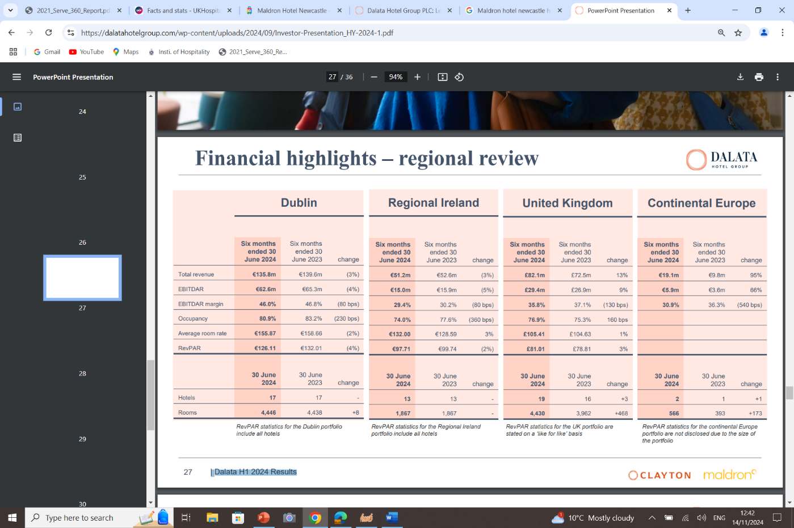
Using the SWOT model to analysis template, the Hotel can identify the issues of SWOT model (Spider Strategies, 2022). Also Analysing using the PEST methods to investigate the factors that impact the Maldron Hotel Newcastle. The focus of the Staffing issue, Retention Challenges, and Impact of Rise in Insurance cost, (Research Methods, 2024).

Conclusion

Having an excellent work experience at the Maldron Hotel in 2024, where attitudes reflect the hospitality industry's core values of justice, service, and honouring staff anniversaries and milestones in addition to the HR, (Human Resources) praising favourable feedback, (Glassdoor, 2024).
Increasing employee salary and benefits, offering training and development opportunities, creating a supportive and upbeat work atmosphere, and recognising and rewarding staff members' efforts and achievements are just a few ways the Maldron Hotel may oversee this problem.
Dalata Hotel Group PLC (2024) is a hotel company which owns and ‘operates fifty-one hotels across Ireland, the United Kingdom and Germany mainly under the brands Maldron Hotels and Clayton Hotels’.
The Maldron Hotel based in Newcastle City Centre is famously near to hot tourist attractions and is situated in the Grainger area is “Dominated by towering Grey’s Monument, central Grainger Town’s elegant streets are lined with neoclassical buildings, including the grand Theatre Royal. Shopping includes fashion boutiques, classic department stores, and food and craft stalls at 19th-century Grainger Market. In the evenings, a diverse crowd fills acclaimed restaurants, craft cocktail bars, old-school pubs, and the art-house Tyneside Cinema.
The reviews from guests and employees have an impact on this hotel as it is so centrally located to travel and attractions. This is an easily accessible target for positive and negative reviews to be branded as great and not so great as the popular site attracts a huge footfall the pressure falls on the employees.
Employee job reviews on being overworked. Many complained of work overload and paid the minimum wage with lack of potential to get a promotion.
The importance of training should be re-introduced every six months to stay fresh in the mind and policies where implement of employees and training should appear in their working roles so not have complaints from visitors. Basic customer service, and this could also be down to employees being overworked and visitors tend to feel this from the employees’ behaviours and expression. Hiring an outsider to train staff especially in customer service would help toward negative reviews from both employees and visitors staying at the Maldron Hotel according to reviews Glassdoor.com (2024) and Indeed (2024).
The Pandemics legacy continue to influence the hospitality sector, particularly through increased insurance cost employee liability costs which collectively pose significant obstacles for hoteliers.
This could also affect the future of uncertainty for work experience students and for young job seekers in the UK, to secure placements. The additional liability costs associated with employing trainees and students further complicate hiring practises. However, some established groups such as the Maldron Hotel sets a positive example by prioritizing costs.
Expecting to work extra hours when feeling pressured, if staffing were organised maybe fewer negative reviews by employees would appear as negatives. these are challenges that are also threats for the Maldron Hotel.
High staff turnover can also have a negative effect on customer satisfaction and service quality. The Maldron Hotel reviews Booking.com (2023) and TripAdvisor.com (2024) reviews left by visitors indicate more on employee performance. This emphasises how crucial it is to deal with workforce management and retention in a proactive manner. Investigate already More solid data is required to support the employment of work-experience students and to provide them with worthwhile chances in the sector, according to recent research. The hospitality sector may strive towards a more secure and fulfilling environment for both employers and employees by concentrating on these areas.
Even though the hotel's location is a huge selling advantage, some customers find the parking to be a drawback. Although there is free parking nearby, another nearby parking lot might be provided for both staff and guests to prevent disappointment. Employees that find it difficult to commute by public transit might benefit from this. Even though most visitors praised the customer service, several expressed dissatisfactions with the personnel's expertise and noise levels. A simple apology from the staff and training on basic procedures may have been appropriate. The primary concerns of workers are compensation, including minimum wage and hierarchy.
Following the pandemic of COVID-19, staff learning techniques expanded to meet the demands of employers and visitors, including online technology use and hygienic practices (Xue, B.w. et al, 2022), (Maldron Hotel, 2024). A robust hiring procedure can guarantee that the Maldron hotel has a varied pool of skilled employees who can support the establishment's success.
A slow or ineffective recruitment process can result in shortage of staff which can lead to decreased efficiency of staff as this can be viewed from the reviews of employees having to work extra on Glassdoor.com (2024) and Booking.com (2024) this could result in employee burnouts and affecting customer dissatisfaction.

Reflective writing, era CYCLE.

The experience I had at my placement at the Maldron Hotel included a 5-minute walk to the train station and a 20-minute train ride to Newcastle. The travel seemed easy as the trains were every 15 minutes. Stepping into The Maldron Hotel my first visual was, very modern contemporary, big glass windows and wide glass doors. The entrance leads off the public footpath and accessibility is available for anyone in a wheelchair. The Hotel has a grand entrance with a view of the front desk and the aisle leads visually to a long hallway with a sight of the bar. Greenery within the halls and sitting areas made the sense of comfort with nature. In my twelve weeks the Maldron Hotel gave me the opportunity to work in the following areas:
Front of house –
I experienced the customer and staff interaction the most at the reception ‘front of house’ Customer comments as they entered the hotel said it gave them excitement and were in awe of excitement mostly. The negative from guest experience whilst on reception was the noise level if they stayed on the second floor. This would be responded to by an apology. At the hotel, I found this challenging as it was always busy the guests would only have the second floor available. One of the key roles of the front of the house was to welcome and check guests in and out whilst also promoting to the guests the use of the digital stand. This was confusing as visitors would make their way to reception to then be forwarded to a computer, better signage would help with this idea to save the customers from confusion. Whilst being trained at the front of house reception I helped with common customer queries as to the Hotel’s restaurant opening closing times, how to report allergies to the chef and what touristic attractions I would recommend. And the lack of training I found from the front of the house on many questions regarding the knowledge of what facilities the hotel has around the area. Was down to research and training in the area. Using the technology of the computerized system to check in and check out customers was quick and efficient. This could be an advantage for the hotel to have less staff at the front of the house but due to system errors which were common a staff member was on stand-by for that role. That member of staff could also have the opportunity at that time to brush up on administrative skills and discuss local landmarks with colleagues, but a strict no-talk talk is in place which prevents these conversations from taking place. If such strict measures were not in place, it could also be a bonding time for employees.
Back of House,
From my observation, this is where the online administration of the hotel's customer satisfaction takes place using technology. Checking emails, reviews, and employee in-house voices as to concerns and steps to solve issues or arrange a nice welcome in the room if it was a visitor celebration. This inspired me to the thoughtfulness of the hotel's style. I experienced the training given to me to be able to complete basic back-of-house duties helped me in my role and I was able to obtain knowledge in operating skills.
Restaurant
The day I spent in the bar and serving in on the restaurant floor it was noticed that the bar is modern with spacious seating the guests are spoilt for choice as to seating. The bar and restaurant accommodate walk in visitors. With a strict code of conduct to a smart appearance white shirt, black skirt, or trousers waist coat optional, aprons must be worn. The staff portrayed the restaurant and bar standards of cleanliness no mess insight. Staff that are well trained on sight, mannerism and uniform reflect the amazing teamwork.
Kitchen
Due to previous experience in placement at my university I was able to apply my learning of health and safety issues and training on how to manage equipment and applied to work for the three days I was working in the kitchen. Handling appliances of the dryers and dishwashers is unique in commercial kitchens where my training was an advantage I could help in busy shifts which bonded me with the staff who always showed support if needed. That no extra time was needed to train me in a busy day in the kitchen. This is where potential work experience students would watch and observe if not trained sometimes, I find it can be a safety hazard in busy times and this does not engage with students learning as staff are busy, they need to get work done. This stage could be changed to offer digital training on this hotel's kitchen layout and how the equipment works, where all products are kept, how to check for out-of-date items, and such. The hotels have no wastage of food as it is sent for compost and all plastics recycled this was remarkably effective strategically done compared to my previous placement.
HR Administration
This gave me insight into what field I would like to work towards in my career as I found HR in the hotel motivated me to question morals and practices. I was inspired by the stress and pressure that is experienced in HR to complete employee administration to Policies, holidays, and errors made. Deciding for training and development for employees. Supportive of each other to grow a strong sense of recognition to daily meetings where always forwarded to other departments. As issues and trends, one of the biggest challenges in the hotel industry affecting employee retention is the high turnover rates and uncertainty of Policies. I became aware of time management and obtained a significant amount of knowledge throughout my placement in HR.

House- Keeping
The Maldron Hotel's in-housekeeping style encourages good timekeeping, working from the heart with the same standards in every room. Sustainable practices were followed by only using products that were needed. The chemicals to clean were also sustainable so as not to harm animals or the environment. The environment is calm and joyful until a colleague in housekeeping cancels a shift. This could then have a domino effect on quality. I was in the housekeeping department where these issues had happened, and I was given the training and tools to prepare a few rooms to help the team so no delays that day. Pacing is crucial with Maldron Standards to be achieved in every room and conference area. Time management is vital to have room ready cleaned guest ready or visitor ready by certain times, Absences however puts a strain on the team as the job is then shared amongst the staff in housekeeping on that day. This is where the pressure to work at speed could result in less good room service by staff and guests and opportunities for a negative review or complaint to arise. The Hotel at these situations could close of a few rooms so staff are not under pressure showing in their ability of how they clean their rooms standards. Teamwork is important every workplace it has ups and down, but the best ones are the ones where the staff could manage their role, action room numbers availability and get the job done. This could be resolved if external outsourcing for housekeeping was available.

ERA
- Experience
My placement at the hotel was a valuable insight in all departments that I concluded comes together as a jigsaw all areas connect. Everyday all areas Managers and staff who wish to have insight can have the opportunity to attend a daily meeting to inform of the days tasks with discussing all areas negative and positive. This was extremely helpful to understand how my day was heading. I had covered early shifts and late shifts at the hotel, I found this to be an impactful experience in all departments. Many factors contribute to staff shortage and employee retention challenges at the hotel. This issue including low pay, long working hours, stressful working conditions, in some areas. The use of Digitization at this hotel made my placement more futuristic and current with trends.

- Reflection
Current issues and trends, one of the biggest challenges in the hotel industry affecting employee retention is the high turnover rates and uncertainty of Policies. Many factors contribute to this issue, including low pay, long working hours, stressful working conditions, and insufficient opportunities for career advancement.
The current challenges left from the impact of the pandemic includes staff shortage and employee retention. These issues are accompanied by rising employee and liability insurance costs.

- Action
To tackle this problem, hotels can implement several measures such as improving their employee compensation and benefits packages, offering training and development programs, creating a positive and supportive working environment, and recognizing and rewarding their staff's hard work and achievements.

For example, hotels can offer competitive salaries, bonuses, and benefits such as health insurance, retirement plans, and paid time off. Providing regular training and development opportunities can help employees enhance their skills and knowledge, which can lead to career advancement and greater employee satisfaction. Creating a positive workplace culture can improve employees' morale and motivation, reduce stress and burnout, and promote teamwork and collaboration.
Moreover, recognizing and rewarding employees' achievements can boost their confidence and encourage them to stay committed to their work. This can be done through various means, appraisal, and discount card such as student discount cards.

References

Abdelazim, A., 2023, August. Causes of High Employee Turnover in the Jobs of the Hospitality Industry. In Proceedings International Conference on Business, Economics & Management (No. 1, pp. 690-714).

A.I Microsoft Word Editor October 2024, to proof-read my own writing for spelling and Grammarly.

Agarwal, P., 2021. Shattered but smiling: Human resource management and the wellbeing of hotel employees during COVID-19. International Journal of Hospitality Management, 93, p.102765.

Agmapisarn, C. and Khetjenkarn, S., 2024. Investigating the impact of resilience on job satisfaction and work engagement, and the moderating role of hotel employees’ work experience during the COVID-19 pandemic. Journal of Human Resources in Hospitality & Tourism, 23(3), pp. 487-507.

Anonymous Employee review (2024). 15th January https://www.glassdoor.co.uk/Reviews/Employee-Review-Maldron-Hotels-RVW83374957.htm

Andriani, L. and Rizky, G., 2024. The Influence of Organizational Commitment, Team Cohesion, and Leadership Style on Employee Retention in the Hotel Industry. International Journal of Business, Humanities, Education and Social Sciences (IJBHES), 6(1), pp. 49-61.

BBC, (2022) Rising cost. Available At: https://www.bbc.co.uk/news/uk-england-wiltshire-62413358.

Bibi, S., Khan, A., Hayat, H., Panniello, U., Alam, M. and Farid, T., 2022. Do hotel employees really care for corporate social responsibility (CSR): a happiness approach to employee innovativeness. Current Issues in Tourism, 25(4), pp. 541-558.

Booking.com (2024). Available at:
https://www.booking.com/hotel/gb/maldron-newcastle.

Chatzoudes, D. and Chatzoglou, P., 2022. Factors affecting employee retention: Proposing an original conceptual framework. International Journal of Economics and Business Administration, 10(1), pp.49-76.

Cheng, S.C., and Kao, Y.H., 2022. The impact of the COVID-19 pandemic on job satisfaction: A mediated moderation model using job stress and organizational resilience in the hotel industry of Taiwan. Heliyon, 8(3).

Dalata Group, (2024) Foinancials. https://dalatahotelgroup.com/wp-content/uploads/2024/09/Investor-Presentation_HY-2024-1.pdf

Dogru, T., McGinley, S., Sharma, A., Isik, C. and Hanks, L., 2023. Employee turnover dynamics in the hospitality industry vs. the overall economy. Tourism Management, 99, p.104783.

Glassdoor Reviews (2024). Available At:
https://www.glassdoor.co.uk/Reviews/Maldron-Hotels-Reviews-E415113.htm

Google Review Maldron Hotel (2024). Available At:
https://www.google.co.ke/travel/hotels/newcastle-upon-tyne-hotels/entity/

Google Map review
https://www.google.co.ke/travel/hotels/newcastle-upon-tyne-hotels/entity/ChkI-5zSwoL9oP8rGg0vZy8xMWY2Y3IyZmZ0EAE/details?utm_campaign=sharing&utm_medium=link&utm_source=htls&ts=CAEaIAoCGgASGhIUCgcI6A8QCxgREgcI6A8QCxgSGAEyAhAAKgkKBToDVVNEGgA&rp=OAHCAhwiGg0AAJJCEhMI887PkbidiQMVTAcHCB3IPxjs

Google (2024). Available at:
https://www.google.com/maps/place/Maldron+Hotel+Newcastle/@54.971759,-1.6166203,15z/data=!4m2!3m1!1s0x0:0x2bfe83e828548e7b?sa=X&ved=1t:2428&ictx=111

History Dalata Group, https://dalatahotelgroup.com/

Ionita, M.E., 2016. An analysis of the success techniques of the employee motivation in use in the Maldron Hotels Chain (Doctoral dissertation, Dublin Business School).

Indeed.co.uk, (2024). Reviews
https://uk.indeed.com/cmp/Dalata-Hotel-Group/reviews?fjobtitle=Duty+Manager&fcountry=GB

Jayawardena, C., McMillan, D., Pantin, D., Taller, M. and Willie, P., 2013. Trends in the international hotel industry. Worldwide Hospitality and Tourism Themes, 5(2), pp. 151-163.

Jung, H.S. and Yoon, H.H., 2015. The impact of employees’ positive psychological capital on job satisfaction and organizational citizenship behaviours in the hotel. International Journal of Contemporary Hospitality Management, 27(6), pp. 1135-1156.

Kim, B.P., Murrmann, S.K. and Lee, G., 2009. Moderating effects of gender and organizational level between role stress and job satisfaction among hotel employees. International Journal of Hospitality Management, 28(4), pp. 612-619.

Khuong, M.N. and Minh Phuong, N.T. (2024) ‘What drives employees’ job performance in green hotels? The mediating effect of employee positive mood and satisfaction,’ Corporate social-responsibility and environmental management, 31(6), pp. 5759–5776. Available at: https://doi.org/10.1002/csr.2892.

Kwok, L., (2022). Labor shortage: a critical reflection and a call for industry-academia collaboration. International Journal of Contemporary Hospitality Management, 34(11), pp. 3929-3943.

Le, L.H., Hancer, M., Chaulagain, S. and Pham, P., 2023. Reducing hotel employee turnover intention by promoting pride in job and meaning of work: A cross-cultural perspective. International Journal of Hospitality Management, 109, p.103409.

Liu- Lastres et al, (2023), A Reflection on the Great Resignation in the Hospitality and ... - IU

Maldron Hotel 4- Star https://www.maldronhotelnewcastle.com/?sa=X&ved=2ahUKEwjN9vS7tfyCAxWDrmQKHUn2BFoQyK4DegQIAxB0

Maldron Hotel (2024), The Dalata group. Available at: https://careers.dalatahotelgroup.com/ (Accessed October 2024).

Maldron Hotel (2023), Available at: https://www.maldronhotels.com/newcastle/?utm_source=GMBlisting&utm_medium=organic. (Accessed October 2024).

Maldron Hotel Newcastle Splash, (2019). https://www.youtube.com/watch?v=8C-TSkbMrZw&pp=ygUYbWFsZHJvbiBob3RlbCBuZXdjYXN0bGUg

Making People Happy: The Case of the Walt Disney Company." 29 Jul. 2016, https://link.springer.com/chapter/10.1007/978-3-319-38845-8_10.
Making People Happy: The Case of the Walt Disney Company

Magnini, V.P. et al. (2024) ‘Understanding hospitality labour shortages: An importance-performance analysis of hospitality career preference drivers’, Journal of human resources in hospitality & tourism, 23(3), pp. 465–486. Available at: https://doi.org/10.1080/15332845.2024.2335127.

Marriott (2021). Available at:
https://serve360.marriott.com/wp-content/uploads/2021/09/2021_Serve_360_Report.pdf (Accessed October 2024).

McCann (2024), https://www.glassdoor.co.uk/Reviews/Maldron-Hotels-Reviews-E415113.htm

Miah, M. and Hafid, N., 2019. A review study of the human resource management practices on job satisfaction of hotel industry employees of Malaysia. International Journal of Human Resource Studies, 9(3), pp. 75-85.

Morosan, C. and Bowen, J.T., 2022. Labor shortage solution: redefining hospitality through digitization. International Journal of Contemporary Hospitality Management, 34(12), pp. 4674-4685.
Msengeti, D.M. and Obwogi, J., 2015. Effects of pay and work environment on employee retention: A study of hotel industry in Mombasa County.

Nain, A., 2018. A study on major challenges faced by hotel industry globally. International Journal of Creative Research Thoughts, 6(1), pp. 561-571.
Peshave, M.A. and Gujarathi, R., 2014. Impact of employment practices adopted by hotels on productivity of its employees: a comparative study between Pune and Hyderabad cities. International Journal of Management Research and Reviews, 4(11), p.1056.

Parking Available at: https://www.maldronhotels.com/newcastle/location

Research Methods (2024): http://www.socialresearchmethods.net/kb/contents.php

Review by, Sedar (March 2020). Available at: https://www.tripadvisor.co.uk/Hotel_Review-g186394-d15193034-Reviews-Maldron_Hotel_Newcastle-Newcastle_upon_Tyne_Tyne_and_Wear_England.html

Statistics, (2023). https://madeinca.ca/hotel-industry-statistics-canada/. Accessed October 2024.

Seo. J. (2022), https://www.thecaterer.com/news/hospitality-venues-insurance-premium-rise

Seaside 36305434517 5th June (2024). https://www.tripadvisor.co.uk/ShowUserReviews-g186394-d15193034-r953904164-Maldron_Hotel_Newcastle-Newcastle_upon_Tyne_Tyne_and_Wear_England.html

Shin, H., Perdue, R. R., & Kang, J. (2019). Front desk technology innovation in hotels: seventy-four, A managerial perspective. Tourism Management.

Statistics, (2024). Available at,
https://madeinca.ca/hotel-industry-statistics-canada/ (Accessed, October 2024).

Science and Pollution Research, 29(48), pp. 72169-72184.

TripAdvisor Maldron Hotel, https://www.tripadvisor.co.uk/Hotel_Review-g186394-d15193034-Reviews-Maldron_Hotel_Newcastle-Newcastle_upon_Tyne_Tyne_and_Wear_England.html#REVIEWS

TripAdvisor Review, 5th June (2024). https://www.tripadvisor.co.uk/ShowUserReviews-g186394-d15193034-r953904164-Maldron_Hotel_Newcastle-Newcastle_upon_Tyne_Tyne_and_Wear_England.html

Tan, Y. et al. (2025) ‘Cost-benefit analysis in UK hotels: A hybrid SOCP-MCDM approach’, Tourism management (1982), 106, pp. 105034-. Available at: https://doi.org/10.1016/j.tourman.2024.105034.

Tavitiyaman, P., So, C. Y. A. and Chan, O. L. K. (2023) ‘Hotel employees’ attitudes toward technology adoption and training support and their engagement, satisfaction, and retention’, Journal of Human Resources in Hospitality & Tourism, 23(2), pp. 266–288. doi: 10.1080/15332845.2024.2282214.

UK. Hospitality (2024), Available at: https://www.ukhospitality.org.uk/media-centre/facts-and-stats/#:~:text=Hospitality%20is%20the%20third%20largest,supporting%20livelihoods%20across%20the%20country. (Accessed, November 2024).

UOW (2024). Available at: https://www2.worc.ac.uk/finance/documents/UoW_Student_Placement_Insurance_Guidance.docx (Accessed November 2024).

Xue, B.W., Lin, H.H., Chen, C.C., Lee, P.Y. and Hsu, C.H., 2022. How to improve the problem of hotel manpower shortage in the COVID-19 epidemic environment? Exploring the effectiveness of the hotel practice training system. Environmental

Yadav, A. and Dhar, R.L., 2021. Linking frontline hotel employees’ job crafting to service recovery performance: The roles of harmonious passion, promotion focus, hotel work experience, and gender. Journal of Hospitality and Tourism Management, 47, pp.485-495.

Yao, T., Qiu, Q. and Wei, Y., 2019. Retaining hotel employees as internal customers: Effect of organizational commitment on attitudinal and behavioural loyalty of employees. International Journal of Hospitality Management, 76, pp.-8.

Youtube (2023) The Maldron hotel Anna Bott Robotic waiter, https://www.youtube.com/watch?v=Evg_UmVlddQ

Zhou, X., Chi, C.G.Q. and Wen, B., 2024. Retaining Generation Z employees in the hotel industry: a time-lag study. International Journal of Contemporary Hospitality Management.

Bibliography

3.1, The Maldron Hotel Location and Location Score

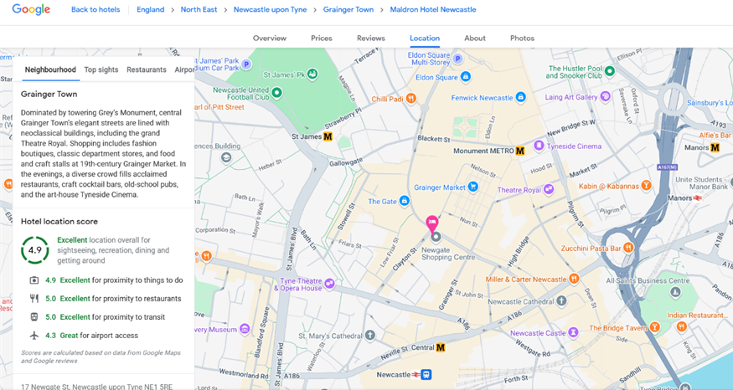

3.2
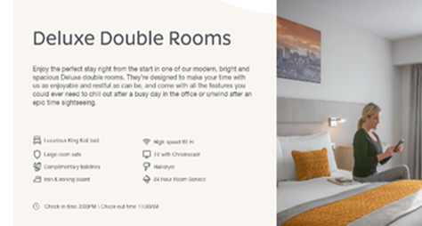
https://www.google.com/search?q=Maldron+hotel+newcastle+how+many+rooms+does+it+have&rlz=1C1CBWT_en-GBGB991GB996&oq=Maldron+hotel+newcastle+how+many+rooms+does+it+have&gs_lcrp=EgZjaHJvbWUyBggAEEUYOTIHCAEQIRigATIHCAIQIRiPAjIHCAMQIRiPAtIBCTE5NDUzajBqN6gCCLACAQ&sourceid=chrome&ie=UTF-8

4.3 Maldron Hotel, the Dalata Group, (2024), half year financial highlights


