Assignment 1
By Krzysztof Matela
Programming in C and documentation

Page index:
Page 2 ………………………………………………………………………………………………… Task C – Card Matching Game
Page 3 …………………………………………………………………………………………………………………………………….Testing
Page 7 ……………………………………………………………………………………………………………………………………… Code
Page 13 ………………………………………………………………………………………………….. Content of “HighScore.txt”

Task C – Card matching game
I was tasked with producing a card matching game in C. This is going to be most complex program that I have written so far and it includes everything I know about C so far.
Problems:
- Visual representation of card matching game
- Randomizing cards and making sure that each card has its match and each pair occurs only once.
- Error trapping mechanism, to prevent user from imputing values that are not expected by program
- Counter for number of matches that user has attempted
- Displaying high score table
- Adding new high score and arranging whole in ascending order
Solutions:
- I have decided to represent the card match using two rows, A and B. both rows will have values that were pre-randomized and “concealed” behind “#”. This table will look like so:
0 | 1 | 2 | 3 | 4 | 5 |
---------------------------------------------------------
A | # | # | # | # | # |
B | # | # | # | # | # |
Whenever user inputs a column number its value will be revealed e.g. ‘1’:
0 | 1 | 2 | 3 | 4 | 5 |
---------------------------------------------------------
A | 1 | # | # | # | # |
B | # | # | # | # | # |
Using Booleans, a loop will determine which values to display and which remain hidden
- For randomizing cards, I had produced a system that will generate a random number and if next generated random number will the same as any before, it will try again until every value is different and in random order for both rows A and B.
- Error trapping mechanism was the most challenging part. It required me to use both integers and characters where in programming, neither can be used together. I have produced two systems for error trapping. First trap, tests of user has input correct numeric value (1 to 5) and ask to reattempt until input is correct. Another trap, requires a test that a number was matched before and ask to reattempt selection until new value is get to be matched.
- To add move count, I have produced a variable that has a value increased by 1 with every match that user attempts. It will also be used for high score table
- Displaying high score table is achieved by reading an external file and displaying its content on screen
- When user wins the game, program requires to input the name which, with combination of moves count, is transferred to a sorting algorithm which will determine where on the score to place it and saves a new high score table.

Testing:
Displaying previous high score:
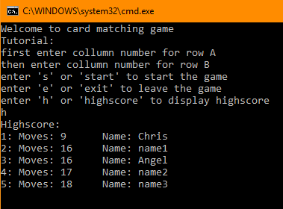
Exiting the game at any given input
Before game starts
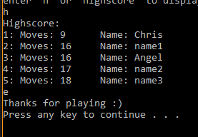
While game is running
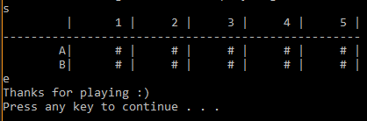

With each new game values are different
Test 1
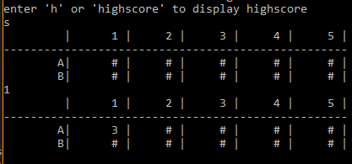
Test 2
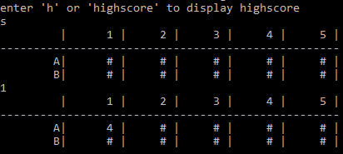
Matching cards:
No match
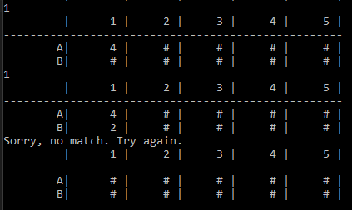
Match (matched cards are left revealed)
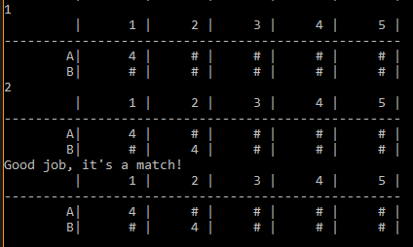
Error trapping:
Letter is input
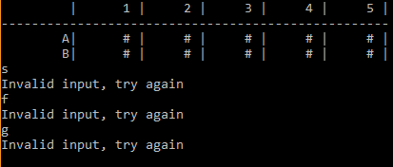

Card has been matched before
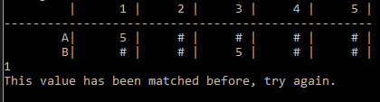
High score updated and sorted:
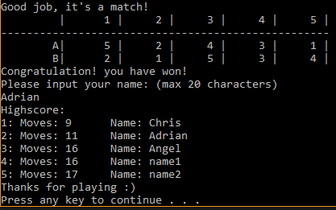
New high score available from the start of the program:
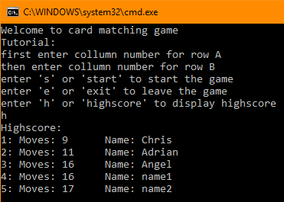

Code:
--------------------------------------------------------------------------------------------------------------------------------------
/************************************************
* title: Card Match game *
*************************************************
* Coding language: C *
* Produced by: Krzysztof Matela *
* Start Date: 03/04/2019 *
*************************************************
* notes: *
*************************************************
* This program will generate two rows of *
* numbers from 1 to 5 which will be displayed *
* in random order. *
* user will be able to display highscore and *
* exit the game at any time they wish. *
* numbers that are not picked or matched will *
* be hidden by default *
* several error trapping must be included *
*************************************************/

#include <stdio.h>
#include <stdlib.h>
#include <time.h>
#include <string.h>

// series of variables for each row with 5 collumns
struct construct
{
int content[5]; // value
bool toBeShown[5]; // used by table generator to display value or '#'
bool picked[5]; // used for error trapping and game won detection
};
// functions
void intro(); // display introductions
void getArray(int *num); // fill array of construct with values
void displayTable(); // display table
int convertToCollumn(int asci); // convert asci to number
int getRandom(); // get random number
void displayHighscore(); // show highscore table
void outro(); // say good bye's
void updateHighscore(int userMoves, char userName[20]); // update and sort highscore table with ascending order

// global variables
int i;
construct a;
construct b;

// main
void main() {
srand(time(NULL)); // include system time
//constructs A and B

// local variables
bool endGame = false;
char userName[20];
int moves = 0;
int collumnPick[2];
char userInput[10];

// load false's
for (i = 0; i < 5; i++) {
a.toBeShown[i] = false;
a.picked[i] = false;

b.toBeShown[i] = false;
b.picked[i] = false;
}

// randomize numbers
getArray(a.content);
getArray(b.content);

// display introduction
intro();

while (endGame == false) {
scanf("%s", &userInput);

// game starts
if (userInput[0] == 's') {
displayTable();
// main loop
while (endGame == false) {
scanf("%s", &userInput);
collumnPick[0] = userInput[0];
// error trapping using ASCI values coming from converting character into an integer
while (collumnPick[0] != 49 && collumnPick[0] != 50 && collumnPick[0] != 51 && collumnPick[0] != 52 && collumnPick[0] != 53) {
if (userInput[0] == 'e') {
outro();
return;
}
// inform of invalid input
printf("Invalid input, try again\n");
scanf("%s", &userInput);
collumnPick[0] = userInput[0];
}
// convert asci to integer
collumnPick[0] = convertToCollumn(collumnPick[0]);
// error trapper for inputing same value again
while (a.picked[collumnPick[0]] == true) {
printf("This value has been matched before, try again.\n");
scanf("%s", &userInput);
collumnPick[0] = userInput[0];
collumnPick[0] = convertToCollumn(collumnPick[0]);
}
// show this value
a.toBeShown[collumnPick[0]] = true;
// display table
displayTable();

scanf("%s", &userInput);
collumnPick[1] = userInput[0];
// error trapping using ASCI values coming from converting character into an integer
while (collumnPick[1] != 49 && collumnPick[1] != 50 && collumnPick[1] != 51 && collumnPick[1] != 52 && collumnPick[1] != 53) {
if (userInput[0] == 'e') {
outro();
return;
}
printf("Invalid input, try again.\n");
scanf("%s", &userInput);
collumnPick[0] = userInput[0];
}

collumnPick[1] = convertToCollumn(collumnPick[1]);
while (b.picked[collumnPick[1]] == true) {
printf("This value has been matched before, try again.\n");
scanf("%s", &userInput);
collumnPick[1] = userInput[0];
collumnPick[1] = convertToCollumn(collumnPick[1]);
}
b.toBeShown[collumnPick[1]] = true;
displayTable();

// match values
if (a.content[collumnPick[0]] != b.content[collumnPick[1]]) {
printf("Sorry, no match. Try again.\n");
a.toBeShown[collumnPick[0]] = false;
b.toBeShown[collumnPick[1]] = false;
}
else {
printf("Good job, it's a match!\n");
a.picked[collumnPick[0]] = true;
b.picked[collumnPick[1]] = true;
}
displayTable();

// add move
moves = moves + 1;

// game stopping
if (a.picked[0] == true && a.picked[1] == true && a.picked[2] == true && a.picked[3] == true && a.picked[4] == true) {
printf("Congratulation! you have won!\n");
printf("Please input your name: (max 20 characters)\n");
scanf("%s", userName);
updateHighscore(moves, userName);
displayHighscore();
outro();
return;
}
}
}
else if (userInput[0] == 'e') {
outro();
return;
}
else if (userInput[0] == 'h') {
displayHighscore();
}
else {
printf("Invalid value");
}
}
outro();
}

void intro() {
printf("Welcome to card matching game\nTutorial:\n");
printf("first enter collumn number for row A\n");
printf("then enter collumn number for row B\n");
printf("enter 's' or 'start' to start the game\n");
printf("enter 'e' or 'exit' to leave the game\n");
printf("enter 'h' or 'highscore' to display highscore\n");
}

void getArray(int *num) {
// 5 random numbers with switch function to make sure none are the same
for (i = 0; i < 5; i++) {
switch (i)
{
default:
num[i] = getRandom();
break;

case 1:
num[i] = getRandom(); // generate random number
while (num[i] == num[0]){ // make sure it is not the same as the others
num[i] = getRandom(); // randomize another number if repeats
}
break;

case 2:
num[i] = getRandom();
while (num[i] == num[0] || num[i] == num[1]) {
num[i] = getRandom();
}
break;

case 3:
num[i] = getRandom();
while (num[i] == num[0] || num[i] == num[1] || num[i] == num[2]) {
num[i] = getRandom();
}
break;

case 4:
num[i] = getRandom();
while (num[i] == num[0] || num[i] == num[1] || num[i] == num[2] || num[i] == num[3]) {
num[i] = getRandom();
}
break;
}

}
}

void displayTable() {
int *tableA = a.content;
bool *tbsA = a.toBeShown;
int *tableB = b.content;
bool *tbsB = b.toBeShown;
// top table
printf("\t |\t1 |\t2 |\t3 |\t4 |\t5 |\n");
printf("---------------------------------------------------\n");

// display row A
printf("\tA|");
for (i = 0; i < 5; i++) {
if (tbsA[i] == false) {
printf("\t# |", tableA[i]);
}
else if (tbsA[i] == true) {
printf("\t%d |", tableA[i]);
}
}

// display row B
printf("\n\tB|");
for (i = 0; i < 5; i++) {
if (tbsB[i] == false) {
printf("\t# |", tableB[i]);
}
else if (tbsB[i] == true) {
printf("\t%d |", tableB[i]);
}
}
printf("\n");
}

int convertToCollumn(int asci){
int collumn;
switch (asci)
{
case 49:
collumn = 0;
break;
case 50:
collumn = 1;
break;
case 51:
collumn = 2;
break;
case 52:
collumn = 3;
break;
case 53:
collumn = 4;
break;
}
return collumn;
}

int getRandom() {
int myRnd;
int low = 1;
int high = 5;

// generate random number
myRnd = rand() % (high - low + 1) + low;

return myRnd;
}

void displayHighscore() {
FILE *fp;
int number;
char name[20];

fp = fopen("highScore.txt", "r");

printf("Highscore:\n");

for (i = 0; i < 5; i++) {
fscanf(fp, "%d", &number);
fscanf(fp, "%s", &name);
printf("%d: Moves: %d\t Name: %s\n", i+1, number, name);
}

fclose(fp);
}

void outro() {
printf("Thanks for playing :)\n");
}

void updateHighscore(int userMoves, char userName[20]) {
FILE *fp;
char string[10][10];
int temp, i, j, k;
int numbers[6];
char temp2[20];

// read arrays and input them accordingly
fp = fopen("HighScore.txt", "r");
for (i = 0; i < 5; i++) {
fscanf(fp, "%d", &numbers[i]);
fscanf(fp, "%s", &string[i]);
}
fclose(fp);

numbers[5] = userMoves;

strcpy(string[5], userName);

// sort out ascending
for (j = 0; j < 6; j++) {
for (k = j + 1; k < 6; k++) {
if (numbers[j] > numbers[k]) {
temp = numbers[j];
numbers[j] = numbers[k];
numbers[k] = temp;

strcpy(temp2, string[j]);
strcpy(string[j], string[k]);
strcpy(string[k], temp2);
}
}
}

// input to file
fp = fopen("HighScore.txt", "w");
for (i = 0; i < 5; i++) {
fprintf(fp, "%d ", numbers[i]);
fprintf(fp, "%s\n", string[i]);
}
fclose(fp);
}
--------------------------------------------------------------------------------------------------------------------------------------

Content of “HighScore.txt”
9 Chris
11 Adrian
16 Angel
16 name1
17 name2

