NAME:
Sentiljano Kacokaj

STUDENT NUMBER:
2313169

MODULE CODE:
ACCA6026

MODULE TITLE:
Data Warehousing & Data Mining

LECTURER NAME:
Dr Nouh Elmitwally

ASSIGNMENT TITLE:
Data Mining

I. Purpose and Practice of Data Mining 2
II. Dataset Description and Exploration 2
III. Data Pre-processing and Post-processing 4
IV. Sample Runs and Analysis Methods 5
A. Classification - J48 Decision Tree 5
B. Classification - Random Forest 6
C. Clustering - SimpleKMeans 7
V. Business Recommendations 9
VI. Reflective Commentary 9
VII. References 10

- Purpose and Practice of Data Mining
Stroke remains one of the primary causes of death and long-term disability globally, placing considerable pressure on healthcare systems that need to move from a reactive treatment approach toward a more targeted prevention approach [1]. Data mining offers a practical solution to that goal. By extracting patterns from large collections of patient records, it becomes possible to identify individuals at elevated risk before a clinical event happens, supporting decisions that would otherwise rely on clinician judgement or generalized population-based recommendations [2].

In healthcare, data mining generally serves two objectives: classification, which categorizes patients according to their attributes and predicted outcomes, and clustering, which groups individuals based on shared characteristics absent a predetermined outcome label. Both are relevant here. Classification can be used to predict whether a patient is likely to experience a stroke from their demographic and clinical profile, while clustering can identify distinct subgroups within the patient population, such as those who show a combination of lifestyle risk factors and pre-existing conditions, including hypertension or elevated glucose levels [1].

What makes this approach particularly valuable is that the relationships between risk factors are rarely straightforward. Age, BMI, smoking status and heart disease do not contribute to stroke risk in isolation, but their interactions matter. Traditional statistical models struggle to capture those interactions, whereas machine learning classifiers are better suited to modelling them [1], [3]. Applied to the Kaggle stroke prediction dataset, these techniques allow a healthcare organisation to move from descriptive questions about who has had a stroke to predictive ones about who is likely to, enabling earlier and more effective intervention.

- Dataset Description and Exploration
The Stroke Prediction Dataset which was sourced from Kaggle [4], contains the records of 5,110 patients, each is characterized by 12 attributes. These attributes, which integrate demographic details, lifestyle choices and clinical assessments, make the dataset appropriate for both classification and clustering applications. The principal variable under investigation is a binary marker showing whether a patient has suffered a stroke.

Of the 12 attributes, five are numeric (excluding the id column): age, BMI, average glucose level and the binary integer flags for hypertension and heart disease. The remaining attributes are categorical, including gender, marital status, work type, residence type and smoking status. The id column serves purely as an identifier and has no analytical value.

The first data quality issue the is immediately found is the BMI that contains 201 missing values, representing roughly 3.9% of the dataset. All other attributes are complete. Smoking status, while technically complete, includes 1,544 records labelled as "Unknown", which introduces a degree of ambiguity that should be taken into account during preparation. How both of these issues were addressed is discussed in the next section.

Perhaps the most significant characteristic of this dataset is its class imbalance. Only 249 of the 5,110 records correspond to a positive stroke outcome, meaning stroke cases account for just 4.9% of the data shown in Table 1. This kind of skew is common in medical datasets where the condition being predicted is relatively rare, but it presents a real challenge for classification models, which tend to favour the majority class unless the imbalance is corrected [5].

No Stroke | Stroke
4861 | 249

Table 1: Stroke Class Distribution

Looking at the numeric variables, age ranges from under one year to 82, with a mean of approximately 43 years. The distribution is relatively spread, with a notable concentration of records in the middle-aged to older adult range (Figure 1). This aligns with what is clinically expected given that stroke risk increases with age [6].

Figure 1: Age Distribution Histogram

Average glucose level has a mean of 106.1 mg/dL but a wide range extending to 271.7, suggesting the presence of diabetic or pre-diabetic patients within the sample. BMI has a mean of 28.9, consistent with an overweight population average.

Smoking status distribution is shown in Figure 2. The "Unknown" category is the second largest group after "never smoked", which raises questions about data completeness that are relevant to how the variable is used in modelling.

Figure 2: Smoking Status Bar Chart

- Data Pre-processing and Post-processing
Before any analysis could begin, the dataset required multiple preparation steps to make sure it was clean, correctly structured and ready to use in Weka. These steps covered missing values, categorical encoding, class imbalance and feature selection.

The first problem encountered was the BMI attribute, which contained 201 missing values stored as "N/A" strings instead of empty cells. Removing these rows would have deleted 3.9% of the dataset without good reason, so mean imputation was used instead. The column mean was calculated from all valid BMI entries using Excel's AVERAGEIF function, which excluded the N/A records from the calculation and returned a value of 28.89. This value was then applied to all missing entries using Excel's Find and Replace function. The effect on the overall distribution was minimal, with the column mean changing by less than 0.001 after imputation, confirming that the missing values were not concentrated in any particular patient group and that mean substitution was a reasonable approach [7].

The smoking status was a different problem. Instead of having missing values, 1,544 records had the label "Unknown," making up 30.2% of the attribute's entries. Removing these records would have reduced the dataset by almost a third, which would have seriously affected model training. So, these records were kept and "Unknown" was recognised as a valid category on its own. This method is in line with how other healthcare studies deal with uncertain categorical data. Keeping uncertain labels preserves the size of the dataset while being transparent about the limitations [7].

The id column was removed before importing the data into Weka, as it serves only as a row identifier and has no predictive value. Keeping it could have introduced noise into distance-based methods such as K-Means clustering.
Beyond the id column, no other attributes were removed. Variables like gender and residence type were kept as they can still contribute to interactions within tree-based classifiers and influence cluster formation. No new features were engineered, as the focus was on how standard algorithms perform with the existing attributes.

Weka reads nominal attributes directly from CSV files, so no manual encoding was needed for categorical variables such as gender, work type, or smoking status. However, the stroke column was stored as a numeric binary value of 0 or 1, which Weka treated as a continuous variable by default. The NumericToNominal filter was applied within Weka's Preprocess tab, targeting the stroke attribute specifically, to convert it into a nominal class label. Without this step, Weka's classifiers would have treated stroke prediction as a regression problem rather than a classification one.

The main problem in this dataset was the class imbalance. With only 249 stroke cases out of 5,110 records, stroke represented just 4.9% of the data. This level of skew can cause classifiers to predict the majority class for every patient, producing misleadingly high accuracy while detecting no actual stroke cases [8]. To correct this, SMOTE (Synthetic Minority Oversampling Technique) was applied using Weka's supervised instance filter, targeting the minority stroke class specifically, instead of duplicating existing stroke cases, SMOTE generates synthetic ones by looking at patients similar to existing stroke cases and creating realistic variations based on their characteristics. The result is a more varied training set than simple duplication would give. SMOTE was applied with five nearest neighbours, increasing the stroke class from 249 to 4,860 instances and bringing the dataset total to 9,721, as shown in Table 2. This technique is widely used in medical data mining where gathering additional real minority class samples is not practical [5].

 | No Stroke | Stroke
Before SMOTE | 4861 | 249
After SMOTE | 4861 | 4860

Table 2: Class Distribution Before and After SMOTE

Once the models had been run, the results were interpreted with a focus on what they mean in a healthcare context rather than just reporting numbers. Because the dataset was heavily imbalanced, metrics such as recall and ROC area were used to judge model performance instead their accuracy, which can be misleading when one class heavily outnumbers the other [9]. For the clustering results, the average values for each group were examined to give each cluster a meaningful description based on patient characteristics such as age, glucose level and presence of hypertension.
- Sample Runs and Analysis Methods
Two classification algorithms and one clustering algorithm were applied to the prepared dataset in Weka. All classification runs used 10-fold cross-validation, which splits the data into ten equal parts, trains on nine and tests on one, rotating until every record has been used for testing. This approach gives a more reliable estimate of model performance than a single train-test split [10].

- Classification - J48 Decision Tree
J48 was the first classifier tested, mainly because decision trees are interpretable and in a healthcare setting, understanding why a model makes a prediction matters as much as the prediction itself [11]. With SMOTE properly applied to the minority class, the pruned J48 produced a tree with 323 leaves and 572 nodes, as shown in Figure 3. The first split divided patients at age 49, with the following splits drawing on variables including marital status, followed by marital status, work type and then factors such as hypertension and heart disease, which is consistent with established clinical knowledge about stroke risk factors [12]. The model achieved 93.4% accuracy with a Kappa statistic of 0.869, indicating strong agreement beyond chance. Recall for stroke cases was 0.937, meaning the model correctly identified 4,553 out of 4,860 stroke patients. The ROC area of 0.958 confirmed strong discriminative ability on both classes [8], [9].

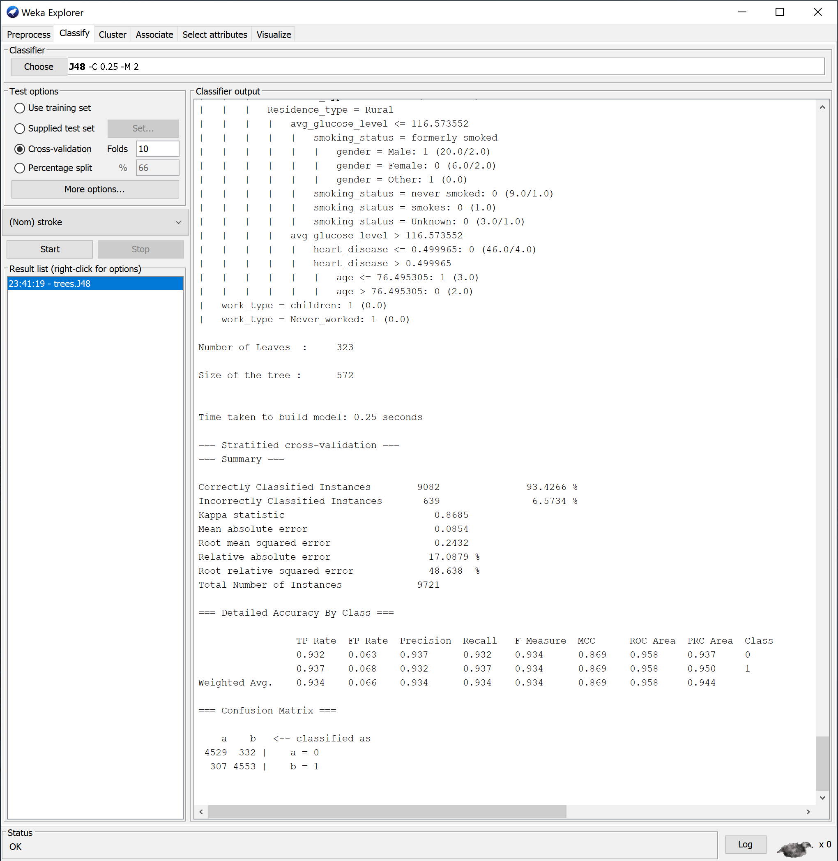
Figure 3: J48 Pruned Decision Tree Results (Post-SMOTE)
- Classification - Random Forest
Random Forest was selected as the second classifier because it creates multiple decision trees and combines their outputs, which generally reduces overfitting and improves performance in complex datasets [13]. With 100 trees and 10-fold cross-validation, the model achieved 95.6% accuracy as shown in Figure 4. Recall for stroke cases was 0.956, with 4,644 out of 4,860 correctly identified. The Kappa statistic of 0.912 and ROC area of 0.990 both indicate strong predictive performance, outperforming J48 in every metric.

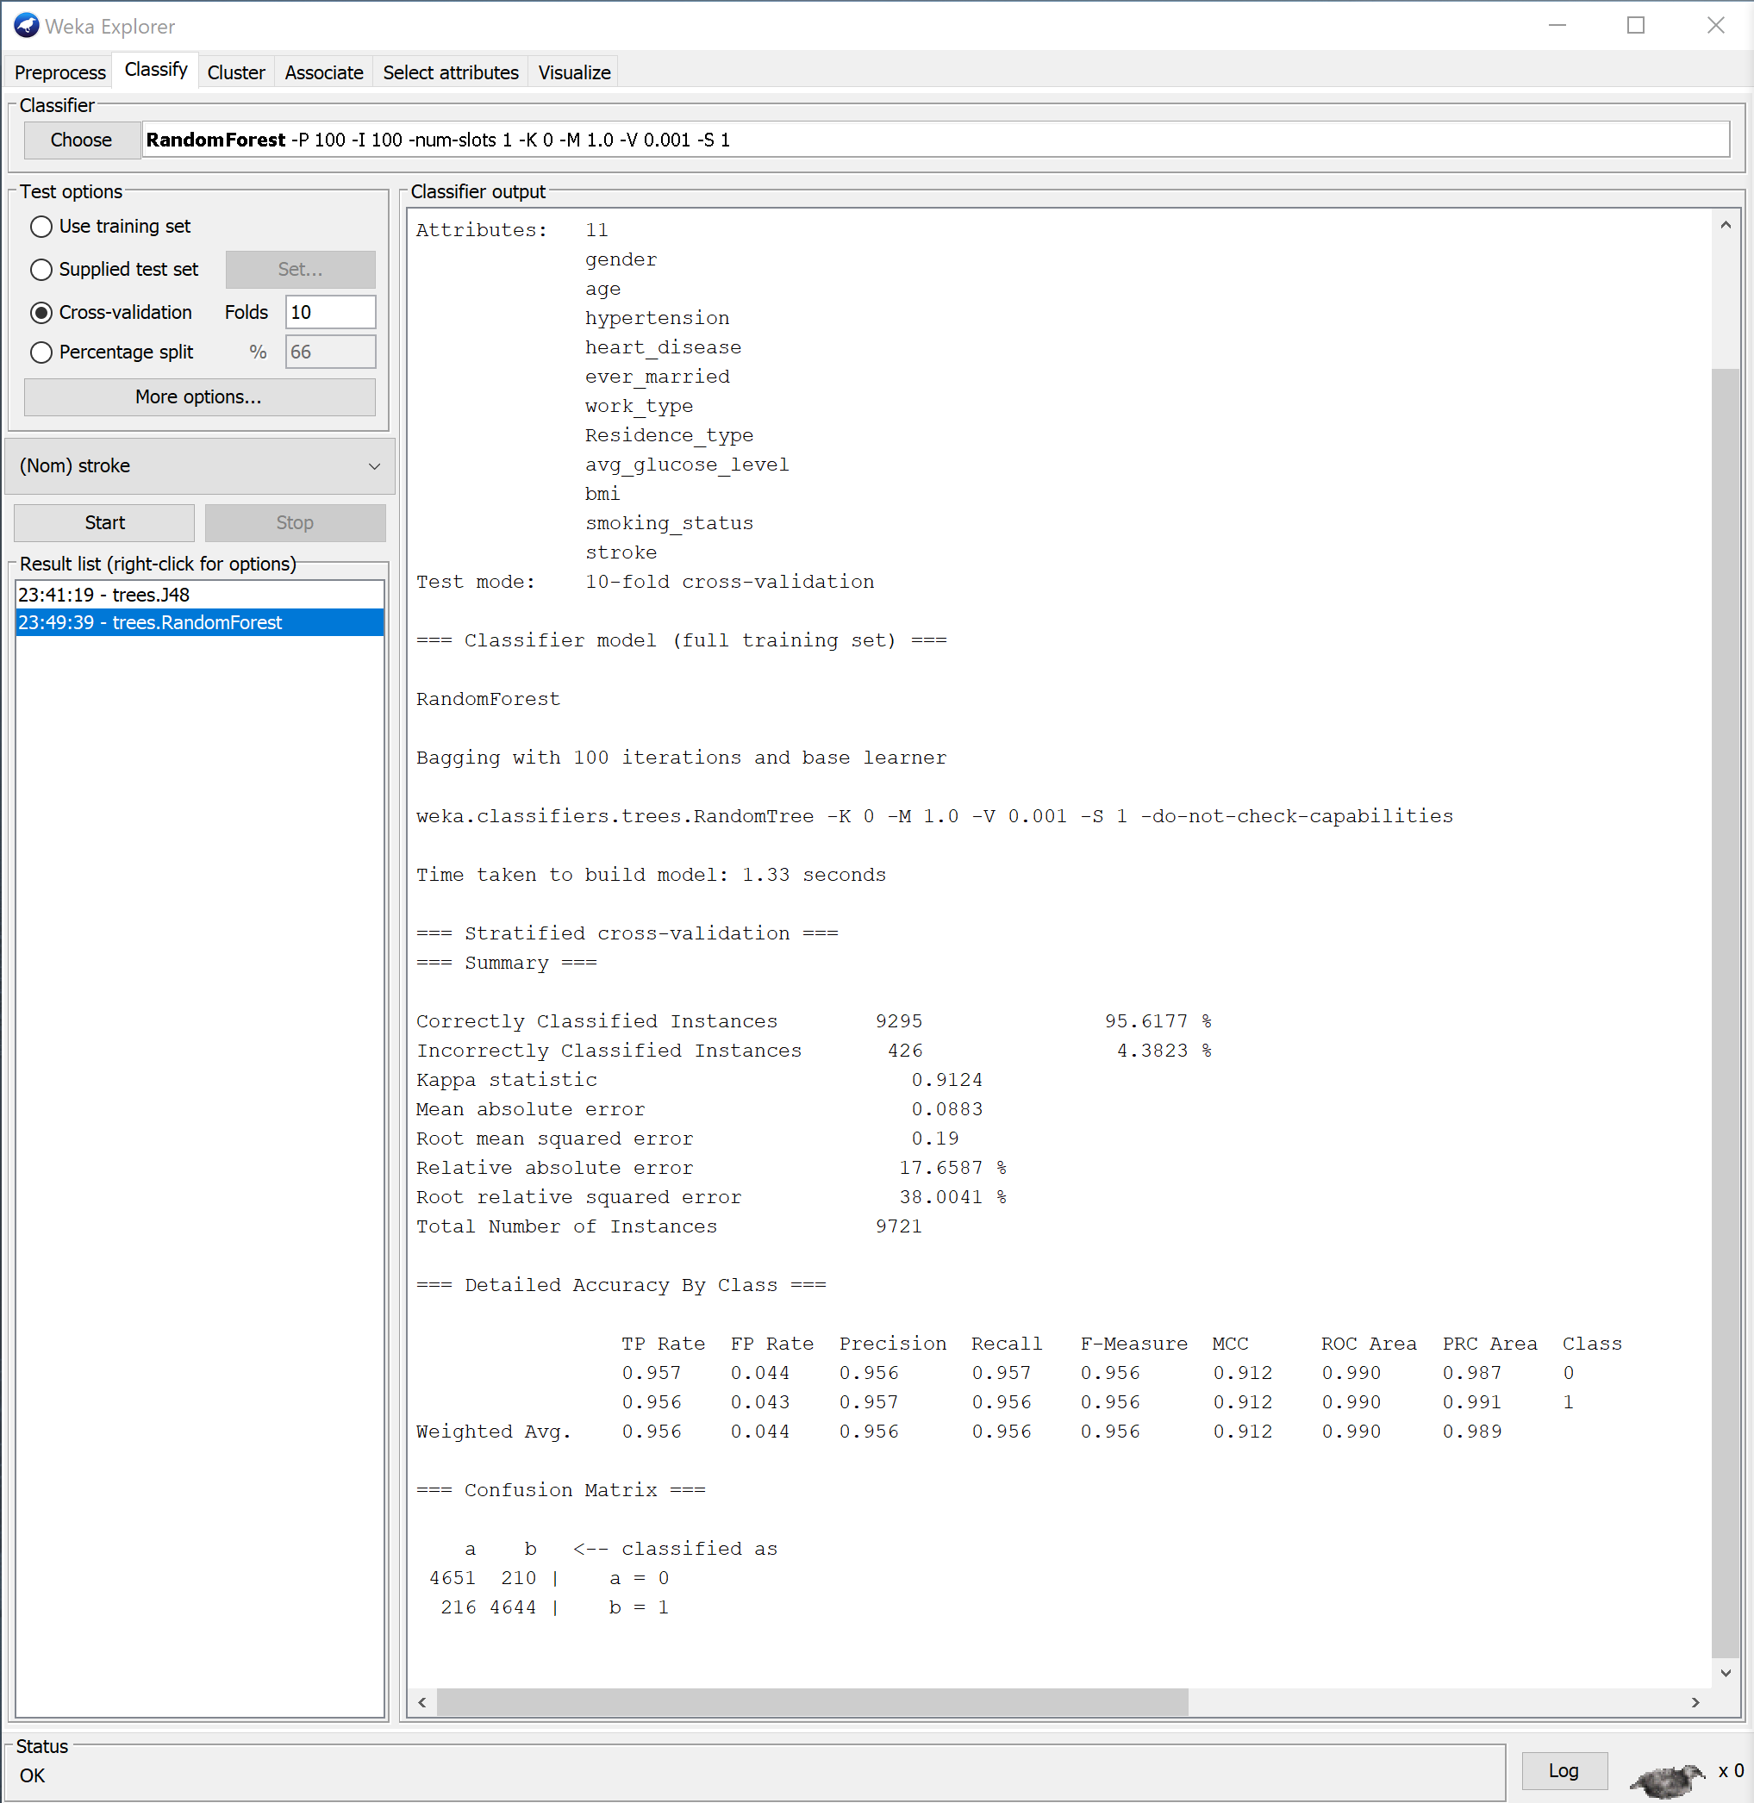
Figure 4: Random Forest Classifier Results

Random Forest's improvement over J48 is consistent with what the literature reports about ensemble methods outperforming single decision trees on complex medical datasets, particularly when class distributions have been properly balanced [14]. Both classifiers demonstrated that with correct SMOTE application, standard algorithms can achieve clinically useful levels of stroke prediction from routine patient data.

- Clustering - SimpleKMeans
SimpleKMeans was chosen for the clustering component because it is efficient and produces clearly interpretable cluster centroids (the average point of each cluster), making it appropriate for identifying patient risk profiles in a healthcare dataset [15].

SMOTE was applied only for the classification tasks, instead clustering was performed on the original dataset to make sure the groupings worked on real patient profiles instead of synthetic ones created by SMOTE. Three clusters were chosen to represent low, medium and high risk groups, since this is a practical split for healthcare screening. Other values of k were not tested, though doing so could have revealed more subgroups. The algorithm reached a stable solution after 9 iterations, with a within-cluster sum of squared errors of 9,109, as shown in Figure 5.

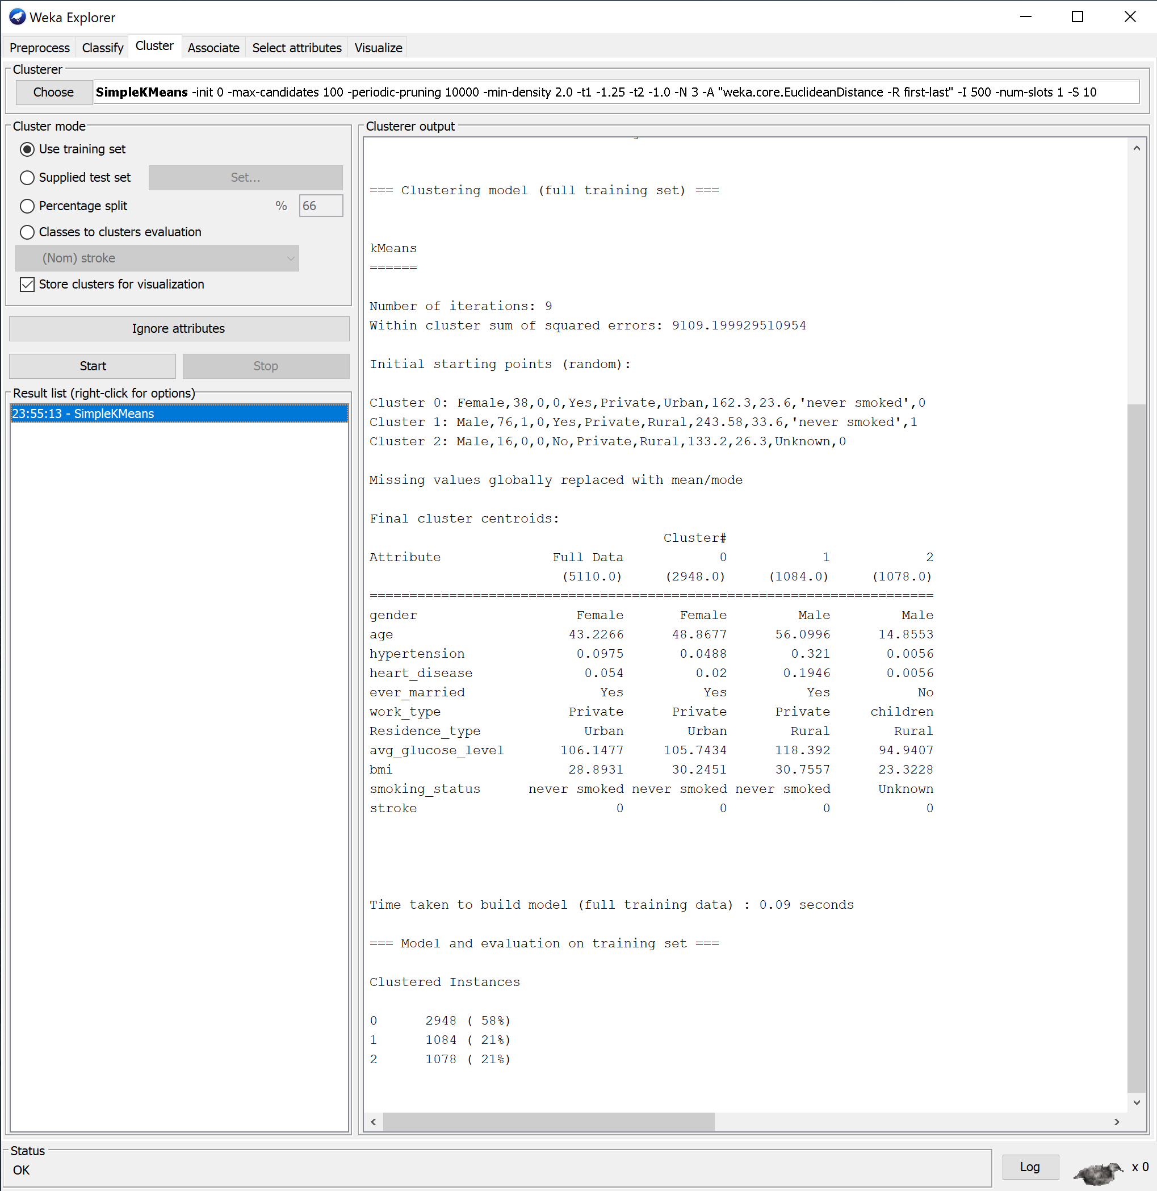
Figure 5: SimpleKMeans Clustering Output

The three clusters broke down into distinct patient profiles. Cluster 0 was the largest, containing 58% of patients, and was characterised by middle-aged women (mean age 48.9) with average glucose levels and moderate BMI. Cluster 2 contained 21% of patients and represented younger male children (mean age 14.9) with the lowest glucose and BMI values and near-zero rates of hypertension and heart disease. Cluster 1, also containing 21% of patients, was the highest-risk group: older males (mean age 56.1) living in rural areas with the highest average glucose level (118.4 mg/dL), a hypertension rate of 32.1%, and a heart disease rate of 19.5%. This group closely matches the demographic profile most associated with stroke risk in the literature [12] and represents the patients that healthcare providers should prioritise for early intervention.

- Business Recommendations
The results from this analysis shows some practical steps that healthcare providers could take around stroke prevention. The Cluster 1 profile, which is older men living in rural areas with a hypertension rate of 32.1% and heart disease rate of 19.5%, is quite similar to other groups of people who are at high risk [12] and suggests that screening this group specifically could be more cost-effective than monitoring the whole population. Prioritising these patients for regular blood pressure checks, glucose monitoring and lifestyle assessments would concentrate resources where they are most needed. The 2024 AHA/ASA primary prevention guidelines support this kind of risk-stratified approach [16].

The classification results reinforce this direction. J48 placed age, hypertension and heart disease at the top of its decision logic, and Random Forest achieved a ROC area of 0.990, confirming that these variables are the most important screening criteria [17]. With recall above 0.93 for both models, they could realistically support clinicians during routine consultations as decision support tools [2], though they should assist clinical judgement rather than replace it [11].

The integration of predictive screening techniques directly to electronic health record systems would allow ongoing patient screening with minimal effort as part of normal care. A large study that used machine learning to predict strokes in community clinical workflows found that this method helped find high-risk people early on during regular consultations, which had long-term benefits for both clinical outcomes and costs [18]. However, another systematic review of 49 machine learning research utilising normal hospital data conducted in 2025 showed that improvements in external validation, calibration and clinical explainability are still necessary before committing to the implementation of these models [19].

The "Unknown" smoking status category, affecting roughly 30% of records here, shows why consistent data collection matters. If lifestyle information like smoking status is not recorded reliably, predictive models lose access to modifiable risk factors that could inform individual patient interventions [7].

- Reflective Commentary
I found that the models started to perform well once the dataset was properly balanced. J48 achieved 93.4% accuracy with a stroke recall of 0.937, while Random Forest reached 95.6% accuracy with a recall of 0.956 and a ROC area of 0.990. These results are supported by Kappa statistics of 0.869 and 0.912 respectively, confirming that both models were identifying stroke cases well beyond what chance would predict.

In my first test, SMOTE had been applied incorrectly to the majority class rather than the minority class, which caused both classifiers to collapse and detect almost no stroke cases at all. Correcting this was the single most important step in the entire analysis and it demonstrated how important classification results are to proper data preparation, a finding consistent with broader research on handling imbalanced medical datasets [14].

One strength was the use of SMOTE to balance the training data, which transformed both classifiers from non-functional to clinically useful. The J48 tree's early splits on age, hypertension and heart disease align with established stroke risk factors [12] and Random Forest's high ROC area confirms it was picking up on genuine patterns in the data. The use of 10-fold cross-validation gave the results more credibility than a single split would have [10].

The main limitation in this case is that these results rely on synthetic oversampling, and it is unclear how well the models would generalise to entirely new patient data. The clustering was also limited to k=3 without testing other values of k, which may have missed important subgroups. Future tests could explore cost-sensitive learning as a complement to SMOTE and test additional algorithms such as logistic regression or gradient boosting to see if further improvements are possible, since no single approach consistently outperforms all others on imbalanced medical datasets [8].

References
[1] M. Sutcu, D. Jouda, B. Yildiz, J. Katrib and K. M. Almustafa, "Predicting Stroke Risk Using Machine Learning: A Data‐Driven Approach to Early Detection and Prevention," vol. 2025, no. 1, pp.2892726, 2025, doi: 10.1155/srat/2892726.
[2] S. Dev, H. Wang, C. S. Nwosu, N. Jain, B. Veeravalli and D. John, "A predictive analytics approach for stroke prediction using machine learning and neural networks," vol. 2, pp.100032, 2022, doi: 10.1016/j.health.2022.100032.
[3] R. Wijaya, F. Saeed, P. Samimi, A. M. Albarrak and S. N. Qasem, "An Ensemble Machine Learning and Data Mining Approach to Enhance Stroke Prediction," vol. 11, no. 7, pp.672, 2024, doi: 10.3390/bioengineering11070672.
[4] F. Soriano. "Stroke Prediction Dataset." Kaggle. Accessed: 12 March 2026. [Online]. Available: https://www.kaggle.com/datasets/fedesoriano/stroke-prediction-dataset
[5] E. F. Agyemang, et al., "Addressing Class Imbalance Problem in Health Data Classification: Practical Application From an Oversampling Viewpoint," vol. 2025, no. 1, 2025, doi: 10.1155/acis/1013769.
[6] M. Yousufuddin and N. Young, "Aging and ischemic stroke," vol. 11, no. 9, pp.2542–2544, 2019, doi: 10.18632/aging.101931.
[7] H. Wang, J. Tang, M. Wu, X. Wang and T. Zhang, "Application of machine learning missing data imputation techniques in clinical decision making: taking the discharge assessment of patients with spontaneous supratentorial intracerebral hemorrhage as an example," BMC Med Inform Decis Mak. vol. 22, no. 1, pp.13–14, Jan 13 2022, doi: 10.1186/s12911-022-01752-6. Available at: https://link.springer.com/article/10.1186/s12911-022-01752-6.
[8] M. Salmi, D. Atif, D. Oliva, A. Abraham and S. Ventura, "Handling imbalanced medical datasets: review of a decade of research," Artif.Intell.Rev. vol. 57, no. 10, pp.273, 2024, doi: 10.1007/s10462-024-10884-2.
[9] E. Richardson, R. Trevizani, J. A. Greenbaum, H. Carter, M. Nielsen and B. Peters, "The receiver operating characteristic curve accurately assesses imbalanced datasets," vol. 5, no. 6, pp.100994, 2024, doi: 10.1016/j.patter.2024.100994.
[10] D. Wilimitis and C. G. Walsh, "Practical Considerations and Applied Examples of Cross-Validation for Model Development and Evaluation in Health Care: Tutorial," vol. 2, pp.e49023, 2023, doi: 10.2196/49023.
[11] S. Lu, C. L. Swisher, C. Chung, D. Jaffray and C. Sidey-Gibbons, "On the importance of interpretable machine learning predictions to inform clinical decision making in oncology," vol. 13, pp.1129380, 2023, doi: 10.3389/fonc.2023.1129380.
[12] S. S. Martin, et al., "2024 Heart Disease and Stroke Statistics: A Report of US and Global Data From the American Heart Association," vol. 149, no. 8, pp.e347–e913, 2024, doi: 10.1161/CIR.0000000000001209. Available at: https://www.ahajournals.org/doi/10.1161/CIR.0000000000001209.
[13] L. Barreñada, P. Dhiman, D. Timmerman, A. Boulesteix and B. Van Calster, "Understanding overfitting in random forest for probability estimation: a visualization and simulation study," Diagn Progn Res. vol. 8, no. 1, pp.14, 2024, doi: 10.1186/s41512-024-00177-1.
[14] A. A. Khan, O. Chaudhari and R. Chandra, "A review of ensemble learning and data augmentation models for class imbalanced problems: Combination, implementation and evaluation," Expert Syst.Appl. vol. 244, pp.122778, 2024, doi: 10.1016/j.eswa.2023.122778.
[15] W. Yang, J. Lai, Y. Liu, Y. Lin, H. Hou and P. Pai, "Using Medical Data and Clustering Techniques for a Smart Healthcare System," vol. 13, no. 1, pp.140, 2024, doi: 10.3390/electronics13010140.
[16] C. Bushnell, et al., "2024 Guideline for the Primary Prevention of Stroke: A Guideline From the American Heart Association/American Stroke Association," vol. 55, no. 12, 2024, doi: 10.1161/STR.0000000000000475. Available at: https://doi.org/10.1161/STR.0000000000000475.
[17] A. Hassan, S. Gulzar Ahmad, E. Ullah Munir, I. Ali Khan and N. Ramzan, "Predictive modelling and identification of key risk factors for stroke using machine learning," Sci Rep. vol. 14, no. 1, pp.11498–23, May 20 2024, doi: 10.1038/s41598-024-61665-4. Available at: https://link.springer.com/article/10.1038/s41598-024-61665-4.
[18] Y. Duan, et al., "Development and validation of a stroke risk prediction model using regional healthcare big data and machine learning," vol. 12, no. 6, pp.558–565, 2025, doi: 10.1016/j.ijnss.2025.10.011.
[19] W. Heseltine-Carp, et al., "Machine learning to predict stroke risk from routine hospital data: A systematic review," vol. 196, pp.105811, 2025, doi: 10.1016/j.ijmedinf.2025.105811.

