

Environmental Pollution Control Engineering
  - Investigation of wastewater treatment
Harjot Singh Ubhi P147965
M6X01198
January 27, 2019
Dr Ala Al-Hussany
Contents
1) Introduction - 1 -
2) Wastewater Treatment Process - 1 -
4) Treatment of Final Effluent for Reuse - 4 -
5) Further Treatment of Sludge - 5 -
6) Conclusion - 6 -
7) References - 7 -

1) Introduction
This report focusses on the general principles of how the Gowerton wastewater treatment site works, and processes that can be implemented in order to produce water suitable for agricultural, industrial and domestic use. It also considers improvements that can be made for processing the residual sludge.

2) Wastewater Treatment Process
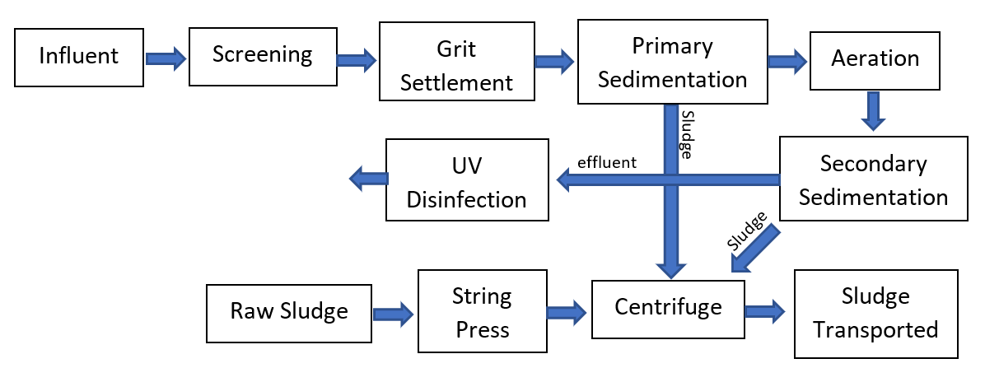
Figure 1: Flowchart of the wastewater treatment process at Gowerton

The influent is sent through a series of screens to remove large objects such as leaves, rags and sanitary products. The collected materials are then compacted and placed in a skip which is emptied weekly. The reason this is done as the first step is to prevent blockages in the pumps and pipes further in the process.
The next step in the process is grit settlement. The water is slowed down so that large particles, such as sand and grit, have a chance to settle to the bottom. The water is then pumped to the top of the works at maximum speed 612 m/s in dry weather flow (DWF), and a maximum speed of 3000 m/s during storm conditions. There five pumps in total; two are DWF pumps, two are storm pumps, and the last one can do both as a backup. Pumps are regulated to maintain a constant flow during the process. As the water level rises the other pumps kick in. The site is designed on normal weather conditions and the population in catchment area. Storm treatment doesn’t need as much treatment as its more diluted so goes straight to a separate set of settlement tanks.
An additional system is currently in the process of being fitted to be able to handle another 300m/s of flow to be treated fully before being allowed to go to storm treatment. These new guidelines have been set by Natural Resource Wales (NRW) to further preserve marine life such as shellfish.
The next part of the process is the primary settlement tanks. As shown in figure 2, The water is pumped up the middle, the solids settle at the bottom and the cleaner water overflows into a channel that takes the water to the next part of the process. Scrapers then push the sludge into hoppers, which is then pumped out. Storm tanks are separate from DWF tanks as they require less treatment, Gowerton has three storm tanks. 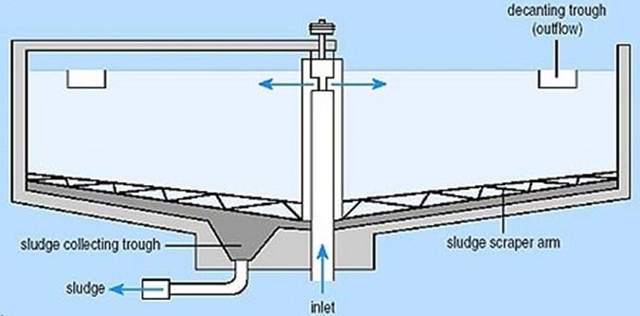
Figure 2: Diagram of a primary sedimentation tank (Anupoju, n.d.)

The effluent gets pumped to the aeration chambers where it is mixed allowing oxygen to dissolve which in turn allows bacteria to thrive and digest certain nutrients, the product is known as activated sludge. (Gray, 2005)
The levels of ammonia were previously too high, so to reduce the levels an anoxic zone was introduced. This is an anaerobic process, where by the bacteria use nitrates instead of oxygen, as there is a lack of it. This produces nitrogen which is release in the form of bubbles.
The next step is the secondary sedimentation, these tanks are flat-bottomed, the smaller particles are removed using venturi system, a centrifugal pump isn’t use so that the flocs don’t get broken up. The sludge is then removed using a helical screw to lift, a slower flow is required for this step.
The effluent then gets passed under UV lights for UV disinfection which kills harmful bacteria still in the effluent. After passing under the UV lights the final flow of the effluent should match the flow of wherever it is being discharged.
Sludge Treatment
Smaller sites bring sludge to Gowerton to be treated. The raw sludge is pumped into a string press, to remove any large particles that could potentially damage the equipment. The string press is a screen with 1mm holes, the waste gets disposed of. The sludge that comes in is only 4% sludge and rest water. It is put through a centrifuge along with polyelectrolyte to clump the sludge together. The sludge produced is 24% sludge. There are two centrifuges on site which operate at 4000rpm. Gowerton fills 3 containers, at 14 tons each of sludge, daily.

4) Treatment of Final Effluent for Reuse
Making the final effluent of a quality to be treated for drinking, the effluent must go through tertiary treatment. This can be done by send the effluent through fine filters like in reverse osmosis, whereby the effluent is passed through a membrane at high pressure. Reverse osmosis can remove dissolved particles as well as heavy metals. Increasing the pressure to the required pressure can be expensive. (Akpor & Muchie, 2010)
Gravity filters can also be implemented, where the effluent goes through a series of layers of decreasing mesh size, with one of the layers being an activated carbon, e.g. anthracite, this will remove odours from the water.
Once the water has been filtered, it will have to go through disinfection. Although the water is disinfected my UV and the end of the wastewater treatment process, this will not protect the water from potential contaminants further down the line, i.e. during transportation. The most common mode of disinfection is chlorination.

5) Further Treatment of Sludge
The sludge at Gowerton waste water treatment plant is already at 24% sludge due to thickening with the use of polyelectrolyte and the use of a centrifuge for dewatering, this can be dewatered further. However, if the sludge will be reused it would be a good idea to stablise the sludge, i.e. prevent anaerobic breakdown of the sludge which causes odours.
The sludge used to do be treated on site via cold digestion where methane produced and burned to heat up the sludge to 36 degrees which produced 10% volume of gas. It was considered more beneficial to transport the sludge to Avon steelworks to undergo advanced digestion which steams the sludge to 120 degrees to get 20% volume of gas which is used produce more steam to generate electricity and supply it to grid. The energy is green energy so is more profitable to sell rather than use.
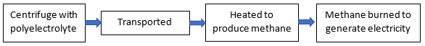
Figure 3: Current process of sludge treatment at Gowerton

There are three methods for the stabilisation of sludge; biological, chemical and thermal. The most common form of biological stabilisation is heated anaerobic digestion. The final sludge is reduced in volume, has a higher solid content and odourless. (Gray, 2005)
the sludge can also be dried using drying beds, but for this scale large amount of land and time would be required.
Gowerton currently send its sludge elsewhere to be used as fuel for electricity generation. The sludge could instead be used for agricultural purposes, due to its richness of organic matter and nutrients. Less common uses of sludge include; brick manufacturing, cement production and top soil. (Gray, 2005)
Lime stabilisation is the most common chemical stabilisation. It works by increasing the pH of the sludge rendering it inhabitable for pathogenic micro-organisms. Lime also has benefits for agriculture, so this would be a good choice if the sludge was to be used for agricultural purposes.
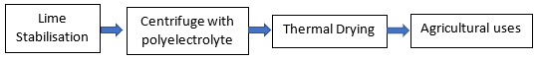
Figure 4: Process of sludge treatment for agricultural use

6) Conclusion
The current process of wastewater treatment at the Gowerton site meets all the current demands. As water scarcity is and increasing possibility the site should consider reusing all water for either agricultural use or domestic use.
The sludge treatment that is currently taking place at Gowerton seems like appropriate use as green energy is being produced. There will still be sludge after the production of electricity as the sludge is not being directly burned, so it could still be used given that it goes through the necessary treatment process.

7) References
Akpor, B. O. & Muchie, M., 2010. Remediation of heavy metals in drinking water and wastewater treatment systems: Processes and applications. International Journal of the Physical Sciences, 5(12), pp. 1807-1817.
Anupoju, S., n.d. Different Types of Sedimentation Tanks used in Water Treatment. [Online]
Available at: https://theconstructor.org/environmental-engg/types-of-sedimentation-tank/14711/
[Accessed 25 January 2019].
Gray, N. F., 2005. Water Technology: An Introduction for Environmental Scientists and Engineers. 2nd ed. s.l.:s.n.
HydroInt, n.d. Hydro International. [Online]
Available at: https://www.hydro-int.com/en/products/dynasand
[Accessed 25 March 2018].
Reedbeds.co.uk, n.d. Reedbeds.co.uk. [Online]
Available at: http://www.reedbeds.co.uk/page/what-is-a-reed-bed-or-a-constructed-wetland.php
[Accessed 25 March 2018].
Wikipedia, n.d. Wikipedia. [Online]
Available at: https://en.wikipedia.org/wiki/Organisms_involved_in_water_purification
[Accessed 25 March 2018].
Wikipedia, n.d. Wikipedia. [Online]
Available at: https://en.wikipedia.org/wiki/Constructed_wetland
[Accessed 25 March 2018].
Wikipedia, n.d. Wikipedia. [Online]
Available at: https://en.wikipedia.org/wiki/Biofilter
[Accessed 25 March 2018].

