Developing and Supporting Physical Development in Early Childhood
Reflective Journal
The aim of this assignment is to reflect upon my experiences in learning about, implementing, supporting, and reflecting upon physical development sessions. I am employed as a year 1 teacher by Swansea City Council. My class consists of 27 children (17 girls and 10 boys), one teaching assistant and one British Sign Language teaching assistant who supports two profoundly deaf children in my class. Sea View Community Primary School in Mayhill, where I carried out the sessions, is a designated 'Communities First' area. It has long been deemed as such by the Welsh Government, because of its long-term social and economic disadvantages. This, together with the after-effects of COVID-19 pandemic has caused us great concern for the physical and mental health of our children. Restrictive measures enforced during this period meant that our children experienced adverse effects on their physical and mental health. The children in my class, and indeed children all over the World, did not get to play with friends, play outdoors, have regular exercise or to develop key movement skills. On returning to school, many of our children continued to spend their free time, as they had done previously, inactively indoors and failed to develop those vital fundamental motor skills (FMS).

This is a group of core skills which includes locomotor skills and object control skills. Locomotor skills define how we move and include movements such as travelling forwards, backwards, sideways and skills such as running, galloping, skipping, hopping, sliding, and leaping (Haywood & Getchell, 2005). Controlling object skills are developed to allow for the efficient and skillful control of objects such as balls, beanbags and the like. Proficiency in these skills is paramount for successful movement and physical activity in later life (Clark & Metcalfe, 2002; Seefeldt, 1980). Learning this fact, together with my own negative experience of physical activity interested me and made me curious to see the results of the intervention of SKIP on our children's physical development and indeed that of the whole child. I aimed to discover if Goddard Blythe’s, idea that “Something happens to attention, behaviour and motivation when children and young people become active.” (Goddard Blythe, 2005 p133). With these words in mind and using Gibbs reflective cycle, I began to assess the children's abilities in these core skills I.e., stability, object control and locomotor skills., work out where they were based on my assessments and then attempt to move them forward. After assessing each child on these core skills, I went about planning and delivering my activities.

The following plan outlines my course of action for my initial warm-up activity:
Physical development plan for warm-up activity.
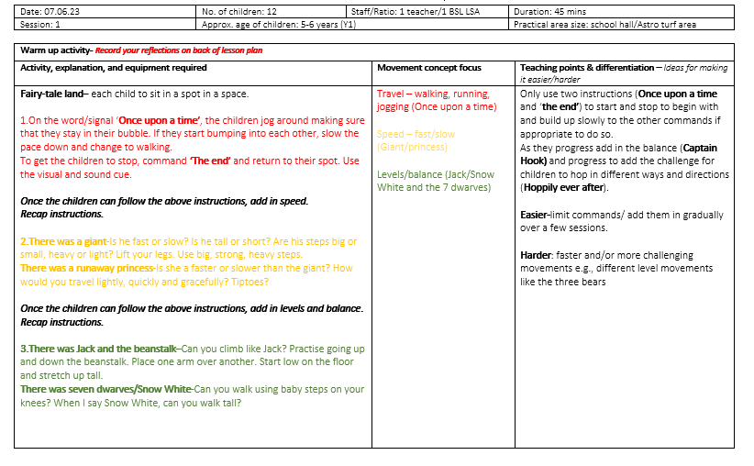
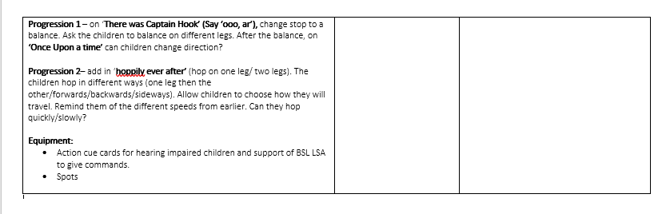
As can be seen from the lesson plan, I decided upon delivering the session to only half of my class at a time. This decision allowed me greater control over the children (they were quite unruly to begin with in previous P.E. lessons), and more importantly it allowed me to hone my practice between the two groups. Furthermore, it allowed me to observe the smaller group more closely and to give ‘on-the-spot' assessments of skills and quality feedback. It was also important to include the three main categories considered to underpin movement. Stability, Object control and locomotor skills. In addition to this, I aimed to include the use of modelled language to help the children to develop a broad vocabulary that describes movement to aid them with future skill progression. I also carefully modelled demonstrations of movements for the children. The idea of modelling these correctly was observed in Goodway and colleagues research where they stated that, “The quality of the demonstration was very important and influenced the pattern of the motor skill performance” (Goodway, Crowe and Ward, 2003 p10). Finally, whenever possible, I used picture cue cards to help the children distinguish between each movement and more importantly to aid the children in my class who had a hearing impairment.

The first session (a warm-up game) was a game entitled ‘Fairy tale Land’. I used the school dining hall which provided a good amount of space for the children to run around safely. At the start of the lesson the children were great at locating a spot and on the words ‘Once upon a time’. Using the associated picture cue card, the children began to run around quickly. They were good at looking where they were going and staying within their ‘bubbles’ which we had practiced doing previously. They responded quickly to the command of ‘The End’ which signaled them to stop, and they were able to find their spots quickly and with ease. I introduced the command of ‘change’ here to get the children to change direction. The group responded well to this, but they needed to work further on travelling backwards as their ability was not so good. I became more aware of the significance of the constraints highlighted in Newell’s model since the children were fully engaged and working well. I introduced different ways to move to change speed. The children loved walking heavily and slowly like a giant and quickly and on tiptoes like the runaway princess. Next, we moved onto including movements which focused on using various levels. The children thought that it was great fun to walk on their knees like dwarves, but I missed an important teaching point here. This would have been a perfect opportunity to ask the children how they thought they would move rather than showing the movement myself. Next, I introduced a new command – Captain Hook (balancing). At first, the children all stood on one leg to show their balance. I thought it was a suitable time to encourage different balances by asking for the balance to involve a different body part. Successfully, all the children balanced on a different body part which was great to share with the group and model the diverse ways they could balance. I was really impressed with the group’s efforts so I asked them if they would like a further challenge which they certainly wanted. I asked them to hop as if they were a frog when travelling on the command of ’Hoppily ever after.’ As the children were jumping (I did not model this for them) they produced different ideas to what I had envisioned. Overall, ‘Fairytale Land’ was a successful warm up game. The use of visuals for all the movements worked well for all children but especially the two hearing impaired children in my class. This allowed them to be fully integrated into the lesson. However, on reflection, I felt I could have included greater work on pathways and an activity to develop relationships with both people and objects e.g., mirroring, in a line/conga/follow the leader/dance. This could be explored further the next time the children played the game.

Cycle 2 and 3 saw the introduction of throwing and catching activities. See the plan outlined below:
Physical development plan for sessions 2 and 3.

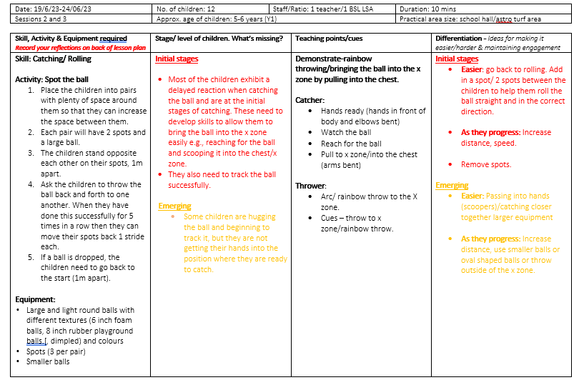
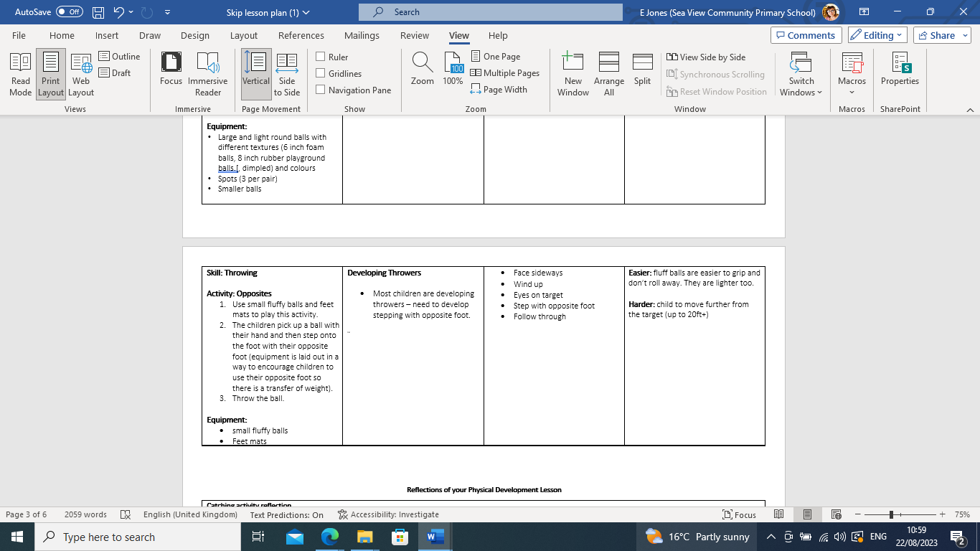
The children had not done many catching activities prior to this (only one lesson at the start of the course), and I was pleased with how much they had remembered. They remembered the term ‘rainbow throw’ and how to do it without prompting or demonstration. However, it was my skills in planning and organising the activity which partly let the activity down. The issue was with how I set up the activity rather than with the children’s abilities. At the start of the lesson, when I asked the children to get into pairs and to find a place approximately 1.5 metres apart, the children could not do this. On reflection, I should have placed spots where I wanted each pair to stand. When I eventually managed to get the children to where I wanted them to be, they really surprised me with their abilities. It was of paramount importance for me to understand what each of the skills looked like in their proficient stage so that I could successfully move each child forward from their individual stage. I referred to the model below to help me understand how the children's level of skill needed to become proficient if they were eventually going to use these skills in the future to play sports.

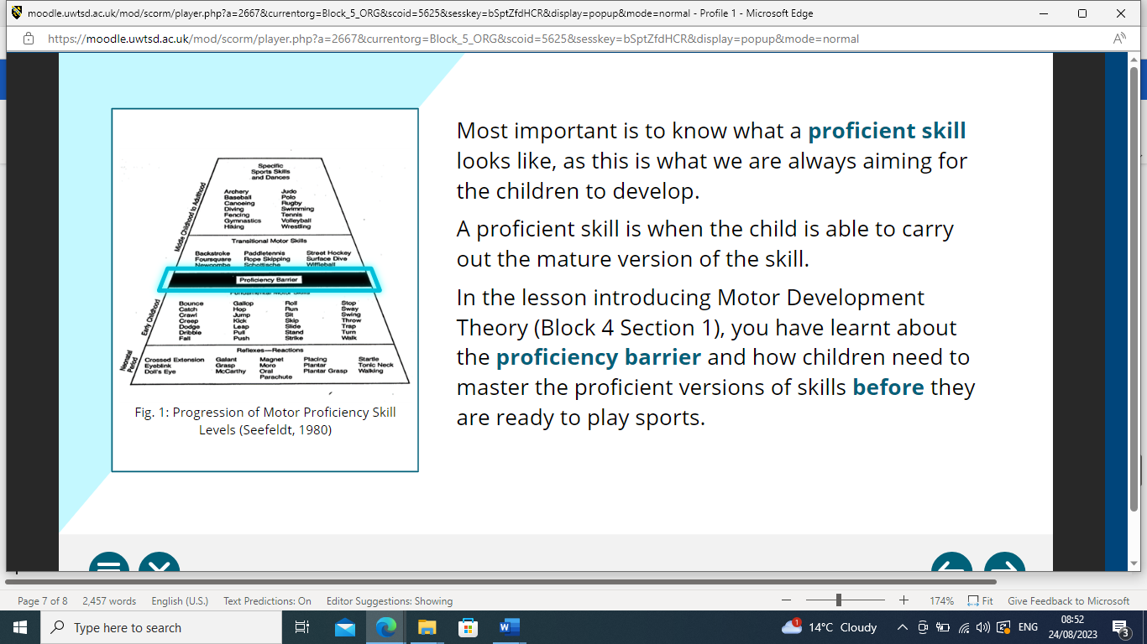
To do this I intervened with the children's movements and demonstrated how to catch and to bring it into the ‘X zone,’ emphasising the language and explaining why we did this. Most children were able to do this, and to those that were successful, I gave a smaller ball to challenge them further. The children that were not so proficient were provided with a larger, dimpled ball. I was so pleased with the catching skills of the children and how a lot of them had already begun to control the ball with greater skill, I added to the lesson and asked the children to work in groups of 3 or 4 bouncing and catching a large ball to each other. This started to introduce the opportunity to develop their tracking and hand/eye coordination to a higher level since the children sometimes had to move their feet or twist their bodies to catch the bouncing ball. With some of the children, I placed spots between them to help them to correctly aim the ball when they bounced it. The children really enjoyed this, and they were all fully engaged. One group of boys who, through play, had more refined catching skills started to improvise and make the activity more challenging by adding extra team members and changing the size of the ball they were using to a smaller one. This allowed them to develop their fine motor skills, and for two for the children, this is particularly important as they struggle with using scissors, holding a pencil correctly and letter formation.

As I stated previously, the children’s skills and level of participation were pleasing, and I felt that I could take them further in their skill development than before. The main criticism of the lesson would be to do with my organisational skills. Next time I do this lesson, I will ensure that I will mark out where I want the children to be.
This throwing lesson was less successful than the catching activity for many reasons. Firstly, there were environmental factors that affected it. It was an incredibly hot and humid afternoon, and the children were not able to do their lesson outside. So, we carried out the lesson in the hall which was extremely uncomfortable for both the children and me. This factor contributed to the children being less focused than usual. The main difficulty the children experienced in this activity was with stepping forward with the opposite foot to their throwing hand after the throw. I too, initially found this action challenging and confusing and consequently failed to model a proficient version of it. Like me, the children were overthinking the movement and over complicating it. I knew what I had to look for to assess the children’s ability in throwing, but I did not feel that I was confident in doing it myself or in using the correct language to encourage it. I demonstrated the movement awkwardly and stuck stick to the phrases, ‘face sideways,’ ‘eyes on the target’, ‘throw’ and ‘follow through’. I did not use ‘windup’ or ‘rotate the body’ as they were struggling with the few commands I used. Unfortunately, because the lesson was not successful, the children did not progress enough in the skill for me to make it more challenging for them in this session. I had planned for them to move further away from the target if they were throwing successfully but this was not the case. If I had had more time for them this might have happened.

In conclusion, I have become far more aware and confident in teaching physical development in the early years. I have become informed as to recogising the stages of each of the FMS and in how to move the children forward to proficiency with the use of modeling language and actions and using appropriate constraints. I anticipate continuing with these lessons in the next academic year, sharing my knowledge with colleagues and parents and observing the benefits of developing FMS over a longer period.
Word Count: 2,221
Reference List

Goddard Blythe, S (2005). The Well-Balanced Child: Movement and Early Learning (Early Years). Hawthorn Press.
Ayres, A. J., & Robbins, J. (2005). Sensory integration and the child: Understanding hidden sensory challenges. Western Psychological Services.
Davies, M. (2003). Movement and dance in early childhood. Sage.
Goodway, J. D., Ozmun, J. C., & Gallahue, D. L. (2019). Understanding motor development: Infants, children, adolescents, adults. Jones & Bartlett Learning.
Goodway, J.D. & Branta, C.F. (2003). ‘Influence of a motor skill intervention on fundamental motor skill development of disadvantaged preschool children’, Research Quarterly for Exercise and Sport, 74(1), 36-46.
Goodway, J.D., Crowe, H. & Ward, P. (2003). ‘Effects of Motor Skill Instruction of Fundamental Motor Skill Development’, Adapted Physical Activity Quarterly, 20(3), pp. 298-314.
Haywood, K. M., & Getchell, N. (2019). Life span motor development. Human kinetics.
Stodden, D. F., Goodway, J. D., Langendorfer, S. J., Roberton, M. A., Rudisill, M. E., Garcia, C., & Garcia, L. E. (2008). A developmental perspective on the role of motor skill competence in physical activity: An emergent relationship. Quest, 60(2), 290-306.

