Research Project

Project Title: Application of Lidar and Point Cloud Technology in Tree Species Classification

Assessment title: Final Draft

Student name: Mingyu LI

Student ID number: 2006612

Tutor’s name: Pepa Grundy

Submission date: September 3, 2021

University/Programme: UWTSD/Master

Word count: …

Table of Contents

1. Introduction 3
2.1 Data cleaning and pre-processing: the processing of experimental data 3
2.2 Individual Tree Segmentation (ITS): the preparation before classification. 3
2.3 Classify Tree Species 4
3. Conclusion 4
Reference List 4

Introduction

Forest stand is the basic unit of forest survey and mapping, and it is the focus of forest resource management and monitoring. Rapid and accurate identification of tree species is the basis for research and protection of forest resources, and tree species identification through remote sensing technology has become one of the important means of forest investigation.
Lidar data can provide information about the vertical structure of the forest, while hyperspectral remote sensing data can provide detailed spectral information of trees. Therefore, combining lidar and hyperspectral data can improve the classification accuracy of tree species.
The research of Hu (2013) found that most of the existing methods rely on geometric distribution features and usually cannot accurately classify a single tree. The horizontal and vertical characteristics of a single tree can improve the classification accuracy.
In order to understand the development status and existing problems of LiDAR in tree species identification research, this article will introduce two aspects of single tree segmentation and tree species identification respectively, and on this basis, further explore the problems and problems faced by joint LiDAR in tree species identification research. Challenges, looking forward to the future direction of research and development.

2.1 Data cleaning and pre-processing: the processing of experimental data

Data preprocessing involves converting the original data set into an understandable format. Preprocessing data is the basic stage of improving data efficiency in data mining. The data preprocessing method directly affects the results of any analysis algorithm.
In this step, we may need to perform the task of coordinate system conversion. For example, data converts from unknown coordinate system to UTF-18.Then,
the converted data will be normalized, to make sure that their ground part will not be affected result.

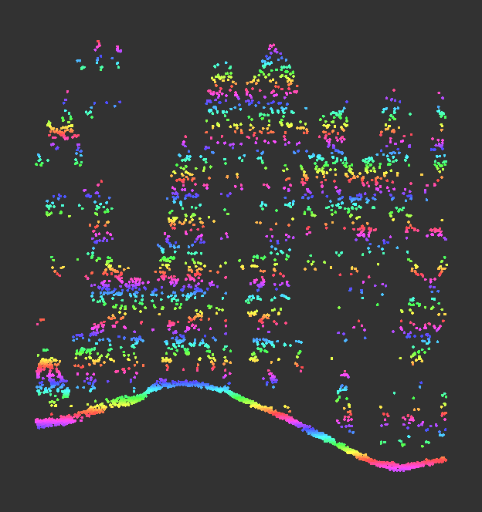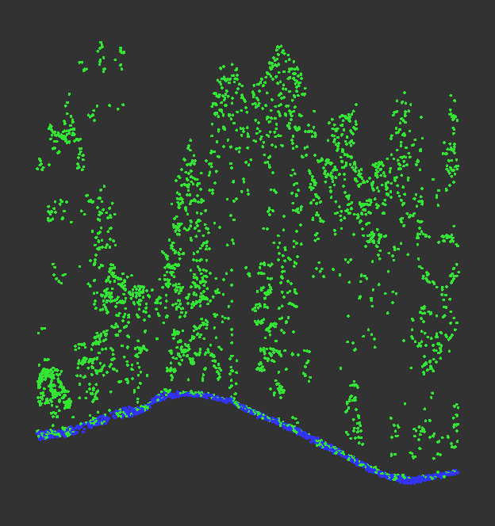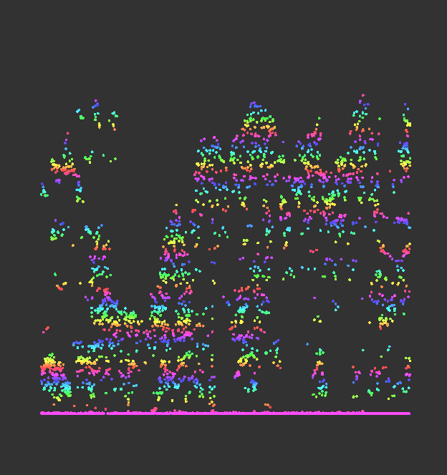
Fig.1. Lidar DataDetect Ground Normalized Digital Surface Model
(It sources from cloud compare software)

2.2 Individual Tree Segmentation (ITS): the preparation before classification.

Although single tree detection provides very useful information about tree density and size, one may wish to further separate and extract each tree separately. (Mäyrä et al., 2021).
There are mainly the following two algorithms available
1. Based on point cloud, it can be executed without Canopy Height Model (CHM).
2. Raster-based execution using CHM.
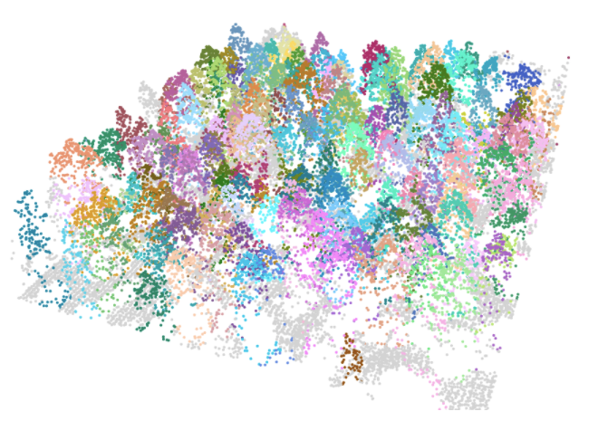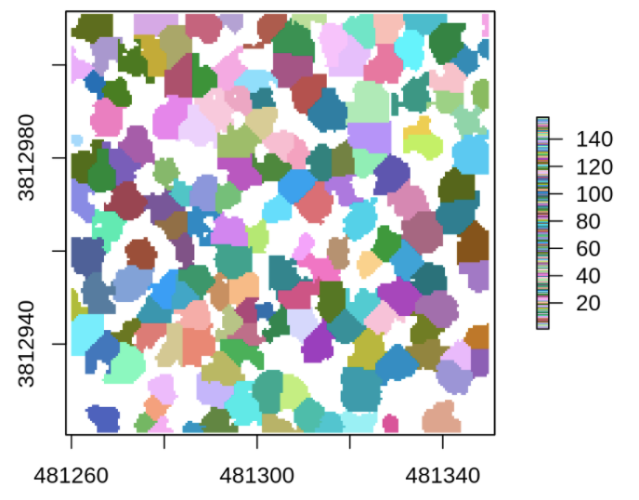
Fig.2. Segmentation of the CHM
(It sources from lidR, https://github.com/Jean-Romain/lidR)

2.3 Classify Tree Species

As an active remote sensing technology, lidar is used to measure the distance of the target object through the laser emitted by the sensor, which can obtain the target space information and accurately extract the structural parameters of a single tree or forest. Machine learning after extracting features is the most common method. For example, using Random Forest to classify full-waveform LIDAR data, and investigates the optimal voxel size for modelling the composite waveforms. (Cao et al., 2016).

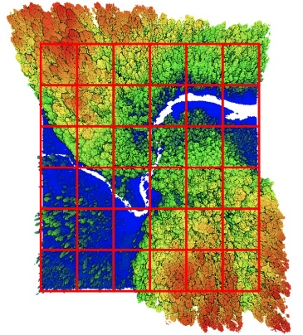
Fig.3. Voxels method on point cloud
(It sources from cloud compare software)
We refer to Puttonen et al. (2010)’s method, use Support Vector Machine (SVM) to classify point cloud which collected by FARO equipment. LIBSVM is a software that integrates support vector machines (C-SVC, nu-SVC), regression, and distribution estimation. In addition, it supports multi-category classification.

Conclusion

Replacing manual surveys by drones is a new attempt in forest surveys. Although there are still many shortcomings to be resolved, its convenience will make it a mainstream trend. Tree species classification is a detailed branch of forest investigation, which plays an important role in understanding tree conditions and judging invasive species.
Most researchers use SVM and RF models to identify tree species. However, LiDAR belongs to active remote sensing data, which is characterized by three-dimensional attribute information, and further exploration is needed in the identification method.

Reference List
Cao, L., et al. (2016). ‘Tree species classification in subtropical forests using small-footprint full-waveform LiDAR data.’ International Journal of Applied Earth Observation and Geoinformation 49, pp. 39-51, https://doi.org/10.1016/j.jag.2016.01.007.
Mäyrä, J., et al. (2021). ‘Tree species classification from airborne hyperspectral and LiDAR data using 3D convolutional neural networks.’ Remote Sensing of Environment 256, pp.112322,
https://doi.org/10.1016/j.rse.2021.112322.
Li, J., et al. (2013). ‘Classification of tree species based on structural features derived from high density LiDAR data.’ Agricultural and Forest Meteorology 171-172, pp. 104-114,
https://doi.org/10.1016/j.agrformet.2012.11.012.
Puttonen, E., et al. (2010). ‘Tree species classification from fused active hyperspectral reflectance and LIDAR measurements.’ Forest Ecology and Management 260(10), pp. 1843-1852,
https://doi.org/10.1016/j.foreco.2010.08.031.
Chen, et al. (2021). ‘Research on the improvement of single tree segmentation algorithm based on airborne LiDAR point cloud.’ Open Geosciences, vol. 13, no. 1, 2021, pp. 705-716.
https://doi.org/10.1515/geo-2020-0266

