
Jurys Inn Ltd
Financial Statement Analysis

February 7, 2022
University of Wales Trinity Saint David

Executive Summary

The purpose of this report is to analyse Jurys Inn’s financial statements and handle this information to executive chief so improvements can be done where needed.
A brief introduction of the company has been done at the beginning of the report and for the financial analysis two figures have been provided, a table of calculated ration with formulas, and a graphic showing the results for both years. Every ratio of profitability, liquidity, and gearing have been assessed, and looking of the ratios that resulted from calculations, Jurys Inn does not do very good with liquidity. Benefits and limitations of financial analysis have also been provided, and on conclusion have been found some ways to improve company’s liquidity.

1

Table of Contents
Executive Summary 1
Introduction 3
Financial Analysis Trends 4-5
Profitability 6-7
Liquidity 7-8
Gearing 8-9
Knowledge from Ratio Analysis 9
Benefits and Limitations of Ratio Analysis 10
Conclusion (average of 10% of word count) 10
Bibliography 11-12

2

Introduction
Jurys Inn is a hospitality company who operates with a hotel’s portfolio across United Kingdom and Northern Ireland. This report is produced for the Chief Executive, with the purpose to calculate ratios for years 2019 and 2020, to discuss rations benefits, and to analyse financial statements, and the end of the report will be present a conclusion regarding what profitability, liquidity, and gearing, the main three elements of the ratios.
Ratios is about the accuracy of the information that a company has. It helps in term of consistency, are used in comparison, and helps a company in term of its goals, and offer entrepreneurs the chance to evaluate their business and compare with competitors that are on the market.
Corporate Finance Institute describe ratios and what analysis we can achieve with them as the following:
Financial ratios are created with the use of numerical values taken from financial statements to gain meaningful information about a company. The numbers found on a company financial statement- balance sheet, income statements, and cash flow statement- are used to perform quantitative analysis and assess a company’s liquidity, leverage, growth, margins, profitability, rates of return, valuation and more.
(CorporateFinanceInstitute, 2022)

Certain ratios are very useful to understand and evaluate both short-term and long-term financial operations. In financial ratios, grass profit and net profit is explored, and this result tells how that business manages it expenses.

3
3

Financial Analysis

- FIGURE 1
4
Formula | Ratio | 2019 | 2020
Gross profit/sales x 100 | Gross profit | 5.050/5.500x100=92 | 5.150/6.000x100=86
Net profits of the year/sales x 100 | Net profit | 4.008/5.500x100=73 | 4.073/6.000x100=68
Net profits of the year +loan interest/ total assets less current liability x 100 | ROCE | 4.008+20/6.226x100=4 | 4.073+18/6.274x100=4.1
Sales/Total assets less current liability | Total assets turnover | 5.500/6.226=0.88 | 6.000/6.274=0.95
Sales/net profit assets | Working capital turnover | 5.500/1.726=3.2 | 6.000/1.624=3.7
Current assets total/ current liabilities total | Current ratio | 3.065/1.339=2.3 | 3.240/1.616=2
Current assets total- stock/ current liabilities total | Quick ratio | 3.065-1.450/1.339=3.1 | 3.240-1.420/1.616=3.2
Debtors x 365 days of the year/ sales | Debtor days | 1.600x365/5.500=106 | 1.800x365/6.000=109
Trade creditors x 365 days/ purchases | Creditor days | 800x365/500=584 | 870x365/850=373
(Total current liabilities +bank loan) (total current assets +fixed assets) answers divided by one another | Debt ratio | (1.339+150)/ (3.065+4.500) =  1.489/7.565= 0.19 | (1.616+145)/(3,240+4.650)= 1.761/7.890= 0.22
Net profit of the year + cash in hand/ loan interest | Interest cover | 4.008+5/20=4.00 | 4.073+5/18=4.07

- FIGURE 2
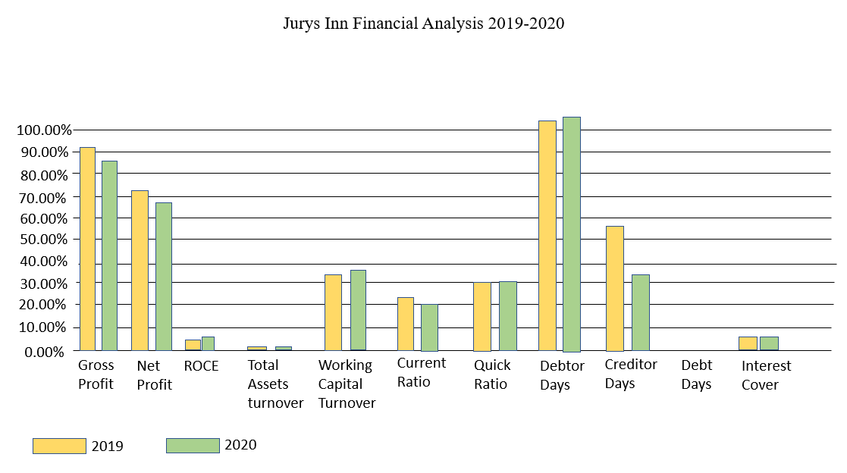

5

Financial Analysis Trends

Profitability

According to (Clear, 2021), an online business tax website, profitability is described as the ratio used to calculate and compare the ability of a company to generate income, after all costs have been paid, during a particular period, and the ratio presents the result of the company.
In other words, profit is the excess of income over expenditure, is what an entrepreneur gets in its pockets after everything is paid out.
Accounting Tools describes in few words what gross profit ratio is and why that is important for a company:
The gross profit ratio shows the proportion of profits generated by the sale of products or services, before selling and administrative expenses. It is used to examine the ability of a business to create sellable products in a cost-effective manner.
(AccountingTools, 2021)
In 2019, gross profit was 92, when in 2020, gross profit result is 86. It remains reasonably constant, as it is expected to be, even if there is a difference of 6 percentage, but that might be the case of higher selling price in 2019.
Net profit margin is the ratio that shows exactly how much money is left after all expenses, tax, and deductions are paid.
Guides describes bet profit as the following:
Net profit is the amount of money your business earns after deducting all operating, interest, and tax expenses over a given period. To arrive at this value, you need to know a company’s gross profit. If the value of net profit is negative, then it is called net loss.
(Guides, 2021)
Net profit in Jurys Inn’s analysis is in 2019 73, and in 2020 68. There is a slight difference between them, but not much. As gross profit analysis, net profit has difference of few percentages, more exactly 5 in this case.
6
Return on Capital Employed (ROCE) is a ratio that measures profitability of a company and the employed efficiency capital. In the perspective of an effective ROCE, “a good rule of thumb is that a ROCE of 15% or more is reflective of a decent quality business and this is almost certain to mean it is generating a return.” (Sieber, 2020)
In this analysis, there is not much difference between 2019 and 2020, in 2019 ROCE is 4, where in 2020 is 4.1
Total assets turnover is something that is owned by the company. However, is not just owned, is something that can be used by the company, like properties, machines, or material. Assets turnover is an efficient ratio which tells how efficient this goods mentioned above are. In 2019, total assets turnover is 0.88, where in 2020 is 0.95.
Working capital turnover shows how a business is using its capital justifiable. If there is a positive turnover, that means the company uses it in the correct way.
Bajaj Finserv is a business web site, which describe working capital turnover ration as the following:
“Working capital turnover ratio is the ratio between the net revenue or turnover of a business and its working capital… The ratio indicates how efficiently a company uses available funds for the streamlined production of goods or services.”
(Finserv, 2021)
In this case, working capital turnover for 2019 is 3.2, and in 2020 is 3.7, showing that in 2020 the company’s capital was used more for justifiable reasons. In the other hand, that could of happen because of the high profit in 2020, so the company could have had more money for capital.

Liquidity

Liquidity ratios are used to help assess weather a business has sufficient cash or equivalent current assets to be able to pay its debts.
Adam Hayes describe Liquidity ratios on an online business website as the following:
Liquidity ratios are an important class of financial metrics used to determine a debtor's ability to pay off current debt obligations without raising external capital. Liquidity ratios measure a company's ability to pay debt obligations and its margin of safety through the calculation of metrics.” (Hayes, 2021)
7
This report analyses current ratios, debtor days, and creditor days.
Looking at general statistics and analysis, a normal current ratio should be between 1.7-2.0, to suggest the business has enough cash to meet its debts. A low ration of between 1.0-1.5 demonstrates otherwise. Jurys Inn has a good current ratio, 2019 is 2.3, and 2020 is 2, so that shows the company has enough cash to pay all its debts.
Another liquidity ratio are creditor days, which are used to “calculate the average time taken for your business to pay suppliers. This number can help you to better understand whether your business is taking full advantage of the trade credit available, as well as identify any potential cashflow problems.” (Rangaswami, 2018) 2020 creditor days are good, ratio is 373, but 2019 is not that good, the ratio is 584. As an example, if creditor days number is double than term days (in this case is nearly double), that means it will take twice longer for the company to pay its debts.
(Wikipedia, 2020) notes that debtor days ratio help a company to measure how quickly debtors can pay back their cash. The longer it takes a company o collect its cash, the higher number of debtors will be.
In this company’s case, in 2019 debtor days are 106, and in 2020 debtor days ratio is 109. Looking at general statistics, average days number that payment should be received from debtors is 30-36 days, which means that in neither of the year the company does not do very good at this chapter.

Gearing

Gearing ratio is a measurement of the company’s financial leverage, to demonstrate a degree to which a company’s activities are funded by owner’s funds or creditor’s funds.
Debt ratio or gearing ratio is used to determine what percentage the business’s assets are financed through debt. Also, “a company's debt ratio offers a view at how the company is financed. This provides a clear indication of the amount of leverage held by a business.” (Debtoor, n.d.)
8
In this analysis, debt ratio in 2019 is 0.19, and 0.22 in 2020, which is very high, a company with a good debt ratio should be between 0.3-0.6.
Interest cover is used to determine how quick a company can pay its debts or interest expenses, which means “higher leverage ratios equate to more financial risk, meaning the borrower’s probability of defaulting on its required debt payments becomes more of a concern.” (WallStreetPrep, 2022) Jurys Inn’s interest cover is good in both 2019 and 2020, both years the ratio is bigger than 4, which means the company can meet its interest expenses.

Knowledge from Ratio Analysis

It is important to analyse a set of financial ratios in any of the financial sector, to determine how the company deals with debs, profit, and other ratios.
Banerjee describes the importance of ratio analysis by the following:
It is vital to assess the performance of the firms by analysing its liquidity, profitability, asset management, and efficiency ratios. These ratios analysis are widely used for making important decisions and future forecasting.
(Banerjee, 2021)
By comparing 2019 and 2020 ratios, trends and needs can be identified and finances can be managed better in the future, especially in hospitality industry, because being so big, requires a very specific set of financial ratios to accurately analyse the industry and conclude.
Looking at profitability in our analysis, all gross profit, net profit, and ROCE are bigger in 2019, so that was a more profitable year. Liquidity analysis shows that both years meet the minimum level for a company to be able to pay its debts. However, in 2019 creditor days statistics are not that good, its ratio being nearly double. Debtor days are also too high for both years. Overall, liquidity must be looked at in the future, and all payments that must be given out in the year coming at least have to be monitored and organised in depth. Debt ratio has a good percentage, so interest cover.
9

Benefits and Limitations of Ratio Analysis

Even if ratio analysis is a powerful tool to manage finance on a certain period for a business, it has advantages and disadvantages also.
ADVANTAGES | DISADVANTAGES
Looking at previous costs, profit and sales, future business activities can be planed for better results | Unclear financial statements might affect the accuracy of the ratio calculation
Estimate future budget figures | Different ratios are listed in different times of the year, for example summertime, when we sell the product better
Indicates how efficient the company is | Changing in price levels
Control costs
Indicate liquidity position and help the company deal better with debts

Conclusion (average of 10% of word count)

Jurys Inn’s profitability and gearing is normal. However, the main problem that the company has is with debtors and the finance that must be paid out. Liquidity ratios does not look well, they have to be monitored and organised in the future, and solutions must be found to economically help the company.
(Newman, 2007) advise 7 steps and ways to improve a company’s liquidity, among which can be used for Jurys Inn: assess overhead costs to see which are unnecessary and can be limited, unproductive assets that does not help the company earn money in this period the company must get rid of, monitor money that goes out the company for non-businesses purpose, review profitability and assess where prices and service costs can be increased for bigger profit.

1000

Bibliography

References
AccountingTools, 2021. Accounting Tools. [Online]
Available at: https://www.accountingtools.com/articles/2017/5/13/gross-profit-ratio-gross-profit-equation
[Accessed 9 2 2022].
Banerjee, P., 2021. Wall Street Mojo. [Online]
Available at: https://www.wallstreetmojo.com/importance-of-ratio-analysis/
[Accessed 9 2 2022].
Clear, 2021. Clear Tax. [Online]
Available at: https://cleartax.in/s/profitability-ratio
[Accessed 9 2 2022].
CorporateFinanceInstitute, 2022. Corporate Finance Institute. [Online]
Available at: https://corporatefinanceinstitute.com/resources/knowledge/finance/financial-ratios/
[Accessed 9 2 2022].
Debtoor, n.d. Debtoor. [Online]
Available at: https://debitoor.com/dictionary/debt-ratio
[Accessed 9 2 2022].
Finserv, B., 2021. Bajaj Finserv. [Online]
Available at: https://www.bajajfinserv.in/what-is-working-capital-turnover-ratio
[Accessed 9 2 2022].
Guides, 2021. Zoho. [Online]
Available at: https://www.zoho.com/books/guides/what-is-the-difference-between-gross-and-net-profit.html
[Accessed 9 2 2022].
Hayes, A., 2021. Investopedia. [Online]
Available at: https://www.investopedia.com/terms/l/liquidityratios.asp
[Accessed 9 2 2022].
Newman, P., 2007. Enterpreneur Europe. [Online]
Available at: https://www.entrepreneur.com/article/187606
[Accessed 9 2 2022].
Rangaswami, I., 2018. Fluidly. [Online]
Available at: https://fluidly.com/blog/creditor-days-calculator/
[Accessed 9 2 2022].
Sieber, T., 2020. Shares. [Online]
Available at: https://www.sharesmagazine.co.uk/article/using-return-on-capital-employed-to-identify-quality-stocks
[Accessed 9 2 2022].

11
WallStreetPrep, 2022. Wall Street Prep. [Online]
Available at: https://www.wallstreetprep.com/knowledge/interest-coverage-ratio/
[Accessed 9 2 2022].
Wikipedia, 2020. Wikipedia. [Online]
Available at: https://en.wikipedia.org/wiki/Debtor_days
[Accessed 9 2 2022].

12

