Student Name: Razina Choudhury
Student ID: 1713006
Module title: Higher Skills for the workplace
Assignment title: Digital Skills and Research Methods
Lecturers Name: Renuga Jayakumar

Contents Page

Introduction
Variation of Technology
Impact of Technology
Uses of Technologies within the work place
Social Media impact
Software 1 – what is (Google Drive)?
Software 2- What is (Drop Box)?
Compare the software’s chosen. (Google drive vs Drop box storage)
Conclusion about software 1 (Conclusion of Google drive)
Conclusion about software 2 (Conclusion of Drop box storage)
Overall conclusion
Bibliography

Introduction

In this report I will be analyzing and comparing different forms of Technology, how the modern society has uses for these specific forms. Also looking into how a place of work will use these various Technologies and implicate them within the place of work. I will also be exploring various social medias and how they have an impact within the marketing world, as well as how individuals will use these to media inputs to gain acknowledgement in the society and the work place.

Variation of Technology

Technology is used profoundly, it is the general source to run almost every business in the current world. There are various sources of technology and ways that it is implicated within a work environment, this is such as; CRM Software, Business phone systems (Virtual PBX), Credit card payment processing software and modern accounting software. These are variations of different technologies used in order to run a modern-day work environment. Due to all these variations of technologies, different prospects are being provided to individuals that are important within a day’s work, from accessing medicine, school profiles, transportation. With these changes implicated by modern day technology, it has significantly improved day to day work, therefore allows tasks to be simplified and executed much more efficiently.

Impact of Technology

In this day and age the modern society lean on technology and its provisions more than they have a decade ago. It can be used amongst anything, from a smart phone, tablet and desktop. Through technology it is a provider of communication, we use these to communicate distant relations, within individual private matters, to larger scales of work sectors. These are such as; emailing, skype calls, facetime and social networking sites, technology provides other sources like social media to be processed in to everyday life. It can be a negative factor; recent experience with the implementation of advanced medical communications systems, however, makes it clear that companies need to be aware of and prepared to manage the indirect, and often undesirable, impacts of Technology on people, culture, power structures, job content, and so forth Douglas, E May. (April 1st1995). The Impact of Technology on Everything Else. Article of Douglas, E May [online] volume:29 Issue:2 Page(s): 665-674. Available at: http://journals.sagepub.com/doi/pdf/10.1177/009286159502900245 [Accessed 22 Aug. 2018]. Although it needs to be monitored in order to prevent negative impacts it can also be an positive factor when used within business and private matters. The following can either simplify certain tasks or much larger tasks to be done within a more adequate time, allowing, which then allows a certain individual to be more lenient on Technology.

Uses of Technology within the workplace

There a various form of Technologies used amongst workplaces, these are key to maintaining a strong hold of communication and effectiveness of performance within an individual’s place of work. Software is put forth in order to achieve these areas, software in which is much needed in a business; document management systems. Such systems include; M-files, CapLinked, File hold or E file cabinet. Today’s document management marketplace requires systems that can handle large volumes of documents, multiple electronic formats, elaborate review and approval processes, worldwide user communities, and regulatory agency validation and audit requirements David Elderkin. (April 1st, 1995). Choosing a Software Development Methodology for Document Management Systems. Article of David Elderkin [online] volume:29 Issue:2 Page(s):687-694. Available at: http://journals.sagepub.com/doi/pdf/10.1177/009286159502900248 [Accessed 22 Aug.2018].
Once a form is chosen these will then need to be stored within a certain demand of software that can handle large volumes of documents as stated with the above reference, it is to be placed in applications such as cloud storage, google drive and approved within mobile device or desktop. In terms of applications used office admin employees as well as businesses need to be able to have sufficient support from software to manage and store files, most businesses and admin users process these files daily;

- word processing programs
- business invoicing programs
- billing programs
- payroll software
- database software
- asset management software
- desktop publishing programs

These need to be well supported by a certain programme. Most of these files and documents are stored within cloud storages, ones in which I will be discussing and analysing further in this report.

Social Media Impact

Social media, a term in which every individual acknowledges. It is a portal in which can enhance an industry further or introduce a negative impact. It is a great marketing tool, as it directs more source of information about a company and can be leading in terms of sales and keeping close relations when it comes to businesses. Business social media marketing, used to engage with its consumers and competitors, or new partners profiles in which share the same interest. Social media has a high demand of users, this has come about since the increase in the progression and adaptation of technology, which has allowed various businesses to reconsider way of implicating they’re digital marketing strategies. Medias such as; Facebook, Twitter, Instagram, YouTube and Tumblr have had huge advances in consumers over the current years, influencing many users from elderly to also the younger audience. The average amount of time spent using social media daily was nearly 11 hours (Papper, Holmes, & Popovich, 2004). But further recent research suggest that these data have been overtaken in light of the growth of the use of smartphones and their value as mobile devices in all contexts, even in classrooms, where BYOD (bring your own device) is a developing educational tool (Cochrane, Antonczak, & Wagner, 2013).

Google Drive

Google drive is a storage system developed to store large amounts of files beyond your hard drive. Google drive can store up too many files such as; photos, videos, pdf’s and Microsoft office files, to almost anything. Documents, for example, can be up to 1.2 million characters in length, and if you convert a document to Google Docs format, it needs to be 50MB or smaller in size. Overall Google drive also allows users to share files as well as edit documents, spreadsheets and presentations with collaborators. Having Google drive is convenient to many users due to the fact it can be placed and open within any device; windows, macOS computers, Android and iOS smartphones and tablets. Therefore, Google drive is seen as a immense rivalry within the storage range systems, as it provides sufficient and unique aspects which allow its users to use Google drive for almost anything.

Drop Box

Drop box, is a personal cloud storage. Drop box is also referred to being an online backup service provider, which is consistently used for file sharing amongst other users and collaborations. It can be installed in the following devices; Windows, Mac, Linux, Android, iOS, Windows Phone, Blackberry and Kindle fire. Storing the files are easily done, as this can be managed by uploading through to the website or, applying it to your desktop apps. Files can be easily moved around from your computer to cloud and other applications by just dragging and dropping files into your Drop Box folder. Drop Box is a phenomenal storage provider as it has various aspects that will draw in its users and other new individuals.

Google Drive Vs Drop Box

There a number of cloud storage providers, but ones that used upmost to date are; Google Drive, Drop Box and also One Drive. These are the top storage providers for users in the current day, as they each contain aspects in which provides exceptional service. ‘By the numbers, Google Drive has the advantage. In early 2017, the company announced it had passed 800 million monthly active users. By now, it’s probably the first cloud storage service to have passed the one-billion-mark’. Joseph Gildred. (Aug.7^{th,} 2017). Best of The Big Three: Dropbox vs Google Drive vs One drive. Article of Joseph Gildred [online]. Available at: https://www.cloudwards.net/dropbox-vs-google-drive-vs-onedrive/ [Accessed: 22 Aug. 2018]. The reference given shows that Google drive is the most actively used storage with the numbers being exceptionally high compared to other storage providers. ‘Nether the less, drop box however last reported 500 million registered users. Of those, 11 million are paying users, including 300,000 business subscription customers (read our Dropbox Business review)’. Joseph Gildred. (Aug.7th, 2017). Best of The Big Three: Drop Box vs Google Drive vs One drive. Article of Joseph Gildred [online]. Available at: https://www.cloudwards.net/dropbox-vs-google-drive-vs-onedrive/ [Accessed: 22 Aug. 2018]. Both these storage providers have a great number of users, making them both popular providers. Here are the price plans and subscriptions of both storage providers;

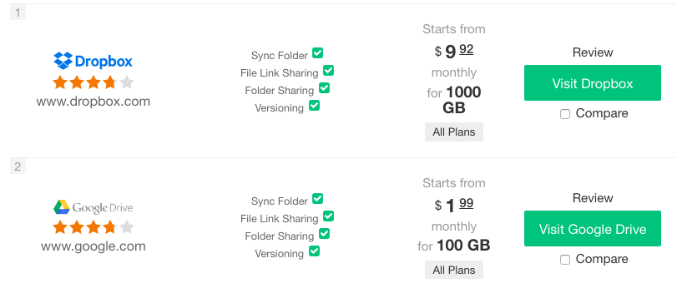
This shows that both providers introduce, sync folder, file link sharing, folder sharing and also versioning. Drop box starts from a price plan of $9.92 monthly but for an exceptional amount of storage of 1000GB whereas Google drive $1.99 monthly plan which provides a 100GB. They both have equal ratings amongst users of 4 stars as it shows in the image above. Here are some further images to give further understanding of the price range and what each storage system provides;

Drop Box:

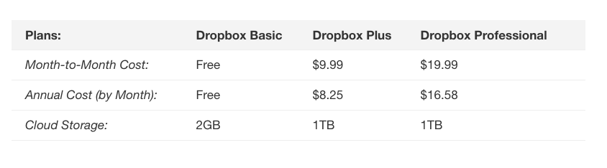
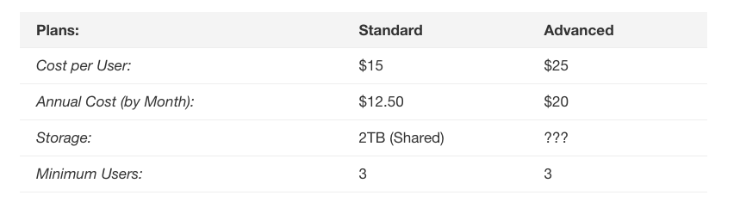

Google Drive:

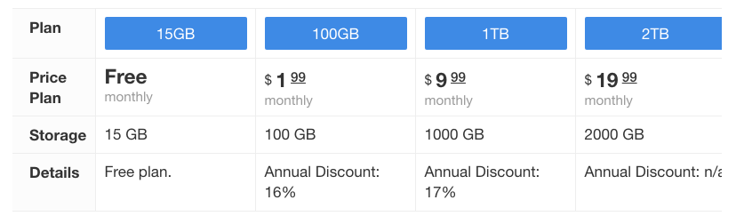
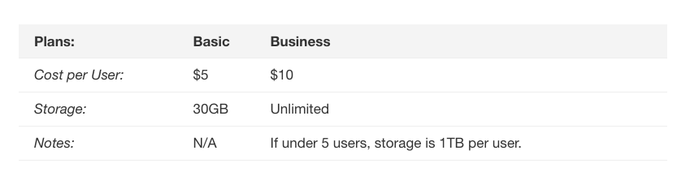
Joseph Gildred. (Aug.7^{th,} 2017). Best of The Big Three: Dropbox vs Google Drive vs One drive. Article of Joseph Gildred [online]. Available at: https://www.cloudwards.net/dropbox-vs-google-drive-vs-onedrive/ [Accessed: 22 Aug. 2018].

Google Drive – Conclusion

Coming to a close with my conclusion of Google drive, Google drives shows a stability of users, the rate prices for the storage you receive is exceptional. For first time users receive a 15GB free of charge, monthly fee 0 as well as overall annual fee. They supply 100GB for $1.99 per monthly charge which will also then be deducted with an overall discount of 16% annually, so therefore save a sufficient amount of cost for 100GB. Overall to be an user of Google drive is promising as within admin work and businesses it is an monthly price of $9.99 for unlimited storage, but that’s is disinclined if the number of users is 5 or less, it then goes on to 1TB per user, which can be seen as a negative to consumers. The positives of Google drive include; that it requires very little set up, especially if you are already a google account. Also, the app can automatically back up photos on its own, so you will not need to do it separately within the individual files, this is required as it is seen as a safeguard. Google drive also has its down falls, for an individual will need to share storage space with Gmail, therefore if your inbox is overfull, it will then be deducted to less cloud storage space.

Drop Box – Conclusion

Coming to a close with the conclusion of Drop Box, it is reportedly shown above that is has a various number of users, from private to business holders. Drop Box does provide a series of plans and storage, for it is seen as simplified version of google drive when it comes to navigating the website and how to store individual files and as follows. Its users will find that is provides plenty of occasions to upgrade to further storage from the 2GB you get free when joining. It also states on the website that when joining, if you participate in a quick sign up tutorial you may get up to 250MB worth of storage. This allows more promising factors to consumers that are willing to join. There storage system is easily accessible and also understood due to the simple yet clean layout. Although it provides a various number of plans, the prices can be seen as higher than other cloud storages such as Google drive, in which may lose consumers that are looking for more affordable and greater plans. Although it provides 1TB with a monthly cost of also $9.99 the storage cannot be excelled further to an unlimited amount for larger businesses and users looking for such storage.

Conclusion (Google drive & Drop Box) –

As I come to the end of my report and my overall conclusion, based on the evidence I have researched and provided, I have seen a number of similarities between the 2 cloud storage suppliers, Google Drive and Drop Box. However, I conclude that for an initial business or admin employee, Google drive will be more expectable and promising as it provides a sufficient amount of storage for a reasonable price plan that consumers will find interesting to look further on towards. As the pricing plan states above for business users, it is a charge of $10 for a unlimited amount of storage so long as the number of users is above 5 within the business, whereas Drop box only provides up to 3 users with the storage of 2TB. Both cloud storages can be used for various reasons, but Google drive is subsequently the ideal cloud storage of the modern day.

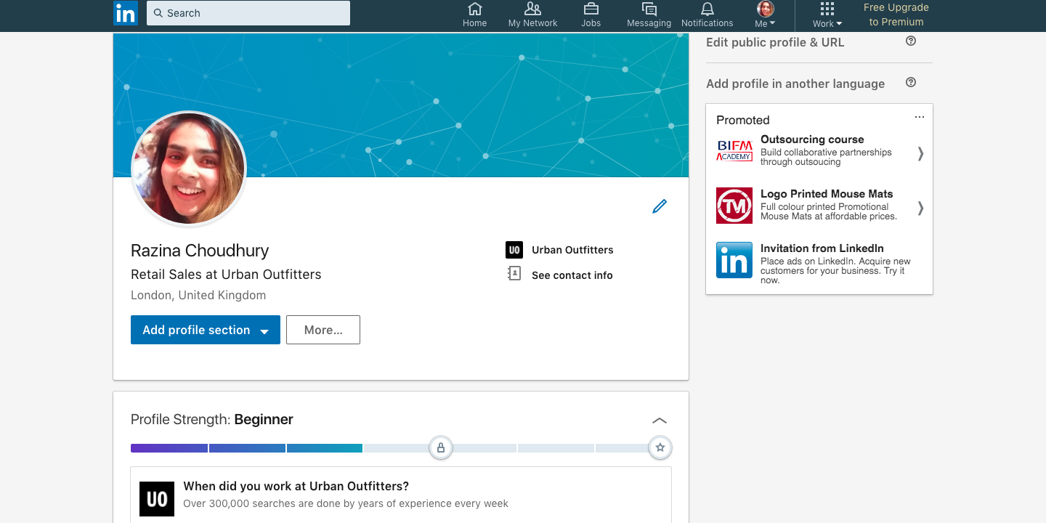
Bibliography

- Douglas, E May. (April 1st1995). The Impact of Technology on Everything Else. Article of Douglas, E May [online] volume:29 Issue:2 Page(s): 665-674. Available at: http://journals.sagepub.com/doi/pdf/10.1177/009286159502900245 [Accessed 22 Aug. 2018].

- David Elderkin. (April 1st, 1995). Choosing a Software Development Methodology for Document Management Systems. Article of David Elderkin [online] volume:29 Issue:2 Page(s):687-694. Available at: http://journals.sagepub.com/doi/pdf/10.1177/009286159502900248 [Accessed 22 Aug.2018].

- (Papper, Holmes, & Popovich, 2004). – Certification in Higher Education: Skills for the Workplace Student Yearbook (pg. 105).

- (Cochrane, Antonczak, & Wagner, 2013). – Certification in Higher Education: Skills for the Workplace Student Yearbook (pg.105).

Joseph Gildred’. (Aug.7^{th,} 2017). Best of The Big Three: Dropbox vs Google Drive vs One drive. Article of Joseph Gildred [online]. Available at: https://www.cloudwards.net/dropbox-vs-google-drive-vs-onedrive/ [Accessed: 22 Aug. 2018].

- Joseph Gildred. (Aug.7^{th,} 2017). Best of The Big Three: Dropbox vs Google Drive vs One drive. Article of Joseph Gildred [online]. Available at: https://www.cloudwards.net/dropbox-vs-google-drive-vs-onedrive/ [Accessed: 22 Aug. 2018].

