Fozia Kiani (2026354)
BMSW-4004
Problem Solving and Decision Making
UWTSD
Lecturer – Jonathan Wyatt
Task-2

Table of Contents
Introduction: 3
1. Stress: 4
2. Stress in workers: 4
3 A Workplaces Environment: 5
4. Impacts of stress in a workplace: 5
5.Psychological Impacts in an organization 6
6. Causes and effects: FISH BONE 6
7. PESTLE ANALYSIS: 7
8. PMI analysis for employees: 8
9. GRID analysis: 9
10. Causes of Stress at the workplace: 9
11. Conclusion: 10
12. References: 11

Introduction:

Stress is the main huddle in main businesses progress. UK is one of the countries which has stress of workers in its industry. Stress in workplace will be explained with the help of mentioned case study. Stress is increasing rapidly in UK due to certain reasons so it will be discussed in the report. The causes and effects of stress in workers will be elaborated .The Impacts of stress on the workers and their workplaces needs to be taken in consideration. Different methods to analysis stress at workplaces in UK will be described through PESTLE analysis, PMI, GRID analysis and fish bone model.

Stress:

Stress is the response of the body happening during an event like working in industry. Workplace related stress causes due to different irregular happenings at place of the work. Stress is a pressure which effects mind and body in making any decision . Stress effects person’s ability to work efficiently.
it has become an alarming issue for the country which is affecting employees of all ages. During the pandemic (Covid-19), these figures increased since most people lost their jobs, and financial difficulties they may have experienced as a result are the main factor. To treat this illness, people have resorted to spending massive amounts from their savings. Last year, over 5.5 million people (about twice the population of Arkansas) were hospitalized due to stress difficulties and spent millions of pounds on treatment. Mental illnesses are a rising condition backed by statistics, that affect people of all age groups. They may have a significant impact on the proper functioning of the body, and may even be the cause of brain abnormalities, heart difficulties, and issues with blood pressure. In every workplace, employees are found facing stress-related issues which are compromising their productivity and ability to work efficiently. A person experiences stress when they perceive that demands exceed their ability to mobilize personal and social resources. (Edward et al,2008)

2. Stress in workers:

Stress always effects workers to give their progress. There are different types of stress in workers as Workload stress is because of too much work to be completed in a limited time. Mental stress at workplace is explained as there is no mental satisfaction to workers from company. Financial stress is created because of low income from work and more expenses due to different circumstances. Behavioural stress is due to different types of behaviours and attitudes from management and officials.(Anton, 2009).
Workers are pressured for a variety of reasons, including discontent with their current role and other issues. Furthermore, workplace regulations and practices might have a negative impact on them, reducing their productivity and aggravating them. The management team is supposed to accommodate their workers and the support mechanism between the organizations and employees for better production of the business (Dagget et al, 2016). There should be some bonuses and promotion opportunities for workers to reduce stress at workplace. Satisfied workers and productive management give more production to increase finances of organization. Workers are most likely to take sick leave due to stress, and that stress usually results from poor organizational conditions. Workers should be provided attractive working atmosphere to reduce mental and physical health (Lagrosen,2020).

A Workplaces Environment:
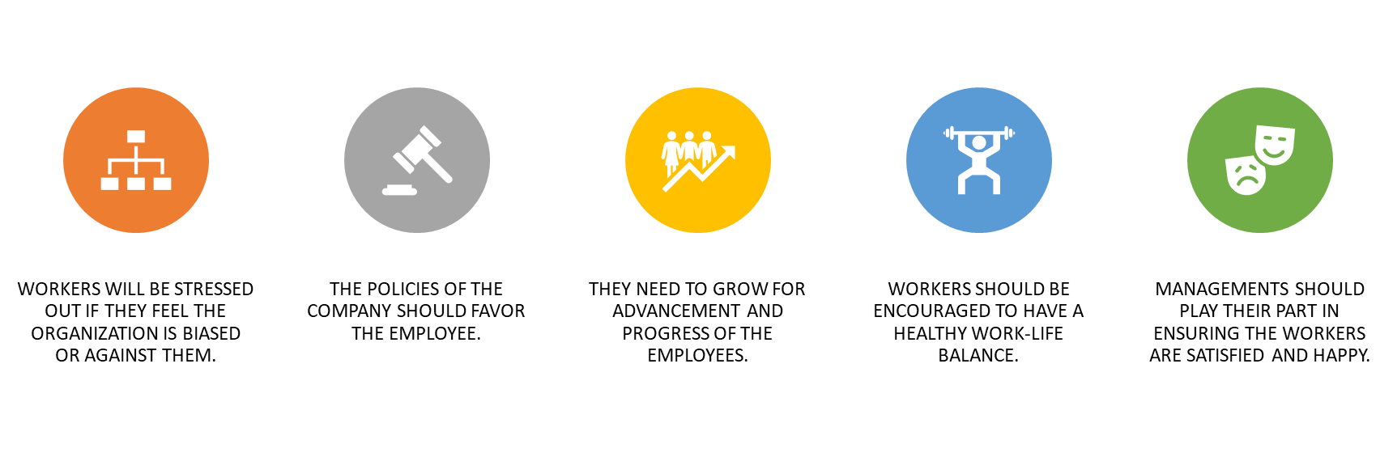

The workplace environment must be safe as well as secure for the workers such as clearly marked fire exits. Organizations should play their role, so the workers have trust in them and work happily with staff. The policies made by the organization are beneficial for the workers. Health and safety policies should be regularly maintained in order to ensure that the employees are not harmed or so that they do not experience unnecessary danger. Bathrooms and food facilities, along with breaks should be provided for the employees, especially in industrial areas. Clean uniforms should also be provided. The workplace must also have an encouraging atmosphere like health and safety regulations applied according to legislation that promotes a higher quality of work. These facilities will reduce attitude stress in workers and increase their confidence to the employer .Management should provide these facilities to the workers as they are custodians of the company, and their responsibility is to increase the production of the company and release stress ( Riya Gangwar,2018).

Impacts of stress in a workplace:

Stress always has a substantial impact in a workplace. Workload stress reduces the production of any organisation if not controlled by management. The other related stress effects progress and efficiency of workers. The main Impact of stress is reduction in finances, if company will give less production due to stress in workers, then more losses and destruction of the business is excepted therefore management is responsible to make arrangements for release of stress at workplaces. (Susan M, 2020)

5.Psychological Impacts in an organization

Other than workplace stress, there are other multiple types of stress that are just as dangerous and harmful and have a significant negative impact on the performance of employees. According to statistics obtained in 2020, work stress is at the top of the list, but other sorts such as financial restrictions, family difficulties, health problems, and personal relationships also affect a considerable number of people. These types are secondary but are still causes of the major problem faced by employees. For example, if an employee is having trouble at work and is always having difficulty coping with his job, it can lead to financial stress, such as losing his job, and over time, it can lead to marital troubles, family stress, and health problems. Therefore, trying to find the root cause of stress and addressing it is important in order to eliminate it. Various surveys have been undertaken, and they all show that workplace stress is the major cause of stress among people, with employees choking up between other types of stress. It is the organizations responsibility to keep a proper check on its employees mental and physical health and provide any assistance that is needed (Zuckerman,2020).

Causes and effects: FISH BONE

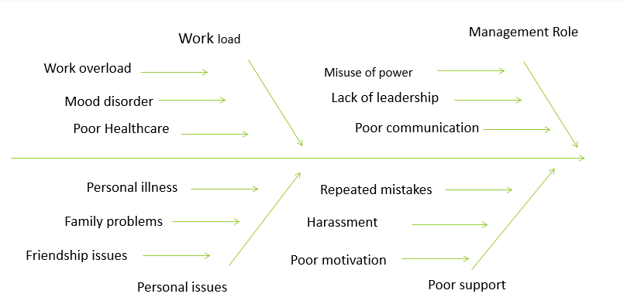

As mentioned above in the diagram there are big impacts of stress to the workers which should be taken into consideration for the relief of employees. If the workers are stress free, then the growth of business goes up and more revenue is generated. Stress effects working capacity of employees and management is responsible to look after the workers (Nair,2016).

PESTLE ANALYSIS:

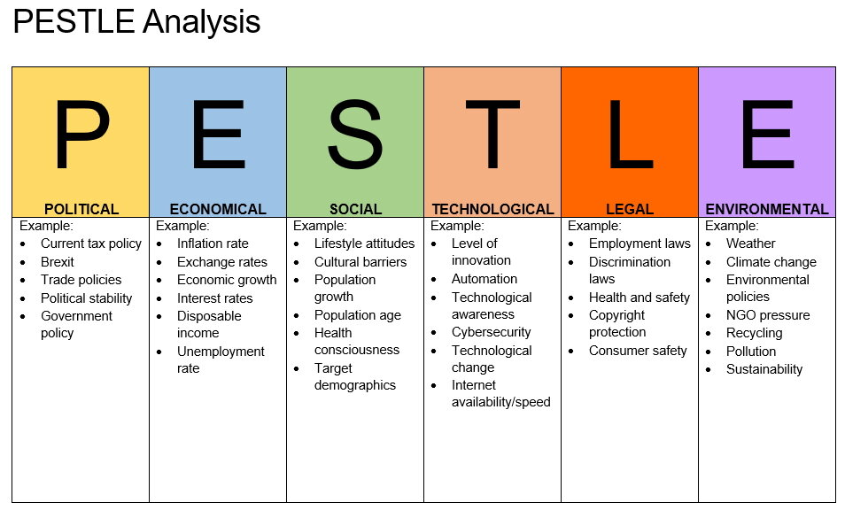
(Source): https://www.impact-innovation.co.uk/pestle-analysis

Pestle represents political, economic, social, technological, legal, and environmental aspects. Pestle analysis elements can be explained in a variety of ways in our given subject of stress in the UK. Political factors or points of view refer to how an authority benefits from a sure industry. From a political standpoint, stress has some poor consequences in our case. If the personnel of a society are under a lot of pressure and have not been able to perform well and efficiently, it could result in a loss for the employer and it would generate less revenue. Less revenue ability less taxes for the government and from a broader perspective, fewer industries would be inclined to invest in the future.
From a financial standpoint, stress can lead to poor employee performance, stifling an establishment's boom and limiting new opportunities that may additionally have arisen. Because of inflation, the employer may also soon be unable to pay off its debts and may face financial difficulties, as well as seeing a reduced profit margin as a direct result of the workers feeling enough stress to the point that they cannot work effectively.
Stress can additionally have an influence on an organization's social stability and relations among workers as employees cannot work in groups for an extended length of time, which creates sure limitations for a business to operate in the lengthy run. Assaults may occur more regularly among distinctly harassed employees rather than those experiencing less stress.
Technology can also add to stress as old software or hardware may cause annoyance to rise within employees due to slower or ineffective facilities, meaning productivity is also lower. The main issue however with technology, is that it may lead to redundancy as there are an increased number of employees losing their job due to robots being able to do the same job, but more efficiently and always, e.g., factory machinery.
Legal issues concerning stress could be to do with health and safety policies, such as ensuring workers feel safe in the environment and are not made to do anything against their will. Along with this, ensuring there are working fire alarms and easily accessible fire exits, etc.
Environmental issues could include mistreatment of employees by their employer or ‘threatening’ atmospheres that may encourage reduced productivity because of stress among the workers.
(Di Martino,et al, 2003).

PMI analysis for employees:
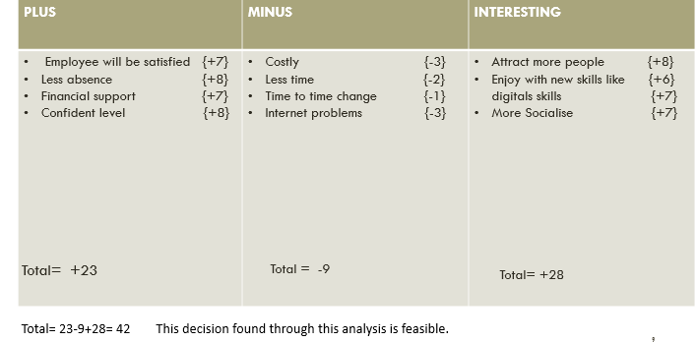
PMI analysis provides the actual happening in any organization through which management acts and makes appropriate arrangements for success of Business. Regular analysis gives enough opportunity and time to management for growth of the revenue of the organization.

GRID analysis:

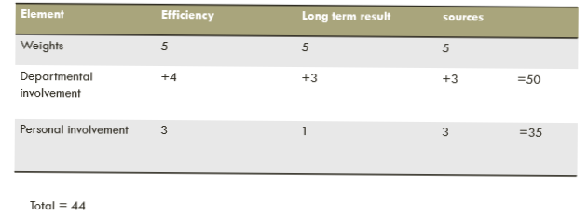
Grid analysis is one of those analyses which UK government does on regular basis to know the consequences of stress at workplaces once they find the ratio and the rate of stress level then find the solution to reduce the stress at workplace. The success of the Business is always based on the figures received through different analysis.

Causes of Stress at the workplace:
Company stress involves a variety of causes, many of which are unique to the individual and the workplace. The following are examples of common job pressures (American Psychological Association, 2018; Neenan, 2018):
Stress is usually described as a form of deviation from the regular functioning of the body that interferes with its most appropriate functioning. Given the comprehensive explanations for the upward shove in workplace stress, it would be insufficient to create a remedy to tackle these difficulties. Another view that holds that stress, to a sure extent, can be useful due to the fact it pushes a man to his limits, but pushing too challenging may lead to breaking. Managing stress and thoughts includes healing, and it’s vital to do that otherwise we are doomed to everlasting grief (Plaford, G. R. 2018). We need to find ways of engaging in extraordinary activities that assist in relieving stress for instance dancing, singing, sports etc. If these do now not prove to be effective, one need to are seeking for aid, and groups should provide counselling to their employees. There must also be some expert honesty amongst firms in that they aid and encourage their people, and if necessary, furnish assistance. This instils confidence in different employees that their organization cares about their well-being. Many firms ignore policies like these on the grounds that the impacts of stress on employees, for some reason, lead to worse difficulties in the future and pressure them to face the charges sooner.
- Work–life balance is impacted by longer working hours.
- Insecurity in the workplace
- Salary is low.
- Excessively long and exhausting commutes
- Workplace demands are increasing.
- Deadlines that are unrealistic
- Opportunities for growth, development, and promotion are limited.
- Colleagues who are demanding or challenging
- There are far too many meetings
- Managers and supervisors who are inept or uncaring
- Goals that are meaningless
- Technology is always changing.
- Inadequate social support
- Inadequate control over workplace decisions
- Job demands that are contradictory and imprecise performance expectations
- Multiple stressors usually combine to cause our work-related stress, which varies in severity throughout the day and even across our careers.

Conclusion:

Stress is currently increasing rapidly in several workplaces. The reason for this is because most workers are exposed to a load of unexpected work, they are not mentally and physically able to complete it. Brexit has caused many things. One of them is the work force returning to Europe. The remaining staff have more burden over work. For example, nurses and doctors work long shifts, this takes up many hours of their time. Covid has restricted many things in our lives including depression and lack of motivation to do regular work. Different surveys and analysis have been performed to Identify work related stress and reduction of

References:

- Anton, C.,( 2009). The impact of role stress on workers' behaviour through job satisfaction and organizational commitment. International journal of psychology, 44(3), pp.187-194.
- Cooper, Sharma, K. A., & Pestonjee, D. M. (2021). Organizational stress around the world: research and practice. Routledge. (Accessed on 5 Decembers 2021).
- Dagget, T., Molla, A. and Belachew, T. (2016). Job related stress among nurses working in Jimma Zone public hospitals, Southwest Ethiopia: a cross sectional study. BMC Nursing, 15(1).
- Di Martino, V., Hoel, H., & Cooper, C. L. (2003). Preventing Violence and Harassment in the Workplace (Report). European Foundation for the Improvement of Living and Working Conditions.
- Edwards, J.A., Webster, S., Van Laar, D. and Easton, S. (2008). Psychometric analysis of the UK Health and Safety Executive’s Management Standards work-related stress Indicator Tool. Work & Stress, 22(2), pp.96–107.
- Grawitch, M.J., Ballard, D.W. and Erb, K.R. (2015). To Be or Not to Be (Stressed): The Critical Role of a Psychologically Healthy Workplace in Effective Stress Management. Stress and Health, 31(4), pp.264–273.
- Hamaideh, S.H. (2011). Occupational Stress, Social Support, and Quality of Life among Jordanian Mental Health Nurses. Issues in Mental Health Nursing, 33(1), pp.15–23.
- Heathingfield, S., 2020. You Can Manage Stress and Experience Success in Your Workplace. [online] The Balance Careers Available at: <https://www.thebalancecareers.com/understanding-stress-and-how-it-affects-the-workplace-1919200> (Accessed 15 December 2021).
- Lagrosen, S. and Lagrosen, Y., 2020. workplace stress and health. Stefan Lagrosen.
- Nair,P,(2016) Available at:https://www.growthbusiness.co.uk/three-ways-to-help-your-employees-cope-with-workplace-stress-2516181/?utm_source=bing&utm_medium=cpc&utm_campaign=growthbiz%20(dynamic)&utm_term=growthbusiness[online] accessed on 22,March 2022.
- PositivePsychology.com. 2021. 16 Causes of Workplace Stress & How to Prevent Its Effects. (online) Available at: https://positivepsychology.com/workplace-stress (Accessed 7 December 2021).
- Zuckerman,A.(2020). 61 Stress statistics Available at: https://comparecamp.com/stress-statistics/ (Assessed on 27, March2022).

